Submitted by the European Union | Informal document WP.29-171-13  (171st WP.29, 14-17 March 2017,  agenda item 4.2.2.)
Proposal to amend document ECE/TRANS/WP.29/2017/53)
Draft General Guidelines for un regulatory procedures and transitional provisions in un Regulations
- Paragraph 25. Figure 1 amend to read:

"Figure 1
Illustration of a transitional period for a vehicle, or vehicle systems, covered by a UN Regulation and its amendments
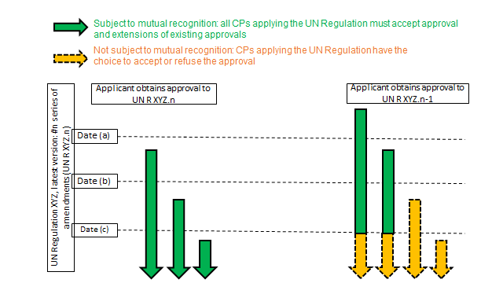
See however special cases 1-1, 1-2 and 1-3 in
Chapter E below

Note: If (b) and (c) dates are not written in to the transitional provisions, they are regarded as identical to date (a).
Existing approvals remain valid, but Contracting Parties are not obliged to accept them as from date (c). "
2. Chapter B.2. amend to read:
"B.2. Supplements
28. A Supplement addresses an amendment to a UN Regulation which does not entail a modification in the approval marking and is normally used for:
(a) Clarification of test procedures not changing the level of stringency of the regulation imposing new requirements; or
(b) Taking into account new developments which have arisen after the adoption of a UN Regulation (i.e. extension of scope) not changing the level of stringency of the regulation.
29. A Supplement shall not be used when it is necessary for Contracting Parties to differentiate the new approvals from the existing approvals.
30. A Supplement becomes applicable as from the date of entry into force (or date of application for special case 2), after which the granting of new approvals and of extensions tests according to the series of amendments to the UN Regulation, affected by that Supplement, need to take into account the Supplement in question. In the absence of any other date mentioned, Supplements become applicable for all procedures for new approvals started after the date of its entry into force, taking into account the transitional provisions, if any, of the series of amendments to which the Supplement refers
31. Unless specifically otherwise foreseen, extensions of existing approvals may continue to be granted on the basis of the provisions valid at the time of the original approval.
3231. Subject to the respect of paragraph 28 (supplement not modifying the level of stringency of the regulation) existing approvals do not need to be extended remain valid because of the enry into force of a new supplement and Contracting Parties shall continue to recognize them unless otherwise provided in the regulation.
32. In case of a Supplement not respecting paragraph 28 (supplement changing the level of stringency, i.e. having the nature of a new series of amendment), in accordance with the provision of Article 12 of the Agreement, Contracting Parties shall only be obliged to accept those type approvals granted pursuant to the highest level of stringency of the latest version of the said UN Regulation from the date of entry into force (or the date of application -special case 2) of the supplement. "

