**Manipulation on EURO IV, EURO V and EURO VI trucks   
by suppression of AdBlue injection**

**Detection of manipulated trucks – situation mid of September 2017**

The six heavy-duty truck control centers in Switzerland have controlled roughly about 20,000 vehicles since February to mid of September 2017. During this period 199 vehicles have been detected with irregularities concerning the pollutant control equipment - this is about 1% of all controlled vehicles.

The following graphs give detailed information about the outcome of the inspections in the biggest Swiss control center in Erstfeld. It is located at the noth-south junction of the Gotthard ramp, i.e. the most heavily travelled transit route in Switzerland. Although the graphs contain only a part of all controlled vehicles in Switzerland - **10,954 vehicles have been controlled in Erstfeld, 94 of them were not ok** - they give a good overview in different ways.

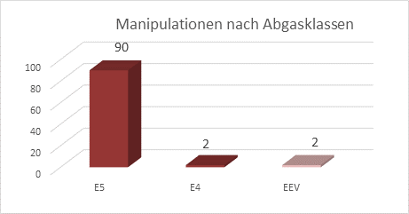

**Manipulation according to emission categories:** - EURO IV 2 vehicles

- EURO V 90 vehicles

- EEV 2 vehicles

- EURO VI 1 vehicle (not shown in table, detected   
 by a multi-brand testing device)

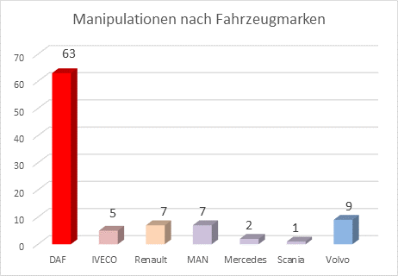

**Manipulation according to vehicle brands**

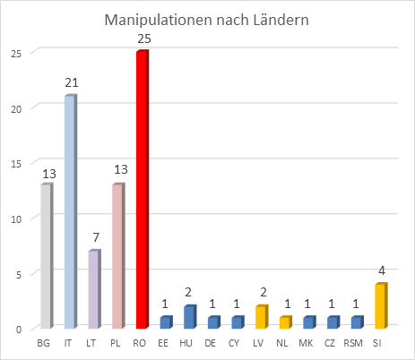

**Manipulation according to countries (acronyms according to ISO 3166)**

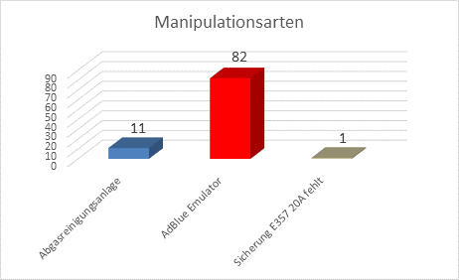

**Kind of manipulation**

● Abgasreinigungsanlage = pollutant control equipment

● AdBlue Emulator

● Sicherung E357 20A fehlt = fuse E357 20 Ampere is missing

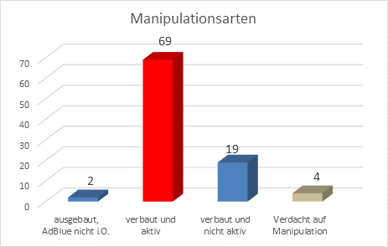

**Kind of manipulation**

● ausgebaut, AdBlue nicht i.O. = emulator removed but AdBlue not ok

● verbaut und aktiv = emulator fitted and active

● verbaut und nicht aktiv = emulator fitted but not active

● Verdacht auf Manipulation = suspicion of manipulation

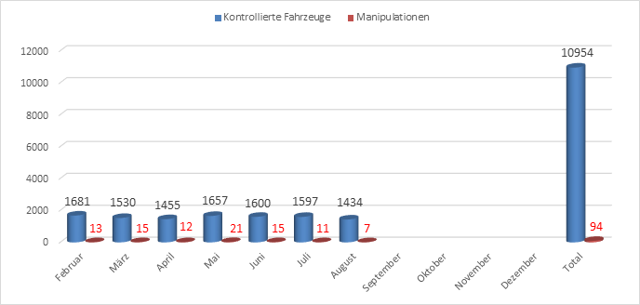

**Controlled vehicles vs. manipulated vehicles**