|  |  |  |  |
| --- | --- | --- | --- |
|  | United Nations | ECE/TRANS/WP.15/AC.1/2017/20 | |
| _unlogo | **Economic and Social Council** | | Distr.: General  21 December 2016  English  Original: French |

**Economic Commission for Europe**

Inland Transport Committee

**Working Party on the Transport of Dangerous Goods**

**Joint Meeting of the RID Committee of Experts and the  
Working Party on the Transport of Dangerous Goods**

Bern, 13-17 March 2017

Item 2 of the provisional agenda

**Tanks**

Tanks with a section including a concave part — Interpretation of 6.8.2.1.18

Transmitted by the Government of France[[1]](#footnote-1)\*,[[2]](#footnote-2)\*\*

Introduction

|  |
| --- |
| *Summary* |
| **Executive summary**: Questions concerning the conformity of some types of tank constructions including a concave part |
| **Reference documents**: ECE/TRANS/WP.15/AC.1/138/Add.1, Item 10 Informal document INF.15 from the March 2015 Joint Meeting. |
|  |

1. In March 2015, in informal document INF.15, the Government of Germany proposed validating the partially cylindrical cross-section of a tank truncated on its lower side by a concave part, with the joints between the convex (cylindrical) part and the concave part of the body formed by fillet welds:

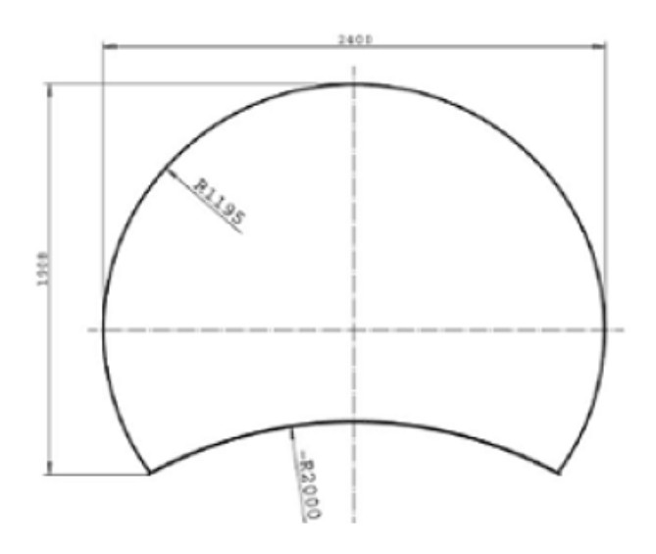

2. The Working Group on Tanks then decided that it should await the outcome of the discussions on this subject in the CEN/TC 296 working group dealing with standard EN 13094.

3. We consider that this matter falls within the purview of the Joint Meeting, in that Chapter 6.8 of RID/ADR establishes relatively clear provisions on the shape of tanks.

4. In our opinion, this type of construction cannot comply with RID/ADR for the reasons given below.

5. The hybrid cross-section shown in paragraph 1 cannot be considered to be a circular or elliptical cross-section; consequently, it is of another shape for the purposes of RID/ADR.

6. For shells not of a circular cross-section, footnote 2 to 6.8.2.1.18 of ADR requires that the radius of convexity of the shell wall should not exceed 2,000 mm at the sides or 3,000 mm at the top and bottom. The shape proposed is bounded on its lower part by a concave radius and thus does not comply with this requirement of ADR.

7. Moreover, under standards EN 13094 and EN 14025 on the design and construction of tanks:

* EN 13094, in 6.3.1, requires a minimum radius of 200 mm linking the top/bottom and side convexities. There are no joints between side and bottom convexities and so this requirement of the standard is not met;
* For the calculation for construction types not given in EN 14025, 6.3.1 of that standard refers to the provisions of EN 13445-3, meaning that the manufacturing requirements of EN 13445-3, and specifically the types of weld joint allowed for shell longitudinal and circular welds, must be met. According to tables A-1 and A-2 of EN 13445-3, fillet welds are not allowed for shell longitudinal or circulars welds; hence, this requirement is not met.

8. We therefore consider that this type of construction does not comply with regulatory and normative requirements and therefore cannot be used for the transport of dangerous goods.

9. We would like to know the opinion of the Joint Meeting on this matter.

1. \* In accordance with the programme of work of the Inland Transport Committee for 2016-2017, (ECE/TRANS/2016/28/Add.1 (9.2)). [↑](#footnote-ref-1)
2. \*\* Circulated by the Intergovernmental Organisation for International Carriage by Rail (OTIF) under the symbol OTIF/RID/RC/2017/20. [↑](#footnote-ref-2)