UN/SCEGHS/33/INF.9
Committee of Experts on the Transport of Dangerous Goods
and on the Globally Harmonized System of Classification
and Labelling of Chemicals
Sub-Committee of Experts on the Globally Harmonized
System of Classification and Labelling of Chemicals 27 June 2017

Thirty-third session
Geneva, 10-12 July 2017
Item 3 (d) of the provisional agenda
Hazard communication: Other issues
Amendments to Annex 7, example 7: single packagings
Transmitted by the United Nations Institute for Training and Research (UNITAR)
Introduction
1. This informal paper proposes amendments to the annex 7, example 7 on single packagings, to improve consistency with requirements and recommendations of the GHS text (specific references are to the 7th revision), particularly as it relates to using the text for capacity building activities.
Current situation
2. Stakeholders rely on the GHS text in order to provide clear and consistent guidance to those responsible for implementing the GHS. Furthermore, it is as an integral tool for training and capacity building.
3. Paragraph 1.4.10.5.4.1 of the GHS – Location of GHS information on the label – states:
“The GHS hazard pictograms, signal word and hazard statements should be located together on the label. The competent authority may choose to provide a specified layout for the presentation of these and for the presentation of precautionary information, or allow supplier discretion. Specific guidance and examples are provided in the chapters on individual hazard classes.”
4. Annex 7, example 7 gives an example of “Single packaging using 3 adjacent panels to convey multiple hazards”. However, in this example, the hazard statements are not located together with the pictograms and the signal word.
5. In addition, other possible areas for amendment have been identified:
(a) The header should read: “(c) Category 2 Specific target organ toxicity (repeated exposure).”
(b) The emergency phone number is currently placed immediately under the company details: it could be placed separately.
(c) The general precautionary statement P102 should be changed to: “Keep out of reach of children.”
(d) The response precautionary statement P312 should be changed to: “Call a POISON CENTER/doctor/…if you feel unwell.” This preserves the option for the manufacturer/supplier or the competent authority to specify the appropriate source of emergency medical advice.
(e) For the purposes of highlighting the hazard, it is suggested to increase the size of the pictograms, given the relative size of the label.
(f) In addition to the product name, there should be a section to provide the chemical identity of the substance, or in the case of a mixture the chemical identities of all ingredients or alloying elements that contribute to certain types of toxicity.

Annex 7, Example 7 from the GHS
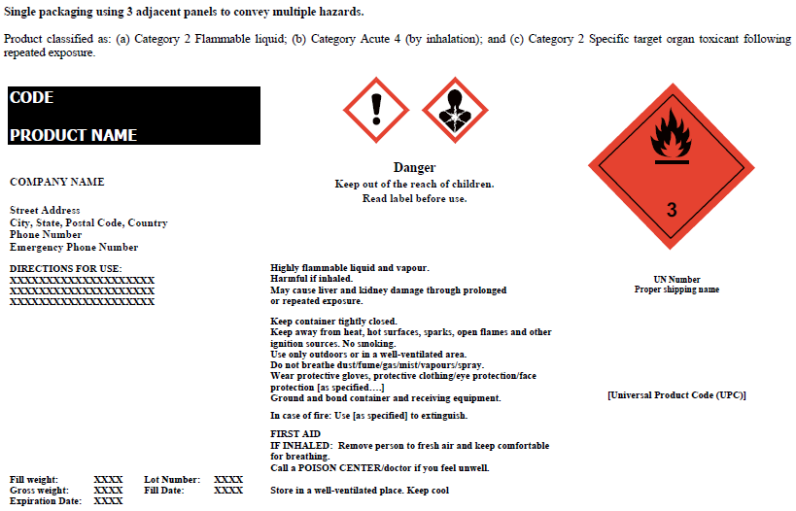
6. While the use of “should” and other options for flexibility are noted in paragraph 1.4.10.5.4.1 and throughout the GHS text, UNITAR believes that making the example 7 more consistent with the recommendations would assist with capacity building.
Proposal
7. As capacity building is an integral part of the GHS, and one of the functions of the Sub-Committee is “to promote understanding and use of the GHS and to encourage feedback”, UNITAR would like to propose that the Annex 7, example 7 is amended to ensure that the label better presents the requirements of the GHS and the spirt of other recommendations. This would serve as a more consistent example of where to place GHS information.
8. Should the Sub-Committee agree, a worked-through proposal for an amended example would be presented as a working document at its thirty-fourth session.
________________

