UN/SCEGHS/33/INF.11
Committee of Experts on the Transport of Dangerous Goods
and on the Globally Harmonized System of Classification
and Labelling of Chemicals
Sub-Committee of Experts on the Globally Harmonized
System of Classification and Labelling of Chemicals 3 July 2017

Thirty-third session
Geneva, 10-12 July 2017
Item 3 (a) of the provisional agenda
Hazard communication: labelling of small packagings
Proposed corrections to document ST/SG/AC.10/C.4/2017/2
Transmitted by the expert from Belgium
This document contains proposals for editorial corrections to the English and French versions of the examples for labelling of sets or kits in document ST/SG/AC.10/C.4/2017/2.
1. Example 10, second paragraph
Amend as follows:
English version
“The supplier identification needs only appear once.
2. Example 10, fourth and fifth paragraphs
Amend as follows:
English version
“The area available on the outer packaging of the set or kit label is large enough to carry the required GHS label elements:
- set or kit identifier (name of the set or kit)
- supplier identification
- storage conditions for the set or kit as a whole
- product identifier of each hazardous substance or mixture
- pictograms of each hazardous substance or mixture
- hazard statements of each hazardous substance or mixture
- precautionary statements of each hazardous substance or mixture”
“If the area available for a label on the different inner packaging is not sufficient to include all required label elements the following minimum required information should be included:
- supplier identification
- product identifier
- hazard pictogram(s)
- signal word
- “Read outer packaging label”
Version française
« La place réservée à l’étiquette sur l’emballage de la trousse est suffisamment grande pour y faire figurer les éléments d’étiquetage prescrits par le SGH :
- Identification de la trousse (nom de la trousse) ;
- Identité du fournisseur ;
- Conditions de stockage de la trousse dans son ensemble ;
- Identification du produit pour chaque substance ou mélange dangereux ;
- Pictogramme de chaque substance ou mélange dangereux ;
- Mentions de danger pour chaque substance ou mélange dangereux ;
- Conseils de prudence pour chaque substance ou mélange dangereux. »
“Si la place réservée à l’étiquette sur les différents emballages intérieurs n’est pas suffisante pour y faire figurer tous les éléments d’étiquetage prescrits, celle-ci devra contenir au moins les informations ci-après :
- Identité du fournisseur ;
- Identification du produit;
- Pictogramme(s) de danger ;
- Mention d’avertissement ;
- L’instruction « Lire l’étiquette de l’emballage extérieur ».
3. Example 10, text under “outer kit label”
The statement “Redundant precautionary statements need, when clearly recognizable, only appear once.” does not seem to be correct. If the intended meaning is that precautionary statements applicable to more than one reagent should only appear once in the label to avoid redundancy when they are put together, it is proposed to modify the sentence as follows:
English version
“Outer kit label
All required GHS label elements of each hazardous substance or mixture appear on the outside packaging. To maintain readability, it might, in individual cases, for example if a lot of precautionary statements are required, be necessary to locate the precautionary statements separately. They should be displayed on a surface that is visible under normal conditions of use. To avoid redundancies, precautionary statements applicable to several substances or mixtures need only appear once in the outer kit label when they are put together (like for storage conditions).”
Version française
Modifier comme suit:
« Étiquette de l’emballage extérieur
Tous les éléments d’étiquetage prescrits par le SGH de chaque substance ou mélange dangereux figurent sur l’emballage extérieur. Pour maintenir la lisibilité, il est possible, dans des cas particuliers, par exemple lorsque de nombreux conseils de prudence sont nécessaires, de prévoir un espace distinct pour ceux-ci. Les informations séparées devraient figurer sur une surface visible dans des conditions normales d’utilisation. Pour éviter les redondances, les conseils de prudence applicables à plusieurs substances ou mélanges ne doivent figurer qu’une fois sur l’étiquette de l’emballage extérieur quand ils sont regroupés (comme pour les conditions de stockage). »
4. Example 10, drawing under “outer kit label”
Amend the labels as follows:
English version
Reagent 1
Signal word
(see 1.4.10.5.2 (a))
Hazard statements
(see 1.4.10.5.2(b))
Product identifier
(see 4.10.5.2 (d)(ii))
Reagent 1
Precautionary statements (see 1.4.10.5.2 (c))
Storage precautionary statements
Reagent 2
Precautionary statements (see 1.4.10.5.2 (c))
Reagent kit for water analysis
Supplier identification (see 1.4.10.5.2 (e))
Reagent 2
Signal word
(see 1.4.10.5.2 (a))
Hazard statements
(see 1.4.10.5.2(b))
Product identifier
(see 4.10.5.2 (d)(ii))
Version française
Trousse de réactif pour l’analyse de l’eau Identité du fournisseur (voir 1.4.10.5.2 e))
Trousse de réactif pour l’analyse de l’eau
Identité du fournisseur (voir 1.4.10.5.2 e))
Réactif 1
Mention d’avertissement
(voir 1.4.10.5.2 a))
Mention de danger
(voir 1.4.10.5.2 b))
Identification du produit
(voir 4.10.5.2 d) ii))
Réactif 1
Mention d’avertissement
(voir 1.4.10.5.2 a))
Déclaration de danger
(voir 1.4.10.5.2 b))
Identification du produit
(voir 4.10.5.2 d) ii))
Réactif 2
Mention d’avertissement
(voir 1.4.10.5.2 a))
Mention de danger
(voir 1.4.10.5.2 b))
Identification du produit
(voir 4.10.5.2 d) ii))

Réactif 2
Mention d’avertissement
(voir 1.4.10.5.2 a))
Déclaration de danger
(voir 1.4.10.5.2 b))
Identification du produit
(voir 4.10.5.2 d) ii))

Réactif 1
Conseils de prudence (voir 1.4.10.5.2 c))
Conseils de prudence concernant le stockage
Réactif 2
Conseils de prudence (voir 1.4.10.5.2 c))
5. Example 11, legend under the drawings for the inner and outer packaging
English version (unchanged)
“Inner packaging (sample bottle)”
“Outer packaging”
Version française
Modifier comme suit:
« Emballage intérieur (flacon d’échantillonnage) »
« Emballage extérieur »
Justification : Le SGH définit l’emballage extérieur et l’emballage intérieur mais ne parle pas d’emballage interne ou externe.
6. Example 11, text under “inner kit label”
Amend as follows:
English version
“Inner kit label
Each inner packaging label contains the following minimum required information:
- supplier identification
- product identifier
- pictogram
- the statement: “Read full label”

Justification: The guidance in chapter 1.4, paragraph 1.4.10.5.2 (e) refers to “supplier identification”. The same terminology should be used in the examples to avoid confusion. Similarly, in example 8 of the GHS, the wording “Read full label” is used with the same intended meaning. We think it is preferable to use a shorter phrase when it is quite understandable. The advantage is also to save space for the translations.
Version française
Modifier comme suit :
« Étiquette de l’emballage intérieur
Chaque étiquette de l’emballage intérieur contient les renseignements minimum requis suivants :
- Identité du fournisseur ;
- Identification du produit ;
- Pictogramme ;
- L’instruction : « Lire l’étiquette complète ». »
7. Example 11, inner kit label drawing
Delete “Signal word (see 1.4.10.5.2(a))”
Replace “Read full labelling information” with “Read full label”
Justification: On this label, the signal word “WARNING” is already given. We don’t need to repeat “Signal word (see 1.4.10.5.2 (a) just below. Moreover, if the proposal to adopt the wording “Read full label” is accepted, the same sentence should be displayed on the example.
The labels, as amended, would read:

English version | Version française
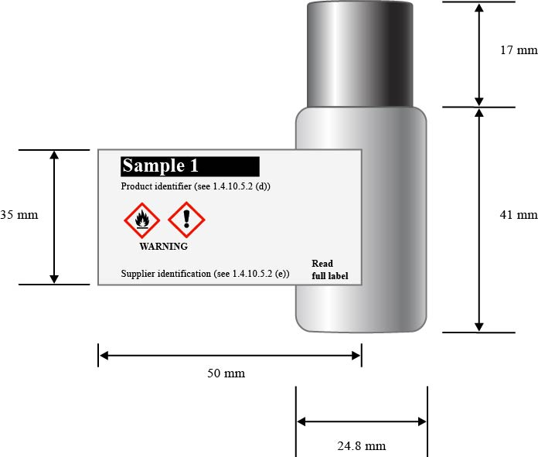 | 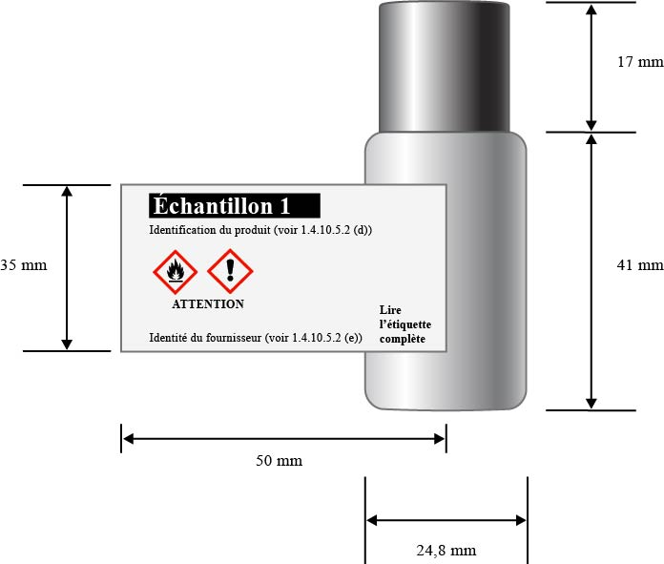
8. Example 11, last sentence in the paragraph preceding the drawing of the inner and the outer packaging
English version (unchanged)
“Depending upon the contents of each bottle, some or all of the 156 substances or mixtures may be classified as hazardous”
Version française
Modifier comme suit:
« L’un ou plusieurs des 156 substances ou mélanges différents peuvent être classés comme dangereux en fonction du contenu de chaque flacon.
9. Example 11, text “outer kit label”
English version
Amend as follows:
“Outer kit label
The outer box, given the limited area for labelling, will display:
- Kit identifier (name of kit)
- Supplier identification
- Storage precautionary statements for the kit as a whole
- Pictograms of each single hazardous substance or mixture without duplication
- Signal word”
Version française
Modifier comme suit:
« Étiquette extérieure de la trousse
Étant donné la place limitée réservée à l’étiquette sur l’extérieur de la boîte, on trouvera sur celle-ci les informations suivantes :
- Identification de la trousse (nom de la trousse) ;
- Identité du fournisseur ;
- Conseils de prudence concernant le stockage de la trousse dans son ensemble ;
- Pictogrammes de chaque substance ou mélange dangereux en omettant les pictogrammes redondants;
- Mention d’avertissement »
10. Example 11, “outer kit label” drawing
The list of information to be displayed in the outer kit label includes the “pictograms of each single hazardous substance or mixture without duplication”.
This recommendation has not been followed in the example. In fact, the flame and the exclamation mark were allocated to sample 1 but are not displayed on the outer packaging.
To make the guidance consistent with the examples, it is suggested to:
- add the pictograms with the flame and the exclamation mark in the drawing for the outer kit label.
- add “(s)” after statement because more than one precautionary statement may be needed for the storage.
- replace the last indication by “Read full label enclosed”
In addition, it is suggested to correct the references to the applicable label elements in Chapter 1.4, as follows:
- “supplier identification (see 1.4.10.5.2 (e))”
- “signal word (see 1.4.10.5.2 (a))”
If all the proposed corrections above are accepted, the outer kit label in document ST/SG/AC.10/C.4/2017/2 should be replaced by the following:

English version
Market kit
Supplier identification (see 1.4.10.5.2 (e))
Signal word (see 1.4.10.5.2 (a))
Storage precautionary statement(s) (see 1.4.10.5.2 (c))

Read full label enclosed

Version française
Trousse commerciale
Identité du fournisseur (voir 1.4.10.5.2 e))
Mention d’avertissement (voir 1.4.10.5.2 (a))
Conseil(s) de prudence concernant le stockage (voir 1.4.10.5.2 (c))

Lire l’étiquette complète à l’intérieur

________________

