|  |
| --- |
| **UN/SCETDG/52/INF.11** |
| **Committee of Experts on the Transport of Dangerous Goods and on the Globally Harmonized System of Classification and Labelling of Chemicals**  **Sub-Committee of Experts on the Transport of Dangerous Goods 2 November 2017**  **Fifty-second session**  Geneva, 27 November-6 December 2017  Item 4 (e) of the provisional agenda **Electric storage systems: Sodium-ion batteries** |

Sodium-Ion Batteries

Submitted by the expert from United Kingdom

Introduction

1. At the fiftieth session of the Sub-Committee the United Kingdom submitted informal document INF.13 which asked for the topic of sodium ion batteries to be placed on the agenda for this biennium.

2. In that paper, it was noted that the current classification system does not address the particular circumstances of sodium-ion batteries. Highlighting that the existing entry for batteries containing sodium (UN3292) and Special Provision 239 are relevant to cell chemistries such as sodium sulphur and sodium metal chloride which contain metallic sodium. It does not recognise the far lesser risk posed by sodium-ion cell chemistry, which contains sodium salts, not sodium metal.

3. Opinion was divided during previous discussions at the Sub-Committee as to whether sodium-ion batteries needed to be covered under the dangerous goods regulations. If they did then it was broadly agreed that the current UN entry, UN3292, was not suitable for the transport conditions of these types of batteries. Those that thought sodium-ion should not be covered under regulations noted that such batteries posed no risk when they were fully discharged (unlike lithium batteries). The Sub-Committee concluded that more work was required before a decision could be made on this type of battery.

4. The aim of this paper is to:

* Provide a background on sodium-ion battery technology;
* Explain the differences in comparison to lithium-ion battery technology;
* Explain the similarities between a shorted sodium-ion battery and a super capacitor; and
* Discuss the consequences for the Model Regulations.

A background to Sodium-ion battery technology

5. The sodium-ion battery (figure 1) is a development of lithium-ion technology in which the active ion, lithium, is replaced by sodium. Sodium–ion cells are manufactured in the same way as lithium-ion cells and they have comparable performance.

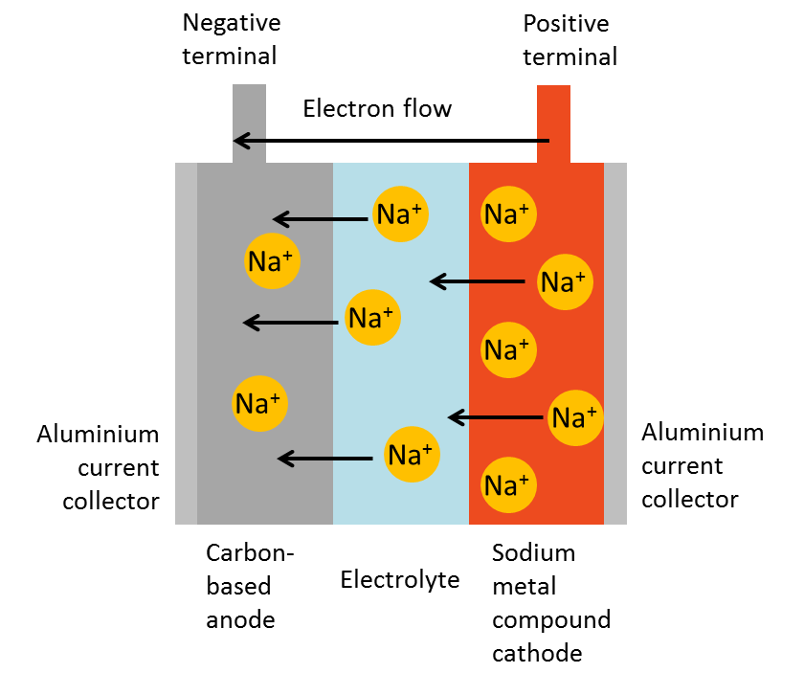

**Figure 1:** Schematic showing the principles of a sodium-ion battery

6. They have the technical advantage of being less dependent on scarce resources than lithium-ion batteries. In addition, and for detailed chemical reasons which are explained below, they are safer. In particular, they can be stored and transported at zero volts.

Definition and working principles of sodium-ion batteries

7. A sodium-ion battery (NIB) is an electrochemical cell that comprises a positive and negative electrode. Sodium-ion transfer occurs between the electrodes via an ionically conducting electrolyte. Figure 1 shows a schematic of the NIB, indicating transport of the sodium-ions from positive to negative electrode via the electrolyte (this is the charging process).

8. A NIB cell is comprised of sheets of positive and negative electrode with a separator between them. The electrodes are comprised of the active material deposited on an aluminium current collector and the separator is an electrically insulating but ionically conducting layer. A cell can be comprised of multiple layers depending on the desired capacity and footprint. Designs include prismatic, wound and cylindrical.

9. The voltage range is typically 1.0 to 4.3 volts, but they can operate down to voltages as low as zero volts without any impairment. This is as a result of aluminium current collectors on both positive and negative electrodes (see paragraphs 14 and 15).

10. NIBs are rechargeable devices and discharge occurs by the same process, in reverse. The positive electrode is comprised of a sodium compound. The negative electrode is carbon-based. The electrolyte is a sodium salt in organic solution. Sodium metal is not used in the construction of a sodium-ion cell.

11. A sodium-ion battery is shown in the schematic Figure 2 below and the two main differences from a lithium-ion battery are that:

(a) In a sodium-ion battery aluminium can be used as a current collector on both electrodes; and

(b) Graphite cannot be used as an anode material in a sodium-ion battery because it is not intercalated by sodium. Instead a material called hard carbon has to be used.

Applications of sodium-ion batteries

12. NIB applications include:

(a) Very large energy storage systems for renewables such as photo-voltaic, wind and wave power;

(b) Automotive applications such as electric vehicles; and,

(c) As an alternative to existing battery technologies providing equivalent performance at a reduced cost.

13. Development of this technology is known to be taking place in China, the UK, France and the USA.

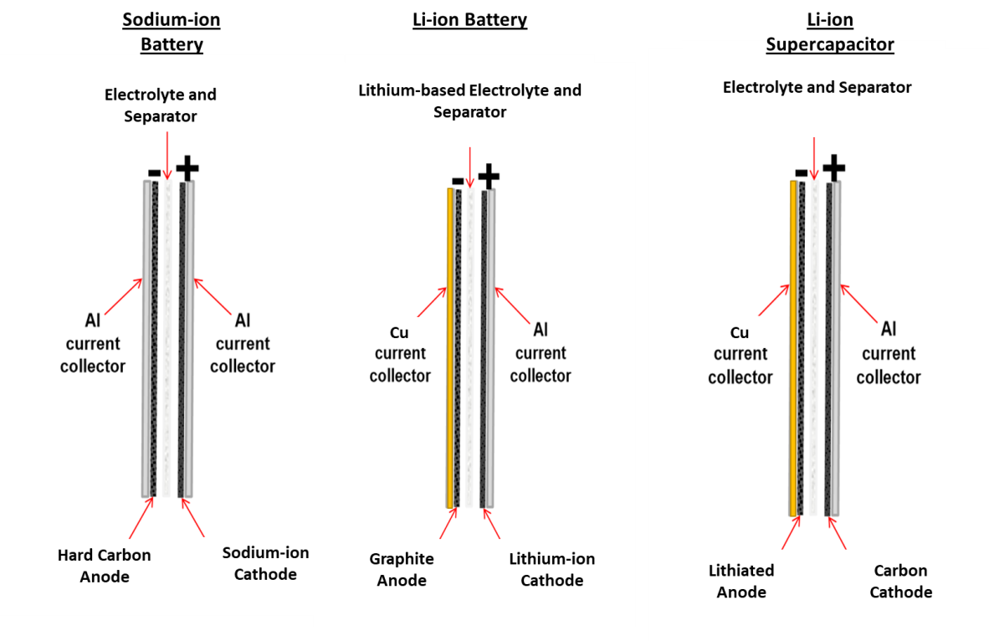**Figure 2**: A sodium-ion battery, a Lithium-ion battery and a Li-ion super capacitor

Differences between Lithium-ion batteries and all Sodium-ion batteries

(a) Current collectors

14. If an aluminium current collector was to be used at the anode in a lithium-ion battery, any lithium present would form an alloy with it. Particularly when the cell was operated close to full charge i.e. when the anode was close to 0V with respect to lithium. Therefore copper current collectors must be used at the anodes of lithium–ion batteries (figure 2). However, when a Li-ion cell is operated at a low SOC (state of charge) (i.e. the CELL voltage approaches 0V) the anode potential can then rise until it is close to about 3.0V compared to lithium, at which point the copper can dissolve in the electrolyte leading to a reduction in capacity and reduced cycle life. For this reason Li-ion batteries need to be transported at no less than 40% SOC in order to preserve their performance.

15. In contrast, sodium does not alloy with aluminium, so that a sodium-ion battery can be constructed with aluminium current collectors on both electrodes and kept at zero SOC for long periods of time with no impact on performance. This is a key safety feature.

16. The state of charge of a metal-ion battery has a significant impact on the heat release rate in a safety incident, shown in figure 3, primarily because of reactions between the lithium or sodium metal at the anode and the electrolyte. It can be seen below that at 0% SOC, the heat release rate is dramatically reduced and the heat emitted is produced over longer time periods compared with the data at higher percentage SOC`s.

17. In turn, since it is the heat release rate which drives other key parameters such as a) the temperature of a battery at which thermal runaway occurs and b) the maximum rate of temperature release from a battery following thermal runaway, the SOC is a major determinant of battery safety.



**Figure 3**: Heat release rate as a function of state of charge in a lithium-ion battery measured by oxygen combustion calorimetry) (Energy Environ. Sci., 2012, 5, 5271)

18. This analysis is borne out by accelerating rate calorimetry tests on 0% SOC sodium-ion batteries compared with a 100% SOC LiFePO4 battery (figure 4).

**Figure 4:** Results of accelerating rate calorimetry tests on 0% SOC sodium-ion batteries compared with a 100% SOC LiFePO4 battery

(b) Anodes and electrolyte solvents

19. In a sodium-ion battery the anode is hard carbon, rather than the graphite used in a lithium-ion battery, because sodium will not intercalate into graphite. As a consequence certain higher vapour pressure solvents such as propylene carbonate (see Table 1) can be used as electrolyte solvents, which would not be feasible in a lithium-ion battery because they have the unwanted property of intercalating with the graphite and causing material damage and capacity loss. Propylene carbonate has the attractive combination of both a wide liquid range and a high flash point. As a consequence in a sodium-ion battery, propylene carbonate can be used to replace some of the low flash point diethyl carbonate (DEC) and dimethyl carbonate (DMC) that have to be added to lithium-ion electrolytes in order to solubilise the ethylene carbonate. This is another safety feature of sodium-ion batteries.

20. Specifically, propylene carbonate is used as a solvent in a sodium ion cell because it is safer and has excellent properties.

|  |  |  |  |  |
| --- | --- | --- | --- | --- |
|  | B.Pt  C | Flash Point  C | M.Pt  C | Comments |
| Propylene carbonate  (PC) | 242 | 116 | -49 | Wide liquid range  High flash point |
| Diethyl carbonate  (DEC) | 126 | 25 | -43 | Low flash point |
| Dimethyl carbonate  (DMC) | 90 | 17 | ~3 | Low flash point |
| Ethylene carbonate  (EC) | 243 | 150 | 34 | High flash point Solid at temperatures of commercial interest |
| Commercial mixtures |  | 36-45 |  |  |

**Table 1:** Some physical properties of propylene carbonate compared with alternative solvents

(c) Electrolytes

21. Published data shows that the decomposition temperature, as measured by differential scanning calorimetry, for sodium hexafluorophosphate (NaPF6) in EC-DMC mixed solvents is ~50C higher than the decomposition temperature of lithium hexafluorophosphate (LiPF6) in the same solvents. (Journal of Power sources 244 (2013) 752).

Differences between certain Lithium-ion batteries and certain Sodium-ion batteries

22. In lithium cobalt oxide, a common cathode in consumer batteries, thermal decomposition of the cathode takes place via disproportionation reactions such as:

LixCoO2------🡪xLiCoO2 + (1-x)/3Co3O4 + (1-x)/3O2

in which the original layered structure gives way to a new structure called a spinel. In a fully discharged (0% SOC) condition, that is when x=1, this reaction does not occur. Lithium nickel manganese cobalt cathodes also degrade to a spinel structure at temperatures in excess of ~170C releasing oxygen.

23. In contrast, sodium metal oxides are much more stable and no oxygen release occurs in either the charged or the uncharged state on heating. This is not unexpected since the sodium metal oxides are synthesised in air at high temperatures (~900C).

24. Depending on the specific chemistry of the battery this is another safety feature.

Similarities and differences between a shorted NIB and symmetric and asymmetric supercapacitors

25. Comparisons are now made between a shorted sodium-ion battery and supercapacitors, because the safety features of these devices are strongly comparable.

26. From a transport perspective, the inherent electrical hazard in an energy storage devices is best quantified by the electrical energy density. Table 2 provides a comparison of the electrical energy density of shorted sodium-ion batteries with other energy storage devices.

27. The amount of heat that may be generated accidentally inside a casing through an unintended short circuit is much lower for asymmetric capacitors compared to other high energy devices such as lithium ion batteries, which is why they can be transported under less stringent conditions of carriage. An electrical double layer capacitor can be shorted and shipped at zero volts. A lithium-ion asymmetric supercapacitor cannot be shorted but nonetheless the electrical energy density it contains is still an order of magnitude less than that of a lithium-ion battery.

|  |  |  |  |  |  |
| --- | --- | --- | --- | --- | --- |
|  | Shorted sodium-ion battery | Shorted electrical double-layer capacitor | Electrical double-layer capacitor | Lithium-ion asymmetric super  capacitor | Lithium-ion battery |
| Operating voltage | 0 | 0 | 2.7-0.4 | 3.8-2.2 | 2-2.75 |
| Electrical Energy Density Wh/l | 0 | 0 | 4-15 | 10-50 | 150-600 |

**Table 2: The voltages and electrical energy densities of certain energy storage devices**

28. The electrical energy density held by a shorted sodium-ion battery is zero, less than that of an asymmetric capacitor (see UN No 3508). Thus, from the point of view of the inherent electrical hazard, the shorted sodium ion battery is in the same class as a shorted electrical double layer capacitor (EDLC) (see UN No 3499).

The safe carriage of shorted sodium-ion cells

(a) Chemical hazard due to the use of electrolyte solutions:

29. Sodium-ion batteries (NIB) may contain an electrolyte meeting the criteria of a class or division of dangerous goods. Electrolyte solutions in NIBs typically consist of sodium salts, such as sodium hexafluorophosphate (NaPF6), or sodium tetrafluoroborate (NaBF4) in an organic solvent, which may meet the criteria for a flammable liquid. Mixtures of PC/EC/DEC (see Table 1) is one example solvent. The electrolyte solution is absorbed onto cell constituents such as carbon materials, other cell materials and separators.

30. Similar to electric double layer capacitors (EDLCs) and asymmetric supercapacitors, NIB`s normally include small amounts of free liquid electrolyte solution to ensure complete wetting of the electrode materials. The integrity of NIB`s containing dangerous goods should be ensured. NIB`s which contain any class or divisions of dangerous goods should be required to withstand a 95kPa pressure differential to confirm the robustness of the battery casing.

31. The amount of flammable liquid in NIBs with a Watt-hour rating of up to 20Wh is below 0.1 litre (cf. 0.5 litre in an asymmetric supercapacitor), and the amount of free liquid is about 9 ml (cf. 5 ml in an asymmetric supercapacitor - approximately the same amount as in an EDLC of 10Wh).

32. On this basis, it is proposed that NIB`s containing flammable liquids with an energy storage capacity of 20Wh or less should be transported without applying other Regulations, when they are capable of withstanding a 1.2 metre drop test unpackaged and can withstand a 95kPa pressure differential test. These tests are the same as those for EDLCs.

(b) Chemical hazard due to presence of cathode material

33. Sodium metal-oxide cathodes are relatively stable since they are synthesised in air at high temperatures (~900C).

The consequence for the Model Regulations

34. Following this explanation of NIB technology the Sub-Committee is invited to consider the following options and offer views:

(a) Option 1 Do nothing

35. To accept that shorted NIB’s pose no safety concern to people, property or the environment during carriage and there should be no mention of them in the Model Regulations.

(b) Option 2 Explicitly exempt from the Model Regulations

36. Recognising that there may be a false assumption that the properties of NIB technology is similar lithium-ion technology, the Model Regulations should explicitly state that shorted NIB’s are not subject to these Regulations. This could be achieved by amending Special Provision 239 associated with UN No. 3292 BATTERIES, CONTAINING SODIUM to include text saying that shorted sodium-ion batteries are not subject to these Regulations.

(c) Option 3 Introduce a new Special Provision

37. To introduce a new Special Provision XXX associated with UN No. 3292 that would be similar to Special Provision 361 associated with UN No. 3499 CAPACITOR, ELECTRICAL DOUBLE LAYER.

Conclusion

38. The UK Delegation will take note of the opinions of the Sub-Committee and return as appropriate with a formal proposal at the next session.