|  |  |  |  |
| --- | --- | --- | --- |
|  | United Nations | ST/SG/AC.10/C.3/2017/51 | |
| _unlogo | **Secretariat** | | Distr.: General  5 September 2017  Original: English |

**Committee of Experts on the Transport of Dangerous Goods  
and on the Globally Harmonized System of Classification  
and Labelling of Chemicals**

|  |
| --- |
| **Sub-Committee of Experts on the Transport of Dangerous Goods** |
| **Fifty-second session** |
| Geneva, 27 November-6 December 2017  Item 2 (j) of the provisional agenda **Explosives and related matters:  miscellaneous** |

A method for transporting controlled shipments of explosives samples (≤ 25 grams)

Transmitted by the Sporting Arms and Ammunition Manufacturers’ Institute (SAAMI)[[1]](#footnote-2)

Introduction

1. Competent authorities and explosives researchers desire increased efficiency in shipping small samples of explosives in a safe and approved manner. Experience with the use of UN 0190, Samples, explosive shows that it is not always efficient, especially for small samples of 25 grams or less. SAAMI informally presented an alternative at the fifty-first session in the meeting of the Working Group on Explosives which was received with interest. SAAMI agreed to return with a draft proposal, presented here.

2. In coordination with various experts, SAAMI suggests a solution based on a specialized container currently used in the United States of America. The proposal in this paper shows how this solution might appear in the context of the Model Regulations. Input is sought now with the intent to make a formal proposal at the next meeting of this biennium.

Current implementation in the United States of America

3. A “special permit” exists in the United States of America which provides an alternative to the hazardous materials (dangerous goods) regulations of the United States of America with an equivalent level of safety. Transport in commerce is authorized for not more than 25 grams of solid explosive or pyrotechnic material, including waste containing explosives that has energy density not significantly greater than that of pentaerythritol tetranitrate, classed as Division 1.4E, when packed in a specialized inner packaging, described later. This alternative method exempts these shipments from explosives testing and approval. Some variations of the container are allowed.

4. The key principles providing the equivalent level of safety are:

(a) An entity must be approved before using the method. The ability to use this method may be limited to qualified explosives experts. To enable enforcement, a copy of the authorization is included with the shipment. Once approved, an entity may offer different explosives for transportation without additional authorizations.

(b) The shipping containers are rated for 25 grams of PETN equivalent or less of explosives that are not forbidden by the US Code of Federal Regulations in Column 3 of the 49 CFR 172.101 Hazardous Materials Table. Substances forbidden in Column 9 are allowed transport in the shipping container due to the reclassification as Division 1.4.

(c) Test data has shown that 35 grams (a 40% overcharge) of dry PETN does not result in any hazardous effects outside of the pipe of Design Type 1 below. All of the explosives effects are contained within the pipe.

5. The US Special Permit 8451 (DOT-SP 8451 38th Revision) describes the currently approved shipping containers and configurations that can be used to safely transport up to 25 grams of solid or powdered explosives comparable to the energy of PETN. These include the following inner packagingst:

(a) Design Type 1: A 4-inch x 14-inch Schedule 80 seamless steel pipe nipple closed at both ends with 4-inch diameter forged steel end caps; or

(b) Design Type 2: A 6-inch x 12 to 14-inch Schedule 80 seamless steel pipe nipple closed at both ends with 6-inch diameter malleable iron end caps; or

(c) Design Type 3: A 8-inch x 30-inch Schedule 80 seamless steel pipe nipple closed at both ends with 8-inch diameter forged steel end caps; or

(d) Design Type 4: Bartle’s device; or

(e) Design Type 5: Los Alamos Model LD-2250” (may only be used if the net mass of explosives contained within does not exceed 15 grams).

Description of a specialized container for solids

6. The explosive sample is sealed in a bag or other leak-proof receptacle and centered inside the pipe container so as to not be next to the walls or caps of the shipping container. The shipping pipe is then placed in a fiberboard, plywood, or metal container.

7. The suggested container to be used for transport of solid or powdered explosive samples is the same as that outlined in DOT-SP 8451, 38th Revision, Design Type 1. A 4-inch shipping pipe and example outer packaging is pictured below.

|  |  |
| --- | --- |
| S:\0-PROJECT\0013 - Shipping Containers\0008 - Shipping Container Photos\4inPipe_I.png |  |

8. Testing was performed on the DOT-SP 8451, 38th revision, Design Type 1 shipping container to verify that 35 grams (a 40% overcharge) of dry PETN does not result in breaching or fragmenting the pipe and to determine the maximum pressure effect outside of the shipping container. 35 grams of PETN was placed inside the pipe with a blasting cap. Wires to the cap were feed through a sealed insulated port to significantly limit the escape of gases. Over pressure probes were used to record the maximum overpressure and video of the test was also recorded. No hazardous effects were observed outside the shipping container: the pipe was not breached or cracked or fragmented. There was no discernible blast overpressure or pressure pulse waveforms. Below is an image of the post-test result.

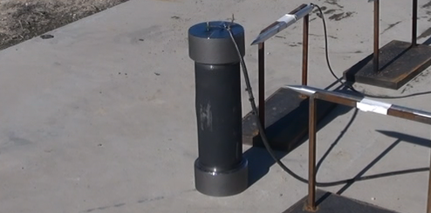

9. An external fire test was also completed to verify that the 25 grams of dry PETN does not result in fragmentation or damage to the pipe. Below is a picture showing the pipe following the test.

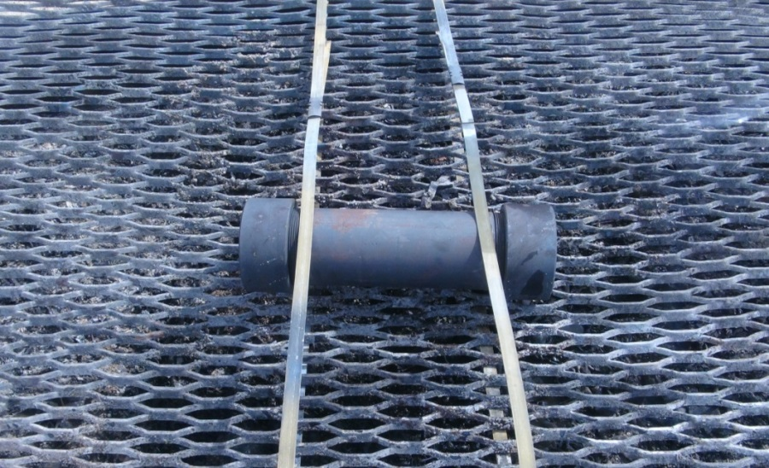

Description of a specialized container for liquids

10. There is also a specialized shipping container for liquids transport as outlined in the United States DOT Special Permit 13481 (DOT-SP 13481, 3rd Revision). The special permit authorizes the transportation of not more than 25 grams of liquid explosive substances that have an energy density not greater than nitroglycerin, classed as Division 1.4 when package in the below described shipping container.

11. The specialized shipping container (DOT-SP 13481) consists of the following:

(a) Inner Packagings – Inner receptacles made of plastic, hard rubber or glass, sealed with a suitable method of closure, each containing no more than twenty-fire (25) grams net weight of liquid explosives.

(b) Intermediate Packaging – Bottles, wide mouth plastic with lids, each containing one inner packaging surrounded with sufficient cushioning material (sawdust, vermiculite or cellulosic materials) to absorb all free liquid in the inner packaging.

(c) Outer Packaging – Not less than 4-inch diameter flanged Schedule 80 seamless carbon steel pipe section not less than 15 inches in length capped on both ends with 8-bolt 150 psi ANSI B 16.5 ASTM A105 flange plates which are sealed with high-temperature resistant graphite gaskets, each containing one intermediate packaging.

12. The suggested container to be used for transport of liquid explosive samples is the same as that outlined in DOT-SP 13481. A 4-inch shipping container for liquids is pictured below.

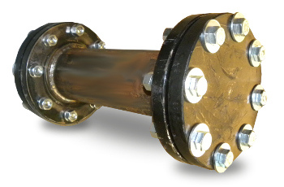

13. Testing was performed on the DOT-SP 13481, 3rd Revision, shipping container to verify that ignition of 25 grams of liquid does not result in breaching or fragmenting the pipe. 25 grams of nitroglycerin was placed inside the pipe with a blasting cap. No hazardous effects were observed outside the shipping container: the pipe was not breached or cracked or fragmented. Below is an image of the post-test result.

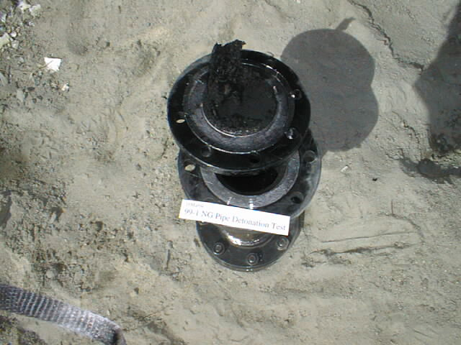

14. A bonfire test was also completed where 25 grams of PETN was placed inside the pipe. Below is a picture showing the pipe following the test. No hazardous effects were observed outside the shipping container.

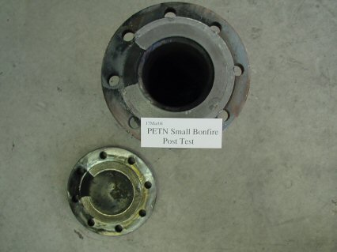

Draft of proposed implementation in the Model Regulations

15. SAAMI proposes the following system for discussion:

* Create a new UN number for shipment of solids
* Create a new UN number for shipment of liquids
* Modify sub-section 2.1.3.4 of the Model Regulations to detail the use of these UN numbers
* Create an annex with specifications for the containers
* Assign a special provision to these UN numbers. The special provision would reference sub-section 2.1.3.4 and the annex, and require a competent authority approval document to accompany the shipment.

Proposal

16. The Sub-Committee is requested to review this proposal and provide input on possible ways forward. SAAMI may return with a proposal for further consideration at the fifty-third session.

1. In accordance with the programme of work of the Sub-Committee for 2017–2018 approved by the Committee at its eighth session (see ST/SG/AC.10/C.3/100, paragraph 98 and ST/SG/AC.10/44, paragraph 14). [↑](#footnote-ref-2)