Proposal for Supplement 1 to the 07 series of Amendments to Regulation No. 16 (Safety-belts)
Proposal of amendments to ECE/TRANS/WP.29/GRSP/2016/24
. Amendments to ECE/TRANS/WP.29/GRSP/24 are marked in red.
I. Proposal
Table of contents, amend to read:
"1. Scope
….
Annexes
….
17 Requirements for the installation of safety-belts and restraint systems for adult
occupants of power-driven vehicles on forward facing seats, for the installation of
ISOFIX child restraint systems and i-size child restraint systems
…

Appendix 3: Table 1 – Table of vehicle handbook information on child restraint
systems installation suitability for various seating positions Example of detailed information e.g. for CRS manufacturers
Table 2 – Table of vehicle handbook information on ISOFIX child
restraint systems installation suitability for various ISOFIX positions
Table 3 - Table of vehicle handbook information on i-Size child restraint
systems for installation in various seating positions
Appendix 4: Installation of 10-year manikin positions
Appendix 5: Installation of booster seat fixtures "
Text of the Regulation,
"2.8. "Airbag assembly" means a device … of the passenger compartment. Any such described deployed structure shall not be considered as a rigid part."
Paragraph 2.30., amend to read
"2.30. "ISOFIX child restraint system" means a child restraint system, fulfilling the requirements of Regulation No. 44 or Regulation No. 129, which has to be attached to an ISOFIX anchorages system, fulfilling the requirements of Regulation No. 14."
Paragraph 2.38., amend to read:
"2.38. "Child restraint fixture" (CRF) means a fixture according to one out of the eight ISOFIX fixtures size classes defined in paragraph 4. of annex 17 - appendix 2 of this Regulation, and particularly whose dimensions are given from figure 1 to figure 78 in the previous mentioned paragraph 4. Those child restraint fixtures (CRF) are used, in this Regulation, to check which what are the ISOFIX child restraint systems size envelopes classes mentioned in Regulation No. 44 or in Regulation No. 129 which can be accommodated on the vehicle ISOFIX positions. Also one of the CRF, the so-called ISO/F2 (B), which is described in figure 2 of the previous mentioned paragraph 4, is used in Regulation No. 14 to check the location and the possibility of access to any ISOFIX anchorages system.
Or a fixture, according to one of the two "booster seat" fixtures defined in annex 17 - appendix 5 of this Regulation, and particularly whose dimensions are given in figures 2 and 3 of Annex 17, Appendix 5 of Regulation No. 16. These fixtures are used, in this Regulation, to check which booster seat size envelopes mentioned in Regulation No. 129 can be accommodated on vehicle seating positions, if any."
Paragraph 2.40., amend to read:
"2.40. "i-Size seating position" means a seating position, if any defined by the vehicle manufacturer, which is designed to accommodate an i-Size child restraint systems, as defined in Regulation No. 129, and fulfils the requirements defined in this Regulation."
Paragraph 5.3.4.2.2.6.,amend to read:
"5.3.4.2.2.6. If the safety-belt is approved following the provisions of paragraphs 6.4.1.3.3. and 6.4.1.3.4. of this Regulation, it shall be marked with the word "AIRBAG" in a rectangle."
Insert new paragraph 6.4.1.3.4., to read:
"6.4.1.3.4. In case of a seating position, other than the outboard front seating position, which is protected with an airbag in front of it, the displacement of the chest reference point may exceed that specified in paragraph 6.4.1.3.2. if its speed at this value does not exceed 24 km/h in tests performed with the airbag in a vehicle related environment, reflecting the vehicle coordinates of the airbag mounting and attachment points."
Paragraph 6.4.1.4.1., amend to read:
"6.4.1.4.1. The movement of the chest reference point may exceed that specified in Paragraph 6.4.1.3.2. above if it can be shown either by calculation or a further test that no part of the torso or the head of the manikin used in the dynamic test would have come into contact with any forward rigid part of the vehicle other than: the chest with the steering assembly, if the latter meets the requirements of Regulation No. 12 and provided contact does not occur at a speed higher than 24 km/h. For this assessment the seat shall be considered to be in the position specified in paragraph 7.7.1.5. below."
Insert new paragraphs 6.4.1.4.1.1. and 6.4.1.4.1.2., to read:
"6.4.1.4.1.1. In the case of the driver, contact of the chest with the steering assembly would be allowed, if the latter meets the requirements of Regulation No. 12 and provided contact does not occur at a speed higher than 24 km/h. For this assessment the seat shall be considered to be in one of the positions specified in paragraph 7.7.1.5. below.
6.4.1.4.1.2. In the case of any other occupant, contact of the head or of the chest with any rigid part of the vehicle in front of the manikin would is not be allowed. Additionally contact of the manikins head with its knees is not allowed.
For this assessment the seat of the tested manikin and, if applicable, the seat in front of the manikin shall be considered to be in the positions specified in paragraph 7.7.1.6. below. With the exception of the deployed structure of an airbag assembly defined in para. 2.8, non-rigid material of < 50 Shore A hardness may be removed in order to demonstrate that covered or padded rigid parts are not contacted by the head or the chest of the manikin during the test."
Paragraph 7.7.1.5., amend to read:
"7.7.1.5. For the assessment of the requirements in paragraphs 6.4.1.4.1. and 6.4.1.4.1.1. the seat shall be positioned in its most forward driving or travelling position appropriate to the dimensions of the manikin."
Insert new paragraphs 7.7.1.6. to 7.7.1.7., to read:
"7.7.1.6. For the assessment of the requirements in paragraphs 6.4.1.4.1. and 6.4.1.4.1.2. the seat adjustment shall be:
7.7.1.6.1. For front passenger seats: the occupant in the front shall be in its most forward travelling position according to the dimensions of the manikin. The positions of the seats shall be stated in the report.
7.7.1.6.2. For rear seats: For any testing position of rear seated occupants, the position of the tested seating position, shall be considered as positioned to the seats R-Point. If the seat back is adjustable, the seat back angle should be adjusted using the 3-D H Point machine with its torso angle as close as possible to 10°.
The seating position in front of the tested seating position shall be adjusted to the middle position of travel and height or in the nearest locking position thereto. If the seat back of this seat is adjustable, the seat back angle should be adjusted using the 3-D H Point machine with its torso angle as close as possible to 10°.
This may be proven by a contour on CAD or drawing of the in-vehicle situation.
7.7.1.7. Alternatively to paragraphs 7.7.1.5. and 7.7.1.6., in the case where those devices cannot be tested on the test trolley, the manufacturer may demonstrate by a conventional frontal impact test at 50 km/h in conformity with the procedure ISO 3560:2013 that the device complies with the requirements of this Regulation."
Paragraphs 7.7.1.6. and 7.7.1.7. (former), renumber as paragraphs 7.7.1.8. and 7.7.1.9.
Paragraph 7.10.1., amend to read:
"7.10.1. The test report shall record the results of all the tests in paragraph 7. above and in particular:
(a) …
…
(i) For any restrain system other than the driver the contour of the contact should be evaluated versus the movement of the manikin in the sled by the technical service in this report.
If by virtue …"
Paragraph 8.2.1., amend to read:
"8.2.1. Safety-belts, restraint systems, and ISOFIX child restraint systems according to table 2 of Annex 17 - Appendix 3, as well as i-Size child restraint systems according to table 3 of Annex 17 - Appendix 3, shall be fixed to anchorages and in case of i-Size child restraint systems, supported by a vehicle floor contact surface, conforming to the specifications of Regulation No. 14, such as the design and dimensional characteristics, the number of anchorages, and the strength requirements."
Paragraph 8.2.2., amend to read:
"8.2.2. The safety-belts, restraint systems and child restraint systems recommended by the manufacturer according to tables 1 to 3 of Annex 17 -Appendix 3, shall be so installed that they will work satisfactorily and reduce the risk of bodily injury in the event of an accident. In particular, they shall be so installed that: ..."
Paragraph 8.2.2.3., amend to read:
"8.2.2.3. The risk of the strap deteriorating through contact with sharp parts of the vehicle or seat structure, and child restraint systems recommended by the manufacturer according to tables 1 to 3 of Annex 17 - Appendix 3, is reduced to a minimum."
Paragraph 8.3.4., amend to read:
"8.3.4. Safety-belts or restraint systems incorporating retractors shall be so installed that the retractors are able to operate correctly and stow the strap efficiently. In case of both a belt adjusting device and a flexible shoulder adjustment device for height, in at least their highest and their lowest position, checks shall be made that the retractor automatically adjusts the strap to the shoulder of the concerned wearer after buckling, as well as that the tongue-plate rolls up in case of an unbuckling."
Paragraph 8.3.5., amend to read:
"8.3.5. In order to inform the vehicle user(s) of the provisions made for the transport of children, vehicles of categories M₁, M₂, M₃ and N₁ shall meet the information requirements of Annex 17. Any vehicle of category M1 shall be equipped with ISOFIX positions, in accordance with the relevant prescriptions of Regulation No. 14.
The first ISOFIX position shall allow at least the installation of one out of the three forward-facing fixtures as defined in appendix 2 of annex 17; the second ISOFIX position shall allow at least the installation of one out of the three rear-facing fixtures as defined in Appendix 2 of Annex 17. For this second ISOFIX position, in case where the installation of the rear-facing fixture is not possible on the second row of seats of the vehicle due to its design, the installation of one out of the six fixtures is allowed in any position of the vehicle."
Paragraph 8.3.6., amend to read:
"8.3.6. Any i-Size seating position shall allow the installation of the ISOFIX child restraint fixture "ISO/F2X" (B1), "ISO/R2" (D), and the support leg installation assessment volume as defined in Appendix 2 of Annex 17, as well as the booster seat fixture "ISO/B2" as defined in Appendix 5 of Annex 17, without the ISOFIX attachments (see detail B). It shall be possible to occupy all adjacent i-Size seating positions simultaneously. This is deemed to be demonstrated when the vertical median planes of individual adjacent positions are at least 440 mm apart."
Annex 1B, item 12, footnote 4, amend to read:
_____________
"⁴ "If a safety-belt is approved following the provisions of paragraph 6.4.1.3.3. of this Regulation, this safety-belt shall only be installed in an outboard front seating position protected by an airbag in front of it, under the condition that the vehicle concerned is approved to Regulation No. 94, 01 series of amendments or its later version in force.
If a safety-belt is approved following the provisions of paragraph 6.4.1.3.4. of this Regulation, this safety-belt shall only be installed in a seating position protected by an airbag in front of it."
Annex 1B, insert new item 12.1., to read:
"12.1. In case a restraint system has been granted/extended, those can be used for particular types of vehicles compatible with the following dimensional conditions: no interior part in a quoted A-zone as shown below (Figure 2):
Figure 2
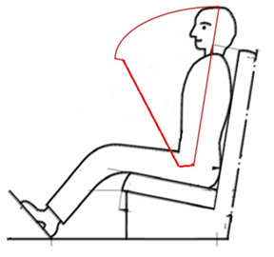"
A-zone
Head & chest
velocities > 0 kph
B-zone
Head & chest
velocities < 0 kph
Annex 2, last example, amend to read:
" The safety-belt bearing this type approval mark is a three-point belt ("A") fitted with an energy absorber ("e"), approved as meeting the specific requirements of paragraph 6.4.1.3.3. or 6.4.1.3.4. of this Regulation, and with a multiple-sensitivity ("m") type 4 ("r4") retractor, in respect of which type approval was granted in the Netherlands ("E 4") under the approval number 062439. The first two digits indicate that the Regulation already incorporated the 06 series of amendments at the time of the approval. This safety-belt has to be fitted to a vehicle equipped with an airbag in the given seating position."
Annex 14,
Paragraph 2.2.3., amend to read:
"2.2.3. Results
Test results shall meet the requirements set out in paragraph 6.4.1.3.1. of this Regulation.
The forward displacement of the manikin may be controlled with regard to paragraph 6.4.1.3.2. of this Regulation (or 6.4.1.4. where applicable) during a test performed with conditioning according to paragraph 1.6.1. of this annex by means of a simplified adapted method.
A simplified, adapted method could be, e.g., the use of a reference chest speed measured at 300 mm forward displacement carried out in a physical test without an airbag or additional restraint system components, to be considered in the conformity control plan."

Paragraph 2.2.3.1., amend to read:
"2.2.3.1. In the case of approval following paragraph 6.4.1.3.3. or 6.4.1.3.4. of this Regulation and paragraph 1.6.1. of this annex, it is only specified that no part of the belt shall be destructed or disengaged, and that a speed of 24 km/h of the chest reference point at 300 mm displacement shall not be exceeded."
Annex 16, amend to read:

" Annex 16
Safety-belt installation showing the belt types and retractor types
Minimum requirements for safety-belts and Retractors
Vehicle category | Forward facing seating positions |  |  |  |  |  | Rearward-facing  seating positions | Side-facing seating position
Vehicle category | Outboard seating positions |  |  | Centre seating position |  |  | Rearward-facing  seating positions | Side-facing seating position
Vehicle category | Front |  | Other than front | Front |  | Other than front | Rearward-facing  seating positions | Side-facing seating position
M₁ | Ar4m |  | Ar4m | Ar4m |  | Ar4m | B, Br3, Br4m | -
M₂ < 3.5 t | Ar4m, Ar4Nm |  | Ar4m, Ar4Nm | Ar4m, Ar4Nm |  | Ar4m, Ar4Nm | Br3, Br4m, Br4Nm | -
M₂ > 3.5 t | Br3, Br4m, Br4Nm, or Ar4m or Ar4Nm ● |  | Br3, Br4m, Br4Nm, or Ar4m or Ar4Nm ● | Br3, Br4m, Br4Nm or Ar4m or Ar4Nm ● |  | Br3, Br4m, Br4Nm or Ar4m or Ar4Nm ● | Br3, Br4m, Br4Nm | -
M₃ | Br3, Br4m, Br4Nm, or Ar4m or Ar4Nm ●  See para. 8.1.7. for conditions when a lap belt is permitted |  | Br3, Br4m, Br4Nm, or Ar4m or Ar4Nm ●  See para. 8.1.7. for conditions when a lap belt is permitted | Br3, Br4m, Br4Nm or Ar4m or Ar4Nm ●  See para. 8.1.7. for conditions when a lap belt is permitted |  | Br3, Br4m, Br4Nm or Ar4m or Ar4Nm ●  See para. 8.1.7. for conditions when a lap belt is permitted | - | B, Br3, Br4m, Br4Nm
N₁ | Ar4m, Ar4Nm |  | Ar4m, Ar4Nm, Br4m, Br4Nm Ø | B, Br3, Br4m, Br4Nm or A, Ar4m, Ar4Nm* ¹ |  | B, Br3, Br4m, Br4Nm | B, Br3, Br4m, Br4Nm | -
N₁ |  |  | Para. 8.1.2.1. lap belt permitted if seat is inboard of a passageway | Para. 8.1.6. lap belt permitted if the windscreen is not in the reference zone
N₂ | Br3, Br4m, Br4Nm orAr4m, Ar4Nm*  Para. 8.1.6. lap belt permitted if the windscreen is outside the reference zone and for the driver's seat |  | B, Br3, Br4m, Br4Nm | B, Br3, Br4m, Br4Nm, or A, Ar4m, Ar4Nm*  Para. 8.1.6. lap belt permitted if the windscreen is not in the reference zone |  | B, Br3, Br4m, Br4Nm | B, Br3, Br4m, Br4Nm | -
N₃ | Br3, Br4m, Br4Nm orAr4m, Ar4Nm*  Para. 8.1.6. lap belt permitted if the windscreen is outside the reference zone and for the driver's seat |  | B, Br3, Br4m, Br4Nm | B, Br3, Br4m, Br4Nm, or A, Ar4m, Ar4Nm*  Para. 8.1.6. lap belt permitted if the windscreen is not in the reference zone |  | B, Br3, Br4m, Br4Nm | B, Br3, Br4m, Br4Nm | -
A: three-point (lap and diagonal) belt  3: automatically locking retractor |  | B: 2-point (lap) belt  4: emergency locking retractor |  |  | r: retractor  N: higher response threshold |  | m: emergency locking retractor with multiple sensitivity
*: Refers to para. 8.1.6. of this Regulation ² |  | Ø: Refers to para. 8.1.2.1. of this Regulation |  |  | ●: refers to para. 8.1.7. of this Regulation² |  | (see Regulation No. 16, paras. 2.14.3. and 2.14.5.)
¹ Erratum to Supplement 12 to the 04 series of amendments, applicable "ab initio."
² Erratum to Revision 4, applicable "ab initio."
Note: In all cases all S-type belts may be fitted in place of all possible A or B type belts, provided their anchorages comply with Regulation No. 14.
Where a harness belt has been approved as a S-type belt according to this Regulation, using the lap belt strap, the shoulder belt straps and possibly one or more retractors, one or two additional crotch straps including their attachments for their anchorages may be provided by the manufacturer/applicant. These additional anchorages need not meet the requirements of Regulation No. 14 (Erratum to Supplement 14 to the 04 series of amendments, applicable "ab initio.")."
"
ECE/TRANS/WP.29/GRSP/2016/12

Annex 17, amend to read:
"Annex 17
Requirements for the installation of safety-belts and restraint systems for adult occupants of power-driven vehicles on forward facing seats, for the installation of ISOFIX child restraint systems and i-size child restraint systems
1. Compatibility with child restraint systems
1.1. The vehicle manufacturer shall include in the vehicle handbook, simple advice to the vehicle user on the suitability of each passenger seating position for the carriage of children up to 12 years old (or up to 1.5 m tall), or the fitting of child restraint systems. This information shall be given by pictograms or in the national language, or at least one of the national languages, of the country in which the vehicle is offered for sale.
For each forward-facing passenger seating position, and for each specified ISOFIX position, the vehicle manufacturer shall either indicate:
(a) Indicate that If the seating position is suitable for child restraints of the "universal" category (see paragraph 1.2. below); and/or
(b) Indicate if the ISOFIX position is suitable for ISOFIX child restraint systems of the "universal" category (see paragraph 1.2. below);
(c) Provide a list of child restraint systems of the "semi-universal", "restricted" or "vehicle-specific" categories, suitable for that vehicle seating position, indicating the mass group(s) for which the restraints are intended;
(d) Provide a list of ISOFIX child restraint systems of the "semi-universal", "restricted" or "vehicle specific" categories, suitable for that vehicle ISOFIX position, indicating the mass group and the ISOFIX size class for which the ISOFIX child restraints are intended;
(e) Provide a built-in child restraint system, indicating the mass group(s) for which the restraint is intended and the corresponding configuration(s);
(f) Provide any combination of (a), (b), (c), (d), (e);
(g) Indicate the mass group(s) of the children which shall not be carried in that seating position.
(b) If the seating position is suitable for i-size child restraint systems (see paragraph 1.4. below); and/or
(c) If the seating position is suitable for child restraint systems other than those specified above (e.g. see paragraph 1.3. below).
The vehicle manufacturer shall identify within the handbook each seating position which is also suitable for the accommodation of an i-Size child restraint system (see paragraph 1.3 below).
If a seating position is only suitable for use with forward-facing child restraint systems, this shall also be indicated in the vehicle handbook.

In addition to the above information for the vehicle user, the vehicle manufacturers shall make available the information as defined by Appendix 3 of this Annex. For example, this information can be included in separate Annexes of the vehicle handbook, or in technical descriptions of the vehicle or on a dedicated webpage. The location to access this information shall be provided in the vehicle handbook.
Tables in a suitable format for the above information are given in Appendix 3 to this annex.
1.2. A child restraint system or ISOFIX child restraint system, of the universal category means a child restraint approved to the "universal" category of Regulation No. 44, Supplement 5 to 03 series of amendments (or subsequent amendments). Positions, or ISOFIX positions, which are indicated by the vehicle manufacturer as being suitable for the installation of child restraints systems of the universal category or ISOFIX child restraints systems shall comply with the provisions of Appendix 1 and Appendix 5 or 2 to this annex. Where applicable any restriction on the simultaneous use on adjacent positions of ISOFIX child restraint systems and/or between ISOFIX-Spositions and adult seating positions shall be reported in the Table 2 of Appendix 3 to this annex.
1.3. An ISOFIX child restraint means a child restraint approved to Regulation No. 44, Supplement 5 to 03 series of amendments or to Regulation No. 129 (or subsequent amendments). Positions, which are indicated by the vehicle manufacturer as being suitable for the installation of ISOFIX child restraints systems shall comply with the provisions of Appendix 2 to this annex.
1.3.4. An i-Size child restraint means a child restraint approved to the i-Size category of Regulation No. 129. Seating positions, which are indicated by the vehicle manufacturer as being suitable for the installation of i-Size child restraints systems shall comply with the provisions of Appendix 2 and Appendix 5 to this annex. Where applicable, any restriction on the simultaneous use on adjacent positions of ISOFIX child restraint systems or i-Size child restraint systems and/or between ISOFIX positions, i-Size positions and adult seating positions shall be reported in the Table 2 of Appendix 3 to this annex."
Annex 17, Appendix 1,
Paragraph 2.7., amend to read:
"2.7. Ensure that the fixture is located with its centreline on the apparent centreline vertical plane of symmetry of the seating position within ±25 mm with its centreline parallel with the centreline of the vehicle of the vertical plane of symmetry of the seating position."
Paragraph 3.2., amend to read:
"3.2. The lap portion of the belt shall touch the fixture on both sides at the rear of the lap belt path (see Figure 3). The seat belt webbing shall always cover the points BP on the left and right ends of the curved edge; the exact position of point BP on the curved edge is indicated in detail W of Figure 1.

Figures 1 to 3, amend to read:

"Figure 1

Specifications of the fixture (all dimensions in mm)

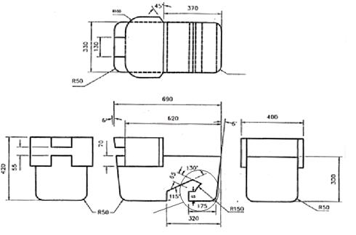
WEIGHT 23kg EVENLY DISTRIBUTED
Detail W
R50 TYP

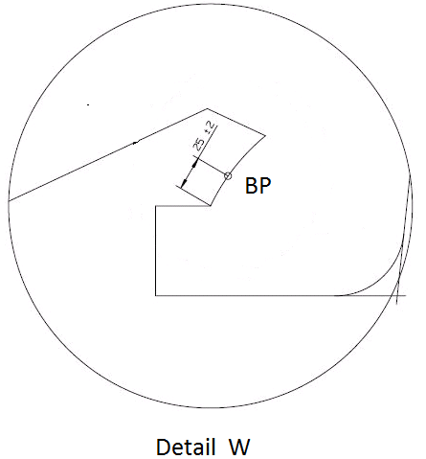

Figure 2 Figure 3
Installation of fixture onto vehicle seat Check for compatibility
(see paragraph 2.6.1.) (see paragraphs 2.6.1. and 3.2)

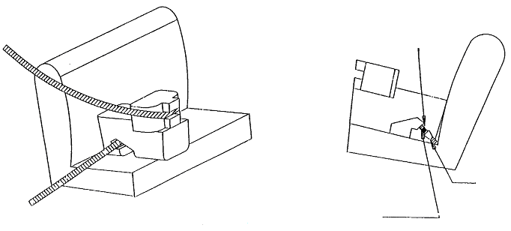
Tongue
Buckle
Note: The seat belt webbing shall contact the curved edge on both sides of the fixture
Lap belt only shown

"
Annex 17, Appendix 2, paragrah 2.3., amend to read:
"2.3. Place cotton clothes on the seat-back and cushion, if needed."
Annex 17, Appendix 2, paragrah 3.1., amend to read:
"3.1. It has to be possible to accommodate the CRF(s), with or without i-Size support leg installation assessment volume, without interference with the vehicle interior. The CRF base shall have a pitch angle of 15° ± 10°, above the horizontal plane passing through the ISOFIX anchorages system. ISOFIX attachments, according to detail Y of figures 1 to 9, may adjust longitudinally between -10mm to +70mm to facilitate the interference check. The figures are showing the most extended positions."
Annex 17, Appendix 2, paragrah 3.3., amend to read:
"3.3. Should the above requirements not be met …. These alternative positions shall be described in the vehicle handbook and with the additional information specified in table 2 and/or 3 given in Appendix 3 to this annex. …"
Annex 17, Appendix 2, paragrah 4., amend to read:
"4. ISOFIX child restraint system size envelope classes and fixtures:
A – ISO/F3: Full-Height Forward Facing toddler CRS
B – ISO/F2: Reduced-Height Forward Facing toddler CRS
B1 – ISO/F2X: Reduced-Height Forward Facing toddler CRS
C – ISO/R3: Full-Size Rearward Facing toddler CRS
D – ISO/R2: Reduced-Size Rearward Facing toddler CRS
– ISO/R2X: Reduced-Size Rearward Facing toddler CRS
E – ISO/R1: Rearward Facing infant CRS
– ISO/L1: Left Lateral Facing position CRS (carry-cot)
G – ISO/L2: Right Lateral Facing position CRS (carry-cot)
The fixtures below above shall be constructed with a mass between 510 and/or 15 13 kg +/- 0.2 kg and shall be of suitable durability and stiffness to satisfy the functional requirements, following the table below:
CRF | Mass (kg) | Tolerance (kg)
R1 a | 10 | ± 0,2
R2 / R2X a | 10 | ± 0,2
R3 | 13 | ± 0,2
L1 / L2 | 13 | ± 0,2
F2 / F2X a | 13 | ± 0,2
F3 | 13 | ± 0,2
a ISOFIX base mass taken into account.

The physical centre of gravity of each CRF shall correspond to the geometrical centroid of the volume.

Annex 17, Appendix 2, insert new paragrah 4.7. and new Figure 7 to read:
"4.7. Rearward facing infant child restraint systems envelope ISO/R2X
Figure 7
Reduced-Size Rearward Facing toddler CRS Envelope dimensions for a reduced-size rearward-facing CRS, modified for improved compatibility with the vehicle interior
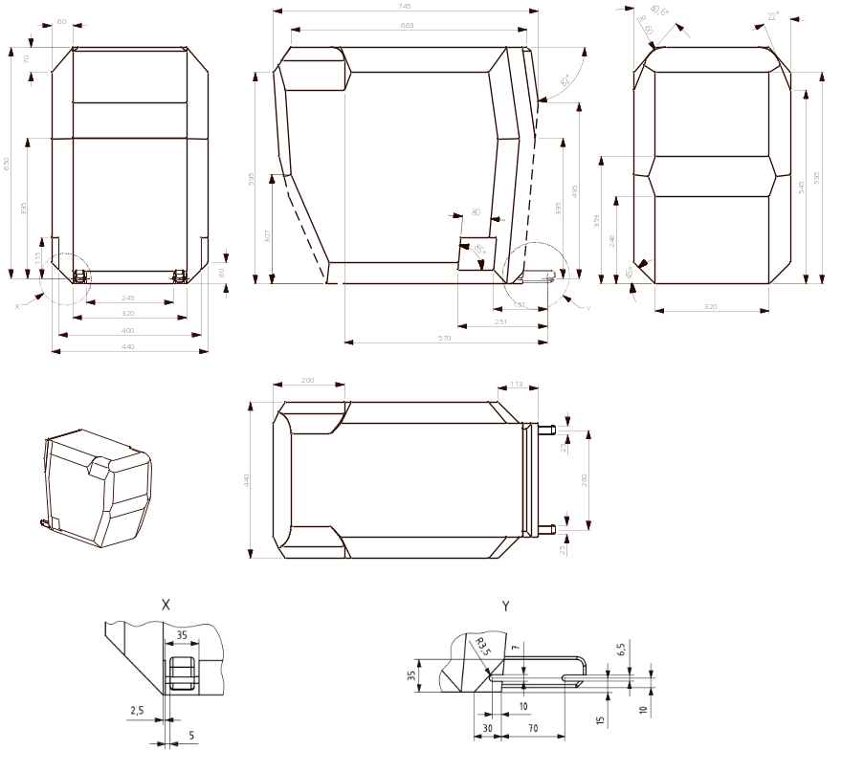

Key
1 limits in the rearward and upward directions
2 dashed lines mark the area where an anti-rotation device, or similar (e.g. rebound bar), is allowed to protrude
[3 the backward limitation (to the right in the figure) is given by the forward-facing envelope in Figure 2]
4 further specifications of the connector area, see detail Y and ISO 13216-1:1999, Figures 2 and 3."
Annex 17, Appendix 2, paragrah 4.7 (former), renumber as paragraph 4.8. and amend to read:
"4.78. Lateral facing child restraint systems envelope
Figure 78
Envelope dimensions for lateral facing position CRS - ISO/L1- ISOFIX SIZE CLASS F or symmetrically opposite - ISO/L2 (figure shown) - ISOFIX CLASS G
Note: The envelope for a left lateral-facing infant CRS (ISO/L1) has dimensions symmetric to ISO/L2 with regard to its intermediate longitudinal plan.
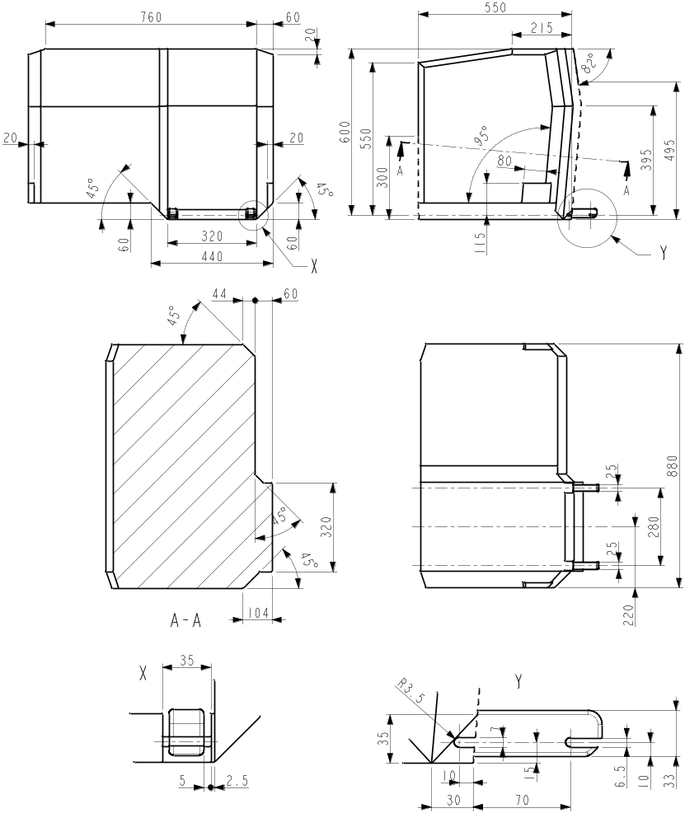
Key
1 limits in the rearward and upward directions
2 dashed lines mark the area where an anti-rotation device, or similar (e.g. rebound bar), is allowed to protrude."
Figures 8 and 9, renumber as Figures 9 and 10.
Annex 17, Appendix 3,
Tables 1 to 3, shall be deleted
Insert new Table 1, to read:
"Annex 17 – Appendix 3
Example of detailed information e.g. for child restraint system manufacturers

Table 1
This table gives technical information specifically intended e.g. for child restraint system manufacturer and as such translation into national languages is not required.
 | Seating position
Seat position number | 1 | 2 | 3 | 4 | 5 | 6 | 7 | 8 | 9
Seating position suitable for universal belted (yes/ no)
i-Size seating position (yes/ no)
Seating position suitable for lateral fixture (L1/ L2)
Largest suitable rearward facing fixture (R1/ R2X/ R2/ R3)
Largest suitable forward facing fixture (F1/ F2X /F2/ F3)
Largest suitable booster fixture (B2/B3)

1. Add information for each non i-size seating position compatible with a support leg, as described in this regulation.
2. Add information for each seating position equipped with lower ISOFIX anchorages but without Top Tether, according to this regulation.
3. Add information if the adult safety belt buckles are located laterally in between both ISOFIX lower anchorages.
Note:
1. Orientation is normal driving direction; columns for seating positions not available in a vehicle can be deleted.
2. The numbering of seating positions shall be made on basis of following definition:
Seat Number | Position in the vehicle
1 | Front left
2 | Front centre
3 | Front right
4 | 2nd row left
5 | 2nd row centre
6 | 2nd row right
7 | 3rd row left
8 | 3rd row centre
9 | 3rd row right
The information about the seat position number can be given by means of a table or by sketches or pictograms."

Annex 17, insert new Appendix 5 to read:
"Annex 17 – Appendix 5
Provisions concerning the installation of forward-facing booster seat child restraint systems of universal and specific categories installed on vehicle seating positions or i-Size seating positions
1. General
1.1. The test procedure and the requirements in this appendix shall be used to determine the suitability of seating positions for the installation of the booster seat fixtures ISO/B2 or ISO/B3, without ISOFIX attachments. Where the vehicle manufacturer has indicated that the vehicle position(s) will accommodate a particular CRF, then it shall be assumed that smaller CRFs of the same orientation will also be accommodated.
1.2. The tests may be carried out in the vehicle or in a representative part of the vehicle. Compliance with this requirement can be proven by a physical test or computer simulation or representative drawings.
2. Test procedure
i-Size positions in the vehicle, defined by the vehicle manufacturer, shall be checked to ensure that the ISO/B2 fixture listed in paragraph 4 of this Appendix can be accommodated, at least without ISOFIX connections.
2.1. Adjust the seat to its fully rearward and lowest position.
2.2. Adjust the seat-back angle to the manufacturer's design position. In the absence of any specification, a torso angle of 25 degrees from the vertical, or the nearest fixed position of the seat-back, should be used.
2.3. When checking a CRF, on a rear seat, the vehicle seat located in front of this rear seat may be adjusted longitudinally forward but not further than the mid position between its rearmost and fore most positions. The seat backrest angle may also be adjusted, but not to a more upright angle than corresponding to a torso angle of 15°. If the front seat is adjustable in height, adjust to the manufacturer's specification. In the absence of any specification, adjust the front seat to mid height position, or the nearest position to mid height.
2.4. If necessary, head restraints may be adjusted or removed, if possible.
2.5. Set the shoulder anchorage to the position defined by the vehicle manufacturer.
2.6. Place cotton cloths on the seat-back and cushion, if needed.
2.7. Remove the ISOFIX attachments from the CRF, or retract them to a position fully inside the backseat line (reference line E, Figure 2 or 3).
2.8. Place the fixture (as described in Figure 2 or 3 of this appendix) on the vehicle seat. The top of the fixture may touch the vehicle roof. Compression of the seat cushion is allowed to move the fixture into position.
2.9. Arrange the seat belt through the CRF in approximately the correct position, and then fasten the buckle. Ensure that all webbing slack is removed. The fixture shall be restrained by the vehicle’s seat belt.
2.10. Ensure that the fixture is located with its centreline on the apparent centreline of the seating position ±25 mm with its centreline parallel with the centreline of the vehicle seat. The roll angle α (see figure 1) shall be within 0º ± 5º
2.11. Push rearwards on the centre of the front of the fixture with a force 100 N ± 10 N, applied parallel to the lower surface, and remove the force.
2.12. When possible, push vertically downwards on the centre of the upper surface of the fixture with a force of 100 N ± 10 N, and remove the force.
3. Requirements
3.1. It shall be possible to secure the fixture in the seating position using the 3-point seat belt and to buckle up the seat belt.
3.2. The roll angle α as shown in Figure 1 shall be equal to or less than 5°.
3.3. The base of the fixture shall be in contact with the seat cushion, and the back face of the fixture shall be in contact with the seat back or head restraint. Full contact with the seat is not necessary, “gaps” due to the vehicle seats contours are permitted as shown by the arrows in Figure 1. The booster seat envelope is equipped with an adjustable backrest. Compatibility with the vehicle seating position shall be achieved in at least one position of the backrest range shown in Figure 2 or Figure 3.
3.4. Should the above requirements not be met with the adjustments indicated in paragraphs 2.1. to 2.12. above, the seat, seat-back and safety-belt anchorages may be adjusted to an alternative position designated by the manufacturer for normal use at which the above installation procedure shall be repeated and the requirements again verified and met. This alternative position shall be described according to paragraph 1.1. of Annex 17 and in detailed technical information specified in Appendix 3.
4. Booster seat child restraint system fixtures:
– ISO/B2: Booster seat, reduced width 440 mm (figure 2)
– ISO/B3: booster seat, full width 520 mm (figure 3)
The fixtures above shall be constructed with a mass of 7 kg +- 0,2 kg and shall be of suitable durability and stiffness to satisfy the functional requirements.

Figure 1
Positioning in Seat
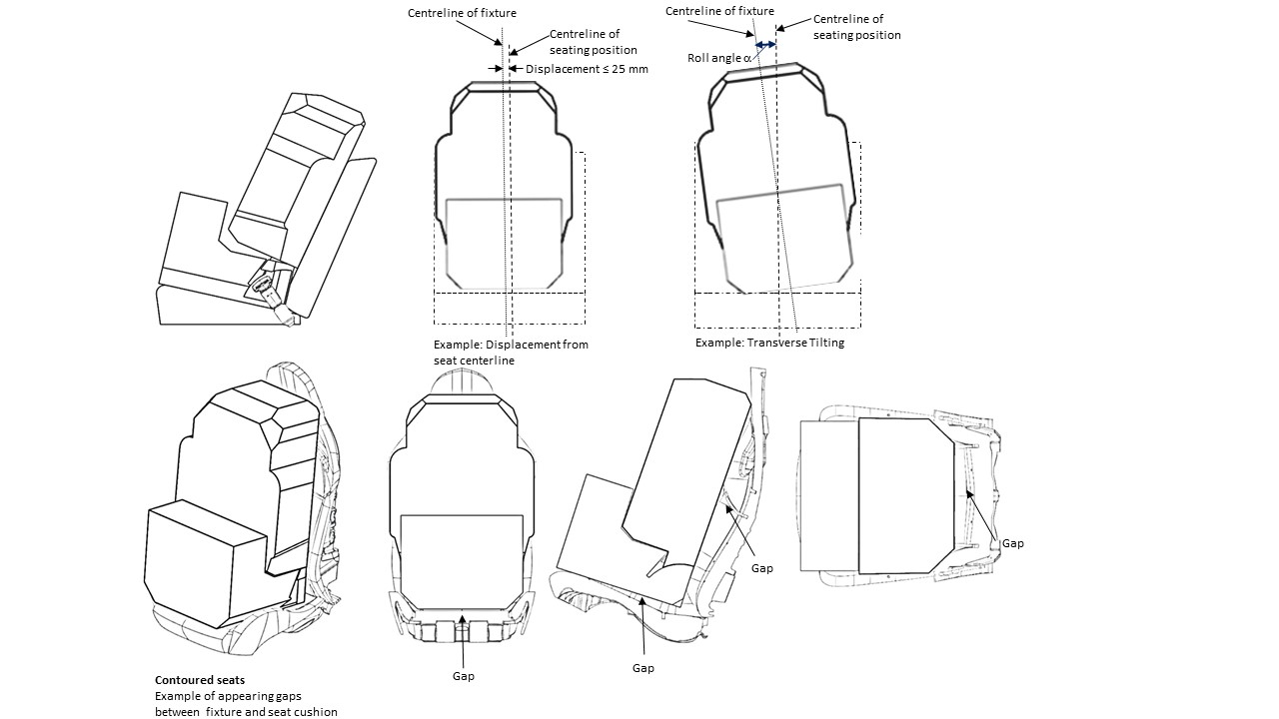

Figure 2
ISO/B2: Envelope dimensions for booster seat, reduced width 440 mm - without ISOFIX, or with connectors removed or stowed within the body of the fixture (behind line E, as defined by detail B).
Key E is the Reference axle of rotation of the backrest (90° to 110°) and reference line for retraction/stowing of ISOFIX

Figure 3
ISO/B3 - Envelope dimensions for booster seat, full width 520 mm - without ISOFIX, or with connectors removed or stowed within the body of the fixture (behind line E, as defined by detail B).
Key E is the reference axle of rotation of the backrest (90° to 110°) and reference line for retraction/stowing of ISOFIX

"
II. Justification
1. Two "Booster Seat" fixtures (ISO/B2 and ISO/B3) were added to Regulation No. 16 to coincide with the implementation of Phase 2 of UN Regulation No. 129. These fixtures were developed within ISO/TC 22/SC 36/WG 2 (Child Restraint Systems) and follow the principle already established in Regulations No. 16 and No. 129 to ensure child restraint to car compatibility. An additional “Reduced-Size Rearward Facing toddler CRS” fixture (ISO/R2x) was added to facilitate compatibility in small cars/seating positions. The ISO/B2 booster seat fixture was added in the i-Size concept. Lateral facing fixtures (ISO/L1 and ISO/L2) have been upgraded.
2. Finally, the proposal at aligning the requirements of the 07 series of amendments with those of Supplements 8 and 9 to the 06 series of amendments (ECE/TRANS/WP.29/2016/98 and ECE/TRANS/WP.29/GRSP/2016/21).

