|  |  |  |  |
| --- | --- | --- | --- |
|  | United Nations | ECE/TRANS/WP.29/GRSG/2016/10 | |
| _unlogo | **Economic and Social Council** | | Distr.: General  10 February 2016  Original: English |

**Economic Commission for Europe**

Inland Transport Committee

**World Forum for Harmonization of Vehicle Regulations**

**Working Party on General Safety Provisions**

**110th session**

Geneva, 26–29 April 2016

Item 12 of the provisional agenda

**Regulation No. 110 (CNG and LNG vehicles)**

Proposal for amendments to Regulation No. 110  
(CNG and LNG vehicles)

Submitted by the experts from the Netherlands and International Association for Natural Gas Vehicles [[1]](#footnote-2)\*

The text reproduced below was prepared by the experts from the Netherlands and International Association for Natural Gas Vehicles (NGV Global). It proposes an amendment to UN Regulation No. 110 to include the Liquefied Natural Gas (LNG) fuel connector provisions as specified in ISO 12617:2015, recently published by the International Organization for Standardization. The modifications to the current text of UN Regulation No. 110 are marked in bold for new characters and strikethrough for deleted characters.

**I. Proposal**

*Annex 4J*

*Paragraphs 2. to 2.2.,* amend to read:

"2. LNG filling receptacle

2.1. The LNG filling receptacle shall comply with the requirements of paragraph 3.

2.2. ~~The manufacturer of the receptacle may require a specific LNG nozzle type to be used.~~ **LNG filling units designed in accordance with ISO12617:2015 and meeting all the requirements therein are deemed to fulfil the requirements of paragraph 3. of this annex**."

*Paragraph 3.1.6.,* correct to read:

"3.1.6. The electrical resistance of the connected LNG filling receptacle and nozzle shall ~~be~~ not be greater than 10 Ω either in …… the endurance test."

*Insert new paragraphs 4. and 4.1.,* to read:

"**4. LNG filling unit dimensions**

**4.1. Figure 1 shows the dimensions of the LNG filling unit.**

Figure 1

**Dimensions of the receptacle**

**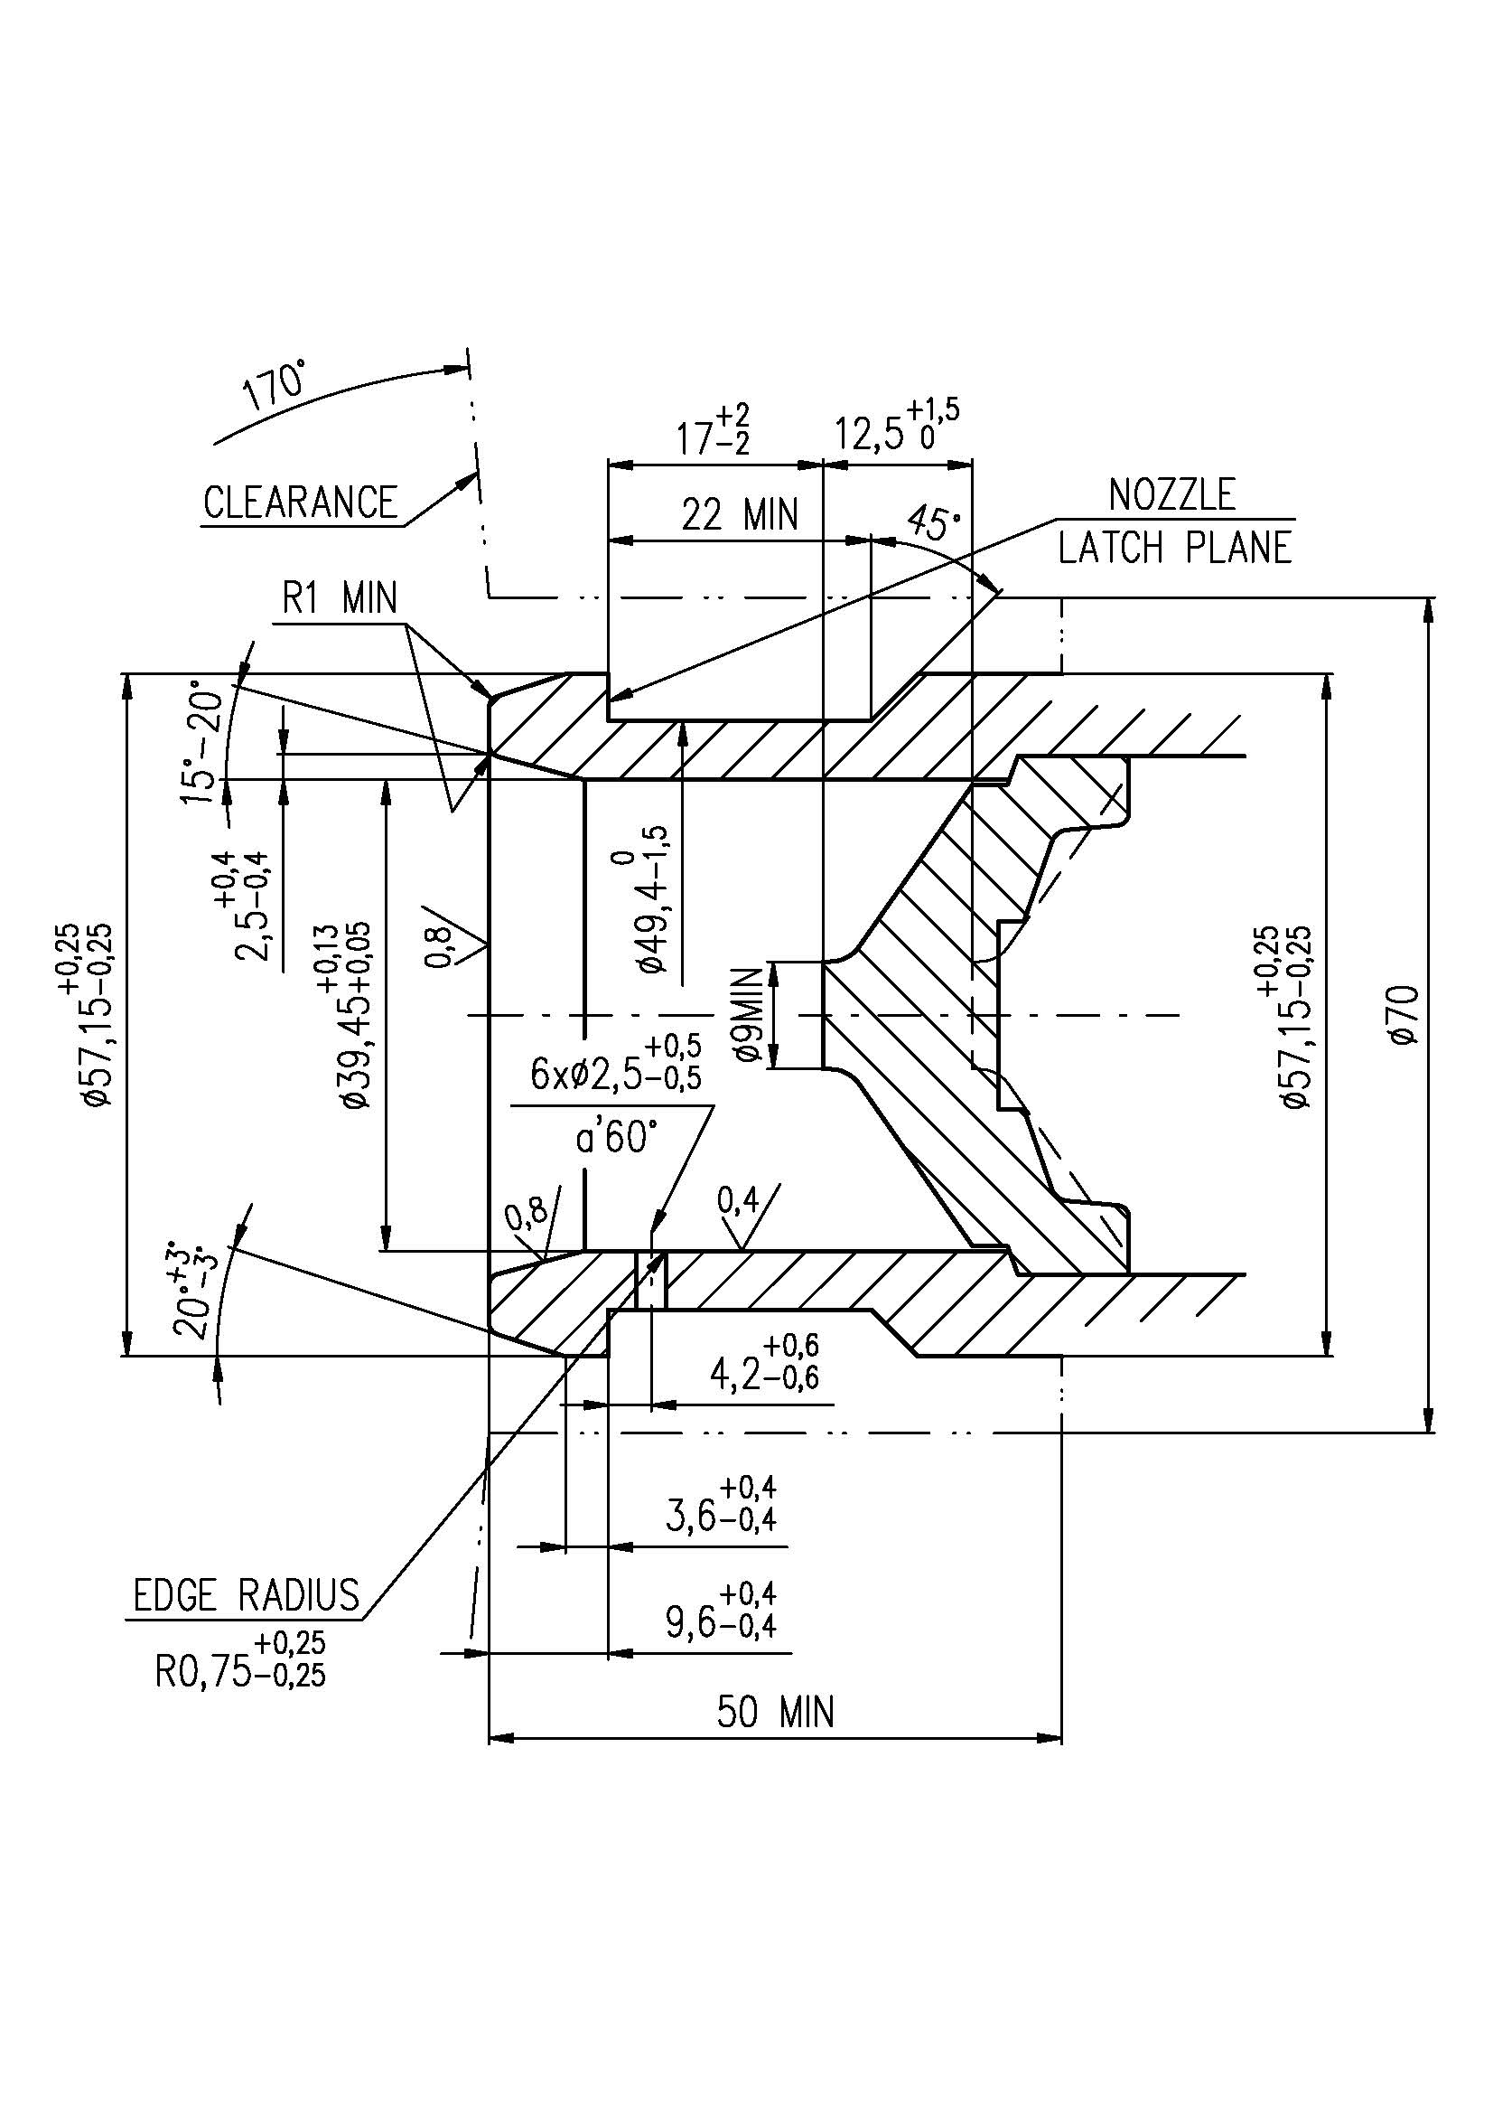**"

The 50 mm dimension is the minimum distance to the mounting flange

II. Justification

1. When the LNG amendments to UN Regulation No. 110 were adopted in 2013, a blank 'reservation' was left in the final text to accommodate the specifications of the ISO standard on LNG fuel connectors, which had not yet been finalized at that time. ISO standard 12617:2015 for LNG fuel connectors was completed in 2015 and should be introduced into the section reserved in UN Regulation No. 110. In the best interests of harmonizing worldwide regulations for vehicles, the Netherlands, with support from a wide range of natural gas vehicle stakeholders including NGV Global, recommend to include the provisions on ISO LNG fuel connector in the UN Regulation, as was the original intent of Working Party on General Safety Provisions when adopting the LNG amendments.

2. The proposal also aims at correcting a topographical error in paragraph 3.1.6.

1. \* In accordance with the programme of work of the Inland Transport Committee for 2014–2018 (ECE/TRANS/240, para. 105 and ECE/TRANS/2014/26, programme activity 02.4), the World Forum will develop, harmonize and update Regulations in order to enhance the performance of vehicles. The present document is submitted in conformity with that mandate. [↑](#footnote-ref-2)