Draft global technical regulation on Evaporative emission test procedure for Worldwide harmonized Light vehicle Test Procedures (WLTP EVAP)

I. Statement of technical rationale and justification

A. Introduction

[Reserved]

B. Procedural background and future development of the WLTP EVAP

[Reserved]

II. Text of the global technical regulation

1. Purpose

This global technical regulation (gtr) aims at providing a worldwide harmonized method to determine the levels of evaporative emission from light-duty vehicles in a repeatable and reproducible manner designed to be representative of real world vehicle operation. The results will provide the basis for the regulation of these vehicles within regional type approval and certification procedures.

2. Scope and application

This gtr applies to vehicles of categories 1-2 and 2, both having a technically permissible maximum laden mass not exceeding 3,500 kg, and to all vehicles of category 1-1.

3. Definitions

3.1. Test equipment

3.1.1. "*Accuracy*" means the difference between a measured value and a reference value, traceable to a national standard and describes the correctness of a result. See Figure 1.

3.1.2. "*Calibration*" means the process of setting a measurement system's response so that its output agrees with a range of reference signals.

3.1.3. "*Calibration gas*" means a gas mixture used to calibrate gas analysers.

3.1.4. "*Linearization*" means the application of a range of concentrations or materials to establish a mathematical relationship between concentration and system response.

3.1.5. "*Major maintenance*" means the adjustment, repair or replacement of a component or module that could affect the accuracy of a measurement.

3.1.6. "*Precision*" means the degree to which repeated measurements under unchanged conditions show the same results (Figure 1) and, in this gtr, always refers to one standard deviation.

3.1.7. "*Reference value*" means a value traceable to a national standard. See Figure 1.

3.1.8. "*Set point*" means the target value a control system aims to reach.

3.1.9. "*Span*" means to adjust an instrument so that it gives a proper response to a calibration standard that represents between 75 per cent and 100 per cent of the maximum value in the instrument range or expected range of use.

3.1.10. "*Total hydrocarbons*" (THC) means all volatile compounds measurable by a flame ionization detector (FID).

3.1.11. "*Verification*" means to evaluate whether or not a measurement system's outputs agrees with applied reference signals within one or more predetermined thresholds for acceptance.

3.1.12. "*Zero gas*" means a gas containing no analyte, which is used to set a zero response on an analyser.

# Figure 1

**Definition of accuracy, precision and reference value**



value

precision

accuracy

reference value

probability

density

3.2. Road load and dynamometer setting

3.2.1. "*Road load*" means the force resisting the forward motion of a vehicle as measured with the coastdown method or methods that are equivalent regarding the inclusion of frictional losses of the drivetrain.

3.2.2. "*Target road load*" means the road load to be reproduced.

3.3. Pure electric, hybrid electric and fuel cell vehicles

3.3.1. "*Charge-depleting operating condition*" means an operating condition in which the energy stored in the REESS may fluctuate but decreases on average while the vehicle is driven until transition to charge-sustaining operation.

3.3.2. "*Charge-sustaining operating condition*" means an operating condition in which the energy stored in the REESS may fluctuate but, on average, is maintained at a neutral charging balance level while the vehicle is driven.

3.3.3. "*Net energy change*" means the ratio of the REESS energy change divided by the cycle energy demand of the test vehicle.

3.3.4. "*Not off-vehicle charging hybrid electric vehicle*" (NOVC-HEV) means a hybrid electric vehicle that cannot be charged from an external source.

3.3.5. "*Off-vehicle charging hybrid electric vehicle*" (OVC-HEV) means a hybrid electric vehicle that can be charged from an external source.

3.3.6. "*Pure electric vehicle*" (PEV) means a vehicle equipped with a powertrain containing exclusively electric machines as propulsion energy converters and exclusively rechargeable electric energy storage systems as propulsion energy storage systems.

3.4. Powertrain

#### 3.4.1. "*Powertrain*" means the total combination in a vehicle, of propulsion energy storage system(s), propulsion energy converter(s) and the drivetrain(s) providing the mechanical energy at the wheels for the purpose of vehicle propulsion, plus peripheral devices.

3.5. General

3.5.1. "*Defeat device*" means any element of design which senses temperature, vehicle speed, engine rotational speed, drive gear, manifold vacuum or any other parameter for the purpose of activating, modulating, delaying or deactivating the operation of any part of the emission control system that reduces the effectiveness of the emission control system under conditions which may reasonably be expected to be encountered in normal vehicle operation and use. Such an element of design shall not be considered a defeat device if:

(a) The need for the device is justified in terms of protecting the engine against damage or accident and for safe operation of the vehicle; or

(b) The device does not function beyond the requirements of engine starting; or

(c) Conditions are substantially included in the Type 1 test procedures.

3.5.2. "*Driver-selectable mode*" means a distinct driver-selectable condition which could affect emissions, or fuel and/or energy consumption.

3.5.3. "*Predominant mode*" for the purposes of this gtr means a single mode that is always selected when the vehicle is switched on regardless of the operating mode selected when the vehicle was previously shut down.

3.5.4. "*Reference conditions (with regards to calculating mass emissions)*" means the conditions upon which gas densities are based, namely 101.325 kPa and 273.15 K (0 °C).

3.6. WLTC

3.6.1. "*Rated engine power*" ($P_{rated}$) means maximum engine power in kW as per the certification procedure based on current regional regulation. In the absence of a definition, the rated engine power shall be declared by the manufacturer according to Regulation No. 85.

3.6.2. "*Maximum speed*" ($v_{max}$) means the maximum speed of a vehicle as defined by the Contracting Party. In the absence of a definition, the maximum speed shall be declared by the manufacturer according to Regulation No. 68.

3.7. Evaporative emission

3.7.1. “*Fuel storage system*” means the devices which allow storing the fuel, comprising of the fuel tank, the fuel filler, the filler cap and the fuel pump.

3.7.2. "*Butane working capacity*” (BWC) means the measure of the ability of an activated carbon canister to adsorb and desorb butane from dry air under specified conditions.

3.7.3. "*Permeability factor*” (PF) means the hydrocarbon emissions as reflected in the permeability of the fuel storage system.

3.7.4. "*Monolayer tank*" means a fuel tank constructed with a single layer of material.

3.7.5. "*Multilayer tank*" means a fuel tank constructed with at least two different layered materials, one of which is impermeable to hydrocarbons, including ethanol."

4. Abbreviations

4.1. General abbreviations

|  |  |
| --- | --- |
| Extra High2 | WLTC extra high speed phase for Class 2 vehicles |
| Extra High3 | WLTC extra high speed phase for Class 3 vehicles |
| FCHV | Fuel cell hybrid vehicle |
| FID | Flame ionization detector |
| High2 | WLTC high speed phase for Class 2 vehicles |
| High3-1 | WLTC high speed phase for Class 3 vehicles with $v_{max} <120$ km/h |
| High3-2 | WLTC high speed phase for Class 3 vehicles with $v_{max}≥ 120$ km/h |
| ICE | Internal combustion engine |
| Low1 | WLTC low speed phase for Class 1 vehicles |
| Low2 | WLTC low speed phase for Class 2 vehicles |
| Low3 | WLTC low speed phase for Class 3 vehicles |
| Medium1 | WLTC medium speed phase for Class 1 vehicles |
| Medium2 | WLTC medium speed phase for Class 2 vehicles |
| Medium3-1 | WLTC medium speed phase for Class 3 vehicles with $v_{max}<120$ km/h |
| Medium3-2 | WLTC medium speed phase for Class 3 vehicles with $v_{max}≥ 120$ km/h |
| NOVC-FCHV | Not off-vehicle charging fuel cell hybrid vehicle |
| NOVC  NOVC-HEV | Not off-vehicle charging  Not off-vehicle charging hybrid electric vehicle |
| OVC-HEV | Off-vehicle charging hybrid electric vehicle |
| RCB | REESS charge balance |
| REESS | Rechargeable electric energy storage system |
| WLTC | Worldwide light-duty test cycle |

4.2. Chemical symbols and abbreviations

|  |  |
| --- | --- |
| C2H5OH | Ethanol |
| C3H8 | Propane |
| THC | Total hydrocarbons |

5. General requirements

5.1. The vehicle and its components liable to affect the evaporative emissions shall be so designed, constructed and assembled as to enable the vehicle in normal use and under normal conditions of use such as humidity, rain, snow, heat, cold, sand, dirt, vibrations, wear, etc. to comply with the provisions of this gtr during its useful life.

5.1.1. This shall include the security of all hoses, joints and connections used within the emission control systems.

5.2. The test vehicle shall be representative in terms of its emissions-related components and functionality of the intended production series to be covered by the approval. The manufacturer and the responsible authority shall agree which vehicle test model is representative.

5.3. Vehicle testing condition

5.3.1. The types and amounts of lubricants and coolant for emissions testing shall be as specified for normal vehicle operation by the manufacturer.

5.3.2. The type of fuel for emissions testing shall be as specified in Annex 2 to this gtr.

5.3.3. All emissions controlling systems shall be in working order.

5.3.4. The use of any defeat device is prohibited.

5.4. Petrol tank inlet orifices

5.4.1. Subject to paragraph 5.4.2. of this gtr, the inlet orifice of the petrol or ethanol tank shall be so designed as to prevent the tank from being filled from a fuel pump delivery nozzle that has an external diameter of 23.6 mm or greater.

5.4.2. Paragraph 5.4.1. of this gtr shall not apply to a vehicle in respect of which both of the following conditions are satisfied:

(a) The vehicle is so designed and constructed that no device designed to control the emissions shall be adversely affected by leaded petrol; and

(b) The vehicle is conspicuously, legibly and indelibly marked with the symbol for unleaded petrol, specified in ISO 2575:2010 "Road vehicles -- Symbols for controls, indicators and tell-tales", in a position immediately visible to a person filling the petrol tank. Additional markings are permitted.

5.5. Provisions for electronic system security

5.5.1. Any vehicle with an emission control computer shall include features to deter modification, except as authorised by the manufacturer. The manufacturer shall authorise modifications if these modifications are necessary for the diagnosis, servicing, inspection, retrofitting or repair of the vehicle. Any reprogrammable computer codes or operating parameters shall be resistant to tampering and afford a level of protection at least as good as the provisions in ISO 15031-7 (March 15, 2001). Any removable calibration memory chips shall be potted, encased in a sealed container or protected by electronic algorithms and shall not be changeable without the use of specialized tools and procedures.

5.5.2. Computer-coded engine operating parameters shall not be changeable without the use of specialized tools and procedures (e.g. soldered or potted computer components or sealed (or soldered) enclosures).

5.5.3. Manufacturers may seek approval from the responsible authority for an exemption to one of these requirements for those vehicles that are unlikely to require protection. The criteria that the responsible authority will evaluate in considering an exemption shall include, but are not limited to, the current availability of performance chips, the high-performance capability of the vehicle and the projected sales volume of the vehicle.

5.5.4. Manufacturers using programmable computer code systems shall deter unauthorised reprogramming. Manufacturers shall include enhanced tamper protection strategies and write-protect features requiring electronic access to an off-site computer maintained by the manufacturer. Methods giving an adequate level of tamper protection will be approved by the responsible authority.

5.6. Evaporative emission family

5.6.1. Only vehicles that fulfil the following requirements may be part of the same evaporative emission family:

(a) TBD

5.6.2. The vehicle shall be considered to produce worst case evaporative emission if:

(a) TBD

6. Performance requirements

6.1. Limit values

[reserved]

6.2. Testing

Testing shall be performed according to:

(a) The type 4 test as described in Annex 1;

(b) The appropriate fuel as described in Annex 2;

Annex 1

Type 4 test procedures and test conditions

1. Introduction

1.1. This Annex describes the procedure for the Type 4 test, which determines the emission of hydrocarbons by evaporation from the fuel systems of vehicles with positive ignition engines.

2. Technical requirements.

2.1. Introduction

2.1.1. The procedure includes the evaporative emissions test and two additional tests, one for the aging of carbon canisters, as described in paragraph 5.1. of this annex, and one for the permeability of the fuel storage system, as described in paragraph 5.2. of this annex The evaporative emissions test (Figure A1/1) is designed to determine hydrocarbon evaporative emissions as a consequence of diurnal temperatures fluctuation, hot soaks during parking, and urban driving.

2.1.2. In the case that the fuel system contains more than one carbon canister, all references to the term canister in this gtr will apply to all canisters.

2.2. The evaporative emissions test consists of:

(a) Test drive including a combination of phases of WLTC as specified in Annex 1 to UN/ECE Global Technical Regulation No. 15.

(b) Hot soak loss determination,

(c) Diurnal loss determination.

The mass emissions of hydrocarbons from the hot soak and the diurnal loss phases shall be added up together with the permeability factor to provide an overall result for the test.

3. Vehicle and fuel

3.1. Vehicle

3.1.1. The vehicle shall be in good mechanical condition and have been run in and driven at least 3,000 km before the test. For the purpose of the determination of evaporative emissions, the mileage and the age of the vehicle used for certification shall be recorded . The evaporative emission control system shall be connected and have been functioning correctly over the run in period and the carbon canister shall have been subject to normal use, neither undergoing abnormal purging nor abnormal loading. The carbon canister aged according to the procedure set out in paragraph 5.1. of this annex shall be connected as described in Figure A1/1.

3.1.2. The Type 4 test shall be done with the vehicle which produces worst case evaporative emission within the evaporative emission family according to paragraph 5.6.2. of this gtr.

3.2. Fuel

3.2.1. The appropriate reference fuel as defined in annex 2 shall be used for testing. For canister aging, fuel specified in paragraph 5.1.3.1.1.1. of this annex shall be used.

4. Test equipment for the evaporative test

4.1. Chassis dynamometer

4.1.1. The chassis dynamometer shall meet the requirements of paragraph 2. of Annex 5 to UN/ECE Global Technical Regulation No. 15.

4.2. Evaporative emission measurement enclosure

4.2.1. The evaporative emission measurement enclosure shall meet the requirements of paragraph 4.2. of Annex 7 to UN/ECE Regulation No. 83.

Figure A1/1

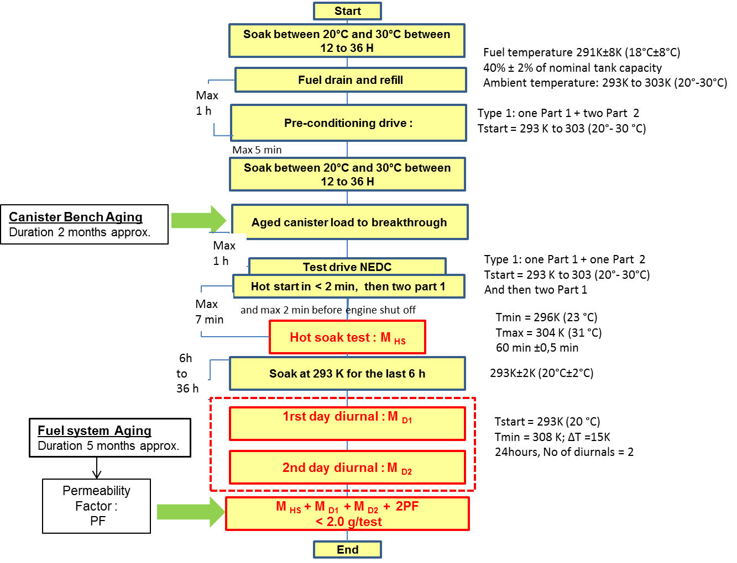

Notes:

4.3. Analytical systems

4.3.1. The analytical systems shall meet the requirements of paragraph 4.3. of Annex 7 to UN/ECE Regulation No. 83.

4.4. Temperature recording

4.4.1. The temperature recording shall meet the requirements of paragraph 4.5. of Annex 7 to UN/ECE Regulation No. 83.

4.5. Pressure recording

4.5.1. The pressure recording shall meet the requirements of paragraph 4.6. of Annex 7 to UN/ECE Regulation No. 83.

4.6. Fans

4.6.1. The fans shall meet the requirements of paragraph 4.7. of Annex 7 to UN/ECE Regulation No. 83.

4.7. Gases

4.7.1. The gases shall meet the requirements of paragraph 4.8. of Annex 7 to UN/ECE Regulation No. 83.

4.8. Additional Equipment

4.8.1. The additional equipment shall meet the requirements of paragraph 4.9. of Annex 7 to UN/ECE Regulation No. 83.

5. Test procedure

5.1. Canister bench aging

Before performing the hot soak and diurnal losses sequences, the canister must be aged according to the procedure described in Figure A1/2.

Figure A1/2: Canister bench aging procedure

**Test Start**

**Select new canister sample**

**1. Temperature conditioning test :**

**Canister brought from -15°C to 60°C**

**210 min; temp gradient 1°C/min**

**2. Canister vibration conditioning test:**

**Canister is shaken along the vertical axis for 12 H. Overall Grms > 1.5 with frequency of 30 ± 10 Hz**

**3. Fuel Aging for 300 cycles (BWC)**

{

X 50

5.1.1. Temperature conditioning test

5.1.1.1. In a dedicated temperature enclosure, the canister shall be cycled between temperatures from -15 °C to 60 °C, with 30 min of stabilisation at -15 °C and 60 °C. Each cycle shall last 210 min as in Figure A1/3.

The temperature gradient shall be as close as possible to 1°C/min. No forced air flow should to pass through the canister.

The cycle shall be repeated 50 times consecutively. In total, this procedure lasts 175 hours.

Figure A1/3: Temperature conditioning cycle

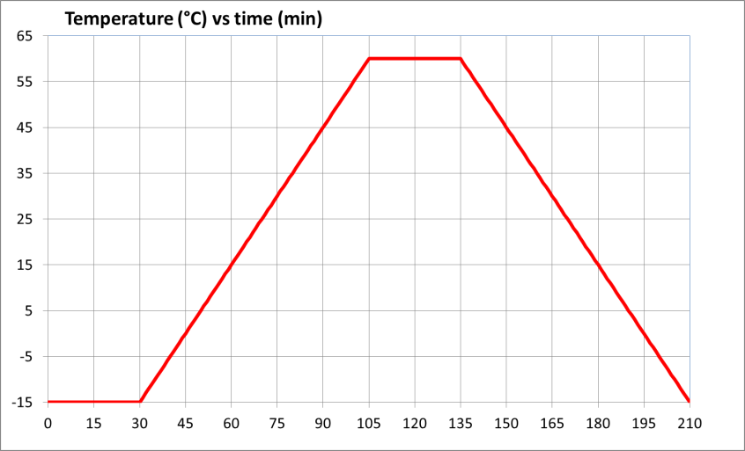

5.1.2. Canister vibration conditioning test

5.1.2.1. Following the temperature aging procedure, the canister shall be shaken along its vertical axis with the canister mounted as per its orientation in the vehicle with overall Grms > 1.5m/sec2 with frequency of 30 ± 10 Hz. The test shall last 12 hours.

5.1.3. Canister fuel aging test

5.1.3.1. Fuel aging for 300 cycles

5.1.3.1.1. After the temperature conditioning test and vibration test, the canister shall be aged with a mixture of Type 1 E10 market fuel as specified in paragraph 5.1.3.1.1.1. of this annex and nitrogen or air with a 50 +/- 15 percent fuel vapour volume. The fuel vapour fill rate shall be be kept between 60 ± 20 g/h.

The canister shall be loaded to the corresponding breakthrough. Breakthrough shall be considered accomplished when the cumulative quantity of hydrocarbons emitted equals 2 grams. As an alternative, the loading shall be deemed completed when the equivalent concentration level at the vent outlet reaches 3000 ppm.

5.1.3.1.1.1 The E10 market fuel used for this test shall fulfil the same requirements as an E10 reference fuel with respect to:

(a) Density at 15 °C;

(b) Vapour Pressure ;

(c) Distillation (evaporates only);

(d) Hydrocarbon analysis (olefins, aromatics, benzene only);

(e) Oxygen content;

(f) Ethanol content.

5.1.3.1.2. The canister shall be purged with 25 ± 5 litres per minute with emission laboratory air until 300 bed volume exchanges are reached. The standard conditions are 273.15 K and 101.325 kPa.

The canister shall be purged between 5 and 60 minutes after loading.

5.1.3.1.3. The procedures set out in paragraphs 5.1.3.1.1. and 5.1.3.1.2. shall be repeated 50 times, followed by a measurement of the Butane Working Capacity (BWC), meant as the ability of an activated carbon canister to absorb and desorb butane from dry air under specified conditions, in 5 butane cycles, as described in paragraph 5.1.3.1.4. of this annex. The fuel vapour ageing will continue until 300 cycles are reached. A measurement of the BWC in 5 butane cycles, as set out in paragraph 5.1.3.1.4. of this annex, shall be made after the 300 cycles.

5.1.3.1.4. After 50 and 300 fuel aging cycles, BWC shall be measured. This consists of loading the canister according to paragraph 5.1.6.3. of Annex 7 to UN/ECE Regulation No. 83 until breakthrough. The BWC shall be recorded.

The canister shall be subsequently purged according the paragraph 5.1.3.1.2. of this annex.

The operation of butane loading shall be repeated 5 times. The BWC shall be recorded after each butane loading step. The BWC50 and BWC300 shall be calculated as the average of the 5 BWC and recorded.

In total, the canister shall be aged with 300 fuel aging cycles + 10 butane cycles and shall be considered to be stabilized.

5.1.3.2. Alternative fuel aging

5.1.3.2.1. [ Reserved ]

5.1.3.3. If the canister is provided by the suppliers, the manufacturers shall inform in advance the responsible authority to it them to witness any part of the aging in the supplier’s facilities.

5.1.3.4. The manufacturer shall provide to the responsible authority a test report including at least the following elements:

(a) Type of activated carbon;

(b) Loading rate;

(c) Fuel specifications;

(d) BWC measurements.

5.2. Determination of the permeability factor (PF) of the fuel system (Figure A1/4)

Figure A1/4: Determination of the PF

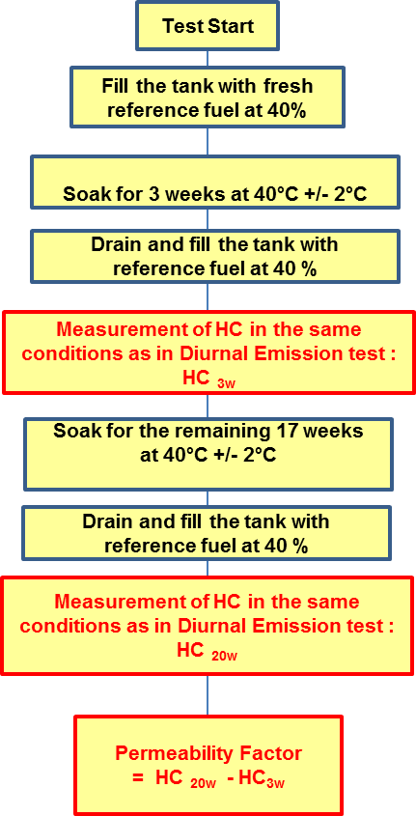

The fuel storage system representative of a family shall be selected and mounted on a rig, and subsequently soaked with E10 reference fuel for 20 weeks at 40°C +/- 2°C. The orientation of the fuel storage system on the rig shall be similar to the orientation in the vehicle.

5.2.1. The tank shall be filled with fresh E10 reference fuel at a temperature of 18°C±8 °C. The tank shall be filled at 40 +/-2 per cent of the nominal tank capacity. The rig with the fuel system shall be placed in a room with a controlled temperature of 40°C +/-2 °C for 3 weeks.

5.2.2. At the end of the 3rd week, the tank shall be drained and refilled with fresh E10 reference fuel at a temperature of 18°C±8 °C at 40 +/-2 per cent of the nominal tank capacity.

Within 6 to 36 hours, the rig with the fuel system shall be placed in an enclosure. The last 6 hours of this period shall be at an ambient temperature of 20 ± 2 °C. In the enclosure, a diurnal procedure shall be performed over a period of 24 hours, according to the procedure described in paragraph 5.7. of Annex 7 of UN/ECE Regulation No. 83. The fuel system shall be vented to the outside of the enclosure to eliminate the possibility of the tank venting emissions being counted as permeation. The HC emissions shall be measured and the value shall be recorded as HC3W.

5.2.3. The rig with the fuel system shall be placed again in a room with a controlled temperature of 40°C +/-2 °C for the remaining 17 weeks.

5.2.4. At the end of the 17th week, the tank shall be drained and refilled with fresh reference fuel at a temperature of 18°C±8 °C at 40 +/-2 per cent of the nominal tank capacity.

Within 6 to 36 hours, the rig with the fuel system shall be placed in an enclosure. The last 6 hours of this period shall be at an ambient temperature of 20 ± 2 °C. In the enclosure, a diurnal procedure shall be performed over a period of 24 hours, according to the procedure described according to paragraph 5.7. Annex 7 of UN/ECE Regulation No. 83. The fuel system shall be vented to the outside of the enclosure to eliminate the possibility of the tank venting emissions being counted as permeation. The HC emissions shall be measured and the valueshall be recorded as HC20W.

5.2.5. The PF is the difference between HC20W and HC3W in g/24h to 3 significant digits and calculated using the following equation:

$PF={HC}_{20w}- {HC}_{3W}$

5.2.6. If the PF is determined by a supplier, the vehicle manufacturer shall inform in advance the responsible authority to allow witness check in the supplier’s facility.

5.2.7 The manufacturer shall provide to the responsible authority a test report containing at least the following:

(a) A full description of the fuel storage system tested, including information on the type of tank tested, whether the tank is monolayer or multilayer, and which types of materials are used for the tank and other parts of the fuel storage system;

(b) The weekly mean temperatures at which the ageing was performed;

(c) The HC measured at week 3 (HC3W);

(d) The HC measured at week 20 (HC20W);

(e) The resulting permeability factor (PF).

5.2.8 As an exception to paragraphs 5.2.1. to 5.2.7. inclusive of this annex, the manufacturer using multilayer tanks may choose to use the following assigned permeability factor (APF) instead of the complete measurement procedure mentioned above

APF multilayer tank = 120 mg/24h

5.2.8.1 Where the manufacturer chooses to use APF, the manufacturer shall provide the responsible authority a declaration in which the type of tank is clearly specified, as well as a declaration of the type of materials used. 5.3. Sequence of measurement of hot soak and diurnal losses

The vehicle shall be prepared in accordance to paragraphs 5.1.1. and 5.1.2. of Annex 7 of UN/ECE Regulation No. 83. At the request of the manufacturer and with the approval of the responsible authority, non-fuel background emission sources may be eliminated or reduced before testing (e.g. baking tire or vehicle, removing washer fluid).

5.3.1. Initial soak

5.3.1.1. The vehicle shall be parked for a minimum of 12 hours and a maximum of 36 hours in the soak area. The engine oil and coolant temperatures shall have reached the soak area temperature ±3 °C at the end of that period.

5.3.2. Fuel drain and refill

5.3.2.1. The fuel drain and refill shall be performed in accordance to the procedure described in paragraph 5.1.7. of Annex 7 of UN/ECE Regulation No. 83.

5.3.3. Preconditioning drive

5.3.3.1. Within one hour after completing the fuel drain and refill, the vehicle shall be placed on the chassis dynamometer and driven through low, medium and high phases followed by [tbd] for class 2 or 3 vehicles, and low and medium phase followed by [tbd] for class1 vehicles,

Exhaust emissions need not be measured during this operation.

5.3.4. Second soak

5.3.4.1. Within five minutes of completing preconditioning, the vehicle shall be parked for a minimum of 12 hours and a maximum of 36 hours in the soak area. The engine oil and coolant temperatures shall have reached the temperature of the area or within ±3 C of it at the end of the period.

5.3.5. Canister breakthrough

5.3.5.1. The canisteraged according to the sequence described in paragraph 5.1. of this annex shall be loaded to breakthrough according to the procedure paragraph 5.1.4. of Annex 7 of UN/ECE Regulation No. 83.

5.3.6. Dynamometer test

5.3.6.1. Within one hour after completing canister loading, the vehicle shall be placed on the chassis dynamometer and driven through low, medium and high phase followed by [tbd] for class 2 or 3 vehicles, and low and medium phase followed by [tbd] for class1 vehicles The engine shall be subsequently shut off. Exhaust emissions may be sampled during this operation but the results shall not be used for the purpose of exhaust emission type approval.5.3.7. Hot soak

5.3.7.1. After the dynamometer test, the hot soak evaporative emissions test shall be performed in accordance to paragraph 5.5. of Annex 7 of UN/ECE Regulation No. 83. The hot soak losses result shall be calculated according to paragraph 6. of Annex 7 of UN/ECE Regulation No. 83 and recorded as MHS.

5.3.8. Third soak

5.3.8.1. After the hot soak evaporative emissions test, a soak shall be performed according to paragraph 5.6. of Annex 7 of UN/ECE Regulation No. 83.

5.3. 9. Diurnal test

5.3.9.1. After the soak, a first measurement of diurnal losses over 24 hours shall be performed according to paragraph 5.7. of Annex 7 of UN/ECE Regulation No. 83. Emissions shall be calculated according to paragraph 6. of Annex 7 of UN/ECE Regulation No. 83. The obtained value shall be recorded as MD1.

5.3.9.2. After the first 24 hour diurnal test, a second measurement of diurnal losses over 24 hours shall be performed according to paragraph 5.7. of Annex 7 to UN/ECE Regulation No. 83. Emissions shall be calculated according to paragraph 6. of Annex 7 to UN/ECE Regulation No. 83. The obtained value shall be recorded as MD2.

5.3. 10. Calculation

5.3.10.1. The result of MHS+MD1+MD2+2PF shall be below the limit defined paragraph 6.1. of this gtr.

5.3.11 The manufacturer shall provide the responsible authority a test report containing at least the following:

(a) Description of the soak periods, including time and mean temperatures;

(b) Description to aged canister used and reference to exact ageing report;

(c) Mean temperature during the hot soak test;

(d) Measurement during hot soak test, HSL;

(e) Measurement of first diurnal, DL1st day;

(f) Measurement of second diurnal, DL2nd day

(g) Final evaporative test result, calculated as (MHS+MD1+MD2+2PF)

Annex 1 - Appendix 1

Calibration of equipment for evaporative emission testing

1. Calibration frequency and methods

1.1. All equipment shall be calibrated before its initial use and then calibrated as often as necessary and in any case in the month before type approval testing. The calibration methods to be used are described in this appendix.

1.2. The temperatures in paragraphs 2.1.1., 2.2.1., 2.2.2., 2.3.3., and 2.3.4. of this appendix should preferably be used. The temperatures in square brackets in those paragraphs may be used as an option.

2. Calibration of the enclosure

2.1. Initial determination of internal volume of the enclosure

2.1.1. Before its initial use, the internal volume of the enclosure shall be determined as follows:

The internal dimensions of the enclosure shall be carefully measured, allowing for any irregularities such as bracing struts. The internal volume of the enclosure shall be determined from these measurements.

For variable-volume enclosures, the enclosure shall be latched to a fixed volume when the enclosure is held at an ambient temperature of 30 °C [optionally: 29 °C]. This nominal volume shall be repeatable within ±0.5 per cent of the reported value.

2.1.2. The net internal volume shall be determined by subtracting 1.42 m3 from the internal volume of the enclosure. Alternatively, the volume of the test vehicle with the luggage compartment and windows open may be used instead of 1.42 m3.

2.1.3. The enclosure shall beverified according to paragraph 2.3. of this appendix. If the propane mass does not correspond to the injected mass to within ± 2 per cent, corrective action shall be required.

2.2. Determination of enclosure background emissions

This procedure determines that the enclosure does not contain any materials that emit significant amounts of hydrocarbons. The verification shall be carried out at the enclosure's introduction to service, after any operations in the enclosure which may affect background emissions and at a frequency of at least once per year.

2.2.1. Variable-volume enclosures may be operated in either latched or unlatched volume configuration, as described in paragraph 2.1.1. of this appendix, ambient temperatures shall be maintained at 35 °C ± 2 °C [optionally: 36 °C ± 2 °C], throughout the 4-hour period mentioned below.

2.2.2. Fixed volume enclosures shall be operated with the inlet and outlet flow streams closed. Ambient temperatures shall be maintained at 35 °C ± 2 °C [optionally: 36 °C ± 2 °C] throughout the 4-hour period mentioned below.

2.2.3. The enclosure may be sealed and the mixing fan operated for a period of up to 12 hours before the 4-hour background sampling period begins.

2.2.4. The analyser (if required) shall be calibrated, zeroed and spanned.

2.2.5. The enclosure shall be purged until a stable hydrocarbon reading is obtained, and the mixing fan turned on if not already on.

2.2.6. The enclosure shall be sealed and the initial background hydrocarbon concentration CHCi, temperature Ti and barometric pressure Pi shall be measured. These shall be used in the enclosure background calculation.

2.2.7. The enclosure shall stand undisturbed with the mixing fan on for a period of 4 hours.

2.2.8. At the end of this time, the same analyser shall be used to measure the final hydrocarbon concentration CHCf in the enclosure. The final temperature Tf and the final barometric pressure Pf shall also be measured.

2.2.9. The change in mass of hydrocarbons in the enclosure shall be calculated over the time of the test in accordance to paragraph 2.4. of this appendix and shall not exceed 0.05 g.

2.3. Calibration and hydrocarbon retention test of the enclosure

The calibration and hydrocarbon retention test in the enclosure provides a check on the calculated volume in paragraph 2.1. of this appendix and also measures any leak rate. The enclosure leak rate shall be determined at the enclosure's introduction to service, after any operations in the enclosure which may affect the integrity of the enclosure, and at least monthly thereafter. If six consecutive monthly retention checks are successfully completed without corrective action, the enclosure leak rate may be determined quarterly thereafter as long as no corrective action is required.

2.3.1. The enclosure shall be purged until a stable hydrocarbon concentration is reached. The mixing fan shall be turned on, if not already switched on. The hydrocarbon analyser shall be zeroed, calibrated if required, and spanned.

2.3.2. On variable-volume enclosures, the enclosure shall be latched to the nominal volume position. On fixed-volume enclosures, the outlet and inlet flow streams shall be closed.

2.3.3. The ambient temperature control system shall be then turned on (if not already on) and adjusted for an initial temperature of 35 °C [optionally: 36 °C].

2.3.4. When the enclosure stabilises at 35 °C ± 2 °C [optionally: 36 °C ± 2 °C], the enclosure shall be sealed and the initial background concentration CHCi, initial temperature Ti and initial barometric pressure Pi shall be measured.

2.3.5. A quantity of approximately 4 grams of propane shall be injected into the enclosure. The mass of propane shall be measured to an accuracy and precision of ± 2 per cent of the measured value.

2.3.6. The contents of the enclosure shall be allowed to mix for five minutes. The hydrocarbon concentration CHCf, temperature Tf and barometric pressure Pf shall be measured. The readings CHCf, Pf, Tf are required for the calibration of the enclosure and the initial readings CHCi, Pi, Ti for the retention check.

2.3.7. Based on the readings taken according to paragraphs 2.3.4. and 2.3.6. inclusive of this appendix and the equation in paragraph 2.4. of this appendix, the mass of propane in the enclosure shall be calculated. This shall be within ± 2 per cent of the mass of propane measured in paragraph 2.3.5. of this appendix.

2.3.8. For variable-volume enclosures, the enclosure shall be unlatched from the nominal volume configuration. For fixed-volume enclosures, the outlet and inlet flow streams shall be opened.

2.3.9.

The ambient temperature shall be cycled from 35 °C to 20 °C to 35 °C over a 24 hour period according to the profile specified in Appendix 2 to this annex within 15 minutes of sealing the enclosure. Tolerances are specified in paragraph 5.7.1. of this annex.

Optionally, the ambient temperature shall be cycled from 35.6 °C to 22.2 °C to 35.6 °C over a 24 hour period according to the profile specified in Appendix 2 to this annex within 15 minutes of sealing the enclosure. Tolerances are specified in paragraph 5.7.1. of this annex.

2.3.10. At the completion of the 24-hour cycling period, the final hydrocarbon concentration CHCf, temperature Tf and barometric pressure Pf shall be measured and recorded. These readings shall be used for the hydrocarbon retention check.

2.3.11. Using the equation in paragraph 2.4. of this appendix, the mass of hydrocarbon shall be calculated from the readings taken in paragraphs 2.3.6. and 2.3.10. of this appendix. The mass may not differ by more than 3 per cent from the hydrocarbon mass given in paragraph 2.3.7. of this appendix.

2.4. Calculations

The calculation of net hydrocarbon mass change within the enclosure shall be used to determine the enclosure’s hydrocarbon background and leak rate. Initial and final readings of hydrocarbon concentration, temperature and barometric pressure shall be used in the following equation to calculate the mass change.



|  |  |  |
| --- | --- | --- |
| where: |  |  |
| MHC |  | is the hydrocarbon mass, g; |
| MHC,out |  | is the mass of hydrocarbons exiting the enclosure, in the case of fixed-volume enclosures for diurnal emission testing; g; |
| MHC,i |  | is the mass of hydrocarbons entering the enclosure when a fixed-volume enclosure is used for testing diurnal emissions, g |
| CHC |  | is the hydrocarbon concentration in the enclosure, ppm carbon;  (*Note*: ppm carbon = ppm propane x 3)), |
| V |  | is the enclosure volume, m³; |
| T |  | is the ambient temperature in the enclosure, K;, |
| P |  | is the barometric pressure, kPa; |
| K | = | is the constant 17.6; |
| where: |  |  |
| i | is an initial reading, | |
| f | is a final reading. | |

3. Verifying the FID hydrocarbon analyzer

3.1. Detector response optimisation

The FID shall be adjusted as specified by the instrument manufacturer. Propane in air should be used to optimise the response on the most common operating range.

3.2. Calibration of the HC analyser

The analyser should be calibrated using propane in air and purified synthetic air. See paragraph 6.2. of Annex 5 to UN/ECE Global Technical Regulation No. 15

A calibration curve shall be determined as described in paragraphs 4.1. to 4.5. inclusive of this appendix.

3.3. Oxygen interference check and recommended limits

The response factor Rf for a particular hydrocarbon species is the ratio of the FID C1 reading to the gas cylinder concentration expressed as ppm C1. The concentration of the test gas shall be at a level to give a response of approximately 80 per cent of full-scale deflection for the operating range. The concentration shall be known to an accuracy of ±2 per cent in reference to a gravimetric standard expressed in volume. In addition, the gas cylinder shall be preconditioned for 24 hours at a temperature between 20 and 30 °C.

Response factors should be determined when introducing an analyser into service and thereafter at major service intervals. The reference gas to be used shall be propane with balance purified air which gives a response factor of 1.00.

The test gases to be used for oxygen interference and the recommended response factor range are:

Propane and nitrogen: 0.95 ≤ Rf ≤ 1.05.

4. Calibration of the hydrocarbon analyzer

Each of the normally used operating ranges shall be calibrated using the procedure in paragraphs 4.1. to 4.5. inclusive of this appendix.

4.1. A calibration curve shall be established using at least five calibration points spaced as evenly as possible over the operating range. The nominal concentration of the calibration gas with the highest concentrations shall be at least 80 per cent of the full scale.

4.2. The calibration curve shall be determined using the least-squares method. If the resulting polynomial degree is greater than 3, the number of calibration points shall be at least numerically equal to the number of the polynomial degree plus 2.

4.3. The calibration curve shall not differ by more than 2 per cent from the nominal value of each calibration gas.

4.4. Using the coefficients of the polynomial derived from paragraph 3.2. of this appendix, a table of indicated reading against true concentration shall be drawn up in steps of no greater than 1 per cent of full scale. This shall be carried out for each analyser range calibrated. The table shall also contain other relevant data such as:

(a) Date of calibration, span and zero potentiometer readings (where applicable);

(b) Nominal scale;

(c) Reference data of each calibration gas used;

(d) The actual and indicated value of each calibration gas used together with the percentage differences;

(e) FID fuel and type;

(f) FID air pressure.

4.5. If it can be shown to the satisfaction of the responsible authority that an alternative technology (e.g. computer, electronically controlled range switch) can give equivalent accuracy, those alternatives may be used.

Annex 1 - Appendix 2

Diurnal ambient temperature profile

|  |  |  |  |  |
| --- | --- | --- | --- | --- |
| *Diurnal ambient temperature profile for the calibration  of the enclosure and the diurnal emission test* | | | *Alternative diurnal ambient temperature profile for the calibration of the enclosure in accordance with paragraphs 1.2. and 2.3.9. in Appendix 1 to Annex 1* | |
| *Time (hours)* | | *Temperature  (°Ci)* | *Time (hours)* | *Temperature  (°Ci)* |
| *Calibration* | *Test* |
| 13 | 0/24 | 20.0 | 0 | 35.6 |
| 14 | 1 | 20.2 | 1 | 35.3 |
| 15 | 2 | 20.5 | 2 | 34.5 |
| 16 | 3 | 21.2 | 3 | 33.2 |
| 17 | 4 | 23.1 | 4 | 31.4 |
| 18 | 5 | 25.1 | 5 | 29.7 |
| 19 | 6 | 27.2 | 6 | 28.2 |
| 20 | 7 | 29.8 | 7 | 27.2 |
| 21 | 8 | 31.8 | 8 | 26.1 |
| 22 | 9 | 33.3 | 9 | 25.1 |
| 23 | 10 | 34.4 | 10 | 24.3 |
| 24/0 | 11 | 35.0 | 11 | 23.7 |
| 1 | 12 | 34.7 | 12 | 23.3 |
| 2 | 13 | 33.8 | 13 | 22.9 |
| 3 | 14 | 32.0 | 14 | 22.6 |
| 4 | 15 | 30.0 | 15 | 22.2 |
| 5 | 16 | 28.4 | 16 | 22.5 |
| 6 | 17 | 26.9 | 17 | 24.2 |
| 7 | 18 | 25.2 | 18 | 26.8 |
| 8 | 19 | 24.0 | 19 | 29.6 |
| 9 | 20 | 23.0 | 20 | 31.9 |
| 10 | 21 | 22.0 | 21 | 33.9 |
| 11 | 22 | 20.8 | 22 | 35.1 |
| 12 | 23 | 20.2 | 23 | 3.4 |
|  |  |  | 24 | 35.6 |

Annex 1 - Appendix 3

Test procedure for all vehicles equipped with sealed tank system

1. [ Reserved ]

Annex 2

Reference fuels

1. As there are regional differences in the market specifications of fuels, regionally different reference fuels need to be recognised. Contracting Parties may select their reference fuels either according to Annex 3 to UN/ECE Global Technical Regulation No. 15. or according to paragraph 2. of this Annex.

2. Specification of reference fuel for testing.

2.1. The reference fuel listed in Tableß A2/1 is designed to be used as the reference fuel for mutual recognition under the rules of the 1998 UN/ECE agreement.

Table A2/1

|  |  |  |  |  |
| --- | --- | --- | --- | --- |
| *Parameter* | *Unit* | *Limits* | | *Test method* |
| *Minimum* | *Maximum* |
| Research octane number, RON |  | 95.0 | 98.0 | EN ISO 5164  JIS K2280 |
| Density at 15 °C | kg/m3 | 743.0 | 756.0 | EN ISO 12185  JIS K2249-1,2,3 |
| Vapour pressure | kPa | 56.0 | 60.0 | EN 13016-1  JIS K2258-1,2 |
| Distillation: |  |  |  |  |
| – evaporated at 70 °C | % v/v | 34.0 | 46.0 | EN ISO 3405 |
| – evaporated at 100 °C | % v/v | 54.0 | 62.0 | EN ISO 3405 |
| – evaporated at 150 °C | % v/v | 86.0 | 94.0 | EN ISO 3405 |
| Hydrocarbon analysis: |  |  |  |  |
| – olefins | % v/v | 6.0 | 13.0 | EN 22854 |
| – aromatics | % v/v | 25.0 | 32.0 | EN 22854 |
| – benzene | % v/v | - | 1.00 | EN 22854 EN 238  JIS K2536-2,3,4 |
| Oxygen content | % m/m | 3.3 | 3.7 | EN 22854  JIS K2536-2,4,6 |
| Sulphur content | mg/kg | — | 10 | EN ISO 20846  EN ISO 20884  JIS K2541-1,2,6,7 |
| Lead content | mg/l | Not detected | | EN 237  JIS K2255 |
| Ethanol | % v/v | 9.0 | 10.0 | EN 22854  JIS K2536-2,4,6 |
| MTBE |  | Not detected | | EN ISO xxxx  JIS K2536-2,4,5,6 |
| Methanol |  | Not detected | | EN ISO xxxx  JIS K2536-2,4,5,6 |
| Kerosene |  | Not detected | | EN ISO xxxx  JIS K2536-2,4 |
|  | | | | |