|  |  |  |  |
| --- | --- | --- | --- |
|  | United Nations | ECE/TRANS/WP.29/2016/94 | |
| Description: _unlogo | **Economic and Social Council** | | Distr.: General  1 September 2016  Original: English |

**Economic Commission for Europe**

Inland Transport Committee

**World Forum for Harmonization of Vehicle Regulations**

**170th session**

Geneva, 15-18 November 2016

Item 4.7.6 of the provisional agenda

**1958 Agreement :   
Consideration of draft amendments**

**to existing Regulations submitted by GRSG**

Proposal for Supplement 1 to the 07 series of amendments to Regulation No. 107 (General construction of buses and coaches)

**Submitted by the Working Party on General Safety Provisions[[1]](#footnote-2)\***

The text reproduced below was adopted by the Working Party on General Safety Provisions (GRSG) at its 110thsession (ECE/TRANS/WP.29/GRSG/89, para. 5). It is mainly based on ECE/TRANS/WP.29/GRSG/2015/21 as reproduced in Annex II to the report. It is submitted to the World Forum for Harmonization of Vehicle Regulations (WP.29) and to the Administrative Committee AC.1 for consideration at their November 2016 sessions.

**Supplement 1 to the 07 series of amendments to Regulation   
No. 107 (General construction of buses and coaches)**

*Annex 3*

*Paragraph 7.7.5.1.,* amend to read:

"7.7.5.1. …

In vehicles of Classes II, III and B, the gauging device according to Annex 4, Figure 6 may come into contact with any monitor or display device mounted from the ceiling above the gangway. The maximum force necessary to move any such monitor or display device out of the way, in both directions, shall not exceed 35 Newton. This maximum force shall be applied normal to the middle of the lower edge of the monitor or display device in both directions in turn until the monitor or display device has reached a position which allows clear passage of the gauging device. After being moved out of the way, the monitor or display device shall maintain its position and not automatically redeploy.

If a vehicle of Class I, II or A is fitted with a barrier, the gauging device according to Annex 4, Figure 6, may come into contact with the barrier provided that the maximum force necessary to move such barrier out of the way does not exceed 50 Newton measured at the point of contact between the gauging device according to Annex 4, Figure 6 and the barrier and applied perpendicular to the barrier.

The maximum force shall apply to both directions of movement of the gauging device.

If the vehicle is equipped with a lift adjacent to the barrier, the barrier may be temporarily blocked during the operation of the lift."

*Paragraphs 7.7.8.4. to 7.7.8.4.2.,* amend to read:

"7.7.8.4. Seat spacing (see Annex 4, Figures 12A and 12B)

7.7.8.4.1. In the case of seats facing in the same direction, the distance between the front of a seat squab and the back of the squab of the seat preceding it (dimension H), shall, when measured horizontally, parallel to the longitudinal plane of the vehicle and at all heights above the floor between the level of the top surface of the seat cushion and a point 620 mm above the floor, not be less than:

| *H* | |
| --- | --- |
| Classes I, A and B | 650 mm |
| Classes II and III | 680 mm |

* + - * 1. All measurements shall be taken, with the seat cushion and squab uncompressed using the testing gauge shown in Annex 4, Figure 12B."

*Paragraph 7.7.8.5.3.,* amend to read:

"7.7.8.5.3. The minimum number of priority seats complying with the requirements of Annex 8, paragraph 3.2. shall be four in Class I, two in Class II and one in Class A. In the case of vehicles of Class III or Class B subject to the requirements of Annex 8, the minimum number of priority seats shall be two in Class III and one in Class B.

A seat that folds out of the way when not in use shall not be designated as a priority seat."

*Annex 4, Figure 12,* amend to read:

"Figure 12A

Seat spacing …

…

Figure 12B

**Testing gauge for H dimension (see Annex 3, paragraph 7.7.8.4.2.)**

Thickness of the gauge: 5 mm maximum

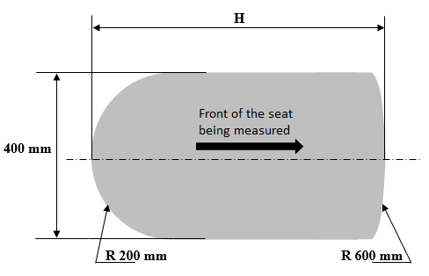"

1. \* In accordance with the programme of work of the Inland Transport Committee for 2016–2017 (ECE/TRANS/254, para. 159 and ECE/TRANS/2016/28/Add.1, cluster 3.1), the World Forum will develop, harmonize and update Regulations in order to enhance the performance of vehicles. The present document is submitted in conformity with that mandate. [↑](#footnote-ref-2)