|  |  |  |  |
| --- | --- | --- | --- |
|  | United Nations | ECE/TRANS/WP.11/2016/21 | |
| _unlogo | **Economic and Social Council** | | Distr.: General  20 July 2016  Original: English |

**Economic Commission for Europe**

Inland Transport Committee

**Working Party on the Transport of Perishable Foodstuffs**

**Seventy-second session**

Geneva, 4-7 October 2016

Item 5 (a) of the provisional agenda

**Proposals of amendments to the ATP:**

**pending proposals**

Pending issues "Multi temperature multi compartment equipment" (MTMC)

Transmitted by the Government of the Netherlands

1. MTMC is a very specific kind of refrigerated equipment. Very specific because it involves only heavily insulated bodies that can internally be partitioned by fixed, movable and removable partitions. Other constructions such a road vehicles consisting of two sections tested and approved separately, for instance one part normally insulated and the other heavily insulated, are not considered to be MTMC’s nor are heavily insulated bodies with compartments at the same temperature (i.e. frozen food/ice cream distribution trucks). For the moment the regulation only deals with *mechanically* refrigerated equipment but in principle all types of heating and cooling can be used.

2. The use of MTMC’s is more related to distribution transport than long distance international transport. However concerning the opening of the markets in Europe and chains of super markets opening in neighboring countries make crossing border use of such equipment is more likely than ever before, justifying introduction in the ATP.

3. In 2011 procedures for the initial approval and certification of MTMC equipment were accepted by WP.11 for coming into force on 23 September 2013. In 2011 it was recognized that some issues would need to be further developed. So far filling in the missing parts was not successful. The following reasons for this can be identified;

(a) details on these topics are already regulated in *national* rules that can only be changed with great difficulty,

*At least in one contracting party rules have been taken up in national legislation for marking of MTMC’s and the procedure for the retest. This may be replaced by a more efficient regulation but there should be a clear advantage or benefit.*

(b) the wish to adopt only a package deal where all remaining issues are included to satisfaction,

*A valid argument because the issues are inter related. A change in one issue leads to changes in the others. The approval process of amendments to the ATP and annexes is long and correcting maybe difficult. An overview is needed but it should also be realized that it will never be perfect first time and that the first approved equipment will come for retest soon.*

(c) making the issues overcomplicated,

*MTMC is only applicable to distribution trucks and not likely to refrigerated containers of rail wagons. The average number of compartments in MTMC trucks are 3, more compartments are not common. Control authorities on the road may want to know that more than one temperature zone can be used in one and the same equipment, but is it necessary to know if where they are or if they have movable or even removable walls?*

(d) lack of development of supporting tools and

*a usable tool for calculating heat requirements in the various configurations of the compartments was developed by industry after adoption of MTMC’s in the ATP. It is now available but available for all? Has it the functionality to make usable overview for approval and change of thermal appliance?*

(e) uncertainties in the already accepted provisions for MTMC’s.

*Are removable partitions included and are "soft" inflatable partitions allowed. Is the heating possibility of the mechanically refrigerating unit to be taken into account?*

4. Taking these possible reasons for not coming to conclusion in mind may help to come to the most acceptable solution for all parties.

The following three issues are identified for development:

* Marking,
* Information for approval,
* Procedure for a retest.

5. In the 4 annexes to this document considerations and suggestions (and 1 proposal) for amendments are given to these issues. It is recognized that the suggestions may need further development and fine tuning that may be forwarded as informal documents modifying or replacing parts of this document.

Annex 1

Marking of MTMC equipment

Marking in general

In general ATP equipment is marked with its class, the equipment belongs to, and date when the approval expires. It can be questioned what the original intentions were to mark the equipment and analyze in which situation markings presents an additional value. The following situations are considered:

(a) For loading:

The loader will have the ATP certificate or ATP plate on the equipment available with more detailed information rather than using the marking on the outside of the equipment. There maybe an additional value when picking up a rental trailer from a parking lot. The expiry date will quickly identify a trailer that should not be used.

(b) For testing:

The tester will rely on the ATP certificate or type approval documentation available rather than the marking on the equipment. The marking has no additional value in this case.

(c) For receiving privilege at border crossings or road side checks:

When crossing borders or being stopped for a road side inspection the marking may be useful to select "on sight" which equipment have more urgency than others to move on. That this is probable intention can be concluded from the argument when an "X" needs to be added to the classification markings in Annex 1 Appendix 4 of the ATP. Equipment marked with a "X" cannot generate additional heat while being stationary or cannot be re-iced/refueled/recharged on the spot.

(d) For road side inspections and custom controls:

A check if carriage is done in accordance with the regulation may be done by the control authority on the road or while crossing a national border. It is not recommended to open doors during a road side check to protect the food stuffs. On the other hand during carriage the ATP certificate or a ATP plate is available for information to the control authority. Conclusion is that the marking is not very significant in this situation.

Conclusion is that markings have additional value while waiting for crossing a border or road side checks.

Marking of MTMC’s.

Taking the above conclusions in mind for MTMC’s it can be questioned which additional or alternative marking for MTMC’s is sufficient:

(a) Loading:

The markings of each compartment in itself may be insufficient for loading because the place of the compartment is not clear and the size of the compartment to fit the load is not known. Additional information is needed to any marking. For selection on a rental lot there may be an advantage to pick-out an MTMC equipment but does this justify the costs?

(b) Testing:

For testing there seems to be no additional value, the ATP certificate or type-approval documentation or other information will be used. Additional marking seems to offer no benefit.

(c) For priority:

MTMC will not behave differently for maintaining temperature than normal "mono" temperature equipment, so no advantage for additional marking.

(d) For roadside checks:

It is not recommended to open doors during a road side check. It may be helpful for the control authority to recognize that foodstuffs requiring different temperature setting can be carried in one insulated body. A simple "M" or stating of compartment classes should be sufficient. More detailed information if partitions are movable or removable seems to be overdone.

Overcomplicating

In practice MTMC are only trucks and trailers. It is possible to have a demountable body which may be seen as a container but real containers for multi-modal transport or railway wagons are not expected to be MTMC’s. If necessary additional or alternative markings may be limited to road vehicles that have a clear front-side simplifying the possible position of the compartments inside the insulated body.

Also the number of compartments seems to be limited in practice to 3 and not up to 8 as sometimes mentioned in discussions. This will restrict the number of alternative markings to a workable number. Regulation shall not be design restrictive so a workable solution needs to be given in case there are more than 3 compartments.

It is questionable if giving alternative markings between parenthesis of square hooks indicating that compartments walls are fixed, movable, removable or even deflatable is useful for users or control authority or just adding to confusion. This detailed information should be given elsewhere, keep the marking simple.

Which marking.

Over the years all options for marking have passed the review in WP.11, from having no additional markings to marking of up to 6 or 7 compartments, some in parenthesis or square brackets if walls are movable or removable.

In in earlier WP.11 sessions the wish to have at least some indication in the marking that equipment is approved as MTMC was expressed. A simple "M" for MTMC or a limited number of classification markings will be equally sufficient.

However opinions are divided; marking of the classification of each compartment, in practice 3, or adding just the "M" have strong following. It should also be noted that at least one contracting party already regulated nationally and that changing this will be difficult for accepting another proposal in the WP.11.

For these reasons a compromise could be the most suitable for acceptance.

Proposal:

Introduce new wording after the classification examples in Annex 1 Appendix 4 to read:

*For equipment approved as Multi compartment-multi temperature equipment (See Annex 1, Appendix 2, section 8):*

*- the distinguishing mark shall be supplemented by the letter "M" or*

*- the distinguishing mark for the equipment as a whole shall be replaced by the distinguishing marks appropriate for each compartment,*

*as required by the competent authority in which the equipment is registered or recorded.*

*Where distinguishing marks appropriate for each compartment are given the sequence of marking shall be from the front compartment to the rear, in the case of longitudinal compartments starting at the front left compartment rotating clockwise (from above) and in case of upper and lower deck compartments the upper deck compartment(s) before the lower deck compartment(s).*

*[No additional markings are required to indicate if partitions are movable or removable.]*

Annex 2

Information on MTMC’s

Information in general

During carriage mono temp equipment is accompanied by an ATP certificate or ATP plate. As it is not regulated in the ATP that the loaders or control authorities have the right to demand the ATP certificate to be produced during a roadside check or border crossing, the information on the ATP plate can be seen as sufficient.

The additional information of the ATP certificate over the ATP plate can be seen as necessary information for retesting and exchange of the thermal appliance.

Information requirements for MTMC’s

For MTMC equipment additional information maybe necessary, the volume of the loading space and temperature settings of the various compartments need to be known for loading.

Also for MTMC’s the need for information can be split in two like for mono-temps above.

For use with the ATP plate only it maybe sufficient to give the (possible) floor space and temperature setting of the compartments while for the ATP certificate to facilitate the retest of exchange of thermal appliance, even more additional information is needed in the form of specific heat requirements for each compartment in the various dimensions of movable walls and temperature settings of the compartment in relation to the temperature settings of the other compartments. For the thermal appliance also the performance of each evaporator in co-operation with evaporators in other compartments need to be known.

To accompany the ATP plate, when fitted, an additional plate with an overhead view of the load space and classification mark for each compartment may be suitable.

The ATP certificate for mono-temps is full of information as it is, it will not be easy to add the necessary information for MTMC’s. An annex to the ATP certificate maybe the best option. This annex should have a relation to the ATP certificate and should also give the identical information of the additional MTMC ATP plate and possibly additional information on heat demands in case of exchange of the thermal appliance.

Suggestion 1

Add a new paragraph after the heading of Annex 1, Appendix 3 A. and before the transitional measure to read:

*The certificate of compliance for multi temperature multi compartment equipment shall be supplemented by an annex containing the information of the Model xy given in Annex 1, Appendix 2.*

Suggestion 2

Add a new paragraph 3 to the end of Annex 1, Appendix 3 B. to read:

*3. For equipment certified as Multi-temperature-Multi –compartment, when a ATP certification plate is fitted, an additional plate shall be affixed to the equipment in a permanent way and in a clearly visible place adjacent to the ATP certification plate. The additional plate shall have the same properties for material and dimensions as the certification plate of paragraph 1. The following particulars shall be indicated on this plate:*

*(f) The Latin letters "ATP" followed by the words "Multi temperature-multi compartment equipment";*

*(g) "EQUIPMENT NUMBER" followed by the individual number assigned to identify the particular item of equipment (which may be the manufacturers number);*

*(h) Overhead plan view of the load area of the equipment as required in Annex 1, Appendix 2 model No. 11, including position of the compartments, minimum and maximum floor surface and distinguishing marks applicable for each compartment. Fixed walls shall be identified by a closed line, movable by a dotted line in the most extreme positions and a removable wall shall de identified by a waved line. The position of the thermal appliance and doors shall also be given.*

*Example of the plate*

*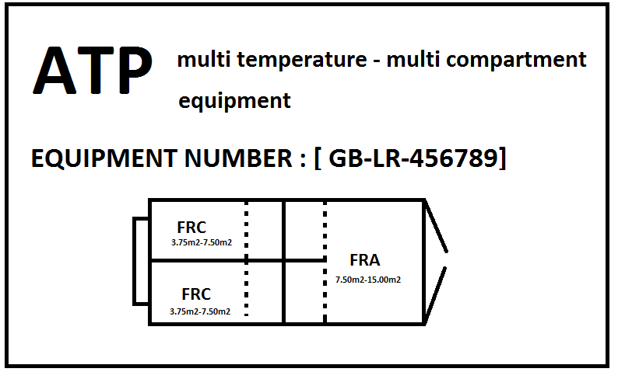*

Suggestion 3

*Introduce a new Model No. xy at the end of Annex 1 Appendix2 to read:*

Model No. xy

Section 2 [or 4]

Information on the internal configuration of Multi Compartment - Multi Temperature equipment, heat demand of compartments and refrigerating capacity of individual evaporators.

Plan (overhead view) of the equipment

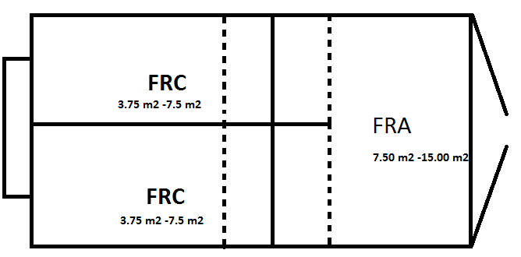

(example)

Legenda:  
Fixed internal wall / rigid door \_\_\_\_\_  
Most extreme position of movable ……..  
Removable wall \_.\_.\_.\_.  
Flexible wall ++++++

\*Number the compartments starting at the left front compartment of the equipment and proceed numbering clockwise.

\*Mark the classification mark of each compartment in the appropriate compartment.

(In case of equipment with an upper and lower deck reproduce an overhead plan view of the lower deck below)

General description of the lay-out of the internal configuration:

(Give an short description of the configuration, i.e. longitudinal compartments, transfers compartments, movable of removable internal dividing walls, no and place of evaporators per compartment, heaters etc.)

………………….

Specifications of the internal dividing walls:

Description of internal dividing wall (i.e. longitudinal wall between compartment 1 and 2)  
- Composition of the wall:

- Material types used in the wall:

- K value of the wall according to 8.3.7

- length and height of the wall in mm.

Description of internal dividing wall   
- Composition of the wall:  
- Material types used in the wall:  
- K value of the wall according to 8.3.7  
- length and height of the wall in mm.

*(Repeat description for other internal dividing walls or floor of upper/lower deck equipment as applicable.)*

Compartment information:

|  |  |  |  |
| --- | --- | --- | --- |
|  | Compartment 1\*\* | Compartment 2\*\* | Compartment 3\*\* |
| Floor surface\* |  |  |  |
| Overall surface\* |  |  |  |
| Surface internal dividing wall(s)\* |  |  |  |
| Calculated Heat requirement\* |  |  |  |
| Evaporator capacity |  |  |  |
| [Average surface in relation to the evaporator capacity] |  |  |  |

\*(when compartment(s) have movable internal dividing walls state the data for the largest and smallest configuration).  
\*\* When two compartments are unitedby a retractable or removable internal dividing wall this united compartment shall not be considered separately.

Annex 3

Efficiency test of a MTMC mechanical refrigerating unit

Efficiency test in general

An efficiency test of a thermal appliance is not a capacity test but a functioning test. It is just to prove that the appliance is still functioning as intended and is able to reach class temperature. The circumstances this test is run under is not a normal situation where a pre-cooled load is in the insulated body.

For this test the insulated body is empty and internal two temperature sensors are used, when de highest temperature sensor has reached class temperature it passes the tests.

Efficiency test for MTMC mechanical refrigeration units

The unit shall be able to fulfill the efficiency test as for mono temp application. It shall be able to reach class temperature. It can be argued if additional testing is required to prove that the different temperature in compartments can be reached. As the regulating mechanism of mechanical MTMC units is sophisticated there is merit in an additional check. The complete test should be limited in time and costs, the test will also give additional pollution.

In France a retest for mechanical MTMC units is in use for some time. The retest starts with a normal efficiency test as applicable for mono temp use. The interior shall be brought to the class temperature which is -200C. In each compartment 2 temperature sensors are applied.

When the class temperature is reached in the equipment as whole and a stabilization period of 10 minutes has passed the temperature of a compartment is raised to 0 0C while the others are kept at class temperature. Once 0 0C is reached in this compartment by the hottest temperature sensor this will be reversed for other compartments after another stabilization period. The compartments are tested in pairs, i.e. 1 and 3 and 2 and 4 (if available). In practice this will result in 3 tests, the normal efficiency test which should be easily reached for well maintained MTMC equipment and 2 times a heat up/cool down test for the compartments. Although there is no time limit for the compartment tests the experience in France is that this can be done for the "standard" 3 compartment units within one working day.

Moveable partitions are placed in relation to the surface of the resulting compartment to the capacity of the evaporators. For this a calculation tool is used but the average surface area can also be predetermined and included in an information document.

The test report of the additional test could be kept fairy simple when the information document to the ATP certificate is available. (see annex 2 of this document Model No. 11).

However Annex 1, Appendix 2 section 8 does not provide for requirements for heating. How to deal with this test if there is no heating? In practice all mechanical MTMC refrigeration units can supply heat. Maybe just opening the doors and start anew. The internal body will be cooled down already but the test is to see if the unit can function and not the capacity. It can be questioned if heating should be part of MTMC equipment and if an additional test is really needed for units working on liquefied gas.

Suggestion 4

Introduce a new (iii) to paragraph 6.2 of Annex 1 Appendix 2 to read: (this is only for mechanically refrigerated!!)

(iii) Multi temperature- multi compartment equipment.

*It shall be verified that the unit for the insulated body as a whole complies with 6.2 (i).*

*The compartments shall be divided into two groups in such a way that, for as far as possible, adjacent compartments have a different temperature setting during the test. One group is brought to the class temperature (-20 0C) while the other group is chilled (0 0C). After reaching the temperature limit this temperature setting shall be reversed for the groups of compartments.*

*For units with a heating function the check shall be started after the efficiency test while the temperature is -20 0C. One group of compartments is heated up while the other group remains at the class temperature. When the temperature is reached this shall be reversed were the chilled compartments are reduced in temperature to -20 0C and the previously frozen compartments are heated up to be chilled. There is not time limit for these tests.*

*For units without a heating function the doors shall be opened and the air temperature of the interior shall be increased to above 5 0C. The doors and openings in the partitions shall be closed and one group shall be brought to -20 0C and the other to 0 0C. When these temperatures are reached this shall be reversed.*

*Between each check there shall be a stabilization period of 10 minutes in which the compartments shall maintain the temperature. Moveable walls shall be set at the position that the overall internal surface area is in relation to that of the evaporators. Removable walls shall be included in the test. In each compartment temperature sensors shall be placed in compliance with 6.4 of this appendix and the hottest sensors of each compartment shall reach class temperature.*

*If the results are acceptable, the equipment may be kept in service as mechanically refrigerated MTMC equipment for a further period of not more than 3 years.*

Annex 4

Miscellaneous

Suggestion 5

If appropriate remove foot note 4 in Annex 1, Appendix 3 A.

Suggestion 6

Include transitional measures in the new Annex 1 paragraph 3 to read:

Equipment first taken into service / [approved] as multi temperature-multi compartment before xx-xx-xxxx in compliance with the regulations in force up to xx-xx-xxxx but that do not comply with requirements of Annex 1, Annex 3 B. paragraph 3, Annex 1, Annex 4 entered into force may continued to be used [until the next retest]