|  |  |  |  |
| --- | --- | --- | --- |
|  | United Nations | ECE/TRANS/2016/3 | |
| _unlogo | **Economic and Social Council** | | Distr.: General  15 December 2015  Original: English |

**Economic Commission for Europe**

Inland Transport Committee

**Seventy-eighth session**

Geneva, 23–26 February 2016  
Item 4 (b) of the provisional agenda  
**Strategic questions of a horizontal policy nature:  
UNECE analytical work on Transport**

UNECE analytical work on Transport

Note by the secretariat

|  |
| --- |
| *Summary* |
| This note provides a brief review of the analytical work undertaken in 2015 by ECE Sustainable Transport Division. The analytical work comprises studies related to topical issues on transport, analysis requested by official Groups of Experts and Task Forces, analytical papers prepared to support activities related to the UN transport conventions and/or capacity-building workshops, as well as analytical studies that provide substantive foundation for, or result from, participation in or management of different projects. The note summarizes the work done both within the programme of work of the Working Party on Transport Trends and Economics as well as in the framework of the Sustainable Transport Division. |
| The Committee is invited to provide guidance on future directions of the analytical work in the field of transport. |
|  |

I. Analytical Work and Capacity Building Workshops Undertaken by the Working Party on Transport Trends and Economics (WP.5)

1. The Working Party on Transport Trends and Economics (WP.5) provides a forum for the exchange of experiences and ideas on the progress in, and particular challenges to, the development of sustainable inland transport. Its mandate allows it to assume the unique role of a transport “think tank” in the framework of the Inland Transport Committee. As such, it aims to: identify the global trends and developments which may have important implications for the transport sector and the challenges that the sector is facing; conduct reviews and provide analyses on said factors based on information provided by member States; and, through consensus, make relevant policy recommendations that should lead to the development of sustainable transport systems.

A. Publications - Studies

1. Transport Trends and Economics 2012–2013: Sustainable Urban Mobility and Public Transport in UNECE capitals

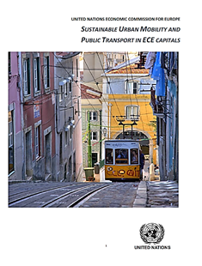2. In 2013–2014 the secretariat finalized the publication on Transport Trends and Economics: Sustainable Urban Mobility and Public Transport in UNECE capitals. This publication was published during 2015 and will be available for the Committee session in 2016. The study was developed for authorities at different levels of government to provide them with a knowledge base on sustainable urban public transport systems and their application. It is structured in the following way:

(a) Chapter 1: reviews the existing knowledge base related to sustainable urban public transport and mobility and draws attention to crucial issues that need to be considered when developing a system;

(b) Chapter 2: evaluates to what extent various UNECE capital cities were able to launch sustainable urban public transport and mobility systems, and provides hints at possible weak points that may require further action;

(c) Chapter 3: provides profiles on 34 UNECE capital cities in the frame of urban public transport and mobility; and

(d) Chapter 4: provides conclusions from the analysis provided in chapter 2, and lists several recommendations for consideration by authorities at various levels on how to further improve urban public transport systems and mobility.

2. Transport Trends and Economics 2014–2015: Financing Transport Infrastructure

3. This publication will make use of the workshops organized during the Committee session and its Policy segment in 2013, as well as in the past two years of the WP.5 sessions on “Financing Transport Infrastructure” and on “Good Practices and New Tools for Financing Transport Infrastructure”. Collection of data is in progress based on questionnaire approved by the Working Party during its 2015 session. This study will include data, analysis and presentations of pre-feasibility or feasibility studies on priority infrastructure projects received from member Governments participating in the Euro-Asian Transport Links (EATL), Trans-European Motorways (TEM) and Trans-European Railway (TER) projects and will focus, inter alia, on:

(a) Presentation of best practices or innovative models regarding financing of transport infrastructure;

(b) Presentation of best practices regarding medium and long-term scheduling, management and delivery of such projects;

(c) Presentation of specific national experiences regarding the financing of their transport infrastructure, including the illustration of specific studies for such projects, types of financing and data provided by the Governments;

(d) Presentation of International Financial Institutions and other donors’ investment portfolios regarding investments or lending in transport infrastructure.

B. Workshops

1. Workshop on Road and Rail transport corridors along Europe and Asia

4. The importance of modern and efficient transport infrastructure as well as the implementation of soft measures and in particular the UN Conventions in order to facilitate border crossings was highlighted during the workshop. Furthermore, the lack of cooperation among the different stakeholders and initiatives for transport corridors development between Europe and Asia was mentioned as one of the key challenges that should be addressed in the future.

5. The participants:

(a) Took note of the initiatives that exist and operate between Europe and Asia on the development of transport corridors;

**Transport Corridors along Europe and Asia**

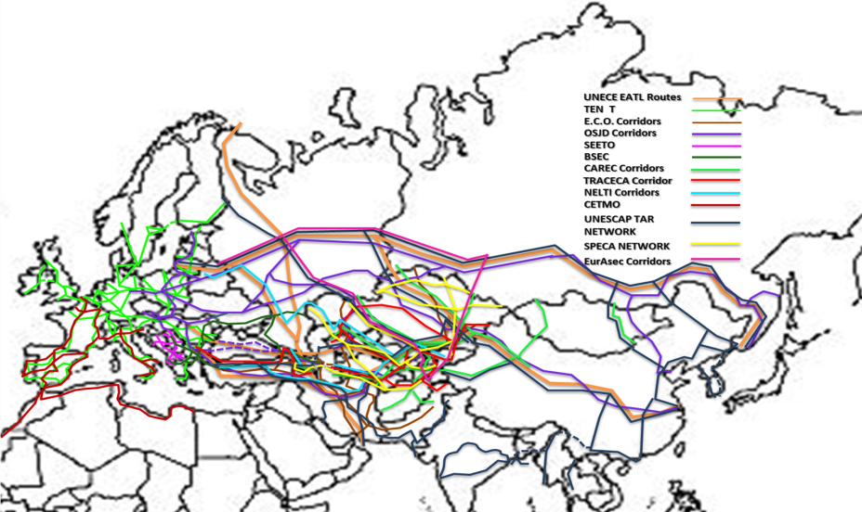

*Source:* UNECE, Transport Division

(b) Agreed that despite the fact that numerous initiatives exist and operate for transport corridors development along Europe and Asia, cooperation among these initiatives is very low or even non-existent;

(c) Noted that China (but not exclusively) is now challenging Europe with the launching of its OBOR (One Belt One Road Policy);

(d) Noted that Asia-Europe trade is the trade route that has one of the highest growth rates for the decades to come;

(e) Observed that it is essential to consider long-term, long distance Asia-Europe transport development plans, in order to set up an efficient, integrated transport system covering all transport modes;

(f) Agreed that it is essential also to consider new technologies in order to make transport operations between the two continents more cost-effective, greener and safer;

(g) Noted that in International rail transport there are a number of obstacles that make railways non-competitive such as: poor infrastructure, non-competitive tariffs, two or even more existing legal regimes, delays in border crossings;

(h) Noted that based on data presented by IRU 57% of road transport time is lost at border crossings and 38% of transport costs is due to unofficial levies!;

(i) Agreed that the development of transport corridors will facilitate the cross border movement of Goods, Services, People, Capital, Information/Knowledge;

(j) Observed and agreed that corridors may impact the distribution of economic activity and development across regions and promote poverty reduction and inclusive growth.

2. Workshop on Vulnerability and Security of Critical Transport Infrastructure

6. Based on the Inland Transport Committee (ITC) mandate where the Division should continue work aimed at enhancing inland transport security, in particular, by organizing events to exchange information and share best practices, the Working Party organized a workshop on vulnerability and security of critical transport infrastructure. The outcome of the workshop should be a contribution to the Inland Transport Security Forum of ITC.

7. Terrorist attacks and criminal activities can all disrupt the infrastructure on which we depend in our daily lives. This infrastructure — often called "critical infrastructure" — includes installations in the transport fields ranging from intermodal hubs and freight villages to rail and road bridges and tunnels. Representatives from Governments and international organizations (program of workshop is in Informal document No. 2) specialized on transport infrastructure security shared their experience and good practices on how to further secure transport infrastructure.

8. The participants during the workshop:

(a) On rail security, noted that specific guides should be prepared for instance for the design of stations;

(b) Noted that while designing security specific technical measures such as buildings design in order to resist a quantifiable degree of blast or laminated glazing used to reduce secondary shrapnel should be taken into account:

(c) Agreed that Security measures should be based upon a risk assessment and the right stakeholders need to be engaged to ensure successful delivery of the project;

(d) Noted that the International Maritime Organization (IMO) has developed the International Ship and Port facility Security Code (ISPS) and agreed that similar code should be developed for inland water transport. Suggested that ECE and especially the Working Party on Inland Water Transport (SC.3) should take action on that;

(e) Agreed that development of an efficient transport security system should include several measures such as development of integrated legal framework, determination of threats to transportation security, etc.;

(f) Agreed that depending on security systems used in critical infrastructure, illicit activities may be undetected, leading to large systemic failures and compromising financial stability, safety and security;

(g) Noted that the shortcomings of security systems can be among others the costs of the systems involved for the surveillance of large areas; the complexity and diversity of the employed systems; the efficiency, robustness and resilience; and the accuracy to detect illicit activity patterns.

C. Group of Experts - Projects

1. Group of Experts on Climate Change Impacts and Adaptation for Transport Networks and nodes

9. Three documents were prepared (ECE/TRANS/WP.5/GE.3/2016/1, ECE/TRANS/WP.5/GE.3/2016/2, Informal Document 1 (2016)) for the Group of Experts on Climate Change Impacts and Adaptation for Transport Networks and nodes work plan. These documents are referring to: the questionnaire that it should be distributed to the Governments in order to collect relevant and required data for the second phase of the group; the draft outline of the contents of the final report of the group; and an updated review on climate change projections for the ECE region. The Terms of Reference (ToR) for the second phase of the Group of Experts’ work include the following:

(a) Identify and establish, if possible, inventories of transport networks in the ECE region which are vulnerable to climate change impacts, if possible in a geographic information system (GIS) environment;

(b) Use/develop models, methodologies, tools and good practices to address potential extreme hazards (e.g. high temperatures and floods) to selected inland transport infrastructure in the ECE region under different scenarios of climate change;

(c) Identification and analysis of case studies on the potential economic, social, and environmental consequences of the climate change impacts and provide a cost/benefit analysis of the adaptation options.

2. Group of Experts on Euro-Asian Transport Links

10. Two analytical papers were prepared in cooperation with the Organization for Security and Co-operation in Europe (OSCE) and by the Hellenic Institute of Transport in order to contribute to the work done by the Group of Experts on Europe Asian Transport Links. The first paper was referring to Transport flows and non-physical barriers along the Euro-Asian corridors. The document concluded that the existing freight trains predominantly focus on long distance East-West movements by using the Trans-Siberian Railway to carry manufactured goods from Asia and Europe to production sites in the Russian Federation, China and Uzbekistan, and from production sites in China to their destination markets in Europe. North-South connections are carrying cargo between the European CIS countries and the Baltic ports. Rail freight however plays a little role for freight transportation, in particular of dry bulk or manufactured goods, to and from Central Asian and the Caucasus countries.

11. The second analytical paper was referring to recent developments in transport infrastructure priority projects on EATL routes. The paper concluded that the significant potential of the Trans-Eurasian railway corridors is undisputable; there are however several issues and bottlenecks that need to be addressed in order to make railways a competitive intermodal alternative to air and maritime transport. These are: police, border crossing and interoperability issues and missing links, safety and security, operational and rolling stock shortcomings and environmental issues.

II. Analytical Activities on cross-cutting issues realized in the framework of the Sustainable Transport Division

A. Introduction

12. Analytical activities are essential supporters of policy dialogue, capacity building and technical assistance. Usually they are directly linked to the regulatory work and the implementation of the UN legal instruments in transport under the purview of the Inland Transport Committee. Because of these inter-linkages they are also discussed under those themes. For example, the ForFITS tool, an outstanding analytical product has been delivered in the framework of a UNDA funded capacity building project. The use of the tool can serve policy dialogues and capacity building in addressing climate change mitigation in transport, and at the same time it can lead to studies at local, national, sub-regional, regional and global levels.

B. Publications - Studies

1. Transport for Sustainable Development: the case of Inland Transport

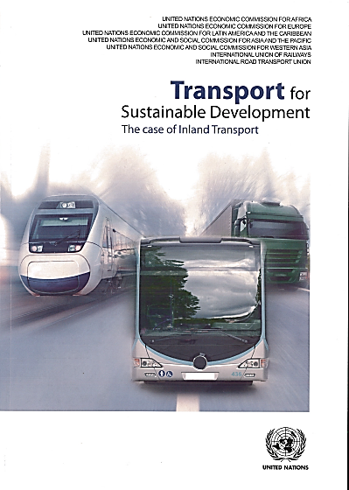13. The study “Transport for Sustainable Development: The case of Inland Transport” — with UNECE as the lead author — is the result of cooperation between the five Regional Commissions of the United Nations and key global stakeholders, in particular, the International Road Transport Union and the International Union of Railways.

14. The study examines issues, progress and challenges in global efforts to achieve a transition to sustainable mobility of freight and people using inland modes of transport, i.e. road, railways, inland waterways and intermodal transport. While transport is a precondition for social and economic interactions, unfortunately, it has also negative impacts, such as road crashes, air and noise pollution, and greenhouse gas emissions.

15. With a wealth of good and best practices, the study showcases results in mitigating the negative impacts, and also identifies the main challenges and opportunities to accelerate the transition to sustainability. It promotes an in-depth and real-world understanding of the five defining dimensions of sustainable transport – accessibility, affordability, safety, security and environmental performance. The study brings forth theoretical insights and best practices from all regions of the world and thus maps similarities and differences among countries of different income groups and geographical regions in their efforts towards sustainable transport.

16. The UN Regional Commissions Transport Departments intend to continue this cooperation and develop a follow-up study: “Transport for Sustainable Development – the case of maritime transport and hinterland connections”. The lead author will be United Nations Economic Commission for Latin America and the Caribbean (ECLAC).

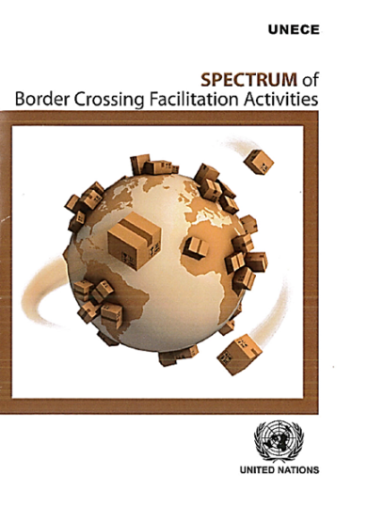 2. Spectrum of Border Crossing Facilitation Activities

17. The UNECE brochure “Spectrum of Border Crossing Facilitation Activities” provides an introduction to the existing UN Conventions administered by the UNECE Inland Transport Committee, covering issues related to border crossing facilitation, as well as other activities and tools that were developed with the aim to facilitate the international movement of goods and persons, improving market-access and opportunities at the global, regional and sub-regional scale. Border inefficiencies are estimated to cost twice the amount spent with tariffs, including duties, import taxes and other fees. It is considered that the removal of those inefficiencies have the potential to increase global trade by as much as US$ 1 trillion, creating as many as 21 million jobs worldwide.

18. While the challenges faced by countries in relation to border crossing can vary, they can be divided in three main categories: harmonization of laws and regulations, standardization of means and simplification of procedures. This brochure demonstrates how the UNECE Inland Transport Committee and its working parties - with special attention to the activities of the Working Party on customs questions affecting transport - have been actively providing regulatory (i.e. through 58 legal instruments), analytical research, technical assistance and capacity building activities, together with its role in facilitating policy dialogue on border crossing facilitation. With the intention of becoming a key promotional material for dissemination in missions and meetings, a tool for raising awareness about the related activities and legal instruments, and the different ways that countries could benefit from participating in the work and meetings of the UNECE Sustainable Transport Division, the Working Party on Customs questions affecting Transport mandated the secretariat to make the Spectrum available in hard print in English and, possibly, also in French and Russian (see ECE/TRANS/WP.30/282, para.3(e)).

3. Together with UNECE on the road to safety

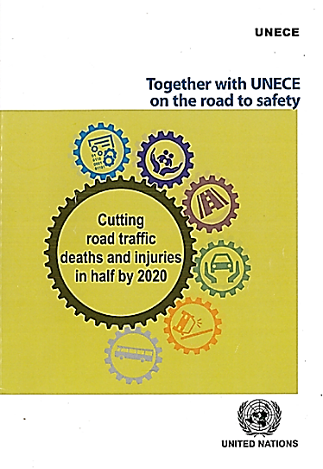19. The world has been paying serious attention to road safety since 2003, following a United Nations General Assembly Resolution on the rapid global increase in road traffic deaths, injuries and disabilities. With roughly 1.25 million people dying each year around the world as a result of traffic accidents, the United Nations Global Plan for the Decade of Action for Road Safety, introduced in 2011, has helped to garner further attention and spur action, particularly when the personal tragedy of every life lost reflects the enormous overall cost of road traffic accidents to society.

20. Doing its part to facilitate international cooperation in the area of road safety, the United Nations Economic Commission for Europe (UNECE) Inland Transport Committee (ITC) has been the “invisible hand” that has been busy applying many courses of action and tools to make roads safer. Its starting point is the international conventions and agreements it administers, which are at the core of all concerted efforts. In addition, UNECE has identified 11 goals derived from the five pillars of the Global Plan to form its strategic approach to road safety during the Decade. This report covers each goal in detail – from protecting vulnerable road users to raising awareness for road safety, from making vehicles safer to mitigating the impact of road crashes. It provides a comprehensive overview, including the status and key results of its goals, as well as descriptions of specific UNECE ITC initiatives and information on the challenges the overall road safety community faces.

21. One of the main conclusions of this report is that political will and the introduction and use of national strategies with relevant laws and regulations are likely to be the difference makers in helping to reach the main goal: halving the number of road traffic deaths and injuries by 2020. The path to road safety is a personal, societal and organizational obligation. “Together with UNECE on the road to safety” clearly underlines this joint responsibility.