UN/SCETDG/50/INF.40
Committee of Experts on the Transport of Dangerous Goods
and on the Globally Harmonized System of Classification
and Labelling of Chemicals 23 November 2016
Sub-Committee of Experts on the Transport of Dangerous Goods
Fiftieth session
Geneva, 28 November–6 December 2016
Item 2 (d) of the provisional agenda
Recommendations made by the Sub-Committee
on its forty-seventh, forty-eighth and forty-ninth sessions
and pending issues: electric storage systems
Lithium Battery T.2 Thermal test
Transmitted by PRBA – The Rechargeable Battery Association and RECHARGE
Introduction
1. Working document ST/SG/AC.10/C.3/2016/81 contains a proposal to reduce the maximum temperature requirement in the lithium battery T.2 Thermal test in Section 38.3 of the Manual of Tests and Criteria from 72 ± 2 °C to 65 ± 2 °C. The proposed change was intended to account for cell and battery designs that have non-resettable safety devices typically found in lithium ion cells. This Informal document is being provided to further support ST/SG/AC.10/C.3/2016/81.
2. According to the UN Manual of Tests and Criteria, the T.2 Thermal test “assesses cell and battery seal integrity and internal electrical connections. The test is conducted using rapid and extreme temperature changes.”
3. Thermal cycling induces mechanical stress in components of the cell or battery. Stress is achieved through a combination of a large difference in temperature, long dwell times at temperature limits, rapid change in temperature, and numerous cycles. The temperature range is arbitrary, but should be dictated (at a minimum) by temperatures encountered in transportation, plus some reasonable margin. However, if temperatures are arbitrarily too high, nuisance failures from unintended chemical mechanisms may occur. This is the case with some lithium ion cells with pressure sensitive safety devices (current interrupt devices, or CID’s).
Lithium ion Stability Between 60° and 85° C
4. Lithium ion battery manufacturers generally recommend that cells should not be exposed to temperatures above 60° C for extended periods, because side reactions within the cell can lead to degradation of performance (self-discharge, permanent capacity loss, increased impedance). Lithium ion cells in the 60° to
85° C range will undergo slow, degradation reactions. Note that this temperature range is still well below the threshold where excessive self-heating reactions can occur with the potential for “thermal runaway.” (Extensive testing by many organizations and government agencies has consistently shown that fully charged lithium in cells do not reach thermal runaway until temperatures begin to exceed 150° C.)
5. Lithium ion cell degradation reactions at moderate temperatures are complex, but generally include some small amount of gas generation in the cell, raising internal cell pressure. Furthermore, cells with built-in CID’s often contain chemical additives that are specifically intended to thermally decompose at elevated temperatures to build pressure in the cell and trigger the safety device. All of these reactions are accelerated by temperature. Higher temperatures and longer cumulative test times will increase the cumulative amount of degradation by-products, including accumulation of gases that may trigger pressure sensitive safety devices within the cell.
Comparison of Thermal Cycling Requirements
6. Other battery standards include thermal cycling test requirements, but with different test parameters (see Table 1). Note that the current T.2 Thermal test has a higher temperature limit and/or longer cumulative time at the temperature limit. The combination of higher temperature (accelerated reaction rate) and longer time can explain the nuisance failures encountered with the T.2 Thermal test, but not typically seen with other standards.
Table 1
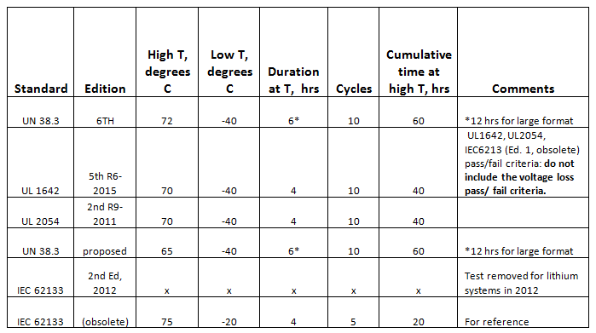

Significance of Temperature and Time Differences
7. The build-up of gaseous degradation by-products is given by:
(reaction rate) x (time)
Time in this case is the cumulative time at elevated temperature during the cycling tests. The reaction rate is a function of temperature. Chemical and electrochemical reaction kinetics generally follow some form of the Arrhenius equation. For first order reactions:
Rate = A exp [-Ea /RT]
Where A is a constant, Ea is the activation energy (J/mol), R is the gas constant
(8.314 J/mol/K) and T is temperature (in Kelvin).
Since formation of by-products may involve multiple reactions, and since these reactions may vary for different cell types, a range of reasonable activation energies is estimated below.
For typical chemical reactions, a change in temperature of 10° C will double the reaction rate. Using this general rule and 65° to 75° C as the temperature range, the “typical” Ea is 67.8 kJ/mol. It is also useful to consider a “high” Ea
(10° C change = 4x rate) of 136 kJ/mol and a “low” Ea of 39.7 kJ/mol
(10° C change = 1.5x rate).
Using these activation energies, relative rates are calculated for reactions occurring during the high temperature portion of different thermal cycling tests. Furthermore, these relative rates can be multiplied by the cumulative test time to provide estimates of “relative amount of cumulative reaction by-products.”
Table II compares the relative rates and relative reaction by-products. Note that regardless of the assumed value of Ea, the cumulative reaction by-products are substantially lower for other testing standards compared to the existing T.2 Thermal test.
Table II
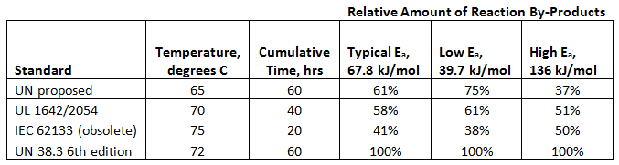

8. Degradation reactions within lithium ion cells are complex processes involving multiple reactions. The above analysis is not intended to be a quantitative proof of the relative change in by-products for the different testing scenarios. However, this analysis does show that it is reasonable to expect significantly more reaction by-products to be generated in the current UN T.2 test, relative to other standards, due to the unique combination of high temperature, high cycle number, and long dwell time. Lowering the thermal cycle temperature limit from 72° to
65° C will preserve the intent of the test, but should significantly reduce generation of gaseous by-products in cells and unintended activation of CID’s.
Summary
9. Lithium ion cells undergo slow decomposition reactions at temperatures between 60° and 85° C. This temperature range is still well-below temperatures where potentially hazardous self-heating occurs.
The combination of higher temperature and longer cumulative time at high temperature in the UN thermal cycling test may build up more reaction by-products, leading to nuisance failures of pressure sensitive safety devices.
The thermal cycling test is primarily intended to check mechanical integrity. The test should include a high cycle number and long dwell time at peak temperatures. Lowering the peak high temperature from 72° to 65° C will still provide a large thermal differential in the test (105° vs. 112° C), but will avoid unintentional over-stressing of cell chemistry.

