|  |  |  |
| --- | --- | --- |
|  |  | **UN/SCETDG/50/INF.39**  **UN/SCEGHS/32/INF.22** |

|  |  |
| --- | --- |
| **Committee of Experts on the Transport of Dangerous Goods  and on the Globally Harmonized System of Classification and Labelling of Chemicals 23 November 2016** | |
| **Sub-Committee of Experts on the  Transport of Dangerous Goods** | **Sub-Committee of Experts on the Globally Harmonized System of Classification and Labelling of Chemicals** |
| **Fiftieth session** | **Thirty-second session** |
| Geneva, 28 November-6 December 2016  Item 8 of the provisional agenda  **Programme of work for the biennium 2017-2018** | Geneva, 7-9 December 2016  Item 7 of the provisional agenda  **Programme of work for the biennium 2017-2018** |

Stability tests for industrial nitrocellulose

Submitted by the expert from Germany

Introduction

1. The expert from Germany was made aware of a comparison study on stability tests used for industrial nitrocellulose (hereafter NC) worldwide. The study was carried out by the Worldwide Nitrocellulose Producers Association (WONIPA), which represents manufacturers of industrial nitrocellulose and accounts for 80% of the worldwide production (approximately 200,000 tons per year).

2. The stabilization of industrial NC is a decisive and critical step in the production process of NC and must be done and controlled properly for each production lot in order to achieve stable industrial NC products that can be transported and used safely without the danger of self-ignition over their entire shelf life. The wetting of NC products with alcohol, water or plasticizer only reduces the burning speed of the NC; it has no effect on the stability of the NC products. Additional measures are necessary to ensure the stability even if the NC product will get completely dry.

Background information

Self-ignition temperature

3. For European land transport, provisions on tests relating to nitrated cellulose mixtures have been incorporated in section 2.3.2 ADR/RID. The ignition temperature test in ADR/RID is a test to determine at what temperature a substance will self-ignite when heated without an external ignition source (a description of the test method is provided in Annex 1). This test is the most important stability test for industrial NC, as it defines the conditions under which the NC can be transported and used without the risk of self-ignition.

4. The self-ignition temperature test in accordance with ADR/RID has been mandatory for NC for more than 30 years. This test requires that the self-ignition temperature be higher than 180 °C for dry NC (higher than 170 °C for NC with plasticizer). The test is carried out using dry NC to make sure that even dry NC will not self-ignite. If the self-ignition temperature of dry NC is above 180 °C, this ensures that even dry NC will not self-ignite at temperatures of up to 65 °C that may occur in a container. In addition, a 30-minute qualitative test of the chemical stability at 132 °C is also mandatory for NC products to be permitted for transport in Europe in accordance with ADR/RID.

Long-term chemical stability

5. For several decades, the European producers within the European Nitrocellulose Producers Association (ENA) have been using the quantitative Bergmann Junk test, which determines the quantity of NO gas formed within 2 hours at 132 °C. The acceptance limit for this test is a maximum of 2.5 ml NO gas per g of NC (a description of the test method is provided in Annex 2). With these conditions that go even beyond those of the test in ADR/RID, highly reliable information about the long-term chemical stability is obtained.

6. The European NC producers have several decades of practical experience of several 100.000 tonnes of properly stabilized NC; this experience shows that NC damped with isopropanol, ethanol or water, or plasticized with plasticizer is sufficiently stable after transport in a container to countries having a hot climate and additional storage of up to 2 years after production at a maximum temperature of 40 °C if the stabilization of the NC during the production process has been done properly and if the requirements of the self-ignition temperature test and the quantitative Bergmann Junk test are fulfilled. Dry NC will also have a self-ignition temperature above 180 °C after 2 years of storage.

7. Therefore, the quantitative Bergmann Junk test also gives reliable information on long-term stability if the NC-products are transported in containers, where the temperature may increase to 65 °C for short periods. The quantitative Bergmann Junk test ensures that the self-ignition temperature is above 180 °C for dry NC (170 °C for plasticized NC, respectively) over the entire duration of transport, storage and use, thus allowing for safe handling of properly stabilized NC.

8. In some regions of the world, qualitative short-term tests at relatively low temperatures are used (e.g. 10 minutes at 80 °C) for testing the long-term chemical stability of NC products. Experience of WONIPA indicates that these test conditions do not give reliable information regarding the long-term chemical stability of nitrocellulose at temperatures of up to 65 °C in a container. There is also a publication[1] available which shows that short-term tests at lower temperatures (e.g. 10 minutes at 80 °C) do not give reliable information regarding the long-term chemical stability of nitrocellulose.

Proposal

9. The expert of Germany is of the opinion that the stability of industrial NC is crucial for it being transported safely and that the available test methods should be evaluated by the Sub-Committee with a view to incorporating provisions into the UN Model Regulations to achieve a consistently high reliability level for the stability tests. Competent authorities should enquire with the producers and importers of NC of their countries about the stability tests currently applied and provide this information to the Subcommittee in order to get an overview of these tests and to facilitate discussion.

10. It is proposed to add the topic “Stability tests for industrial nitrocellulose” to the work program for the 2017/2018 biennium (Focal point: TDG Sub-Committee).

Annex 1

Ignition temperature test of ADR

The ignition temperature is determined by heating 0.2 g of substance enclosed in a glass test tube in a Wood´s alloy metal bath. The test tube is placed in the bath when the latter has reached 100 °C. The temperature of the bath is than progressively increased by 5 ° C per minute.

The test shall be repeated three times, the temperature at which the ignition occurs, being noted each time. The lowest temperature recorded in the three tests is the ignition temperature.

[**https://www.unece.org/fileadmin/DAM/trans/danger/publi/adr/adr2015/ADR2015e_WEB.pdf**](https://www.unece.org/fileadmin/DAM/trans/danger/publi/adr/adr2015/ADR2015e_WEB.pdf)

Annex 2

BERGMAN-JUNK STABILITY TEST METHOD

***Issued by the WONIPA Technical Committee***

1 – Application

The Bergman-Junk test is a quantitative stability test applicable to all types of nitrocellulose (NC).

2 – Principals of test

The quantity of nitrous vapours given off by 1 (one) or 2 (two) gram(s) of nitrocellulose heated for two hours at 132 °C ± 1 °C *(Plasticised NC: 3 (three) grams are heated for 1 hour)* is determined by titration with alkali.

3 – Apparatus

3.1 Analytical Balance, precision 10mg or better.

3.2 Bergman-Junk tube made of clear glass, approximately 17.5mm inner diameter, 19.5 mm, outer diameter, and 270-350 mm long fitted with a condensing chamber. Several different types of suitable condensing chambers are commercially available. (for examples see Annexes 3 and 4).

3.3 Stability bath: Oil or suitable fluid bath or metal block capable of maintaining the temperature of the stability tubes at 132 °C ± 1 °C. The temperature of the bath should be monitored with a calibrated thermometer or thermocouple (precision 0.1 oC) which is located in one of the test wells.

3.4 Polycarbonate protective screen or safety cabinet to prevent horizontal, and limit vertical projection of material should the tubes break.

3.5 10 cm3 semi-automatic pipette or equivalent.

3.6 250 cm3 conical flash with wide neck.

3.7 50 cm3 test tube.

3.8 Titration burette 10- 25 ml

4 – Reagents

4.1 Sodium hydroxide (NaOH) solution N/100.

S4.2 Suitable pH indicator e.g. methyl orange, methyl red, methyl red/methylene blue or R8 B3 coloured indicating fluid (Tacchiro). Solution composed of 1 % alcohol mixed with 8 g of methyl red and 3 g of purple methyl.

4.3 Fully deionized or distilled water with a conductivity < 1 µS.

5 – Operational procedure

5.1 Weigh 1 (one) or 2 (two) gram(s) of dry NC to an accuracy of 0,001 g. *(Weigh 3 (three) grams of plasticised NC to an accuracy of 0,001 g)*. The moisture content of the sample must be below 1 % after the drying process and at the time, when it is introduced in the tube. With the help of a funnel introduce this into the tube which must be dry and clean. Wipe the ground section thoroughly and adjust the condensing chamber making sure that the above is well greased with silicone grease; it may also not be greased.

5.2 Measure out 15-50ml of distilled water, depending on the condenser type, in a test tube and pour into the bulbs of the condenser. Ensure that no water enters the stability tube.

5.3 Make sure that the stability bath has reached a temperature of 132 °C ± 1 °C and then insert each tube into one of the apertures in the bath. The depth of immersion of the tube will vary depending on the type of stability bath used but must be between 110 and 220 mm. Make a note of the time at which the experiment begins.

If using a protective screen, the operator must take care to turn the open side of the protective screen towards the wall or an unoccupied part of the room both when loading and removing the test tubes from the bath. If there is no protective screen the face should be protected with a visor.

5.4 Maintain the tubes at a temperature of 132 °C ± 1 °C for two hours unless pronounced fuming is observed. If fuming occurs, the test shall be stopped immediately and the duration of the heating period noted.

5.5 After two hours at 132 °C *(1 hour for plasticised NC)*remove the tube from the bath, place it in its stand and allow to cool behind a safety screen. During this time some water may be drawn into the lower tube. After thirty minutes cooling transfer the contents of the condensing chamber into the lower tube and rinse the condensing chamber with distilled water.

5.6 Transfer the contents of the lower tube into the conical flask and rinse with distilled water. The total amount of liquid should not be more than 175 ml.

5.7 Titrate with N/100 sodium hydroxide solution.

6 – Calculations

**2 NaOH + 2 NO + ½ O2 🡪 2 NaNO2 + H20**

cNaOH x CNaOH x VNO,m

mNC

VNO = = CNaOH x 0.22

VNO = volume of the evolved nitrogen oxide in cm3/g

cNaOH = concentration of caustic soda = 0.01 mol/l

CNaOH = consumption of caustic soda in ml.

VNO,m  = molar volume of NO = 22.38 l/mol

mNC = mass nitrocellulose in g

The total absence of acidity in the water is verified by a mock test; otherwise the value determined by the mock test is subtracted.

Also aliquot portions of the water containing the NOx may be used, resulting in different   
factors in the formula.

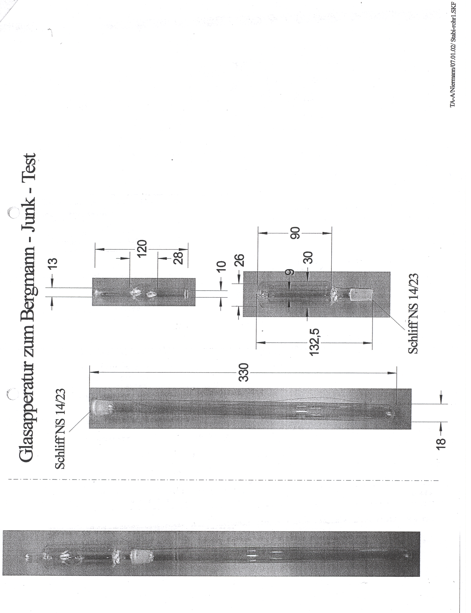

**Annex 3**

***ANNEX 4***



_____________

1. Ruth Sopranetti, Markus Fahrni and Beat Vogelsanger, Wimmis Switzerland /Aschau Germany: Nitrocellulose Characterization -Survey of standardized test methods – Stability testing of NC , AWE Nitrocellulose Symposium 2007.