UN/SCETDG/50/INF.36
UN/SCEGHS/32/INF.21

Committee of Experts on the Transport of Dangerous Goods
and on the Globally Harmonized System of Classification
and Labelling of Chemicals 23 November 2016
Sub-Committee of Experts on the  Transport of Dangerous Goods | Sub-Committee of Experts on the Globally Harmonized System of Classification and Labelling of Chemicals
Fiftieth session | Thirty-second session
Geneva, 28 – 6 December 2016  Item 7 (g) of the provisional agenda  Issues relating to the Globally Harmonized System of Classification and Labelling of Chemicals: use of the Manual of Tests and Criteria in the context of the GHS | Geneva, 7– 9 (morning) December 2016  Item 2 (b) of the provisional agenda  Classification criteria and related hazard communication: work of the TDG Sub-Committee on matters of interest to the GHS Sub-Committee
Proposed corrections to the 6th revised edition of the Manual of Tests and Criteria
Note by the Secretariat
The secretariat invites the sub-committee to consider the corrections below for inclusion in a forthcoming corrigendum to the 6th revised edition of the Manual of Tests and Criteria.
1. Section 1, Table 1.2, for test series 3, under “test code”
For “3 (c)” read “3 (c)(i)”
2. Table of contents of Part I, “Test 3 (c) (ii)”
For “13.6.1” read “13.6.2”
3. Section 10, figure 10.3
Replace the line leading from box 24 to box 19 with an arrow, i.e,
For |  | read
4. Section 10, figure 10.8, item 6 (box 32)
For “Is there nevertheless a small hazard in the event of ignition or initiation?” read “Would the hazard hinder fire-fighting in the immediate vicinity?”
5. Sub-section 13.4, table under paragraph 13.4.6.5.2, heading of column 2
For “in assembly 2” read “in assembly 3”
6. Sub-section 13.5, paragraph 13.5.1.3.4, paragraph number and heading
For “13.5.1.3.4 Test criteria and method of assessing results” read “13.5.1.4 Test criteria and method of assessing results”
7. Sub-section 13.6, paragraph 13.6.1.3.2, third sentence
For “procedure given in should” read “procedure given in 13.6.1.3.3 should”
(The correction does not apply to the French and Spanish versions)
8. Section 16.7, paragraph 16.7.1.4 (b)
For “80 ± 3 g/m²” read “80 ± 10 g/m²”
(For the English version, correction already included in ST/SG/AC.10/11/Rev.6/Corr.1)
9. Section 17, table 17.1, third column
In the section number for 7 (k), for “17.13.2” read “17.13.1”
10. Sub-section 18.6, paragraph 18.6.1.1
Replace “of a candidate ammonium nitrate emulsion, suspension or gel, intermediate for blasting explosives” with “of a candidate for “ammonium nitrate emulsion, suspension or gel, intermediate for blasting explosives”
11. Sub-section 18.6, paragraph 18.6.1.2.3, last but one sentence
For “any draughts does” read “any draught does”
12. Section 20, paragraph 20.2.6
For “see section 32.5.2” read “see section 33.3”
13. Section 20, figure 20.1 (b)
For “12.1 Significative” read “12.1 Not low”
14. Section 25, paragraph 25.4.1.3.5
At the end of the first sentence, delete “mm”
15. Section 31, paragraph 31.1.3, definition of “aerosol”
For “made of metal glass” read “made of metal, glass”
16. Section 33, paragraph 33.2.1.4.4.1
For “33.2.1.3.4.2” read “33.2.1.4.3.2”.
17. Section 35, paragraph 35.4.3.2 (b)
In the second sentence, for “35.3.3.2 (a)” read “34.3.3.2 (a)”
18. Section 38, paragraph 38.3.2.3, definition of mass loss
For “Table 38.3.2.2 below” read “Table 38.3.1 below”
19. Section 38, paragraph 38.3.3 (c)
In the French text, delete the last paragraph («Dans le cas des piles prismatiques, …»)
(The correction only applies to the French version)
20. Section 38.3, paragraph 38.3.4.4.2, Figure 38.3.4.2
Replace the existing figure with the following (the legend of the axis remains unchanged)
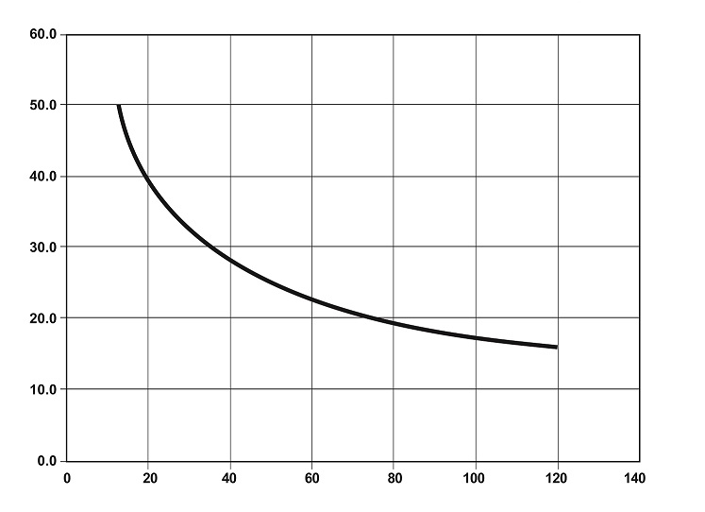
(For the English version, correction already included in ST/SG/AC.10/11/Rev.6/Corr.1)
21. Section 51, paragraph 51.4.4.2 (g)
In the formula, for “A_{10r}” read “A_{10t}”
22. Section 51, paragraph 51.4.6
In the last formula, for “A_{t}” read “A_{c}”
23. Appendix 8, table
In the third cell, under the heading “Case” for “calibration tests ¤” read “calibration tests*”

