UN/SCETDG/50/INF.13
Committee of Experts on the Transport of Dangerous Goods
and on the Globally Harmonized System of Classification
and Labelling of Chemicals
Sub-Committee of Experts on the Transport of Dangerous Goods 28 October 2016
Fiftieth session
Geneva, 28 November-6 December 2016
Item 2 (d) of the provisional agenda
Recommendations made by the Sub-Committee
on its forty-seventh, forty-eighth and
forty-ninth sessions and pending issues:
electric storage systems
Sodium-Ion Batteries
Submitted by the expert from United Kingdom
Introduction
1. At the forty-eighth session of the Sub-Committee, the United Kingdom submitted informal document INF.6, which invited comments on how the Model Regulations should address the transport requirements for advanced low cost battery materials based on sodium technology.
2. In that paper, it was noted that the current classification system does not address the particular circumstances of sodium-ion batteries. Highlighting that the existing entry for batteries containing sodium (UN3292) and Special Provision 239 are relevant to cell chemistries such as sodium sulphur and sodium metal chloride which contain metallic sodium. It does not recognise the lesser risk posed by sodium-ion cell chemistry, which contains sodium salts, not sodium metal.
3. Opinion was divided during discussions as to whether sodium-ion batteries needed to be covered under the dangerous goods regulations. If they did then it was broadly agreed that the current UN entry, UN3292, was not suitable for the transport conditions of these types of batteries. Those that thought sodium-ion should not be covered under regulations noted that such batteries posed no risk when they were fully discharged (unlike lithium batteries). The Sub-Committee concluded that more work was required before a decision could be made on this type of battery.
4. The purpose of this paper is to:
(a) Present some further information about these batteries and to explore the idea of whether fully discharged sodium-ion batteries should be treated as dangerous goods by the Regulations;
(b) Ask for the topic to be placed on the work programme for the next biennium; and,
(c) Seek the opportunity for experts on sodium-ion batteries to give a presentation during the next biennium and to answer questions.
Background
Definition and working principles of sodium-ion batteries
5. A sodium-ion battery (NIB) is an electrochemical cell that comprises of a positive and negative electrode. Sodium-ion transfer occurs between the electrodes via an ionically conducting electrolyte. Figure 1 of the annex shows a schematic of the NIB, indicating transport of the sodium-ions from positive to negative electrode via the electrolyte (this is the charging process).
6. A NIB cell is comprised of sheets of positive and negative electrode with a separator between them. The electrodes are comprised of the active material deposited on an aluminium current collector and the separator is an electrically insulating but ionically conducting layer. A cell can be comprised of multiple layers depending on the desired capacity and footprint. Designs include prismatic, wound and cylindrical. Figure 2 shows a schematic of the layers in a NIB prismatic cell and examples of the cell designs are shown in figure 3.
7. The voltage range is typically 1.0 to 4.3 volts, but they can operate down to voltages as low as zero volts without any impairment. This is as a result of aluminium current collectors on both positive and negative electrodes. Figure 4(a) shows typical charge/discharge curves for a NIB cell cycled between 4.1 and zero volts, with a 96 hour hold at zero volts between cycles. Figure 4(b) shows that there is no adverse effect on cell chemistry for the same NIB cell under these conditions. Thus they can be transported with no stored electrochemical energy without adversely effecting performance (i.e., fully discharged).
8. NIBs are rechargeable devices and discharge occurs by the same process, in reverse. The positive electrode is comprised of a sodium compound. The negative electrode is carbon-based. The electrolyte is a sodium salt in organic solution. Sodium metal is not used in the construction of a sodium-ion cell.
Applications of sodium-ion batteries
9. NIB cells can be arranged in series and/or parallel to form battery modules. Figure 7 shows a NIB module. These modules can then be connected to form a pack and the number and arrangement of the cells and modules can be tailored to the specific energy and power requirements of an application.
10. Commercial markets where NIBs have application include:
(a) Energy storage for renewable energy systems such as photo-voltaic, wind and wave power;
(b) Automotive applications such as electric vehicles; and,
(c) As an alternative to existing battery technologies providing equivalent performance at a reduced cost.
Sodium-ion battery safety
11. Sodium-ion batteries are intrinsically safe for transport in terms of electrically stored energy because:
(a) The ability of NIBs to be discharged to zero volts, without affecting performance, means that they can be stored and transported in a completely discharged state, with terminals shorted if required. In this state they do not pose a risk from stored electro-chemical energy;
(b) At zero volts a short circuit will not lead to any changes in cell temperature or pressure, which could cause overheating. NIBs are chemically stable at a cell voltage of zero volts (as a result of utilising aluminium for the current collector). Figure 5 shows that there is no change in a cell external temperature at zero volts with a short across the terminals. Thus an external short circuit will not lead to thermal runaway;
(c) The cathode in NIBs can have a specific energy density of 400-600 Wh/kg, which is similar to that of lithium ion batteries (LIBs) (figure 6). However, NIBs are chemically stable at 0% State of Charge (SOC), the electrochemical trigger for a hazardous event is absent under zero volt conditions;
(d) In the fully uncharged state there is no electrochemical reaction occurring in a NIB. Figure 5 shows the external cell temperature of a NIB shorted when already at zero volt (i.e. shorted from the proposed transport SOC).This shows that the cell temperature remains at ambient room temperature; and
(e) NIBs can be transported in a fully discharged state (zero volts) with a physical short between the positive and negative terminals, which offers visual certainty that the cell is fully discharged. An example of a physically shorted cell is shown in figure 8.
Other possible risks in transport and safety assessment of sodium-ion batteries
12. The following potential risks are associated with sodium-ion batteries:
- Flammable liquids in the electrolyte;
The electrolyte solution may contain flammable liquids, such as diethyl carbonate (flash point 25°C), dimethyl carbonate (17°C), ethylene (143°C), ethyl methyl carbonate (24°C) and propylene carbonate (116°C), either separately or as a mixture, as well as containing the sodium-ion salt. Typical mixtures will have a flashpoint in the region of 30 to 45°C, depending on the specific composition.
Typical quantities of electrolyte in a cell are in the range 7 to 10 g/Ah, depending on cell type (pouch, wound etc.). For example, in a single 4 Ah (or 12 Wh) battery (typical of that used in power tools), this equates to 28g to 40g of electrolyte.
NIB’s will be subject to the following tests to confirm safety their safety as consumer products:
- Altitude simulation (low pressure test): no leakage, no disassembly, no rupture and no fire under 95 kPa pressure differential; and
- Drop test: no leakage, no disassembly, no rupture and no fire.
(b) Sodium metal
The positive electrode is comprised of a sodium compound, NIBs do not contain any metallic sodium under normal operating and storage conditions. Instead containing sodium salts.
Tentative proposal
13. To place this topic onto the work plan for discussion during the next biennium.

Annex A
Figures 1 to 9
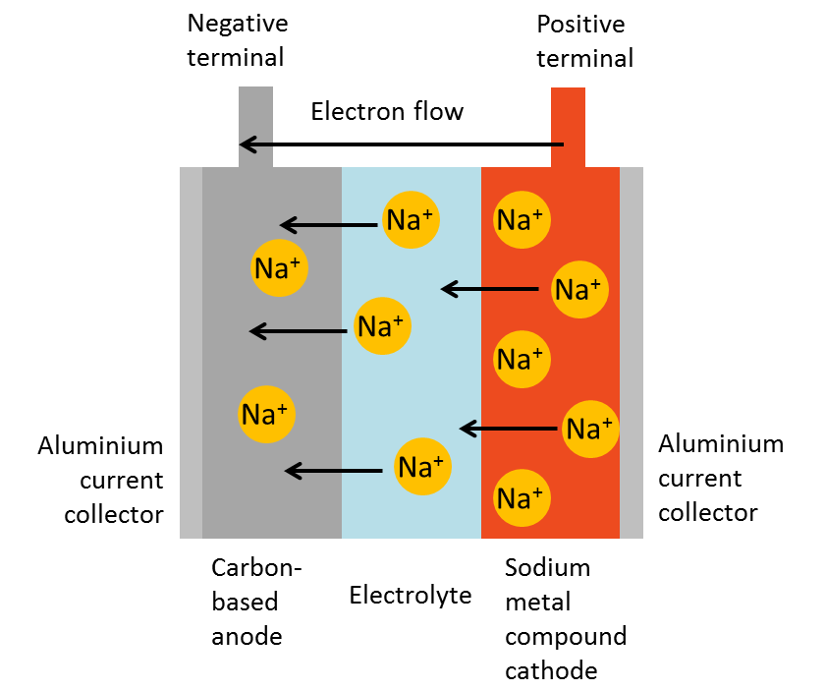
Figure 1: Schematic showing the principles of a sodium-ion battery

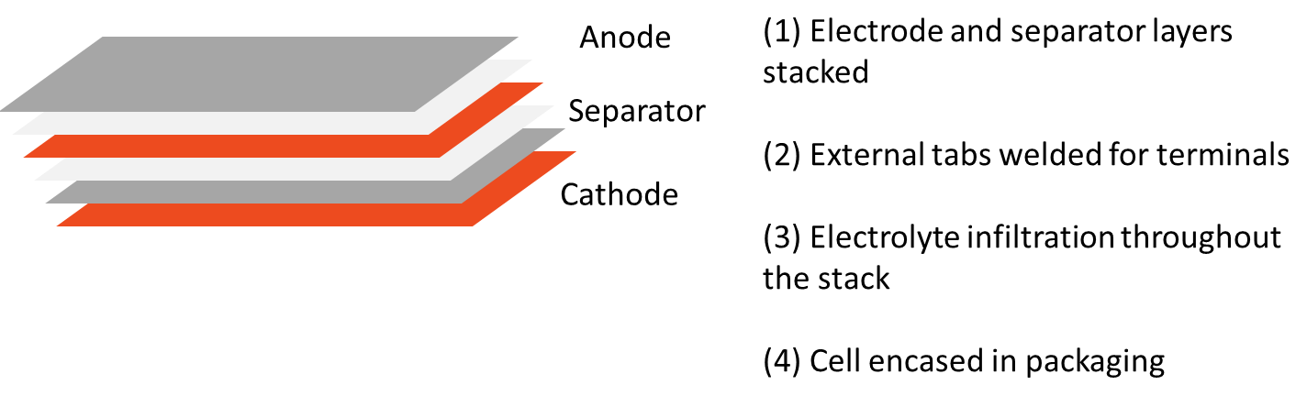
Figure 2: Schematic showing the layer stacking arrangement in a sodium-ion battery prismatic cell and cell construction steps after stacking.
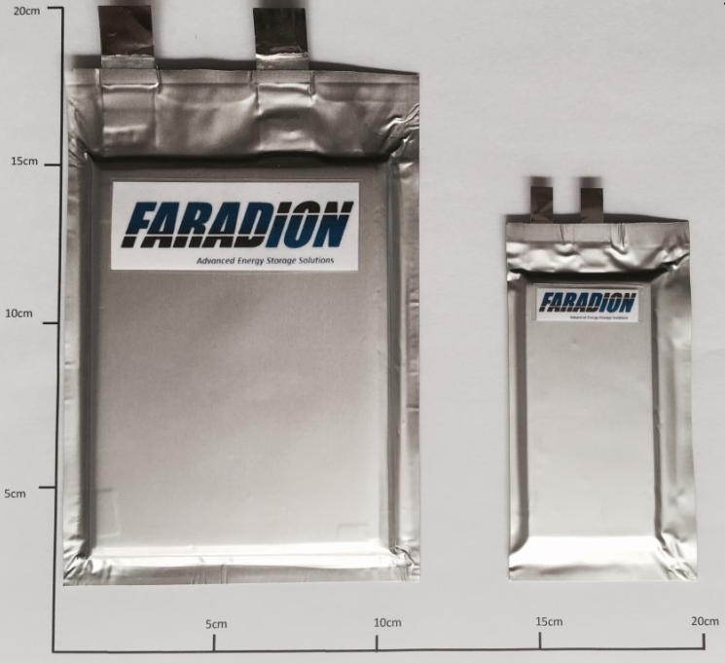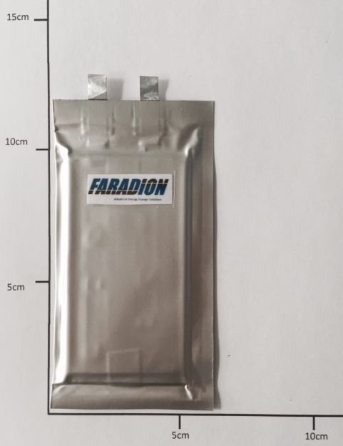
(a) (b)

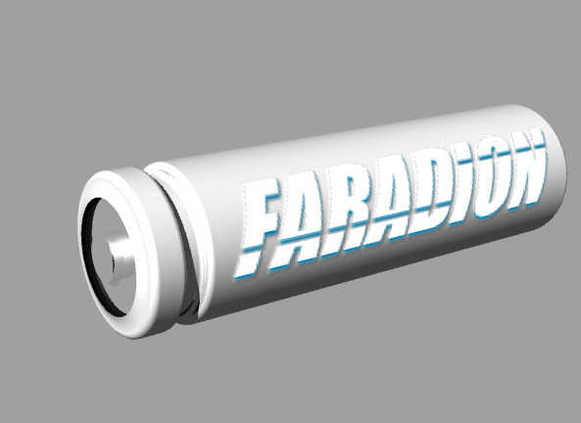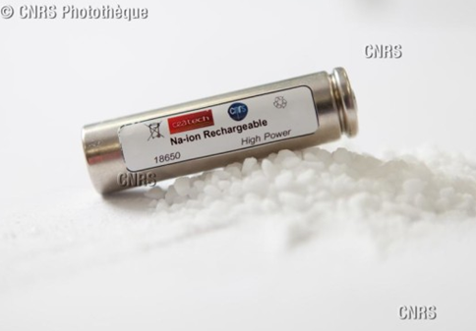
(c) (d)
Figure 3: Examples of NIB cell designs. (a) prismatic (showing different footprint cells, 3 Ah on left, 1 Ah on right. (b) wound (1Ah). (c) a schematic of a cylindrical cell. (d) a 18650-type NIB cell (© Vincent GUILLY/CEA)

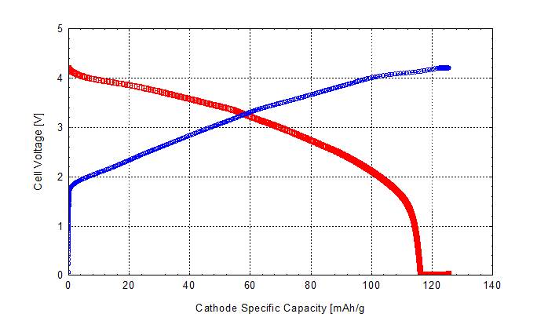
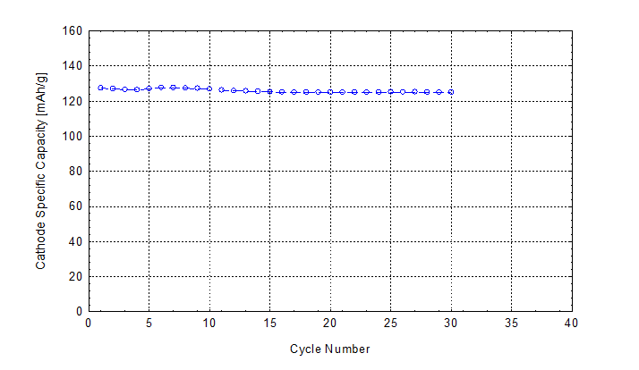
Figure 4: Na-ion cell cycled between 4.1 – 0.0 V and held at o V for 96 h at the end of each discharge to simulate a storage and transportation period. First graph typical charge (blue) and discharge (red) curves for NIB to 0 V. Second graph cell capacity after cycling with 96 hour dwell at 0 V between cycles.

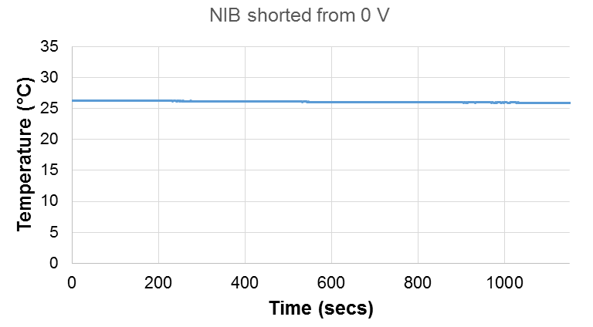
Figure 5: Temperature change of sodium-ion battery on shorting of the cell from a zero volt state (i.e. negligible change in cell voltage).

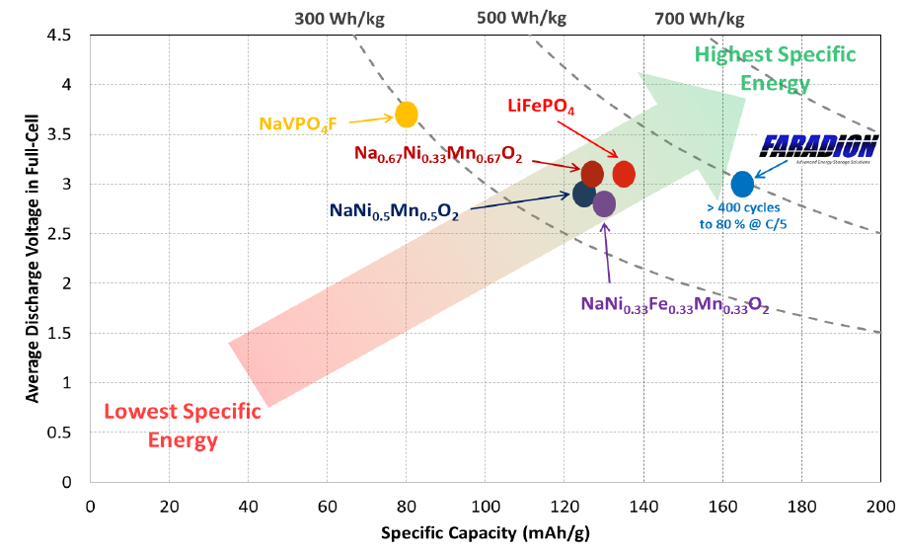
Figure 6: Graph showing the specific cathode capacities as a function of average discharge voltage of sodium-ion and lithium ion cathode materials and the relationship to increasing specific cathode energy (indicated by the arrow). The energy densities are shown on the top x-axis and indicated by dotted lines on the graph.

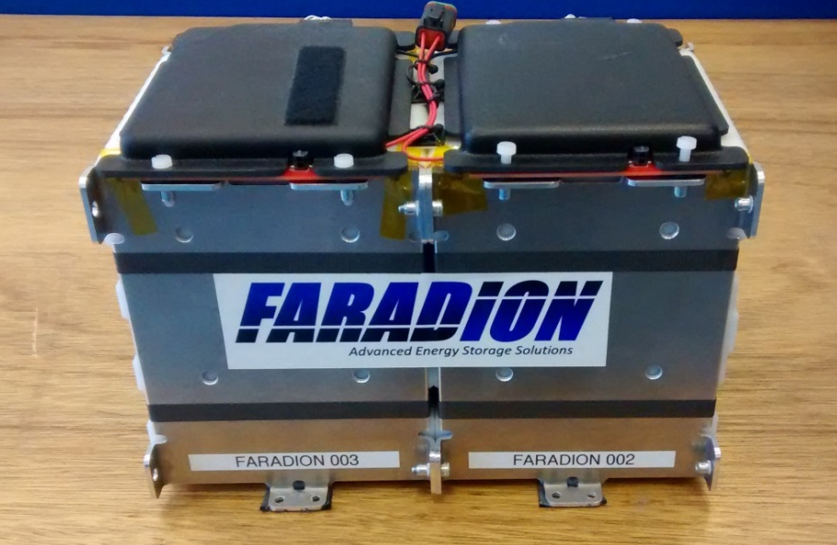
Figure 7: Sodium-ion battery comprised of two modules, each containing twelve 13 Ah cells.
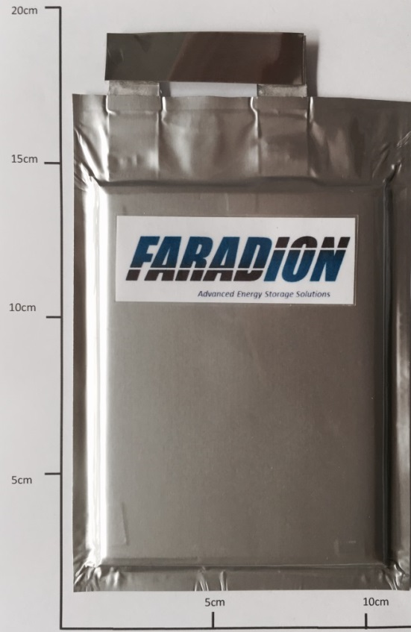
Figure 8: Example of a sodium-ion battery cell which is shorted between the positive and negative terminals and displays visual verification of the short from the metallic strip connecting the terminals
___________________

Annex A contains all the figures mentioned in this paper

