UN/SCETDG/49/INF.68
Committee of Experts on the Transport of Dangerous Goods
and on the Globally Harmonized System of Classification
and Labelling of Chemicals
Sub-Committee of Experts on the Transport of Dangerous Goods 30 June 2016
Forty-ninth session
Geneva, 27 June – 6 July 2016
Item 7 of the provisional agenda
Global harmonization of transport of dangerous goods regulations
with the Model Regulations
Excerpt of Safety Guide TS-G-1.1 (rev.1) for the analysis of paragraph 10 of ST/SG/AC.10/C.3/2016/15 in relation with the proposed mild steel definition
Transmitted by the observer from Romania
Introduction
1. The paragraph 727.13 of the Advisory Material for the IAEA Regulations for the Safe Transport of Radioactive Material, IAEA Safety Standards Series No. TS-G-1.1 (Rev. 1) must be analysed in conjunction with the proposed definition for mild steel of paragraph 35 of document ST/SG/AC.10/C.3/2016/15 as follows:
"Mild steel means a steel with a [guaranteed] minimum tensile strength of 360 N/mm² to 440 N/mm²".
2. Between UN Model Regulations and the Safety Guide TS-G-1.1 (rev.1) texts is a certain difference coming from the use of different mechanical properties of the steels.
3. The Safety Guide TS-G-1.1 (rev.1) is available in English and Spanish also at http://www-ns.iaea.org/standards/documents/topics.asp?sub=250.
4. Excerpt of the paragraph 727.13 of TS-G-1.1 (rev.1):
EN For drop II, the required minimum length of the penetrating bar is 20 cm. A longer bar length should be used when the distance between the outer surface of a package and any inner component important for the safety of the package is greater than 20 cm or when the orientation of the model requires it. This is particularly true for specimens with large impact limiting devices, where the penetration can be considerable. The material specified for the construction of the bar is mild steel. The minimum yield stress of such material should not be less than 150 MPa nor more than 280 MPa. The yield to ultimate stress ratio should not be greater than 0.6. It may be difficult to perform a test where buckling of the bar is possible. In this case, justification of the bar length to obtain maximum damage to the specimen should be carried out.
ES Para la caída II se requiere una longitud mínima de 20 cm de la barra de penetración. Debería utilizarse una barra más larga cuando la distancia entre la superficie exterior del bulto y cualquier componente interior importante para la seguridad del bulto sea mayor de 20 cm o cuando lo requiera la orientación que se dé al modelo. En particular, esto es válido para los especímenes con grandes dispositivos que hagan de limitadores de impacto, en los que la penetración podría ser considerable. El material especificado para la construcción de la barra es el acero dulce. El límite elástico mínimo de ese material no debería ser inferior a 150 MPa ni superior a 280 MPa. La razón entre el límite elástico y la tensión de rotura no debería ser superior a 0,6. Quizás sea difícil llevar a cabo un ensayo en el que sea posible el pandeo de la barra. Para tales casos debería justificarse que la longitud que se elija para la barra será la que produzca el máximo daño al espécimen.
5. Coming from the TS-G-1.1 yield stress limits will determine the range of values for the minimum tensile strength of the mild steels allowed as follows:
- 150 MPa/0.6 = 250 MPa and 280MPa/0.6 = 467 MPa;
6. The proposed range of values of the minimum tensile strength from the proposed mild steel definition is 360 MPa – 440 MPa.
7. As you see the allowed range of values for the tensile strength in TS-G-1.1 is broader.
8. For a better understanding of the texts the figures of the properties of the steel can be clarifying:

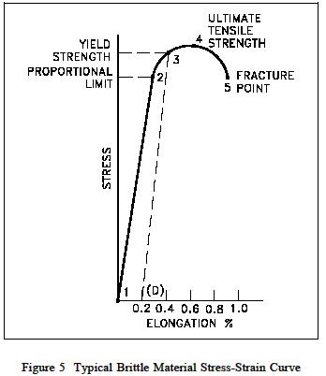
9. Due to the potential rule out of the approvals of some package designs, it should be verified with the IAEA experts if the proposed definition for mild steel produces consequences or simply, accept the broader limits for radioactive material.
10. In this case the definition for mild steel will be:
"Mild steel means a steel with a [guaranteed] minimum tensile strength of 360 N/mm² to 440 N/mm². For radioactive material packages tests the minimum tensile strength is of 250 N/mm² to 467 N/mm²".

