UN/SCETDG/49/INF.60
Committee of Experts on the Transport of Dangerous Goods
and on the Globally Harmonized System of Classification
and Labelling of Chemicals
Sub-Committee of Experts on the Transport of Dangerous Goods 27 June 2016
Forty-ninth session
Geneva, 27 June-6 July 2016
Item 7 of the provisional agenda
Global harmonization of transport of dangerous goods regulations with the Model Regulations
Parametric Analysis of Test Series 8 and ANE Bulk Transport Containers.
Transmitted by AEISG
Background
1. At the forty-seventh session it was concluded by the Explosives Working Group that the Koenen Test was unsuitable for ammonium nitrate emulsions (ANEs). Previous studies had demonstrated that the extended time required for a response in the Koenen Test has the effect of altering the strength of the steel and resulting in false positives. At the forty-eighth session Canada proposed the Minimum Burning Pressure Test as an alternative to the Koenen Test.
2. With respect to heating rates, a comparison has been made with the Koenen and the Vented Pipe Tests of Test Series 8, and how these tests compare with actual transportation vessels. These differences are discussed in this paper.
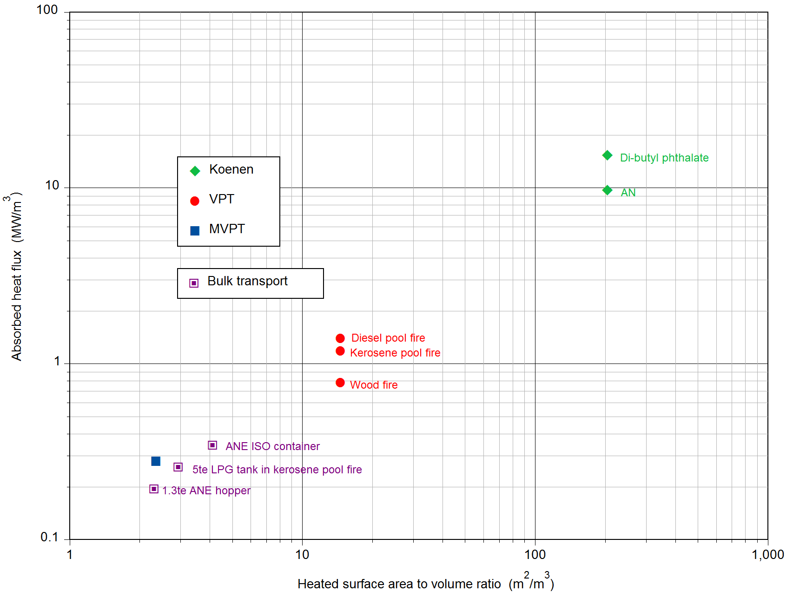
3. Figure 1 compares the estimated absorbed heat flux versus heated surface area to volume (S:V) ratio for the Test Series 8 vessels and for various forms of bulk transport. The two data points for the Koenen test were calculated from the measured heating rates and the known heat capacities for di-butyl phthalate and for powdered ammonium nitrate (AN) – the lower estimated absorbed heat flux of the latter presumably reflects the poorer thermal conductivity across the interface between the vessel wall and a powdered solid than with a liquid. The datum point for the MVPT was calculated from the measured heating rate during calibration and the known heat capacity of water. The three data points for the variants of the VPT were estimated from comparisons of the observed reaction times of whatever ANE samples were common to these variants of the VPT and to the calibrated MVPT and their respective S:V ratios. The datum point for the 5te LPG tank was derived from the measured heat flux published by K. Moodie et al., “Fire engulfment tests on a 5 tonne LPG tank”, J. Haz. Mat. 20 (1988) pp 55-71. The two data points for the 1.3te ANE hopper and the ANE ISO container have been estimated from the 5te LPG tank point based on the respective heat capacities of LPG and ANE and the respective S:V ratios of the containers.
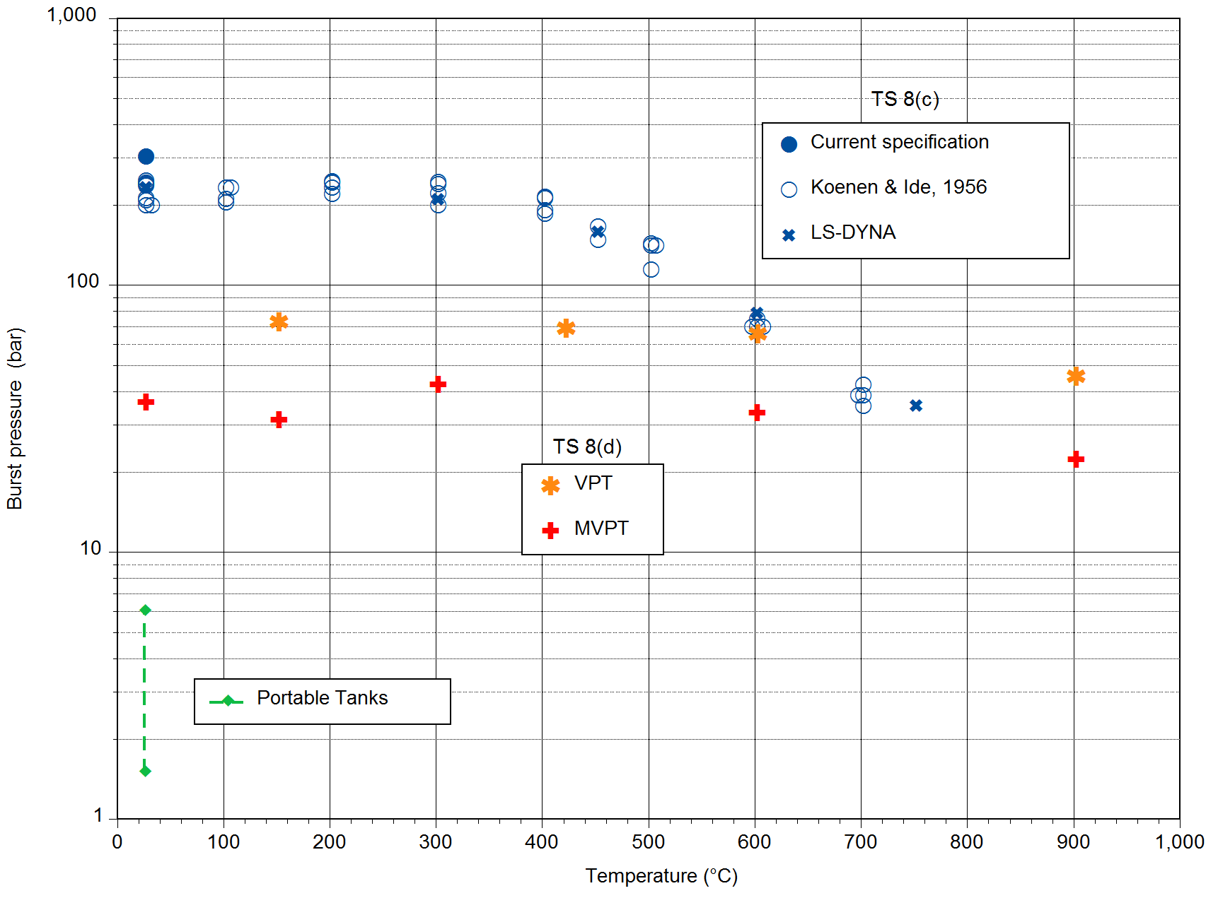
4. Figure 2 compares the burst pressures for the Test Series 8 vessels and for various forms of bulk transport. The current specification of 30 ± 3 MPa (300 ± 30 bar) for the burst pressure of the Koenen vessel refers to its strength at ambient temperature; the figure includes measurements by Koenen and Ide† examining the variation of burst pressure with temperature for the original vessels manufactured from corrosion-resistant steel, together with the burst pressures predicted by the finite element hydrocode LS-DYNA based on the variation of yield strength with temperature for this type of steel. The burst pressures for the VPT and MVPT vessels have been predicted by LS-DYNA again based on the variation of yield strength with temperature for their type of steel. Finally, an indication is given of the range of burst pressures expected for typical transport tanks prior to fire exposure, varying from the minimum burst pressure specified for T1/T2 Portable Tanks to 50% higher than the minimum burst pressure specified for T9/T10 Portable Tanks.
5. The data above support the finding of the Explosives Working Group that the Koenen, and in principle the Vented Pipe Tests are unsuitable for testing ANEs due to:
i. the experimental design of these tests in the context of use for ANEs;
ii. the test criterion, and
iii. the wide departure from working pressures of tanks used for bulk transport of ANEs.
6. The MBPs of ANEs (7-13 MPa, or 70-130 bar) are typically almost an order of magnitude higher than the burst pressure of road transport tanks. As such, the likelihood of an event in which the ANE would reach its MBP will be very unlikely as the tank would fail well before that pressure is reached.
Proposal
7. In the light of this data the Working Group consider use of the Minimum Burning Pressure Test as an alternative to the both the Koenen and Vented Pipe Tests for ANEs.

† H. Koenen and K Ide, Explosivstoffe, 4 (1956) p. 119.

