UN/SCETDG/49/INF.56

Committee of Experts on the Transport of Dangerous Goods
and on the Globally Harmonized System of Classification
and Labelling of Chemicals 24 June 2016
Sub-Committee of Experts on the Transport of Dangerous Goods
Forty-ninth session
Geneva, 27 June – 6 July 2016
Item 4 (a) of the provisional agenda
Electric storage systems: testing of lithium batteries
Activation of Lithium Cell or Battery Protective Mechanisms and Criteria for Voltage Loss Limit in T.2 Thermal Test in UN Manual of Tests and Criteria - Section 38.3
Transmitted by PRBA – The Rechargeable Battery Association and RECHARGE
Purpose
1. During the last two lithium battery informal working group meetings in Washington, DC and Bordeaux, technical information was presented regarding the activation of lithium cell or battery protective mechanism devices when subjected tests T.1 to T.4 in the UN Manual of Tests, Section 38.3. This issue is referenced in the report on the Bordeaux meeting as item #6 on page 11 of ST/SG/AC.10/C.3/2016/46.
2. Currently, the pass criteria for tests T.1 to T.4 require the open circuit voltage of each unit after the test to be more than 90% of its initial voltage before the test. The voltage loss limit aims to detect internal cell anomalies.
3. However, there are situations in which lithium ion cells or batteries have integrated resettable and/or non-resettable protective mechanisms that are designed to activate due to temperature or mechanical conditions. When these devices activate, the battery or cell open voltage becomes close to zero volts, thus not meeting the voltage loss pass criteria. This means the cell or battery designs technically fail the tests when in fact the tests prove the safety features in the cell or battery are working as designed.
4. An example of such protective mechanism is the non-resettable current interrupting safety device in cells, commonly known as CID. The CID mechanical construction is a diaphragm connected through welding to the top button (cap) terminal. The device is designed to break open due to cell pressure increase during cycling or elevated exposure to high temperature conditions, such as the T.2 Thermal test limit of 72 °C for six hours.
5. The X-ray images and graphics below show a comparison between a normal and activated cell CID mechanism. In the activated CID image, under internal cell pressure, the diaphragm connections to the button are broken, resulting in disconnection of the internal cell to the outside terminal (cell button). This disconnection results in low open circuit voltage (close to 0V) measured between the cell terminals. (The same logic as above applies to activation of the battery safety protective device mechanisms.)
6. During the working group meetings in Washington, DC and Bordeaux, representatives from battery testing labs explained that it is a common practice to reset the resettable protective mechanisms in batteries if they are activated during the T.2 Thermal test and continue on with testing. When the non-resettable protective mechanisms in a cell or battery are activated and voltage drops to zero, the cell and battery manufactures are essentially being penalized for designing a safe cell or battery. Our proposed changes to the T.2 Thermal test are intended to address this shortcoming in the UN Manual.
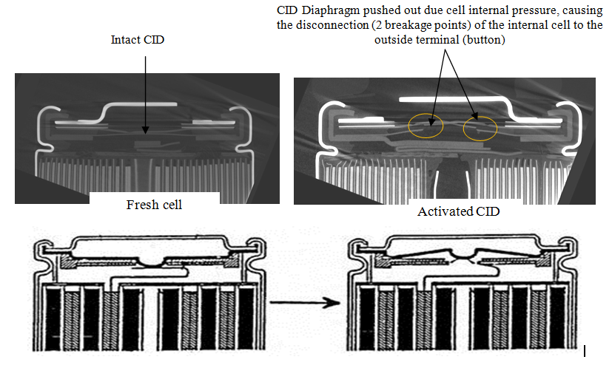

Proposal
7. To address the issues associated with the activation of cell or battery protective mechanism devices when subjected to the T.2 Thermal test in the UN Manual of Tests and Criteria, Section 38.3, PRBA and RECHARGE propose the following changes in the UN Manual of Tests and Criteria, Section 38.3.4.2.2:
38.3.4.2.2 Test procedure
Test cells and batteries are to be stored for at least six hours at a test temperature equal to 72 ± 2 °C, followed by storage for at least six hours at a test temperature equal to - 40 ± 2 °C. If protective devices are designed to activate at or below 72 °C during thermal cycling resulting in voltage loss, cells and batteries may be tested at a temperature equal to 65 ± 2 °C followed by storage for at least six hours at a test temperature equal to - 40 ± 2 °C. The maximum time interval between test temperature extremes is 30 minutes. This procedure is to be repeated until 10 total cycles are complete, after which all test cells and batteries are to be stored for 24 hours at ambient temperature (20 ± 5 °C). For large cells and batteries the duration of exposure to the test temperature extremes should be at least 12 hours.

