UN/SCETDG/49/INF.32
Committee of Experts on the Transport of Dangerous Goods
and on the Globally Harmonized System of Classification
and Labelling of Chemicals
Sub-Committee of Experts on the Transport of Dangerous Goods 16 June 2016
Forty-ninth session
Geneva, 27 June – 06 July 2016
Item 4 (d) of the provisional agenda
Electric storage systems: miscellaneous
New UN number for Rechargeable Lithium Metal Polymer batteries
Transmitted by RECHARGE and the Rechargeable Battery Association °(PRBA)
Supporting safety data of RLMP batteries for the working paper ST/SG/AC.10/C.3/2016/33
1. This paper includes safety performance information on rechargeable lithium metal polymer (RLMP) cells, These data are compared to the data obtained with lithium-ion batteries (LIB) and Lithium metal batteries (LIM) cell in the same testing conditions. It includes thermo gravimetric analysis (TGA) data for types of electrolyte, and safety data collected at extreme abuse states, i.e., heating a cell of being 100% SOC at 200 °C for one hour. The collected information is additionally supporting safety evidence for RLMP cells and batteries as presented in the working paper ST/SG/AC.10/C.3/2016/33.
2. For UL 1642’s thermal abuse, lithium ion cell of being 100% SOC is heated at 130 °C for 10min. For other more extreme cases, i.e., for IEEE 1725 and CTIA, cells of being 80% SOC are heated at 150 °C for one hour. From these standards for heating, it seems that the level of SOC tends to be decreased if the heating temperature is increased. On the other hand, for SAE G-27’s meetings, heating at 200°C for one hour is being discussed as a parameter to develop standard packaging performance for lithium ions cells and batteries, in order to verify the level of protection in case of thermal run-away of the cells.
3. A RLMP cell includes three basic parts within a sealed pouch: anode, polymer electrolyte, and cathode, as described in annex 1 of ST/SG/AC.10/C.3/2016/33. The cathode consists of several materials, such as powders containing lithium ions, conductive powders, and lithium salt-solved polymer binder. The anode is lithium metal laminated with copper metal. The polymer electrolyte is a composited, lithium salt-solved polymer, which is designed to be non-flammable, strong itself, well adhesive to lithium metal, and highly ionic-conductive. These properties are fundamentally required for making safe the use of lithium metal in rechargeable cells: Lithium metal is highly water-reactive, flammable solid. It melts at 180°C, and molten lithium is pyrophoric (self-ignition temperature =179°C). For this reason, non-flammable, low vapour-emitting polymer electrolyte is efficient for providing RLMP cells with high safety.
4. In view of safety, electrolyte can be considered point of the cell components. TGA is a simple, powerful tool to confirm which electrolyte is thermally more stable. As shown in Annex 1-Fig. 1, two different types of electrolyte for lithium metal cells, Type A and Type B, and LIB’s electrolyte as reference are analyzed. For LIB’s electrolyte, 64% of its initial weight is decomposed by heating up to 200°C. This implies that for its application to a cell, lots of gases could be generated, so that the cell would swell largely. Type A is flammable, liquid electrolyte, which was studied in the beginning stage of developing lithium metal cells (LIM). Its weight loss is 20% smaller than that of LIB’s electrolyte. It means that gases generated by heat would be relatively smaller. Type B is one of the typeused in RLMB meeting the criteria in Fig. 1. Its weight loss is just 11% by heating up to 200°C. In addition, it is also non-flammable. This implies that its cell would be much safer than Type A cell.
5. The benefit of the new electrolytes has been verified during the heating test of complete RLMB cells, and compared to LIB and LIM cells. The testing conditions are described in Annex 2:
– Figure 2 shows a charging profile. All cells for heating test were charged to 100% SOC.
– Figure 3 shows the overview of a simple apparatus for heating a single cell at 200°C. It consists of a commercial oven, a home-made controller, and a data logger.
– Figure 4 shows the profile for heating, and Figure 5 shows the position of thermocouples and V-sensing wires.
6. The testing results are shown in Annex 3, for LIB, LIM and RLMP cells.
6.1 Test of LIB
As reference, commercial LIB cells were evaluated with the above condition. As expected, an event appeared by heating. As shown in Fig. 6, after heating, cell’s voltage becomes zero, and the peak temperatures are increased in the range of 550°C. As expected from its TGA data, the pouch became swollen, the sealing near the tabs was made open, though which some smoke emitted. As shown in Fig. 7, as temperature was reaching 200°C, the inside became more heated due to some internal shorts, letting much intense smoke and some red-hot particles emitting. As shown Fig. 8, after heating, cell’s appearance is completely different from its fresh one. In addition, its weight was reduced by 20% after heating. Considering its TGA data, most of the lost might come from firing of electrolyte.
6.2. Test of LIM (type A electrolyte).
Figure 9 shows a result of heating at 200°C for a Type A cell. It is seen that an event of thermal run-away takes place near 200 °C, as expected from its TGA data.
Figure 10 shows two pictures of LIM cell’s taken from its video at the time that the event occurs. The left picture shows that the cell becomes largely swollen and heated red-hot near the tabs. The right picture shows a moment of the event. Red-hot particles are seen to be scattering. The maximum temperature measured is 700°C, and the voltage is reduced to zero volt. This is a result of applying types of flammable and liquid electrolyte to lithium metal cells. Based on such electrolyte, it was revealed that the cells are not safe for heating at that temperature. Various Type A cells were tested, and the cells were destructed by fire and rupture.
6.3. Test of RLMB (type B electrolyte).
As shown in Fig. 11, nothing happens during the heating test, except for a decrease in voltage. Number of Type B cells was tested, and their results were confirmed to be same.
After heating, its appearance was compared with its fresh one. As seen in Fig.12, except for some dusts and wrinkles on the pouch, no change is clearly observed. As not apparently seen in the right picture, the sealing part near the tabs was observed to be lightly made open. This might happen because the sealing material of the pouch, polypropylene, can melt at about 170°C. Thanks to the new design including the polymer electrolyte, the behaviour of the RLMP remains safe, even when heated above the temperature of fusion of the lithium metal.
Conclusion
7. This complementary set of data is supporting the conclusion of working paper ST/SG/AC.10/C.3/2016/33: thanks to his safety properties, the RLMP (Rechargeable lithium metal polymer) can be favourably compared with the lithium-ion batteries. The transport regulation of RLMP could be harmonized with the one applicable to lithium-ion batteries.
Annex 1
Thermo gravimetric analysis (TGA)
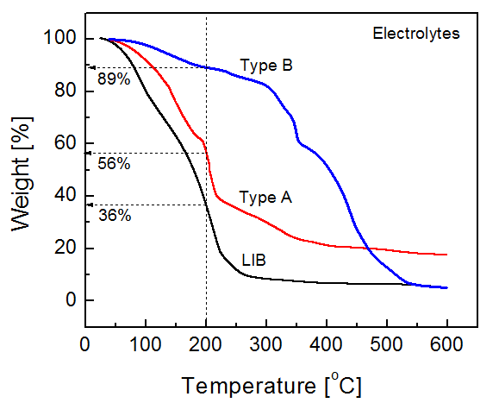
Fig.1 TGA profiles for three different electrolytes: liquid electrolyte for a LIB (lithium-ion) cell; Type A (liquid) and Type B (polymer) for lithium metal cells. LIB’s electrolyte is non-flammable, Type A has part of flammable liquid, and Type B is totally non-flammable. Less integral loss up to 200°C corresponds to Type B, which indicates that Type B cells could not be swollen or little by heating up to 200°C.

Annex 2
Testing conditions for RLMB and LIB cells
Charging profile for 100% SOC
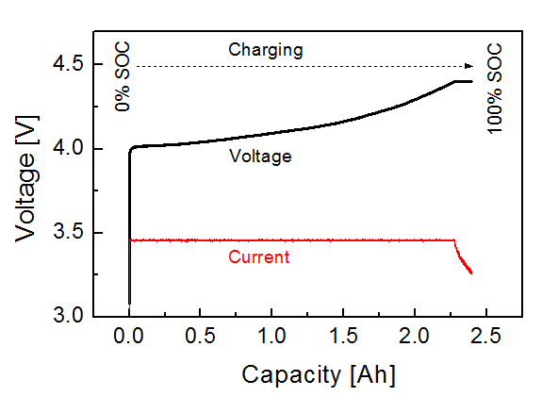

Fig.2 Charging profile for a RLMP cell. Before heating, the cells were charged to 100% SOC with a CC-CV mode where CC and CV are simplified words of “constant current” and “constant voltage”, respectively.
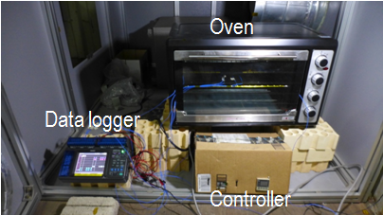
Setup for heating test

Fig.3 Overview of an apparatus for heating test. It consists of three parts: a commercial oven, a power controller, and a data logger.

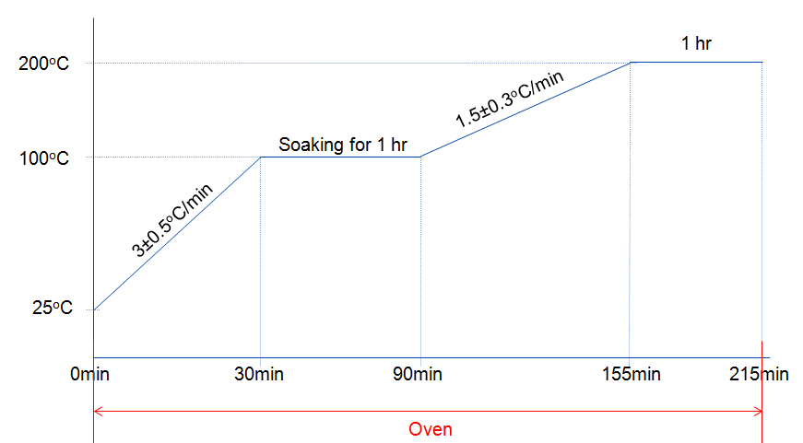
Fig.4 Temperature profile for the heating test. The temperature of the oven is set to rise to 100°C at a rate of 3°C/min, and is kept at 100°C for one-hour soaking, and then it again rises to 200°C with a rate of 1.5°C/min and at that temperature it is kept for one hour.
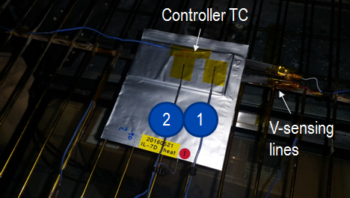

Fig.5 Cell’ appearance placed on a wire mesh in the oven. The wires are covered with polyimide tape for electrical insulation. The mesh is in the middle of the oven. The heating elements are positioned at top and bottom sites of the oven, heating the cell downward and upward. Cell’s tabs are connected with the voltage sensing wires covered with polyimide tape to prevent electrical shorts.

Annex 3
Heating test results
1) LIB cell (Li-ion)
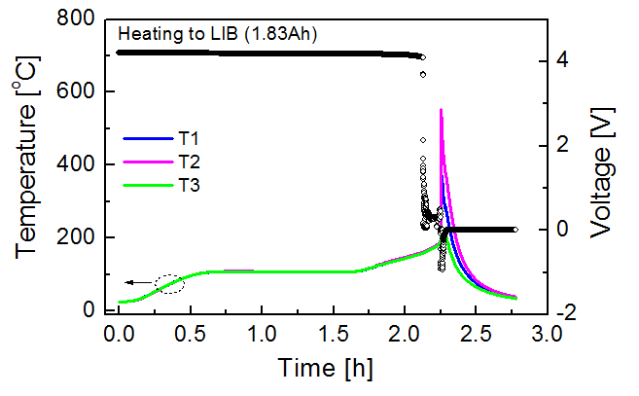
a. Voltage profile during heating
Fig.6 Plots of voltage and temperatures measure during heating for a LIB cell. Seeing its temperatures, when the temperature arrives at 200°C, then an abrupt increase of temperature happens. Unlike the temperature behaviours, a change in voltage happens below 200°C. At about 160°C an abrupt drop of voltage appears. Waving in voltage is seen. When the event happens, the voltage becomes zero.
b. LIB cell’s appearance during heating
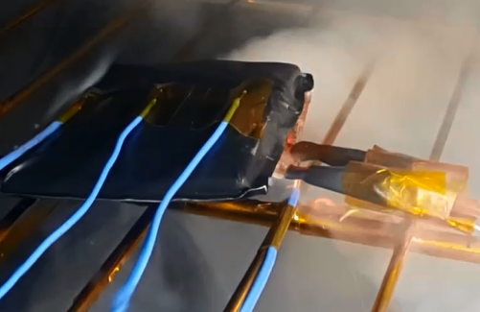
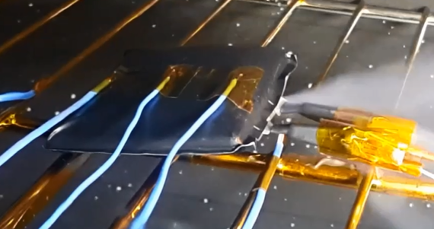

Fig.7 As the cell was being heated up, it became first swollen. Later smoke emission was observed at the sealing part near tabs. At the time that temperature reached near 200°C, emission of heat and smoke was observed, indicating thermal run-away. Its peak temperature was about 550°C, but the cell was not fired..

c. LIB cell’s appearance after heating
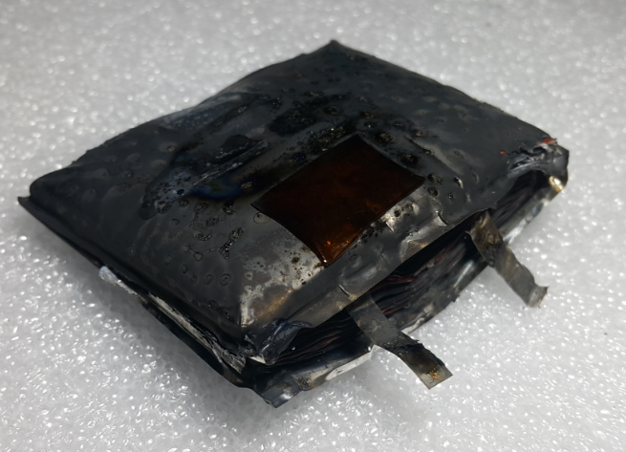
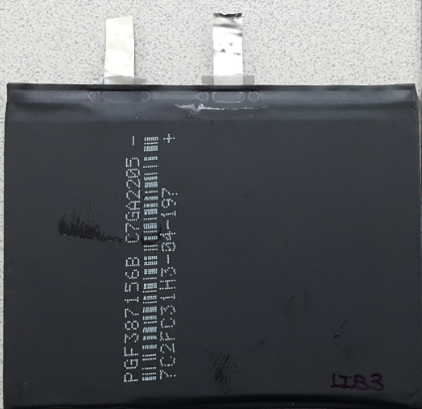

Fig.8 LIB cell’s appearance before and after heating (200°C for one hour). After heating, the cell lost 20 percent in weight (30.79g →24.93g).
2) LIM (Lithium metal with Type A liquid electrolyte)
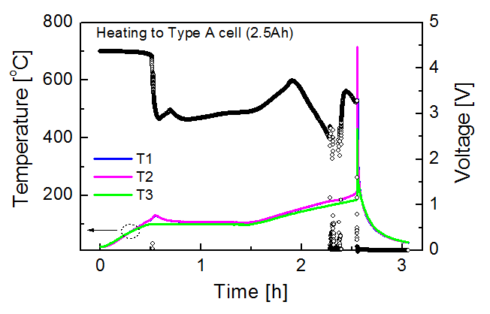
a. Voltage profile during heating

Fig.9 Plots of voltage and temperatures measured during heating for a Type A cell. Seeing its temperatures, a small rise appears at 100°C and thermal run-away occurs as the temperature arriving near 200°C. The voltage behaviours seem to be more complex. A large drop is driven at 100°C, which probably happens with a relation with the temperature rise. Various changes in voltage follow but cannot be clearly explained. Anyway, the voltage finally gets to zero, which is a result of the thermal run-away.

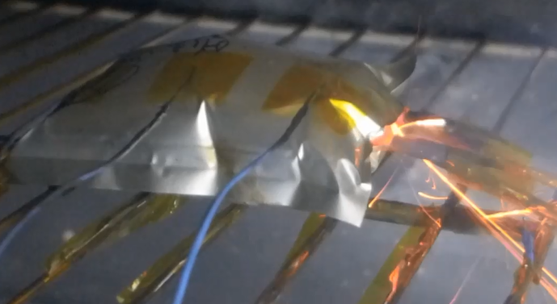
b. Images during heating
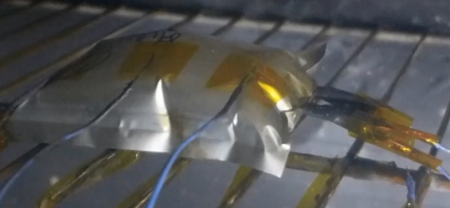
Fig.10 Type A cell’s appearance during heating. The cell was already swollen below 100°C. Once the ambient temperature rose to 100°C, generation of little heat was observed, and it followed a smell of electrolyte, indicating that the pouch was getting open at that temperature. As the temperature increased near 200°C, much heat was abruptly generated, causing thermal run-away.
3) RLMP (Rechargeable lithium metal polymer with Type B polymer electrolyte)
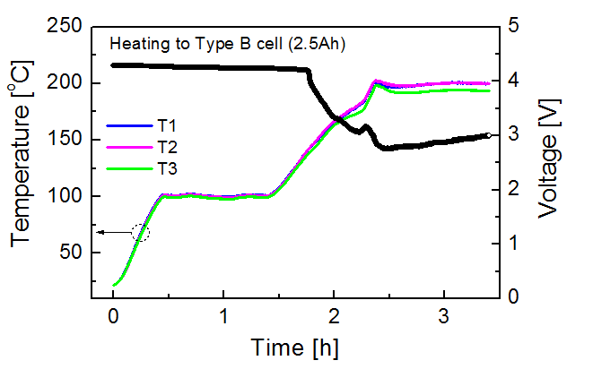
a. Voltage profile during heating
Fig.11 Plots of voltage and temperatures measured during for a Type B. Seeing its temperatures, no change is seen. It just follows the temperature profile of the oven. Unlike the temperature behaviours, it shows some change. A drop appears at about 140 °C, which probably corresponds to one component of the composite electrolyte. When the temperature is reaching at 180°C, little change follows. The change probably occurs as influence that lithium metal is melting at that temperature. The cell is heated at 200°C for one hour, but no event occurs.

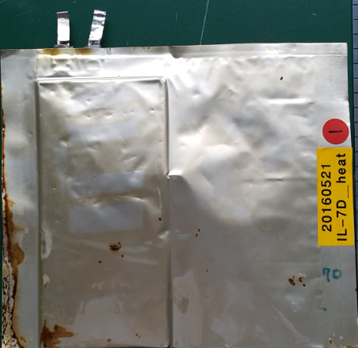
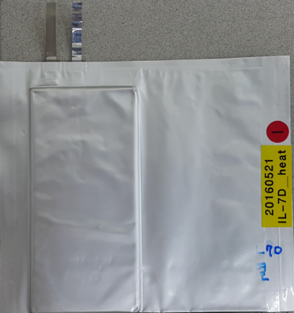
b. Type B cell’ appearance before and after heating

Fig.12 Type B cell’s appearance before and after heating. The weight of the cell was hardly changed (30.29g → 30.05g) even though the pouch was made open by heat. The opening happens because pouch’s sealing polymer, polypropylene, is melting above 170°C.

