UN/SCETDG/49/INF.24
Committee of Experts on the Transport of Dangerous Goods
and on the Globally Harmonized System of Classification
and Labelling of Chemicals 14 June 2016
Sub-Committee of Experts on the Transport of Dangerous Goods
Forty-ninth session
Geneva, 27 June-6 July 2016
Item 3 of the provisional agenda
Listing, classification and packing
Definition of vapour pressure
Transmitted by the expert from Canada
Introduction
1. The UN Model Regulations make frequent use of the term “vapour pressure”. Most importantly, it is one of the fundamental characteristics used in determining the state of a substance (i.e., solid, liquid, or gas) and is frequently used in determining means of containment requirements for substances.
2. While vapour pressure can be defined for a pure substance as a fundamental property of the substance, the definition of vapour pressure for a mixture can be more complicated, especially when considering that many of the test methods that reference vapour pressure require the use of a specific vapour: liquid (V/L) ratio in the test method (e.g., ASTM D 323). The vapour pressure of a mixture can vary with the V/L ratio at a given temperature.
Discussion
3. The UN Model Regulations contains the following definition for a liquid:
(a) Liquid means a dangerous good which at 50 °C have a vapour pressure of not more than 300 kPa (3 bar), which is not completely gaseous at 20 °C or less at a pressure of 101.3 kPa, and which has a melting point or initial melting point of 20 °C or less at a pressure of 101.3 kPa. A viscous substance for which a specific melting point cannot be determined shall be subjected to the ASTM D 4359-90 test; or to the test for determining fluidity (penetrometer test) prescribed in section 2.3.4 of Annex A of the European Agreement concerning the International Carriage of Dangerous Goods by Road.
4. The UN Model Regulations also define a gas in 2.2.1.1 as:
2.2.1.1 A gas is a substance which:
(a) At 50 °C has a vapour pressure greater than 300 kPa; or
(b) Is completely gaseous at 20 °C at a standard pressure of 101.3 kPa.
5. For a pure substance, the vapour pressure is understood to mean the pressure exerted by a vapour in thermodynamic equilibrium (no matter or energy exchange) with its condensed phases at a given temperature in a closed system. The vapour pressure of a pure substance is temperature-dependent, but does not vary with the outage that may be present above the liquid so long as both liquid and vapour are present when at thermodynamic equilibrium. It can be measured directly or calculated using various methods (e.g., Antoine equations).
6. For a mixture, the calculation of vapour pressure can be a complex endeavour. For a defined system with defined components, the sum of the partial pressures of the components is equal to the total vapour pressure of the mixture. A simplified calculation is shown in Figure 1 below. The partial pressure of a substance is the contribution a particular substance makes to the overall vapour pressure of a mixture.

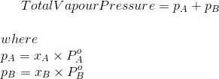
Figure 1: Vapour pressure calculation for a two-species system
Pº is the vapour pressure of A and B if they were on their own as pure liquids.
x_{A} and x_{B} are the mole fractions of A and B – the fraction of the total number of moles present of A and B.
7. For a pure substance or for a defined system of substances, the vapour pressure of the substance can be measured directly or calculated using calculations such as those presented above. The calculation becomes more complicated as more substances are added to a mixture, but methods do exist (e.g., partial pressures).
8. When considering undefined mixtures or mixtures where some components are present in small quantities, the measurement of the mixture’s vapour pressure can become more complex. The volume of the vapour space above the liquid can affect the vapour pressure measured and may result in measurements that are not equivalent to a pure substance vapour pressure.
9. When measuring the vapour pressure of a substance, the determination of the vapour pressure of a mixture must be taken at the point where the V/L ratio approaches zero (0) – the bubble point; this is the point that accounts for the vapour pressure contribution of all the substances present in a mixture, the non-linearity and interactions present in a real mixture, and is the equivalent measurement to the vapour pressure of a pure substance.
10. For example, a pure substance’s vapour pressure is independent of the vapour space above provided there is liquid present at thermodynamic equilibrium at a given temperature in a closed system.

See Figure 2.
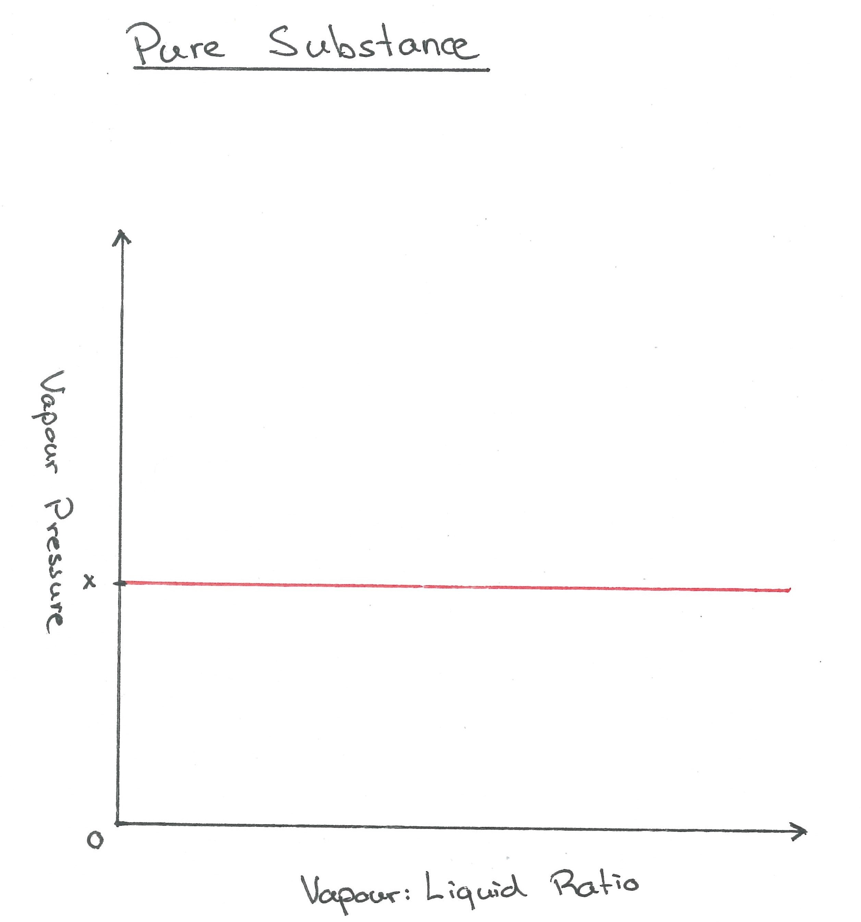
Figure 2: Vapour Pressure of a Pure Substance
11. For a mixture with small amounts of a high vapour pressure substance (e.g., methane), the contribution of methane to the total vapour pressure can vary with changing V/L ratio. As the small amount of methane is vaporised into the vapour space, it eventually reaches a limit where it has fully vaporised. Above this point, the partial pressure contribution of methane will begin to drop with regard to the overall vapour pressure of the mixture. As the V/L ratio is increased, the partial pressure of methane will decrease because the same amount of methane is now present in a larger volume and so its mole fraction decreases, decreasing its overall contribution to the vapour pressure. This same effect can happen multiple times over for each substance in a complex mixture, leading to a changing vapour space at thermodynamic equilibrium when the V/L ratio is varied. See Figure 3.
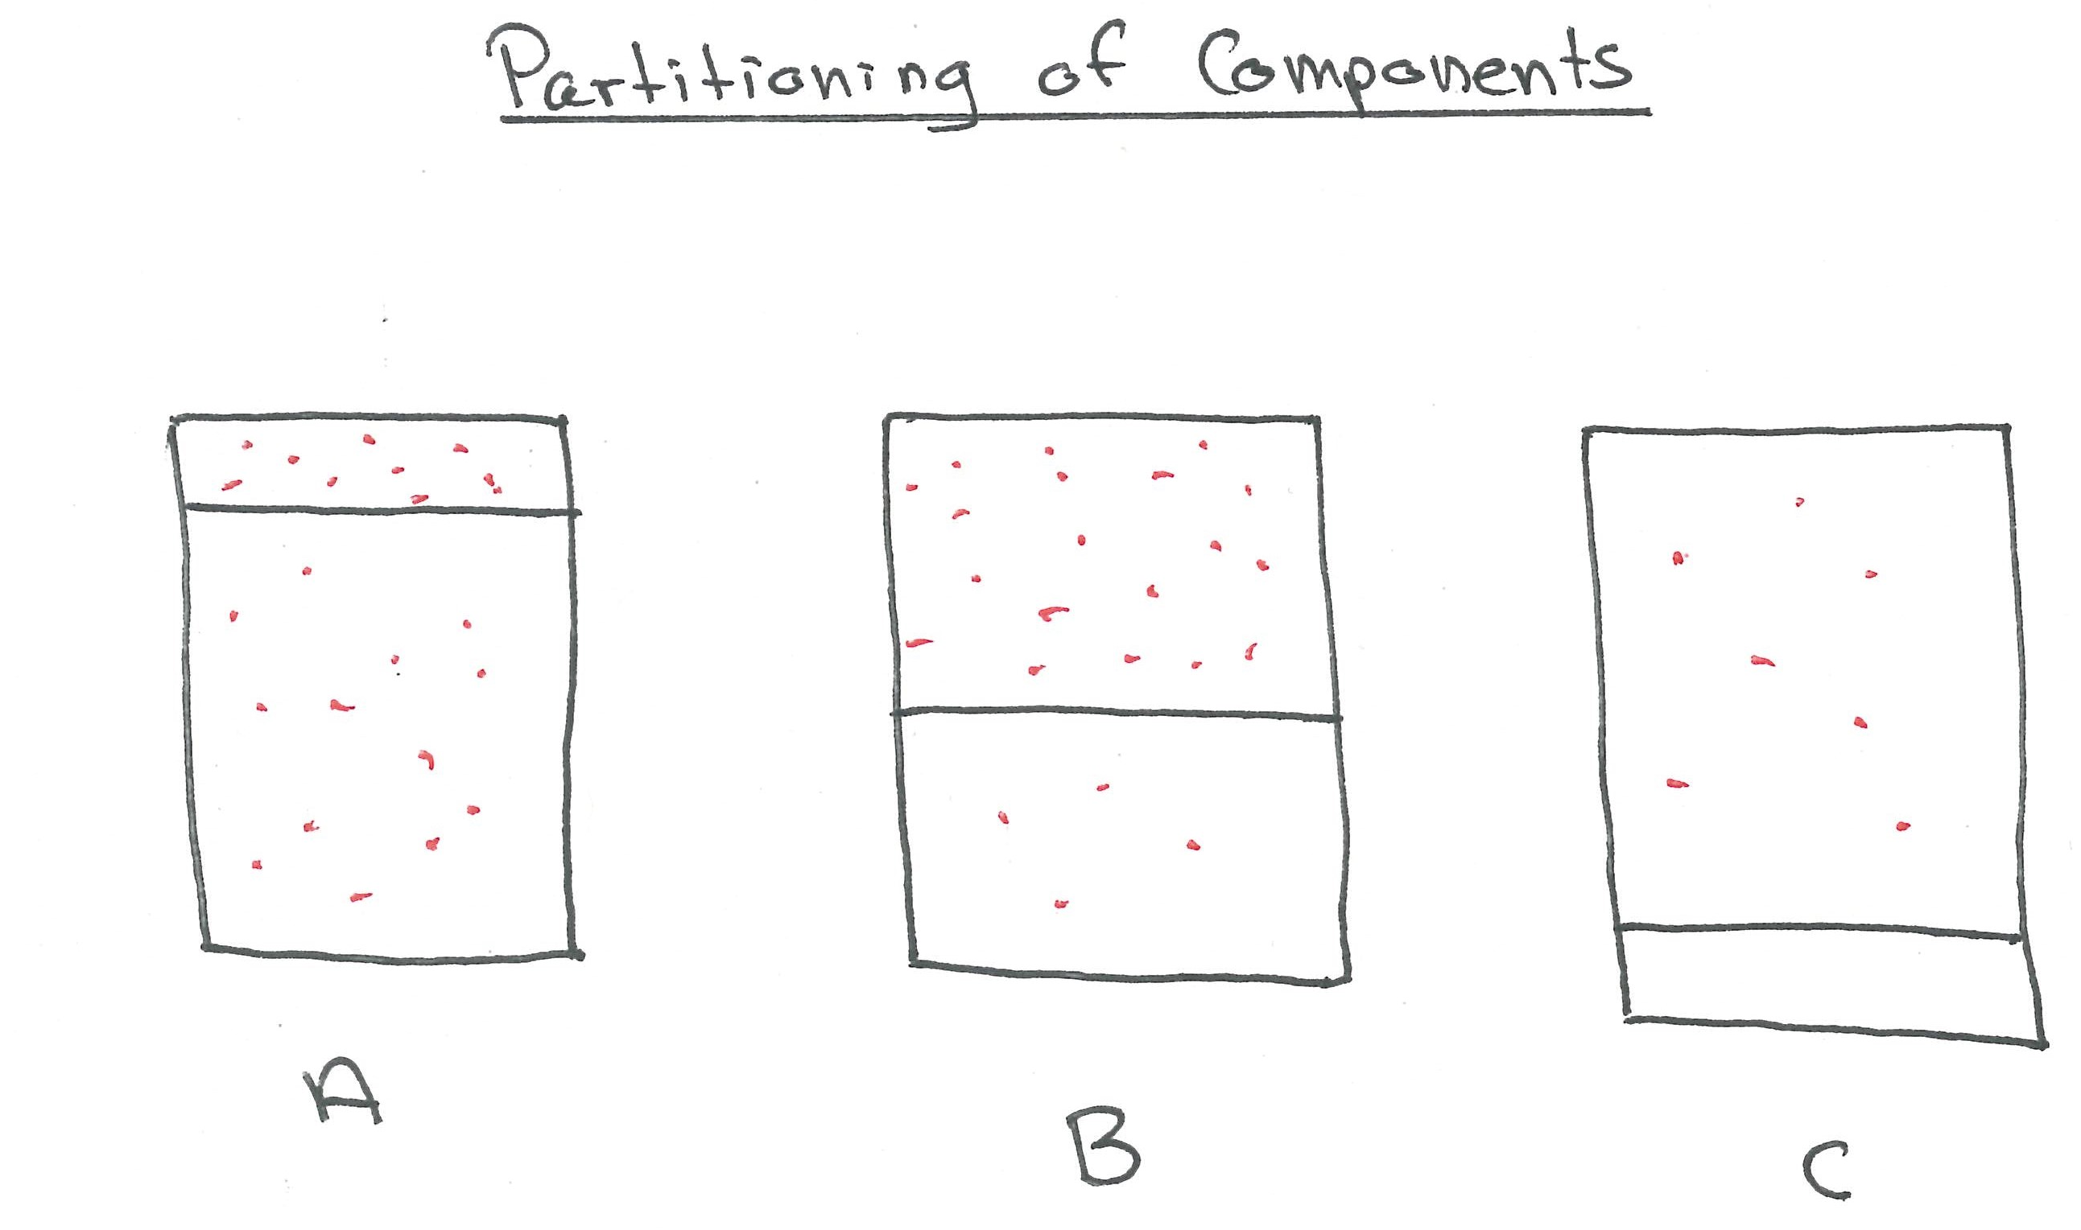
Figure 3. Partitioning of components
12. Figure 3 can be interpreted as follows:
(a) A volatile component is present in both the liquid and gas phases, contributing to the vapour pressure of the mixture;
(b) As the vapour phase is expanded, less of the volatile component is present in the liquid;
(c) In this case, the volatile component is completely in the vapour phase, it is no longer in equilibrium with the liquid phase. As the vapour space continues to expand, its partial pressure (see Figure 1) will begin to decrease, which will affect the overall vapour pressure of the mixture as shown in Figure 4, causing it to vary with changes in V/L ratio.
13. This is problematic because some test methods allow the V/L ratio to be varied, or the methods use a V/L ratio that may result in a vapour pressure measurement that underestimates the vapour pressure of the mixture and it’s resulting hazard or proper classification (e.g., whether it should be considered a liquid or gas). Depending on the V/L ratio used, the measured vapour pressure will vary (see Figure 4) due to the effects discussed in paragraph 0, and due to non-linear interactions that occur in the mixture. A definition of vapour pressure should specify and account for this variance in establishing a vapour pressure for a mixture, and specify the V/L point equivalent to a pure substance to ensure consistency and ensure proper classification of mixtures (see Figure 5).

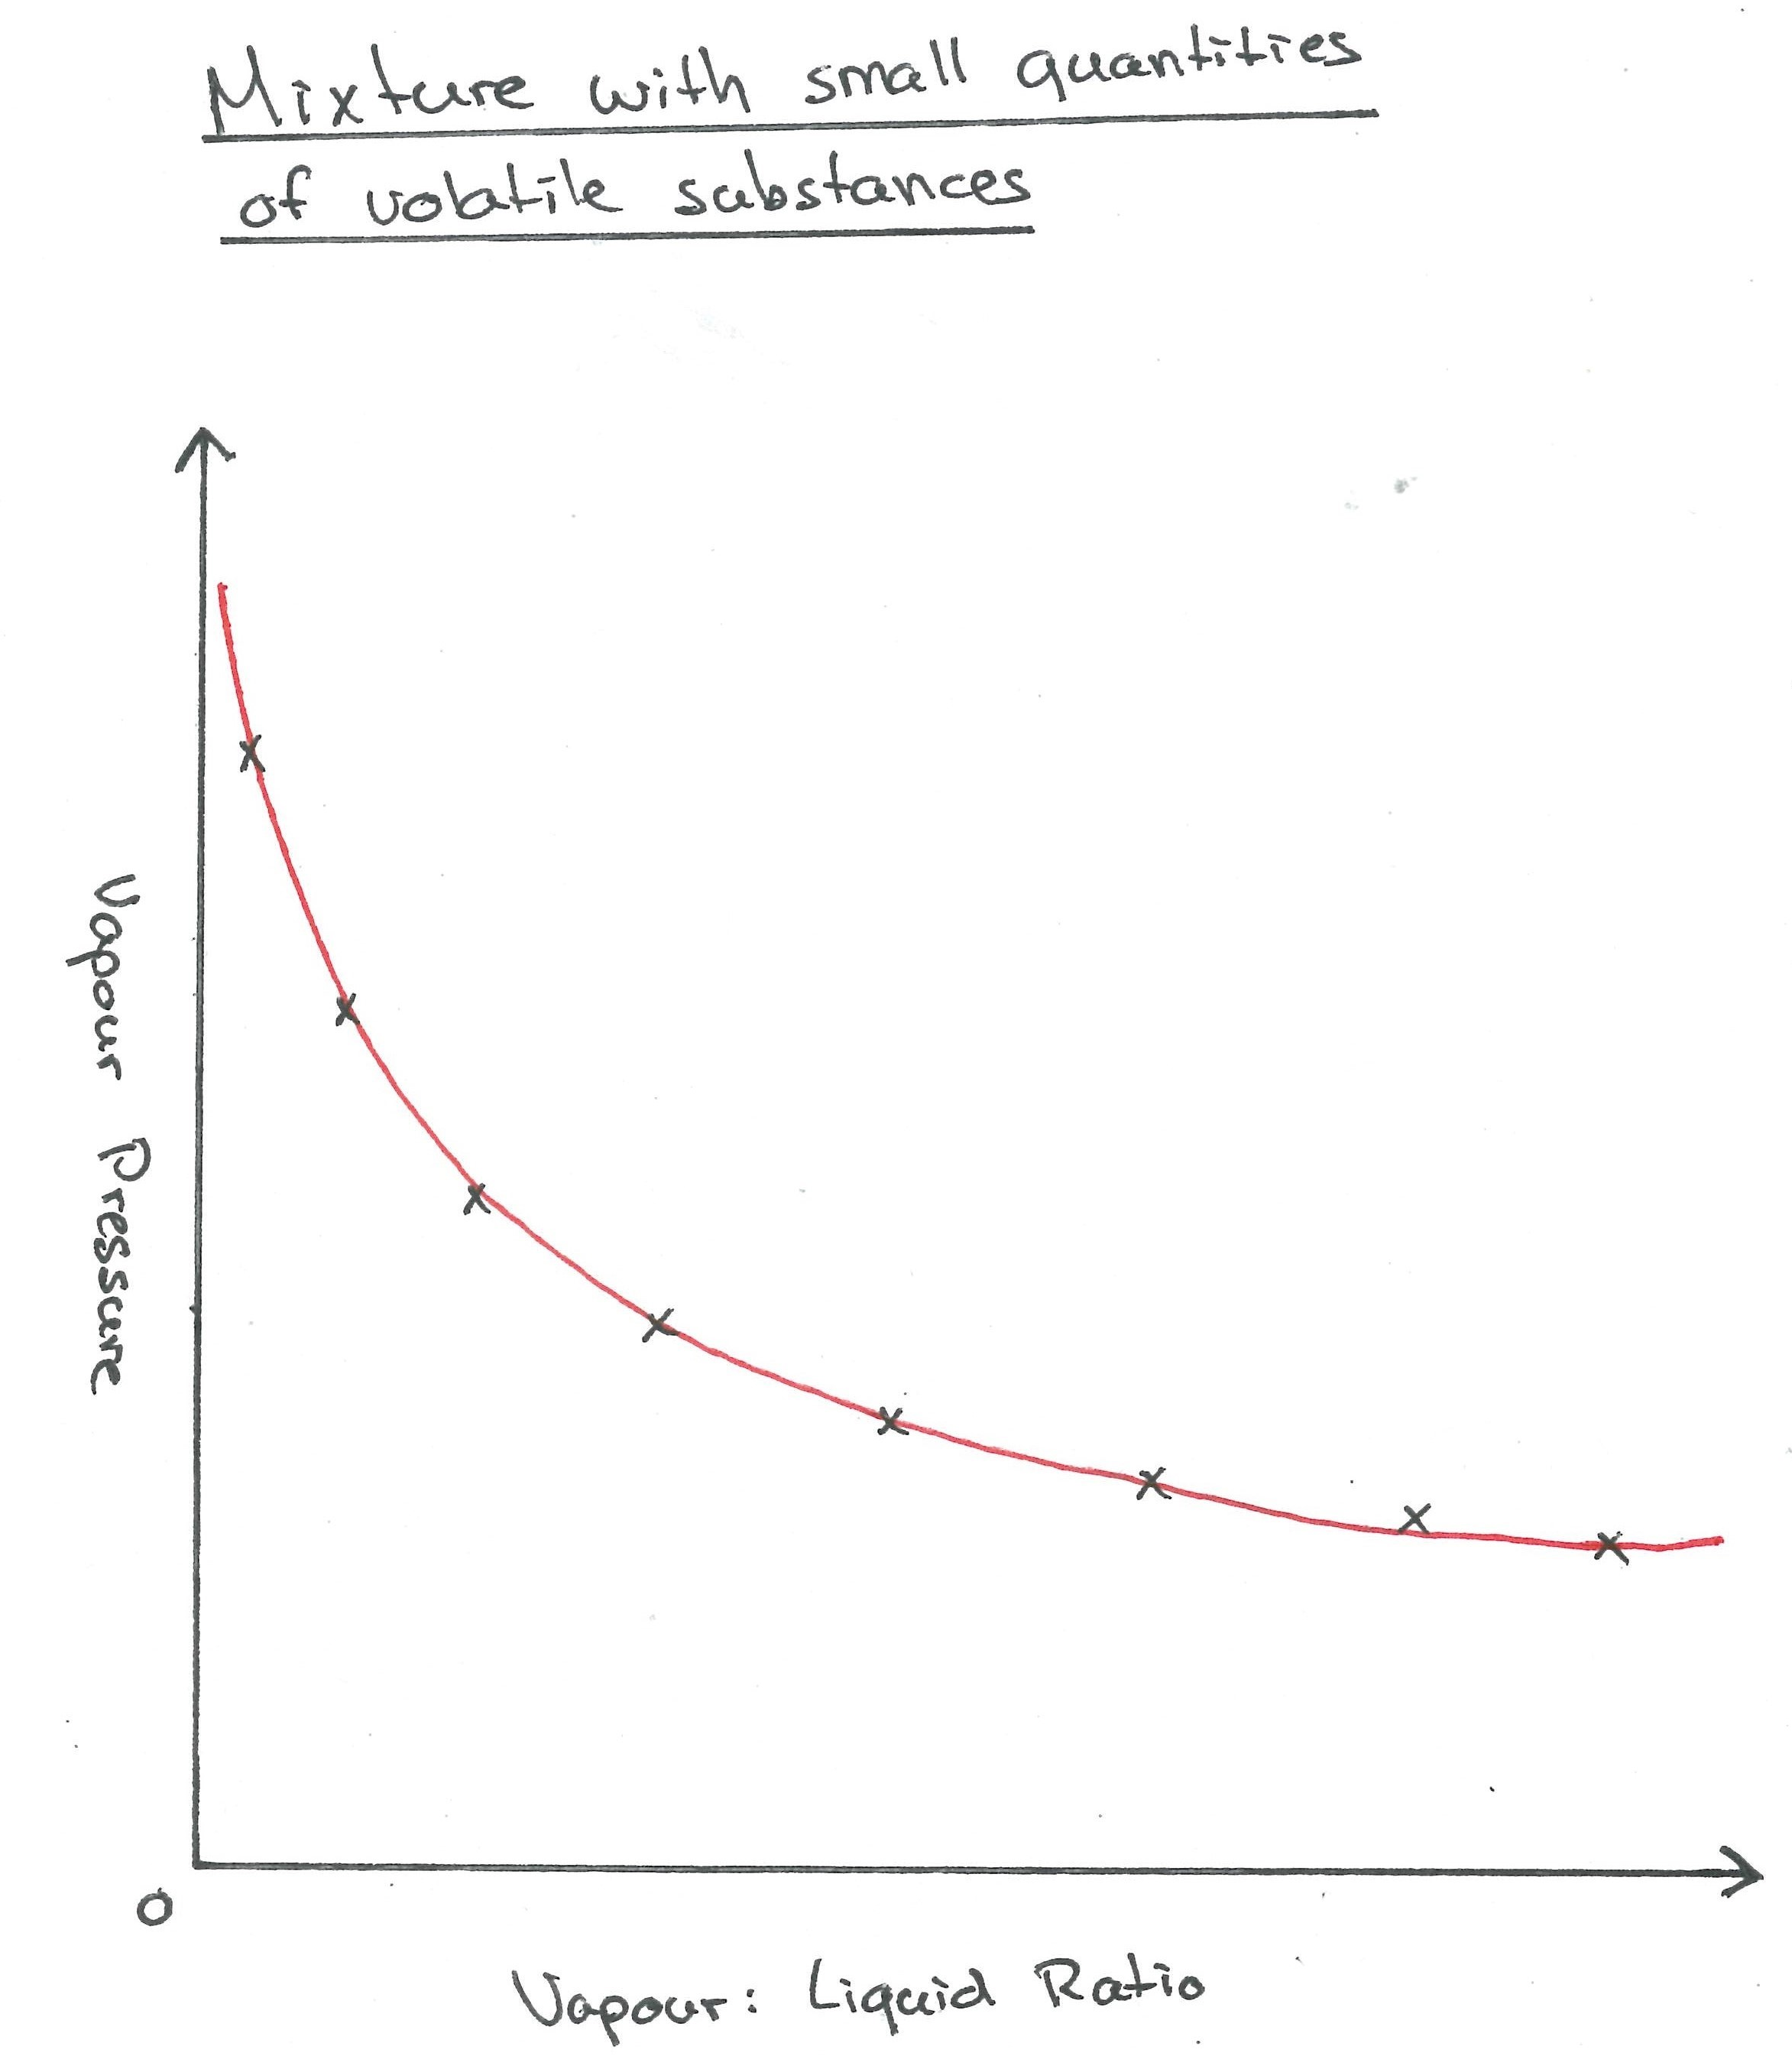
Figure 4. Vapour pressure of a mixture

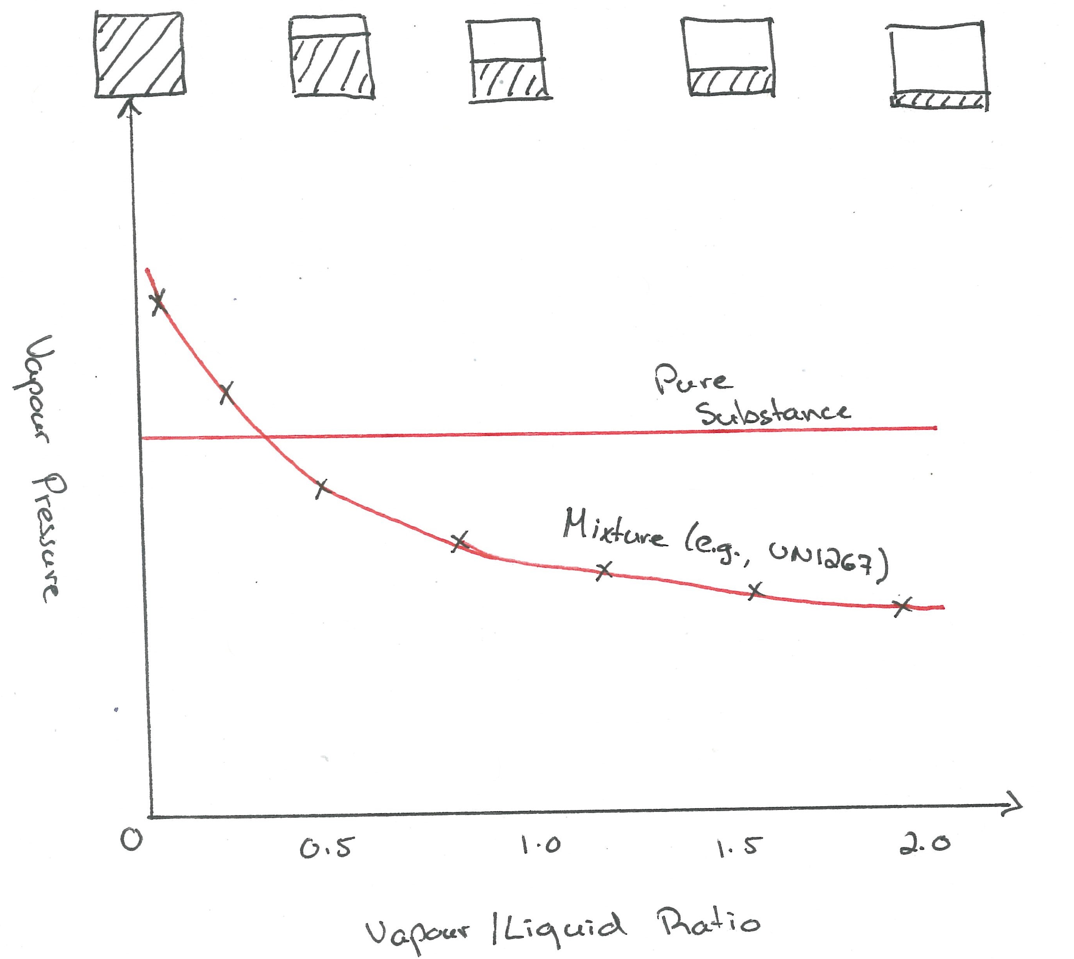
Figure 5: Comparison of the vapour pressure for a mixture and pure substance
14. Practically speaking, in a means of containment, the V/L ratio of the means of containment may be very different than the V/L ratio used in testing for the vapour pressure, and can vary significantly from the vapour pressure of that substance – the point at which the V/L ratio reaches zero (0) which is analogous to the vapour pressure of a pure substance. If not accounted for, this can underestimate the pressures experienced by that means of containment during transport and impact on the hazards present in transport.
15. Such difficulties have been encountered in some regions, specifically North America, when considering complex mixtures such as petroleum products.
Next Steps
16. Given the complexities when it comes to measuring the vapour pressure of a complex liquid mixture, the expert from Canada proposes that the Sub-Committee consider introducing a definition of vapour pressure that clarifies how it should be interpreted for mixtures.
17. The expert from Canada proposes the following definition for vapour pressure:
Vapour Pressure means the pressure exerted by a vapour in thermodynamic equilibrium with its condensed phases at a given temperature in a closed system. For a mixture, the vapour pressure means the vapour pressure at a V/L ratio of zero (0).
18. The expert from Canada invites comments from members of the Sub-Committee. Following discussions, Canada can prepare a formal proposal for the Fiftieth Session of the Sub-Committee.

