|  |  |  |  |
| --- | --- | --- | --- |
|  | United Nations | ST/SG/AC.10/C.3/2016/21/Corr.1 | |
| _unlogo | **Secretariat** | | Distr.: General  22 April 2016  English only |

**Committee of Experts on the Transport of Dangerous Goods  
and on the Globally Harmonized System of Classification  
and Labelling of Chemicals**

|  |  |
| --- | --- |
| **Sub-Committee of Experts on the Transport of Dangerous Goods** |  |
| **Forty-ninth session** |  |
| Geneva, 27 June – 6 July 2016  Item 3 of the provisional agenda  **Listing, classification and packing** |  |

Proposal for revision of Chapter 2.8 of the Model Regulations: introduction of alternative methods for classification and packing group assignment

Transmitted by the expert from Canada, the European Chemical Industry Council (CEFIC), and the International Association for Soaps, Detergents and Maintenance Products (AISE) [[1]](#footnote-2)

Corrigendum

Page 14: Replace Figure 2.8.4.3 by the following:

**Figure 2.8.4.3: Calculation method**

**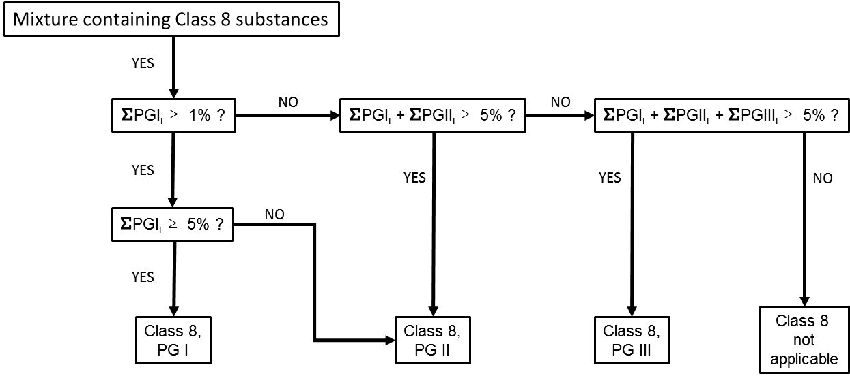**

\_\_\_\_\_\_\_\_\_\_\_\_\_\_\_

1. In accordance with the programme of work of the Sub-Committee for 2015–2016 approved by the Committee at its seventh session (see ST/SG/AC.10/C.3/92, paragraph 95 and ST/SG/AC.10/42, para. 15). [↑](#footnote-ref-2)