|  |  |  |  |
| --- | --- | --- | --- |
|  | United Nations | ECE/TRANS/WP.29/GRSP/2015/30 | |
| _unlogo | **Economic and Social Council** | | Distr.: General  22 September 2015  Original: English |

**Economic Commission for Europe**

Inland Transport Committee

**World Forum for Harmonization of Vehicle Regulations**

**Working Party on Passive Safety**

**Fifty-eighth session**

Geneva, 8-11 December 2015

Item 21 of the provisional agenda

**Collective amendments to Regulations Nos. 16, 44, 94   
and 129 (Enhanced Child Restraint Systems)**

Collective amendments to Regulations Nos. 16, 44, 94 and 129 (Enhanced Child Restraint Systems)

Submitted by the expert from the European Commission[[1]](#footnote-2)\*

The text reproduced below was prepared by the expert from the European Commission to harmonize information in the airbag warning label on the correct installation of Child Restraint Systems (CRS). The modifications to the current text of the UN Regulation are marked in bold for new or strikethrough for deleted characters.

I. Proposal for Supplement 7 to the 06 series of Amendments to Regulation No. 16 (Safety belts)

*Paragraph 8.1.8.*, amend to read:

"8.1.8. Every passenger seating position which is fitted with a frontal protection airbag shall be provided with a warning against the use of a rearward-facing child restraint in that seating position. ~~As a minimum~~, This information …

…

The overall dimensions **of the label** shall be at least 120 x 60 mm or the equivalent area.

The label ~~shown above~~ may be adapted in such a way that the layout differs from the example **shown here** ~~above~~; however, the content shall meet the **precise** ~~above~~ prescriptions. **Furthermore, no other type of information shall be included on the label unless it is placed outside a clearly marked rectangle with at least the overall dimensions as required above.**

**It shall also be ensured that no deviations in the shape and orientation of the provided pictograms are permitted, notably that any customised appearance of the prescribed pictogram images shall be prohibited, with the exception of the hand with pointing index finger and the open face booklet with letter 'i' on its right page provided that they are clearly recognisable as such. Small irregularities concerning line thickness, label imprinting and other relevant production tolerances shall be accepted.**"

*Paragraph 8.1.10.*, amend to read:

"8.1.10. Detailed information, making reference to the warning, shall be contained in the owner's manual of the vehicle; as a minimum, the following text in all official languages of the country or countries where the vehicle could reasonably be expected to be registered (~~e.g.~~ **i.e.** within the territory of the European Union– **all 24 official languages**, in Japan – **Japanese**, in Russian Federation – **Russian, in Egypt** – **Modern Standard Arabic** or in New Zealand – **English**, etc.), shall at least include:

…"

II. Proposal for Supplement 11 to the 04 series of Amendments to Regulation No. 44 (Child restraint systems)

*Paragraph 4.4.*, amend to read:

"4.4. On the visible inner surface (including the **inside surface of any** side wing beside the child's head) in the approximate area where the child's head rests within the child restraint system, rearward facing restraints shall have the ~~following~~ **shown** label permanently attached ~~(the information shown is a minimum)~~.

~~Label minimum size: 60 x 120 mm.~~

**The overall dimensions of the label shall be at least 120 x 60 mm or the equivalent area.**

**The label may be adapted in such a way that the layout differs from the example shown here; however, the content shall meet the precise prescriptions. Furthermore, no other type of information shall be included on the label unless it is placed outside a clearly marked rectangle with at least the overall dimensions as required above.**

**It shall also be ensured that no deviations in the shape and orientation of the provided pictograms are permitted, notably that any customised appearance of the prescribed pictogram images shall be prohibited, with the exception of the hand with pointing index finger and the open face booklet with letter 'i' on its right page provided that they are clearly recognisable as such. Small irregularities concerning line thickness, label imprinting and other relevant production tolerances shall be accepted.**

The label shall …"

III. Proposal for Supplement 6 to the 01 series of Amendments, Supplement 6 to the 02 series of Amendments and Supplement 1 to the 03 series of Amendments to Regulation No. 94 (Frontal collision protection)

*Paragraph 6.2.1.*, amend to read:

"6.2.1. ~~As a minimum~~, this information…

…

The overall dimensions **of the label** shall be at least 120 x 60 mm or the equivalent area.

The label ~~shown above~~ may be adapted in such a way that the layout differs from the example **shown here** ~~above~~; however, the content shall meet the **precise** ~~above~~ prescriptions. **Furthermore, no other type of information shall be included on the label unless it is placed outside a clearly marked rectangle with at least the overall dimensions as required above.**

**It shall also be ensured that no deviations in the shape and orientation of the provided pictograms are permitted, notably that any customised appearance of the prescribed pictogram images shall be prohibited, with the exception of the hand with pointing index finger and the open face booklet with letter 'i' on its right page provided that they are clearly recognisable as such. Small irregularities concerning line thickness, label imprinting and other relevant production tolerances shall be accepted.**"

*Paragraph 6.2.3.*, amend to read:

"6.2.3. Detailed information, making reference to the warning, shall be contained in the owner's manual of the vehicle; as a minimum, the following text in all official languages of the country or countries where the vehicle could reasonably be expected to be registered (~~e.g.~~ **i.e.** within the territory of the European Union– **all 24 official languages**, in Japan – **Japanese**, in Russian Federation – **Russian, in Egypt** – **Modern Standard Arabic** or in New Zealand – **English**, etc.), shall at least include:

…"

IV. Proposal for Supplement 5 to Regulation No. 129 (Enhanced child restraint systems)

*Paragraph 4.4.*, amend to read:

"4.4. On the visible inner surface (including the **inside surface of any** side wing beside the child's head) in the approximate area where the child's head rests within the child restraint system, rearward facing restraints shall have the ~~following~~ **shown** label permanently attached ~~(the information shown is a minimum)~~.

~~Label minimum size: 60 x 120 mm.~~

**The overall dimensions of the label shall be at least 120 x 60 mm or the equivalent area.**

**The label may be adapted in such a way that the layout differs from the example shown here; however, the content shall meet the precise prescriptions. Furthermore, no other type of information shall be included on the label unless it is placed outside a clearly marked rectangle with at least the overall dimensions as required above.**

**It shall also be ensured that no deviations in the shape and orientation of the provided pictograms are permitted, notably that any customised appearance of the prescribed pictogram images shall be prohibited, with the exception of the hand with pointing index finger and the open face booklet with letter 'i' on its right page provided that they are clearly recognisable as such. Small irregularities concerning line thickness, label imprinting and other relevant production tolerances shall be accepted.**

The label shall …"

V. Justification

1. It has become evident that some vehicle manufacturers are adding random information to the airbag warning label to the detriment of child safety. This dilutes the compulsory information aimed to protect children transported in cars.

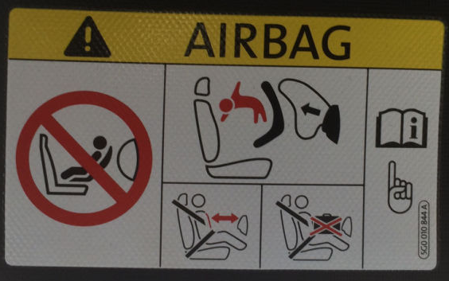

**This intrusive information is not related to child safety and thus reduces the clarity, putting children at risk**

2. The text on the warning not to use a rearward facing child restraint on a seat protected by an active airbag shall be included in the owner’s manual. Moreover, this warning shall be provided in all official languages of the country or countries where the vehicle could reasonably be expected to be registered. However, certain vehicle types are sold in the European Union market with the important warning only in one official language of the country where the vehicle is initially shipped by the manufacturer. Since, child safety should be one of the top priorities for all vehicle manufacturers the relevant requirements are more explicitly clarified.

3. Moreover, it seems that there are diverging interpretations on the wording: ‘pictogram images shall be grouped, exact or larger’. Notably, that pictogram images do not appear exactly as prescribed by the relevant regulations. It seems that altered versions are being authorised despite the clear rules, as shown in these examples.

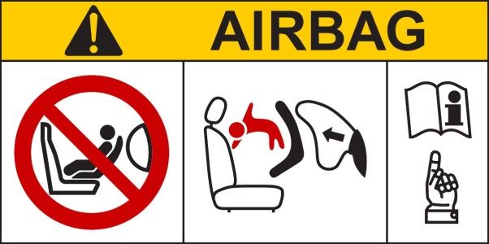

**Label as prescribed in the regulations**

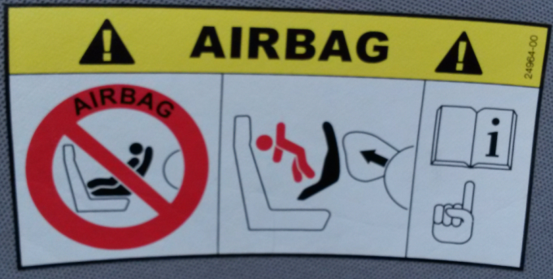 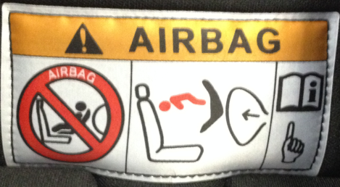

**Labels as found in the field with altered pictogram images**

4. To provide the same harmonized basis for all the actors involved in the development, production and approval process of the warning labels, clarifications on what is and what is not permitted are deemed necessary.

5. Particularly, to ensure that there is no degradation of the level of safety for children transported in cars, any label that is not in compliance should be brought in line with the key aim of the legislative text on airbag warning labels.

1. \* In accordance with the programme of work of the Inland Transport Committee for 2012–2016 (ECE/TRANS/224, para. 94 and ECE/TRANS/2012/12, programme activity 02.4), the World Forum will develop, harmonize and update Regulations in order to enhance the performance of vehicles. The present document is submitted in conformity with that mandate. [↑](#footnote-ref-2)