Submitted by the expert from Hungary Informal document GRSG-108-15
(108th GRSG, 4-8 May 2015
Agenda item 4)

Proposal for amendments to UN Regulation No. 43
(Safety glazing)

The aim of this proposal is to specify clearly the parameters of the abrasion test machine.

Proposal

Annex 3, Figure 4, shall be replaced by this diagram:

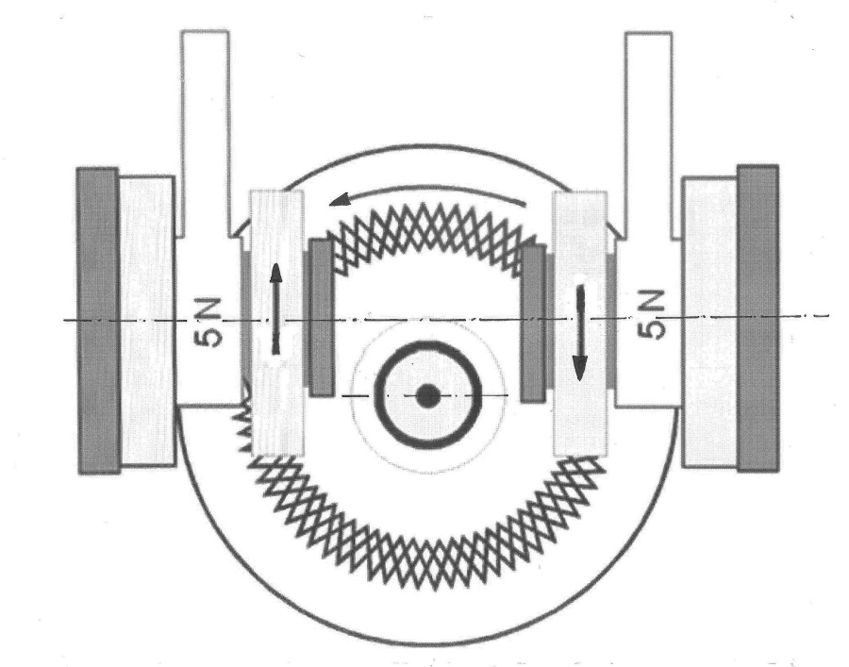

Annex 3, paragraph 4.1.1., inserted after the 2nd sub-paragraph the following text:
"The distance between the symmetry planes of the wheels shall be 65 mm and the offset of the wheel axis from the turntable axis shall be 19 mm.
Wheels shall seat evenly on the specimen in their full width so that abrasion shall be nearly the same in the full width of the abraded area. Abraded particles shall be sucked away during the test so that they do not influence abrasion."

Justifications

- The offset of the axis and the distance of the wheels are not specified and Figure 4 shows no offset between the axes. However, this offset and this distance have an extremely high influence to the sliding between the wheels and the glass, i.e. to the abrading effect; therefore they shall be specified by all means.
- Description of the method shall comply with the parameters of the Taber instrument which is referred in the Regulation.
_____________________

