Transmitted by the experts from Germany and Japan | Informal document GRE-73-17  (73rd GRE, 14 - 17 April 2015,  agenda item 6 (b))

Proposal for the [07] series of amendments to Regulation No. 48 (Installation of lighting and light-signalling devices)

The text reproduced below was prepared by the experts from Germany and Japan to reduce glare problems for drivers by imposing automatic levelling. The modifications to the existing text of the Regulation are marked in bold for new or strikethrough for deleted characters.
I. Proposal
List of Annexes,
Annex 8, shall be deleted
Annexes 9 to 15, renumber as Annexes 8 to 14
Paragraph 2.7.1., footnote *, amend to read:
∗ For clarification see Annex 9.
Paragraph 2.34., amend to read:
"2.34. "Gonio(photo)meter system (if not otherwise specified in a particular Regulation)" means ... (see Annex 14 to this Regulation). …."
Paragraph 4.2., amend to read:
"4.2. An approval number shall be assigned to each type approved. Its first two digits (at present [07], corresponding to the [07] series of amendments) shall indicate the series …."
Paragraph 6.1.9.3.3.2., amend to read:
"6.1.9.3.3.2. A test drive according to paragraph 1 in Annex 11..... "
Paragraph 6.2.6.2.2., shall be deleted
Paragraph 6.2.6.2.3., renumber as 6.2.6.2.2. and amend to read:
"6.2.6.2.2. In the event of a failure of devices described in paragraphs 6.2.6.2.1. and 6.2.6.2.2., the dipped-beam shall not assume a position on which the dip is less than it was at the time when the failure of the device occurred."
Paragraph 6.2.7.6.1., amend to read:
"6.2.7.6.1. The dipped-beam headlamps shall be...according to the requirements of Annex 12; or"
Paragraph 6.2.7.6.1., amend to read:
"6.2.7.6.3.3. A tell-tale visual, auditory or both, shall be activated only in reduced ambient lighting conditions as defined in Annex 12..... "
Paragraph 6.2.9., amend to read:
"6.2.9. Other requirements
The requirements of paragraph 5.5.2. shall not apply to dipped-beam headlamps.
Dipped-beam headlamps with a light source or LED module(s) producing the principal dipped-beam and having a total objective luminous flux which exceeds 2,000 lumens shall only be installed in conjunction with the installation of headlamp cleaning device( s) according to Regulation No. 45.
With respect to vertical inclination the provisions of paragraph 6.2.6.2.2. above shall not be applied for dipped-beam headlamps:
(a) With LED module(s) producing the principal dipped-beam, or
(b) With a light source producing the principal dipped-beam and having an objective luminous flux which exceeds 2,000 lumens.
In the case of filament lamps for which more than one test voltage is specified, the objective luminous flux which produces the principal dipped-beam, as indicated in the communication form for the type approval of the device, is applied.
..... "
Paragraph 6.21.5.1., amend to read:
"6.21.5.1. for rear conspicuity markings (see Annex 10, Figure 1a and 1b) the …"
Paragraph 6.21.5.2., amend to read:
"6.21.5.2. for side conspicuity markings (see Annex 10, Figure 2)…"
Paragraph 6.22.6.3., amend to read:
"6.22.6.3. Horizontal orientation:
...., as defined according to Annex 9 of Regulation No. 123. "
Paragraph 6.22.9.2.4., amend to read:
"6.22.9.2.4. To verify, .... , the technical service shall perform a test drive according to paragraph 2 in Annex 11. .... "
Paragraph 6.24.9.3., amend to read:
"6.24.9.3. .... in Annex 13. "
Paragraph 6.26.9.1., amend to read:
"6.26.9.1. . ... in Annex 13. "Paragraph 8.2.2., amend to read:
"8.2.2. ensure that …in Annex 8 to …"
Insert a new paragraph 12.6., to read
"12.6. Transitional provisions applicable to 07 series of amendments
Contracting Parties applying this Regulation:
From [1 September 20XX] (XX months after the date of entry into force) shall grant approvals only if the vehicle type to be approved meets the requirements of this Regulation as amended by the 07 series of amendments."
Annex 2, amend to read:
“Annex 2
Arrangements of Approval Marks
Model A
(See paragraph 4.4. of this Regulation)
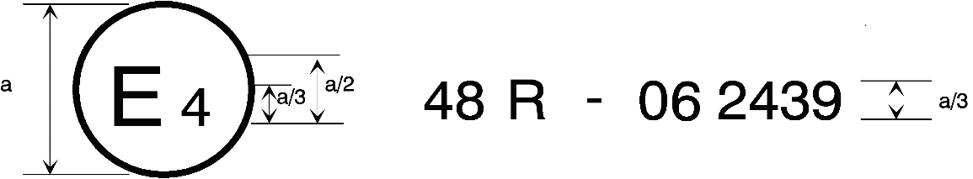
07
a = 8 mm min.
The above … Regulation No. 48 as amended by the [07] series of amendments. The approval number indicates that the approval was granted in accordance with the requirements of Regulation No. 48 as amended by the [07] series of amendments.
Model B
(See paragraph 4.5. of this Regulation)
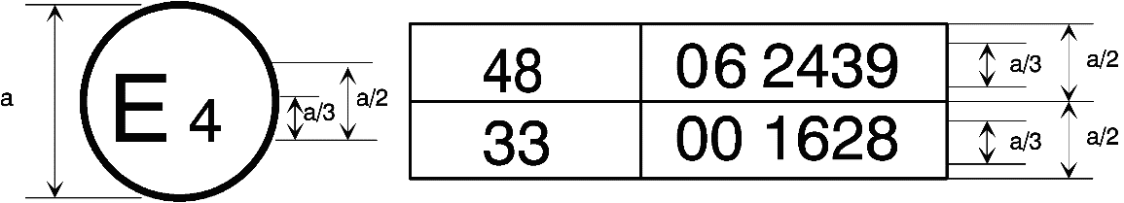
07
a = 8 mm min.
The above … Regulation No. 48 as amended by the [07] series of amendments and Regulation No. 33. The approval number indicates that, at the dates when the respective approvals were given, Regulation No. 48 was amended by the [07] series of amendments and Regulation No. 33 was still in its original form."
Annex 6, paragraph 5.5., amend to read:
"5.5. Measurements
The variation of … with paragraph 5.2. above.
If the vehicle is fitted with a manual headlamp-levelling system, the latter shall be adjusted to the positions specified by the manufacturer for given loading conditions (according to Annex 5)."
Annex 8, shall be deleted
Annexes 9 to 15 (former), renumber as Annexes 8 to 14
II. Justification
1. This proposal is aimed at reducing glare problems for drivers to improve road traffic safety by deleting an old exemption in Regulation No. 48 that allows manual leveling for dipped-beam headlamps, which was established forty years ago with the introduction of automatic leveling. At that time automatic leveling was becoming mandatory and manual leveling was allowed to manufacturers to provide a simple and cheap alternative at the beginning and for a certain period only.
2. Automatic leveling for all headlamps became mandatory at the beginning of the 1990s, starting with manual leveling (later only in limited cases). However, even at that time it was still a challenge for the manufacturers to ensure that all types of vehicles would meet this requirement. But the technical progress over the last two decades no longer justifies this exemption.
3. The experience over the years (especially during periodical inspections) has shown that many vehicle drivers do not know how to handle such manual leveling devices and/or use them (un)intentionally in a wrong way. Wrong use especially can worsen, or even cause, glare instead of actually avoiding it (which was one of the original intentions).
4. Incorrect use of manual leveling also could lead to a (drastic) reduction of the driver’s distance visibility, thus reducing safety. This occurs for instance in cases when the control for the manual headlamp-leveling device is inadvertently left in position that gives the greatest downward inclination for the headlamps. While automatic leveling ensures optimal distance visibility and therefore can contribute significantly to an increase of night-time driving safety.
5. The improvements with respect to glare reduction and keeping the seeing-distance in an optimum will be underlined by several studies (e.g. University of Michigan Transportation Research Institute 2007-46), which was carried out in a country with a relative critical view on such aspects. Also the studies on pedestrian protection show clearly the safety benefit of a sufficient seeing distance.
6. The results of GTB organized field test showed that all headlamps, even with Halogen light sources, could cause glare for drivers depending on the pitch angles (GRE-68-38). It was made clear that light source was not a factor influencing the glare assessment, not to mention vehicle category. All this means that headlamps should have automatic leveling to solve the current glare problems on the road traffic.
7. Japan has tried to know how many accidents have happened because of glare from headlamps in Japan. As the result, our data center ITARDA (Institute of Traffic Accident Research and Data Analysis) says that at least 49 fatalities and 1,063 injuries were reported for these 10 years. We should not blink this fact even though these numbers are not so big.
8. The technical progress of recent years makes the manual operation outdated and offers safer sensor controlled solutions. From the aspect of technical progress, the environmental burden and road safety, automatic leveling devices must be accepted with not a little cost-benefit. Therefore, the experts from Germany and Japan propose, as a next step to improve road traffic safety, that vehicle should be equipped with automatic leveling, by deleting this old exemption which still allows manual operation of a leveling device for the dipped-beam headlamps.
9. Furthermore, by deleting provision which causes different treatment LED from other light sources, this proposal will promote the shift to the use of LEDs which contribute to a decrease of CO₂ emissions by 1.0g according to the technical guidelines of the European Union (EU) (GRE/2014/34).
10. According to European legislation, new types of vehicles shall be fitted with Electronic Stability Control (ESC), starting from the end of 2011 (depending on vehicle category). And new vehicles (existing types) shall be fitted with ESC no later than by the end of 2014. All this means that currently new vehicles are equipped with a basic electronic network, thus enabling manufacturers to equip their vehicles with sensors for automatic leveling with little additional effort and cost. Moreover, the manual leveling control unit on the dashboard will no longer be needed, which may actually provide an additional saving.

Contracting Parties to the respective regulations can still prohibit the use of mechanical cleaning systems when headlamps with plastic lenses, marked "PL", are installed.
The second number is given merely as an example.

