Revised proposal for Supplement 5 to the 01 series of amendments to Regulation No. 119 (Cornering lamps)
Note: This informal document is replacing document ECE/TRANS/WP.29/GRE/2015/19. The modifications to the existing text of the Regulation are marked in bold for new or strikethrough for deleted characters.
I. Proposal
Paragraph 1.1., renumber as 1.1.1.
Insert a new paragraph 1.1.2. to read:
"1.1.2. "Side illuminating lamp" means a lamp used to provide supplementary illumination of the part of the road which is located on the left side (for right hand traffic) or on the right side (for left hand traffic) of the vehicle to improve road visibility for oncoming drivers in situation when they are exposed for headlights glare."
Paragraph 1.2., amend to read:
"1.2. "Cornering lamps or side illuminating lamp of different types" means lamps which differ in such essential respects as: …"
Paragraphs 6.1. to 6.5., renumber as 6.1.1. to 6.1.5., respectively.
Insert a new paragraph 6.1. to read:
"6.1. Cornering lamp"
Renumbered paragraph 6.1.1 ammend to read
6.1.1 The intensity … in paragraphs 6.1.2. and 6.1.3. The intensity shall be…
Insert new paragraphs 6.2. to 6.2.4. to read:
"6.2. Side illuminating lamp
6.2.1. The intensity of light emitted by lamp shall be at least the minimum intensity and not greater than the maximum intensity specified in paragraphs 6.2.2. and 6.2.3. The intensity shall be measured in relation to the axis of reference in the directions shown below (expressed in degrees of angle with the axis of reference).
6.2.2. The minimum intensity of the light between the specified measuring points shall be not less than 500 cd for 4.0 D and 150 cd for 10 D. Below the 4.0 D and above 10 D, 80 FRONT and 80 REAR line shall be not less than 200 cd. Below the 10 D and above 20 D, 80 FRONT and 80 REAR line shall be not less than 100 cd. At the specified measuring points shall be as follows:
(a) 4 D – 60 FRONT : 2500 cd
(b) 4 D – 0 SIDE: 500 cd
(c) 4 D – 60 REAR: 2500 cd
(d) 10 D – 60 FRONT: 500 cd
(e) 10 D – 0 SIDE: 150 cd
(f) 10 D – 60 REAR: 500 cd
6.2.3. The intensity of the light emitted in all directions shall not exceed:
(a) 60 cd above the 1.0 U, 90 FRONT and 90 REAR line;
(b) 200 cd between the horizontal plane and the 1.0 U, 90 FRONT and 90 REAR line; and
(c) 20,000 cd below the 3.5 D, 80 FRONT and 80 REAR line;
(d) 2,500 cd between the 2 D, 3.5 D line and 80 FRONT and 80 REAR line
(e) 600 cd below the horizontal plane to 2 D line, and in any directions not prescribed above. "
Annex 1, amend to read:
"…
of a type of cornering lamp/side illuminating lamp pursuant to Regulation No. 119
…"
Annex 3,
Paragraph 2.1., renumber as 2.1.1.
Insert a new paragraph 2.1. to read:
"2.1. Cornering lamp"
Former paragraph 2.1.1., renumber as 2.1.1.1.
Insert new paragraphs 2.2., 2.2.1. and 2.2.1.1. to read:
"2.2. Side illuminating lamp

3.5º

80º
0º
80º
2º

H
20º
4º
10º

2º

H
20º
4º
10º

500
min.
2500
min.
2500
min.
150
min.
500
min.
500
min.
3.5º

60º
0º
60º

= = Minimum intensity in cd

REAR
FRONT

2.2.1. Field of geometric visibility

Figure 3

Reference axis
Vehicle
FRONT

80FRONT
80REAR

Figure 4

TOP
20D
2D
Reference axis

Vehicle

2.2.1.1. The directions H = 0° and V = 0° correspond to the axis of reference. On the vehicle, they are horizontal, perpendicular to the median longitudinal plane of the vehicle and oriented to the left side of vehicle. They pass through the centre of reference. The values shown in the table give the minimum intensities in cd for the various directions of measurement."
II. Justification
When vehicles pass in the opposing direction, drivers are exposed to headlamp glare. Visibility is impaired. Also, the practical road illumination distance of passing beams adjusted according requirements of Reg. 48 can be limited to 20-50 m. It is illustrated on Fot.1.

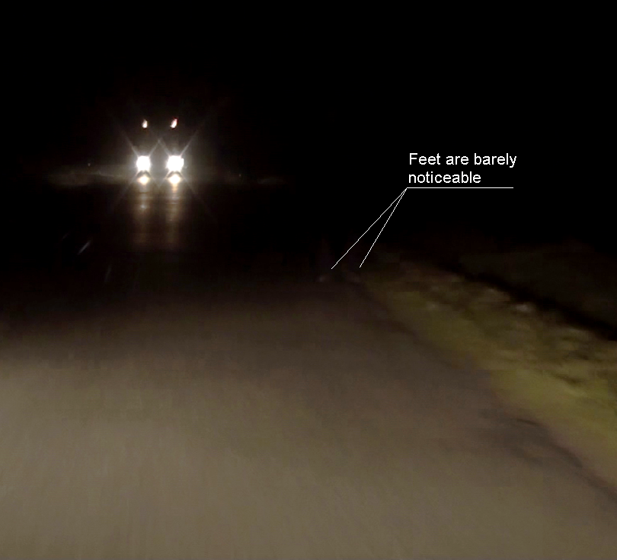
Fot. 1. Real situation. By using typical passing beam pedestrians wearing dark clothes can be seen only at very close distance.
Visibility could be significantly improved by introducing supplementary light emitted by additional “side illuminating lamp” for that part of the road which is located on the left side (for right hand traffic) or right side(for left hand traffic) of approaching vehicles where pedestrians, animals, etc. are “invisible” to the glared driver. It is illustrated on Fot.2.

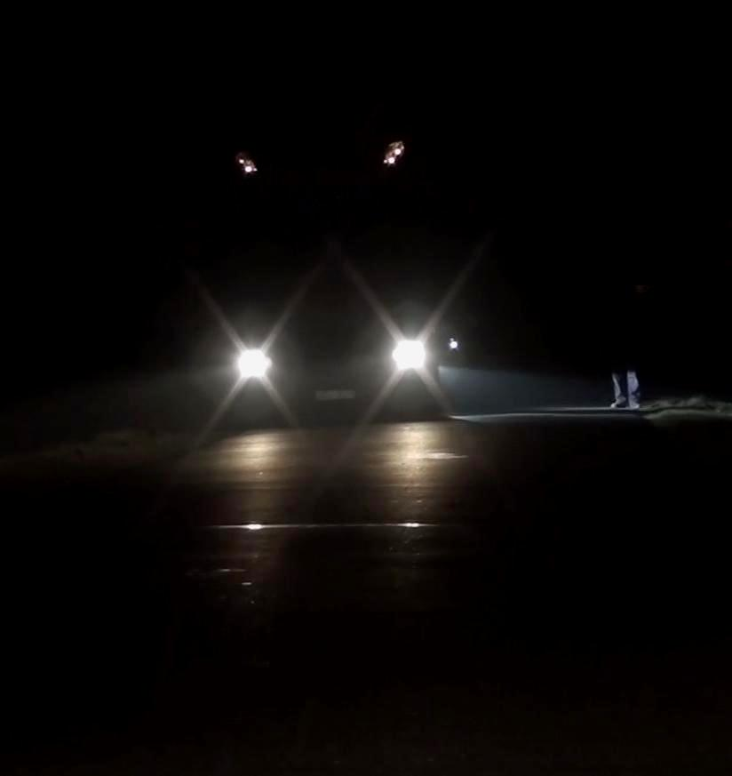
Fot. 2. Side illuminating lamp perfectly illuminates pedestrian’s leg even in black trousers.

Many following vehicles in typical situation of dense traffic equipped with such lights can provide additional illumination at a much greater distance to oncoming drivers. Because these lights are directed down and to the side they not hamper other road users. These are similar to cornering lights but are much less visible to other road users.
Test made with few such lamps in traffic showed that they are very helpful.
These lamps are to be introduced as optional.

Strikethrough as appropriate

