|  |  |  |  |
| --- | --- | --- | --- |
|  | United Nations | ECE/TRANS/WP.29/GRE/2015/38 | |
| _unlogo | **Economic and Social Council** | | Distr.: General  6 August 2015  Original: English |

**Economic Commission for Europe**

Inland Transport Committee

**World Forum for Harmonization of Vehicle Regulations**

**Working Party on Lighting and Light-Signalling**

**Seventy-fourth session**

Geneva, 20–23 October 2015

Item 7 (c) of the provisional agenda

**Other Regulations - Regulation No. 50 (Position, stop, direction indicators lamps for mopeds and motorcycles)**

Proposal for Supplement 18 to Regulation No. 50 (Position, stop, direction indicators lamps for mopeds and motorcycles)

Submitted by the expert from the International Motorcycle Manufacturers Association[[1]](#footnote-2)\*

The text reproduced below was prepared by the expert from the International Motorcycle Manufacturers Association (IMMA) to amend the angle of incidence for the rear registration plate illuminating device in Regulation No. 50 taking into consideration the availability of a new technology. The document is based on informal document GRE-73-16. The modifications to the existing Regulation are marked in bold for new or strikethrough for deleted characters.

**I. Proposal**

*Annex 5, paragraph 3.,* amend to read:

"3. Angle of incidence

The manufacturer of the illuminating device shall specify one or more or a field of positions in which the device is to be fitted in relation to the space for the registration plate~~; when the lamp is placed in the position(s) specified by the manufacturer the angle of incidence of the light on the surface of the plate does not exceed 82° at any point of the surface to be illuminated, this angle being measured from the mid-point of the edge of the illuminating surface of the device which is furthest from the surface of the plate. If there is more than one illuminating device, the foregoing requirement shall apply only to the part of the plate intended to be illuminated by the device concerned.~~

The device shall be so designed that no light is emitted directly towards the rear, with the exception of red light if the device is combined or grouped with a rear lamp."

II. Justification

1. The angle of incidence was developed to ensure illuminating of the plate. However, with new technologies (example: light emitting diodes) the performance requirements in Annex 5, paragraph 1 "Space to be illuminated" and in Annex 5, paragraph 5 "Photometric characteristics" can be met without the need to maintain the angle of incidence.

2. This proposal will NOT change the performance of illumination of the plate.

3. This proposal allows for design packaging flexibility only (see Figure 1 below).

**Figure 1**

**Illumination of the plate**

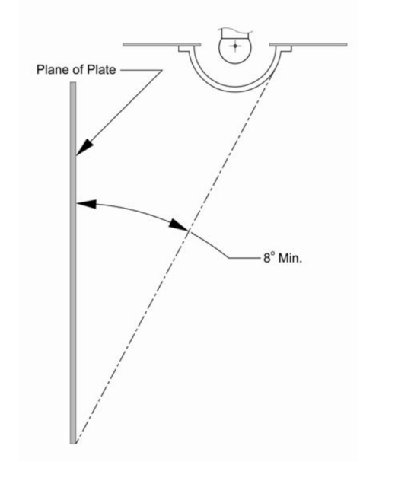

1. \* In accordance with the programme of work of the Inland Transport Committee for 2012–2016 (ECE/TRANS/224, para. 94 and ECE/TRANS/2012/12, programme activity 02.4), the World Forum will develop, harmonize and update Regulations in order to enhance the performance of vehicles. The present document is submitted in conformity with that mandate. [↑](#footnote-ref-2)