|  |  |  |  |
| --- | --- | --- | --- |
|  | United Nations | ECE/TRANS/WP.29/GRE/2015/36 | |
| _unlogo | **Economic and Social Council** | | Distr.: General  10 August 2015  Original: English |

**Economic Commission for Europe**

Inland Transport Committee

**World Forum for Harmonization of Vehicle Regulations**

**Working Party on Lighting and Light-Signalling**

**Seventy-fourth session**

Geneva, 20–23 October 2015

Item 7 (b) of the provisional agenda

**Other Regulations - Regulation No. 10 (Electromagnetic compatibility)**

Proposal for a Supplement to the 05 series of amendments to Regulation No. 10 (Electromagnetic compatibility)

Submitted by the expert from China[[1]](#footnote-2)\*

The text reproduced below was transmitted by the expert from China. The modifications to the current text of Regulation No. 10 are marked in bold for new or strikethrough for deleted characters.

**I. Proposal**

*Paragraph 1.3. (a),* amend to read:

"1.3. It covers:

(a) Requirements regarding the immunity to radiated and conducted disturbances for functions related to direct control of the vehicle, related to driver, passenger and other road users' protection, related to disturbances, which would cause confusion to the driver or other road users, related to vehicle data bus functionality, related to disturbances, which would affect vehicle statutory data**,** **related to charging mode when coupled to the power grid;**"

*Paragraph 7.4.2.,* amend to read:

"7.4.2. Vehicle type approval limit

7.4.2.1. If measurements are made using the method described in Annex 12, the limits for rated current ≤ 16 A per phase and not subjected to conditional connection are those defined in IEC 61000-3-3, paragraph 5**;**

**- the value of Pst shall not be greater than 1.0;**

**- the value of Plt shall not be greater than 0.65;**

**- the value of d(t) during a voltage change shall not exceed 3.3 per cent for more than 500 ms;**

**- the relative steady-state voltage change, dc, shall not exceed 3.3 per cent;**

**- the maximum relative voltage change dmax, shall not exceed 4 per cent.**

7.4.2.2. If measurements are made using the method described in Annex 12, the limits for rated current > 16 A and ≤ 75 A per phase and subjected to conditional connection are those defined in IEC 61000-3-11, paragraph 5**;**

**- the value of Pst shall not be greater than 1.0;**

**- the value of Plt shall not be greater than 0.65;**

**- the value of d(t) during a voltage change shall not exceed 3.3 per cent for more than 500 ms;**

**- the relative steady-state voltage change, dc, shall not exceed 3.3 per cent;**

**- the maximum relative voltage change dmax, shall not exceed 4 per cent.**"

*Annex 4, Appendix 1, Figure 1,* delete.

*Annex 6, paragraph 4.1.*, amend to read:

"4.1. …

Frequency step size and dwell time shall be chosen according to ISO 11451-1.

**Recommendations on the frequency step size are given in the table below:**

|  |  |  |
| --- | --- | --- |
| *Frequency (MHz）* | *Step size  (MHz）* | *Logarithm step size  (percentage）* |
| 20 < f ≤ 200 | 5 | 5 |
| 200 < f ≤ 400 | 10 | 5 |
| 400 < f ≤ 1 000 | 20 | 2 |
| 1 000 < f ≤ 2 000 | 40 | 2 |

"

*Annex 6, paragraph 5.1.2.*, amend to read:

"5.1.2. Calibration

~~For TLS one field probe at the facility reference point shall be used.~~

**For antennas one field probe at the vehicle reference point shall be used for category L vehicles.**

For antennas four field probes at the ~~facility~~ **vehicle** reference line shall be used **for categories M, N, O vehicles.**"

II. Justification

*Paragraph 1.3. (a)*

1. This proposal is consistent with paragraph 2.12. "Immunity related functions".

*Paragraph 7.4.2.*

2. The maximum relative voltage change dmax is different for different devices in standards IEC 61000-3-3 and IEC 61000-3-11 and should be clearly defined.

*Annex 4, Appendix 1, Figure 1*

3. The outdoor site for vehicles of category L does not meet the requirements of standard CISPR 12.

*Annex 6, paragraph 4.1.*

4. Clearly defined frequency steps can facilitate the compliance with the "90 per cent of the frequency" requirement in paragraph 6.4.2.1.

*Annex 6, paragraph 5.1.2.*

5. ISO 11451-2 prescribes two kinds of reference points, namely the facility reference point (line) and the vehicle reference point (line). They are different, as shown in Figures 1 and 2 below:

**Figure 1**

**Vehicle reference point**

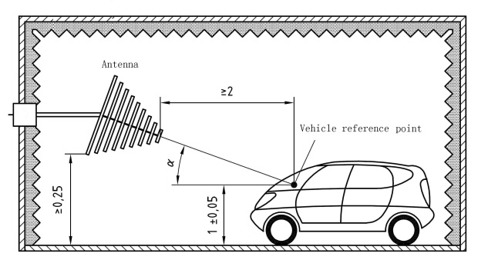

**Figure 2**

**Facility reference point**

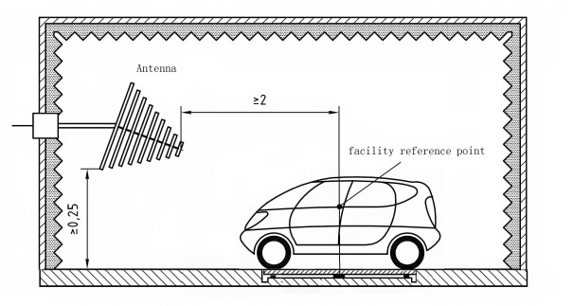

6. The calibration and actual measurement are based on the vehicle reference point. The use of the reference point can lead to the following problems:

(a) The antenna is close to the vehicle, so the reflection of vehicle body will affect the antenna's radiation efficiency.

(b) The antenna is close to the control unit located in the front part of the vehicle, so as to increase the difficulty of the test.

7. For L category vehicles, Annex 6, paragraph 3.3. clearly defines a reference point. For a single probe calibration method, it should be described separately.

1. \* In accordance with the programme of work of the Inland Transport Committee for 2012–2016 (ECE/TRANS/224, para. 94 and ECE/TRANS/2012/12, programme activity 02.4), the World Forum will develop, harmonize and update Regulations in order to enhance the performance of vehicles. The present document is submitted in conformity with that mandate. [↑](#footnote-ref-2)