|  |  |  |  |
| --- | --- | --- | --- |
|  | United Nations | ECE/TRANS/WP.29/GRE/2015/2 | |
| Description: _unlogo | **Economic and Social Council** | | Distr.: General  23 January 2015  Original: English |

**Economic Commission for Europe**

Inland Transport Committee

**World Forum for Harmonization of Vehicle Regulations**

**Working Party on Lighting and Light-Signalling**

**Seventy-third session**

Geneva, 14–17 April 2015

Item 5 of the provisional agenda

**Regulations Nos. 37 (Filament lamps), 99 (Gas-discharge light sources)   
and 128 (Light emitting diodes light sources)**

Proposal for Supplement 11 to the original series of Regulation No. 99 (Gas-discharge light sources)

Submitted by the expert from the International Automotive Lighting and Light Signalling Expert Group (GTB)[[1]](#footnote-2)\*

The text reproduced below was prepared by the expert from GTB to introduce a new category, 'D9S'. The modifications to the existing text of the Regulation are marked in bold for new or strikethrough for deleted characters.

I. Proposal

*Annex 1, List of categories of gas-discharge light sources and their sheet numbers,* amend to read:

"

| *Light source category* |  | *Sheet numbers* |
| --- | --- | --- |
| D1R |  | DxR/1 to 7 |
| D1S |  | DxS/1 to 6 |
| D2R |  | DxR/1 to 7 |
| D2S |  | DxS/1 to 6 |
| D3R |  | DxR/1 to 7 |
| D3S |  | DxS/1 to 6 |
| D4R |  | DxR/1 to 7 |
| D4S |  | DxS/1 to 6 |
| D5S |  | D5S/1 to 5 |
| D6S |  | D6S/1 to 5 |
| D8R |  | D8R/1 to 6 |
| D8S |  | D8S/1 to 5 |
| **D9S** |  | **D9S1 to 5** |

"

*List of sheets for gas-discharge light sources and their sequence in this Annex*, amend to read:

"

|  |  |
| --- | --- |
| *Sheet numbers* |  |
| DxR/1 to 7 | (Sheet DxR/6: two pages) |
| DxS/1 to 6 |  |
| D5S/1 to 5 |  |
| D6S/1 to 5 |  |
| D8R/1 to 6 |  |
| D8S/1 to 5 |  |
| **D9S/1 to 5** |  |

"

*Insert new sheets D9S/1 to 5, after D8S/5,* to read (see following pages; one page per sheet):

**Category D9S Sheet D9S/1**

The drawings are intended only to illustrate the essential dimensions (in mm)

# Figure 1

# **Category D9S - Cap PK32d-9**

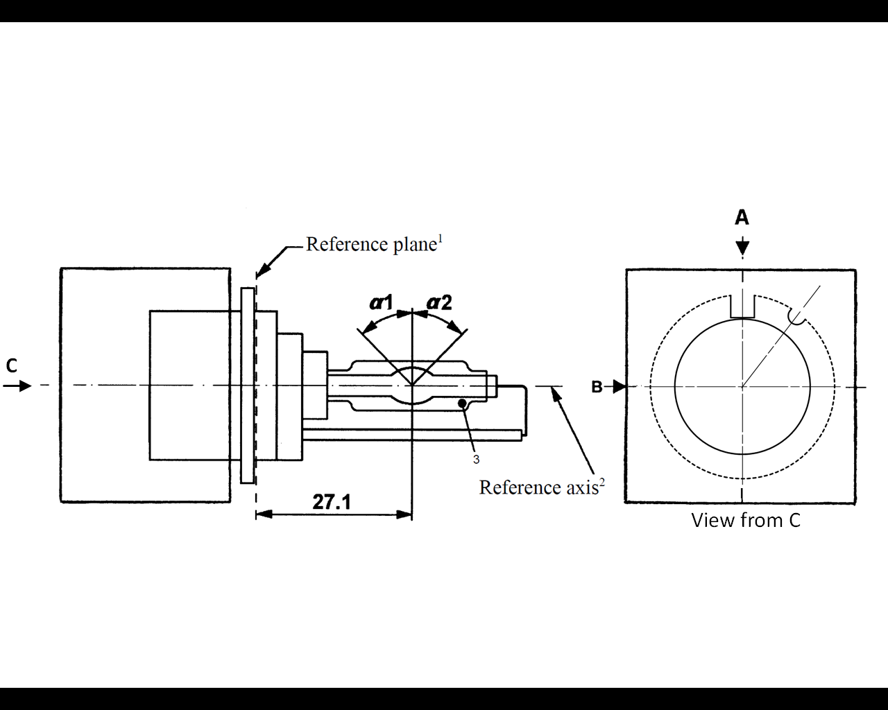

**1** The reference plane is defined by the positions on the surface of the holder on which the three supporting bosses of the cap ring will rest.

**2** See sheet D9S/2.

**3** When measured at a distance of27.1 mm from the reference plane and with respect to the mid-point of the inner bulb, the outer bulb shall have an eccentricity of 1 mm max.

**Category D9S Sheet D9S/2**

# Figure 2

# **Definition of reference axis1**

The cap shall be pushed in this direction



Reference axis

# Figure 3

# **Maximum lamp outline2**



52

**Reference axis**

**1** The reference axis is perpendicular to the reference plane and crosses the intersection of the two parallel lines as indicated in figure 2.

**2** Glass bulb and supports shall not exceed the envelope, as indicated in figure 3.The envelope is concentric with the reference axis.

**Category D9S Sheet D9S/3**

|  |  |  |  |  |  |  |  |
| --- | --- | --- | --- | --- | --- | --- | --- |
| *Dimensions* | | | | *Production*  *light sources* | | *Standard*  *light sources* | |
| Position of the electrodes | | | | Sheet D9S/4 | | | |
| Position and form of the arc | | | | Sheet D9S/5 | | | |
| α1, α2 1 | | | | 55° min. | | 55° min. | |
| D9S: Cap PK32d-9 | | in accordance with IEC Publication 60061 (sheet 7004-111-5) | | | | | |
| Electrical and photometric characteristics | | | | | | | |
| Rated voltage of the ballast | | | V | 12 2 | | 12 | |
| Rated wattage | | | W | 27 | 35 | 27 | 35 |
| Test voltage | | | V | 13.5 | | 13.5 | |
| Objective lamp voltage | | | V | 34 ± 6 | 38 ± 8 | 34 ± 4 | 38 ± 4 |
| Objective lamp wattage | | | W | 27 ± 3 | 35 ± 3 | 27 ± 0.5 | 35 ± 0.5 |
| Objective Luminous flux | | | lm | 2000 ± 300 | 3000 ± 450 | 2000 ± 100 | 3000 ± 150 |
| Chromaticity coordinates | Objective | |  | x = 0.375 | | y = 0.375 | |
| Tolerance area 3 | | Boundaries | x = 0.345  x = 0.405 | | y = 0.150 + 0.640 x  y = 0.050 + 0.750 x | |
| Intersection  points | x = 0.345 | | y = 0.371 | |
| x = 0.405 | | y = 0.409 | |
| x = 0.405 | | y = 0.354 | |
| x = 0.345 | | y = 0.309 | |
| Hot-restrike switch-off time | | | s | 10 | | 10 | |

**1** The part of the bulb within the angles α1 and α2 shall be the light emitting part. This part shall be as homogeneous in form as possible and shall be optically distortion free. This applies to the whole bulb circumference within the angles α1 and α2.

**2** Application voltages of ballasts may differ from 12 V.

**3** See Annex 4.

**Category D9S Sheet D9S/4**

Position of the electrodes

This test is used to determine whether the electrodes are correctly positioned relative to the reference axis and the reference plane.

Side and top view (schematic):

Reference axis

a2

b2

25.6mm from reference plane

c

Reference plane

a1

b1

Measuring direction: light source side and top view

The arc attachment point to the electrode nearest to the reference plane shall be positioned in the area defined by a1 and b1. The arc attachment point to the electrode furthest from the reference plane shall be positioned in the area defined by a2 and b2. The geometrical data is valid for 27W and 35W operation.

|  |  |  |
| --- | --- | --- |
| *Dimension*  *in* *mm* | *Production*  *light* *sources* | *Standard*  *light* *sources* |
| a1 | 0.30 | 0.20 |
| a2 | 0.50 | 0.25 |
| b1 | 0.30 | 0.15 |
| b2 | 0.60 | 0.30 |
| c | 3.00 | 3.00 |

**Category D9S Sheet D9S/5**

Position and form of the arc

This test is used to determine the form of the arc and its position relative to the reference axis and the reference plane by measuring its bending and diffusion in the cross section at a distance 27.1 mm from the reference plane.

|  |  |  |
| --- | --- | --- |
|  |  |  |
| Relative luminance distribution in the central cross section D. | The form of the arc is for illustration purpose only. | Measuring direction:  light source side view |

When measuring the relative luminance distribution in the central cross section as indicated in the drawing above, the maximum value shall be located within the distance r from the reference axis. The point of 20 per cent of the maximum value shall be within s. The geometrical data is valid for 27W and 35W operation.

|  |  |  |
| --- | --- | --- |
| *Dimension* *in* *mm* | *Production* *light* *sources* | *Standard* *light* *sources* |
| r (arc bending) | 0.35 +/- 0.25 | 0.35 +/- 0.15 |
| s (arc diffusion) | 0.80 +/- 0.25 | 0.80 +/- 0.15 |

**II. Justification**

1. This proposal introduces a short arc, high luminance dual level gas-discharge light source category optimized for modern headlamp systems.

2. The proposal describes a high intensity gas discharge light source category with optimized parameters like significantly increased luminance (+50 per cent) and reduced electrode distance (3 mm). The higher luminance enables a more compact headlamp design and improved beam performance.

3. The dual power mode helps to enable systems with optimised performance, including adaptive systems (e.g. ADB).

1. \* In accordance with the programme of work of the Inland Transport Committee for 2012–2016 (ECE/TRANS/224, para. 94 and ECE/TRANS/2012/12, programme activity 02.4), the World Forum will develop, harmonize and update Regulations in order to enhance the performance of vehicles. The present document is submitted in conformity with that mandate. [↑](#footnote-ref-2)