Japan’s Comments on ECE/TRANS/WP.29/GRB/2015/3

The following are Japan’s comments regarding a proposal to relax certain regulatory limits (“Relaxation Proposal”) in the document ECE/TRANS/WP.29/GRB/2015/3, which was drawn up at the R51-IWG meeting on 29 October 2014.

I. Discussions
(i). Background to the Inclusion of the Relaxation Proposal in the R51-03 Amendment Proposal
At the 60th session of GRB held in September 2014, the proposal for the 03 series of amendments to Regulation No. 51 (“R51-03”) was adopted and was to be submitted to WP.29 in March as ECE/TRANS/WP.29/2015/3. In this GRB session, it was concluded that the Relaxation Proposal would not be included in the R51-03 but would be added to the Amendment List so that Contracting Parties could continue to discuss this issue at R51-IWG.

At the R51-IWG meeting held on 25 September 2014, it was agreed that since it would take time for consensus to be reached regarding the Relaxation Proposal, this issue would be continued to be discussed, separately from the proposal for Supplement 1 to R51-03, which was to be submitted to GRB in January.

However, later at the R51-IWG meeting held on 29 October 2014, some Contracting Parties made the Relaxation Proposal, even though Japan insisted that technical discussions should be held. It was decided that the Relaxation Proposal would be included in the proposal for Supplement 1 to R51-03 (ECE/TRANS/WP.29/GRB/2015/3) without any technical discussion.

It is regrettable that the Relaxation Proposal was included in the R51-03-Supplement 1 proposal (ECE/TRANS/WP.29/GRB/2015/3) without any technical discussion.

(ii). Possible Impact of the Relaxation Proposal on the Contracting Parties (including Japan)
The objective of the Relaxation Proposal is to relax regulatory limits, and the limits to be relaxed should be determined based on the consideration of its possible impact on negative impact in Contracting Parties.

In Japan, as shown below, currently there are about 47,000 vehicles (based on the annual sales volume) that are applicable to the Relaxation Proposal. However, it has been verified that these vehicles are able to comply with the Phase 1 limits.

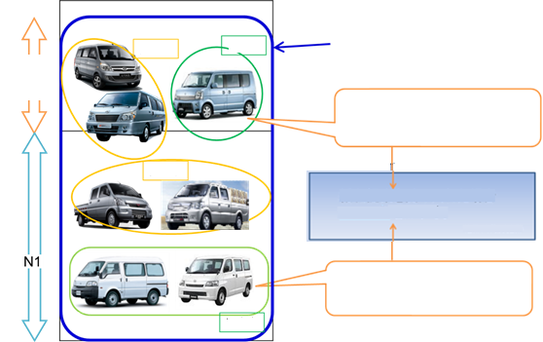
Relaxation Proposal:
(M1 derived from N1, N1 (GVW≤2.5 tons) + R-point height > 800 mm + the centre point of gravity of the engine is between 300 mm and 1,500 mm behind the front axle + Rear drive)
M1 derived from N1

If the Relaxation Proposal is accepted, the number of applicable vehicles will rise to 46,768 vehicles (based on the annual sales volume).
MAZDA, TOYOTA
22,768 vehicles
(based on the annual sales volume)
SUZUKI
24,000 vehicles
(based on the annual sales volume)
Japanese vehicles

Proposed vehicles

Japanese vehicles

Proposed vehicles

(iii). Amendment of Regulatory Limits as Part of Series of Amendments
The Relaxation Proposal is a proposal relating to regulatory limits. According to the General Guidelines for un Regulatory Procedures and Transitional Provisions in un regulations (ECE/TRANS/WP.29/1044/Rev.1), amendment proposals relating to regulatory limits should not be part of a Supplement and should take the form of series of amendments. Hence, proposals to relax regulatory limits should not be submitted as part of a Supplement.

II. Conclusions
Sufficient technical discussions on the Relaxation Proposal have yet to be held. Moreover, since the Relaxation Proposal is a proposal that addresses relaxation of regulatory limits, it is necessary to sufficiently study its possible impact on Contracting Parties. It gives negative impact as far as Japan is concerned. In addition, an amendment proposal relating to regulatory limits needs to be submitted as part of series of amendments and not as part of a Supplement. Japan is ready to address and discuss these issues sufficiently at GRB.

Page 11 of ECE/TRANS/WP.29/2015/3 , “add a new paragraph 11.8.”

