UNECE and automated vehicles
I. IWG on ITS/AD
Documentation: ECE/TRANS/WP.29/1114, Annex III
1. The mandate of the Informal Working Group (IWG) on Intelligent Transport Systems / Automated Driving (ITS/AD) specifies the work items to be covered by the activities of the group based on three pillars:
(a) Prepare a proposal with harmonized definitions of Automated Driving Technologies (ADT)
(b) Identify the main horizontal issues and legal obstacles to automated driving technologies and, where possible and appropriate, those not within the remit of WP.29.
(c) Prepare a proposal on harmonized general guidelines for eSecurity and eSafety in motor vehicles.
2. In addition, the group is exchanging information on driverless technologies.
II. GRRF and the IWG on ACSF
A. Automated commanded steering functions (ACSF)
Documentation: ECE/TRANS/WP.29/GRRF/80, Annex V
3. The IWG on ACSF gave a status report to GRRF at the September 2015 session. The group is reviewing the requirements and limitations associated with Automatically Commanded Steering Function technology (ACSF) as defined in Regulation No. 79. Especially, the group is reviewing the current speed limitation (10 km/h) with the purpose of permitting ACSF functionality during interurban journeys; it is defining the Human Machine Interphase (HMI) requirements as well as requirements to enable the evaluation of ACSF during periodic technical inspection. The provisions for ACSF shall request that the driver shall be able to activate and deactivate the system and at all times, be able to override the system.
4. The group didn't use the definitions of automation levels as a basis for its work. It defined five categories (A to E) of ACSF systems with various degrees of automation. The following figure shows the current structure of the discussed proposal:
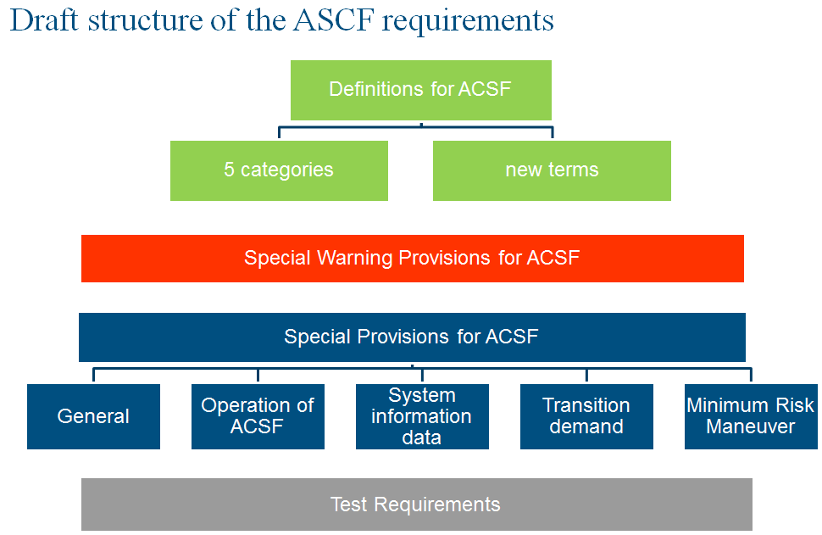
Content of the draft Annex 7
B. Remote Control Parking (RCP)
Documentation: GRRF-80-18
5. In February 2015, GRRF received a proposal from Japan and German introducing in R.E.3 provisions on Remote Control Parking. GRRF advised the authors of the proposal to consider a new Regulation for RCP. In September 2015, GRRF received a demonstration of a vehicle equipped with RCP. A day before on 16 September 2015, the Ministers of Transport of the G7 Countries witnessed a similar demonstration in their meeting at the Frankfurt Motor Show. In their declaration, the transport ministers of the G7 States and the European Commissioner for Transport stressed that "A key prerequisite for the widespread deployment of innovative and reliable technologies in road transport is that modern vehicle systems are legally permissible and suitable for mass production. Revising, as appropriate, regulations applicable in the G7 states, and those established under the agreements administered by the UN World Forum for the Harmonization of Vehicle Regulations (WP.29) - is of crucial importance.".
6. The expert from OICA introduced GRRF-80-18 (i) presenting the system and those Regulations relevant for the type-approval of this system, (ii) concluding that RCP could by type-approved according to Regulations Nos. 79 and 13-H and (iii) in line with the requirements of the 1968 Vienna Convention on road traffic. The expert of GRRF expressed first positive comments about the systems and agreed that clarifications should be added in the relevant Regulations to capture the benefits of such systems without compromising safety. GRRF noted that even though correctly type-approved, such system would still be subject to regulations related to the use of road vehicles.
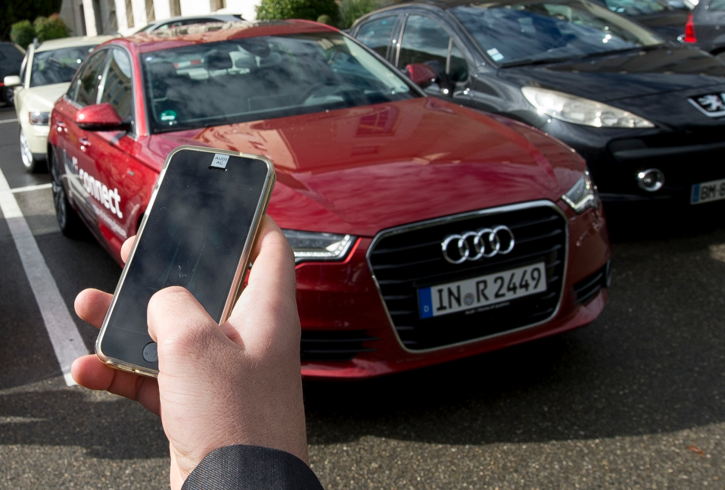
Demonstration in the Palais des Nations on 16 September 2015
III. GRSG – Event Data Recorder (EDR)
7. During the October 2015 session of GRSG, the expert from UK recalled the discussion on EDR subject at the previous GRSG session and acknowledged that the wording "Event Data Recorder" was probably not the correct terminology and could be misleading. The expert from Germany underlined the importance to exchange view in GRSG on this specific subject. He stressed the need to develop a new Regulation on optional installation on vehicles of such devices and to define the technical parameters to be stored, including the access and security of the data. GRSG endorsed that position and agreed that such an activity should be coordinated with ITS/AD and other Working Parties involved in automated driving activities, such as GRRF. The expert from UK volunteered to prepare a concrete proposal on the possible distribution of these tasks within the subsidiary bodies of WP.29, for consideration at the next GRSG session.
IV. WP.1 activities
Documentation: ECE/TRANS/WP.1/145 (Annex)
8. The amendment to the 1968 Vienna Convention on Road Safety, introducing Paragraph 5bis to Article 8 below, will enter into force on 23 March 2016.
"5bis. Vehicle systems which influence the way vehicles are driven shall be deemed to be in conformity with paragraph 5 of this Article and with paragraph 1 of Article 13, when they are in conformity with the conditions of construction, fitting and utilization according to international legal instruments concerning wheeled vehicles, equipment and parts which can be fitted and/or be used on wheeled vehicles*
Vehicle systems which influence the way vehicles are driven and are not in conformity with the aforementioned conditions of construction, fitting and utilization, shall be deemed to be in conformity with paragraph 5 of this Article and with paragraph 1 of Article 13, when such systems can be overridden or switched off by the driver."
Documentation: ECE/TRANS/WP.1/149/Add.1
9. In parallel to the activities on the 1968 Vienna Convention, WP.1 decided to align the text of the 1949 Geneva Convention on Road Traffic (parent convention to the 1968 Convention) and especially the text of Article 8 with the agreed text that will enter into force in March 2016. The 1949 Geneva Convention has 96 Contracting Parties (CP), among others the USA (not CP to the 1968 Vienna Convention).
10. WP. 1 decided to establish an informal working group on automated driving. The first session was scheduled on 05 November 2015 in Amsterdam under the lead of the Netherlands.
Documentation: ECE/TRANS/WP.1/2015/8
11. WP.1 reviewed a document tabled by the governments of Belgium and Sweden, describing and analyzing the role of the driver in a vehicle with a more advanced level of automation. It also puts forward further amendment proposals to Article 8 of the 1968 Convention on Road Traffic.
V. Other relevant subjects not yet addressed
12. The WP.29 secretariat is proposing to WP.29 to also focus on non-technical regulations related to automations. Other regulatory aspects such as registration, tax, enforcement and traffic fines may be taken into account. These items are not internationally harmonized but international fora could provide exchange ideas, present new principles, as well as best practices.
13. The following paragraphs contain examples known from the secretariat to highlight items which may need coordination. In France, if a car is exceeding the speed limit, the car holder is receiving the traffic fine, even though it is not demonstrated that he/she was the driver who committed the offense. In Germany a picture of the person driving the car is provided with the traffic fine. In Germany, the car insurance premium depends on the experience of the driver and previous road accidents, while in Moldova it depends on the vehicle type.
14. If nothing is done, these rules will remain the same even though one might think that they are not relevant or fitting the case of automated vehicles:
(a) If a car, in a self-driving mode, is speeding or passing a red light in France, the car owner would receive the traffic fine.
(b) The price of the insurance premium for a highly automated vehicle registered in Germany would still depend on the age of the customer, the number of kilometre driven per year and the previous road accidents and damages covered by the insurance.
(c) The maintenance would still be in the responsibility of the car owner, verified after several years by the authorities. If a car owner neglects the maintenance of his vehicle and is missing an important safety relevant software update, it would only be noticed at the PTI, provided that the PTI system is able to check this.
(d) The registration of a car is made possible upon verification of several technical properties of the vehicle usually done via vehicle approval or certification. If one of them is changed e.g. because of a software update, the car would probably have to be re-approved (?) and may even have to be re-registered (?).
15. Automated vehicles will introduce new challenges due to the communication aspect, so these new aspects may need to be under scrutiny from the beginning on. The aspect related to privacy and data collection will be a controversial issue to manage as there is no general consensus among experts and nations. Some ICT companies are collecting data and using those data to generate revenue. If these practices are accepted by private persons, not always aware of the real value of their personal data as well as the risks of sharing them, these practices may become an issue for professionals in the transport sectors.
16. In the recent years, data leaks occurred unfortunately rather regularly e.g. Sony. These data leaks may disclose publicly important information that should remain undisclosed e.g. for healthy competition reasons. Data leaks may create important market distortions and affect transport systems.
17. Addressing the issues of data privacy before connected automated vehicles are put in the market seems essential in order to continue to provide a sustainable international transport.
18. The purpose of this non-exhaustive list above is to demonstrate that several issues may rise if the regulator only focus on the technical aspect related to self-driving functions. The purpose is also to suggest that these issues are universal among the countries having cars on their roads. In order to address these issues in an efficient manner, the reflection could be conducted at the international level.

