DETA financing scheme
1. Introduction
WP.29 has considered various options to set up a system that would allow type approvals granted according to UN Regulations annexed to the 1958 Agreement to be managed electronically. The initial objective of the WP.29 discussion in 2002/2003 was to reinforce the transparency and the efficiency of the 1958 Agreement. Currently, the activities concerning the creation of an electronic Database for Exchange of Type Approvals (DETA) as well as the final adoption of draft Revision 3 to the 1958 Agreement are in the final stages and are of highest priority. . According to the provisions of each UN Regulation annexed to the 1958 Agreement, the competent authority of each Contracting Party applying a Regulation shall communicate, to the competent authority of the other Contracting Parties to the 1958 Agreement which apply that Regulation, a notice of approval or of extension or refusal of approval of a type of vehicle, equipment or parts pursuant to that Regulation. This communication should take place by means of a form following the model annexed to the Regulation. Under the current Revision 2 of the 1958 Agreement, this communication shall be done by sending paper copies via mail. To reduce the costs related to type approval documentation for all Contracting Parties, WP.29 has considered the possibility of distributing the type approval documentation electronically. Among other benefits, this system would help a Type Approval Authority keep track of whether a vehicle has already received a refusal. WP.29 has expressed the wish for DETA to be hosted by UNECE.

2. Costs estimations
A. Costs

Table 1 lists the estimated total costs for hosting DETA. The first year of operation would include initial startup costs covering the license and hardware and totaling $45,000 in addition to administrative costs of $53,000. Once the system is in operation, reoccurring costs, including operating costs and administration costs, would come up to $98,000 per year. Following UN Rules, all cost estimates must include an allotment request of 13% for support costs and a mandatory operating reserve of 15%. These percentages have been added to the total costs shown in the table.

 |  |  | Year 1 | Year 2 | Year 3 | Year 4 | Year 5
Initial start-up cost
 | Licence |  | 30 | - | - | - | -
 | Hardware |  | 15 | - | - | - | -
Recurring costs
 | Operating costs
 |  | Licence | - | 30 | 30 | 30 | 30
 |  | Hardware | - | 15 | 15 | 15 | 15
 | Administration costs
 |  | Human resources | 90 | 40 | 40 | 40 | 40
 |  | Travel costs | 3 | 3 | 3 | 3 | 3
 |  |  |  |  | 5-year system costs: |  |  | 490
 |  |  |  |  | Allotment request 13% |  |  | 63.7
 |  |  |  |  | Operating reserve 15% |  |  | 73.5
 |  |  |  |  | Total 5-years system costs: |  |  | 627
 |  |  | Average yearly costs to be allocated by Licence Fees: |  |  |  |  | 125

Table 1. Cost estimates for DETA for the five first years of operation (thousand USD)
3. DETA financing options at UNECE
A. Options to finance DETA according to the internal UNECE procedures
1. Request additional resources for the UNECE regular budget (RB)
2. Extra budgetary (XB) solutions
Guidance is provided by the ECE Directive No. 17, on Establishment of Agreements and Management of Extrabudgetary Resources on the following options:
(a) Trust fund
(b) Cooperation without any financial implication for the organization - PPP
(c) (Host Country)
B. Outcome of the WP. 29 Informal Group on DETA reviewing possible financing schemes:
WP.29 Informal Group on DETA suggested the following options for financing schemes:

(a) Fee based on usage
The fee could be set per upload, per user or per Contracting Party. The fee per upload option would be the fairest as it would charge users based on how much they use the service.
(b) The flat rate fee for each Country.
The group considered this option as a potential road block for future Contracting Parties to the 1958 Agreement, as they would have financial implications if acceding to the Agreement.
UNECE would have to establish a system for invoicing of users on a regular basis. The group was concerned by the costs that it would generate.
(c) Request additional resources for the UNECE RB.
4. Activities in 2014
The UNECE secretariat undertook the following activities in 2014:
(a) Cost reduction with the software house: WP.29 decided to reduce the availability of the hotline to the business hours (CET in Geneva).
(b) Informal presentation of the concept to ICTMG.
5. Activities in 2015
As the current UNECE RB is not addressing DETA and the UNECE management therefore preferred the XB option, other XB options were explored:
(a) Review of potential possibilities to finance projects according to the internal UNECE procedures:
(i) Directive 17 of the OES.
(ii) Focus on the establishment of trust funds.
(b) Benchmarking: Revenue producing activities of the UN.
There are examples of revenue producing activities in the UN. Usually revenue is collected from the sales of publications, but there are examples of UN agencies asking for a payment for the use of a database. One example is UNIDO with its Industrial Statistics Databases (http://www.unido.org/en/resources/statistics/statistical-databases/how-to-purchase-unido-database.html). This could perhaps be replicated at UNECE.
To set up this option would likely take time.
(c) Financing involving the software provider "T-Systems"
T-systems may see an opportunity in participating in our activities. They may be willing to partially finance the costs generated by DETA. This was addressed during the last meeting with T-Systems in March 2015, which was aimed at clarifying this possibility. As a result, two options involving T-Systems were identified, as presented below.
(i) Trust fund
In this option, the financing scheme is based on licence fees being collected from Contracting Parties using the service. These funds would be channelled to a trust fund, established by UNECE, where they would be used to cover the licencing, administration and operation costs, as described in Figure 1.
Figure 1. Financing option: Trust Fund
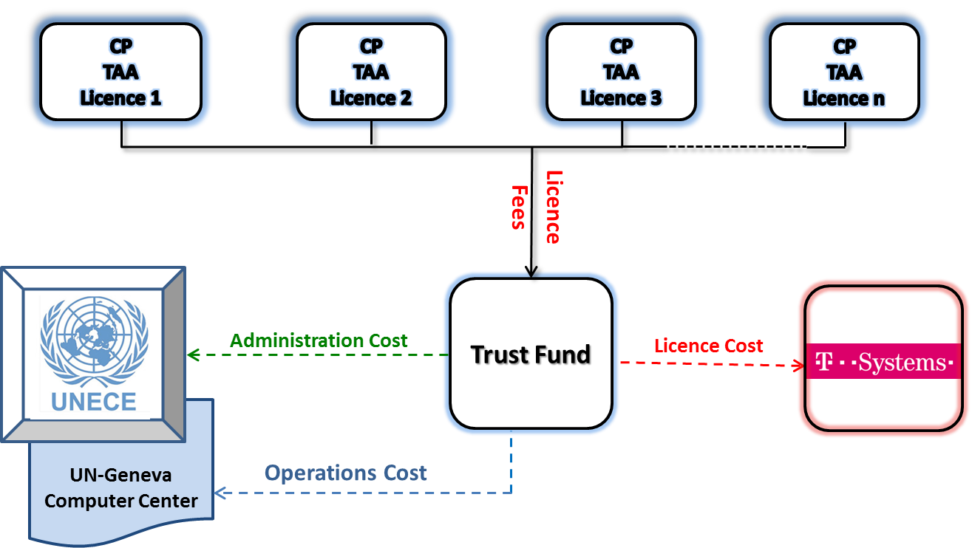
(ii) Public-private partnership (PPP)
In this option UNECE and T-Systems would form a public-private partnership, where license fees collected from Contracting Parties using the service would be channeled to T-Systems, who would then cover both administration and operations costs as described in Figure 2.
Figure 2. Financing option: Public-private partnership
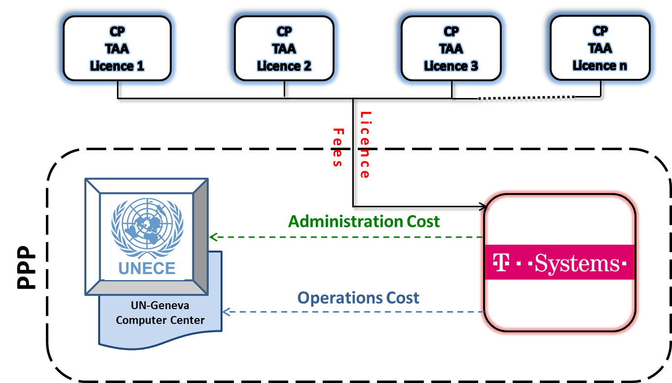
(d) Financing from one or more Contracting Party(ies)
Some Countries already announced that, in the case UNECE would be facing a budget cut or related difficulties to provide DETA, they would consider offering the DETA hosting, at least for a limited period of time.
(e) Regular budget
The informal working group on DETA had its last meeting in March 2015. It was informed about the recent cut in the UNECE regular budget and that UNECE didn't include in its Regular Budget any financing for DETA. The group stressed that the financing should be included in the Regular Budget of the UNECE as agreed by WP.29 in the past. Contracting Parties have the possibility to independently request the General Assembly and its subcommittees for a budget increase, as a separate process from the UNECE budget activities.
6. Comparison of financing options for DETA
The table below presents an assessment of the four most feasible options considered for financing DETA. It compares their ease of establishment, management and additional work load for the secretariat and the Contracting Parties as well as possible risks.
Table 1: Comparison of financing options for DETA

Financing option  Consideration |  | Trust Fund | Public-Private Partnership (PPP) | Financing by Contracting Party | Additional Regular Budget
Establishment
 | Ease of establishment | Medium based on F.238 and review by budget division | Possibly challenging: undefined procedure | Simple: decision by WP.29 and EO | Challenging: decision by GA -Depending on CPs action
 | Estimated time to establish | Medium (<1yr) | Long (>1yr) | Medium (<1yr) | Long (>1yr)
Operation/management
 | Management responsibility | UNECE | UNECE/  T-Systems | UNECE | UNECE
 | Ease of management | Special reporting required | Procedures to be agreed | Special reporting required | Similar to other regular budget activities
 | Additional workload | High | High | Medium | Low
Financing
 | Stability of financing | Slight risk of discontinuing | Slight risk of discontinuing | Risk of discontinuing | Stable
Risks
 | Transparency of operations | Transparent | Possibly less transparent | Transparent | Transparent
 | Flexibility of financing non-operational costs (e.g. travel expenses) | Flexible | Flexible | Flexible | Not flexible
 | EO= Executive Office of UNECE
 | GA= General Assembly
Based on the analysis presented in the table above, it appears that the PPP option presents additional challenges that are not envisioned in the other options. In addition, the UNECE process for establishing PPPs is not as mature. The remaining options seem to be similar in terms of feasibility, although the conditions for the implementation of each option slightly differ and depend on, for example, the willingness of Contracting Parties to pay or to take action to bring about an increase in the UNECE regular budget. The secretariat assesses the political feasibility for "additional regular budget" option questionable in times of austerity policy.
7. Sources
ECE directive No. 17 (25/11/2014)
ST/AI/284 (01/03/1982)
ST/SGB/188 (01/03/1982)
ST/SGB/2013/4
Revised UN Business Guidelines ~2009 (From a press release in iSeek)

