UN/SCEGHS/30/INF.15
Committee of Experts on the Transport of Dangerous Goods
and on the Globally Harmonized System of Classification
and Labelling of Chemicals
Sub-Committee of Experts on the Globally Harmonized
System of Classification and Labelling of Chemicals 30 November 2015
Thirtieth session
Geneva, 9 – 11 December 2015
Item 3 (e) of the provisional agenda
Classification criteria and related hazard communication:
Miscellaneous
New example for portable tanks and multi-element gas containers (MEGC’s)
Transmitted by the Dangerous Goods Advisory Council (DGAC)
Background
1. DGAC has submitted proposal ST/SG/AC.10/C.3/2015/54-ST/SG/AC.10/C.4/2015/11 for the 48th session of the Sub-Committee of Experts on the Transport of Dangerous Goods. This proposal deals with “Prohibition in transport of non-transport GHS pictograms when not in a complete GHS label”. It would add a note to the UN Model Regulations to reference new GHS section 1.4.10.4.4. The underlying purpose is to increase clarity for enforcement of proper GHS labeling on portable tanks and MEGC’s when present during transport. Unlike other transport conveyances, these are not excepted from GHS requirements during transport, and national requirements vary.
2. In addition to the note proposed for TDG, a recommendation was made during the discussion at the last session of TDG to include a new example in GHS Annex 7 for portable tanks and MEGC’s. This would illustrate the possible approaches to GHS labeling of these conveyances, which are currently not addressed by any examples. This informal proposal includes a draft example for comment which, depending on comments of the Sub-Committee, may be developed into a formal proposal for the next session.
Discussion
3. GHS states in section 1.4.10.5.1:
“1.4.10.5.1 Information required for packages covered by the UN Model Regulations on the Transport of Dangerous Goods
… The GHS pictograms not required for the transport of dangerous goods should not be displayed on freight containers, road vehicles or railway wagons/tanks.”
It is inferred from the guidance stating pictograms should not be displayed that there should also be no label, as a label by definition includes pictogram(s).
4. Portable tanks and MEGC’s are not included in the exception of 1.4.10.5.1 shown above. In discussions last biennium leading to the adoption of new GHS section 1.4.10.4.4, it was found that this omission was intentional, at least for portable tanks. These are frequently used in facilities after transport where labeling is desired. In such cases, the labeling may or may not be a complete GHS label, as alternate means of hazard communication may be feasible in industrial use which are not possible in transport. Therefore 1.4.10.4.4 was made flexible and only states:
“1.4.10.4.4 Use of GHS pictograms in transport
In transport, a GHS pictogram not required by the UN Model Regulations on the Transport of Dangerous Goods, Model Regulations should only appear as part of a complete GHS label (see 1.4.10.5.4.1) and not independently.”
This is intended to eliminate the use of “GHS placards”, meaning a pictogram of identical size to transport placards, but with no other GHS label elements, the use of which could impede transport due to uncontrolled development of non-harmonized requirements covering this voluntary approach.
5. In practice, mandatory implementations of GHS do not require GHS labels on portable tanks in transport. One regional regulation has issued guidance that portable tanks are not single packages or packages at all, and are therefore excepted in transport. Alternatively, some workplace regulations exempt transport totally, but may come into force directly after transport. Therefore it may be desirable to not use GHS labels on portable tanks through multiple jurisdictions, where varying regulations and many languages render labeling unfeasible. Alternatively, for transport within a single mono-lingual jurisdiction an efficient approach to compliance in the workplace may necessitate labeling during transport. This latter approach is likely to take the form of a mono-lingual tag at the discharge valve.
6. Given this variety of options, further guidance in the form of examples might be helpful. While the examples in GHS Annex 7 include combination packages and single packages, portable tanks and MEGC’s are not addressed. DGAC provides a draft example in case the Sub-Committee may think it useful to provide guidance. This draft uses Example 2 as the beginning basis for format and content. This proposed example only addresses dangerous goods. In keeping with the structure of Annex 7, an example for non-dangerous goods would be separate.
Definition of Container
7. During development of this proposal, it came to our attention that the definition of container includes portable tank, which is contrary to the previous understanding of the Sub-Committee.
8. According to ISO 1496, freight containers include tank containers for liquids, gases and pressurized dry cargo (ISO 1496-3). The UN Model Regulations do not exclude portable tanks nor MEGCs from the definition of freight containers, and the definitions of portable tanks and MEGCs do not exclude freight containers. The definition of portable tanks only exclude road tank vehicles, tank wagons, non-metallic tanks, gas cylinders, large receptacles, and IBCs. The specific reference to non-metallic tanks seems to imply in fact, a contrario, that metallic tanks may be covered by the definition of freight containers. Furthermore, para 6.7.1.1 of the UN Model Regulations references the International Convention for Safe Containers (CSC), (1972, as amended), and specifies that portable tanks and MEGCs that meet the definition of containers in the CSC must comply with the relevant provisions of the CSC.
9. Therefore the Sub-Committee may wish to consider a new paragraph 1.4.10.5.5.4 shown in the proposal section of this paper, as a companion to the proposed example. In light of the Sub-Committee’s desire to require full or partial GHS labels on tanks in use, a tag is now proposed as mandatory, so that as a convenience and insurance of compliance, it will already be present at the point the tank transfers from transport to use. Valid concerns were previously voiced about multi-lingual requirements and the resulting impracticality of tags. This has been addressed by limiting the warnings on the tag to the language(s) of the destination state.
10. As the addition of this new text would represent a change rather than just an example of existing practice, we propose two options. The first option would be the example without this new change, leaving the tag optional. The second option is to add the paragraph and eliminate the asterisks and notes in the example, thus making the tag mandatory. The graphic in the example remains the same in either option.
11. DGAC believes it is important to resolve the issues of GHS labeling of portable tanks in the current biennium to avoid delay and denial in transport from inconsistent implementations. As this is the second meeting of the biennium, we thought it best to mention this development for the consideration of the Sub-Committee, and return with a vetted proposal next session.
Action requested
12. The Sub-Committee may wish to consider further development of one of the following proposals for adoption at a future session in this biennium.
13. Option 1
Adopt the example shown in the following Annex.
14. Option 2
a) Adopt the example in the following Annex but eliminate the asterisks and notes.
b) Add a new paragraph as follows to the GHS:
1.4.10.5.5.4 Labelling of portable tanks and bulk containers.
The GHS label should be displayed next to the discharge devices of portable tanks and bulk containers. The language(s) used on the label should be that or those used at the place of discharge. The GHS label may take the form of a tag attached to the discharge device. The GHS label need not be displayed before or during a transport operation. It may be displayed after a transport operation and before discharge.

Annex
Example X: Portable tanks containing a Category 1 specific target organ toxicant and Category 2
flammable liquid

Portable tank with a flammable liquid transport placard*
Outlet valve with a GHS label affixed as a tag**

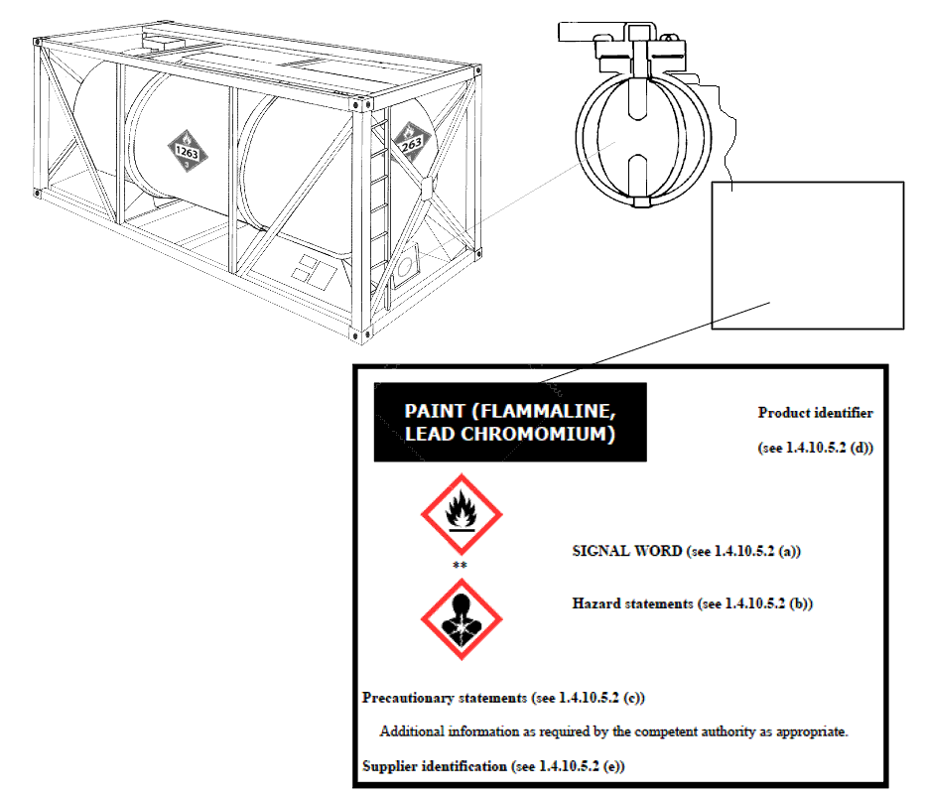

* Only the UN transport markings and labels are required for portable tanks.
** It is optional to display a GHS label (see 1.4.10.4.4). This may be done, for example, by using a tag at the valve.

