|  |  |  |  |
| --- | --- | --- | --- |
|  | United Nations | ST/SG/AC.10/C.3/2015/54-ST/SG/AC.10/C.4/2015/11 | |
| _unlogo | **Secretariat** | | Distr.: General  8 September 2015  Original: English |

**Committee of Experts on the Transport of Dangerous Goods  
and on the Globally Harmonized System of Classification  
and Labelling of Chemicals**

|  |  |
| --- | --- |
| **Sub-Committee of Experts on the Transport  of Dangerous Goods** | **Sub-Committee of Experts on the Globally Harmonized System of Classification and Labelling of Chemicals** |
| **Forty-eighth session** | **Thirtieth session** |
| Geneva, 30 November – 9 December 2015  Item 10 (h) of the provisional agenda  **Issues relating to the Globally Harmonized System of Classification and Labelling of Chemicals: Miscellaneous** | Geneva, 9 - 11 December 2015  Item 2 of the provisional agenda **Joint work with the Sub-Committee of Experts on the Transport of Dangerous Goods (TDG Sub-Committee).** |

Prohibition in transport of non-transport GHS pictograms when not in a complete GHS label

Transmitted by the Dangerous Goods Advisory Council (DGAC)[[1]](#footnote-2)

Introduction

1. In the last biennium, DGAC raised this issue within the GHS Sub-Committee and a new section in the GHS was agreed as follows:

"1.4.10.4.4 Use of GHS pictograms in transport

In transport a GHS pictogram not required by the UN Model Regulations on the Transport of Dangerous Goods should only appear as part of a complete GHS label (see 1.4.10.5.4.1) and not independently.”.

2. At the forty-seventh session of the TDG Sub-Committee, DGAC proposed to create a corresponding prohibition in the Model Regulations under proposal ST/SG/AC.10/C.3/2015/23 − ST/SG/AC.10/C.4/2015/3. We attempted to bridge the gap between the non-regulatory text of GHS and the Model Regulations for transport. Difficulties were addressed, but in the resulting discussion, a majority felt that a prohibition in transport of markings of other regulations could create legal difficulties.

3. Comments were received from the Sub-Committee supporting a modified proposal, by introducing the GHS text as a note. DGAC now proposes to implement these suggestions.

4. An additional suggestion was to also create an additional example in the GHS for portable tanks and multi-element gas containers. This would be similar to the example found in GHS Annex 7, Example 7, Paragraph (e). DGAC intends to return with an informal paper for a new example to begin consideration within the GHS Sub-Committee at its thirtieth session.

Discussion

5. For convenience, pictures from previous proposals are replicated to demonstrate the issue under discussion.

6. DGAC feels that the suggestion to use a note has two main advantages. First, it eliminates the jurisdictional difficulties. Secondly, it provides a solution for transposing the exact GHS text into the Model regulations. Although this is a non-mandatory implementation, it should prove helpful as guidance to transport enforcement authorities.

7. It remains to choose an optimal location within the UN Model Regulations for a note. The GHS use of labels spans the broad range of hazard communication covered under TDG marks, labels and placards. Therefore DGAC proposes a new note at the end of Chapter 5.1, General Provisions within the Model Regulations.

Proposal

8. Create a new note in the Model Regulations at the end of Chapter 5.1, as follows:

***NOTE***: In accordance with the Globally Harmonized System of Classification and Labeling of Chemicals (GHS), a GHS pictogram not required by the UN Model Regulations on the Transport of Dangerous Goods should only appear as part of a complete GHS label and not independently. See GHS 1.4.10.4.4.

Annex

Examples of GHS pictograms appearing alone, not compliant with GHS 1.4.10.4.4

Example 1

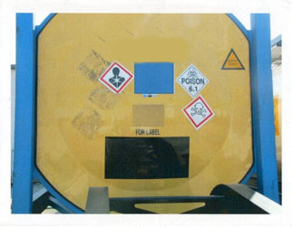

Example 2

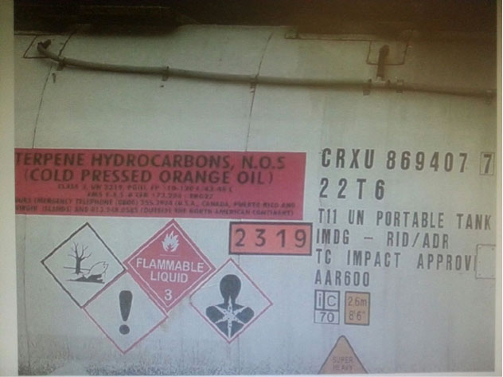

\_\_\_\_\_\_\_\_\_\_\_\_\_\_\_\_\_

1. In accordance with the programme of work of the Sub-Committee for 2015-2016 approved by the Committee at its seventh session (refer to ST/SG/AC.10/C.3/92, paragraph 95 and ST/SG/AC.10/42, para. 15). [↑](#footnote-ref-2)