UN/SCETDG/47/INF.13/Rev.1
Committee of Experts on the Transport of Dangerous Goods
and on the Globally Harmonized System of Classification
and Labelling of Chemicals
Sub-Committee of Experts on the Transport of Dangerous Goods 12 June 2015
Forty-seventh session
Geneva, 22 June-26 June 2015
Item 4 (a) of the provisional agenda
Electric storage system: testing of lithium batteries
New proper shipping name for rechargeable lithium metal batteries
Transmitted by the expert from the Republic of Korea
Introduction
1. Rechargeable lithium metal batteries (RLMBs) have been developed and commercialized for many years but remain a very small segment of the lithium battery market. However, due to improvements in the technology, the applications and use of RLMBs are expected to increase substantially over the next 5 to 10 years. Therefore, the UN Sub-Committee is invited to consider changes to the UN Model Regulations to accommodate these batteries as discussed in more detail below.
2. A RLMB utilizes lithium metal in the anode of a cell instead of graphite, which is typically how lithium ion batteries are designed. The demand is largely driven by requests for higher energy density than that provided by the current lithium ion batteries. Up to now, the lithium ion battery technology is reaching its theoretical limit with a combination of all available technologies including cell components, designs, production and circuits. (Fig1) Like lithium ion batteries, RLMBs can be widely used to power electrical devices like hand held phones, power tools, electric vehicles and energy storage systems. Consequently, new proper shipping names and amendments to existing special provisions for transporting RLMBs are necessary to address the growing demand for shipping RLMBs.
Background information on lithium batteries
Definition of a RLMB
3. A RLMB is a rechargeable electrochemical device in which charge and discharge can be repeated by plating or stripping lithium ions at the negative electrode, and by intercalating and deintercalating lithium ions, or alloying reaction of lithium ions at the positive electrode, depending on the chemistry of the positive active materials. The negative electrode is comprised of lithium metal with a specially designed, protective layer leading to uniform plating and stripping reactions on the lithium surfaces. Depending on the chemistry, the positive electrode can be comprised of an oxide, sulfur composite or other material. The electrolyte used in RLMB is a non-flammable, partial solid.

Constituent of a RLMB and operating principle
4. A RLMB cell is comprised of a negative electrode, positive electrode, separator and electrolyte. (Fig.2) A RLMB is a rechargeable lithium metal battery which can store the electrical energy by plating and stripping lithium ions at the negative electrode, and by intercalating and deintercalating lithium ions at the positive electrode in the case of oxides (Fig.3), or alloying and dealloying lithium ions in the case of sulfur composites. (Fig.4)
5. As for a RLMB, the anode electrode is comprised of lithium metal and a protective layer, in place of graphite as typically found in lithium ions batteries. In the case of graphite, its principle is based on the intercalating and deintercalation chemistry. On the other hand, in the case of lithium metal, the principle is based on the plating and stripping chemistry. Unlike graphite, no housing for lithium ions exists in lithium metal. Therefore, electricity is stored at the negative electrode by lithium plating. Since there is no boundary for the plating, non-uniform growth of lithium ions (i.e., dendrites) could appear at the negative electrode, which could cause safety concerns. (Fig.5) For this reason, the protective layer, an ultra thin polymer matrix including various additives like salts, nanopowders and other proprietary materials, is needed.
Features of RLMBs (comparison with lithium ions batteries)
6. A RLMB has the following features compared to lithium ion batteries: (Table 1)
(a) The chemistry of lithium metal is plating and stripping whereas that of graphite it is intercalating and deintercalating.
(b) The gravimetric charge density of lithium metal is 10.4 times higher than that of graphite: Lithium 3,862mAh/g vs. Graphite 372 mAh/g.
(c) The volumetric charge density of lithium metal is about 2.4 times higher than that of graphite: Lithium 2,047 mAh/cm³ vs. 837mAh/cm³.
(d) The potential of lithium metal vs. lithium is zero whereas that of graphite it is 0.05V. This difference can be transferred to an increase in capacity.
(e) A large volumetric change appears from lithium metal, compared to that of graphite.
(f) Because lithium metal can be more reactive than lithiated graphite, these safety concerns must be addressed through proper cell and battery design and testing.
Applications of RLMBs
7. A RLMB can be applied to all devices in which current lithium ions batteries are being used. A system of lithium metal/LiCoO₂ is 1.64 times higher in gravimetric energy density than that of graphite/LiCoO₂, when the active-only energy density is calculated. See Table 2 and Fig 6: Li/LiCoO₂ 998Wh/kg vs. Graphite/LiCoO₂ 607Wh/kg.
8. A RLMB is quite suitable for applications which require higher energy density, high power density and low cost. Potential applications for a RLMB are as follows:
(a) Small-sized, portable devices like smart watches, hand-held phones, tablets, NPC;
(b) Medium-sized devices like power tools, e-bikes; and
(c) Large-sized devices like electric vehicles and energy storage systems.
History of transport regulations for lithium batteries (Table 3)
9. Reviewing the history of international transport regulations for Li batteries since 2001, three significant changes occurred.
- The first change occurred in 2003. Medium-sized cells (1g<Li≤5g) were classed into Class 9, Miscellaneous dangerous goods, even if the battery passed the tests in UN Manual of Tests and Criteria (UN 38.3). In addition, small-sized cells (Li≤1g for Li metal, ELC≤1.5g for Li ion) were required to be tested in accordance with UN 38.3 (T1-T8).
- The second change occurred in 2009. A new UN number for Li ion batteries was created, and the criterion to decide Class 9 was replaced with a concept of watt-hour instead of equivalent lithium content (ELC). In other words, if a Li ion cell capacity is below 20Wh, then it is except from the requirements of Class 9 as found in Special Provision 188, while if greater than 20Wh, then it would be assigned to Class 9.
- The last change occurred this year and the decision taken by the ICAO Dangerous Goods Panel. That is, from January1, 2015, lithium metal cells and batteries are forbidden as cargo on passenger aircraft. The ICAO Dangerous Goods Panel also is expected to adopt more restrictive lithium battery regulations in 2017.
Draft proposal
10. Rechargeable lithium metal cells and batteries, connecting the technology track over the existing lithium ion technology, are close to market (Fig.7) but are currently not addressed in the UN Model Regulations. Therefore, it is important for the UN Sub-Committee to consider a new proper shipping name for RLMBs, and to define the criterion to determine Class 9 applicability. RLMBs are not the same as existing lithium metal batteries, which are being used to power many consumers, medical and military application, contain a flammable electrolyte and are non-rechargeable. On the other hand, RLMBs are integrations of the state-of-the art technologies. (Fig.8) Their safety is expected to be equal to that of lithium ion batteries. Now the cells are being evaluated about safety. Safety data will be added to the formal proposal in the next session.
11. Our draft proposal is described in the following dangerous goods list. In regard to RLMBs (Fig.9), the criterion to determine Class 9 assignment needs to be changed from Li content to watt hour as is for Li ion batteries. The existing UN 38.3 shall be passed. It is recognized that changes to the applicable Special Provisions also will be necessary to account for the new entries associated with “LITHIUM METAL BATTERIES, RECHARGEABLE” Moreover, we recommend this issue be discussed in detail among safety experts, including the working group tasked with reviewing and amending the lithium battery tests in the UN Manual of Tests and Criteria.

Dangerous Goods List (UN Model Regulations 18th)

UN No. | Name and description | Class | Sub  Sidiary  risk | UN  packing  group | Special  provisions | Limited and excepted quantities |  | Packing instruction
(1) | (2) | (3) | (4) | (5) | (6) | (7a) | (7b) | (8)
3090 | LITHIUM METAL BATTERIES, NONRECHAREGABLE (including lithium alloy batteries) | 9 | - | - | 188,230,  310,376,  377 | 0 | E0 | P903  P908  P909  LP903  LP904
3091 | LITHIUM METAL BATTERIES, NONRECHARGEABLE CONTAINED IN EQUIPMENT or LITHIUM METAL BATTERIES PACKED WITH EQUIPMENT (including lithium alloy batteries) | 9 | - | - | 188, 230,  360, 376,  377 | 0 | E0 | P903  P908  P909  LP903  LP904
3480 | LITHIUM ION BATTERIES  (including lithium ion polymer batteries) | 9 | - | - | 188, 230,  310, 348,  376, 377 | 0 | E0 | P903  P908  P909  LP903  LP904
3481 | LITHIUM ION BATTERIES CONTAINED IN EQUIPMENT or LITHIUM ION BATTERIES PACKED WITH EQUIPMENT  (including lithium ion polymer batteries) | 9 | - | - | 188, 230,  348, 360,  376, 377 | 0 | E0 | P903  P908  P909  LP903  LP904
3xxx | LITHIUM METAL BATTERIES, RECHARGEABLE | 9 | - | - | 188, 230,  310, 348,  376, 377 | 0 | E0 | P903  P908  P909  LP903  LP904
3xxx | LITHIUM METAL BATTERIES, RECHARGEABLE CONTAINED IN EQUIPMENT or RECHARGEABLE LITHIUM METAL BATTERIES PACKED WITH EQUIPMENT | 9 | - | - | 188, 230,  348, 360,  376, 377 | 0 | E0 | P903  P908  P909  LP903  LP904

Safety tests and requirements
12. According to UN Manual of Tests & Criteria (UN 38.3), RLMBs shall be subject to the “T” Tests.
Part III,  Subsection | T Tests | Content
38.3.4.1 | T1 | Altitude simulation
38.3.4.2 | T2 | Thermal
38.3.4.3 | T3 | Vibration
38.3.4.4 | T4 | Shock
38.3.4.5 | T5 | External short circuit
38.3.4.6 | T6 | Impact/crush
38.3.4.7 | T7 | Overcharge
38.3.4.8 | T8 | Forced discharge
Action requested of the Sub-Committee
13. The expert from the Republic of Korea does not request the Sub-Committee to consider this informal document proposing the establishment of a new Proper Shipping Name for RLMBs in this session since he intends to submit a formal proposal to the next session. To facilitate favorable progress, we politely request the members of the Sub-Committee to provide comments during the meeting and prior to the next meeting allowing adequate time for the expert from Korea to take the comments into account and prepare a formal proposal.

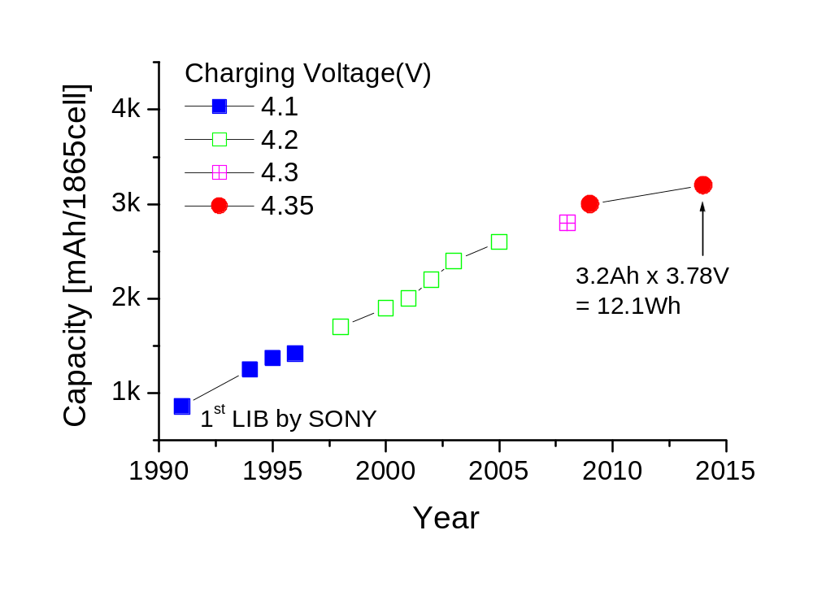
Fig.1 Capacity progress of cylindrical cells. The capacity is maximized in 2014, which is 3.2Ah or 12.1Wh.

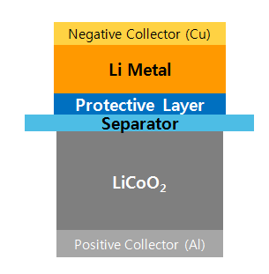
Fig.2 Constituent of a rechargeable lithium metal cell where the two active materials are exposed to non-flammable, solid electrolyte

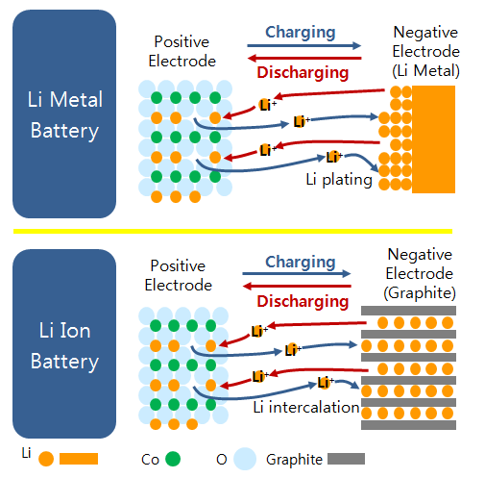

Fig.3 Operating principle of lithium metal and lithium ion cells

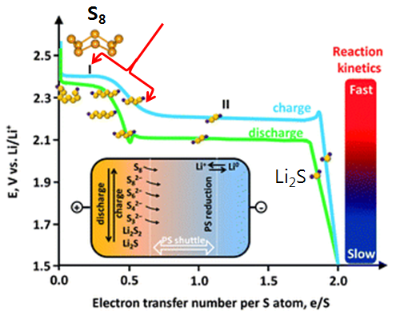

Fig.4 Operating principle of a lithium meta-sulphur cell

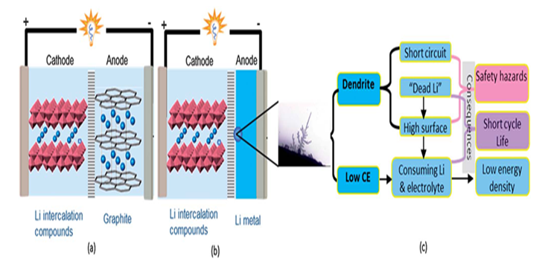

Fig.5 Schematic diagram of (a) lithium ion batteries; (b) lithium metal batteries; (c) the typical morphology if lithium dendrites and the main problems related to dendrites and low Coulombic efficiency

Table 1 Comparison of properties of anode materials

Parameter | Anode Material
Parameter | Unit | Graphite | Al | Sn
Chemistry | - | intercalating | alloying | alloying
Density | g/cm³ | 2.25 | 2.70 | 7.29
Litigated phase | - | LiC₆ | LiAl | Li_{4.4}Sn
Gravimetric cap. density | mAh/g | 372 | 993 | 994
Volumetric cap. density | mAh/cm³ | 837 | 2,681 | 7,746
Volumetric change | % | 12 | 96 | 260
Potential vs. Li | V | 0.05 | 0.3 | 0.6
Main challenge |  | capacity | change to powder | vol. expansion
 | Unit | Mg | Li | Si
Chemistry | - | alloying | plating | alloying
Density | g/cm³ | 1.30 | 0.53 | 2.33
Lithiated phase | - | Li₃Mg | Li | Li_{4.4}Si
Gravimetric cap. density | mAh/g | 3,350 | 3,862 | 4,200
Volumetric cap. density | mAh/cm³ | 4,355 | 2,047 | 9,786
Volumetric change | % | 100 | 100 | 320
Potential vs. Li | V | 0.1 | 0 | 0.4
Main challenge |  | change in phase | dendrite | vol. expansion

Table 2 Comparison of properties of alternative lithium ion technologies
Combination |  | Calculation of active-only | Realized cell  (expectation) |  | Major technical hurdles
 |  | Gravimetric energy density |  | V
Anode | Cathode | Wh/kg |  | V | Materials | Limited utilization
Lithium metal | Sulfur | 2,392 | (500) | 2.05 | Sulfur | L/L: 10 → 1~2 mg/cm²
 |  |  |  |  |  | Sulfur: 100 → 50%
Lithium metal | LiCoO₂ | 998 | (300~350) | 3.90 | Li metal | Li excess: 0 → 70~100%
 |  |  |  |  | LiCoO₂ | 5.0 → 3.5~4.0g/cm³  272 → 172 mAh/g
Lithium metal | O₂ | 3,505 | (1,000) | 3.00 | O₂ | O₂ tank
 |  |  |  |  |  | Carbons & catalysts
Graphite | LiCoO₂ | 607 | 200~250 | 3.85 | Graphite | 2.25 → 1.65 g/cm³
 |  |  |  |  | LiCoO₂ | 5.06 → 3.5~4.0g/cm³ 272 → 172 mAh/g

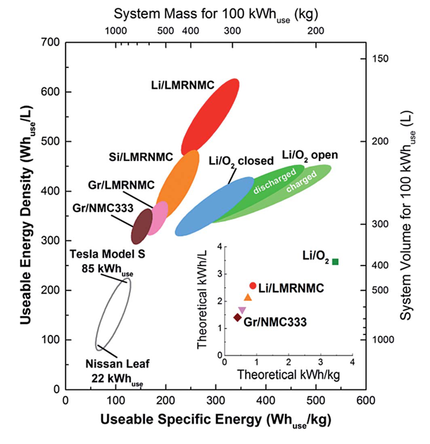

Fig.6 Calculated systems-level energy density and specific energy for100 kW h of useable energy and 80 kW of net power at a nominal voltage of 360 V. (inset) Theoretical specific energy and energy density considering both anode and cathode active materials.

Table 3 Records of transport regulations for lithium batteries
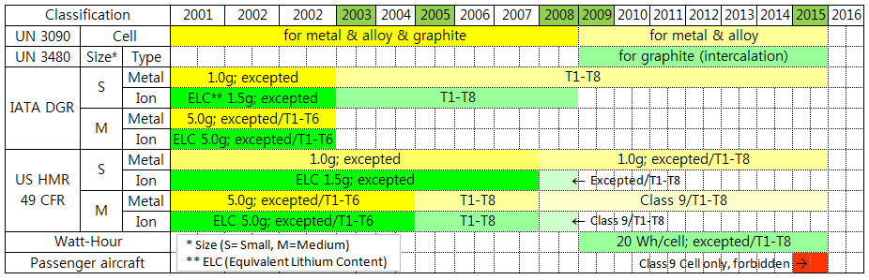

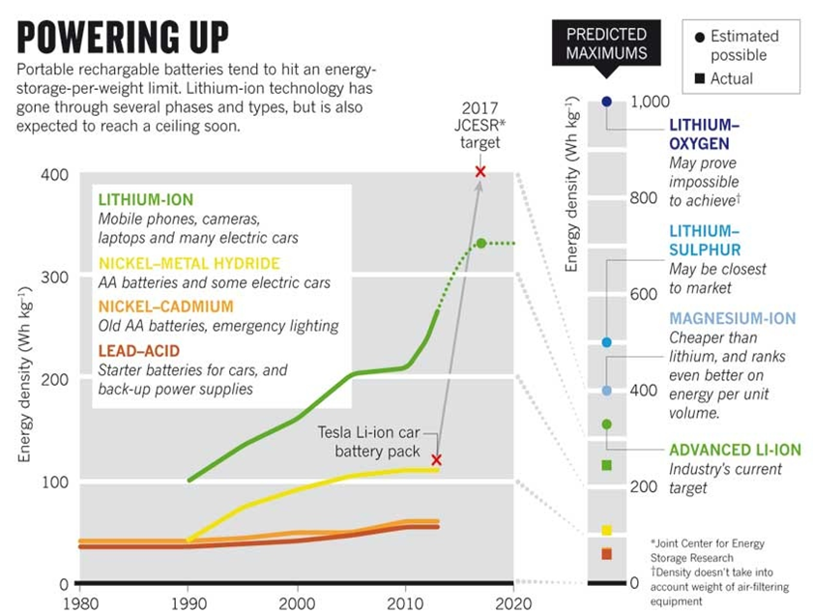

Fig.7 Portable rechargeable batteries tend to hit an energy-storage-per-weight limit. Lithium-ion technology has gone through several phases and types, but is also expected to reach a ceiling soon.

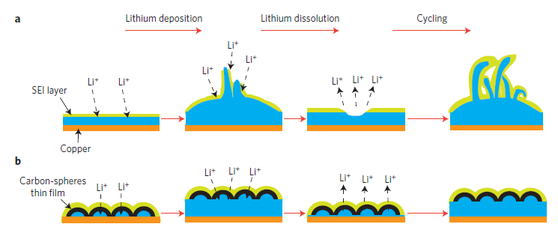

Fig.8 Schematic diagrams of the different lithium anode structures. a, A thin film of SEI layer forms quickly on the surface of deposited lithium (blue). Volumetric changes during the lithium deposition process can easily break the SEI layer, especially at high current rates. This behavior leads to ramified growth of lithium dendrites and rapid consumption of the electrolytes. b, Modifying the Cu substrate with a hollow carbon nanosphere layer creates a scaffold for stabilizing the SEI layer. The volumetric change of the lithium deposition process is accommodated by the flexible hollow-carbon-nanosphere coating

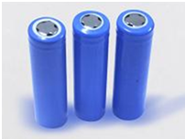
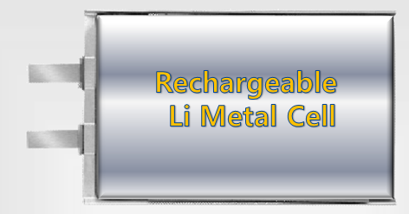

Fig.9 Pictures of rechargeable lithium metal cells

