|  |  |  |  |
| --- | --- | --- | --- |
|  | United Nations | ECE/TRANS/WP.29/GRE/2014/24 | |
| Description: _unlogo | **Economic and Social Council** | | Distr.: General  8 August 2014  Original: English |

**Economic Commission for Europe**

Inland Transport Committee

**World Forum for Harmonization of Vehicle Regulations**

**Working Party on Lighting and Light-Signalling**

**Seventy-second session**

Geneva, 20–22 October 2014

Item 4 (a) of the provisional agenda

**1958 Agreement - Regulations**

**Regulations Nos. 37 (Filament lamps) and 128 (Light emitting diodes light sources)**

Proposal for Supplement 10 to the original series of Regulation No. 99 (Gas-discharge light sources)

Submitted by the expert from the International Automotive Lighting and Light Signalling Expert Group (GTB)[[1]](#footnote-2)\*

The text reproduced below was prepared by the expert from GTB to introduce a new category, D8R. The modifications to the existing text of the Regulation are marked in bold for new or strikethrough for deleted characters.

I. Proposal

*Paragraph 3.6.2.,* amend to read:

"3.6.2. Run-up

3.6.2.1. For gas-discharge light sources having an objective luminous flux which exceeds 2000 lm:

When measured according to the conditions specified in Annex 4, the gas-discharge light source shall emit at least:

After 1 second: 25 per cent of its objective luminous flux;

After 4 seconds: 80 per cent of its objective luminous flux.

The objective luminous flux as indicated on the relevant data sheet.

3.6.2.2. For gas-discharge light sources having an objective luminous flux which does not exceed 2000 lm **and does not contain black stripes:**

When measured according to the conditions specified in Annex 4, the gas-discharge light sources shall emit at least 800 lm after 1 second and at least 1000 lm after 4 seconds.

The objective luminous flux as indicated on the relevant data sheet.

**For gas-discharge light sources having an objective luminous flux which does not exceed 2000 lm but does contain black stripes:**

**When measured according to the conditions specified in Annex 4, the gas-discharge light sources shall emit at least 700 lm after 1 second and at least 900 lm after 4 seconds.**

**The objective luminous flux as indicated on the relevant data sheet."**

*Annex 1, List of categories of gas-discharge light sources and their sheet numbers,* amend to read:

"

| *Light source category* |  | *Sheet numbers* |
| --- | --- | --- |
| D1R |  | DxR/1 to 7 |
| D1S |  | DxS/1 to 6 |
| D2R |  | DxR/1 to 7 |
| D2S |  | DxS/1 to 6 |
| D3R |  | DxR/1 to 7 |
| D3S |  | DxS/1 to 6 |
| D4R |  | DxR/1 to 7 |
| D4S |  | DxS/1 to 6 |
| D5S |  | D5S/1 to 5 |
| D6S |  | D6S/1 to 5 |
| **D8R** |  | **D8R/1 to 6** |
| D8S |  | D8S/1 to 5 |

"

*List of sheets for gas-discharge light sources and their sequence in this Annex*, amend to read:

"

|  |  |
| --- | --- |
| *Sheet numbers* |  |
| DxR/1 to 7 | (Sheet DxR/6: two pages) |
| DxS/1 to 6 |  |
| D5S/1 to 5 |  |
| D6S/1 to 5 |  |
| D8S/1 to 5 |  |
| **D8R/1 to 6** |  |

"

*Insert new sheets D8R/1 to 6, after D8S/5,* to read (see following pages; one page per sheet):

***“***

**Category D8R Sheet D8R/1**

The drawings are intended only to illustrate the essential dimensions (in mm)

of the gas-discharge light source

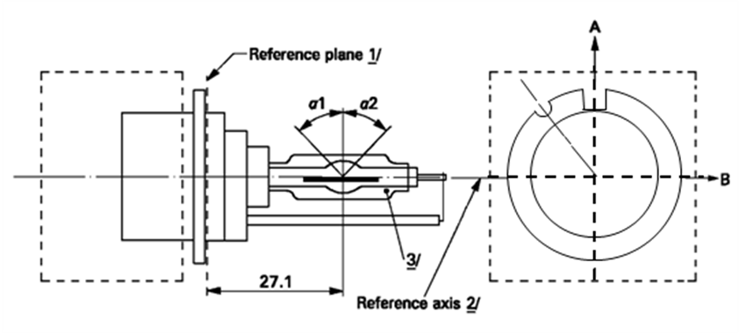

**Reference axis *2***

**Reference plane *1***

View from C

**C**

Figure 1

**Category D8R - Cap PK32d-8**

**1** The reference plane is defined by the positions on the surface of the holder on which the three supporting bosses of the cap ring will rest.

**2** See sheet D8R/2.

**3** When measured at a distance of27.1 mm from the reference plane and with respect to the mid-point of the inner bulb, the outer bulb shall have an eccentricity of 1 mm max.

**Category D8R Sheet D8R/2**

The cap shall be pushed in this direction

**Reference axis**



Figure 2

**Definition of reference axis1**



**Reference axis**

Figure 3

**Maximum lamp outline2**

**1** The reference axis is perpendicular to the reference plane and crosses the intersection of the two parallel lines as indicated in figure 2.

**2** Glass bulb and supports shall not exceed the envelope, as indicated in figure 3.The envelope is concentric with the reference axis.

**Category D8R Sheet D8R/3**

|  |  |  |  |  |  |
| --- | --- | --- | --- | --- | --- |
| *Dimensions* | | | | *Production*  *light sources* | *Standard*  *light sources* |
| Position of the electrodes | | | | Sheet D8R/4 | |
| Position and form of the arc | | | | Sheet D8R/5 | |
| α11 | | | | 55° min. | |
| α21 | | | | 55° min. | |
| D8R: Cap PK32d-8 | | in accordance with IEC Publication 60061(sheet 7004-111-5) | | | |
| Electrical and photometric characteristics | | | | | |
| Rated voltage of the ballast | | | V | 12 2 | 12 |
| Rated wattage | | | W | 25 | 25 |
| Test voltage | | | V | 13.2 | 13.2 |
| Objective lamp voltage | | | V | 42 ± 9 | 42 ± 4 |
| Objective lamp wattage | | | W | 25 ± 3 | 25 ± 0.5 |
| Objective Luminous flux | | | lm | 1900 ± 300 | 1900 ± 100 |
| Chromaticity coordinates | Objective | |  | x = 0.375 | y = 0.375 |
| Tolerance area 3 | | Boundaries | x = 0.345  x = 0.405 | y = 0.150 + 0.640 x  y = 0.050 + 0.750 x |
| Intersection  points | x = 0.345 | y = 0.371 |
| x = 0.405 | y = 0.409 |
| x = 0.405 | y = 0.354 |
| x = 0.345 | y = 0.309 |
| Hot-restrike switch-off time | | | s | 10 | 10 |

**1** The part of the bulb within the angles α1 and α2 shall be the light emitting part. This part shall be as homogeneous in form as possible and shall be optically distortion free. This applies to the whole bulb circumference within the angles α1 and α2 except for the black stripes.

**2** Application voltages of ballasts may differ from 12 V.

**3** See Annex 4.

**Category D8R Sheet D8R/4**

Position of the electrodes

This test is used to determine whether the electrodes are correctly positioned relative to the reference axis and the reference plane.

Top view (schematic):

Reference axis

a2

b2

25.15mm from reference plane

c

Reference plane

a1

b1

Side view (schematic):

Reference axis

a2

b2

25.15mm from reference plane

c

Reference plane

0.10 mm

a1

b1

Measuring direction: light source side and top view

The arc attachment point to the electrode nearest to the reference plane shall be positioned in the area defined by a1 and b1. The arc attachment point to the electrode furthest from the reference plane shall be positioned in the area defined by a2 and b2.

|  |  |  |
| --- | --- | --- |
| *Dimension*  *in* *mm* | *Production*  *light* *sources* | *Standard*  *light* *sources* |
| a1 | 0.50 | 0.20 |
| a2 | 0.70 | 0.35 |
| b1 | 0.40 | 0.15 |
| b2 | 0.80 | 0.30 |
| c | 3.90 | 3.90 |

**Category D8R Sheet D8R/5**

Position and form of the arc

This test is used to determine the form of the arc and its position relative to the reference axis and the reference plane by measuring its bending and diffusion in the cross section at a distance 27.1 mm from the reference plane.



|  |  |  |
| --- | --- | --- |
|  |  |  |
| Relative luminance distribution in the central cross section D. | The form of the arc is for illustration purpose only. | Measuring direction:  light source side view |

When measuring the relative luminance distribution in the central cross section as indicated in the drawing above, the maximum value shall be located within the distance r from the reference axis. The point of 20 per cent of the maximum value shall be within s.

|  |  |  |
| --- | --- | --- |
| *Dimension* *in* *mm* | *Production* *light* *sources* | *Standard* *light* *sources* |
| r (arc bending) | 0.50 +/- 0.25 | 0.50 +/- 0.15 |
| s (arc diffusion) | 0.70 +/- 0.25 | 0.70 +/- 0.15 |

**Category D8R Sheet D8R/6**

Position of black stripes

This test is used to determine whether the black stripes are correctly positioned relative to the reference axis and the reference plane.

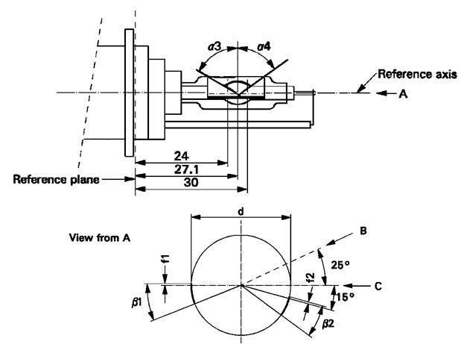

Reference axis

Reference plane

View from A

When measuring the luminance distribution of the arc in the central cross section as defined on sheet D8R/5, after having turned the light source so that the black stripe is covering the arc, the measured luminance shall be ≤ 0.5 % of Lmax.

|  |  |  |
| --- | --- | --- |
| *Dimensions* | *Production light sources* | *Standard light sources* |
| α3 | 70° min. | |
| α4 | 65° min. | |
| β1/24, β1/30, β2/24, β2/30 | 25° ± 5° | |
| f1/24, f2/24 1/ | 0 ± 0.25 | 0 ± 0.20 |
| f1/30 1/ | f1/24 mv ± 0.15 2/ | f1/24 mv ± 0.1 |
| f2/30 1/ | f2/24 mv ± 0.15 2/ | f2/24 mv ± 0.1 |
| f1/24 mv - f2/24 mv | ± 0.3 max. | ± 0.2 max. |
| d | 9 ± 1 | |

1 "f1/.." means dimension f1 to be measured at the distance from the reference plane indicated in mm after the stroke.

2/ "../24 mv" means the value measured at a distance of 24 mm from the reference plane.***“****Annex 4, paragraph 10.,* amend the text to read (and keep the drawing):

"10. Colour

The colour of the light source shall be measured in an integrating sphere using a measuring system which shows the CIE chromaticity co-ordinates of the received light with a resolution of ± 0.002. The following figure shows the colour tolerance area for colour white and the restricted tolerance area for the gas-discharge light sources D1R, D1S, D2R, D2S, D3R, D3S, D4R, D4S, D5S, D6S**, D8R** and D8S."

II. Justification

1. Currently 25W HID light sources are only available for projection systems while there is also a market need for light sources suitable for reflector systems. This proposal introduces a new category D8R for reflector systems.

2. Because black stripes reduce the lumen output, studies have been conducted to optimize the black stripe geometry. The outcome was that optimized passing beam performance can be achieved when the circular stripe is removed and the axial stripes are shifted. The run-up requirements are equivalent to the values specified for D8S.

1. \* In accordance with the programme of work of the Inland Transport Committee for 2012–2016 (ECE/TRANS/224, para. 94 and ECE/TRANS/2012/12, programme activity 02.4), the World Forum will develop, harmonize and update Regulations in order to enhance the performance of vehicles. The present document is submitted in conformity with that mandate. [↑](#footnote-ref-2)