 | United Nations | ST/SG/AC.10/C.3/2014/83
 | Secretariat |  | Distr.: General  5 September 2014  Original: English
Committee of Experts on the Transport of Dangerous Goods
and on the Globally Harmonized System of Classification
and Labelling of Chemicals
Sub-Committee of Experts on the Transport of Dangerous Goods
Forty-sixth session
Geneva, 1 – 9 December 2014
Item 2 (d) of the provisional agenda
Recommendations made by the Sub-Committee on its forty-third, forty-fourth and
forty-fifth sessions and pending issues: transport of gases
Marking on packages
Transmitted by the European Industrial Gases Association (EIGA) and the European Liquefied Petroleum Gas Association (AEGPL)
Introduction
1. The requirements of 5.2.2.2.1.2. within 5.2.2.2. (Provisions for labels) cannot be fulfilled for new cylinder designs and for small cylinders.
2. That is the reason why EIGA and AEGPL propose a new wording that would allow the use of labels which have been reduced in size according to ISO 7225:2005 for these kinds of cylinders.
3. This subject has been already discussed during the forty-fifth session (see ST/SG/AC.10/C.3/2014/35 and informal document INF.45.
4. Further to several comments, it was decided that EIGA and AEGPL would propose a new document during the forty-sixth session of the Sub-Committee.
5. The general information below (point 6 to 9) has been already given in the previous working document.
6. Within 5.2.2.2, (Provisions for labels), 5.2.2.2.1.2 allows for cylinders of Class 2 to display labels which have been reduced in size according to ISO 7225:2005 on the non-cylindrical part (shoulder) of such cylinders. This ensures that labels are visible during transport. This provision accommodates the majority of cylinders in service.
7. However, with the introduction of new cylinder designs, other locations for the display of the labels have been introduced (see attached pictures). Although these alternative locations have advantages and meet the objectives of the specific precautionary labelling (the label remains visible and irremovable during transport and undamaged when the cylinder is transported or stored), they do not meet fully the wording of 5.2.2.2.1.2.
8. Furthermore, there are a number of small cylinders in service where it is not possible to affix even a reduced size label to the cylinder shoulder. The only possible place to affix the label is on the cylindrical part, (parallel portion) of the cylinder. Due to their size, such cylinders are not transported with other larger cylinders as it is not possible to secure them to vehicles. The method of transport is usually within an overpack which is labelled accordingly.
9. The proposal is to permit the display of the label on a fitting attached to the upper part of the cylinder or valve (casing, handling device) and for small cylinders only, on the cylindrical part of the cylinder.
10. Three comments were discussed during the last session.
11. First, the proposal should allow the use of labels which have been reduced in size according to ISO 7225:2005 for cylinders used to transport dangerous goods other than gases, such as liquid, this kind of labelling on the upper part of the cylinder being more visible than a traditional labelling onto the cylindrical part. That the reason why it is proposed to remove the words “for Class 2”.
12. Secondly, the display of the labels on a non-permanent attachment might result in a potential risk of confusion between different gases if the attachment is refitted to the wrong cylinder. It shall be noticed that for some new design cylinders the label has to be affixed onto the casing otherwise it would not be visible as the casing completely covers the inner receptacle. The casing is not a permanent attachment: it can be removed for maintenance or for periodic inspection. In order to prevent a risk of confusion between different gases, it is proposed to limit the scope of the modification allowing display of the label on a non-permanent attachment to dedicated LPG cylinders with a water capacity of 40 litres or less. This type of cylinder is very specific and their customers’ segment too. The risk of fitting of an attachment of an LPG cylinder to another gas cylinder is very low and, in any case, the individuals that accept the cylinders for transport or carry the cylinders for transport have to be trained according to the regulation and would therefore reject a cylinder that is not fitted with its usual fitting.
13. Lastly, due to visibility concerns, it has to be specified that the label is to be affixed on the exterior surface of the attachment.
Proposal
14. In order to take into account new cylinder designs and small cylinders, and to provide clarification to the regulations it is proposed to amend 5.2.2.2.1.2. To assist in evaluating the proposal, 5.2.2.2.1.2 is reproduced in full, and the additional text is italicised and underlined.
“5.2.2.2.1.2 Cylinders may, on account of their shape, orientation and securing mechanisms for transport, bear labels representative of those specified in this section, which have been reduced in size, according to ISO 7225, for display on the non-cylindrical part (shoulder) of such cylinders, on the exterior surface of a permanent attachment to the upper part of the cylinder (e.g. collar, handling device) or on a securely affixed attachment to the cylinder valve. Labels may overlap to the extent provided for in ISO 7225:2005 “Gas cylinders – Precautionary labels”, however in all cases, the labels representing the primary hazard and the numbers appearing on any label shall remain fully visible and the symbols recognisable.
NOTE: For cylinders intended for the carriage of gases No. 1965, hydrocarbon gas mixture liquefied, n.o.s., with a water capacity of 40 litres of less, labels reduced in size according to ISO 7225 may be displayed on the exterior surface of a securely affixed attachment to the upper part of the cylinder.
When the diameter of the cylinder is too small to permit the display of the reduced size labels on the non-cylindrical upper part of the cylinder, the reduced sized labels may be displayed on the cylindrical part.”
Justification
15. The justification is that it clarifies where labels for new cylinder designs and small cylinders may be affixed such that the appropriate information is readily available. It allows the use of labels which have been reduced in size according to ISO 7225:2005 for cylinders used to transport dangerous goods other than gases, such as liquids.
Safety implications
16. No safety implications are foreseen as this proposal will ensure that labels are securely attached to cylinders and visible. Moreover, this new wording would permit the labels to be displayed beside the UN number and letters “UN” corresponding to the dangerous goods on the handling device (see 5.2.1.1.).

Examples of cylinder labelling for LPG Cylinders

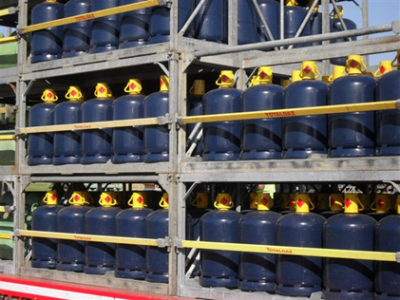

Cylinders loaded on vehicle

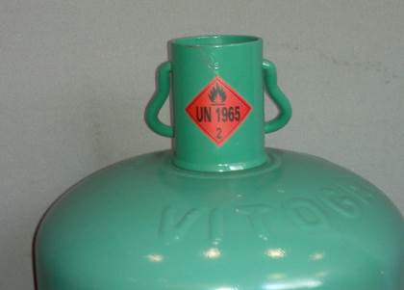

Label on cap

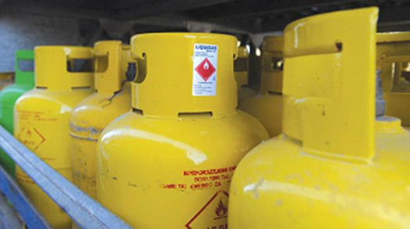

Label on fixed guard

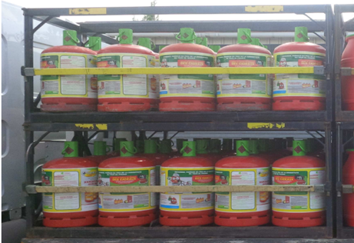

Cylinders loaded into pallet

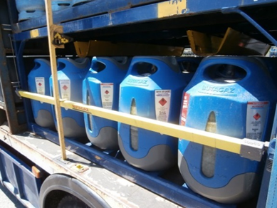

Cylinders loaded into pallet

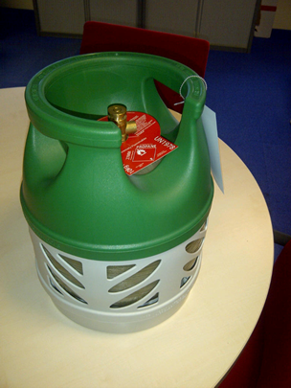

Label located beneath valve

In accordance with the programme of work of the Sub-Committee for 2013-2014 approved by the Committee at its sixth session (refer to ST/SG/AC.10/C.3/84, para. 86 and ST/SG/AC.10/40, para. 14).

