 | United Nations | ST/SG/AC.10/C.3/2014/78
 | Secretariat |  | Distr.: General  8 September 2014  Original: English
Committee of Experts on the Transport of Dangerous Goods
and on the Globally Harmonized System of Classification
and Labelling of Chemicals
Sub-Committee of Experts on the Transport of Dangerous Goods
Forty-sixth session
Geneva, 1 – 9 December 2014
Item 2 (e) of the provisional agenda
Recommendations made by the Sub-Committee on its forty-third, forty-fourth
and forty-fifth sessions and pending issues: miscellaneous pending issues
Marking of portable tanks
Transmitted by the European Chemical Industry Council (CEFIC)
Introduction
1. Compliance with the general requirements on placarding and marking of cargo transport units causes substantive issues considering the specific properties of small portable tanks, which are not being presented as a single cargo transport unit. Whereas national dangerous goods transport regulations already authorize placards of reduced size for small portable tanks, this topic has also been discussed at the International Maritime Organization (IMO) resulting in amendments that will be reflected in the forthcoming revision of the IMDG Code.
2. Bearing in mind the need for global harmonization of transport regulations with the Model Regulations, this issue was discussed at the forty-fourth session on the basis of informal document INF.37 and at the forty-fifth session on the basis of ST/SG/AC.10/C.3/2014/24, both submitted by CEFIC.
3. Several delegations supported the proposal to authorize placards and marks of reduced size for small portable tanks and provided valuable comments (see ST/SG/AC.10/C.3/90, paras 103–104). For this session, CEFIC submits a new working document, taking into account these comments as well as editorial remarks received from the secretariat.
Discussion
4. According to the Model Regulations, Chapter 5.3, the following sizes apply for the placarding and marking of cargo transport units:
(a) Placards shall be not less than 250 mm x 250 mm;
(b) The UN number shall be displayed in digits not less than 65 mm high;
(c) The sides of the triangular shaped elevated temperature mark shall be at least
250 mm; and
(d) The environmentally hazardous substance mark shall have a minimum dimension of 250 mm x 250 mm.
5. These requirements are integrally applicable even to small portable tanks, which are not being presented as a single cargo transport unit. However, due to the small size and sometimes to the shape of such tank units it is very difficult or impossible to comply with these requirements. The example below clearly illustrates this problem.
6. National transport regulations, e.g. in the United States (CFR 49), Australia (ADG Code) and Europe (ADR/RID), already recognize these needs and address exemptions from general placarding and marking requirements by permitting labels as an alternative to placards, e.g. ADR/RID 5.3.1.7.3 or ADG Code 5.3.3.5, and a reduced size of markings, e.g. CFR 49 §172.302 (b)(2) for the UN identification number, allowing a minimum height of 25 mm for the characters to be applied.

Example of a small cylindrical portable tank:
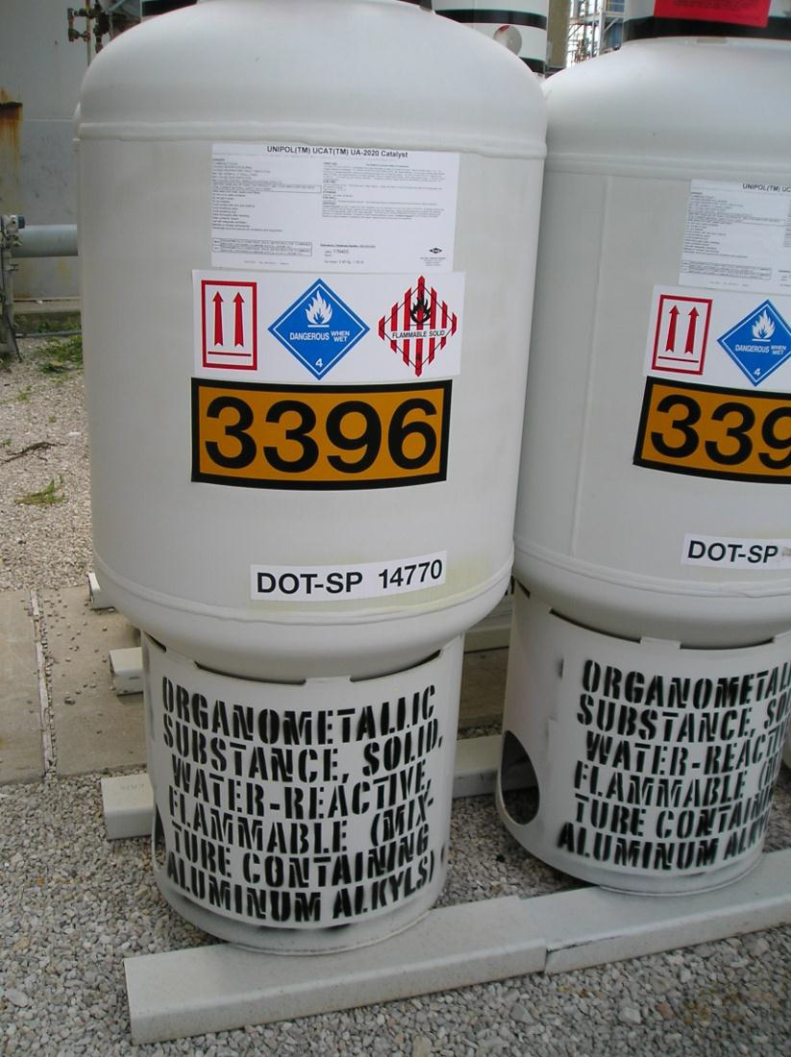
The label size (100 mm x 100 mm) is not in compliance with the placarding requirements (250 mm x 250 mm, four sides) of the Model Regulations, however are in compliance with CFR 49 §172.514 (c)(1), permitting labels as an alternative to placards.
Proposal
7. In consideration of the above, the following amendments are proposed to chapter 5.3 (new text underlined):
5.3.1.1.4 Cargo transport units carrying dangerous goods or the residue of dangerous Goods in unpurged tanks or empty uncleaned bulk containers shall display placards clearly visible on at least two opposing sides of the units and in any case in such a position as may be seen by all those involved in the loading or unloading process. Where the cargo transport unit has a multiple compartment tank which is carrying two or more dangerous goods and/or the residues of dangerous goods, appropriate placards shall be displayed along each side at the position of the relevant compartments. For portable tanks with a capacity of not more than 3000 litres and with an available surface area insufficient to affix the prescribed placards, placards may be replaced by labels conforming to 5.2.2.2 to be affixed on two opposite sides of the portable tank.
5.3.2.1.2 The UN number for goods shall be displayed in black digits not less than 65 mm high, either:
(b) On an orange rectangular panel not less than 120 mm high and 300 mm wide, with a 10 mm black border, to be placed immediately adjacent to each placard (see Figure 5.3.3). For portable tanks with a capacity of not more than 3000 litres and with an available surface area insufficient to affix the prescribed placards, the UN number shall be displayed on an orange rectangular panel of appropriately reduced size on the external surface of the tank in characters not less than 25 mm high.
5.3.2.2 Elevated temperature substances (second paragraph)
The marking shall be an equilateral triangle. The colour of the mark shall be red. The minimum dimensions of the sides shall be 250 mm. For portable tanks with a capacity of not more than 3000 litres and with an available surface area insufficient to affix the prescribed placards, the minimum dimensions of the sides may be reduced to 100 mm. Where dimensions are not specified, all features shall be in approximate proportion to those shown.
5.3.2.3.2 The environmentally hazardous substance mark for cargo transport units shall be as described in 5.2.1.6.3 and Figure 5.2.2, except that the minimum dimensions shall be 250 mm x 250 mm. For portable tanks with a capacity of not more than 3000 litres and with an available surface area insufficient to affix the prescribed placards, the minimum dimensions may be reduced to 100 mm X 100 mm.
Justification
8. Reduction of the prescribed minimum size for placards and markings as proposed for small portable tanks, which are not being presented as a single cargo transport unit, does not result in a loss of information and also does not impair the warning effect of the required hazard symbols. The proposal is based on practical experience with comparable requirements of national dangerous goods transport regulations and considers the specific properties of small portable tanks, which allows being compliant with the placarding and marking requirements for cargo transport units in any case.

In accordance with the programme of work of the Sub-Committee for 2013-2014 approved by the Committee at its sixth session (refer to ST/SG/AC.10/C.3/84, para. 86 and ST/SG/AC.10/40, para. 14).

