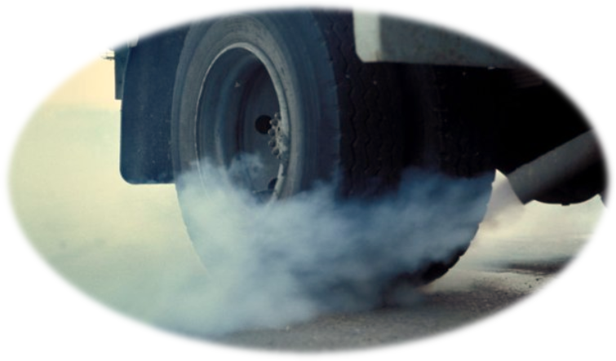
UNECE | Emissions of air pollutants in transport: an overview

Transmitted by the secretariat Informal document No. WP.29-160-19-Rev.1
160th WP.29, 25-28 June 2013
Agenda item 8.2

Table of Contents
Table of Contents 0
I. Introduction 3
II. Main air pollutants and their effects on human health and the environment 4
III. Emissions and emissions’ concentration 5
IV. Emissions of the main air pollutants 6
IV.1 Historical trends 6
IV.1.1 Canada 6
IV.1.2 European Union 7
IV.1.3 Japan 7
IV.1.4 Republic of Korea 8
IV.1.5 United States 9
IV.2 The role of different economic sectors 10
IV.2.1 European Union 10
IV.2.2 North America 12
V. Exposure to air pollution 12
VI. International agreements and obligations on air pollutants 13
VII. Policy approach to emissions at national and regional level 14
VII.1 Current situation 14
VII.1.1 Canada 15
VII.1.2 European Union 15
VII.1.3 Japan 17
VII.1.4 Republic of Korea 18
VII.1.5 United States 19
VII.2 Transport policies 20
VII.3 UNECE activities in the transport sector 22
VII.3.1 Common test procedures 22
VII.3.2 Regulations setting limit values for pollutant emissions 24
VII.3.3 Other relevant activities 27
VII.3.3 Emission regulations and fuel quality parameters 28
VII.4 Focus on diesel exhaust emissions 28
VII.5 Further legislative action 31
VIII. Conclusions and recommendations 34
VIII.1 Conclusions 34
VIII.2 Recommendations 35
VIII.2.1 Within the current scope of WP.29 work 35
VIII.2.2 Outside of the current scope of WP.29 work 36
IX. References 36

Emissions of air pollutants in transport: an overview

I. Introduction
1. The objective of this background note is to provide basic information about some recent and important developments in air pollution; to illustrate the results of recent studies on the harmful effects of diesel exhausts to public health; to inform about recent policy developments on the reduction of pollutant emissions to address health and environmental concerns. The overview includes information with global relevance and focuses especially on the European Union, North America, and Japan.
2. Section II contains a list of the main air pollutants and their effects on human health and the environment.
3. Section III provides information on the difference between emissions and emission concentrations.
4. Building on published information, Section IV provides information on the recent trends of emissions of the main air pollutants and the sources that generate them (stationary and mobile sources).
5. Section V focuses on the compliance with existing international agreements, as well as EU legislation. It reports briefly on an assessment of the atmospheric concentration of the main air pollutants in Europe and considers in further detail the emissions of some of these pollutants in UNECE Member States. This second part of the assessment includes, in particular, data on the distance between actual emissions of air pollutants and those that would allow respecting emission reduction ceilings as stipulated by the recently amended Protocol of the Convention on Long-Range Transboundary Air Pollution (CLRTAP) and for the EU Member States by the EU National Emissions Ceiling (NEC) Directive.
6. Section VI provides some information on the exposure to air pollution, briefly attempting to identify the most problematic pollutants in terms of harm to health and the environment.
7. Section VII focuses on policies aiming at the improvement of air quality and the reduction of pollutant emissions to address health and environmental concerns. First, it gives an overview of the current situation. Second, it focuses on the transport sector, also providing an overview of relevant regulatory measures undertaken in this field in the UNECE framework. Third, considering that a recent classification of diesel exhaust emissions by the World Health Organization (WHO) as carcinogenic, section VII focuses on diesel emissions. Finally, it gives an outline of legislative action that can be undertaken in the forthcoming years. .
8. The information in this background note is a compilation of facts from the work in the framework of CLRTAP, its Task Force on Health, published information (e.g. from the European Environment Agency (EEA) and the United States Environmental Protection Agency (US EPA)), and the work undertaken in the framework of the Inland Transport Committee and its subsidiary bodies, particularly the World Forum for the Harmonization of Vehicle Regulations (WP.29).

II. Main air pollutants and their effects on human health and the environment
9. A recent report from the European Environment Agency (EEA) (EEA, 2012) provides a brief description (partly reported in Box 1) of the main air pollutants and their effects on human health and the environment. This list includes the "criteria air pollutants" regulated in the United States of America by the Clean Air Act Amendments of 1970 (and its following modifications) because they can harm health and the environment: particle pollution often referred to as particulate matter (PM), ground-level ozone (O₃) (represented in the list below by its precursors), carbon monoxide (CO), sulphur oxides (SO_{X}), nitrogen oxides (NO_{X}), and lead (Pb) (US EPA, 2012a). Sulphur dioxide (SO₂) and nitrogen oxides (NO_{X}) are also precursors of acid rain formation.
Box 1. Description of the main local air pollutants (gases, particulate matter and heavy metals)
Sulphur oxides (SO_{X}): SO_{X} are emitted when fuels containing sulphur are burned. They contribute to acid deposition, the impacts of which can be significant: adverse effects on aquatic ecosystems in rivers and lakes, and damage to forests. Furthermore, the formation of sulfate particles results in reflection of solar radiation, which leads to net cooling of the atmosphere.
Nitrogen oxides (NO_{X}): NO_{X} are emitted during fuel combustion, as practiced by industrial facilities and the road transport sector. As with SO_{X}, NO_{X} contribute to acid deposition but also to eutrophication of soil and water. Of the chemical species that NO_{X} comprises, it is nitrogen dioxide (NO₂) that is associated with adverse effects on health: high concentrations cause inflammation of the airways and reduced lung function. NO_{X} also contribute to the formation of secondary inorganic particulate matter and tropospheric (ground-level) ozone with associated climate effects.
Ammonia (NH₃): NH₃, like NO_{X}, contributes to both eutrophication and acidification. The vast majority of NH₃ emissions - around 94 % in Europe - come from the agricultural sector, in connection with activities such as manure storage, slurry spreading and the use of synthetic nitrogenous fertilizers.
Carbon monoxide (CO): CO is produced as a result of fuel combustion. The road transport sector, commercial and household sector, and industry are important sources. Long-term exposure to low concentrations of CO can result in neurological problems and potential harm to unborn babies. CO can react with other pollutants to produce ground-level ozone. Elevated levels of ozone can cause respiratory health problems and can lead to premature mortality.
Non-methane volatile organic compounds (NMVOC): NMVOC, important O₃ precursors, are emitted from a large number of sources including paint application, road transport, dry-cleaning and other solvent uses. Certain NMVOC species, such as benzene (C₆H₆) and 1,3-butadiene, are directly hazardous to human health. Biogenic NMVOC are emitted by vegetation, with amounts dependent on the species and on temperature.
Particulate matter (PM): PM is emitted from many sources and is a complex heterogeneous mixture comprising both primary and secondary PM; primary PM is the fraction of PM that is emitted directly into the atmosphere, whereas secondary PM forms in the atmosphere following the oxidation and transformation of precursor gases (mainly SO_{X}, NO_{X}, NH₃ and some volatile organic compounds (VOCs)). From a regulatory perspective, PM is divided into PM₁₀ and PM_{2.5}, defined (ISO, 2008) as the size fractions where the median aerodynamic diameter of the particles is respectively 10 and 2.5 microns (this means that 50% of the particles in these fractions have diameters respectively greater, or smaller, than 10 microns and 2.5 microns. Sources of coarse particles include crushing or grinding operations, and dust stirred up by vehicles traveling on roads. Sources of fine particles include all types of combustion, including motor vehicles, power plants, residential wood burning, forest fires, agricultural burning, and some industrial processes. Considering the potential to harm human health, PM is one of the most important pollutants as it penetrates into sensitive regions of the respiratory system. In addition, Black Carbon (BC) is the most strongly light-absorbing component of particulate matter (PM) (US EPA, 2012b). Emitted directly into the atmosphere in the form of fine particles (PM_{2.5}) and notwithstanding its short lifetime, BC is estimated to have a 20-year global warming potential (GWP) more than 4000 times higher than the GWP of CO₂ and a 100-year GWP 1500 to 2240 times higher than CO₂ (Jacobson, 2007). This, combined with the amounts emitted in the atmosphere, is such that BC is likely to be one of the leading causes of global warming after carbon dioxide (Jacobson, 2007).
Heavy metals (HMs): the HMs arsenic (As), cadmium (Cd), lead (Pb), mercury (Hg), chromium (Cr), copper (Cu), nickel (Ni), selenium (Se) and zinc (Zn) are emitted mainly as a result of various combustion processes and industrial activities, like metals works and smelters. As for Benzo(a)pyrene (BaP), heavy metals can reside in or be attached to PM. As well as polluting the air, HMs can be deposited on terrestrial or water surfaces and subsequently builds up in soils or sediments. HMs are persistent in the environment and may bio-accumulate in food chains.
Sources: EEA, 2012a, US EPA, 2012a
10. Additional information on air pollutants, including considerations on their characteristics, sources, sinks, mixing ratios in the atmosphere (differentiating between ambient air and indoor air), and health effects are also available in dedicated literature, such as Jacobson (2012).

III. Emissions and emissions’ concentration
11. Many air pollutants, including NO_{X} and sulphur dioxide (SO₂), are directly emitted into the air from anthropogenic activities such as fuel combustion or releases from industrial processes. Other air pollutants, such as O₃ and the major part of PM, form in the atmosphere emissions from various precursor species, having either anthropogenic or natural origin. Natural sources of aerosol particle emissions that are included in PM may occur from volcanic eruptions, soil-dust and sea-spray uplifts, natural biomass burning fires, and biological material release. Major anthropogenic sources include fugitive dust emissions, fossil-fuel combustion, anthropogenic biomass burning and industrial emissions (Jacobson, 2012). Particulate Matter (PM) can also be distinguished in primary PM, directly emitted from its sources, and secondary PM, subsequently formed in the atmosphere by chemical processes from a range of previously emitted precursor gases. This secondary fraction is mainly generated through a series of chemical reactions involving nitrogen oxides (NO_{X}), sulfur dioxide (SO₂), ammonia (NH₃) and a large number of volatile organic compounds (VOCs), which may react with other reactive molecules in the atmosphere forming the secondary inorganic aerosol (SIA) and secondary organic aerosol (SOA).
12. The concentration of air pollutants in the lower part of the atmosphere does not only depend on levels of emission of pollutants and their precursors, but also on specific characteristics of the pollutant (such as their average lifetime against phenomena like photolysis), as well as changes in meteorological conditions (Jacobson, 2012 and EEA, 2009). Specific climatic conditions like the thermal inversion, for instance, can lead to high concentrations of secondary aerosol in the air, such that the latter may become the predominant contribution to PM₁₀ and PM_{2.5} as compared to primary particles. The transport in the atmosphere, over long distances and across national boundaries, of anthropogenic acid-deposition precursors such as SO₂ and NO_{X} (and the subsequent acidification of water bodies) was particularly relevant in the process leading to the UNECE Convention on Long-Range Transboundary Air Pollution (CLRTAP), the first agreements dealing with air pollution at the international level (Jacobson, 2012).
13. These considerations are important to bear in mind that complex links exist between the emissions of air pollutants and the air quality (the latter being measured via the ambient/atmospheric concentration of pollutants). As a result, changes in the emissions of selected pollutants do not always lead to a corresponding change in their atmospheric concentrations, even if they are a necessary step towards the improvement of air quality.

IV. Emissions of the main air pollutants

IV.1 Historical trends
14. A number of modeling instruments have been developed, especially in developed countries, for the estimation of the emissions of air pollutants over time and their attribution to different driving sources. According to the model results, the emissions of air pollutants in the atmosphere have been on a downward trend in developed countries. A similar evolution is also expected to continue in the forthcoming years. According to the experimental measurements of the concentration of air pollutants in the atmosphere, the concentration of air pollutants also tended to improve, but results are not as encouraging as in the case of emissions.
15. In rapidly developing countries, the economic development is expected to be coupled with a strong growth in the activity of economic sub-sectors that are responsible for the emissions of a wide range of air pollutants. As a result, emission trends may or may not follow downward paths. In the case of transport, the policy framework can play a very relevant role, since the evolution of the emission trends is strongly dependent on the pace of enforcement of emission regulations (WBCSD, 2004).

IV.1.1 Canada
Figure 1. Canadian emission trends (open and natural sources excluded)
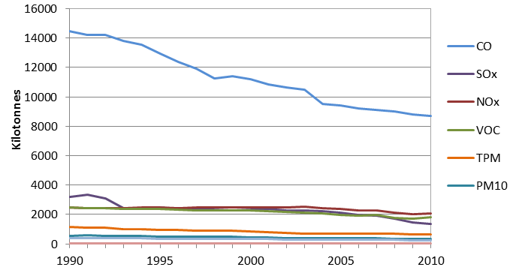Source: Canada, 2013a
16. In Canada, the emissions of air pollutants experienced significant reductions in recent years. Between 1990 and 2010, Canada's total SO_{X} emissions have decreased by 57%, CO emissions have been reduced by 40%, PM_{2.5} by 35% and NO_{X} emissions by 18% (Figure 1).

IV.1.2 European Union
Figure 2. EU-27 emission trends for the main air pollutants and for particulate matter
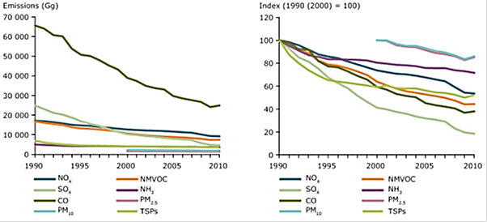
Source: EEA, 2012a
Figure 3. Indexed trends in air quality
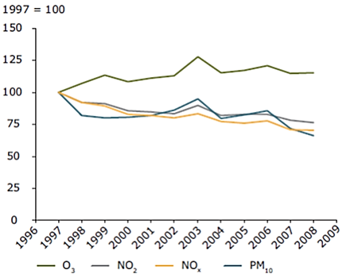
Source: EEA, 2010
17. According to the EEA (which builds on the results obtained with these modeling instruments), air pollutant emissions in Europe (including EEA Member States and Countries of the Western Balkans) have decreased since 1990. In 2010 (EEA, 2012a):
- SO_{X} emissions were 82 % lower than in 1990;
- emissions of the other main air pollutants have dropped significantly since 1990, including emissions of the three air pollutants primarily responsible for the formation of ground-level ozone: CO (62 % reduction), NMVOC (56 % reduction) and NO_{X} (47 % reduction);
- Total Suspended Particles (TSP) have seen a reduction of 48 % from 1990. For PM₁₀ and PM_{2.5}, the aggregated EU-27 emission reduction achieved since 2000 is 14 % and 15 %, respectively.
18. Despite these reductions, measured concentrations of health-relevant pollutants such as PM and O₃ have not shown a corresponding improvement (Figure 3) (EEA, 2010).

IV.1.3 Japan
19. In Japan, results from the environmental monitoring on the atmosphere are conducted by prefectural governments in compliance with the Air Pollution Control Law and reported to the Ministry of the Environment. The evolution of the atmospheric concentration of SO₂, suspended particulate matter (SPM) and NO_{X}, shown in Figure 4, illustrates that the atmospheric concentration of all these pollutants has been on a downward trend in the past few decades.
Figure 4. Atmospheric concentration SO₂, suspended particulate matter and NO_{X} in Japan
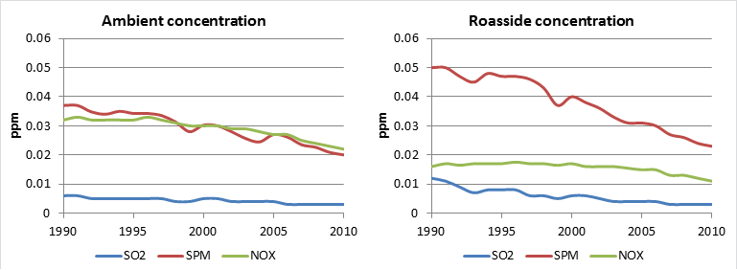Source: JASIC, 2013

IV.1.4 Republic of Korea
20. In the Republic of Korea (Korea), air pollutants are continuously and automatically measured by using monitoring equipment. Real time data are collected through the National Ambient air Monitoring Information System (NMAIS) and published by Air Korea.
21. In 2001, the Ministry of Environment (MOE) published information on the concentration level of air pollutants such as sulfur dioxide (SO₂), nitrogen dioxide (NO₂), particulate matter and ozone (Figure 5) in the environmental review of Korea. The MOE underlined a downward trend of sulphur dioxide emissions, justifying it with the support for strengthening the fuel regulation system, a higher concentration of nitrogen dioxide in Seoul, where the number of automobile registration and traffic is the largest, and a decrease of the concentration of particulate matter since 2008 (MOE Korea, 2011). The environmental review of Korea also reported ozone concentration, mentioning that annual increases in the ozone concentration are likely to have been driven by the rise of temperature and insolation due to recent global warming.
Figure 5. Atmospheric concentration of SO₂, NO₂, PM and O₃ in Korea
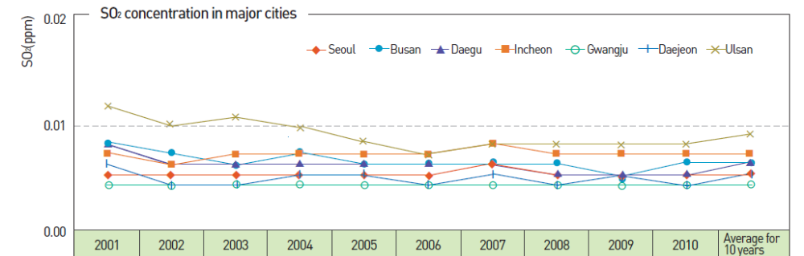
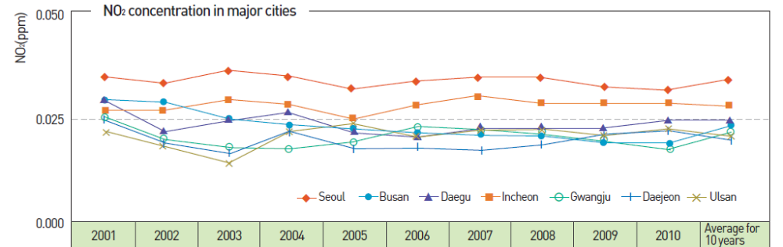
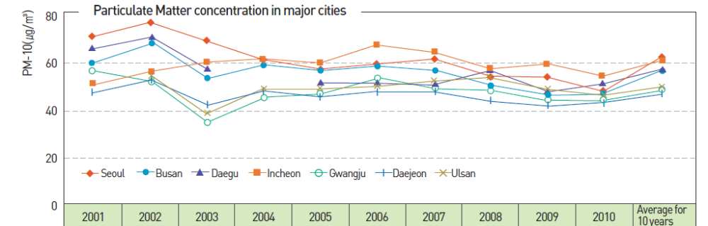
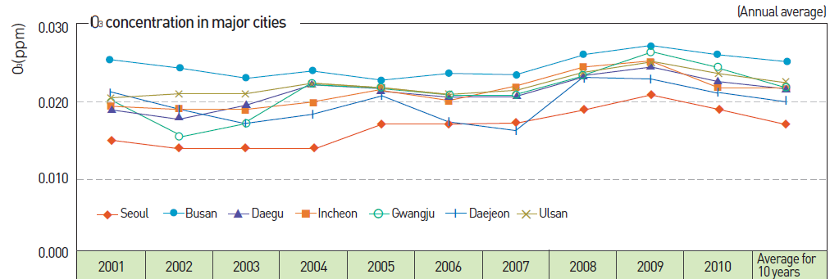
Source: MOE Korea, 2011

IV.1.5 United States
22. Downward trends are observable in the United States (Figure 6), where, between 1990 and 2012, SO₂ emissions diminished by more than 70%, CO emission fell by more than 60%, NO_{X} emission decreased by more than 40%, and PM (both PM₁₀ and PM_{2.5}) emissions declined by roughly 20%.
Figure 6. Air pollutant emissions trends in the United States
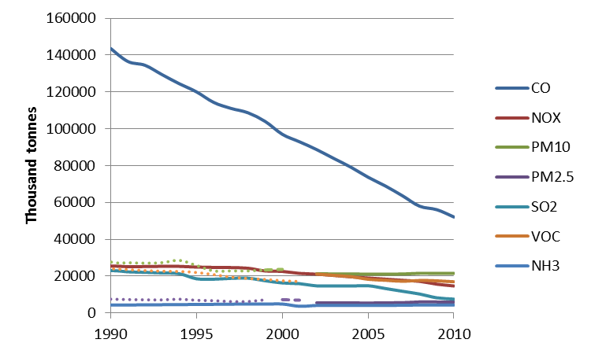
Source: US EPA, 2012

IV.2 The role of different economic sectors

IV.2.1 European Union
23. In addition to total emissions, the EEA estimated the role of different European economic sectors with respect to the emissions of different pollutants. Figure 7 and Table 1 show that energy, transport (distinguishing between road and non-road transport), industrial processes, the use of solvents and other similar products, as well as the commercial and household sectors have emerged as the key sources of emissions a wide range of air pollutants, including NO_{X}, SO_{X}, NMVOC, CO, and PM (EEA, 2012a). In particular, the EEA (EEA, 2010 and EEA, 2012a) points out that:
- The energy sector accounts for around three quarters of Europe's sulphur oxides (SO_{X}) emissions and about 20 % of NO_{X} output;
- Transport (namely road transport) vehicles are important emitters of NO_{X}, carbon monoxide (CO), PM and NMVOCs. Road transport is the biggest emitting economic sector only for NO_{X};
- Energy combustion from households and commercial/institutional buildings - burning fuels such as wood and coal - is the main source of directly emitted PM (especially primary PM_{2.5});
- Agriculture accounts for most (about 95 %) of Europe's NH₃ emissions (not shown in Figure 7).
24. The EEA report shows that a number of key source categories were identified as being key categories for more than one of the 15 pollutants assessed. These key categories are defined as the individual sources that overall contributed most to 2010 emissions of pollutants, determined by a level assessment for each of the main air pollutants, PM, heavy metals (HMs) and persistent organic pollutants (POPs). From a total of 109 source categories, 49 source categories were identified as being key categories for at least 1 pollutant. A number of source categories were identified as being key categories for more than 1 of the 15 pollutants assessed. Road transport was designated as a key category for six types of emissions: NO_{X}, CO, NMVOC, lead, PM₁₀, and PM_{2.5}. Other sectors, i.e. residential (stationary plants), public electricity and heat production, stationary combustion in manufacturing industries and construction, and iron and steel production, have higher numbers of occurrences as key categories (thirteen, eleven, ten and – again – ten times, respectively).
Figure 7. Share of emissions of the main pollutants by economic sector in the EU-27
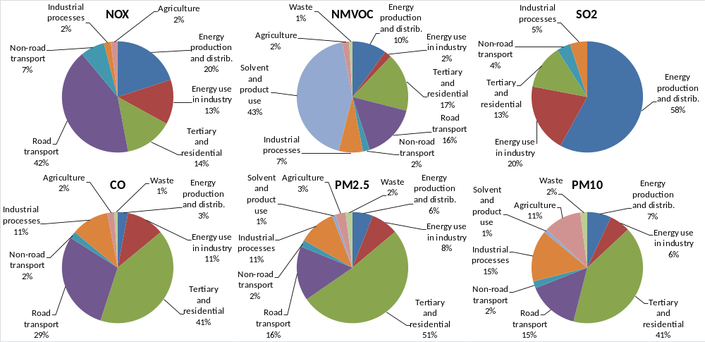
Source: EEA, 2012a
Table 1. Share of EU-27 emissions of the main pollutants by sector group
Pollutants | Sector with highest share per pollutant |  | Road Transport | Non Road Transport
Pollutants | Sector | Share | Road Transport | Non Road Transport
NO_{X} | Road Transport | 42 % | 42% | 7 %
NMVOC | Solvent and product use | 43 % | 16 % | 2 %
SO_{X} | Energy production and distribution | 58 % | 0 % | 4 %
NH₃ | Agriculture | 94 % | 2 % | 0 %
PM_{2.5} | Commercial, institutional and households | 52 % | 16 % | 2 %
PM₁₀ | Commercial, institutional and households | 41 % | 15 % | 2 %
CO | Commercial, institutional and households | 41 % | 29 % | 2 %
Pb | Energy use in industry | 36 % | 10 % | 1 %
Cd | Commercial, institutional and households | 39 % | 3 % | 1 %
Hg | Energy production and distribution | 41 % | 0 % | 4 %
PCDD/Fs | Commercial, institutional and households | 37 % | 1 % | 1 %
Total PAHs | Commercial, institutional and households | 59 % | 2 % | 0 %
HCB | Industrial processes | 70 % | 2 % | 0 %
HCH | Industrial processes | 66 % | 0 % | 0 %
PCBs | Waste | 35 % | 4 % | 0 %
Source: EEA, 2012a
25. Road transport is the major source category for NO_{X} (Table 1). Similarly, energy production is the main source for SO_{X}; agriculture for NH₃; solvent and product use for NMVOC; and the commercial, institutional and household sector for CO, PM_{2.5}, PM₁₀ and other pollutants. NO_{X} emissions from the road transport sector have decreased by 46 % since 1990, mainly as a result of the introduction of three-way catalytic converters on passenger cars and stricter regulation of emissions from heavy-duty vehicles across Europe.
26. Among the top five key categories, the highest relative reductions in emissions between 1990 and 2010 were achieved for passenger cars (-82.9 %).

IV.2.2 North America
Figure 8. Share of emissions of the main pollutants by economic sector in the United Sates
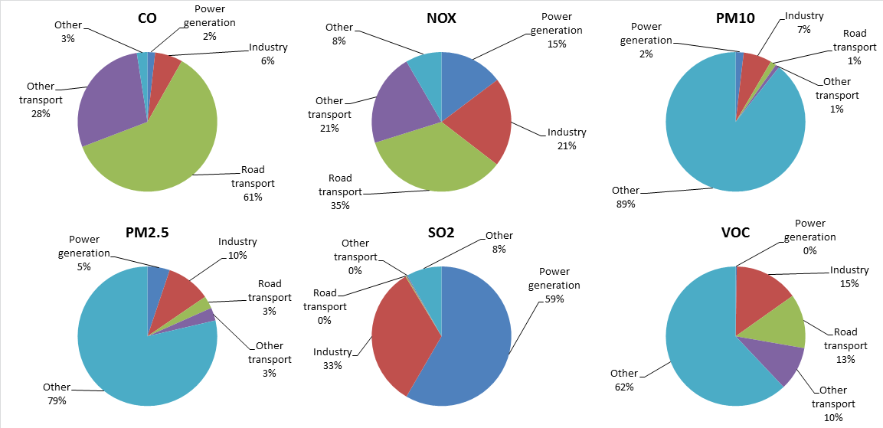
Source: US EPA, 2013
27. In the United States, the US EPA published similar data, illustrating the evolution of emissions in different economic sectors. Figure 8 summarizes the information available from the National Emissions Inventory (NEI) Air Pollutant Emissions Trends Data (US EPA, 2013a). Transport (and especially road transport) plays a relevant role for what concerns CO and NO_{X}, and it is an important source of emission for VOC emissions. Notwithstanding different classifications of the economic sectors, the main difference with the European shares can be identified in the PM emissions, where road transport has a lower relevance in the United States. This difference can be explained with the actions taken in the North America, where diesel technology, for light vehicles, is by far not as widespread as in other regions, and where stricter PM emission limits than in Europe have been enforced. As in the case of Europe, low-sulphur fuels allowed achieving very low SO₂ emissions in the transport sector.
28. In Canada, emission trends due to transportation follow comparable patters to those seen in the United States, with PM_{2.5} emissions from the diesel powered on-road fleet counting less than in Europe and having experienced a 75 % decrease between 1985 and 2010. NO_{X} emissions from the diesel heavy-duty and light-duty fleet also went down 40 % in 2010 from 1998 peak values. As in the case of Europe and the United States, these changes occurred despite an increase in the total annual vehicle kilometers travelled by diesel vehicles.

V. Exposure to air pollution
29. In developed countries, the situation of the achievement of transport-related air quality standards improved substantially in recent years. Notwithstanding this progress in reducing anthropogenic emissions of the main air pollutants over recent decades, poor air quality remains an important public health issue (EEA, 2010). This is particularly relevant for airborne particulate matter (PM), tropospheric (ground-level) ozone (O₃) and nitrogen dioxide (NO₂).
30. The air quality concerns regarding these three groups of pollutants (now seen as the most problematic pollutants in terms of harm to health) are confirmed by the following observations:
- A significant proportion of the global population lives in urban areas;
- Cities are the areas with the highest exposure to air pollution because this is where most exceedances of the air quality reference levels occur (e.g. EU (EC, 2008) and WHO (WHO, 2011));
- In the EU Member States, 16 to 30 % of the urban population was exposed (in the period 2008-2010) to PM_{2.5} concentrations above the EU reference levels (the percentages increase to 90-95 % for WHO reference levels). Similarly, exposure estimates for ozone are 15-17 % (EU) and > 97 % (WHO), respectively (EEA, 2012);
- In Japan, the rate of achievement of environmental quality standards is close to 100% for CO. For NO_{X}, the same rate falls close to 90% for roadside monitoring stations, and 100% for ambient monitoring stations. Rates of achievement of the air quality targets are similar for PM, but much lower for PM_{2.5} (about 30% in 2010, when the first valid monitoring of PM_{2.5} was conducted) and ozone (JASIC, 2013).
31. As pointed out in Section III, emissions from buildings used for households and commercial/institutional activities are amongst the most important contributors to ozone and PM ambient concentrations levels. Other important anthropogenic sources include industrial processes and road transport. The latter is the main sector responsible for NO_{X} emissions, followed by the energy and household/commercial sector.

VI. International agreements and obligations on air pollutants
32. In the case of PM₁₀, the EEA points out that the majority of EU Member States have not attained the limit values required by the Air Quality Directive by 2005 (EEA, 2010). In particular, the exceedance of the daily mean PM₁₀ limit is considered by the EEA as the biggest PM compliance problem in most urban environments (EEA, 2010).
33. Critical issues also emerge when looking at the emission of air pollutants with respect to the limits included in the relevant European and international legislation.
34. According to the recently reported data (CEIP, 2012) nine Parties to the CLRTAP, including eight EU Member States, failed to reduce their nitrogen oxides emissions below the 2010 national ceilings (Table 2) set in the Gothenburg Protocol. On the same issue, EEA announced that eleven Member States failed to reduce their air pollutant emissions set in the NEC Directive (EEA, 2012b). A few EU-15 "old" Member States also missed their targets for the other pollutants included in the Gothenburg Protocol. On the other hand, all new EU Member States (EU-12) have met their emission ceilings for all pollutants covered in it.
35. The tenth Party that missed its NO_{X} target is the EU-15 that itself is a Party to the Gothenburg Protocol. Moreover, Austria and Ireland that - up till now - have not ratified the Protocol and therefore are not listed in Table 3, also missed their 2010 NO_{X} ceilings by 76 and 15 %, respectively. The two Parties provided their respective ceilings (107 and 65 Gg) when signing the Gothenburg Protocol (GP) in 1999.
36. The figures for EU-15, ten EU Member States, and Norway that missed their GP ceilings for NO_{X} in 2010 are shown in decreasing order in Table 3. The ten EU Member States listed in Table 3 made up a 49 % share of the EU-27 NO_{X} emissions in 2010 (EEA, 2012a).
Table 2. Distance of 2010 NO_{X} emissions (reported in 2012) to the Gothenburg Protocol ceilings
NO_{X} | 2010 emission [Gg] | GP ceilings [Gg] | Distance to target | Compliance
Belgium | 221 | 181 | 22 % | No
Bulgaria | 115 | 266 | -57 % | Yes
Croatia | 71 | 87 | -19 % | Yes
Cyprus | 18 | 23 | -22 % | Yes
Czech Republic | 239 | 286 | -16 % | Yes
Denmark | 129 | 127 | 1 % | No
Finland | 167 | 170 | -2 % | Yes
France | 1080 | 860 | 26 % | No
Germany | 1323 | 1081 | 22 % | No
Hungary | 162 | 198 | -18 % | Yes
Latvia | 34 | 84 | -60 % | Yes
Lithuania | 58 | 110 | -47 % | Yes
Luxembourg | 46 | 11 | 320 % | No
Netherlands | 276 | 266 | 4 % | No
Norway | 184 | 156 | 18 % | No
Portugal | 186 | 260 | -28 % | Yes
Romania | 272 | 437 | -38 % | Yes
Slovakia | 89 | 130 | -32 % | Yes
Slovenia | 45 | 45 | 0 % | Yes
Spain | 890 | 847 | 5 % | No
Sweden | 161 | 148 | 9 % | No
Switzerland | 79 | 79 | 0 % | Yes
United Kingdom | 1106 | 1181 | -6 % | Yes
United States of America |  | 6897 | - | -
EU-15 | 7219 | 6671 | 8 % | No
Table 3. Distance to target of 2010 NO_{X} emissions in the Gothenburg Protocol in deceasing order
NO_{X} | 2010 emission [Gg] | GP ceilings [Gg] | Distance to target
Luxembourg | 46 | 11 | 320 %
Austria | 189 | 107 | 76 %
France | 1080 | 860 | 26 %
Germany | 1323 | 1081 | 22 %
Belgium | 221 | 181 | 22 %
Norway | 184 | 156 | 18 %
Ireland | 75 | 65 | 15 %
Sweden | 161 | 148 | 9 %
EU-15 | 7219 | 6671 | 8 %
Spain | 890 | 847 | 5 %
Netherlands | 276 | 266 | 4 %
Denmark | 129 | 127 | 1 %
Parties in italics have not ratified the Gothenburg Protocol.

VII. Policy approach to emissions at national and regional level

VII.1 Current situation
37. Several national governments have developed national legislation to offer an umbrella or framework regulation to improve air quality and monitor and curb emissions of air pollutants.

VII.1.1 Canada
38. In Canada, the Canadian Environmental Protection Act, 1999 (Canada, 2013b) is the federal environmental legislation aimed at preventing pollution, protecting the environment and human health, and contributing to sustainable development. Canadian Ambient Air Quality Standards (CAAQS) for fine particulate matter (PM_{2.5}) and ozone were recently established as objectives under the authority of the Canadian Environmental Protection Act, 1999 by Environment Canada and Health Canada. These health-based standards are more stringent and more comprehensive than the previous Canada-wide Standards for PM_{2.5} and ozone; providing lower short-term limits for both PM_{2.5} and ozone and introducing a long-term (annual) exposure limit for PM_{2.5}.
39. The standards (summarized in Table 4) are a key component of the Air Quality Management System being implemented by federal, provincial, and territorial governments, and will drive air quality improvements across the country. Because of their significant impact on human health, air quality standards for PM_{2.5} and ozone were developed first. The work to support the development of additional standards for sulphur dioxide and nitrogen dioxide has been initiated by federal, provincial, and territorial governments and is expected to be completed during the coming years.
Table 4. Canadian Ambient Air Quality Standards (CAAQS)
Pollutant | Averaging Time | Canadian Ambient Air Quality Standards |  | Form or Metric
Pollutant | Averaging Time | Effective in 2015 | Effective in 2020 | Form or Metric
PM_{2.5} | Annual | 10 µg/m³ | 8.8 µg/m³ | The 3-year average of the annual average concentrations
PM_{2.5} | 24-Hour | 28 µg/m³ | 27 µg/m³ | The 3-year average of the annual 98th percentile of the daily 24-hour average concentrations
Ozone | 8-Hour | 63 ppb | 62 ppb | The 3-year average of the 4th highest daily maximum 8-hour average concentrations

VII.1.2 European Union
40. The European Union (EU) set up a number of instruments aiming to avoid, prevent or reduce harmful effects on human health and the environment as a whole. The policies in place limit the emissions of air pollutants, and/or establish objectives for ambient air quality. Key legislative EU instruments include the following:
- In 2001, the EU Directive on National Emission Ceilings for certain pollutants (NEC Directive) (EC, 2001a), setting upper limits for each Member State for the total emissions in 2010 (and beyond) of the four pollutants responsible for acidification, eutrophication and ground-level ozone pollution: sulphur dioxide (SO₂), nitrogen oxides (NO_{X}), volatile organic compounds (VOC) and ammonia (NH₃). The NEC Directive left to the EU Member States the decision on which measures to take in order to comply, but it included the requirement to develop (in 2002, with a second round foreseen for 2006) national programmes for the attainment of the targets. These programmes have been analyzed and evaluated.
Table 5. Limit values of the European Air Quality Directive for the protection of human health
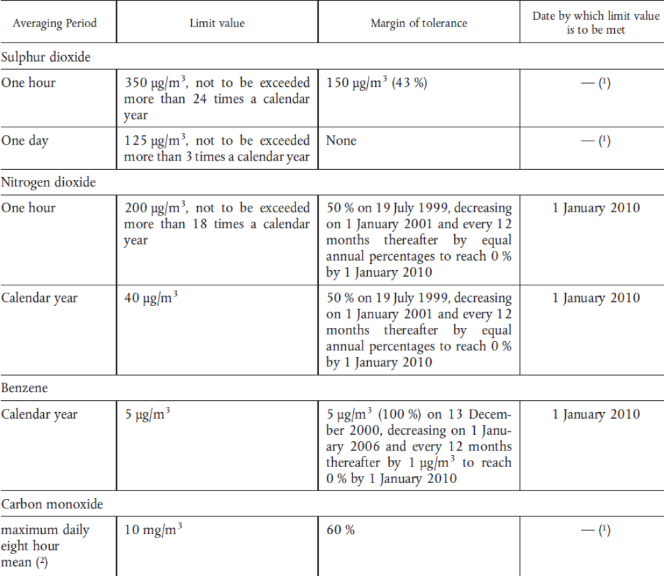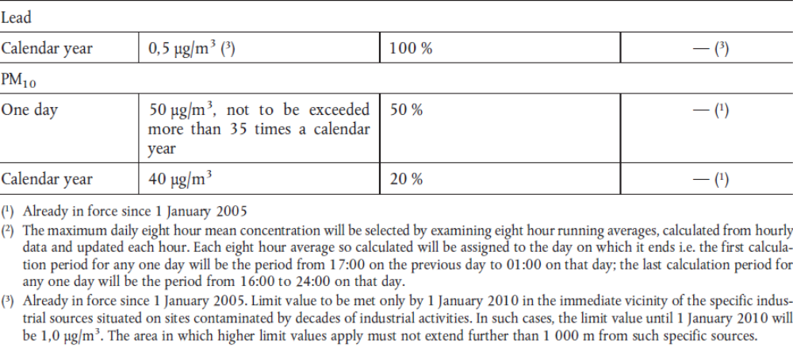
Source: EC, 2008
- In 2002, the Sixth Environment Action Programme (6EAP) set long-term objective of achieving levels of air quality that do not give rise to significant negative impacts on, and risks to, human health and the environment.
- In 2005, the Thematic Strategy on Air Pollution (EC, 2005) identified a number of key measures to be taken to help meeting the 2020 interim objectives for human health and the environment. The revision of the NEC Directive, now under preparation, was identified as one of the key measures in this strategy.
- In 2008, the Air Quality Directive (EC, 2008) merged most of the previous legislation on air quality (i.e. legislation targeting the ambient concentration of pollutants, with the exception of target values for the concentration of arsenic, cadmium, nickel and benzo(a)pyrene in ambient air) into a single directive, with no change to pre-existing air quality objectives. The Air Quality Directive also introduced new air quality objectives for PM_{2.5} (fine particles), the possibility to discount natural sources of pollution when assessing compliance against limit values, and the possibility for time extensions of three years (PM₁₀) or up to five years (NO₂, benzene) for complying with limit values, based on conditions and the assessment by the European Commission. The limit values for the protection of human health included in the Air Quality Directive are reported in Table 5.
41. According to the final assessment on the 6EAP, the review of the European air quality policy is expected by 2013 (EC, 2011). The review of the NEC Directive is expected to set emission ceilings for the four already regulated substances (SO₂, NO_{X}, volatile organic compounds and ammonia), as well as the primary emissions (i.e. the fraction of emissions that is emitted directly into the atmosphere, rather than following the oxidation and transformation of precursor gases) of fine particulate matter (PM2.5) (EC, 2012a).
42. Parallel to the development of the EU NEC Directive, the EU Member States together with Central and Eastern European countries, the United States of America and Canada have negotiated the "multi-pollutant" protocol (the so-called Gothenburg Protocol, agreed in November 1999 (UNECE, 1999)) under the UNECE Convention on Long-Range Transboundary Air Pollution (CLRTAP) (UNECE, 1979). The Gothenburg Protocol includes emission ceilings for nitrogen oxides (NO_{X}), sulphur dioxide (SO₂), ammonia (NH₃) and non-methane volatile organic compounds (NMVOCs). The emission ceilings in the protocol are equal or less ambitious than the NEC Directive (EC, 2012b).
43. In early May 2012, Parties of CLRTAP reached a consensus to revise the Gothenburg Protocol. The revision (not in force yet) sets new emission ceilings for NO_{X}, SO₂, NH₃ and NMVOCs for the year 2020 and beyond. It introduces emission ceilings for fine particular matter (PM_{2.5}).

VII.1.3 Japan
44. In Japan, Environmental Quality Standards for Air (EQSs), summarized in Table 6, are designated for the purpose of protection of human health from environmental pollution established by the Basic Environment Law. The substances targeted by the EQSs include Suspended Particulate Matter (SPM), NOx and PM_{2.5} (Table 6).
45. In transport, vehicle emissions regulations were first established in Japan under the Air Pollution Control Law in 1973 for gasoline vehicles and in 1974 for diesel vehicles. A reinforcement of these regulations resulted in adding PM as the targeted substance for regulations in 1994.
46. In Japan, the Central Environment Council is in charge of issuing recommendations to review and reinforce measures for vehicle emission, including establishing the maximum permissible limits, in response to inquiry by Minister of the Environment. The Council, responsible for consideration of issues related to environmental protection, discusses measures for vehicle emissions taking into account of technological development and changes in regulations taking place in other global areas.
Table 6. Japanese environmental air quality standards
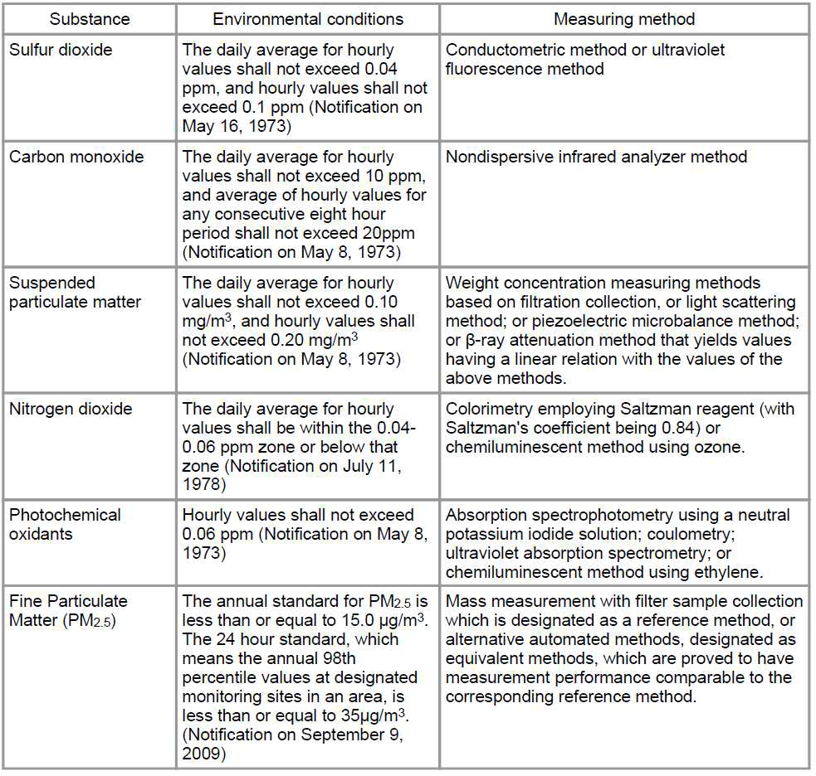
Source: JASIC, 2013

VII.1.4 Republic of Korea
47. The first comprehensive national policy addressing air quality came into effect in the Republic of Korea (Korea) in August 1990. All national ambient air quality regulations are based on the Clean Air Conservation Act of the Ministry of Environment (MOE), a part of the Environmental Conservation Act (1977) within the Environmental Pollution Prevention Act (1963) (TransportPolicy.net, 2013 and Lim, 2013).
48. Sulfur dioxide (SO₂) was first regulated in Korea in 1978. CO, NO₂, TSP, O₃ and total hydrocarbons (HC) were added to the list of the regulated pollutants in 1983. Lead (Pb) was added in 1991. In 1993 and 1995 the regulatory limits for SO₂ and CO were made more stringent. PM₁₀ regulations were established in 1995. In 2001, TSP became exempt from any environmental regulations, while stringencies were increased for SO₂, PM₁₀ and lead. Finally, regulatory limits for NO₂ emissions were strengthened in 2007. In the same year, benzene emissions were regulated. This last measure was implemented in 2010. PM_{2.5} regulation will implement in 2015 (TransportPolicy.net, 2013 and Lim, 2013).
49. Local legislation focusing on the protection of air quality of certain metropolitan regions was also enforced in Korea. A key example is the Special Act on Metropolitan Air Quality Improvement ratified by the Seoul Metropolitan Air Quality Improvement Program Organization in 2003 (TransportPolicy.net, 2013 and Lim, 2013).
Table 7. Korean air quality limits
Air pollutants | National ambient air quality standard
SO₂ | Yearly | 0.02ppm or less
SO₂ | 24-hour | 0.05ppm or less
SO₂ | 1-hour | 0.15ppm or less
CO | 8-hour | 9ppm or less
CO | 1-hour | 25ppm or less
NO₂ | Yearly | 0.03ppm or less
NO₂ | 24-hour | 0.06ppm or less
NO₂ | 1-hour | 0.10ppm or less
PM-10 | Yearly | 50㎍/㎥ or less
PM-10 | 24-hour | 100㎍/㎥ or less
O₃ | 8-hour | 0.06ppm or less
O₃ | 1-hour | 0.1ppm or less
Pb | Yearly | 0.5㎍/㎥ or less
Benzene | Yearly | 5㎍/㎥ or less
Source: Air Korea, 2013

VII.1.5 United States
50. In the United States, the Clean Air Act provides the main framework for the undertaking of measures aimed to protect air quality. It identifies two types of national ambient air quality standards. Primary standards provide public health protection, including protecting the health of sensitive populations such as asthmatics, children, and the elderly. Secondary standards provide public welfare protection, including protection against decreased visibility and damage to animals, crops, vegetation, and buildings (US EPA, 2011a).
51. Under the Clean Air Act, EPA's Office of Air Quality Planning and Standards (OAQPS) is responsible for setting the national ambient air quality standards (NAAQS) for pollutants which are considered harmful to people and the environment (US EPA, 2011b).
52. The NAAQS set by the US EPA for six principal pollutants (the "criteria air pollutants") are summarized in Table 8.
Table 8. National Ambient Air Quality Standards in the United States
Pollutant |  | Primary/  Seconary | Averaging Time | Level | Form
Carbon monoxide (CO) |  | primary | 8-hour | 9 ppm | Not to be exceeded more than once per year
 |  | primary | 1-hour | 35 ppm | Not to be exceeded more than once per year
Lead |  | primary &  secondary | Rolling 3 month average | 0.15 μg/m³ | Not to be exceeded
Nitrogen dioxide (NO₂) |  | primary | 1-hour | 100 ppb | 98th percentile, averaged over 3 years
 |  | primary &  secondary | Annual | 53 ppb | Annual Mean
Ozone (O₃) |  | primary &  secondary | 8-hour | 0.075 ppm | Annual fourth-highest daily maximum 8-hr concentration, averaged over 3 years
Particlulate matter (PM) | PM_{2.5} | primary | Annual | 12 μg/m³ | annual mean, averaged over 3 years
Particlulate matter (PM) | PM_{2.5} | secondary | Annual | 15 μg/m³ | annual mean, averaged over 3 years
Particlulate matter (PM) | PM_{2.5} | primary &  secondary | 24-hour | 35 μg/m³ | 98th percentile, averaged over 3 years
Particlulate matter (PM) | PM₁₀ | primary & | 24-hour | 150 μg/m³ | Not to be exceeded more than once per year on average over 3 years
Particlulate matter (PM) | PM₁₀ | secondary | 24-hour | 150 μg/m³
Sulfur dioxide (SO₂) |  | primary | 1-hour | 75 ppb | 99th percentile of 1-hour daily maximum concentrations, averaged over 3 years
 |  | secondary | 3-hour | 0.5 ppm | Not to be exceeded more than once per year
Source: US EPA, 2011a

VII.2 Transport policies
53. To date, ambient air quality improvements have been primarily tackled, in transport, by measures to reduce road transport emissions through the introduction of more stringent emission standards for a wide range of vehicle categories.
54. In the United States, the first federal automobile emission standards were set in 1965, with the Motor Vehicle Air Pollution Control Act. In the 1970s catalytic converters were developed in response to the automobile emission regulations related with the amendments of the Clean Air Act, a regulatory text of 1963 that did not specify controls for automobiles in its first draft. Federal regulation of heavy-duty engine emissions in the United States began in 1974. Emissions of air pollutants from motorcycles were first regulated in 1978. Non-road machinery emissions were first regulated in 1994. Amendments and revisions tightened earlier standards with the aim to ameliorate problems related to air pollution (Jacobson, 2013).
55. Similarly, in Canada, progressively more stringent emission standards have been in place for on-road and off-road vehicles since 1971. More recently, greenhouse gas regulations for light and heavy duty vehicles have been developed.
56. In the EU, the first introduction of measures to be taken against air pollution by emissions from motor vehicles (Euro 0) dates back to 1970 for light vehicles (Directive 70/220/EEC), the late 1980s (Directive 88/77/EEC) for heavy duty engines, and the late 1990s for two wheelers and non-road mobile machinery. In the early 1990s, the "Euro" regulations were first enforced for light vehicles and heavy-duty engines. Updates were introduced in the years following the first introduction of regulatory measures for all vehicles and engine categories (TransportPolicy.net, 2013).
57. In Japan, emissions limits for light vehicles were first established in 1973. Diesel emission regulations for heavy commercial vehicles were first enforced in 1974 (JASIC, 2013). Emissions from non-road machinery were first applied in 2003. As in the case of other developed countries, the regulatory limits have been tightened in following years. The maximum permissible limit values of emissions from road transport are now prescribed by the Road Vehicles Act. The Ministry of Land, Infrastructure, Transport and Tourism enforces the Road Vehicles Act which prescribes the limit value in consideration of Air Pollution Control Law.
58. Similar regulations on the emissions of air pollutants have also been enforced in several developing countries, to varying degrees.
(a) The limits used for Chinese regulatory measures are similar to European regulations, with a delay in their implementation and enforcement. In China, nationwide emission controls for light vehicles began in the late 1990s. China regulates heavy-duty emission since 2001, non-road machinery since 2002, and two wheelers since 2003 (TransportPolicy.net, 2013).
(b) India began to lower the pollution emission limits for road vehicles since 2001, also using European regulations as a reference. Non-road vehicle emissions in India were first addressed in 1999 (agricultural tractors) and 2007 (construction equipment). Two and three-wheeler emissions regulations were first enforced in 1991. In the case of two- and three-wheelers, Indian regulations are not aligned with the European ones (TransportPolicy.net, 2013).
(c) Since 1988, Brazil used to adopt emission regulations for light vehicles that were equivalent to those applied in the EU. The regulations have been revised and tightened in following years. Emissions from non-road mobile machinery in Brazil were first regulated in 2011, using the US regulation as a basis. These limits will be effective between 2015 and 2019. Brazilian standards are used as a base by neighboring South American countries (TransportPolicy.net, 2013).
(d) Mexican emission requirements for light and heavy-duty vehicles became effective in 1993. Emission regulations were tightened in following years, using European and US limit values as a reference (TransportPolicy.net, 2013).
59. In recent years, the introduction of vehicle emission standards was also accompanied by parallel legislations that established limits for fuel parameters. This is especially relevant for the sulphur content of fuels, since sulphur in fuels can impair the effectiveness of air pollution mitigation vehicle technologies such as three-way catalytic converters, oxidation catalysts, NO_{X} traps and particulate filters.
(a) In the European Union vehicle emission standards and air quality targets were linked with fuel quality parameters after the negotiations started with the Auto-Oil programme. In particular, as it has been considered that the Euro 4 emission regulations for petrol cars can be attained using fuels containing a maximum 50 mg/kg of sulphur, both Euro 4 and the 50 mg/kg sulphur fuel quality parameters have been mandated for 2005 by Directives 98/69/EC and 98/70/EC, respectively (EC, 2001b). Similar considerations explain the introduction of Euro 5 light duty emission regulations, Euro IV and V heavy duty regulations, and the introduction of ultra-low sulphur fuels (i.e. containing less than 10 mg/kg of sulphur).
(b) In the United States, Tier 2 tailpipe emissions standards for all passenger vehicles were introduced jointly with lower standards for sulfur in gasoline, treating vehicles and fuels as a system with the aim to ensure the effectiveness of low emission-control technologies in vehicles, in order to reduce harmful air pollution (US EPA, 1999 and 2000a). This regulatory instrument set a limit of 30 mg/kg average sulfur level, with a maximum cap of 80 mg/kg. The proposed Tier 3 program uses the same system approach, introducing tighter vehicle emissions standards and a lower sulfur content of gasoline (10 mg/kg) since 2017 (US EPA, 2013b). Similarly, A 15 mg/kg sulfur specification, known as Ultra Low Sulfur Diesel (ULSD), was phased in for highway diesel fuel from 2006-2010. Diesel engines equipped with advanced emission control devices must use highway ULSD fuel (US EPA, 2000b).
(c) In Japan, the sulfur content in diesel fuels in Japan has been reduced, since the 1990s, in several steps: 2000 mg/kg in 1992, 500 mg/kg since 1997, 50 mg/kg since 2004 (in practice, this was introduced since April 2003, following voluntary move from the petroleum industry), and 10 mg/kg since 2007 (2005 in practice, the earliest introduction of ultra-low sulphur fuels globally) (JASIC, 2013). The link between vehicle and fuel technologies (and related regulations) for cleaner air quality was assured, in Japan, in the framework of the JCAP (Japan Clean Air Porgramme) II Research Activities (JCAP, 2007).
60. Looking specifically at cleaner fuels, the Partnership for Cleaner Fuels and Vehicles of the United Nations Environment Program (UNEP-PCFV), launched in 2002, brought together committed partners from governments, international organizations, industry, and NGOs to promote clean fuels and vehicles. The UNEP-PCFV has focused its activities on the elimination of lead in gasoline, the phase down of sulphur in diesel and gasoline fuels, concurrent with the adoption of cleaner vehicle technologies.

VII.3 UNECE activities in the transport sector
61. UNECE World Forum for Harmonization of Vehicle Regulations (WP.29) has already done extensive work in the field of air pollution containment, with major achievements towards reducing the emissions of air pollutants from all motor vehicles engines. This work largely benefitted from on the regulatory initiatives undertaken by the European Union. Besides contributing to extend their scope to a larger portion of the globe, the work undertaken at the UNECE was particularly relevant to make significant progress on technical matters, including those concerning the test procedures that are required for the enforcement of emission control legislation.

VII.3.1 Common test procedures
62. In 1997, a process aimed at the world-wide test cycle harmonization for heavy-duty engines was started in the WP.29 framework. This began with the creation, under the Working Party on Pollution and Energy (GRPE, a subsidiary body of WP.29), of a working group on the World-wide Heavy-Duty Certification procedure (WHDC). The work of this group resulted in the establishment, in 2006, of a harmonized UN Global Technical Regulation (UN GTR No. 4) on the certification procedure for heavy-duty engines (UNECE, 2013a). This regulatory text provides a common basis, at global level, for measuring the performance of existing and future heavy-duty engines in terms of emissions of gaseous pollutants and particulate matter. The UN GTR contains two representative test cycles (a transient test cycle (WHTC) with both cold and hot start requirements and a hot start steady state test cycle (WHSC)), closely reflecting world-wide on-road heavy-duty engine operation (a marked improvement in comparison with earlier approaches).
63. In 2001, the working group World-Wide harmonized Heavy duty On-Board Diagnostics (WWH-OBD) was established to develop harmonized prescriptions for technical requirements for on-board diagnostic systems for road vehicles. This activity (now concluded) led to the adoption, in 2006, of the UN GTR No. 5 (UNECE, 2013b), a regulatory text that is directed at OBD requirements for heavy-duty engines/vehicles that are necessary to maintain emissions-related performance (i.e. emissions-OBD). The text is also structured in a manner that facilitates a wider application of OBD to other vehicle systems in the future.
64. In 2001, WP.29 created the working group on Off-Cycle Emissions (OCE) with the aim to ensure that off-cycle emissions from heavy-duty engines and vehicles are appropriately controlled over a broad range of engine and ambient operating conditions potentially encountered during in-use vehicle operation and falling outside of the scenarios foreseen by WHDC. This work resulted in the adoption, in 2009, of the UN GTR No. 10 (UNECE, 2013c), a text that was designed to be applicable to engines certified or type approved under the test procedures of UN GTR No. 4 on the Worldwide harmonized Heavy Duty Certification (WHDC).
65. The work initiated for the UN GTR No. 4 and continued with UN GTRs Nos. 5 and 10 is now being brought forward by the informal working group on Heavy Duty Hybrids (HDH), established in 2010 to develop new provisions for a hybrid specific engine cycle for the measurement of pollutants and CO₂ emission from heavy duty hybrids. The focus of this group is again on the development of a test procedure, in order to keep providing a common technical basis to the Parties having an interest to regulate the emissions of pollutants and CO₂ from heavy duty vehicles. The HDH working group is expected to finalize its work by the end of 2013.
66. In 1999, the development of a Worldwide-harmonized Motorcycle Test Cycle (WMTC) was also started. First, this was a tripartite project between the Netherlands Ministry of the Environment (VROM), TNO Automotive and the International Motorcycle Manufacturer Association (IMMA). In 2000 this project was brought in the UNECE/WP.29 framework, with the creation of the WMTC working group. The work of this group led to the adoption, in 2005, of UN GTR No. 2 (UNECE; 2013d) on the certification procedure for motorcycles. The UN GTR contains a representative test cycle in three parts, covering different road types. It includes a gearshift procedure, based on real life data, and an update of the general laboratory conditions for the emission test. The regulatory text covers the emission of gaseous pollutants, CO₂ emissions and fuel consumption, enabling a realistic testing of existing and future motorcycle exhaust-emissions technologies.
67. A similar process started in 2003 for Non-Road Mobile Machinery (NRMM), with the creation of a working group (under WP.29/GRPE) aiming to develop new worldwide harmonized provisions for NRMM engines. Similarly to the case of heavy duty vehicles and UN GTR No. 4, the work of the NRMM group led to the establishment, in 2009, of the UN GTR No. 11 (UNECE; 2013e), containing a common test procedure on the measurement of emissions of gaseous pollutants (NO_{X}, CO, HC, particles) from NRMM compression-ignition engines.
68. The development of a regulatory text with a Worldwide harmonized Light vehicles Test Procedure (WLTP), covering the measurement procedure for the emissions of gaseous pollutants (NO_{X}, CO, HC) and particles, as well as fuel consumption and the emissions of CO₂, started in 2007, with the creation of a working group under GRPE. In 2009, a proposal for the development of a UN GTR was adopted. By 2010, the work of the WLTP groups was organized in sub-groups. Some of the activities originally planned, such as those concerning Mobile Air Conditioning systems, were considered as a parallel work stream to the main development of the regulatory text and the related test procedures. The WLTP drafted a preliminary text for the UN GTR on the light vehicle test (UNECE; 2013f) and is expected to deliver, by 2014, the final regulatory framework containing harmonized test procedures to enable the certification of existing and future light vehicles technologies.

VII.3.2 Regulations setting limit values for pollutant emissions
69. UN Regulations Nos. 49 (heavy duty vehicles) (UNECE, 2013g) and 83 (light vehicles) (UNECE, 2013h) specify limit values for emissions of particulate matter (expressed, in the last updates, both in terms of particulate mass and particle number), carbon monoxide, hydrocarbons (also specifying the part of non-methane hydrocarbons, in the last updates) and oxides of nitrogen. They build on the emission regulations enforced in the European Union (Euro pollutant emission standards, enacted through directives and, in recent years, regulations). Table 9a and 9b summarize the evolution of emission limits of CO, HC, NO_{X}, and PM for light vehicles (both for the transport of passengers and goods), since the Euro 1 norms, also specifying the EU regulatory text and the corresponding version of the UN Regulation No. 83 that contain provisions on the different sets of limit values. Tables 10a and 10b provide a similar summary for heavy duty vehicles regulated by UN Regulation No. 49.
70. Similar limit values, for carbon monoxide (CO), hydrocarbons, NO_{X} and PM, have been enforced for engines of non-road mobile machinery (UN Regulation No. 96) (UNECE, 2013i), i.e. engine fitted to self-propelled machinery including agricultural/forestry tractors, construction equipment and industrial equipment. The current limit values for the pollutant emissions of non-road mobile machinery depend on the net power of the engine. For PM, they range between 0.025 g/kWh (large engines) and 0.8 g/kWh (small ones). NO_{X} limits range between 2 g/kWh (lowered to 0.4 g/kWh for a large part of the power range, commencing from 2014) and 8 g/kWh. For CO, the limits are set between 3.5 g/kWh and 5.5 g/kWh. Hydrocarbon emission limits range between 0.19 g/kWh and 1.5 g/kWh.
Table 9a. Emission limits for light vehicles
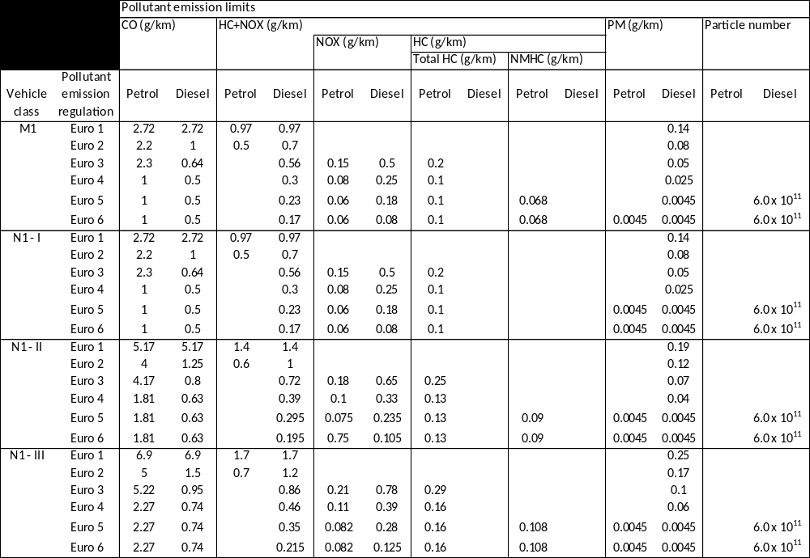
Table 9b. Regulatory texts for light vehicles
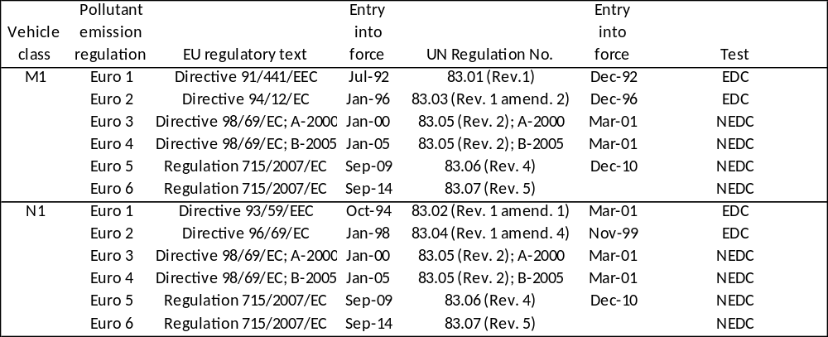
71. In 2010, WP.29/GRPE established an informal working group on Retrofit Emission Control devices (REC) to evaluate harmonized requirements for the treatment of diesel exhaust emissions with the aim to develop a new UN Regulation for REC to be installed on heavy duty vehicles, non-road mobile machinery and tractors already in use. The activities of the group follow a number of initiatives aiming to contain pollutant emissions, including in particular the adoption of low emission zones. The technical work of the REC group will address the need for defined performance requirements for retrofit emission control devices, delivering uniform provisions applicable to vehicles engaged in cross-border transport and fostering the market entry of these new technologies. The text of the new UN Regulation on REC is currently being finalized and the performance-oriented requirements included are expected to be established by the end of 2013 (UNECE, 2013j).
Table 10a. Emission limits for heavy duty vehicles
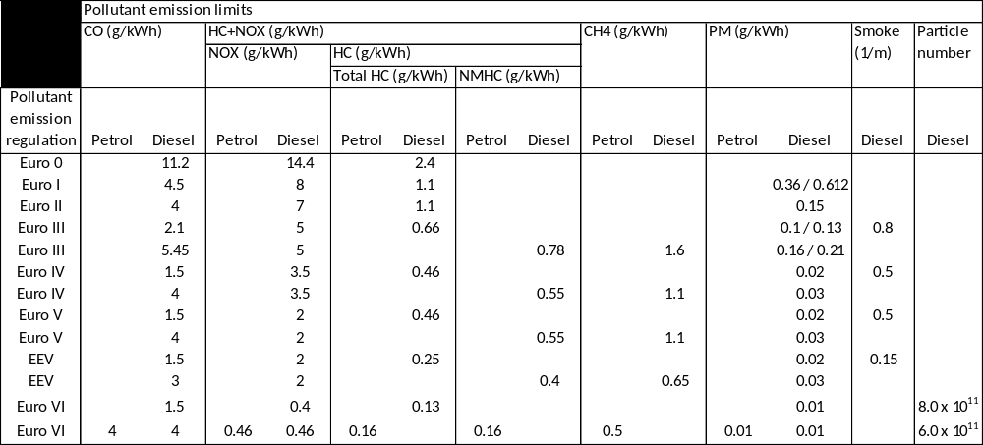
Table 10b. Regulatory texts for heavy duty vehicles
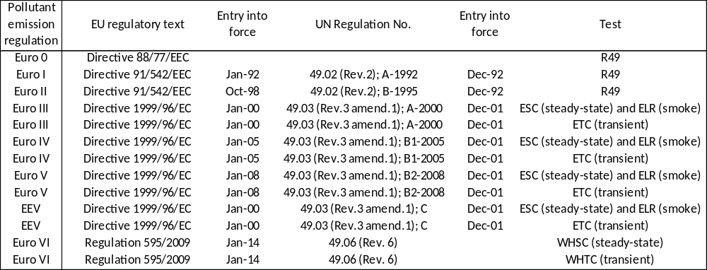
72. UN Regulations No. 40 and 47 contain, respectively, provisions concerning the emissions of ai pollutants from motorcycles and mopeds. Such provisions, summarized in Table 11, have been complemented in 2011 by a set of limit values included in UN GTR No. 2. The latter reflect basic information about the current legal situation regarding the WMTC application.
Table 11. Regulatory texts for light vehicles
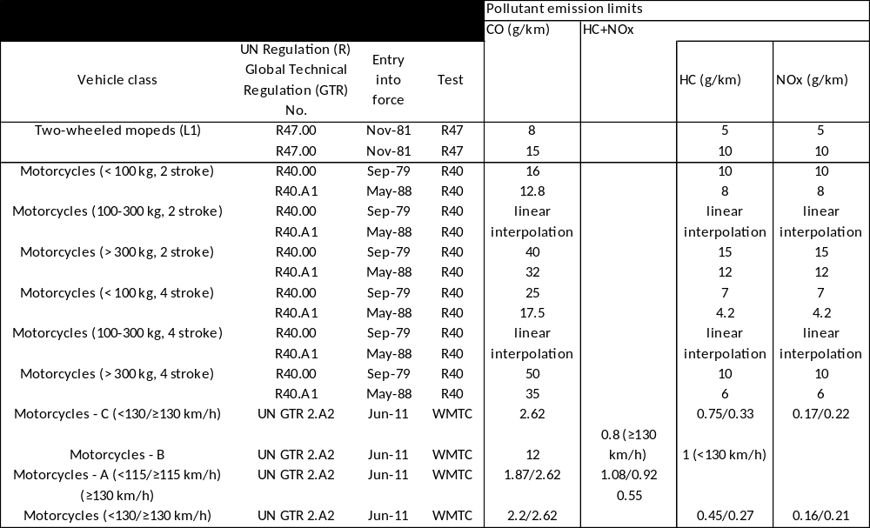

VII.3.3 Other relevant activities
73. A number of other activities were started in order to support the work undertaken by the groups working on UN GTRs and UN regulations.
(a) In 2001, the World Forum WP.29 established an informal working group on the Particle Measurement Programme (PMP). The main focus of this group is, and has been, the development of standardized methodologies to measure emissions of solid tailpipe particles from vehicles and engines. This has been the basis for the development of regulatory instruments targeting the emission reduction of pollutants, notably particulate matter (PM) and particle number (PN). Since its inception, the PMP group activities have focused on the development of an alternative metric with increased sensitivity compared to the existing PM mass measurement system for heavy-duty and light-duty engines/vehicles (M and N category vehicles). This phase concluded with the development and adoption into UN Regulation Nos. 83 (for light-duty emissions) and 49 (for heavy-duty emissions) of a PN counting method for ultrafine solid particles. The PMP activities also led to enhancements of the PM mass measurement procedure in UN Regulation No. 83. Initially, this updated PN protocol was applied for diesel engines/vehicles only in the 06 series of amendments to UN Regulation No. 83 and the 06 series of amendments to UN Regulation No.49. Subsequently it has been extended to cover spark-ignition direct injection engined vehicles (07 series of amendments to UN Regulation No. 83). As a result of the introduction of emission standards based on the particle number measured according to the methodology developed by the PMP group, diesel road vehicles complying with the latest series of amendments of UN Regulations No. 83 and 49 need to be fitted with the best available technology, i.e. the wall-flow diesel particulate filters having the capability of reducing particle emissions with an efficiency larger than 95%.
Today, PMP remains an active informal working group. It focuses primarily on calibration issues and is considering the possible extension (e.g. to non-road mobile machinery) and improvement (namely for PN) of the tailpipe measurement method.
(b) The informal working group on Electric Vehicles and the Environment (EVE), established under GRPE by WP.29 in 2012, was created with the aim to act as an international forum to examine a range of issues related to electric vehicles, including sharing information about developing technologies, current regulatory activities, policy approaches, research priorities, and the deployment of EVs. The EVE group is currently developing a global EV Regulatory Reference Guide that will compile requirements (voluntary, regulatory, etc.) for hybrid, plug-in and electric vehicles for GRPE Contracting Parties and WP.29 informal working groups.

VII.3.3 Emission regulations and fuel quality parameters
74. Since 2012, the Special Resolution No. 1 (UNECE, 2013k) and the Consolidated Resolution on the Construction of Vehicles (R.E.3) (UNECE, 2013l), developed in the framework of the 1998 Agreement on UN Global Technical Regulations and the 1958 Agreement concerning the Adoption of Uniform Technical Prescriptions, administered by WP.29, contain recommendations developed to inform governments about appropriate market fuel quality that is protective of vehicle emission control technologies.

VII.4 Focus on diesel exhaust emissions
75. Internal combustion engines powered by diesel fuel oil tend to offer better performances in terms of fuel consumption (also associated with lower greenhouse gas emissions) with respect to comparable gasoline engines. Even if diesel ICEs cost more than their gasoline equivalents, the fuel savings they generate tend to exceed the incremental investment cost gap they require for their purchase. Since savings are larger in applications that require an intensive use of the ICE, diesel ICEs are the main technology of choice in heavy-duty stationary and mobile applications. This is the case for a wide range of economic and industrial sectors, including for instance goods movement, public transportation, construction and agriculture.
76. In June 2012, the World Health Organization’s International Agency on Research on Cancer (IARC) concluded that diesel engine exhaust is carcinogenic to humans based on sufficient evidence that exposure is associated with an increased risk for lung cancer (IARC, 2012). IARC thereby changed its finding from 1988, when it classified diesel exhaust as probably being carcinogenic to humans. The finding from a previous evaluation in 1989, that gasoline exhaust is possibly carcinogenic to humans, remained unchanged.
77. It is noteworthy that the IARC decision was unanimous and was based on "compelling" scientific evidence. It urged people worldwide to reduce their exposure to diesel fumes as much as possible. Large populations are exposed to diesel exhaust in everyday life, whether through their occupation or through the ambient air. People are exposed not only to motor vehicle exhausts but also to exhausts from other diesel engines, including those from other modes of transport (e.g. diesel trains and ships) and stationary sources (e.g. power and motion generators used in the energy and in the industrial sectors).
78. However, the mounting concern about the cancer-causing potential of diesel exhaust was based on findings in epidemiological studies that were re-emphasized by the publication in March 2012 of the results of a US National Cancer Institute/National Institute for Occupational Safety and Health study of occupational exposure to such emissions by underground miners, showing an increased risk of death from lung cancer (IARC, 2012).
79. Dr. Kurt Straif, Head of the IARC Monographs Program, indicated that "the main studies that led to the above mentioned conclusion were in highly exposed workers (mines) and that they came up to this conclusion based on other carcinogens, such as radon, that initial studies showing a risk in heavily occupational groups were followed by positive finding for the general population" (IARC, 2012).
80. Dr. Christopher Wild, IARC Director, answering the question if the new diesel engines are so clean that the findings from this monograph meeting are no longer relevant to today´s situation, replied: "the new diesel engines contain far fewer particles and chemicals compared to the older technology engines. In addition to that, there are also qualitative changes, so the composition of the mixture in the exhaust is different", also adding that "what we do not know at this stage is if this composition and the decreased levels of these components translated to a different healthy fact in exposed people and here we should encourage further research in the future" (Wild, 2012). He also underlined that in many developing countries the transition from the old technology to the new one will take time and therefore, for many people in the world, the exposures are still from the exhaust of old diesel engines (Wild, 2012).
81. The US EPA considers that the health effects of diesel emissions are well studied, but complex (US EPA, 2002). Even if the level and duration of exposure that causes harm varies from one substance to the next, the EPA has designated diesel exhaust as a likely carcinogen to humans by inhalation at environmentally adequate exposures (US EPA, 2002). In the United States, a number of other agencies (National Institute for Occupational Safety and Health, the International Agency for Research on Cancer, the World Health Organization, California EPA, and US Department of Health and Human Services) have made similar classifications.
82. Overall, the importance of the health risks pointed out by the IARC and other authoritative sources calls for continued action aiming at limiting emission of air pollutants characterizing diesel exhaust and, more broadly, to reduce human exposure to them.
83. To date, the legislation targeting the emissions of air pollutants was the main contributor to the achievement of major reductions of air pollutant emissions that also address diesel combustion.
84. The strong relationship between transport and ICEs was such that legislative actions were aimed primarily to limit pollution generated in road transport applications. In Europe and other highly motorized countries, recent policy measures that impose stricter pollutant emission limits for the construction of new road transport vehicles, extend into the forthcoming years the achievement of substantial impacts in terms of abating the emissions from diesel exhaust emissions. In particular, many of the recent PM regulatory decisions affecting fuels, engine designs and exhaust aftertreatment are likely to result in significant reductions in the emissions of both fine and ultrafine particles.
85. A selection of measures addressing diesel exhaust emissions recently taken by Canada, the European Union, Japan, Switzerland and the United States is included in Box 2. Table 12 contains a summary of the limit values of exhaust gas emissions from diesel heavy duty vehicles in Japan, including those that concern the near future.
86. These considerations highlight that, to date, road transport played a very prominent role in the limitation of health and environmental effects due to ICEs, including in those powered by diesel fuel oil. The efficacy of the regulations limiting the emissions of air pollutants from diesel ICEs used in road transport application is confirmed by the recognition that new diesel engines used on road vehicles contain far fewer particles and chemicals compared to older diesel ICEs, notwithstanding qualitative changes that require further research.
Box 2. Selected regulatory actions on diesel-related emissions in Canada, the European Union, Japan, Switzerland and the United States
Canada regulates new on-road light passenger cars and trucks, as well as on-road heavy-duty trucks and off-road machinery. Most recently, Canada aligned with the Tier 4 air pollutant standards of the United States of America for off-road diesel engines used in mining, agricultural and construction sectors. Canada has also implemented regulations to reduce the maximum allowable content of sulphur diesel fuel to 15 part per million (ppm) in order to ensure the effective operation of exhaust after-treatment systems used on diesel engines to meet increasingly stringent emission standards.
The high share of light vehicles running on diesel in the European Union is one of the reasons why the European Union was an early adopter (as a result of the entry into force of Euro 5 emission regulation) of technologies like the diesel particulate filter (DPF) on light vehicles. DPFs are also necessary to comply with heavy duty emission regulation.
The current Japanese "Post New Long Term Regulation" for diesel vehicles came into force in October 2009, in accordance with the Eighth Report of Future Policy for Motor Vehicle Emission Reduction published by the Central Environment Council on April 2005. In addition, the Tenth Report of Future Policy for Motor Vehicle Emission Reduction published on July 2010 recommends the adoption of Worldwide harmonized Heavy Duty Certification (WHDC) and reinforcement of NO_{X} permissible limit for heavy-duty diesel vehicles effective from 2016 on (CEC, 2005 and 2010).
Having considered that solutions to limit particle emissions with efficient filters are enforced for several diesel source categories (passenger cars, buses of public transport, construction machinery, ships, locomotives, heavy duty vehicles), the Swiss Federal Council modified the emission control provisions for construction site equipment, specifying more stringent maximum emission levels which, given current developments in technology, can only be met by employing efficient particle filter systems (Switzerland, 2009 and 2012).
The United States has a full suite of regulatory actions that address emissions from diesel engines and diesel fuel. Since 2007, diesel engines introduced into the US market must meet the most stringent standards. Diesel sulphur levels were also dramatically reduced at that time. Diesel engines used in non-road sources like agricultural or construction uses will need to meet strict Tier 4 emissions requirements beginning in 2014. Additionally, within the last five years the US has adopted regulations for emissions controls from locomotives and marine vessels.
Table 12. Limit values of exhaust gas emissions from diesel heavy duty vehicles in Japan
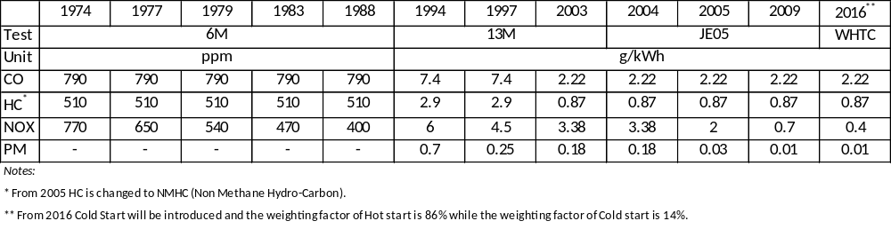
87. Some of the opportunities to further reduce emissions are available on stationary engines and the in-use mobile fleet, since older in-use diesel engines and vehicles can remain in operation for over 20 years. Such measures include retrofitting or removing the older in-use fleet off the road to ensure that newer engines and vehicles, which are compliant with newer more recent air pollutant regulations, have a chance to lead to improved health and environmental outcomes. Some initiatives in this area have already been undertaken by a number of governments. In particular, the Government of Canada is the co-chair of a pan-Canadian working group which holds discussions on reducing emissions from the in-use fleet. The working group has identified off- and on-road diesel emissions as a concern and is now looking at discrete initiatives to achieve reductions in this area over the next 3 years.
88. In some high exposure areas, there might be the need to set up policy measures aimed at replacing vehicles equipped with older engine technologies with new vehicles complying with the new regulations or to retrofit the engines with appropriate emission control devices. In this respect, countries like Canada and the United States of America are looking at initiatives aimed at exploring the financing options which can help support heavy duty fleets to further reduce GHG and air pollutant emissions by making the purchase of emission reduction technologies for their in-use fleets more feasible and affordable.
89. In road transport, accelerating the worldwide rate of introduction of cleaner and more efficient vehicle technology remains hugely important. Equally important is the parallel introduction of low sulphur diesel fuels.
90. Regulatory measures aiming to limit pollution from road transport applications were not frequently mirrored by comparable measures in other transport areas and in other economic domains, such as residential and commercial/institutional sector. This is especially relevant when looking at pollutants associated with diesel exhausts (namely PM and NO_{X}), since substantial amounts of diesel and residual fuel oil are combusted in applications widely employed in the energy, industry and residential/commercial sector, and since a significant fraction of these emissions (namely those originating in the residential and commercial sector, which is responsible for the largest fraction of PM emissions) is likely to insist on urban agglomerations, i.e. the areas subject to the largest exposure to air pollution.

VII.5 Further legislative action
91. Addressing the issues associated with the most problematic pollutants (PM, ground-level ozone, and NO_{X}) is likely to require further legislative action aiming at reducing the emissions of air pollutants.
92. Actions contributing to this target should take into account of the following elements:
- The nature of the pollutants concerned, including information on the geographical scale that they are likely to affect (e.g. because of local meteorological characteristics, the chemical properties of the pollutant such as its average lifetime in different ambient conditions, etc.);
- The sectors bearing most of the responsibility for their emissions in the atmosphere (likely to be targeted with higher priority, unless high costs justify taking action elsewhere), taking into account their importance in the areas characterized by the highest exposure levels.
93. In order to maximize their efficacy, it is widely recognized that all actions should make sure that they are maximizing social benefits while minimizing social costs. It will be important, in this context, to back all proposals with robust analysis demonstrating a positive balance of costs and benefits as well as technical feasibility.
94. Even if the definition of specific strategies will need to take into account local characteristics, a qualitative analysis indicates that higher priorities are more likely to target:
- The urban fractions of the household and commercial/institutional sector;
- Urban road mobility;
- Industrial activities and energy transformation plants located close to urbanized regions.
95. In order to avoid further efforts in case of inefficient solutions, e.g. generating uneven costs (for comparable benefits) across different economic sectors, the same strategies will also need to consider the actions that have already been undertaken to date.
96. A complex task such as the abatement of harmful air pollutants in the ambient air is unlikely to be feasible using a single policy interventions or measures that are limited to specific sectors. This is especially true when policies do not only address air pollution, but also congestion, noise impact and abatement of greenhouse gases (e.g. CO₂ emission) contributing to climate change effects. An effective strategy should include the adoption of a package of instruments, often comprising a range of different types of policies reinforcing the impact (and offsetting the disadvantages) of others (ADB, 2009).
97. The instruments available to get to this objective typically include economic measures, regulatory approaches and participatory initiatives. Economic measures comprise taxes, subsidies, the exemptions from levies and other financial incentives, or the combination of these instruments. Command and control (or regulatory) policies can be easier to implement than economic instruments, but they are not immune from inefficiencies such as the obligation to face different marginal costs for different users. They are best suited for a number of specific situations: emergencies, interventions targeting specific fields and cases when the optimum is very close to a condition that can be easily and precisely defined (e.g. zero emissions of a given pollutant, when even a small release of this pollutant would lead to high social and environmental losses). Participatory instruments are concerned with the direct involvement of consumers and businesses. They encompass awareness-raising campaigns, instruments capable to improve consumer information (e.g. labelling schemes or the dissemination of best practices) and the negotiation of voluntary agreements between the industry and regulators. They can be combined with economic instruments (e.g. reducing the cost of training programs through fiscal incentives, or using taxation in combination with labelling) and regulatory approaches (e.g. the progressive phase-out of obsolete and underperforming options, combined with labelling and awareness-raising initiatives).
98. The reduction of air pollution has been most frequently tackled with regulatory instruments. Economic instruments such as differentiated taxation on fuels (e.g. on natural gas for transport and residential/commercial heating) also exist. In most cases, however, they have been enforced to pursue primarily other policy objectives, such as energy diversification. Typical examples of regulatory policy interventions were mentioned earlier in this Section. They include mandatory fuel quality specifications and regulations limiting pollution levels (e.g. for noxious pollutants released by the combustion of fuels). In transport, other regulatory instruments can also target the access to different part of the infrastructures of the transportation network (e.g. city centers), speed limits, as well as decisions on land-use planning, e.g. to influence the development of urban areas along transit axes and to promote modal shifts in a way that favors less polluting options, like public transportation.
99. When looking at regulatory measures to be adopted in the future, it is important to underline that:
(a) The same EEA report (EEA, 2010) identifying airborne particulate matter (PM), tropospheric (ground-level) ozone (O₃) and nitrogen dioxide (NO₂) as Europe's most problematic pollutants also openly recognizes that regulatory action such as the Euro vehicle emission regulations and EU directives on large combustion plants have considerably reduced emissions of PM, NMVOCs, NO_{X} and SO₂.
(b) Recent EU legislations, like the Euro 5 and Euro 6 regulations for light road transport vehicle and the EURO VI regulation for engines used on heavy duty vehicles - recently introduced on a global level through UN Regulations Nos. 83 (UNECE, 2010) and 49 (UNECE, 2012) by the UNECE World Forum for Harmonization of Vehicle Regulations (WP.29) - have further strengthened the action being taken on road transport vehicles. Similar legislative initiatives (as well as related fuel quality improvements) have been enforced in North America (US EPA, 2000a) and are being progressively considered in countries with rapidly increasing motorization rates. As the positive impact on air quality that these measures will have will not be fully realized until vehicle fleets are renewed, non-technical measures shall also be introduced to speed-up the introduction of cleaner and more efficient technologies, not just in the developed areas of the world but also in developing countries. Policies requiring the introduction of advanced vehicle technologies for the containment of air pollution shall also be coupled with measures introducing the necessary fuel quality improvements.
(c) Significant reductions in exhaust emissions from non-road transport modes, as well as for non-road machines in general, have been achieved. The standards imposed in the non-road sector, however, are currently somewhat less demanding, in some areas, than those for road transport. This reflects a recognition both of the heterogeneous nature of the sector, and the consequent range of costs and benefits across it, and its less significant contribution to air quality problems.
(d) In other sectors, such as the household and commercial/institutional sector, legislative initiatives have been undertaken with less frequency and with lower ambitions than in road transport. One of the few examples of legislative action in the residential and commercial area is available in Germany, where new small firing installations, such as stoves, are subject to regulatory requirements, and where the same legislative framework also requires the modernization of existing installations of the same kind (BMU, 2010)..
100. Considering specifically the diesel exhausts, action limiting air pollution is likely to be most urgently needed in exposure areas. In transport, the rapid motorization taking place in urban areas of emerging economies and developing countries, as well as the high motorization rate characterizing cities in developed regions are both likely to remain associated with high exposure to air pollution. This is likely to call for regulatory measures capable to promote a swifter evolution towards the adoption of advanced pollutant emission control technologies (including the vehicle and the fuel components). The strong efforts already undertaken to reduce emissions of road vehicles for personal and commercial use, as well as the contextual difficulties encountered in improving air quality to date, also encourage the adoption of measures that favor selection of transport modes that are characterized by lower emissions of pollutants. The example set by the pollutant emission regulation in road transport should also be extended (with greater ambition in comparison with current practice) to other transport modes whenever their contribution to the concentration of air pollution in high exposure areas like cities is relevant. Finally, pollutant emission mitigation should target all economic sectors, including applications that have not been targeted with the same stringency used for transport applications (such as residential diesel-powered heating plants).

VIII. Conclusions and recommendations

VIII.1 Conclusions
101. Many successful national and international policy and regulatory initiatives to control air pollutant emissions from the transportation sector have led to significant reductions. In developed countries, substantial reductions in tailpipe particle emissions are expected over the next decade and beyond, as the best available technology equipped on all new passenger cars, light-duty and heavy-duty commercial vehicles forms an increasing part of the vehicle fleet. In developing countries, the evolution of the emission trends is not on the same path. In this case, the actual development of the emission of air pollutants is strongly dependent on the pace of enforcement of stricter regulations, both on tailpipe emissions from vehicles and fuel quality. A large part of the exhaust emissions from road transport is mainly due to older vehicles. As the fleet age increases in many countries, this is a problem that needs to be tackled as well, in order to facilitate and accelerate the market introduction of modern technologies replacing the old ones.
102. Overall, air pollution continues to have varying and significant environmental and health-related impacts in specific areas. For these reasons, it is important that regulatory bodies like World Forum for Harmonization of Vehicle Regulations and its Working Party on Pollution and Energy continue to support initiatives to reduce these emissions.
103. The WP.29 Secretariat is well-positioned to continue work that will result in reduced pollutant emissions from vehicles and address the WHO reclassification of diesel exhaust because it provides a framework for developing globally harmonized regulations on vehicles, which encourages globally harmonized emissions standards. The development of stringent standards applied to broader regions of the world will lead to environmental benefits, including reducing exposure of large populations to vehicle emissions.
104. Action limiting the exposure to air pollution, especially considering diesel engines, is urgently needed in all economic sectors and applications, and should not be limited to the transportation sector.

VIII.2 Recommendations

VIII.2.1 Within the current scope of WP.29 work
105. Understanding the purpose of the WHO reclassification and pending publication, there is now strong evidence on which to justify continued development of regulatory texts (such as UN GTRs and UN Regulations) concerning air pollutant emissions, including diesel exhaust.
106. Continued work of the WP.29 to reduce the emissions of air pollutants from vehicles could take different forms. Some approaches that might be considered are set out below, although the list should not be regarded as exhaustive:
(a) Amendment of existing UN Regulations to update emission standards, including possible modifications to UN Regulations No. 40 (motorcycles), 47 (mopeds), 49 (heavy duty), 83 (light vehicles), and 96 (non-road mobile machinery);
(b) Amendment of exiting UN GTRs that are related to emissions, to incorporate emission standards, including possible amendments to UN GTRs Nos. 2 (motorcycles), 4 (World Heavy Duty test Cycle), 11 (non-road mobile machinery test cycle), and the forthcoming UN GTR on the light vehicle test cycle;
(c) Introduction (and update) of UN Regulations and UN GTRs on retrofit emission control devices, addressing emissions of air pollutants from vehicles already in use;
(d) Amendment of current and/or development of testing procedures included in regulatory texts for measuring emissions to more accurately reflect "real life" driving scenarios and emissions;
(e) Continued work on low emission vehicle technologies by GRPE informal working groups focused like the informal working groups on EVE and HDH and/or via the establishment of new GRPE informal working groups focused on new low emission vehicle equipment and/or technologies;
(f) Continued work to consider updating of the recommendations on market fuel quality introduced in the Consolidated Resolution on the Construction of Vehicles (R.E.3) and in the Special Resolution (S.R.1), to ensure an integrated approach to vehicle emission regulations and fuel quality parameters.
(g) Continued work to further reduce exhaust emissions limits, as new needs arise and new technologies are developed, taking into account all parameters, including cost/efficiency and impact assessment.
These approaches should also take into account the need to consider measures and regulatory developments concerning other important goals, like the reduction of greenhouse gas emissions, the improvement of energy efficiency and the diversification of energy sources for the transport sector.

VIII.2.2 Outside of the current scope of WP.29 work
107. Recognizing that the WHO reclassification press release specifically notes slow in-use fleet and fuel turn-over as problematic, along with lagging emission standards in non-road applications world-wide, the following areas are proposed as recommendations for areas of work to be addressed:
(a) Measures to reduce emissions from the in-use fleet, such as: (i) road charging to take into account for environmental and health-costs resulting from air pollution due to the exhaust emissions of vehicles; (ii) traffic management, including speed limits and access restrictions, e.g. for selected vehicle classes and pollution levels, especially relevant for high exposure areas; and (iii) the application of periodical technical inspections to vehicles in use;
(b) Subject to the need to assure economic efficiency, measures capable to accelerate the renewal of the existing fleets;
(c) Measures to accelerate the widespread availability of cleaner fuels on the market, especially in developing regions, extending the successes achieved so far by the PCFV – UNEP;
(d) Measures to reduce emissions from non-road applications that are out of the scope of UN Regulation No. 96 and UN GTR No. 11 (e.g.: stationary diesel engines);
(e) Measures to reduce emissions from the marine sector
(f) Measures to reduce emissions in the energy transformation sector (i.e. from refineries, power plants, etc.), especially in view of an increased energy diversification in transport.

IX. References
ADB (2009), Rethinking Transport and Climate Change, ADB Sustainable Development
Working Paper Series, http://www.adb.org/Documents/Papers/ADB-Working-Paper-Series/ADB-WP10-Rethinking-Transport-Climate-Change.pdf
Air Korea (2013), Air Quality Standards, http://www.airkorea.or.kr/airkorea/eng/information/main.jsp?action=standard
BMU (Bundesministerium für Umwelt, Naturschutz und Reaktorsicherheit) (2010), General information Air Pollution Control, http://www.bmu.de/english/air_pollution_control/general_information/doc/4352.php
Canada (Government of Canada) (2013a), National Pollutant Release Inventory, http://www.ec.gc.ca/inrp-npri/
Canada (2013b), Canadian Environmental Protection Act, 1999, Justice Laws Website, http://laws-lois.justice.gc.ca/eng/acts/c-15.31/
CEC (Central Environment Council) (2005), Future Policy for Motor Vehicle Emission Reduction (Eigth Report), http://www.env.go.jp/en/air/aq/mv/vehicle-8th.pdf
CEC (Central Environment Council) (2010), Future Policy for Motor Vehicle Emission Reduction (Tenth Report), https://www2.env.go.jp/library/materials/37194
CEIP (Centre on Emission Inventories and Projections) (2012), WebDab -EMEP (Co-operative programme for monitoring and evaluation of long range transmission of air pollutants in Europe) database, http://www.ceip.at/webdab-emission-database/
Dieselnet (2013a), Emission Standards. Japan. Nonroad Engines (MOT/MOC), http://www.dieselnet.com/standards/jp/nonroad_mot.php
Dieselnet (2013b), Fuel Regulations. Japan: Diesel Fuel, http://www.dieselnet.com/standards/jp/fuel.php
EC (European Commission) (2001a), Directive 2001/81/EC of the European Parliament and of the Council of 23 October 2001 on national emission ceilings for certain atmospheric pollutants, http://eur-lex.europa.eu/LexUriServ/LexUriServ.do?uri=OJ:L:2001:309:0022:0030:EN:PDF
EC (2001b), Directive of the European Parliament and of the Council on the quality of petrol and diesel fuels and amending Directive 98/70/EC, Explanatory memorandum, http://www.unece.org/fileadmin/DAM/trans/doc/2001/wp29grpe/TRANS-WP29-GRPE-42-inf09e.pdf
EC (2005), Thematic Strategy on air pollution, COM(2005) 446, http://eur-lex.europa.eu/LexUriServ/LexUriServ.do?uri=COM:2005:0446:FIN:EN:PDF
EC (2008), Directive 2008/50/EC of the European Parliament and of the Council of 21 May 2008 on ambient air quality and cleaner air for Europe, http://eur-lex.europa.eu/LexUriServ/LexUriServ.do?uri=OJ:L:2008:152:0001:0044:EN:PDF
EC (2011), The Sixth Community Environment Action Programme. Final assessment, COM(2011) 531, http://eur-lex.europa.eu/LexUriServ/LexUriServ.do?uri=COM:2011:0531:FIN:EN:PDF
EC (2012a), European Commission, Environment, Air, Emissions of Air Pollutants, Revision of the National Emission Ceilings Directive, http://ec.europa.eu/environment/air/pollutants/rev_nec_dir.htm
EC (2012b), European Commission, Environment, Air, Emissions of Air Pollutants, National Emission Ceilings, http://ec.europa.eu/environment/air/pollutants/ceilings.htm
EEA (European Environment Agency) (2010), The European environment - state and outlook 2010. Air pollution, http://www.eea.europa.eu/soer/europe/air-pollution/at_download/file
EEA (2012a), European Union emission inventory report 1990–2010 under the UNECE Convention on Long-range Transboundary Air Pollution (LRTAP), http://www.eea.europa.eu/publications/eu-emission-inventory-report-1990-2010/at_download/file
EEA (2012b), Eleven Member States exceed air emissions limits under LRTAP Convention, http://www.eea.europa.eu/highlights/eleven-member-states-exceed-air
International Agency for research on Cancer, World Health Organization (IARC) (2012), IARC: Diesel engines exhaust carcinogenic, press release N° 213, 12 June 2012, http://press.iarc.fr/pr213_E.pdf
International Road Transport Union (IRU) 2012, Vehicles are getting cleaner worldwide, quoting a Price Waterhouse Coopers report (2008), personal communication
ISO (International Organization for Standardization) (2008), ISO 7708:1995. Air quality -- Particle size fraction definitions for health-related sampling, http://www.iso.org/iso/catalogue_detail.htm?csnumber=14534
Jacobson, M. Z. (2007), Testimony for the Hearing on Black Carbon and Arctic House Committee on Oversight and Government Reform, Unites States House of Representatives, http://oversight-archive.waxman.house.gov/documents/20071018110606.pdf
Jacobson, M. Z. (2012), Air Pollution and Global Warming: History, Science, and Solutions, http://www.cambridge.org/gb/knowledge/isbn/item6633790
JASIC (Japan Automobile Standards Internationalization Center) (2013), direct communication
JCAP (Japan Clean Air Programme) (2007), General Overview of JCAP II. Research Activities, 5th JCAP Conference, http://www.pecj.or.jp/english/jcap/jcap2/pdf/5th/1-1_kadoya.pdf
Lim (2013), personal communication with Yun Sung Lim, Transportation Pollution Research Center, National Institute of Environmental Research, Ministry of Environment
MOE (ministry of Environment) Korea (2011), ECOREA. Environmental Review 2011, Korea, http://eng.me.go.kr/board.do?method=view&docSeq=9728&bbsCode=law_law_paper&currentPage=1&searchType=&searchText=
Swizzerland (2009), Information on newly introduced emission control provisions for construction site equipment, http://www.unece.org/fileadmin/DAM/trans/doc/2009/wp29grpe/ECE-TRANS-WP29-GRPE-57-inf04r1e.pdf
Switzerland (2012), Partikelfilter für Maschinen und Geräte/ Filtre à particules pour les machines et engins/ Filtro antiparticolato per macchine e strumenti, http://www.bafu.admin.ch/luft/11025/11027/11318/index.html
TransportPolicy.net (2013), http://transportpolicy.net
UNECE (1979), Convention on Long-range Transboundary Air Pollution, http://www.unece.org/env/lrtap/lrtap_h1.html
UNECE (1999), Gothenburg Protocol to Abate Acidification, Eutrophication and Ground-level Ozone, http://www.unece.org/env/lrtap/multi_h1.html
UNECE (2010), Report of the World Forum for Harmonization of Vehicle Regulations on its 150th session, paragraph 83, http://www.unece.org/fileadmin/DAM/trans/doc/2010/wp29/ECE-TRANS-WP29-1083e.pdf
UNECE (2012), Report of the World Forum for Harmonization of Vehicle Regulations on its 157th session, paragraph 77, http://www.unece.org/fileadmin/DAM/trans/doc/2012/wp29/ECE-TRANS-WP29-1097e_01.pdf
UNECE (2013a), UN Global Technical Regulation No. 4 (worldwide harmonized heavy duty test cycle), http://www.unece.org/trans/main/wp29/wp29wgs/wp29gen/wp29glob_registry.html
UNECE (2013b), UN Global Technical Regulation No. 5 (on-board diagnostic systems for road vehicles), http://www.unece.org/trans/main/wp29/wp29wgs/wp29gen/wp29glob_registry.html
UNECE (2013c), UN Global Technical Regulation No. 5 (off-cycle emissions), http://www.unece.org/trans/main/wp29/wp29wgs/wp29gen/wp29glob_registry.html
UNECE (2013d), UN Global Technical Regulation No. 2 (worldwide harmonized motorcycle test cycle), http://www.unece.org/trans/main/wp29/wp29wgs/wp29gen/wp29glob_registry.html
UNECE (2013e), UN Global Technical Regulation No. 11 (non-road mobile machinery test cycle), http://www.unece.org/trans/main/wp29/wp29wgs/wp29gen/wp29glob_registry.html
UNECE (2013f), WLTP UN GTR: draft texts, https://www2.unece.org/wiki/display/trans/WLTP+UN+GTR%3A+draft+texts
UNECE (2013g), UN Regulation No. 83 (emissions of M₁ and N₁ vehicles), http://www.unece.org/trans/main/wp29/wp29regs81-100.html
UNECE (2013h), UN Regulation No. 49 (emissions of heavy duty engines), http://www.unece.org/trans/main/wp29/wp29regs41-60.html
UNECE (2013i), UN Regulation No. 96 (emissions of agricultural tractors and non-road mobile machinery), http://www.unece.org/trans/main/wp29/wp29regs81-100.html
UNECE (2013j), Retrofit Emission Control devices (REC), https://www2.unece.org/wiki/pages/viewpage.action?pageId=2523175
UNECE (2013k), Special Resolution No. 1, http://www.unece.org/trans/main/wp29/wp29wgs/wp29gen/wp29resolutions.html
UNECE (2013l), Consolidated Resolution on the Construction of Vehicles (R.E.3), http://www.unece.org/trans/main/wp29/wp29wgs/wp29gen/wp29resolutions.html
US EPA (United States Environmental Protection Agency) (1999), EPA's Program for Cleaner Vehicles and Cleaner Gasoline, Regulatory Announcement, http://www.epa.gov/tier2/documents/f99051.pdf
US EPA (2000a), Control of Air Pollution From New Motor Vehicles: Tier 2 Motor Vehicle Emissions Standards and Gasoline Sulphur Control Requirements, http://www.gpo.gov/fdsys/pkg/FR-2000-02-10/pdf/00-19.pdf
US EPA (2000b), Heavy-Duty Engine and Vehicle Standards and Highway Diesel Fuel Sulfur Control Requirements, Regulatory Announcement, http://www.epa.gov/otaq/regs/hd2007/frm/f00057.pdf
US EPA (2002), Diesel Hazard Assessment Document for Diesel Engine Exhaust, EPA600-9-90-057F Office of Research and Development, Washington DC, http://cfpub.epa.gov/ncea/cfm/recordisplay.cfm?deid=29060
US EPA (2011a), National Ambient Air Quality Standards (NAAQS), http://www.epa.gov/air/criteria.html
US EPA (2011b), Air quality, http://www.epa.gov/airquality/cleanair.html
US EPA (2012a), What Are the Six Common Air Pollutants?, http://www.epa.gov/air/urbanair/
US EPA (2012b), Black Carbon. Basic Information, http://www.epa.gov/blackcarbon/basic.html
US EPA (2013a), National Emissions Inventory (NEI) Air Pollutant Emissions Trends Data, http://www.epa.gov/ttn/chief/trends/index.html#tables
US EPA (2013b), EPA Proposes Tier 3 Motor Vehicle Emission and Fuel Standards, http://www.epa.gov/otaq/documents/tier3/420f13016a.pdf
Wild. C. (2012), Videocast, http://www.iarc.fr/en/media-centre/iarcnews/2012/mono105-videocast_Wild.php
WBCSD (World Business Council for Sustainable Development) (2004), Mobility 2030: meeting the challenges to sustainability, http://www.wbcsd.org/pages/edocument/edocumentdetails.aspx?id=69
WHO (World Health Organization) (2011), Air quality and health, Fact sheet N°313, http://www.who.int/mediacentre/factsheets/fs313/en/index.html

The EEA report also includes descriptive information on other pollutants (polycyclic aromatic hydrocarbons (PAHs)/Benzo(a)pyrene (BaP), dioxins and furans (PCDD/Fs), polychlorinated biphenyls (PCBs), hexachlorobenzene (HCB), and hexachlorocyclohexane (HCH)) that are not considered in this analysis.
Later amended as part of the accession of new EU Member States.
IARC is a specialized agency of WHO. It produces evidence-based science to be translated into public health policies and actions by national or international public health authorities such as WHO. IARC defines potential cancer risks to humans, but it does not recommend legislation or regulation. The IARC evaluation is designed to assist national and international health authorities in making their risk assessments and taking preventive action.
In the case of road transport, the scale and relevance of the action already taken in recent years (in relation to measures addressing other sectors) is further confirmed by the explicit reference to Euro 5/6 and EURO VI regulation amongst the key examples to take into account in the proposals for the forthcoming revision of the NEC Directive (EC, 2012a).

