 | United Nations | ST/SG/AC.10/C.3/2013/23
 | Secretariat |  | Distr.: General  9 April 2013  Original: English
Committee of Experts on the Transport of Dangerous Goods
and on the Globally Harmonized System of Classification
and Labelling of Chemicals
Sub-Committee of Experts on the Transport of Dangerous Goods
Forty-third session
Geneva, 24–28 June 2013
Item 2 (a) of the provisional agenda
Explosives and related matters: tests and criteria for flash compositions
A proposed modification to the HSL flash composition test apparatus
Transmitted by the expert from the United States of America
Introduction
1. At the forty-second session of the Sub-Committee, the expert from the United States of America submitted informal document INF.28 containing comments on the similarity of results between the HSL and the US Flash Composition Tests. In this informal paper it was observed that the HSL test apparatus firing plug design as described in Appendix 7 of the Manual of Tests and Criteria had variable gas leakage rates which appeared primarily attributable to the side set screw ports which connect the wire leads of the electric match to the insulated and un-insulated electrodes of the firing circuitry. The hot gas leakage down the holes with the wire leads from the match head was also producing partial damage to the wires themselves and to the plastic used in the insulated electrode components. The HSL firing plug was therefore redesigned to have both electrodes threaded up from the bottom and make contact with the wire leads by means of a conical end tip and the threads and orifices all sealed with silicone grease to further minimize gas leakage during operation. The experimental improvement in HSL flash composition test data from this modification was previously presented in Table II of informal document INF.28 and is not repeated here.
2. The Chairman of the Working Group on Explosives has suggested that the re-design of the HSL flash composition test apparatus be detailed in a separate working paper so that other experts may experimentally verify the performance and consistency of the fixture seen by the expert from the US. In response, this paper is an attempt to comply with that suggestion with design drawings, photographs and experimental details to facilitate such consideration by the working group.
Discussion
3. The existing HSL firing plug design is shown in Figure 1 as compared with the Modified HSL Firing Plug design shown in Figure 2. The details of the firing plug dimensions are given in Figures 3-4. The un-insulated electrode on the left is changed from a set post to a threaded screw with a knob end for easy tightening as shown in Figures 5-6. The insulated electrode on the right is identical to the un-insulated electrode but it is electrically shielded from the body of the firing plug by means of a Nylon (“DelrinTM”) threaded inter-sleeve detailed in Figures 7-8. The actual size of the disassembled components are shown in the photograph in Figure 9, including the lead washer which seals the plug to the apparatus body.

Figure 1: Current HSL Firing Plug Design
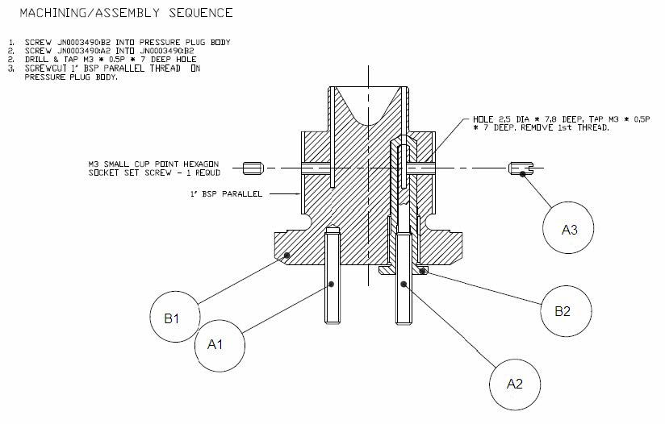

Figure 2: Modified HSL Firing Plug Design
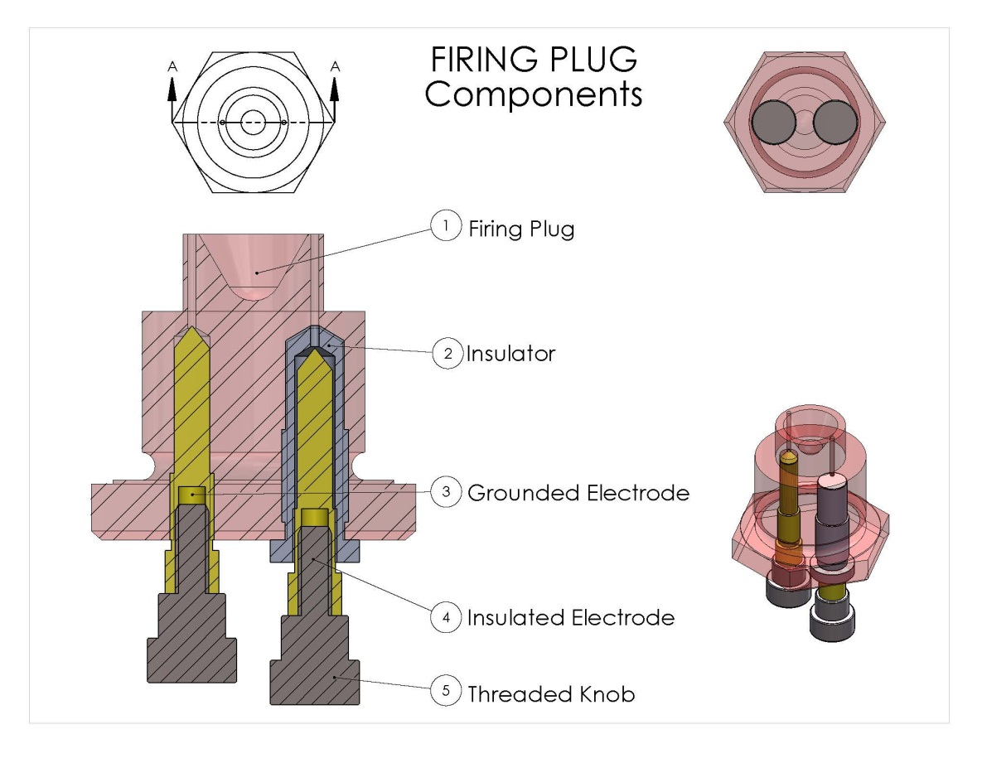
Figure 3: Modified Firing Plug Outer Diameters
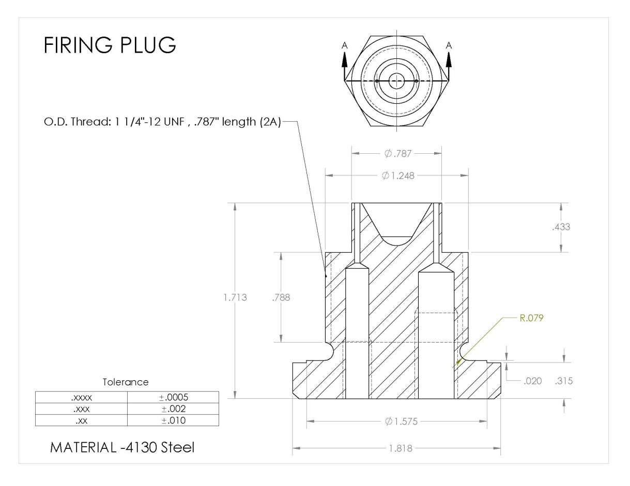
Figure 4: Modified Firing Plug InnerDiameters
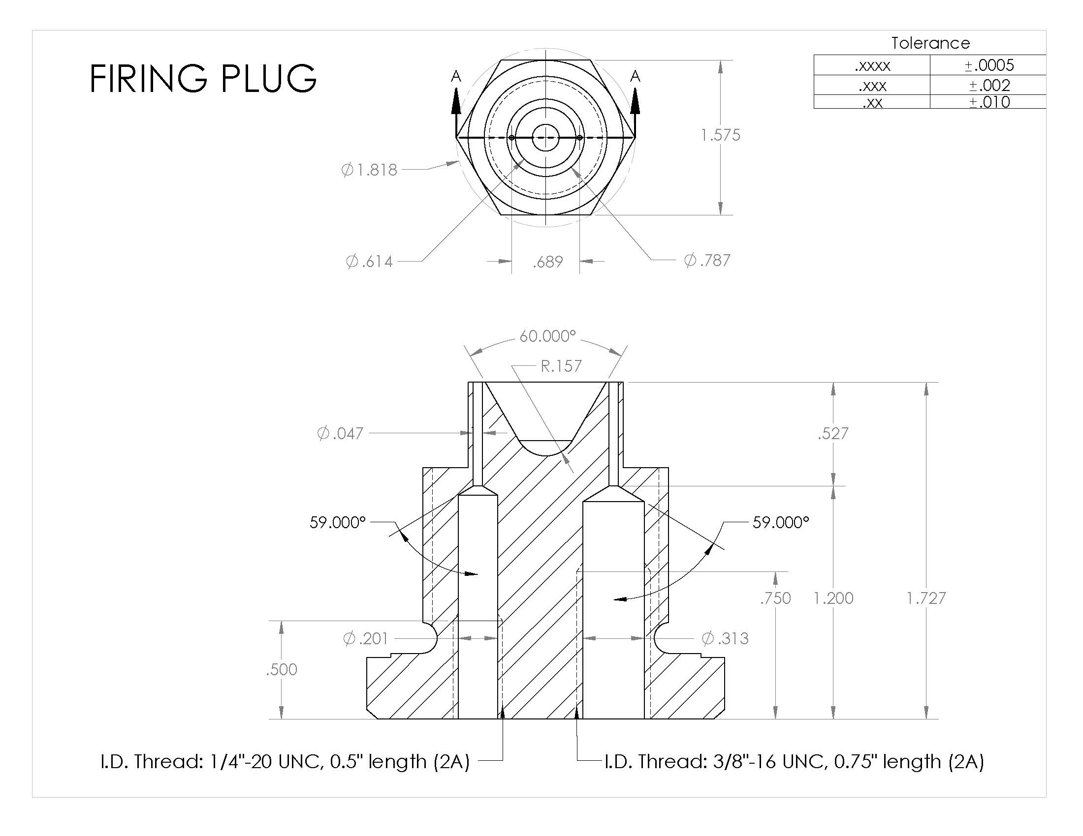
Figure 5: Electrode Details
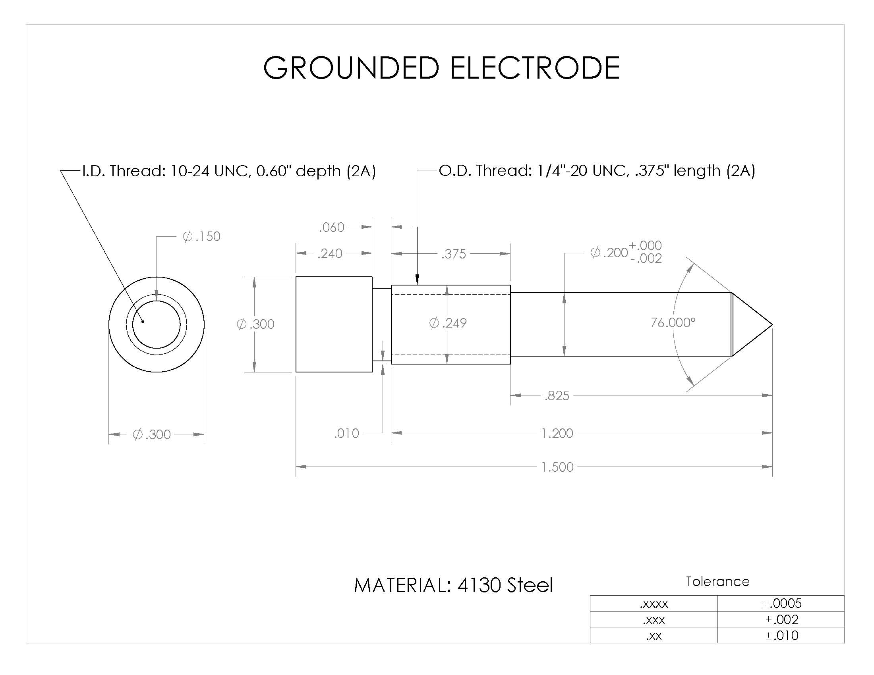
Figure 6: External Threaded Knob Details
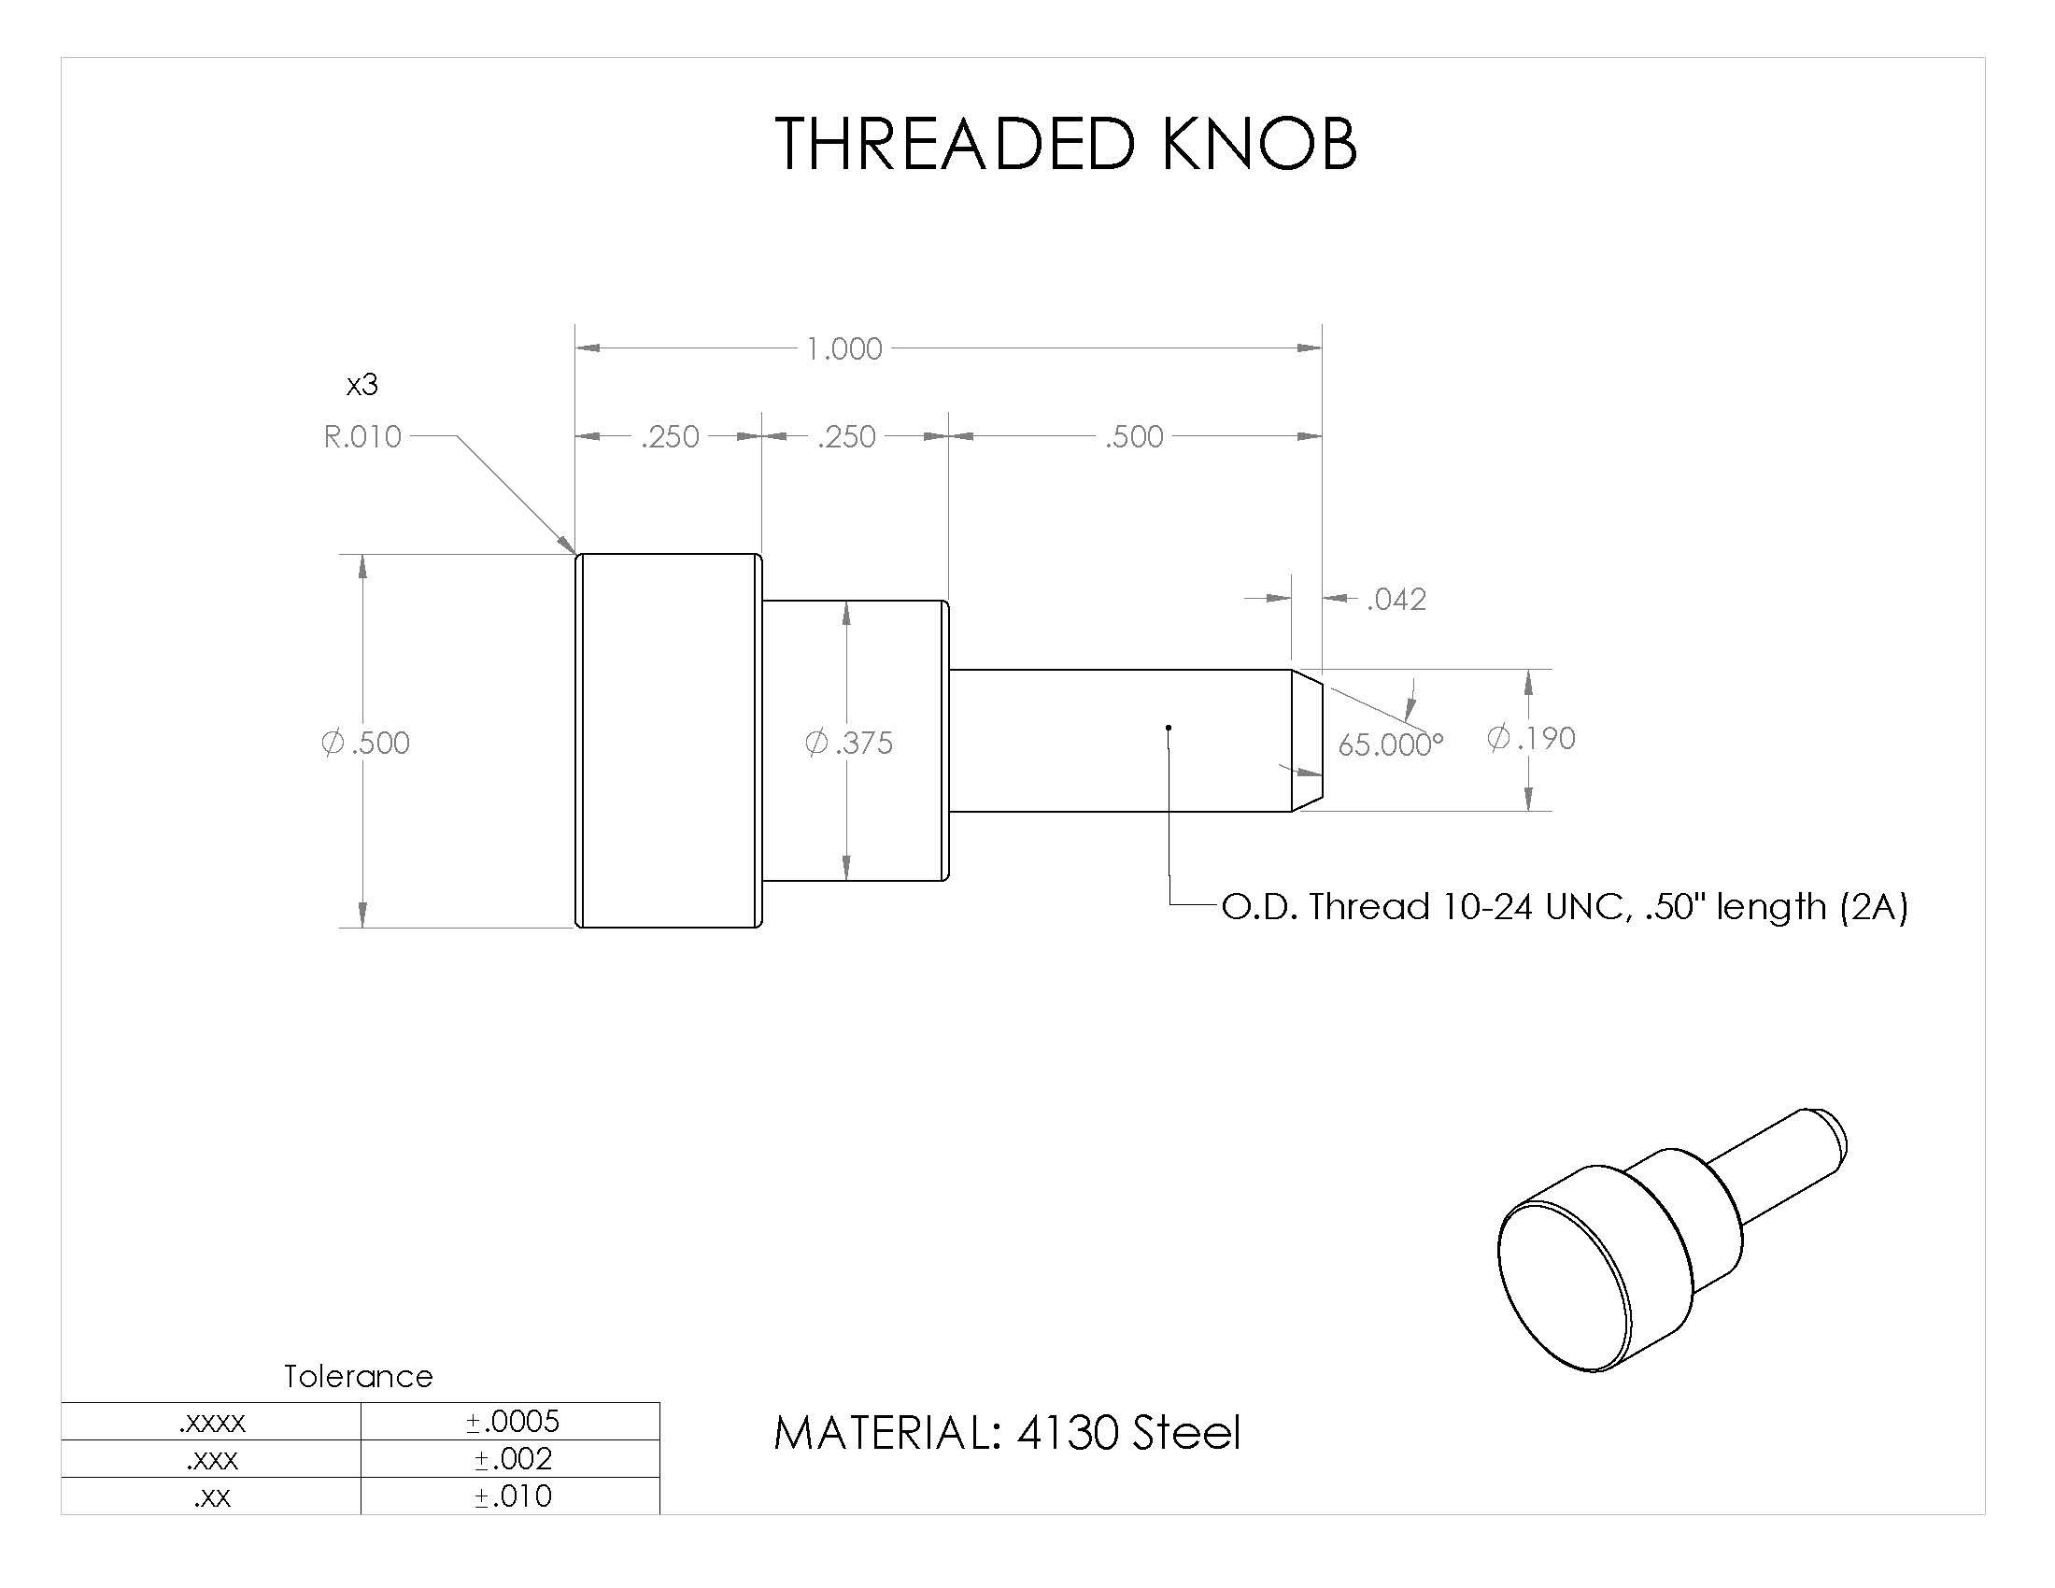
Figure 7: Electrode Plastic Insulator Inner Diameters
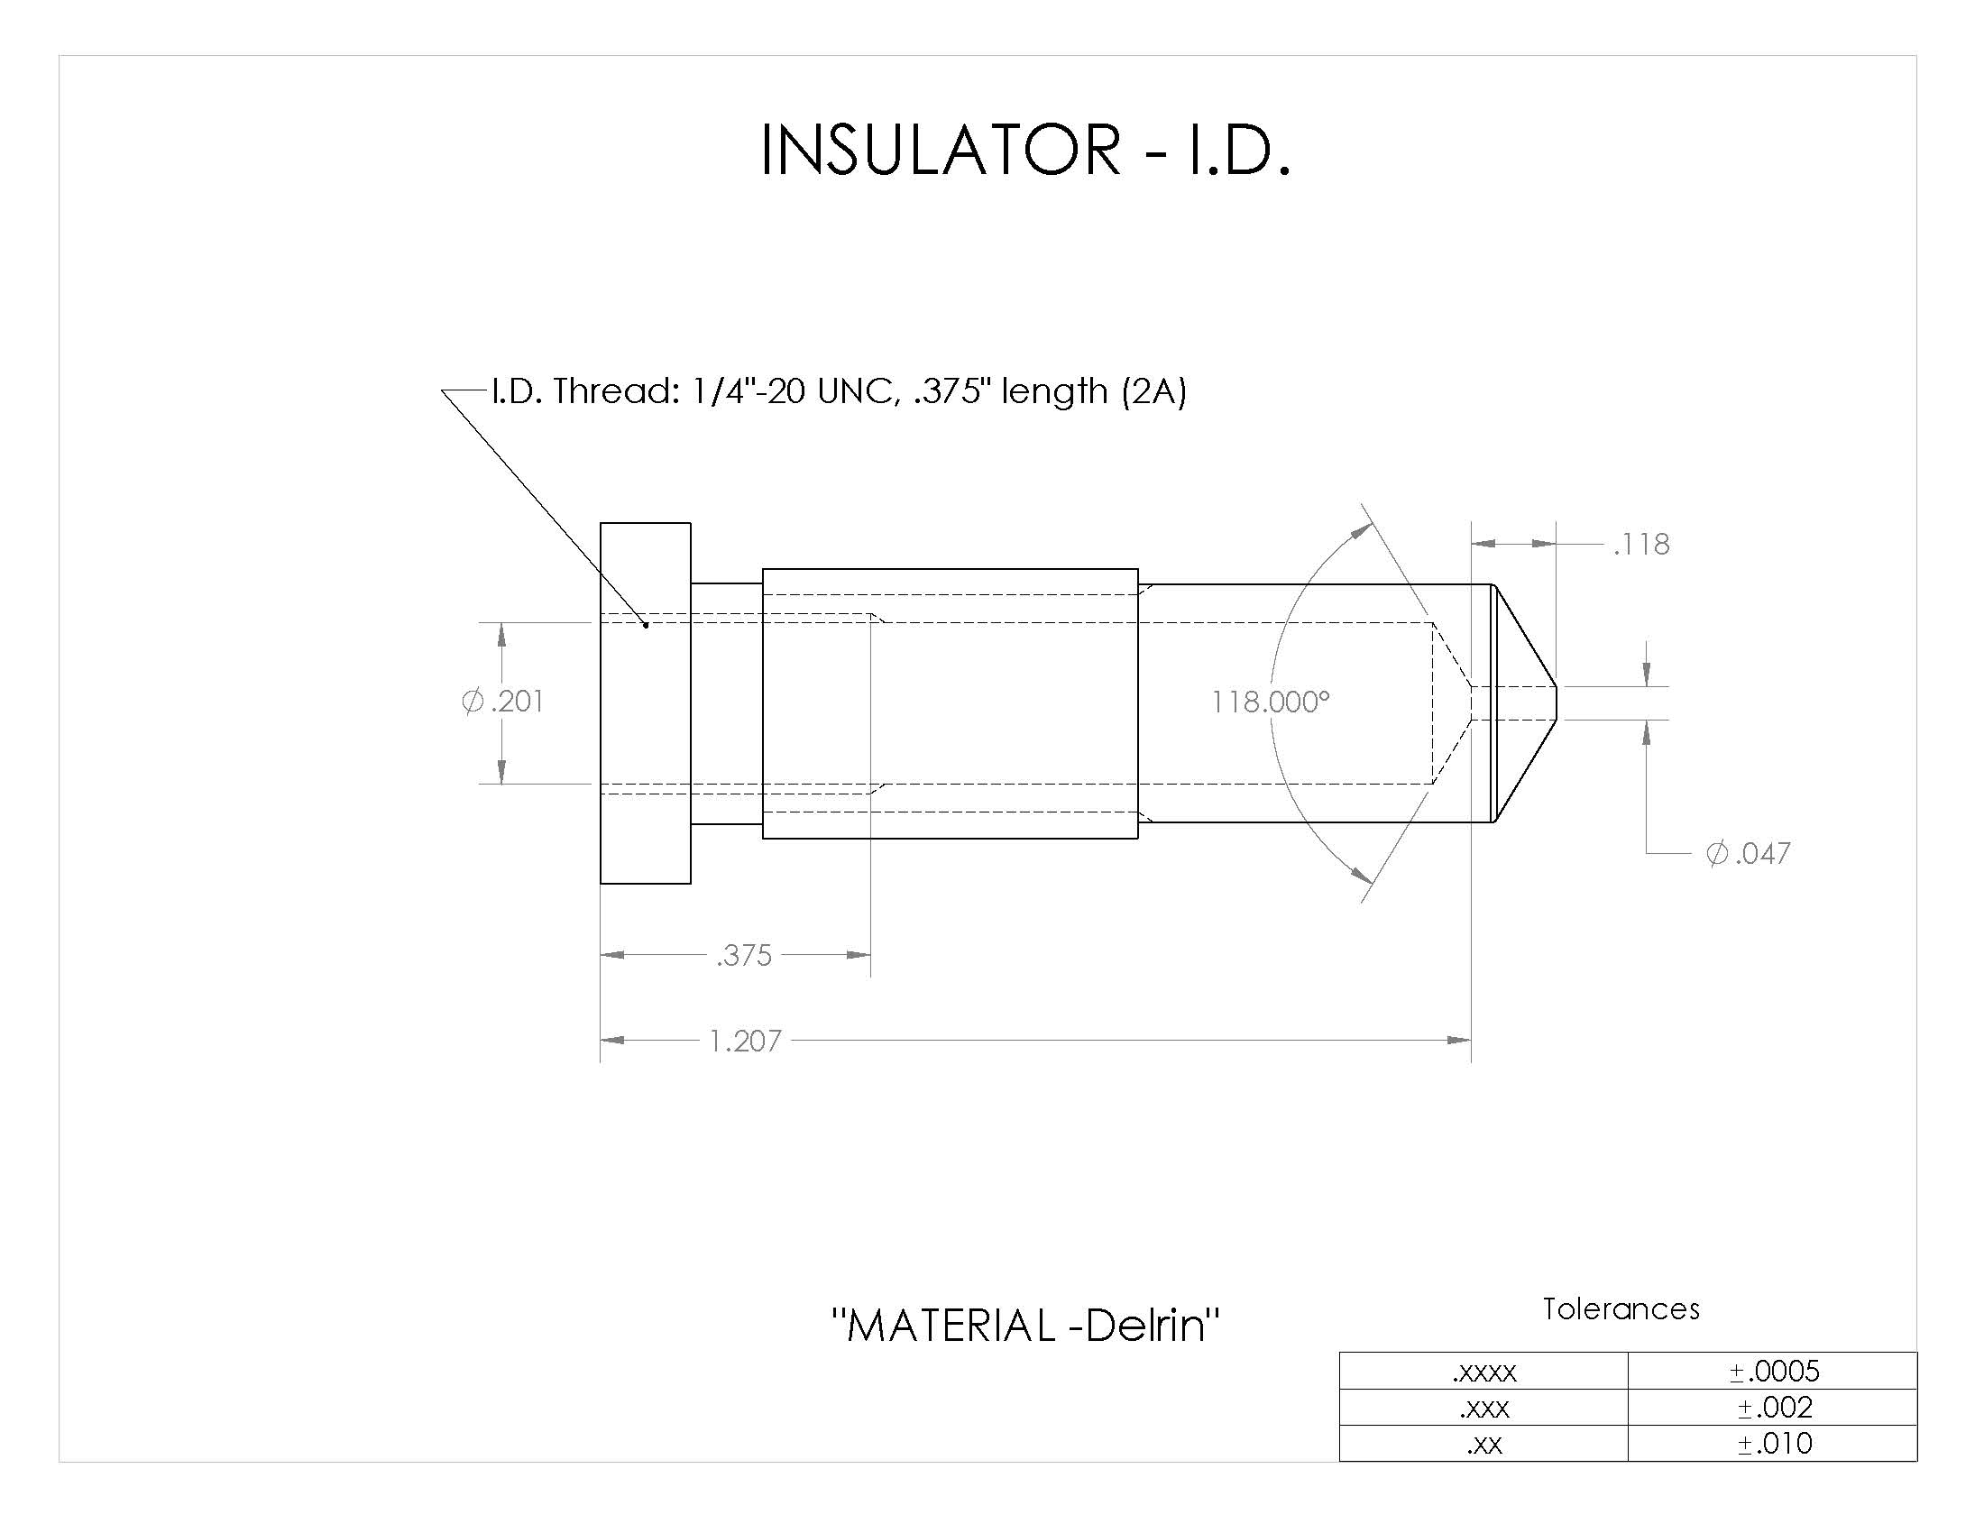
Figure 8: Electrode Plastic Insulator Outer Diameters
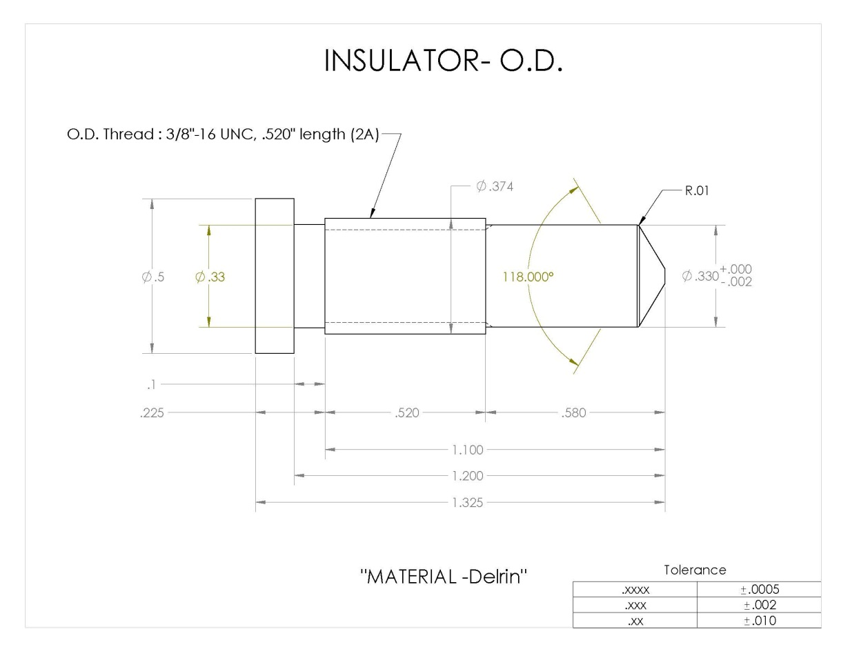

Figure 9: Photo of Modified Firing Plug Dis-assembled
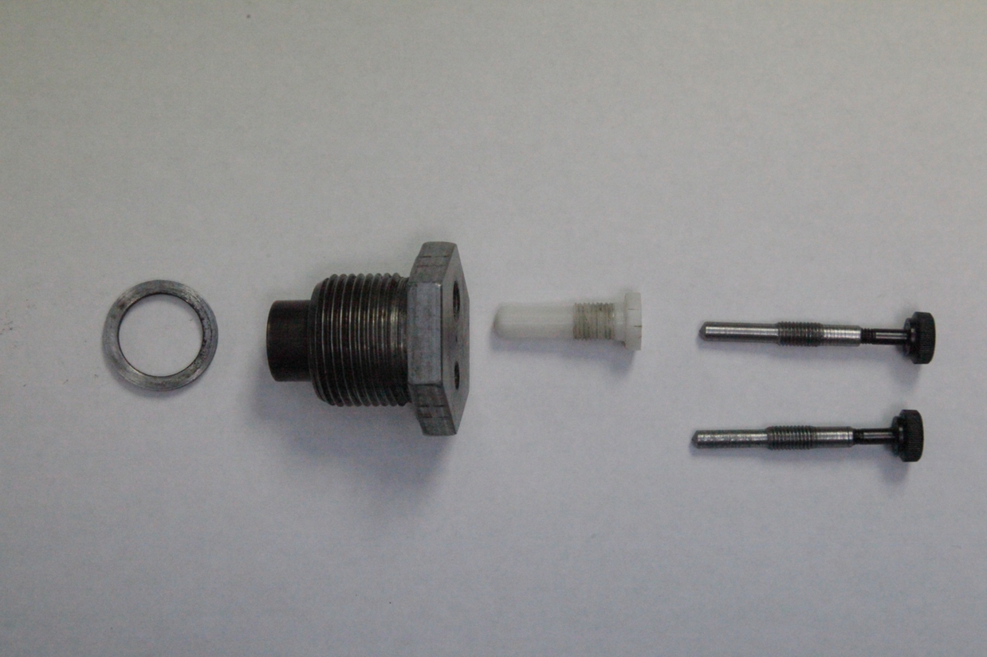
Set-up and operating procedures
4. Once all the modified components are fabricated and assembled, the set-up begins with the electric match (See Figure 10.), the lead wires of which are first trimmed to the approximate length of the firing plug thickness to extend just beyond the body and the ends stripped of insulation approx. 4 mm and kinked to match the approximate angle of the beveled electrode tips as shown in Figure 11.
5. A small dab of silicone grease (e.g., Dow-Corning Electrical Insulating Compound No. 4) is then applied to each threaded electrode opening, the electric match leads are then slowly withdrawn to the crowns of the electrode channels and the electrodes are threaded in slowly until they just catch and tighten onto both electric match wire leads while at the same time forcing silicone upward through the wire lead holes, thus additionally sealing and insulating them. The result is shown in Figure 12.
6. In the final step, any excess silicone grease extruded from the wire lead channels should be removed and the extra lead wire lengths are coiled and the electric match head positioned in place just above the sample cup as shown in Figure 13.
Figure 10: Davy-Bickford Electric Match
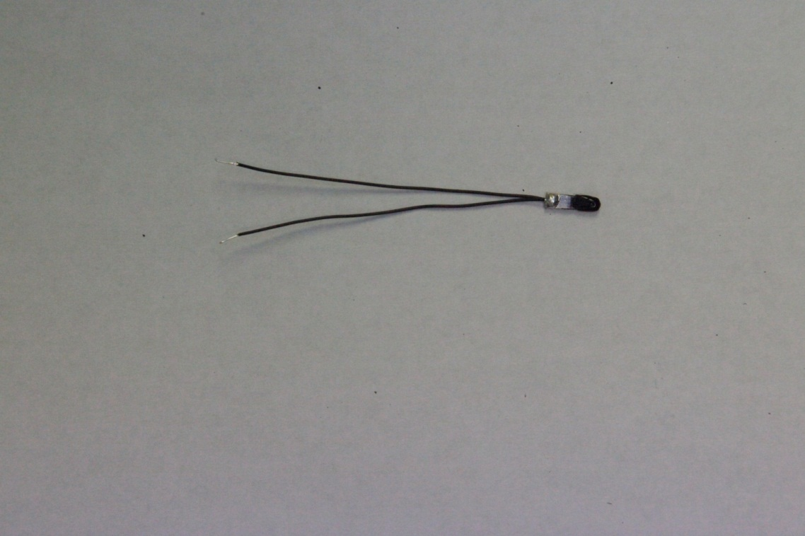

Figure 11: Exposed electric match lead wires with crimped ends
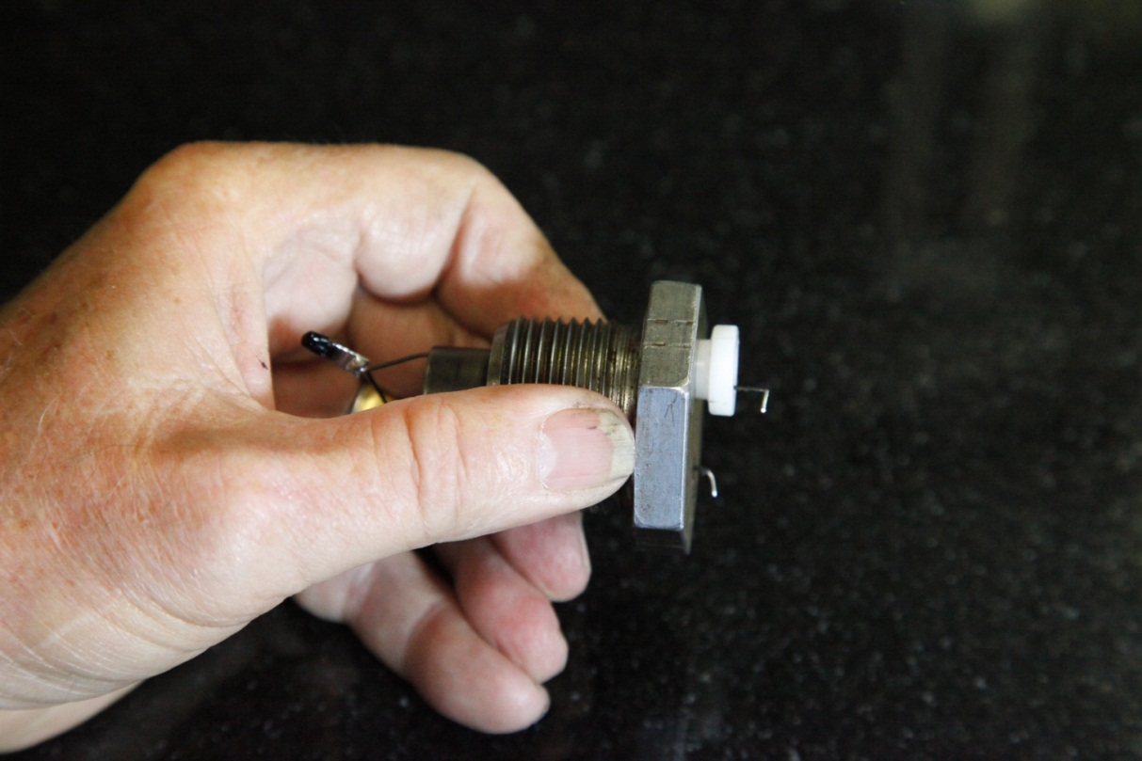

Figure 12: Assembled modified firing plug with electric match
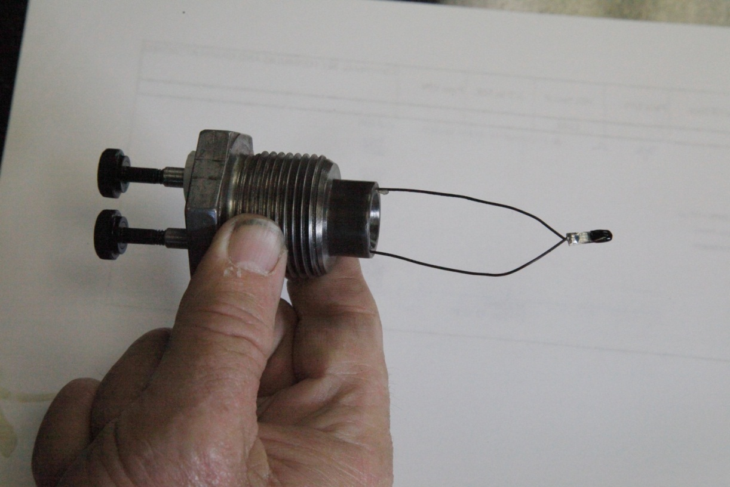

Figure 13: Assembled Modified Firing Plug with Folded Electric Match
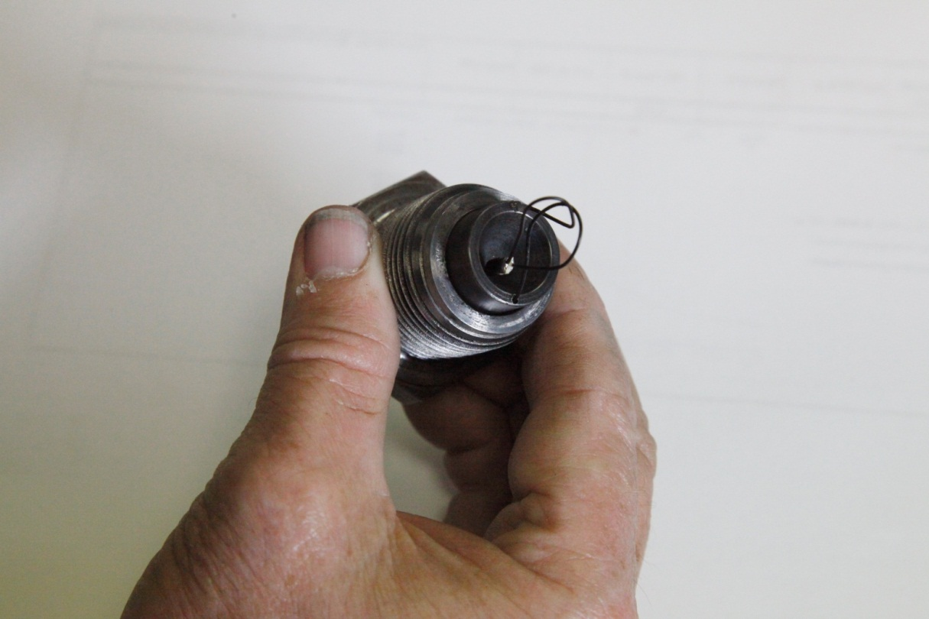

7. Once the firing plug circuitry is completed, it should be checked for electrical continuity with an ohm-meter to be sure all connections are tight and working. When the electrical continuity is assured, then the sample cup can be filled with the material to be tested, threaded into the body of the HSL Test Apparatus from the bottom and tightened securely.
Experimental
8. In order to demonstrate the reliability and efficiency of the HSL modified firing plug design, twelve new pyrotechnic mixtures (Numbered 31 through 42) were prepared, consisting of five generic “whistle or burst” compositions and seven generic “color” compositions which might typically be found in aerial display firework “star” effects. All twelve new compositions were then tested three times (36 tests in total) using the new firing plug design. The test results are shown in Table I, which showed generally small average deviations for the fast burning compositions and the more typically wider deviations for the slower burning non-flash compositions..
9. The testing was undertaken with two modified firing plugs which were rotated in use by two technicians. One technician prepared the modified firing plug assemblies ahead while the other technician weighed the samples, filled and assembled the tester apparatus and collected the test results. There were no interruptions or periods of time when the modified firing plug had to be dis-assembled and cleaned out. All thirty-six tests were successfully completed in under four hours elapsed time.
Conclusion
10. In summary, the modifications made to the HSL Firing Plug Assembly appear to make a significant improvement in the overall operability of the HSL Flash Composition Test Method given in Appendix 7 of the Manual of Tests and Criteria with equivalent or better reproducibility.
11. The expert from the United States invites other international experts to also try the modifications in design and procedures to the HSL Test method presented here. If there is sufficient agreement in future that it provides a significant improvement, then the final step would be to propose a revision of Appendix 7 to incorporate the modified firing plug design as an alternate or replacement for the existing design may be proposed as future work.

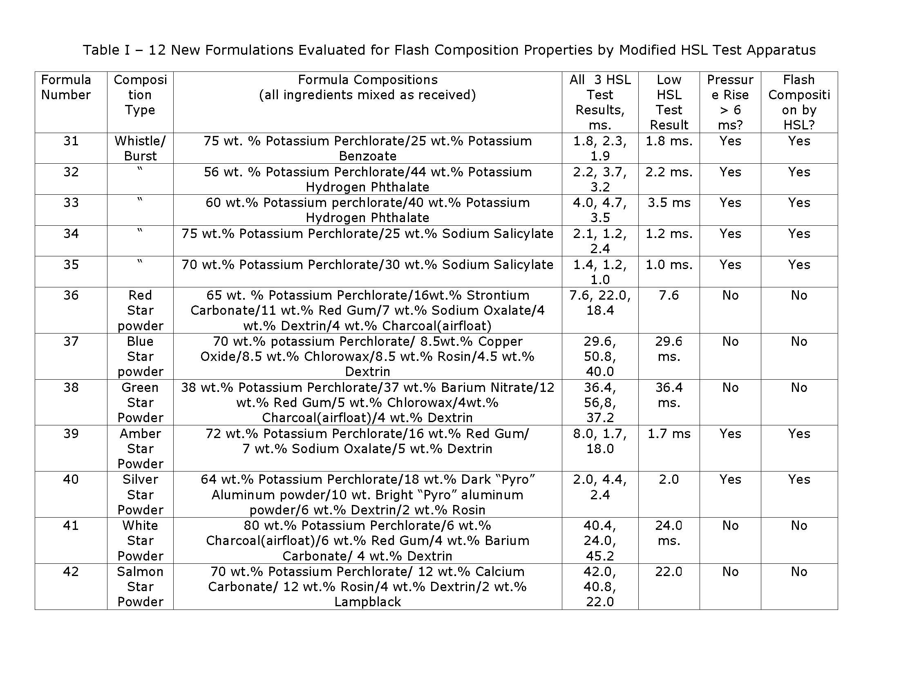
(English only)
Recommendation
12. The expert from the United States offers this paper as a basis for discussion by the Working Group on Explosives at the forty-third session of the Sub-Committee.

In accordance with the programme of work of the Sub-Committee for 2013-2014 approved by the Committee at its sixth session (refer to ST/SG/AC.10/C.3/84, para. 86 and ST/SG/AC.10/40, para. 14).

