 | United Nations | ST/SG/AC.10/40/Add.1
 | Secretariat |  | Distr.: General  7 March 2013  English  Original: English and French
Committee of Experts on the Transport of Dangerous Goods
and on the Globally Harmonized System of Classification
and Labelling of Chemicals
Report of the Committee of Experts on the Transport of Dangerous Goods and on the Globally Harmonized System of Classification and Labelling of Chemicals on its sixth session
held in Geneva on 14 December 2012
Addendum
Annex I
Amendments to the seventeenth revised edition of the Recommendations on the Transport of Dangerous Goods, Model Regulations (ST/SG/AC.10/1/Rev.17)
Chapter 1.1
1.1.1.6 In (b) add “, and that does not meet the definitions and criteria of classes, other than Class 7, or divisions, as defined in Part 2.” after “Table 2.7.2.4.1.2”.
1.1.1.9 Insert as new paragraph to read as follows:
“1.1.1.9 Lamps containing dangerous goods
The following lamps are not subject to these Regulations provided that they do not contain radioactive material and do not contain mercury in quantities above those specified in special provision 366 of Chapter 3.3:
- Lamps that are collected directly from individuals and households when transported to a collection or recycling facility;
- Lamps each containing not more than 1 g of dangerous goods and packaged so that there is not more than 30 g of dangerous goods per package, provided that:
(i) the lamps are certified to a manufacturer’s quality management system;
Note: The application of ISO 9001:2008 may be considered acceptable for this purpose.
and
(ii) each lamp is either individually packed in inner packagings, separated by dividers, or surrounded with cushioning material to protect the lamps and packed into strong outer packagings meeting the general provisions of 4.1.1.1 and capable of passing a 1.2 m drop test.
- Used, damaged or defective lamps each containing not more than 1 g of dangerous goods with not more than 30 g of dangerous goods per package when transported from a collection or recycling facility. The lamps shall be packed in strong outer packagings sufficient for preventing release of the contents under normal conditions of transport meeting the general provisions of 4.1.1.1 and that are capable of passing a drop test of not less than 1.2 m.
NOTE: Lamps containing radioactive material are addressed in 2.7.2.2.2(b).”.
Chapter 1.2
1.2.1 In the definitions, whenever the term “for the transport of Class 7 material” is used, replace it with “for the transport of radioactive material”.
1.2.1 Amend the definitions hereafter as follows:
Design: In the first sentence, insert “fissile material excepted under 2.7.2.3.5 (f),” after “the description of”.
Exclusive use: Replace “and unloading is carried” with “and unloading and shipment are carried” and insert “, where so required by these Regulations;” after “consignee”.
Freight container: Replace the last paragraph with the following:
“In addition: Small freight container means a freight container that has an internal volume of not more than 3 m³. Large freight container means a freight container that has an internal volume of more than 3 m³.”.
Multiple-element gas container: replace “and bundles” with “or bundles”.
Radiation level: Amend the end of the definition to read: “millisieverts per hour or microsieverts per hour;”.
1.2.1 Add the following new definitions in alphabetical order:
“Large salvage packaging means a special packaging which
(a) is designed for mechanical handling; and
(b) exceeds 400 kg net mass or 450 litres capacity but has a volume of not more than 3 m³;
into which damaged, defective or leaking dangerous goods packages, or dangerous goods that have spilled or leaked are placed for purposes of transport for recovery or disposal;”.
“Management system, for the transport of radioactive material, means a set of interrelated or interacting elements (system) for establishing policies and objectives and enabling the objectives to be achieved in an efficient and effective manner;”.
“Neutron radiation detector is a device that detects neutron radiation. In such a device, a gas may be contained in a hermetically sealed electron tube transducer that converts neutron radiation into a measureable electric signal;”.
“Radiation detection system is an apparatus that contains radiation detectors as components;”.
Chapter 1.5
1.5 Replace the title with “GENERAL PROVISIONS CONCERNING RADIOACTIVE MATERIAL”.
1.5.1.1 Amend the second and third sentences to read:
“These Regulations are based on the IAEA “Regulations for the Safe Transport of Radioactive material, 2012 Edition, IAEA Safety Standards Series No. SSR–6, IAEA, Vienna 2012). Explanatory material can be found in “Advisory material for the IAEA Regulations for the Safe Transport of Radioactive Material, IAEA Safety Standards Series No. TS-G-1.1 (Rev.2), IAEA, Vienna (2012).”.
1.5.1.2 In the second sentence of the last paragraph replace “imposing requirements” with “imposing conditions”.
1.5.1.4 Amend the first sentence to read: “These Regulations do not apply to any of the following:”
1.5.1.4 Insert a new sub-paragraph (d) to read as follows and rename current sub-paragraphs (d) to (f) accordingly:
“(d) Radioactive material in or on a person who is to be transported for medical treatment because the person has been subject to accidental or deliberate intake of radioactive material or to contamination;”.
Amend sub-paragraph (f) (former (e)) to read as follows:
“(f) Natural material and ores containing naturally occurring radionuclides (which may have been processed), provided the activity concentration of the material does not exceed 10 times the values specified in Table 2.7.2.2.1, or calculated in accordance with 2.7.2.2.2 (a) and 2.7.2.2.3 to 2.7.2.2.6. For natural materials and ores containing naturally occurring radionuclides that are not in secular equilibrium the calculation of the activity concentration shall be performed in accordance with 2.7.2.2.4;”.
1.5.1.5.1 Amend to read as follows:
“1.5.1.5.1 Excepted packages which may contain radioactive material in limited quantities, instruments, manufactured articles and empty packagings as specified in 2.7.2.4.1 shall be subject only to the following provisions of Parts 5 to 7:
(a) The applicable provisions specified in 5.1.1.2, 5.1.3.2, 5.1.5.2.2, 5.1.5.4, 5.2.1.7, 7.1.8.3.1, 7.1.8.5.1 to 7.1.8.5.4 and 7.1.8.6.1; and
(b) The requirements for excepted packages specified in 6.4.4.
except when the radioactive material possesses other hazardous properties and has to be classified in a class other than Class 7 in accordance with special provision 290 or 369 of Chapter 3.3, where the provisions listed in (a) and (b) above apply only as relevant and in addition to those relating to the main class or division.”.
1.5.1.5.2 Insert a new second sentence to read as follows:
“If the excepted package contains fissile material, one of the fissile exceptions provided by 2.7.2.3.5 shall apply and the requirements of 7.1.8.4.3 shall be met.”.
1.5.2.2 In the second sentence, delete the comma after “persons exposed” and replace “doses to individuals be subject” with “doses to individuals are subject”.
1.5.2.4 Amend the end of the introductory sentence to read “that the effective dose either:” and insert “or” at the end of sub-paragraph (a).
1.5.2.5 Insert “IAEA” before “Safety Standard Series”.
1.5.3 Amend to read as follows:
“1.5.3 Management system
1.5.3.1 A management system based on international, national or other standards acceptable to the competent authority shall be established and implemented for all activities within the scope of these Regulations, as identified in 1.5.1.3, to ensure compliance with the relevant provisions of these Regulations. Certification that the design specification has been fully implemented shall be available to the competent authority. The manufacturer, consignor or user shall be prepared:
(a) To provide facilities for inspection during manufacture and use; and
(b) To demonstrate compliance with these Regulations to the competent authority.
Where competent authority approval is required, such approval shall take into account and be contingent upon the adequacy of the management system.”.
1.5.4.2 Replace “Class 7” with “radioactive material”, twice.
1.5.6 The amendment does not apply to the English text.
1.5.6.1 In the introductory sentence, delete “a” before “non-compliance”. In (a) amend the introductory sentence to read:
“The consignor, consignee, carrier and any organization involved during transport, who may be affected, as appropriate, shall be informed of the non-compliance:”.
In (b) (iv), delete “and” at the end of the sentence.
The other amendments to 1.5.6.1 do not apply to the English text.
Chapter 2.0
2.0.1.3 Add the following new paragraph at the end:
"Articles are not assigned to packing groups. For packing purposes any requirement for a specific packaging performance level is set out in the applicable packing instruction.".
2.0.3.2 Amend the last sentence to read as follows:
"For radioactive material in excepted packages, except for UN 3507, URANIUM HEXAFLUORIDE, RADIOACTIVE MATERIAL, EXCEPTED PACKAGE, special provision 290 of Chapter 3.3 applies.".
Chapter 2.1
Amend Note 2 in 2.1.3.5.5 to read as follows:
“NOTE 2: “Flash composition” in this table refers to pyrotechnic substances in powder form or as pyrotechnic units as presented in the firework that are used to produce an aural effect or used as a bursting charge, or propellant charge unless the time taken for the pressure rise is demonstrated to be more than 6 ms for 0.5 g of pyrotechnic substance in the HSL Flash Composition Test in Appendix 7 of the Manual of Tests and Criteria.”.
Chapter 2.2
2.2.1.2 Add a new indent (e) to read as follows:
“(e) Adsorbed gas – a gas which when packaged for transport is adsorbed onto a solid porous material resulting in an internal receptacle pressure of less than 101.3 kPa at 20 °C and less than 300 kPa at 50 °C.”.
Chapter 2.3
2.3.2.2 and 2.3.2.3 Amend to read as follows:
“2.3.2.2 Viscous flammable liquids such as paints, enamels, lacquers, varnishes, adhesives and polishes having a flash point of less than 23 °C may be placed in packing group III in conformity with the procedures prescribed in the Manual of Tests and Criteria, Part III, sub-section 32.3, provided that:
(a) The viscosity expressed as the flowtime in seconds and flash point are in accordance with the following table:
Flow-time t in seconds | Jet diameter (mm) | Flash point, closed-cup (°C)
20 < t ≤ 60 | 4 | above 17
60 < t ≤ 100 | 4 | above 10
20 < t ≤ 32 | 6 | above 5
32 < t ≤ 44 | 6 | above -1
44 < t ≤ 100 | 6 | above -5
100 < t | 6 | no limit
(b) Less than 3% of the clear solvent layer separates in the solvent separation test;
(c) The mixture or any separated solvent does not meet the criteria for Division 6.1 or Class 8;
(d) The substances are packed in receptacles of not more than 450 litre capacity.
2.3.2.3 Reserved.”.
2.3.2.5 At the beginning, replace “Viscous substances” with “Viscous liquids”. Amend the fourth indent to read as follows:
“- are packed in receptacles of not more than 450 litre capacity”.
Chapter 2.4
Amend the second part of figure 2.4.1 to read as follows:
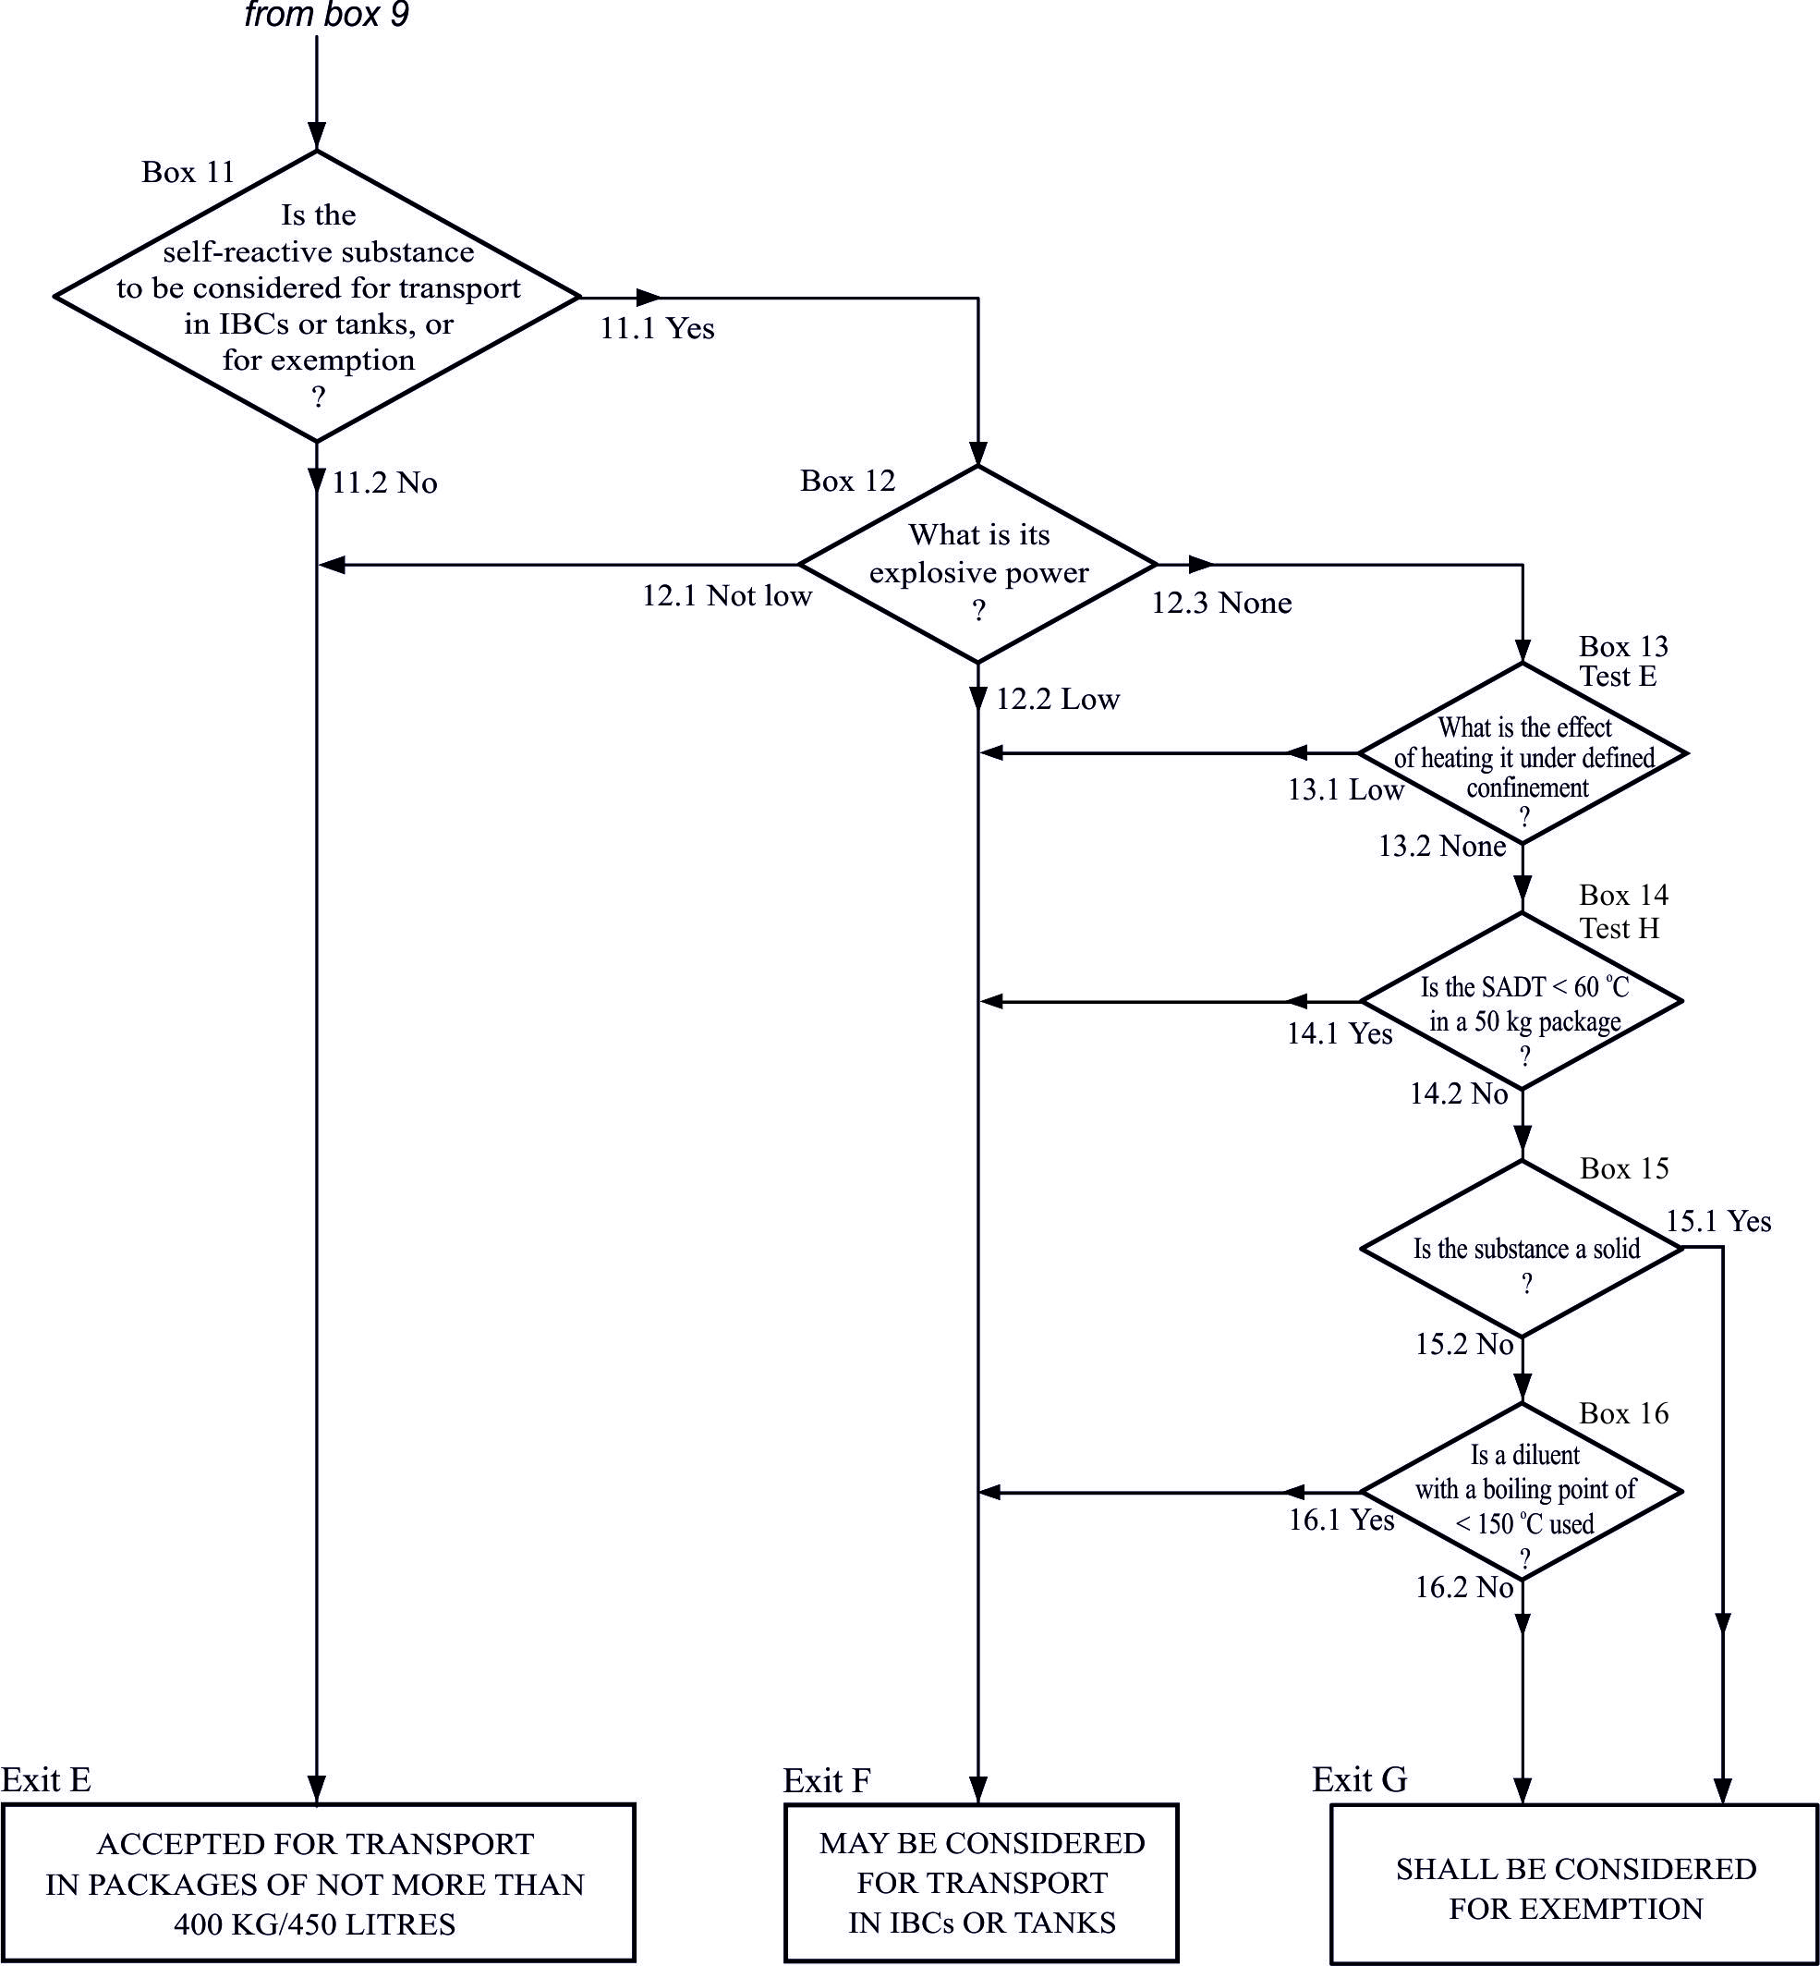
Chapter 2.5
Amend the second part of figure 2.5.1 to read as follows:
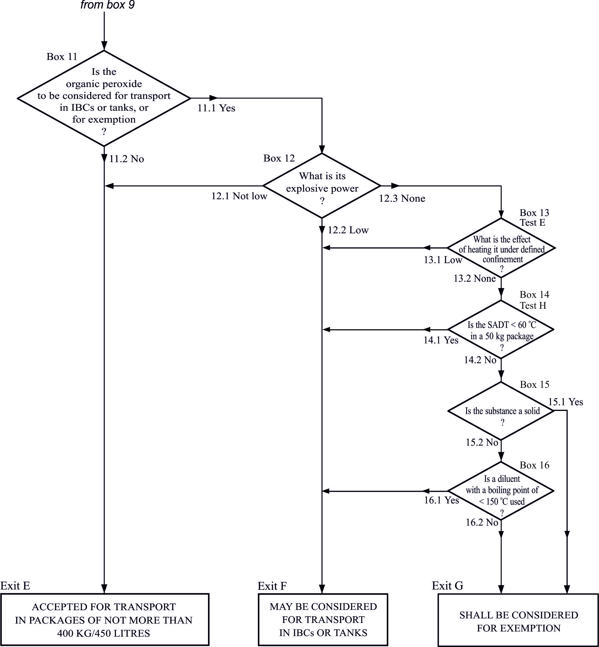
2.5.2.2.1.1 Amend to read as follows:
“2.5.2.2.1.1 Tests are performed to measure the potential for the solid substance to increase the burning rate or burning intensity of a combustible substance when the two are thoroughly mixed. The procedure is given in the Manual of Tests and Criteria, Part III, sub-section 34.4.1 (test O.1) or alternatively, in sub-section 34.4.3 (test O.3). Tests are conducted on the substance to be evaluated mixed with dry fibrous cellulose in mixing ratios of 1:1 and 4:1, by mass, of sample to cellulose. The burning characteristics of the mixtures are compared:
(a) In the test O.1, with the standard 3:7 mixture, by mass, of potassium bromate to cellulose. If the burning time is equal to or less than this standard mixture, the burning times shall be compared with those from the packing group I or II reference standards, 3:2 and 2:3 ratios, by mass, of potassium bromate to cellulose respectively; or
(b) In the test O.3, with the standard 1:2 mixture, by mass, of calcium peroxide to cellulose. If the burning rate is equal to or greater than this standard mixture, the burning rates shall be compared with those from the packing group I or II reference standards 3:1 and 1:1 ratios, by mass, of calcium peroxide to cellulose, respectively.”.
2.5.2.2.1.2 Amend to read as follows:
“2.5.2.2.1.2 The classification test results are assessed on the basis of:
(a) The comparison of the mean burning time (for the test O.1) or burning rate (for the test O.3) with those of the reference mixtures; and
(b) Whether the mixture of substance and cellulose ignites and burns.”.
2.5.2.2.1.3 Amend to read as follows:
“2.5.2.2.1.3 A solid substance is classified in Division 5.1 if the 4:1 or 1:1 sample-to-cellulose ratio (by mass) tested, exhibits:
(a) In the test O.1, a mean burning time equal to or less than the mean burning time of a 3:7 mixture (by mass) of potassium bromate and cellulose ; or
(b) In the test O.3, a mean burning rate equal to or greater than the mean burning rate of a 1:2 mixture (by mass) of calcium peroxide and cellulose.”.
2.5.2.2.2 Amend to read as follows:
“2.5.2.2.2 Assignment of packing groups
Solid oxidizing substances are assigned to a packing group according to one of the test procedures in the Manual of Tests and Criteria, Part III, sub-section 34.4.1 (test O.1) or sub-section 34.4.3 (test O.3), in accordance with the following criteria:
(a) Test O.1:
(i) Packing group I: any substance which, in the 4:1 or 1:1 sample-to-cellulose ratio (by mass) tested, exhibits a mean burning time less than the mean burning time of a 3:2 mixture, by mass, of potassium bromate and cellulose;
(ii) Packing group II: any substance which, in the 4:1 or 1:1 sample-to-cellulose ratio (by mass) tested, exhibits a mean burning time equal to or less than the mean burning time of a 2:3 mixture (by mass) of potassium bromate and cellulose, and the criteria for packing group I are not met;
(ii) Packing group III: any substance which, in the 4:1 or 1:1 sample-to-cellulose ratio (by mass) tested, exhibits a mean burning time equal to or less than the mean burning time of a 3:7 mixture (by mass) of potassium bromate and cellulose , and the criteria for packing groups I and II are not met;
(iv) Not Division 5.1: any substance which, in both the 4:1 and 1:1 sample-to-cellulose ratio (by mass) tested, does not ignite and burn, or exhibits mean burning times greater than that of a 3:7 mixture (by mass) of potassium bromate and cellulose.
(b) Test O.3:
(i) Packing group I: any substance which, in the 4:1 or 1:1 sample-to-cellulose ratio (by mass) tested, exhibits a mean burning rate greater than the mean burning rate of a 3:1 mixture (by mass) of calcium peroxide and cellulose;
(ii) Packing group II: any substance which, in the 4:1 or 1:1 sample-to-cellulose ratio (by mass) tested, exhibits a mean burning rate equal to or greater than the mean burning rate of a 1:1 mixture (by mass) of calcium peroxide and cellulose, and the criteria for packing group I are not met;
(ii) Packing group III: any substance which, in the 4:1 or 1:1 sample-to-cellulose ratio (by mass) tested, exhibits a mean burning rate equal to or greater than the mean burning rate of a 1:2 mixture (by mass) of calcium peroxide and cellulose, and the criteria for packing groups I and II are not met;
(iv) Not Division 5.1: any substance which, in both the 4:1 and 1:1 sample-to-cellulose ratio (by mass) tested, does not ignite and burn, or exhibits a mean burning rate less than the mean burning rate of a 1:2 mixture (by mass) of calcium peroxide and cellulose.”.
Chapter 2.6
2.6.3.2.3.5 Amend to read as follows:
“2.6.3.2.3.5 Dried blood spots, collected by applying a drop of blood onto absorbent material, are not subject to these Regulations.”.
Insert two new paragraphs 2.6.3.2.3.6 and 2.6.3.2.3.7 to read as follows and renumber existing paragraphs accordingly:
“2.6.3.2.3.6 Faecal occult blood screening samples are not subject to these Regulations.
2.6.3.2.3.7 Blood or blood components which have been collected for the purposes of transfusion or for the preparation of blood products to be used for transfusion or transplantation and any tissues or organs intended for use in transplantation as well as samples drawn in connection with such purposes are not subject to these Regulations.”.
Chapter 2.7
The first amendment does not apply to the English text.
2.7.1.3 Amend the definitions hereafter as follows:
Fissile nuclides: Amend the end of the introductory text before (a) to read: “of fissile material are the following:”.
In (a), delete “and”.
Insert the following new sub-paragraphs and text:
“(c) material with fissile nuclides less than a total of 0.25 g;
(d) any combination of (a), (b) and/or (c).
These exclusions are only valid if there is no other material with fissile nuclides in the package or in the consignment if shipped unpackaged.”.
Surface contaminated object At the end, replace “surfaces” with “surface”.
2.7.2.1.1 Amend to read as follows: “Radioactive material shall be assigned to one of the UN numbers specified in Table 2.7.2.1.1, in accordance with 2.7.2.4.2 to 2.7.2.5, taking into account the material characteristics determined in 2.7.2.3.”.
Table 2.7.2.1.1 Add a new heading row to read:
UN Nos. | Proper shipping name and descriptionª
Table 2.7.2.1.1 For UN Nos. 2912, 3321, 3322, 2913, 2915, 3332, 2916, 2917, 3323, 2919 and 2978, insert a reference to a new note “b” after “fissile-excepted”.
Table 2.7.2.1.1 Under the headings "Excepted packages" and “Uranium hexafluoride” add the following new entry :
"UN 3507 URANIUM HEXAFLUORIDE, RADIOACTIVE MATERIAL, EXCEPTED PACKAGE less than 0.1 kg per package, non-fissile or fissile-excepted^{b,c}".
Table 2.7.2.1.1 Under the heading "Excepted packages", the amendments to the name for UN Nos. 2909, 2910 and 2911 do not apply to the English text.
Table 2.7.2.1.1 Add the following table notes “a”, “b” and “c” after the table:
“ª The proper shipping name is found in the column “proper shipping name and description” and is restricted to that part shown in capital letters. In the cases of UN Nos. 2909, 2911, 2913 and 3326, where alternative proper shipping names are separated by the word “or” only the relevant proper shipping name shall be used;
^{b} The term “fissile-excepted” refers only to material excepted under 2.7.2.3.5.
^{c} For UN No. 3507, see also special provision 369 in Chapter 3.3.”.
2.7.2.2.1 In (b), insert “limits” after “concentration”.
Table 2.7.2.2.1 In the heading of column 4 insert “limit” after “concentration”.
In (a) after the table, in the introductory sentence, replace “from daughter radionuclides” with “from their progeny”.
2.7.2.2.2 Amend the text before the Table to read as follows:
“2.7.2.2.2 For individual radionuclides:
(a) Which are not listed in Table 2.7.2.2.1 the determination of the basic radionuclide values referred to in 2.7.2.2.1 shall require multilateral approval. For these radionuclides, activity concentration limits for exempt material and activity limits for exempt consignments shall be calculated in accordance with the principles established in the International Basic Safety Standards for Protection against Ionizing Radiation and for the Safety of Radiation Sources, Safety Series No.115, IAEA, Vienna (1996). It is permissible to use an A₂ value calculated using a dose coefficient for the appropriate lung absorption type as recommended by the International Commission on Radiological Protection, if the chemical forms of each radionuclide under both normal and accident conditions of transport are taken into consideration. Alternatively, the radionuclide values in Table 2.7.2.2.2 may be used without obtaining competent authority approval;
(b) In instruments or articles in which the radioactive material is enclosed or is included as a component part of the instrument or other manufactured article and which meet 2.7.2.4.1.3 (c), alternative basic radionuclide values to those in Table 2.7.2.2.1 for the activity limit for an exempt consignment are permitted and shall require multilateral approval. Such alternative activity limits for an exempt consignment shall be calculated in accordance with the principles set out in the International Basic Safety Standards for Protection against Ionizing Radiation and for the Safety of Radiation Sources, Safety Series No.115, IAEA, Vienna (1996).”.
Table 2.7.2.2.2 In the heading of the fourth column, insert “limit” after “concentration”.
2.7.2.2.4 In the introductory sentence delete “the determination of” and in the legend for X(i) and X_{m} replace “concentration” with “concentration limit”.
2.7.2.3.1.2 In (a) (i), delete “which are intended to be processed for the use of these radionuclides”.
2.7.2.3.1.2 Amend (a) (iii) to read: “(iii) radioactive material for which the A₂ value is unlimited. Fissile material may be included only if excepted under 2.7.2.3.5;”.
2.7.2.3.1.2 In (a) (iv), replace “, excluding fissile material not excepted under 2.7.2.3.5” with “. Fissile material may be included only if excepted under 2.7.2.3.5”.
2.7.2.3.1.2 In (b) (i), delete “or”.
2.7.2.3.1.2 In (c), introductory sentence, replace “meeting the requirements” with “that meet the requirements”.
2.7.2.3.1.2 In (c) (i) replace “bitumen, ceramic, etc.” with “bitumen and ceramic”.
2.7.2.3.2 Delete “and” at the end of sub-paragraphs (a) (i) and (ii), and (b) (i) and (ii).
2.7.2.3.3.5 (d) The amendment does not apply to the English text.
2.7.2.3.3.6 The amendment to the introductory sentence does not apply to the English text. Amend (a) to read as follows:
“(a) The tests prescribed in 2.7.2.3.3.5 (a) and (b) provided that the specimens are alternatively subjected to the impact test prescribed in ISO 2919:2012: “Radiation Protection - Sealed Radioactive Sources - General requirements and classification”:
(i) The Class 4 impact test if the mass of the special form radioactive material is less than 200 g;
(ii) The Class 5 impact test if the mass of the special form radioactive material is more than 200 g but less than 500 g;”.
2.7.2.3.3.6 In (b), replace “ISO 2919:1999” with “ISO 2919:2012”.
2.7.2.3.3.8 In (b), replace “which are acceptable” with “provided that they are acceptable”.
2.7.2.3.5 Amend the first paragraph to read as follows:
“Fissile material and packages containing fissile material shall be classified under the relevant entry as “FISSILE” in accordance with Table 2.7.2.1.1 unless excepted by one of the provisions of sub-paragraphs (a) to (f) below and transported subject to the requirements of 7.1.8.4.3. All provisions apply only to material in packages that meets the requirements of 6.4.7.2 unless unpackaged material is specifically allowed in the provision.”.
2.7.2.3.5 Delete current sub-paragraphs (a) and (d). Current (b) and (c) become new (a) and (b) respectively.
2.7.2.3.5 Insert the following new sub-paragraphs (c) to (f):
“(c) Uranium with a maximum uranium enrichment of 5% by mass uranium-235 provided:
(i) there is no more than 3.5 g of uranium-235 per package;
(ii) the total plutonium and uranium-233 content does not exceed 1% of the mass of uranium-235 per package;
(iii) Transport of the package is subject to the consignment limit provided in 7.1.8.4.3 (c);
(d) Fissile nuclides with a total mass not greater than 2.0 g per package provided the package is transported subject to the consignment limit provided in 7.1.8.4.3 (d);
(e) Fissile nuclides with a total mass not greater than 45 g either packaged or unpackaged subject to limits provided in 7.1.8.4.3 (e);
(f) A fissile material that meets the requirements of 7.1.8.4.3 (b), 2.7.2.3.6 and 5.1.5.2.1.”.
Table 2.7.2.3.5 Delete.
Insert a new paragraph 2.7.2.3.6 to read as follows:
“2.7.2.3.6 A fissile material excepted from classification as “FISSILE” under 2.7.2.3.5 (f) shall be subcritical without the need for accumulation control under the following conditions:
- The conditions of 6.4.11.1 (a);
- The conditions consistent with the assessment provisions stated in 6.4.11.12 (b) and 6.4.11.13 (b) for packages;
- The conditions specified in 6.4.11.11 (a), if transported by air.”.
2.7.2.4.1.1 Amend to read as follows:
“2.7.2.4.1.1 A package may be classified as an excepted package if it meets one of the following conditions:
- It is an empty package having contained radioactive material;
- It contains instruments or articles not exceeding the activity limits specified in columns (2) and (3) of Table 2.7.2.4.1.2;
- It contains articles manufactured of natural uranium, depleted uranium or natural thorium;
- It contains radioactive material not exceeding the activity limits specified in column (4) of Table 2.7.2.4.1.2; or
- It contains less than 0.1 kg of uranium hexafluoride not exceeding the activity limits specified in column (4) of Table 2.7.2.4.1.2.”.
2.7.2.4.1.3 In the introductory sentence replace “only if” with “provided that”.
2.7.2.4.1.3 The amendment to (a) does not apply to the English text.
2.7.2.4.1.3 In (b), replace “except” with “on its external surface except for the following:”
2.7.2.4.1.3 The amendment to (b)(i) does not apply to the English text. Amend (b)(ii) to read as follows:
“(ii) consumer products that either have received regulatory approval in accordance with 1.5.1.4 (e) or do not individually exceed the activity limit for an exempt consignment in Table 2.7.2.2.1 (column 5), provided such products are transported in a package that bears the marking “RADIOACTIVE” on its internal surface in such a manner that a warning of the presence of radioactive material is visible on opening the package; and”
2.7.2.4.1.3 Insert a new sub-paragraph (iii) under (b) to read as follows:
“(iii) Other instruments or articles too small to bear the marking “RADIOACTIVE”, provided that they are transported in a package that bears the marking “RADIOACTIVE” on its internal surface in such a manner that a warning of the presence of radioactive material is visible on opening the package;”.
2.7.2.4.1.4 Amend (b) to read as follows:
“(b) The package bears the marking “RADIOACTIVE” on either:
(i) An internal surface in such a manner that a warning of the presence of radioactive material is visible on opening the package; or
(ii) The outside of the package, where it is impractical to mark an internal surface.”.
Insert a new 2.7.2.4.1.5 to read as follows:
“2.7.2.4.1.5 Uranium hexafluoride not exceeding the limits specified in Column 4 of Table 2.7.2.4.1.2 may be classified under UN 3507 URANIUM HEXAFLUORIDE, RADIOACTIVE MATERIAL, EXCEPTED PACKAGE, less than 0.1 kg per package, non-fissile or fissile-excepted provided that:
(a) The mass of uranium hexafluoride in the package is less than 0.1 kg;
(b) The conditions of 2.7.2.4.5.1 and 2.7.2.4.1.4 (a) and (b) are met.”.
Current 2.7.2.4.1.5 becomes new 2.7.2.4.1.7.
The other amendments do not apply to the English text.
2.7.2.4.1.6 Replace “only if” with “provided that”. The second amendment does not apply to the English text.
2.7.2.4.1.7 (former 2.7.2.4.1.5) In the introductory sentence replace “only if” with “provided that”. The other amendments do not apply to the English text.
2.7.2.4.4 In the sentence preceding sub-paragraph (a), replace “activities greater than the following:” with “activities greater than either of the following:”.
2.7.2.4.4 In (a), delete “or”.
2.7.2.4.4 In the legend for C(j), delete “and”.
2.7.2.4.5 Amend to read as follows:
"2.7.2.4.5 Classification of uranium hexafluoride
2.7.2.4.5.1 Uranium hexafluoride shall only be assigned to:
- UN No. 2977, RADIOACTIVE MATERIAL, URANIUM HEXAFLUORIDE, FISSILE;
- UN No. 2978, RADIOACTIVE MATERIAL, URANIUM HEXAFLUORIDE, non-fissile or fissile-excepted; or
- UN No. 3507, URANIUM HEXAFLUORIDE, RADIOACTIVE MATERIAL, EXCEPTED PACKAGE less than 0.1 kg per package, non-fissile or fissile-excepted.
2.7.2.4.5.2 The contents of a package containing uranium hexafluoride shall comply with the following requirements:
- For UN Nos. 2977 and 2978, the mass of uranium hexafluoride shall not be different from that allowed for the package design, and for UN 3507, the mass of uranium hexafluoride shall be less than 0.1 kg;
- The mass of uranium hexafluoride shall not be greater than a value that would lead to an ullage smaller than 5% at the maximum temperature of the package as specified for the plant systems where the package shall be used; and
- The uranium hexafluoride shall be in solid form and the internal pressure shall not be above atmospheric pressure when presented for transport.".
2.7.2.4.6.1 Replace “competent authority approval certificate” with “competent authority certificate of approval”.
2.7.2.4.6.2 Amend to read: “2.7.2.4.6.2 The contents of a Type B(U), Type B(M) or Type C package shall be as specified in the certificate of approval”.
2.7.2.4.6.3 and 2.7.2.4.6.4 Amend to read as follows:
“2.7.2.4.6.3 and 2.7.2.4.6.4 Deleted”.
Chapter 2.9
2.9.2 Under “Substances which, on inhalation as fine dust, may endanger health”, replace all three entries by:
“2212 ASBESTOS, AMPHIBOLE (amosite, tremolite, actinolite, anthophyllite, crocidolite)
2590 ASBESTOS, CHRYSOTILE”.
2.9.2 Replace “Electric double layer capacitors” with “Capacitors” and, under this heading:
Replace the existing entry with the following two entries:
“3499 CAPACITOR, ELECTRIC DOUBLE LAYER (with an energy storage capacity greater than 0.3Wh)
3508 CAPACITOR, ASYMMETRIC (with an energy storage capacity greater than 0.3Wh)”.
2.9.2 Under “Live-saving appliances”, replace the three entries for UN No. 3268 by:
“3268 SAFETY DEVICES, electrically initiated”.
2.9.2 For “Other substances or articles presenting a danger during transport, but not meeting the definitions of another class”, add the following new entry:
“3509 PACKAGING DISCARDED, EMPTY, UNCLEANED”.
2.9.4 At the end of (a), insert the following new text before the Note:
“Cells and batteries manufactured according to a type meeting the requirements of sub-section 38.3 of the Manual of Tests and Criteria, Revision 3, Amendment 1 or any subsequent revision and amendment applicable at the date of the type testing may continue to be transported, unless otherwise provided in these Regulations.
Cell and battery types only meeting the requirements of the Manual of Tests and Criteria, Revision 3, are no longer valid. However, cells and batteries manufactured in conformity with such types before 1 July 2003 may continue to be transported if all other applicable requirements are fulfilled.”.
2.9.4 (a) Amend the note to read as follows:
"NOTE: Batteries shall be of a type proved to meet the testing requirements of the Manual of Tests and Criteria, part III, sub-section 38.3, irrespective of whether the cells of which they are composed are of a tested type.".
Chapter 3.2
Dangerous goods list
For UN Nos. 0082, 0241, 0331 and 0332, in column (9), delete “PP65”.
For UN 0222 Amend column (2) to read “AMMONIUM NITRATE”. In column (6) insert “370”. In column (8) insert “IBC100”. In column (9), insert "B2, B3, B17".
For UN No. 0503 In column (2), amend name to read: “SAFETY DEVICES, PYROTECHNIC†”.
For UN 1008, in column (6) insert “373”.
For UN Nos. 1043, 1051 PG I, 1089 PG I, 1228 PG II, 1259 PG I, 1261 PG II, 1278 PG II, 1308 PG I, 1331 PG III, 1361 PG II and PG III, 1363 PG III, 1364 PG III, 1365 PG III, 1373 PG III, 1376 PG III, 1378 PG II, 1379 PG III, 1386 PG III, 1545 PG II, 1560 PG I, 1569 PG II, 1583 all packing groups, 1603 PG II, 1613 PG I, 1614 PG I, 1649 PG I, 1672 PG I, 1693 PG I and PG II, 1694 PG I, 1697 PG II, 1698 PG I, 1699 PG I, 1701 PG II, 1722 PG I, 1732 PG II, 1792 PG II, 1796 PG II, 1802 PG II, 1806 PG II, 1808 PG II, 1826 PG II, 1832 PG II, 1837 PG II, 1868 PG II, 1889 PG I, 1906 PG II, 1932 PG III, 1939 PG II, 2002 PG III, 2006 PG III, 2030 PG II, 2073, 2212 PG II, 2217 PG III, 2249 PG I, 2254 PG III, 2295 PG I, 2363 PG I, 2381 PG II, 2404 PG II, 2438 PG I, 2442 PG II, 2443 PG II, 2558 PG I, 2626 PG II, 2691 PG II, 2740 PG I, 2743 PG II, 2749 PG I, 2798 PG II, 2799 PG II, 2826 PG II, 2835 PG II, 2881 PG II, 2956 PG III, 3048 PG I, 3097 PG II and PG III, 3100 PG II, 3121 PG II, 3122 PG I, 3123 PG I, 3127 PG II and PG III, 3129 PG II, 3130 PG II, 3133 PG II and PG III, 3208 PG II, 3242 PG II, 3251 PG III, 3294 PG I, 3315 PG I, 3336 PG I, 3416 PG II, 3448 PG I and PG II, 3450 PG I, 3483 PG I and 3498 PG II, amend the code in column (7b) to read "E0".
For UN 1044, in column (9), insert “PP91”.
For UN 1082, in column (2), add “(REFRIGERANT GAS R 1113)” at the end.
For UN Nos. 1210, 1263, 3066, 3469 and 3470 In column (6), insert “367”.
For UN Nos. 1700, 2016, 2017, 3090, 3091, 3268, 3292, 3356, 3480, 3481 and 3506, delete the packing group in column (5).
For UN 1942 Amend column (2) to read “AMMONIUM NITRATE with not more than 0.2% combustible substances, including any organic substance calculated as carbon, to the exclusion of any other added substance”.
For UN 2212 In column (2) amend the name to read “ASBESTOS, AMPHIBOLE (amosite, tremolite, actinolite, anthophyllite, crocidolite)”. In column (6), insert “274”.
For UN 2590 In column (2) amend the name to read “ASBESTOS, CHRYSOTILE”.
For UN 2909 The amendment does not apply to the English text.
For UN 2910 The amendment to the name in column (2) does not apply to the English text.
For UN 2910 Delete "325" and insert "368" in column (6).
For UN 2911 The amendment to the name in column (2) does not apply to the English text.
For UN Nos. 3077 and 3082, in column (6), insert “375”.
For UN 3089, packing group III In column (8) replace “IBC06” by “IBC08”. In column (9) insert “B2, B4”.
For UN Nos. 3090, 3091, 3480 and 3481 In column (6) insert “376” and “377”, in column (8) insert “P908, P909” and “LP903”. In column (9) insert “P908 LP904”.
For UN 3164, in column (6), insert “371”.
For UN 3268 In column (2), amend the name to read: “SAFETY DEVICES, electrically initiated”.
For UN 3316 Replace the existing entry with the two following new entries:
(1) | (2) | (3) | (4) | (5) | (6) | (7a) | (7b) | (8) | (9) | (10) | (11)
3316 | CHEMICAL KIT or FIRST AID KIT | 9 |  | II | 251  340 | See SP 251 in chapter 3.3 | See SP 340 in chapter 3.3 | P901
3316 | CHEMICAL KIT or FIRST AID KIT | 9 |  | III | 251  340 | See SP 251 in chapter 3.3 | See SP 340 in chapter 3.3 | P901
For UN 3375 In column (8), replace “P099 IBC99” by “P505 IBC02”. In column (9), insert “B16” against “IBC02”.
For UN Nos. 3393, 3394, 3395, 3396, 3397, 3398, and 3399 (all packing groups): Insert “TP41” in column (11).
For UN 3499 In column (2) amend the proper shipping name to read as follows: “CAPACITOR, ELECTRIC DOUBLE LAYER (with an energy storage capacity greater than 0.3Wh)”.
Add the following new entries to the Dangerous goods list:
(1) | (2) | (3) |  | (4) | (5) | (6) | (7a) | (7b) | (8) | (9) | (10) | (11)
3507 | URANIUM HEXAFLUORIDE, RADIOACTIVE MATERIAL, EXCEPTED PACKAGE, less than 0.1 kg per package, non-fissile or fissile-excepted |  | 8 | 7 | I | 317  369 | 0 | E0 | P805
3508 | CAPACITOR, ASYMMETRIC  (with an energy storage capacity greater than 0.3Wh) |  | 9 |  |  | 372 | 0 | E0 | P003
3509 | PACKAGING  DISCARDED,  EMPTY,  UNCLEANED |  | 9 |  |  | 374 | 0 | E0
3510 | ADSORBED GAS, FLAMMABLE, N.O.S. |  | 2.1 |  |  | 274 | 0 | E0 | P208
3511 | ADSORBED GAS, N.O.S. |  | 2.2 |  |  | 274 |  | E0 | P208
3512 | ADSORBED GAS, TOXIC, N.O.S. |  | 2.3 |  |  | 274 | 0 | E0 | P208
3513 | ADSORBED GAS, OXIDIZING, N.O.S. |  | 2.2 | 5.1 |  | 274 | 0 | E0 | P208
3514 | ADSORBED GAS, TOXIC, FLAMMABLE, N.O.S. |  | 2.3 | 2.1 |  | 274 | 0 | E0 | P208
3515 | ADSORBED GAS, TOXIC, OXIDIZING, N.O.S. |  | 2.3 | 5.1 |  | 274 | 0 | E0 | P208
3516 | ADSORBED GAS, TOXIC, CORROSIVE, N.O.S. |  | 2.3 | 8 |  | 274 | 0 | E0 | P208
3517 | ADSORBED GAS, TOXIC, FLAMMABLE, CORROSIVE, N.O.S. |  | 2.3 | 2.1  8 |  | 274 | 0 | E0 | P208
3518 | ADSORBED GAS, TOXIC, OXIDIZING, CORROSIVE, N.O.S. |  | 2.3 | 5.1  8 |  | 274 | 0 | E0 | P208
3519 | BORON TRIFLUORIDE, ADSORBED |  | 2.3 | 8 |  |  | 0 | E0 | P208
3520 | CHLORINE, ADSORBED |  | 2.3 | 5.1  8 |  |  | 0 | E0 | P208
3521 | SILICON TETRAFLUORIDE, ADSORBED |  | 2.3 | 8 |  |  | 0 | E0 | P208
3522 | ARSINE, ADSORBED |  | 2.3 | 2.1 |  |  | 0 | E0 | P208
3523 | GERMANE, ADSORBED |  | 2.3 | 2.1 |  |  | 0 | E0 | P208
3524 | PHOSPHORUS PENTAFLUORIDE, ADSORBED |  | 2.3 | 8 |  |  | 0 | E0 | P208
3525 | PHOSPHINE, ADSORBED |  | 2.3 | 2.1 |  |  | 0 | E0 | P208
3526 | HYDROGEN SELENIDE, ADSORBED |  | 2.3 | 2.1 |  |  | 0 | E0 | P208
Chapter 3.3
SP66 Replace “Mercurous chloride and cinnabar are” with “Cinnabar is”.
SP122 At the end, add: “, 4.1.4.2 packing instruction IBC520 and 4.2.5.2.6 portable tank instruction T23.”.
SP135 Amend to read as follows:
“135 The dihydrated sodium salt of dichloroisocyanuric acid does not meet the criteria for inclusion in Division 5.1 and is not subject to these Regulations unless meeting the criteria for inclusion in another Class or Division.”.
SP172 Amend to read as follows:
“172 Where a radioactive material has (a) subsidiary risk(s):
- The substance shall be allocated to Packing Group I, II or III, if appropriate, by application of the packing group criteria provided in Part 2 corresponding to the nature of the predominant subsidiary risk;
- Packages shall be labelled with subsidiary risk labels corresponding to each subsidiary risk exhibited by the material; corresponding placards shall be affixed to transport units in accordance with the relevant provisions of 5.3.1;
- For the purposes of documentation and package marking, the proper shipping name shall be supplemented with the name of the constituents which most predominantly contribute to this (these) subsidiary risk(s) and which shall be enclosed in parenthesis;
- The dangerous goods transport document shall indicate the subsidiary class or division and, where assigned the packing group as required by 5.4.1.4.1(d) and (e).
For packing, see also 4.1.9.1.5.".
SP225 At the end, add:
“Fire extinguishers shall be manufactured, tested, approved and labelled according to the provisions of the country of manufacture. Fire extinguishers under this entry comprise:
- portable fire extinguishers for manual handling and operation;
- fire extinguishers for installation in aircraft;
- fire extinguishers mounted on wheels for manual handling;
- fire extinguishing equipment or machinery mounted on wheels or wheeled platforms or units transported similar to (small) trailers, and
- fire extinguishers composed of a non-rollable pressure drum and equipment, and handled e.g. by fork lift or crane when loaded or unloaded.”.
SP235 Amend to read as follows:
“235 This entry applies to articles which contain Class 1 explosive substances and which may also contain dangerous goods of other classes. These articles are used to enhance safety in vehicles, vessels or aircraft – e.g. air bag inflators, air bag modules, seat-belt pretensioners, and pyromechanical devices.”.
SP251 Insert the following new third paragraph (after “to any individual substance in the kit.”):
“Where the kit contains only dangerous goods to which no packing group is assigned, no packing group need be indicated on the dangerous goods transport document.”.
SP280 Amend to read as follows:
“280 This entry applies to safety devices for vehicles, vessels or aircraft, e.g. air bag inflators, air bag modules, seat-belt pretensioners, and pyromechanical devices, which contain dangerous goods of Class 1 or of other classes, when transported as component parts and if these articles as presented for transport have been tested in accordance with Test Series 6(c) of Part 1 of the Manual of Tests and Criteria, with no explosion of the device, no fragmentation of device casing or pressure receptacle, and no projection hazard nor thermal effect which would significantly hinder fire-fighting or emergency response efforts in the immediate vicinity. This entry does not apply to life saving appliances described in special provision 296 (UN Nos. 2990 and 3072).”.
SP289 Amend to read as follows:
“289 Safety devices, electrically initiated and safety devices, pyrotechnic installed in vehicles, vessels or aircraft or in completed components such as steering columns, door panels, seats, etc. are not subject to these Regulations.”.
SP306 Amend to read as follows:
“306 This entry may only be used for substances that are too insensitive for acceptance into Class 1 when tested in accordance with Test Series 2 (see Manual of Tests and Criteria, Part I).”.
SP309 Amend the last sentence to read as follows:
“Substances shall satisfactorily pass Tests 8(a), (b) and (c) of Test Series 8 of the Manual of Tests and Criteria, Part I, Section 18 and be approved by the competent authority.”.
SP363 In subparagraph (c), replace “loaded in an orientation” with “oriented”.
Add the following new special provisions:
“367 For the purposes of documentation and package marking:
The proper shipping name “Paint related material” may be used for consignments of packages containing “Paint” and “Paint related material” in the same package;
The proper shipping name “Paint related material, corrosive, flammable” may be used for consignments of packages containing “Paint, corrosive, flammable” and “Paint related material, corrosive, flammable” in the same package;
The proper shipping name “Paint related material, flammable, corrosive” may be used for consignments of packages containing “Paint, flammable, corrosive” and “Paint related material, flammable, corrosive” in the same package; and
The proper shipping name “Printing ink related material” may be used for consignments of packages containing “Printing Ink” and “Printing ink related material” in the same package.”.
"368 In the case of non-fissile or fissile-excepted uranium hexafluoride, the material shall be classified under UN 3507 or UN 2978.".
"369 In accordance with 2.0.3.2, this radioactive material in an excepted package possessing corrosive properties is classified in Class 8 with a radioactive material subsidiary risk.
Uranium hexafluoride may be classified under this entry only if the conditions of 2.7.2.4.1.2, 2.7.2.4.1.5, 2.7.2.4.5.2 and, for fissile-excepted material, of 2.7.2.3.6 are met.
In addition to the provisions applicable to the transport of Class 8 substances, the provisions of 5.1.3.2, 5.1.5.2.2, 5.1.5.4.1(b), 7.1.8.5.1 to 7.1.8.5.4 and 7.1.8.6.1 shall apply.
No Class 7 label is required to be displayed.”.
“370 This entry applies to:
- ammonium nitrate with more than 0.2% combustible substances, including any organic substance calculated as carbon, to the exclusion of any added substance; and
- ammonium nitrate with not more than 0.2% combustible substances, including any organic substance calculated as carbon, to the exclusion of any added substance, that is not too sensitive for acceptance into Class 1 when tested in accordance with Test Series 2 (see Manual of Tests and Criteria, Part I). See also UN No. 1942.”.
“371 (1) This entry also applies to articles, containing a small pressure receptacle with a release device. Such articles shall comply with the following requirements:
- The water capacity of the pressure receptacle shall not exceed 0.5 litres and the working pressure shall not exceed 25 bar at 15 °C;
- The minimum burst pressure of the pressure receptacle shall be at least four times the pressure of the gas at 15 °C;
- Each article shall be manufactured in such a way that unintentional firing or release is avoided under normal conditions of handling, packing, transport and use. This may be fulfilled by an additional locking device linked to the activator;
- Each article shall be manufactured in such a way as to prevent hazardous projections of the pressure receptacle or parts of the pressure receptacle;
- Each pressure receptacle shall be manufactured from material which will not fragment upon rupture;
- The design type of the article shall be subjected to a fire test. For this test, the provisions of paragraphs 16.6.1.2 except letter g, 16.6.1.3.1 to 16.6.1.3.6, 16.6.1.3.7 (b) and 16.6.1.3.8 of the Manual of Tests and Criteria shall be applied. It shall be demonstrated that the article relieves its pressure by means of a fire degradable seal or other pressure relief device, in such a way that the pressure receptacle will not fragment and that the article or fragments of the article do not rocket more than 10 metres;
- The design type of the article shall be subjected to a single package test. A stimulating mechanism shall be used to initiate one article in the middle of the packaging. There shall be no hazardous effects outside the package such as disruption of the package, metal fragments or a receptacle which passes through the packaging.
(2) The manufacturer shall produce technical documentation of the design type, manufacture as well as the tests and their results. The manufacturer shall apply procedures to ensure that articles produced in series are made of good quality, conform to the design type and are able to meet the requirements in (1). The manufacturer shall provide such information to the Competent Authority on request.”.
“372 This entry applies to asymmetric capacitors with an energy storage capacity greater than 0.3 Wh. Capacitors with an energy storage capacity of 0.3 Wh or less are not subject to these Regulations.
Energy storage capacity means the energy stored in a capacitor, as calculated according to the following equation,
Wh = 1/2C_{N}(U_{R}²-U_{L}²) × (1/3600),
using the nominal capacitance (C_{N}), rated voltage (U_{R}) and rated lower limit voltage (U_{L}).
All asymmetric capacitors to which this entry applies shall meet the following conditions:
- Capacitors or modules shall be protected against short circuit;
- Capacitors shall be designed and constructed to safely relieve pressure that may build up in use, through a vent or a weak point in the capacitor casing. Any liquid which is released upon venting shall be contained by packaging or by equipment in which a capacitor is installed;
- Capacitors shall be marked with the energy storage capacity in Wh; and
- Capacitors containing an electrolyte meeting the classification criteria of any class or division of dangerous goods shall be designed to withstand a 95 kPa pressure differential;
Capacitors containing an electrolyte not meeting the classification criteria of any class or division of dangerous goods, including when configured in a module or when installed in equipment are not subject to other provisions of these Regulations.
Capacitors containing an electrolyte meeting the classification criteria of any class or division of dangerous goods, with an energy storage capacity of 20 Wh or less, including when configured in a module, are not subject to other provisions of these Regulations when the capacitors are capable of withstanding a 1.2 metre drop test unpackaged on an unyielding surface without loss of contents.
Capacitors containing an electrolyte meeting the classification criteria of any class or division of dangerous goods that are not installed in equipment and with an energy storage capacity of more than 20 Wh are subject to these Regulations.
Capacitors installed in equipment and containing an electrolyte meeting the classification criteria of any class or division of dangerous goods, are not subject to other provisions of these Regulations provided that the equipment is packaged in a strong outer packaging constructed of suitable material, and of adequate strength and design, in relation to the packaging’s intended use and in such a manner as to prevent accidental functioning of capacitors during transport. Large robust equipment containing capacitors may be offered for transport unpackaged or on pallets when capacitors are afforded equivalent protection by the equipment in which they are contained.
Note: Notwithstanding the provisions of this special provision, nickel-carbon asymmetric capacitors containing Class 8 alkaline electrolytes shall be transported as UN 2795, BATTERIES, WET, FILLED WITH ALKALI, electric storage.”.
“373 Neutron radiation detectors containing non-pressurized boron trifluoride gas may be transported under this entry provided that the following conditions are met.
- Each radiation detector shall meet the following conditions.
(i) The pressure in each detector shall not exceed 105 kPa absolute at 20°C;
(ii) The amount of gas shall not exceed 13 g per detector;
(iii) Each detector shall be manufactured under a registered quality assurance programme;
Note: The application of ISO 9001:2008 may be considered acceptable for this purpose.
(iv) Each neutron radiation detector shall be of welded metal construction with brazed metal to ceramic feed through assemblies. These detectors shall have a minimum burst pressure of 1800 kPa as demonstrated by design type qualification testing; and
(v) Each detector shall be tested to a 1 x 10⁻¹⁰ cm³/s leaktightness standard before filling.
- Radiation detectors transported as individual components shall be transported as follows:
(i) Detectors shall be packed in a sealed intermediate plastics liner with sufficient absorbent material to absorb the entire gas contents;
(ii) They shall be packed in strong outer packaging. The completed package shall be capable of withstanding a 1.8 m drop test without leakage of gas contents from detectors;
(iii) The total amount of gas from all detectors per outer packaging shall not exceed 52 g.
- Completed neutron radiation detection systems containing detectors meeting the conditions of paragraph (a) shall be transported as follows:
(i) The detectors shall be housed in a strong sealed outer casing;
(ii) The housing shall contain sufficient absorbent material to absorb the entire gas contents;
(iii) The completed systems shall be packed in strong outer packagings capable of withstanding a 1.8 m drop test without leakage unless a system’s outer casing affords equivalent protection.
The transport document shall include the following statement “Transport in accordance with special provision 373”.
Neutron radiation detectors containing not more than 1 g of boron trifluoride, including those with solder glass joints, are not subject to these Regulations provided they meet the requirements in paragraph (a) and are packed in accordance with paragraph (b). Radiation detection systems containing such detectors are not subject to these Regulations provided they are packed in accordance with paragraph (c). Packing instruction P200 of 4.1.4.1 is not applicable.”.
“374 This entry may only be used, as authorized by the competent authority, for packagings, large packagings or intermediate bulk containers (IBC), or parts thereof, which have contained dangerous goods, other than radioactive material, which are transported for disposal, recycling or recovery of their material, other than reconditioning, repair, routine maintenance, remanufacturing or reuse, and which have been emptied to the extent that only residues of dangerous goods adhering to the packaging parts are present when they are handed over for transport.”.
"375 These substances when transported in single or combination packagings containing a net quantity per single or inner packaging of 5 l or less for liquids or having a net mass of 5 kg or less for solids, are not subject to any other provisions of these Regulations provided the packagings meet the general provisions of 4.1.1.1, 4.1.1.2 and 4.1.1.4 to 4.1.1.8.”.
“376 Lithium ion cells or batteries and lithium metal cells or batteries identified as being damaged or defective such that they do not conform to the type tested according to the applicable provisions of the Manual of Tests and Criteria shall comply with the requirements of this special provision.
For the purposes of this special provision, these may include, but are not limited to:
- Cells or batteries identified as being defective for safety reasons;
- Cells or batteries that have leaked or vented;
- Cells or batteries that cannot be diagnosed prior to transport; or
- Cells or batteries that have sustained physical or mechanical damage.
NOTE: In assessing a battery as damaged or defective, the type of battery and its previous use and misuse shall be taken into account.
Cells and batteries shall be transported according to the provisions applicable to UN 3090, UN 3091, UN 3480 and UN 3481, except special provision 230 and as otherwise stated in this special provision.
Packages shall be marked “DAMAGED/DEFECTIVE LITHIUM-ION BATTERIES” or “DAMAGED/DEFECTIVE LITHIUM METAL BATTERIES”, as applicable.
Cells and batteries shall be packed in accordance with packing instructions P908 of 4.1.4.1 or LP904 of 4.1.4.3, as applicable.
Cells and batteries liable to rapidly disassemble, dangerously react, produce a flame or a dangerous evolution of heat or a dangerous emission of toxic, corrosive or flammable gases or vapours under normal conditions of transport shall not be transported except under conditions specified by the competent authority.”.
“377 Lithium ion and lithium metal cells and batteries and equipment containing such cells and batteries transported for disposal or recycling, either packed together with or packed without non-lithium batteries, may be packaged in accordance with packing instruction P909 of 4.1.4.1.
These cells and batteries are not subject to the requirements of section 2.9.4. Additional exemptions may be provided under the conditions defined by modal transport regulations.
Packages shall be marked “LITHIUM BATTERIES FOR DISPOSAL” or “LITHIUM BATTERIES FOR RECYCLING”.
Identified damaged or defective batteries shall be transported in accordance with special provision 376 and packaged in accordance with P908 of 4.1.4.1 or LP904 of 4.1.4.3, as applicable.”.
Chapter 3.4
Amend section 3.4.7 and 3.4.8 to read as follows:
“3.4.7 Marking for packages containing limited quantities
3.4.7.1 Except for air transport, packages containing dangerous goods in limited quantities shall bear the marking shown in Figure 3.4.1:

Figure 3.4.1
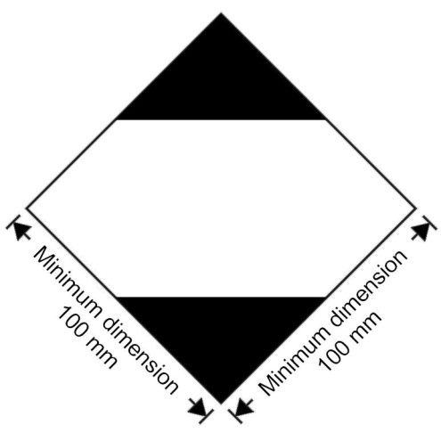
Marking for packages containing limited quantities
The marking shall be readily visible, legible and able to withstand open weather exposure without a substantial reduction in effectiveness.
The marking shall be in the form of a square set at an angle of 45 degrees (diamond-shaped). The top and bottom portions and the surrounding line shall be black. The centre area shall be white or a suitable contrasting background. The minimum dimensions shall be 100 mm x 100 mm and the minimum width of line forming the diamond shall be 2 mm. Where dimensions are not specified, all features shall be in approximate proportion to those shown.
3.4.7.2 If the size of the package so requires, the minimum outer dimensions shown in Figure 3.4.1 may be reduced to be not less than 50 mm x 50 mm provided the marking remains clearly visible. The minimum width of the line forming the diamond may be reduced to a minimum of 1 mm.
NOTE: The provisions of 3.4.7 from the seventeenth revised edition of the Model Regulations may continue to be applied until 31 December 2016.”.
3.4.8 Marking for packages containing limited quantities conforming to Part 3, Chapter 4 of the ICAO Technical Instructions for the Safe Transport of Dangerous Goods by Air
3.4.8.1 Packages containing dangerous goods packed in conformity with the provisions of Part 3, Chapter 4 of the ICAO Technical Instructions for the Transport of Dangerous Goods may bear the marking shown in Figure 3.4.2 to certify conformity with these provisions:

Figure 3.4.2
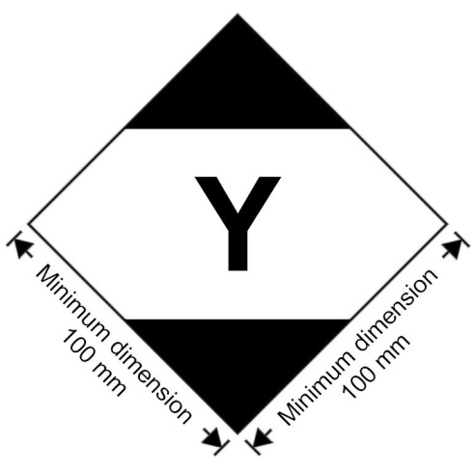
Marking for packages containing limited quantities conforming to Part 3, Chapter 4 of the ICAO Technical Instructions for the Safe Transport of Dangerous Goods by Air
The marking shall be readily visible, legible and able to withstand open weather exposure without a substantial reduction in effectiveness.
The marking shall be in the form of a square set at an angle of 45 degrees (diamond-shaped). The top and bottom portions and the surrounding line shall be black. The centre area shall be white or a suitable contrasting background. The minimum dimensions shall be 100 mm x 100 mm and the minimum width of line forming the diamond shall be 2 mm. The symbol “Y” shall be placed in the centre of the mark and shall be clearly visible. Where dimensions are not specified, all features shall be in approximate proportion to those shown.
3.4.8.2 If the size of the package so requires, the minimum outer dimensions shown in Figure 3.4.2 may be reduced to be not less than 50 mm x 50 mm provided the marking remains clearly visible. The minimum width of the line forming the diamond may be reduced to a minimum of 1 mm. The symbol “Y” shall remain in approximate proportion to that shown in Figure 3.4.2.
NOTE: The provisions of 3.4.8 from the seventeenth revised edition of the Recommendations on the Transport of Dangerous Goods, Model Regulations may continue to be applied until 31 December 2016.”.
3.4.9 Amend to read as follows:
“3.4.9 Packages containing dangerous goods bearing the marking shown in 3.4.8 with or without the additional labels and markings for air transport shall be deemed to meet the provisions of section 3.4.1 as appropriate and of sections 3.4.2 to 3.4.4 and need not bear the marking shown in 3.4.7.”.
3.4.10 Amend to read as follows:
“3.4.10 Packages containing dangerous goods in limited quantities bearing the marking shown in 3.4.7 and conforming with the provisions of the ICAO Technical Instructions for the Safe Transport of Dangerous Goods by Air, including all necessary marks and labels specified in Parts 5 and 6, shall be deemed to meet the provisions of section 3.4.1 as appropriate and of sections 3.4.2 to 3.4.4 when transported by land or by sea.”.
Chapter 3.5
3.5.4.2 and 3.5.4.3 Amend to read as follows:
“3.5.4.2 Excepted quantities mark

Figure 3.5.1

Minimum dimension 100 mm
Minimum dimension 100 mm

Excepted quantities mark
* The Class or, when assigned, the Division number(s) shall be shown in this location
** The name of the consignor or of the consignee shall be shown in this location if not shown elsewhere on the package
The marking shall be in the form of a square. The hatching and symbol shall be of the same colour, black or red, on white or suitable contrasting background. The minimum dimensions shall be 100 mm x 100 mm. Where dimensions are not specified, all features shall be in approximate proportion to those shown.
3.5.4.3 An overpack containing dangerous goods in excepted quantities shall display the markings required by 3.5.4.1, unless such markings on packages within the overpack are clearly visible.
NOTE: The provisions of 3.5.4.2 and 3.5.4.3 from the seventeenth revised edition of the Model Regulations may continue to be applied until 31 December 2016.”.
Appendix A
Add the following new entries to Appendix A:
Class or Division | Subsidiary Risk | UN No | Proper Shipping Name
2.1 |  | 3510 | ADSORBED GAS, FLAMMABLE, N.O.S.
2.2 |  | 3511 | ADSORBED GAS, N.O.S.
2.3 |  | 3512 | ADSORBED GAS, TOXIC, N.O.S.
2.2 | 5.1 | 3513 | ADSORBED GAS, OXIDIZING, N.O.S.
2.3 | 2.1 | 3514 | ADSORBED GAS, TOXIC, FLAMMABLE, N.O.S.
2.3 | 5.1 | 3515 | ADSORBED GAS, TOXIC, OXIDIZING, N.O.S.
2.3 | 8 | 3516 | ADSORBED GAS, TOXIC, CORROSIVE, N.O.S.
2.3 | 2.1 + 8 | 3517 | ADSORBED GAS, TOXIC, FLAMMABLE, CORROSIVE, N.O.S.
2.3 | 5.1 + 8 | 3518 | ADSORBED GAS, TOXIC, OXIDIZING, CORROSIVE, N.O.S.
The amendments for Class 7 do not apply to the English text.
Appendix B
Amend the entry for “AIR BAG INFLATORS, PYROTECHNIC or AIR BAG MODULES, PYROTECHNIC or SEAT-BELT PRETENSIONERS, PYROTECHNIC” to read, “SAFETY DEVICES, electrically initiated”.
Amend the definition to read as follows:
“Articles which contain pyrotechnic substances or dangerous goods of other classes and are used in vehicles, vessels or aircraft to enhance safety to persons. Examples are: air bag inflators, air bag modules, seat-belt pretensioners and pyromechanical devices. These pyromechanical devices are assembled components for tasks such as but not limited to separation, locking, or release-and-drive or occupant restraint. The term includes “SAFETY DEVICES, PYROTECHNIC”.”.
Alphabetical index
Amend the entries for “AIR BAG INFLATORS, PYROTECHNIC or AIR BAG MODULES, PYROTECHNIC or SEAT-BELT PRETENSIONERS, PYROTECHNIC” to read as follows:
«Air bag inflators, see | 1.4G  9 | 0503  3268»
«Air bag modules, see | 1.4G  9 | 0503  3268»
«Seat-belt pretensioners, see | 1.4G  9 | 0503  3268»
In the entries for “Actinolite”, “Anthophyllite”, “Talcum with tremolite and/or actinolite” and “Tremolite” in the UN No. column, replace “2590” by “2212”.
Delete the entries for “Asbestos, blue or brown”, “Asbestos, white”, “Chryosotile”, , “BLUE ASBESTOS (crocidolite)”, “BROWN ASBESTOS (amosite, mysorite)”, “WHITE ASBESTOS (chrysotile, actinolite, anthophyllite, tremolite)”.
In the entry for “TRIFLUOROCHLOROETHYLENE, STABILIZED” UN No. 1082, add at the end “REFRIGERANT GAS R 113”.
In the entry for “AMMONIUM NITRATE”, (UN 1942), amend the description to read as follows “AMMONIUM NITRATE with not more than 0.2% combustible substances, including any organic substance calculated as carbon, to the exclusion of any other added substance”.
In the entry for “AMMONIUM NITRATE”, (UN 0222), amend the description to read as follows “AMMONIUM NITRATE”.
In the entry for “CAPACITOR, electric double layer…” (UN 3499), amend the description to read as follows: “CAPACITOR, ELECTRIC DOUBLE LAYER (with an energy storage capacity greater than 0.3Wh)”.
The amendments to the entries for “RADIOACTIVE MATERIAL, EXCEPTED PACKAGE - ARTICLES MANUFACTURED FROM NATURAL URANIUM or DEPLETED URANIUM or NATURAL THORIUM”, “RADIOACTIVE MATERIAL, EXCEPTED PACKAGE - LIMITED QUANTITY OF MATERIAL” and “RADIOACTIVE MATERIAL, EXCEPTED PACKAGE - INSTRUMENTS or ARTICLES” do not apply to the English text.
Add the following new entries in alphabetical order:
Name and description | Class | UN No.
ADSORBED GAS, FLAMMABLE, N.O.S. | 2.1 | 3510
ADSORBED GAS, N.O.S. | 2.2 | 3511
ADSORBED GAS, OXIDIZING, N.O.S. | 2.2 | 3513
ADSORBED GAS, TOXIC, CORROSIVE, N.O.S. | 2.3 | 3516
ADSORBED GAS, TOXIC, FLAMMABLE, CORROSIVE, N.O.S. | 2.3 | 3517
ADSORBED GAS, TOXIC, FLAMMABLE, N.O.S. | 2.3 | 3514
ADSORBED GAS, TOXIC, N.O.S. | 2.3 | 3512
ADSORBED GAS, TOXIC, OXIDIZING, CORROSIVE, N.O.S. | 2.3 | 3518
ADSORBED GAS, TOXIC, OXIDIZING, N.O.S. | 2.3 | 3515
Amphibole asbestos, see | 9 | 2212
ARSINE, ADSORBED | 2.3 | 3522
ASBESTOS, AMPHIBOLE | 9 | 2212
ASBESTOS, CHRYSOTILE | 9 | 2590
BORON TRIFLUORIDE, ADSORBED | 2.3 | 3519
CAPACITOR, ASYMMETRIC, (with an energy storage capacity greater than 0.3Wh) | 9 | 3508
CHLORINE, ADSORBED | 2.3 | 3520
Chrysotile, see | 9 | 2590
GERMANE, ADSORBED | 2.3 | 3523
HYDROGEN SELENIDE, ADSORBED | 2.3 | 3526
Mercurous chloride, see | 6.1 | 2025
PACKAGING DISCARDED, EMPTY, UNCLEANED | 9 | 3509
PHOSPHINE, ADSORBED | 2.3 | 3525
PHOSPHORUS PENTAFLUORIDE, ADSORBED | 2.3 | 3524
SAFETY DEVICES, electrically initiated | 9 | 3268
SAFETY DEVICES, PYROTECHNIC | 1.4G | 0503
SILICON TETRAFLUORIDE, ADSORBED | 2.3 | 3521
URANIUM HEXAFLUORIDE, RADIOACTIVE MATERIAL, EXCEPTED PACKAGE, less than 0.1 kg per package, non-fissile or fissile-excepted | 8 | 3507
Chapter 4.1
4.1.1.5 Add a new 4.1.1.5.2 to read as follows:
“4.1.1.5.2 Use of supplementary packagings within an outer packaging (e.g. an intermediate packaging or a receptacle inside a required inner packaging) additional to what is required by the packing instructions is authorized provided all relevant requirements are met, including those of 4.1.1.3, and, if appropriate, suitable cushioning is used to prevent movement within the packaging.”.
4.1.4.1, P003 Add a new special packing provision PP91 to read as follows:
“PP91 For UN 1044, large fire extinguishers may also be transported unpackaged provided that the requirements of 4.1.3.8 (a) to (e) are met, the valves are protected by one of the methods in accordance with 4.1.6.1.8 (a) to (d) and other equipment mounted on the fire extinguisher is protected to prevent accidental activation. For the purpose of this special packing provision, “large fire extinguishers” means fire extinguishers as described in indents (c) to (e) of special provision 225 of Chapter 3.3.”.
4.1.4.1, P114(a) under Outer Packagings, Drums: Before “fibre (1G)” insert “plywood (1D)”.
4.1.4.1, P116 In the column for “outer packagings”, amend the first entry for “bags” to read: “woven plastics (5H1, 5H2, 5H3)”. Amend special packing provision PP65 to read: “Deleted”.
4.1.4.1, P131 and P137 In the entry for “boxes”, in the column for “outer packagings” add: “plastics, solid (4H2)”.
4.1.4.1, P404 (1) Amend to read as follows:
(1) Combination packagings
Outer packagings: (1A1, 1A2, 1B1, 1B2, 1N1, 1N2, 1H1, 1H2, 1D, 1G, 4A, 4B, 4N, 4C1, 4C2, 4D, 4F, 4G or 4H2)
Inner packagings: Metal receptacles with a maximum net mass of 15 kg each. Inner packagings shall be hermetically sealed and have threaded closures;
Glass receptacles, with a maximum net mass of 1 kg each, having threaded closures with gaskets, cushioned on all sides and contained in hermetically sealed metal cans.
Outer packagings shall have a maximum net mass of 125 kg.
4.1.4.1, P501, P502 and P504 Amend the last entry under “Composite packaging” to read as follows:
“Glass receptacle in steel, aluminium, fibre or plywood drum (6PA1, 6PB1, 6PD1 or 6PG1) or in a steel, aluminium, wood or fibreboard box or in wickerwork hamper (6PA2, 6PB2, 6PC, 6PG2 or 6PD2) or in solid or expanded plastics packaging (6PH1 or 6PH2).”.
4.1.4.1, P601 (2) and P602 (2) At the beginning, insert “or plastics” after “consisting of metal”.
4.1.4.1, P650 Amend the diagram in paragraph (4) to read as follows:
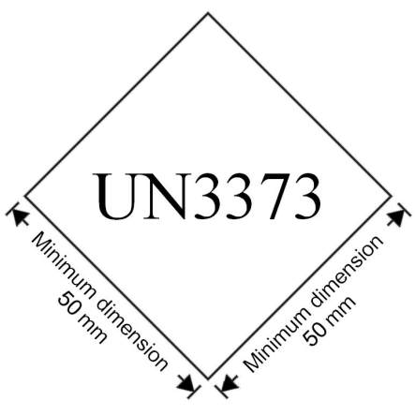
“NOTE: The mark shown in paragraph (4) of Packing Instruction P650 of the seventeenth revised edition of the Recommendations on the Transport of Dangerous Goods, Model Regulations may continue to be applied until 31 December 2016.”.
4.1.4.1, P802 (3) Amend to read as follows:
“(3) Composite packagings: Glass receptacle in steel, aluminium or plywood drum (6PA1, 6PB1 or 6PD1) or in a steel, aluminium or wood box or in wickerwork hamper (6PA2, 6PB2, 6PC or 6PD2) or in solid plastics packaging (6PH2); maximum capacity: 60 litres.”.
4.1.4.1, P901 After “(see 3.3.1, special provision 251)”, insert the following new sentence: “Where the kit contains only dangerous goods to which no packing group is assigned, packagings shall meet Packing Group II performance level.”.
4.1.4.1, P903 In paragraph (2), replace subparagraphs (a) and (b) with the following subparagraphs (a) to (c):
“(a) Strong outer packagings;
(b) Protective enclosures (e.g., fully enclosed or wooden slatted crates); or
(c) Pallets or other handling devices.”.
4.1.4.1, P904 Amend the diagram to read as follows:
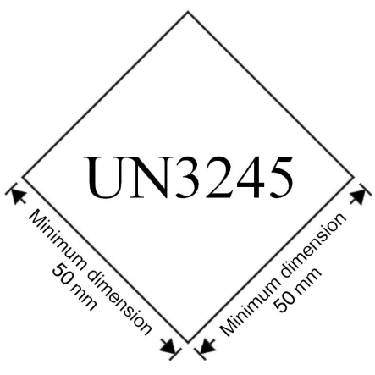
“NOTE: The mark shown in paragraph (2) of Packing Instruction P904 of the seventeenth revised edition of the Recommendations on the Transport of Dangerous Goods, Model Regulations may continue to be applied until 31 December 2016.”.
4.1.4.1, P906 (2) Amend to read as follows:
“(2) For transformers and condensers and other devices:
(a) Packagings in accordance with packing instructions P001 or P002. The articles shall be secured with suitable cushioning material to prevent inadvertent movement during normal conditions of transport; or
(b) Leakproof packagings which are capable of containing, in addition to the devices, at least 1.25 times the volume of the liquid PCBs, polyhalogenated biphenyls or terphenyls present in them. There shall be sufficient absorbent material in the packagings to absorb at least 1.1 times the volume of liquid which is contained in the devices. In general, transformers and condensers shall be carried in leakproof metal packagings which are capable of holding, in addition to the transformers and condensers, at least 1.25 times the volume of the liquid present in them.”.
4.1.4.1 Insert the following new packing instructions:
P208 | PACKING INSTRUCTION | P208
This instruction applies to Class 2 adsorbed gases.
(1) The following packagings are authorized provided the general packing requirements of 4.1.6.1 are met:
Cylinders specified in Chapter 6.2 and in accordance with ISO 11513:2011 or ISO 9809-1:2010.
(2) The pressure of each filled cylinder shall be less than 101.3 kPa at 20 °C less than 300 kPa at 50 °C.
(3) The minimum test pressure of the cylinder shall be 21 bar.
(4) The minimum burst pressure of the cylinder shall be 94.5 bar.
(5) The internal pressure at 65 °C of the filled cylinder shall not exceed the test pressure of the cylinder.
(6) The adsorbent material shall be compatible with the cylinder and shall not form harmful or dangerous compounds with the gas to be adsorbed. The gas in combination with the adsorbent material shall not affect or weaken the cylinder or cause a dangerous reaction (e.g. a catalyzing reaction).
(7) The quality of the adsorbent shall be verified at the time of each fill to assure the pressure and chemical stability requirements of this packing instruction are met each time an adsorbed gas package is offered for transport.
(8) The adsorbent material shall not meet the criteria of any of the Classes or Divisions in these Regulations.
(9) Requirements for cylinders and closures containing toxic gases with an LC₅₀ less than or equal to 200 ml/m³ (ppm) (see Table 1) shall be as follows:
- Valve outlets shall be fitted with pressure retaining gas-tight plugs or caps having threads matching those of the valve outlets.
- Each valve shall either be of the packless type with non-perforated diaphragm, or be of a type which prevents leakage through or past the packing.
- Each cylinder and closure shall be tested for leakage after filling.
- Each valve shall be capable of withstanding the test pressure of the cylinder and be directly connected to the cylinder by either a taper-thread or other means which meets the requirements of ISO 10692-2:2001.
- Cylinders and valves shall not be fitted with a pressure relief device.
(10) Valve outlets for cylinders containing pyrophoric gases shall be fitted with gas-tight plugs or caps having threads matching those of the valve outlets.
(11) The filling procedure shall be in accordance with Annex A of ISO 11513:2011.
(12) The maximum period for periodic inspections shall be 5 years.
(13) Special packing provisions that are specific to a substance (see Table 1).
Material compatibility
a: Aluminium alloy cylinders shall not be used.
b: When steel cylinders are used, only those bearing the "H" mark in accordance with 6.2.2.7.4 (p) are permitted.
Gas specific provisions
r: The filling of this gas shall be limited such that, if complete decomposition occurs, the pressure does not exceed two thirds of the test pressure of the cylinder.
Material Compatibility for N.O.S Adsorbed Gas Entries
z: The construction materials of the cylinders and their accessories shall be compatible with the contents and shall not react to form harmful or dangerous compounds therewith.

P208 |  | PACKING INSTRUCTION |  |  | P208
Table 1: ADSORBED GASES
UN  No. | Name and description |  | Class  or Division | Subsidiary  risk |  | LC₅₀  ml/m³ | Special packing provisions
(1) | (2) |  | (3) | (4) |  | (5) | (6)
3510 | ADSORBED GAS, FLAMMABLE, N.O.S. |  | 2.1 |  |  |  | z
3511 | ADSORBED GAS, N.O.S. |  | 2.2 |  |  |  | z
3512 | ADSORBED GAS, TOXIC, N.O.S. |  | 2.3 |  |  | ≤ 5000 | z
3513 | ADSORBED GAS, OXIDIZING, N.O.S. |  | 2.2 | 5.1 |  |  | z
3514 | ADSORBED GAS, TOXIC, FLAMMABLE, N.O.S. |  | 2.3 | 2.1 |  | ≤ 5000 | z
3515 | ADSORBED GAS, TOXIC, OXIDIZING, N.O.S. |  | 2.3 | 5.1 |  | ≤ 5000 | z
3516 | ADSORBED GAS, TOXIC, CORROSIVE, N.O.S. |  | 2.3 | 8 |  | ≤ 5000 | z
3517 | ADSORBED GAS, TOXIC, FLAMMABLE, CORROSIVE, N.O.S. |  | 2.3 | 2.1  8 |  | ≤ 5000 | z
3518 | ADSORBED GAS, TOXIC, OXIDIZING, CORROSIVE, N.O.S. |  | 2.3 | 5.1  8 |  | ≤ 5000 | z
3519 | BORON TRIFLUORIDE, ADSORBED |  | 2.3 | 8 |  | 387 | a
3520 | CHLORINE, ADSORBED |  | 2.3 | 5.1  8 |  | 293 | a
3521 | SILICON TETRAFLUORIDE, ADSORBED |  | 2.3 | 8 |  | 450 | a
3522 | ARSINE, ADSORBED |  | 2.3 | 2.1 |  | 20 | d
3523 | GERMANE, ADSORBED |  | 2.3 | 2.1 |  | 620 | d, r
3524 | PHOSPHORUS PENTAFLUORIDE, ADSORBED |  | 2.3 | 8 |  | 190
3525 | PHOSPHINE, ADSORBED |  | 2.3 | 2.1 |  | 20 | d
3526 | HYDROGEN SELENIDE, ADSORBED |  | 2.3 | 2.1 |  | 2

P505 | PACKING INSTRUCTION |  |  | P505
This instruction applies to UN No. 3375
The following packagings are authorized, provided that the general provisions of 4.1.1 and 4.1.3 are met:
Combination packagings: |  | Inner packaging maximum capacity | Outer packaging maximum net mass
Boxes (4B, 4C1, 4C2, 4D, 4G, 4H2) or drums (1B2, 1G, 1N2, 1H2, 1D) jerricans (3B2, 3H2) with glass, plastics or metal inner packagings |  | 5 l | 125 kg
Single packagings: |  | Maximum capacity
Drums
aluminium (1B1, 1B2), plastics (1H1, 1H2) |  | 250 l
Jerricans
aluminium (3B1, 3B2), plastics (3H1, 3H2) |  | 60 l
Composite packagings
plastics receptacle with outer aluminium drum (6HB1) |  | 250 l
plastics receptacle with outer fibre, plastics or plywood drum (6HG1, 6HH1, 6HD1) |  | 250 l
plastics receptacle with outer aluminium crate or box or plastics receptacle with outer wooden, plywood, fibreboard or solid plastics box (6HB2, 6HC, 6HD2, 6HG2 or 6HH2) |  | 60 l
glass receptacle with outer aluminium, fibre or plywood drum (6PB1, 6PG1, 6PD1) or with outer solid plastics or expanded plastics receptacles (6PH1 or 6PH2) or with outer aluminium crate or box or with outer wooden or fibreboard box or with outer wickerwork hamper (6PB2, 6PC, 6PG2 or 6PD2) |  | 60 l

P805 | PACKING INSTRUCTION | P805
This instruction applies to UN 3507.
The following packagings are authorized provided that the general provisions of 4.1.1 and 4.1.3 and the special packing provisions of 4.1.9.1.2, 4.1.9.1.4 and 4.1.9.1.7 are met:
Packagings consisting of:
(a) Metal or plastic primary receptacle(s); in
(b) Leakproof rigid secondary packaging(s); in
(c) A rigid outer packaging:
Drums (1A2, 1B2, 1N2, 1H2, 1D, 1G);
Boxes (4A, 4B, 4C1, 4C2, 4D, 4F, 4G, 4H1, 4H2);
Jerricans (3A2, 3B2, 3H2).
Additional requirements:
1. Primary inner receptacles shall be packed in secondary packagings in a way that, under normal conditions of transport, they cannot break, be punctured or leak their contents into the secondary packaging. Secondary packagings shall be secured in outer packagings with suitable cushioning material to prevent movement. If multiple primary receptacles are placed in a single secondary packaging, they shall be either individually wrapped or separated so as to prevent contact between them;
2. The contents shall comply with the provisions of 2.7.2.4.5.2;
3. The provisions of 6.4.4 shall be met.
Special packing provision:
In the case of fissile-excepted material, limits specified in 2.7.2.3.5 and 6.4.11.2 shall be met.

P908 | PACKING INSTRUCTION | P908
This instruction applies to UN Nos. 3090, 3091, 3480 and 3481.
The following packagings are authorized for damaged or defective lithium ion cells and batteries and lithium metal cells and batteries including those contained in equipment, provided the general provisions of 4.1.1 and 4.1.3 are met:
For cells and batteries and equipment containing cells and batteries:
Drums (1A2, 1B2, 1N2, 1H2, 1D, 1G)
Boxes (4A, 4B, 4N, 4C1, 4C2, 4D, 4F, 4G, 4H1, 4H2)
Jerricans (3A2, 3B2, 3H2)
Packagings shall conform to the packing group II performance level.
1. Each cell or battery or equipment containing such cells or batteries shall be individually packed in inner packaging and placed inside of an outer packaging. The inner packaging or outer packaging shall be leak-proof to prevent the potential release of electrolyte.
2. Each inner packaging shall be surrounded by sufficient non-combustible and non-conductive thermal insulation material to protect against a dangerous evolution of heat.
3. Sealed packagings shall be fitted with a venting device when appropriate.
4. Appropriate measures shall be taken to minimize the effects of vibrations and shocks, prevent movement of the cells or batteries within the package that may lead to further damage and a dangerous condition during transport. Cushioning material that is non-combustible and non-conductive may also be used to meet this requirement.
5. Non combustibility shall be assessed according to a standard recognized in the country where the packaging is designed or manufactured.
For leaking cells or batteries, sufficient inert absorbent material shall be added to the inner or outer packaging to absorb any release of electrolyte.
A cell or battery with a net mass of more than 30 kg shall be limited to one cell or battery per outer packaging.
Additional requirements:
Cells or batteries shall be protected against short circuit.

P909 | PACKING INSTRUCTION | P909
This packing instruction applies to UN Nos. 3090, 3091, 3480 and 3481 transported for disposal or recycling, either packed together with or packed without non-lithium batteries:
(1) Cells and batteries shall be packed in accordance with the following:
(a) The following packagings are authorized, provided that the general provisions of 4.1.1 and 4.1.3, are met:
Drums (1A2, 1B2, 1N2, 1H2, 1D, 1G);
Boxes (4A, 4B, 4N, 4C1, 4C2, 4D, 4F, 4G, 4H2); and
Jerricans (3A2, 3B2, 3H2).
(b) Packagings shall conform to the packing group II performance level.
(c) Metal packagings shall be fitted with a non-conductive lining material (e.g., plastics) of adequate strength for the intended use.
(2) However, lithium ion cells with a Watt-hour rating of not more than 20 Wh, lithium ion batteries with a Watt-hour rating of not more than 100 Wh, lithium metal cells with a lithium content of not more than 1 g and lithium metal batteries with an aggregate lithium content of not more than 2 g may be packed in accordance with the following:
(a) In strong outer packaging up to 30 kg gross mass meeting the general provisions of 4.1.1, except 4.1.1.3, and 4.1.3.
(b) Metal packagings shall be fitted with a non-conductive lining material (e.g., plastics) of adequate strength for the intended use.
(3) For cells or batteries contained in equipment, strong outer packagings constructed of suitable material, and of adequate strength and design in relation to the packaging capacity and its intended use, may be used. Packagings need not meet the requirements of 4.1.1.3. Large equipment may be offered for transport unpackaged or on pallets when the cells or batteries are afforded equivalent protection by the equipment in which they are contained.
(4) In addition, for cells or batteries with a gross mass of 12 kg or more employing a strong, impact resistant outer casing, strong outer packagings constructed of suitable material and of adequate strength and design in relation to the packagings capacity and its intended use, may be used. Packagings need not meet the requirements of 4.1.1.3.
Additional requirements:
1. Cells and batteries shall be designed or packed to prevent short circuits and the dangerous evolution of heat.
2. Protection against short circuits and the dangerous evolution of heat includes, but is not limited to,
-individual protection of the battery terminals,
-inner packaging to prevent contact between cells and batteries,
-batteries with recessed terminals designed to protect against short circuits, or
-the use of a non-conductive and non-combustible cushioning material to fill empty space between the cells or batteries in the packaging.
3. Cells and batteries shall be secured within the outer packaging to prevent excessive movement during transport (e.g. by using a non-combustible and non-conductive cushioning material or through the use of a tightly closed plastics bag).
4.1.4.2 In IBC02, insert the following new special provision B16:
“B16 For UN 3375, IBCs of type 31A and 31N are not allowed without competent authority approval.”.
4.1.4.2 In IBC04 Replace “and 21N” with “, 21N, 31A, 31B and 31N”.
4.1.4.2 In IBC05 (1) Replace “and 21N” with “, 21N, 31A, 31B and 31N”.
4.1.4.2 In IBC05 (2) Replace “and 21H2” with “, 21H2, 31H1 and 31H2”.
4.1.4.2 In IBC05 (3) Replace “and 21HZ1” with “, 21HZ1 and 31HZ1”.
4.1.4.2 In IBC06 (1), IBC07 (1) and IBC08 (1) Replace “and 21N” with “, 21N, 31A, 31B and 31N”.
4.1.4.2 In IBC06 (2), IBC07 (2) and IBC08 (2) Replace “and 21H2” with “, 21H2, 31H1 and 31H2”.
4.1.4.2 In IBC06 (3), IBC07 (3) and IBC08 (3) Replace “and 21HZ2” with “21HZ2 and 31HZ1”.
IBC100 In the first line of packing instruction IBC100, insert “0222” after “0082”. Insert the following special packing provisions:
“B2 For UN No. 0222 in IBCs other than metal or rigid plastics IBCs, the IBCs shall be transported in closed cargo transport units.”
“B3 For UN No. 0222, flexible IBCs shall be sift-proof and water resistant or shall be fitted with a sift-proof and water resistant liner.”
“B17 For UN No. 0222, metal IBCs are not authorized.”
4.1.4.3 Insert the following new packing instructions:
LP903 | PACKING INSTRUCTION | LP903
This instruction applies to UN Nos. 3090, 3091, 3480 and 3481
The following large packagings are authorized for a single battery, including for a battery contained in equipment, provided that the general provisions of 4.1.1 and 4.1.3 are met:
Rigid large packagings conforming to the packing group II performance level, made of:
steel (50A);
aluminium (50B);
metal other than steel or aluminium (50N);
rigid plastics (50H);
natural wood (50C);
plywood (50D);
reconstituted wood (50F);
rigid fibreboard (50G).
The battery shall be packed so that the battery is protected against damage that may be caused by its movement or placement within the large packaging.
Additional requirement:
Batteries shall be protected against short circuit.

LP904 | PACKING INSTRUCTION | LP904
This instruction applies to UN Nos. 3090, 3091, 3480 and 3481
The following large packagings are authorized for a single damaged or defective battery and for a single damaged or defective battery contained in equipment, provided the general provisions of 4.1.1 and 4.1.3 are met
For batteries and equipment containing batteries:
steel (50A)
aluminium (50B)
metal other than steel or aluminium (50N)
rigid plastics (50H)
plywood (50D)
Packagings shall conform to the packing group II performance level.
1. Each battery or equipment containing such battery shall be individually packed in inner packaging and placed inside of an outer packaging. The inner packaging or outer packaging shall be leak-proof to prevent the potential release of electrolyte.
2. Each inner packaging shall be surrounded by sufficient non-combustible and non-conductive thermal insulation material to protect against a dangerous evolution of heat.
3. Sealed packagings shall be fitted with a venting device when appropriate.
4. Appropriate measures shall be taken to minimize the effects of vibrations and shocks, prevent movement of the battery within the package that may lead to further damage and a dangerous condition during transport. Cushioning material that is non-combustible and non-conductive may also be used to meet this requirement.
5. Non combustibility shall be assessed according to a standard recognized in the country where the packaging is designed or manufactured.
For leaking batteries, sufficient inert absorbent material shall be added to the inner or outer packaging to absorb any release of electrolyte.
Additional requirements:
Batteries shall be protected against short circuit.
4.1.6.1.2 Replace “ISO 11114-1:1997” with “ISO 11114-1:2012”.
4.1.9 Amend the title to read “Special packing provisions for radioactive material”
4.1.9.1.3 Delete “, other than an excepted package,”.
4.1.9.1.6 Amend the introductory sentence to read as follows:
“Before a packaging is first used to transport radioactive material, it shall be confirmed that it has been manufactured in conformity with the design specifications to ensure compliance with the relevant provisions of these Regulations and any applicable certificate of approval. The following requirements shall also be fulfilled, if applicable:”.
4.1.9.1.6 In (a), replace “package” with “packaging”.
4.1.9.1.6 In (b) amend the beginning of the sentence to read as follows: “For each packaging intended for use as a Type B(U), Type B(M) or Type C package and for each packaging intended to contain fissile material…”.
4.1.9.1.6 Amend (c) to read as follows:
“(c) For each packaging intended to contain fissile material, it shall be ensured that the effectiveness of the criticality safety features is within the limits applicable to or specified for the design and in particular where, in order to comply with the requirements of 6.4.11.1 neutron poisons are specifically included, checks shall be performed to confirm the presence and distribution of those neutron poisons.”.
4.1.9.1.7 Insert a new paragraph to read as follows:
“4.1.9.1.7 Before each shipment of any package, it shall be ensured that the package contains neither:
(a) Radionuclides different from those specified for the package design; nor
(b) Contents in a form, or physical or chemical state different from those specified for the package design.”
Current paragraphs 4.1.9.1.7 to 4.1.9.1.11 become new paragraphs 4.1.9.1.8 to 4.1.9.1.12.
4.1.9.1.8 (former 4.1.9.1.7) Amend to read as follows:
“4.1.9.1.8 Before each shipment of any package, it shall be ensured that all the requirements specified in the relevant provisions of these Regulations and in the applicable certificates of approval have been fulfilled. The following requirements shall also be fulfilled, if applicable:
(a) It shall be ensured that lifting attachments which do not meet the requirements of 6.4.2.2 have been removed or otherwise rendered incapable of being used for lifting the package, in accordance with 6.4.2.3;
(b) Each Type B(U), Type B(M) and Type C package shall be held until equilibrium conditions have been approached closely enough to demonstrate compliance with the requirements for temperature and pressure unless an exemption from these requirements has received unilateral approval;
(c) For each Type B(U), Type B(M) and Type C package, it shall be ensured by inspection and/or appropriate tests that all closures, valves and other openings of the containment system through which the radioactive contents might escape are properly closed and, where appropriate, sealed in the manner for which the demonstrations of compliance with the requirements of 6.4.8.8 and 6.4.10.3 were made;
(d) For packages containing fissile material the measurement specified in 6.4.11.5 (b) and the tests to demonstrate closure of each package as specified in 6.4.11.8 shall be performed.”.
4.1.9.2.2 Amend to read as follows:
“4.1.9.2.2 For LSA material and SCO which are or contain fissile material, which is not excepted under 2.7.2.3.5, the applicable requirements of 7.1.8.4.1 and 7.1.8.4.2 shall be met.”.
4.1.9.2.3 Insert a new paragraph 4.1.9.2.3 to read as follows:
“4.1.9.2.3 For LSA material and SCO which are or contain fissile material, the applicable requirements of 6.4.11.1 shall be met.”.
Current paragraphs 4.1.9.2.3 and 4.1.9.2.4 become new paragraphs 4.1.9.2.4 and 4.1.9.2.5 respectively. Table 4.1.9.2.4 is renumbered as 4.1.9.2.5.
4.1.9.2.4 (former 4.1.9.2.3) In (b), delete “and” at the end.
Add a new sub-paragraph (d) to read as follows:
“(d) Unpackaged fissile material shall meet the requirements of 2.7.2.3.5 (e)”.
4.1.9.2.5 (former 4.1.9.2.4) Replace “4.1.9.2.3” with “4.1.9.2.4” and “Table 4.1.9.2.4” with “Table 4.1.9.2.5”.
Table 4.1.9.2.5 In note “a” under the table replace “4.1.9.2.3” with “4.1.9.2.4”.
4.1.9.3 Amend to read as follows:
“4.1.9.3 The contents of packages containing fissile material shall be as specified for the package design either directly in these Regulations or in the certificate of approval.”.
Chapter 4.2
4.2.5.2.6 Amend the header to the tabulated portable tank instructions for T1 – T22 to read as follows:
“These portable tank instructions apply to liquid and solid substances of Class 1 and Classes 3 to 9. The general provisions of section 4.2.1 and the requirements of section 6.7.2 shall be met.”.
4.2.5.2.6 In tank instruction T23, at the end of footnote d add: ““CORROSIVE” subsidiary risk placard required (Model No 8, see 5.2.2.2.2).”.
4.2.5.3 In special provision TP32, paragraph (b), at the beginning, insert “For UN 3375 only,”.
4.2.5.3 Add the following new portable tank special provision:
“TP41 The 2.5 year internal examination may be waived or substituted by other test methods or inspection procedures specified by the competent authority or its authorized body, provided that the portable tank is dedicated to the transport of the organometallic substances to which this tank special provision is assigned. However this examination is required when the conditions of 6.7.2.19.7 are met.”.
Chapter 5.1
5.1.2.1 Add the following new sentence and note at the end:
“The lettering of the “OVERPACK” marking shall be at least 12 mm high.
NOTE: The size requirement for the “OVERPACK” marking shall apply as from 1 January 2016.”.
5.1.3.2 Replace “Packagings, including IBCs, and tanks” with “Freight containers, tanks, IBCs, as well as other packagings and overpacks,”.
5.1.5.1.1 In the first sentence replace “for package designs” with “of package designs”.
5.1.5.1.2 In sub-paragraph (d) replace “according to” with “in accordance with”.
5.1.5.1.4 (c) Replace “for shipment approval” with “for approval of shipment (see 6.4.23.2)”.
5.1.5.2.1 In (a), insert a new sub-paragraph (iii) to read as follows:
“(iii) fissile material excepted under 2.7.2.3.5 (f);”.
Consequently, current sub-paragraphs (iii) to (vi) become new (iv) to (vii).
5.1.5.2.1 In (v) (former (iv)) delete “all” and “replace “6.4.11.2” with “2.7.2.3.5, 6.4.11.2 or 6.4.11.3”.
5.1.5.2.1 Insert new (d) and (e) to read as follows:
“(d) Determination of the basic radionuclide values referred to in 2.7.2.2.1 for individual radionuclides which are not listed in Table 2.7.2.2.1 (see 2.7.2.2.2 (a));
(e) Alternative activity limits for an exempt consignment of instruments or articles (see 2.7.2.2.2 (b));”.
5.1.5.2.1 Amend the second paragraph after sub-paragraphs (a) to (e) to read as follows:
“The certificates of approval for the package design and the shipment may be combined into a single certificate.”.
5.1.5.2.3 In the first sentence, amend the beginning of the sentence to read: “For package designs where it is not required that a competent authority issue a certificate of approval, the consignor…”.
5.1.5.3.4 In the first sentence, replace “and overpacks” with “, overpacks and freight containers”.
5.1.5.3.4 In (a), replace (twice) “or overpack” with “, overpack or freight container”.
5.1.5.3.4 In (e), insert “or freight container” after “overpack”.
Table 5.1.5.3.4 Replace “and overpacks” with “, overpacks and freight containers”.
In note “b” to the table insert at end: “except for freight containers (see Table 7.1.8.3.3)”.
5.1.5.3.5 Replace “design or shipment approval” with “approval of design or shipment”.
5.1.5.4 Amend the title to read “Specific provisions for excepted packages of radioactive material of Class 7”.
5.1.5.4.1 After “excepted packages”, insert “of radioactive material of Class 7”.
5.1.5.4.2 Amend to read as follows:
“5.1.5.4.2 The documentation requirements of Chapter 5.4 do not apply to excepted packages of radioactive material of Class 7, except that:
(a) The UN number preceded by the letters “UN” and the name and address of the consignor and the consignee and, if relevant, the identification mark for each competent authority certificate of approval (see 5.4.1.5.7.1 (g)) shall be shown on a transport document such as a bill of lading, air waybill or other similar document complying with the requirements of 5.4.1.2.1 to 5.4.1.2.4;
(b) The requirements of 5.4.1.6.2 and, if relevant, those of 5.4.1.5.7.1 (g), 5.4.1.5.7.3 and 5.4.1.5.7.4 shall apply;
(c) The requirements of 5.4.2 and 5.4.4 shall apply.”.
5.1.5.4.3 Insert a new paragraph to read as follows:
“5.1.5.4.3 The requirements of 5.2.1.5.8 and 5.2.2.1.12.5 shall apply if relevant.”.
Chapter 5.2
5.2.1.1 Amend the second sentence to read as follows:
“The UN number and the letters “UN” shall be at least 12 mm high, except for packages of 30 litres capacity or less or of 30 kg maximum net mass and for cylinders of 60 litres water capacity when they shall be at least 6 mm in height and except for packages of 5 litres or 5 kg or less when they shall be of an appropriate size.”.
5.2.1.3 Add the following new sentence and note at the end:
“The lettering of the “SALVAGE” marking shall be at least 12 mm high.
NOTE: The size requirement for the “SALVAGE” marking shall apply as from 1 January 2016.”.
5.2.1.5 Replace “for Class 7” with “for radioactive material”.
5.2.1.5.1 Insert the following sentence at the end: “Each overpack shall be legibly and durably marked on the outside of the overpack with an identification of either the consignor or consignee, or both unless these markings of all packages within the overpack are clearly visible.”.
5.2.1.5.2 After “excepted packages” insert “of radioactive material of Class 7”.
5.2.1.5.5 Amend the introductory sentence to read as follows:
“Each package which conforms to a design approved under one or more of paragraphs 5.1.5.2.1, 6.4.22.1 to 6.4.22.4, 6.4.23.4 to 6.4.23.7 and 6.4.24.2 shall be legibly and durably marked on the outside of the packaging with the following information:”.
5.2.1.5.5 Amend (c) to read as follows:
“(c) “Type B(U)”, “Type B(M)” or “Type C”, in the case of a Type B(U), Type B(M) or Type C package design”.
5.2.1.5.5 Delete (d).
5.2.1.5.7 Replace “4.1.9.2.3” with “4.1.9.2.4”.
5.2.1.5.8 Replace “competent authority design or shipment approval” with “competent authority approval of design or shipment”.
5.2.1.6.1 Amend to read as follows:
“5.2.1.6.1 Unless otherwise specified in these Regulations, packages containing environmentally hazardous substances meeting the criteria of 2.9.3 (UN Nos. 3077 and 3082) shall be durably marked with the environmentally hazardous substance mark.”.
5.2.1.6.3 Amend 5.2.1.6.3 and figure 5.2.2 to read as follows:
“5.2.1.6.3 The environmentally hazardous substance mark shall be as shown in Figure 5.2.2.
Figure 5.2.2
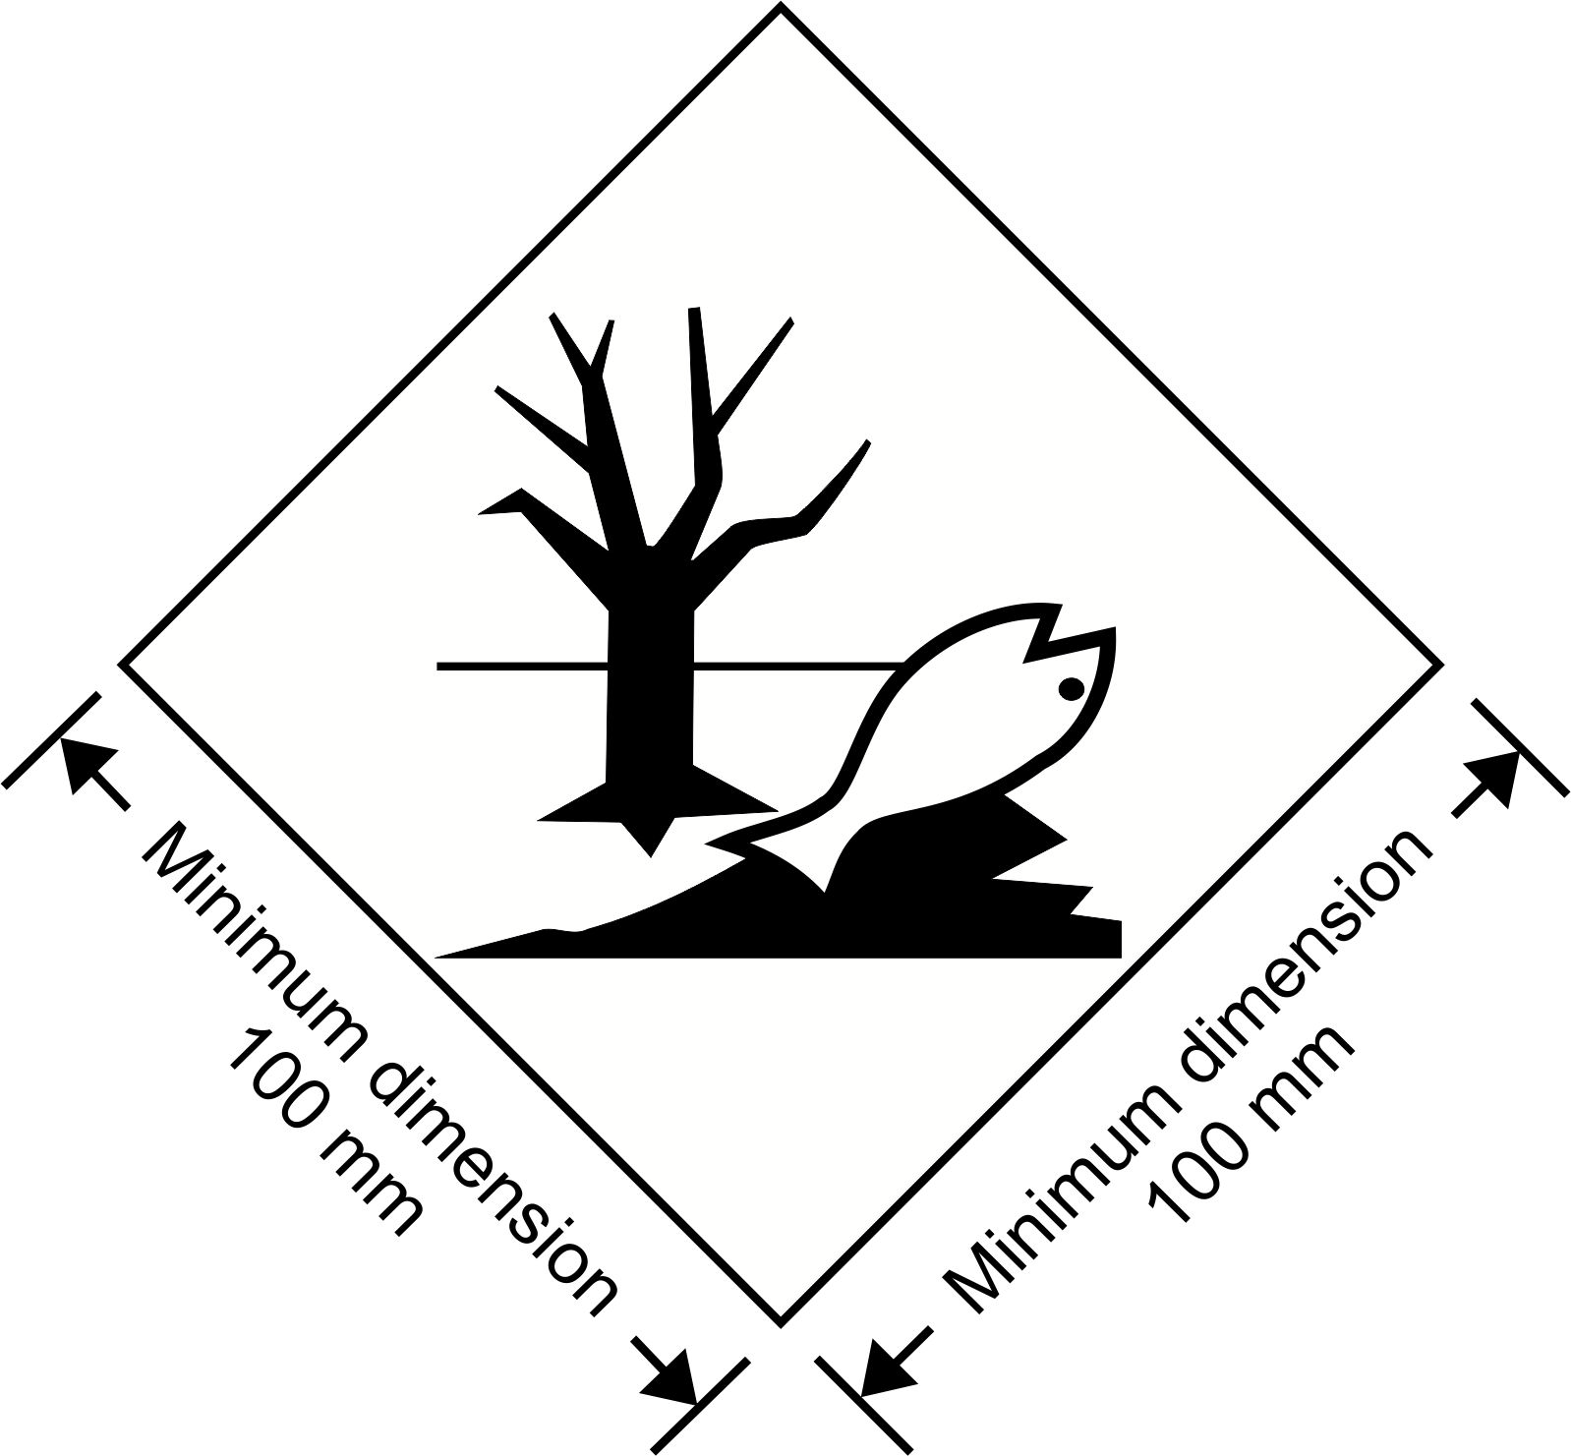
Environmentally hazardous substance mark
The marking shall be in the form of a square set at an angle of 45 degrees (diamond-shaped). The symbol (fish and tree) shall be black on white or suitable contrasting background. The minimum dimensions shall be 100 mm x 100 mm and the minimum width of line forming the diamond shall be 2 mm. If the size of the package so requires, the dimensions/line thickness may be reduced, provided the marking remains clearly visible. Where dimensions are not specified, all features shall be in approximate proportion to those shown.
NOTE 1: The labelling provisions of 5.2.2 apply in addition to any requirement for packages to bear the environmentally hazardous substance mark.
NOTE 2: The provisions of 5.2.1.6.3 from the seventeenth revised edition of the Recommendations on the Transport of Dangerous Goods, Model Regulations may continue to be applied until 31 December 2016.”.
5.2.1.7.1 Number the figures and amend the caption to read as follows:
“Figure 5.2.3 Figure 5.2.4

or
Two black or red arrows on white or suitable contrasting background.
The rectangular border is optional
All features shall be in approximate proportion to those shown.”.
5.2.2.1.12.1 Amend the first and second sentences to read as follows:
“Except when enlarged labels are used in accordance with 5.3.1.1.5.1, each package, overpack and freight container containing radioactive material shall bear the labels conforming to the applicable models Nos. 7A, 7B or 7C, according to the appropriate category. Labels shall be affixed to two opposite sides on the outside of the package or overpack or on the outside of all four sides of a freight container or tank.”.
5.2.2.1.12.1 In the fourth sentence:
For “under 6.4.11.2” read “under the provisions of 2.7.2.3.5”;
Replace “which conform to model” with “conforming to model”;
Replace the last phrase of the fourth sentence with the following: “such labels, where applicable shall be affixed adjacent to the labels conforming to the applicable model Nos. 7A, 7B or 7C.”.
5.2.2.1.12.2 In the introductory sentence, replace “models numbers 7A, 7B and 7C” with “the applicable model No. 7A, 7B or 7C”.
5.2.2.1.12.2 In (b), amend the last sentence to read as follows:
“For fissile material, the total mass of fissile nuclides in units of grams (g), or multiples thereof, may be used in place of activity”.
5.2.2.1.12.3 Amend to read as follows:
“5.2.2.1.12.3 Each label conforming to the model No. 7E shall be completed with the criticality safety index (CSI) as stated in the certificate of approval applicable in the countries through or into which the consignment is transported and issued by the competent authority or as specified in 6.4.11.2 or 6.4.11.3.”.
5.2.2.1.12.4 Amend to read as follows:
“5.2.2.1.12.4 For overpacks and freight containers, the label conforming to model No. 7E shall bear the sum of the criticality safety indexes of all the packages contained therein”.
5.2.2.1.12.5 Replace “competent authority design or shipment approval” with “competent authority approval of design or shipment”.
5.2.2.2.1.1 Amend to read as follows:
“5.2.2.2.1.1 Labels shall be configured as shown in Figure 5.2.5.
Figure 5.2.5
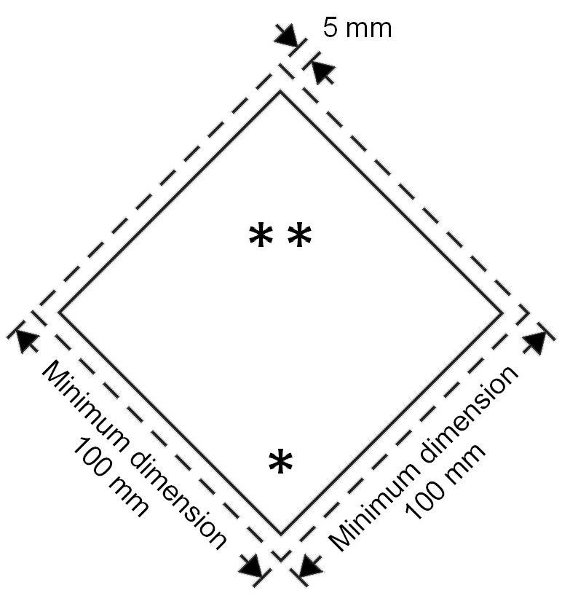
➲  
➲ 
➲
Class/division label
* The class or, for divisions 5.1 and 5.2, the Division number shall be shown in the bottom corner
** Additional text/numbers/letters shall (if mandatory) or may (if optional) be shown in this bottom half
*** The class or division symbol or, for divisions 1.4, 1.5 and 1.6, the division number and for Model No 7E the word “FISSILE” shall be shown in this top half”.
5.2.2.2.1.1.1 Labels shall be displayed on a background of contrasting colour, or shall have either a dotted or solid outer boundary line.
5.2.2.2.1.1.2 The label shall be in the form of a square set at an angle of 45 degrees (diamond-shaped). The minimum dimensions shall be 100 mm x 100 mm and the minimum width of the line inside the edge forming the diamond shall be 2 mm. The line inside the edge shall be parallel and 5 mm from the outside of that line to the edge of the label. The line inside the edge on the upper half of the label shall be the same colour as the symbol and the line inside the edge on the lower half of the label shall be the same colour as the class or division number in the bottom corner. Where dimensions are not specified, all features shall be in approximate proportion to those shown.
5.2.2.2.1.1.3 If the size of the package so requires the dimensions may be reduced, provided the symbols and other elements of the label remain clearly visible. The line inside the edge shall remain 5 mm to the edge of the label. The minimum width of the line inside the edge shall remain 2 mm. Dimensions for cylinders shall comply with 5.2.2.2.1.2.
NOTE: The provisions of 5.2.2.2.1.1 from the seventeenth revised edition of the Recommendations on the Transport of Dangerous Goods, Model Regulations may continue to be applied until 31 December 2016. When so applied, 5.2.2.2.1.1.1, 5.2.2.2.1.1.2 and 5.2.2.2.1.1.3 shall not apply until 31 December 2016.”.
Chapter 5.3
5.3.1.1.5.1 Amend the last sentence to read as follows:
“Instead of using both labels and placards, it is permitted as an alternative to use enlarged labels only, as shown in label models Nos. 7A, 7B and 7C, except having the minimum size shown in Figure 5.3.1.”.
5.3.1.1.5.2 In the introductory sentence replace “No.” with “Nos.”, “or 7E” with “and 7E” and “(Model 7D)” with “(model No.7D)”.
5.3.1.2.1 Amend read as follows:
“5.3.1.2.1 Except as provided in 5.3.1.2.2 for the Class 7 placard, and in 5.3.2.3.2 for the environmentally hazardous substance mark, a placard shall be configured as shown in Figure 5.3.0.
Figure 5.3.0
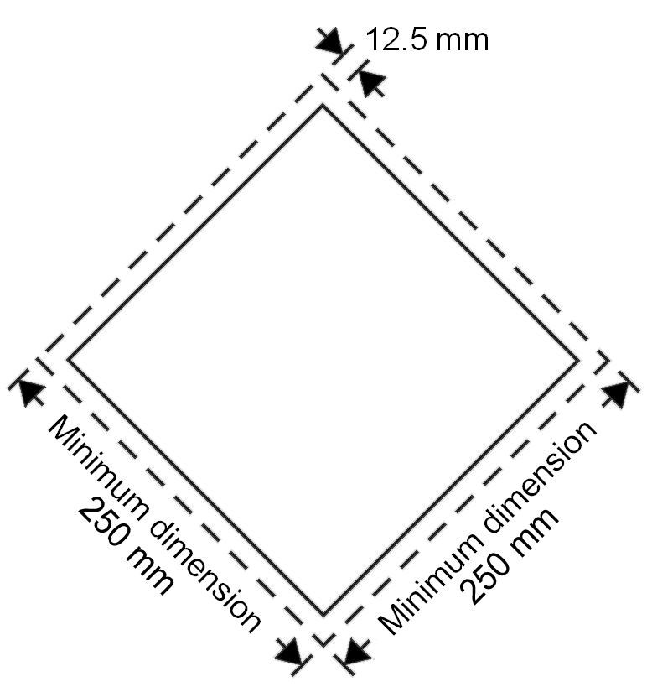
Placard (except for class 7)
The placard shall be in the form of a square set at an angle of 45 degrees (diamond-shaped). The minimum dimensions shall be 250 mm x 250 mm (to the edge of the placard). The line inside the edge shall be parallel and 12.5 mm from the outside of that line to the edge of the placard. The symbol and line inside the edge shall correspond in colour to the label for the class or division of the dangerous goods in question. The class or division symbol/numeral shall be positioned and sized in proportion to those prescribed in 5.2.2.2 for the corresponding class or division of the dangerous goods in question. The placard shall display the number of the class or division (and for goods in Class 1, the compatibility group letter) of the dangerous goods in question in the manner prescribed in 5.2.2.2 for the corresponding label, in digits not less than 25 mm high. Where dimensions are not specified, all features shall be in approximate proportion to those shown.
NOTE: The provisions of 5.3.1.2.1 from the seventeenth revised edition of the Recommendations on the Transport of Dangerous Goods, Model Regulations may continue to be applied until 31 December 2016.”.
5.3.2.2 Amend to read as follows:
“5.3.2.2 Elevated temperature substances
Cargo transport units containing a substance that is transported or offered for transport in a liquid state at a temperature equal to or exceeding 100 °C, in a solid state at a temperature equal to or exceeding 240 °C shall bear on each side and on each end the mark shown in Figure 5.3.4.
Figure 5.3.4
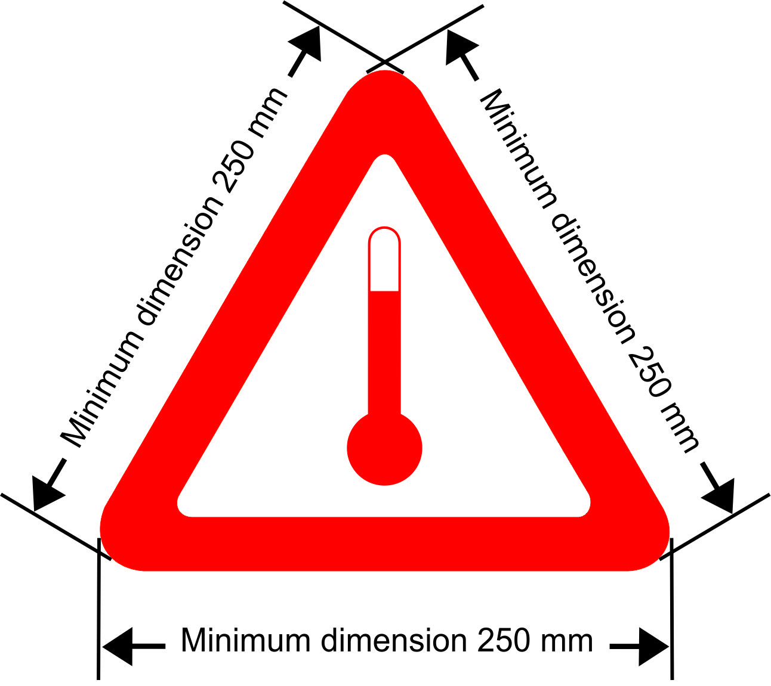
Mark for carriage at elevated temperature
The marking shall be an equilateral triangle. The colour of the mark shall be red. The minimum dimension of the sides shall be 250 mm. Where dimensions are not specified, all features shall be in approximate proportion to those shown.
NOTE: The provisions of 5.3.2.2 from the seventeenth revised edition of the Recommendations on the Transport of Dangerous Goods, Model Regulations may continue to be applied until 31 December 2016.”.
5.3.2.3.2 Add a new paragraph 5.3.2.3.2 as follows:
“5.3.2.3.2 The environmentally hazardous substance mark for cargo transport units shall be as described in 5.2.1.6.3 and Figure 5.2.2, except that the minimum dimensions shall be 250 mm x 250 mm.
NOTE: The requirements of 5.3.2.3.2 shall apply as from 1st January 2017.”.
Chapter 5.4
5.4.1.5.7.1 Amend (f) to read as follows:
“(f) For fissile material:
(i) Shipped under one exception of 2.7.2.3.5 (a) to (f), reference to that paragraph;
(ii) Shipped under 2.7.2.3.5 (c) to (e), the total mass of fissile nuclides;
(iii) Contained in a package for which one of 6.4.11.2 (a) to (c) or 6.4.11.3 is applied, reference to that paragraph;
(iv) The criticality safety index, where applicable.”.
5.4.1.5.7.1 In (g), replace “competent authority approval certificate” with “competent authority certificate of approval” and insert “fissile material excepted under 2.7.2.3.5 (f),” before “special arrangement”.
5.4.1.5.7.3 Replace “competent authorities design or shipment approval” with “competent authority approval of design or shipment”.
5.4.1.6.1 In the text of the certification, after “above”, add a reference to footnote 2. The footnote reads as follows: “or below”.
5.4.2.1 Renumber footnote 2 as footnote 3.
5.4.2.1 (h) Amend to read as follows:
“(h) When substances presenting a risk of asphyxiation are used for cooling or conditioning purposes (such as dry ice (UN 1845) or nitrogen, refrigerated liquid (UN 1977) or argon, refrigerated liquid (UN 1951)), the container/vehicle is externally marked in accordance with 5.5.3.6; and”.
Chapter 5.5
Amend 5.5.2.3.2 and Figure 5.5.1 to read as follows:
“5.5.2.3.2 The fumigation warning mark shall be as shown in Figure 5.5.1.

Figure 5.5.1
* Insert details as appropriate
DANGER

THIS UNIT IS UNDER FUMIGATION
WITH ( fumigant name* ) APPLIED ON
( date* )
( time* )
VENTILATED ON ( date* )

DO NOT ENTER

Minimum dimension 400 mm
Minimum dimension 300 mm
Fumigation warning mark
The marking shall be a rectangle. The minimum dimensions shall be 400 mm wide x 300 mm high and the minimum width of the outer line shall be 2 mm. The marking shall be in black print on a white background with lettering not less than 25 mm high. Where dimensions are not specified, all features shall be in approximate proportion to those shown.
NOTE: The provisions of 5.5.2.3.2 from the seventeenth revised edition of the Recommendations on the Transport of Dangerous Goods, Model Regulations may continue to be applied until 31 December 2016.”.
5.5.3 Add a new subparagraph 5.5.3.1.4 to read as follows:
“5.5.3.1.4 Cargo transport units containing substances used for cooling or conditioning purposes include cargo transport units containing substances used for cooling or conditioning purposes inside packages as well as cargo transport units with unpackaged substances used for cooling or conditioning purposes.”.
5.5.3.2.2 Amend to read as follows:
“5.5.3.2.2 When dangerous goods are loaded in cargo transport units containing substances used for cooling or conditioning purposes any provisions of these Regulations relevant to these dangerous goods apply in addition to the provisions of this section.”.
5.5.3.2.4 Amend to read as follows:
“5.5.3.2.4 Persons engaged in the handling or transport of cargo transport units containing substances used for cooling or conditioning purposes shall be trained commensurate with their responsibilities.”.
5.5.3.6.1 Add “purposes” after “cooling or conditioning” in the first sentence.
5.5.3.6.2 Amend paragraph to read as follows:
“5.5.3.6.2 The warning mark shall be as shown in Figure 5.5.2
Figure 5.5.2
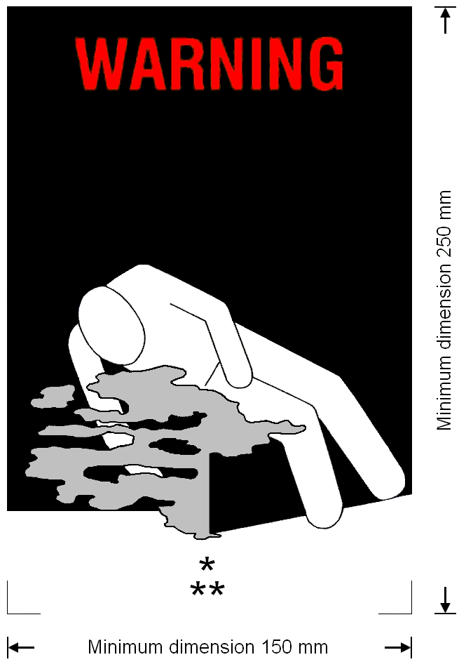
Coolant/conditioning warning mark for cargo transport units
* Insert proper shipping name of the coolant/conditioner. The lettering shall be in capitals, all be on one line and shall be at least 25 mm high. If the length of the proper shipping name is too long to fit in the space provided, the lettering may be reduced to the maximum size possible to fit. For example: CARBON DIOXIDE, SOLID
** Insert “AS COOLANT” or “AS CONDITIONER” as appropriate. The lettering shall be in capitals, all be on one line and be at least 25 mm high
The marking shall be a rectangle. The minimum dimensions shall be 150 mm wide x 250 mm high. The word “WARNING” shall be in red or white and be at least 25 mm high. Where dimensions are not specified, all features shall be in approximate proportion to those shown.
NOTE: The provisions of 5.5.3.6.2 from the seventeenth revised edition of the Recommendations on the Transport of Dangerous Goods, Model Regulations may continue to be applied until 31 December 2016.”.
5.5.3.7.1 Replace “that have been cooled or conditioned” with “containing or have contained substances used for cooling or conditioning purposes”.
Chapter 6.1
6.1.1.1 (d) After “Packagings” insert “for liquids, other than combination packagings,”.
6.1.3.1 (e) Insert an reference to note * at the centre of the symbol and add the following note under the symbol:
“* The last two digits of the year of manufacture may be displayed at that place. In such a case, the two digits of the year in the type approval marking and in the inner circle of the clock shall be identical.”.
6.1.3.1 (e) Insert a new Note at the end to read as follows:
“NOTE: Other methods that provide the minimum required information in a durable, visible and legible form are also acceptable.”.”
Chapter 6.2
6.2.1.1.5 Add the following new last sentence:
“The test pressure of a cylinder for an adsorbed gas shall be in accordance with packing instruction P208”.
6.2.2 Add the following new second sentence: “Manufacture of new pressure receptacles or service equipment according to any particular standard in 6.2.2.1 and 6.2.2.3 is not permitted after the date shown in the right hand column of the tables.”.
Renumber the existing NOTE as “NOTE 1”.
Add the following new note: “NOTE 2: UN pressure receptacles and service equipment constructed according to standards applicable at the date of manufacture may continue in use subject to the periodic inspection provisions of these Regulations.”.
6.2.2.1.1 In the table, add a new third column. Add a new first row with the following text:
Reference | Title | Applicable for manufacture
For ISO Standards “ISO 9809-1:1999”, “ISO 9809-2:2000”and “ISO 9809-3:2000”, in the third column, add “Until 31 December 2018”.
After ISO Standard “ISO 9809-1:1999” add the following new standard:
ISO 9809-1:2010 | Gas cylinders -- Refillable seamless steel gas cylinders -- Design, construction and testing -- Part 1: Quenched and tempered steel cylinders with tensile strength less than 1 100 MPa | Until further notice
After ISO Standard “ISO 9809-2:2000” add the following new standard:
ISO 9809-2:2010 | Gas cylinders – Refillable seamless steel gas cylinders – Design, construction and testing – Part 2: Quenched and tempered steel cylinders with tensile strength greater than or equal to 1 100 MPa | Until further notice
After ISO Standard “ISO 9809-3:2000” add the following new standard:
ISO 9809-3:2010 | Gas cylinders -- Refillable seamless steel gas cylinders -- Design, construction and testing -- Part 3: Normalized steel cylinders | Until further notice
For all the other standards, in the column “Applicable for manufacture”, add “Until further notice”.
6.2.2.1.2 In the table, add a new third column. Add a new first row with the following text:
Reference | Title | Applicable for manufacture
For ISO Standard “ISO 11120:1999”, in the column “Applicable for manufacture”, add “Until further notice”.
6.2.2.1.3 Amend the first table to read as follows:
Reference | Title | Applicable for manufacture
ISO 9809-1:1999 | Gas cylinders – Refillable seamless steel gas cylinders – Design, construction and testing – Part 1: Quenched and tempered steel cylinders with tensile strength less than 1 100 MPa  NOTE: The note concerning the F factor in section 7.3 of this standard shall not be applied for UN cylinders. | Until 31 December 2018
ISO 9809-1:2010 | Gas cylinders – Refillable seamless steel gas cylinders – Design, construction and testing – Part 1: Quenched and tempered steel cylinders with tensile strength less than 1 100 MPa | Until further notice
ISO 9809-3:2000 | Gas cylinders – Refillable seamless steel gas cylinders – Design, construction and testing – Part 3: Normalized steel cylinders | Until 31 December 2018
ISO 9809-3:2010 | Gas cylinders – Refillable seamless steel gas cylinders – Design, construction and testing – Part 3: Normalized steel cylinders | Until further notice
6.2.2.1.3 (second table), 6.2.2.1.4 and 6.2.2.1.5 In the tables, add a new third column. Add a new first row with the following text:
Reference | Title | Applicable for manufacture
For all the standards, in the column “Applicable for manufacture”, add “Until further notice”.
After 6.2.2.1.5 insert the following new paragraphs:
“6.2.2.1.6 The standard shown below applies for the design, construction and initial inspection and test of UN bundles of cylinders. Each cylinder in a UN bundle of cylinders shall be a UN cylinder complying with the requirements of 6.2.2. The inspection requirements related to the conformity assessment system and approval for UN bundles of cylinders shall be in accordance with 6.2.2.5.
Reference | Title | Applicable for manufacture
ISO 10961:2010 | Gas cylinders – Cylinder bundles – Design, manufacture, testing and inspection | Until further notice
NOTE: Changing one or more cylinders of the same design type, including the same test pressure, in an existing UN bundle of cylinders does not require re-certification of the existing bundle.”.
“6.2.2.1.7 The following standards apply for the design, construction and initial inspection and test of UN cylinders for adsorbed gases except that the inspection requirements related to the conformity assessment system and approval shall be in accordance with 6.2.2.5.
Reference | Title | Applicable for manufacture
ISO 11513:2011 | Gas cylinders – Refillable welded steel cylinders containing materials for sub-atmospheric gas packaging (excluding acetylene) – Design, construction, testing, use and periodic inspection | Until further notice
ISO 9809-1:2010 | Gas cylinders – Refillable seamless steel gas cylinders – Design, construction and testing – Part 1: Quenched and tempered steel cylinders with tensile strength less than 1 100 MPa | Until further notice
”.
6.2.2.2 Replace “ISO 11114-1:1997” with “ISO 11114-1:2012”. In the title for standard “ISO 11114-1:2012”, delete “Transportable”. Delete the note at the end.
6.2.2.3 Amend the first table to read as follows:
Reference | Title | Applicable for manufacture
ISO 11117:1998 | Gas cylinders – Valve protection caps and valve guards for industrial and medical gas cylinders – Design, construction and tests | Until 31 December 2014
ISO 11117:2008 + Cor 1:2009 | Gas cylinders − Valve protection caps and valve guards − Design, construction and tests | Until further notice
ISO 10297:1999 | Gas cylinders – Refillable gas cylinder valves – Specification and type testing | Until 31 December 2008
ISO 10297:2006 | Gas cylinders – Refillable gas cylinder valves – Specification and type testing | Until further notice
ISO 13340:2001 | Transportable gas cylinders – Cylinders valves for non-refillable cylinders – Specification and prototype testing | Until further notice
6.2.2.3 In the second table, add a new third column. Add a new first row with the following text:
Reference | Title | Applicable for manufacture
For ISO Standard “ISO 16111:2008”, in the column “Applicable for manufacture”, add “Until further notice”.
6.2.2.4 In the table, add a new third column. Add a new first row with the following text:
Reference | Title | Applicable
For all standards, in the column “Applicable”, add “Until further notice”.
6.2.2.4 In the table of standards for periodic inspection and test, after the entry for “ISO 10462:2005” add the following new entry:
ISO 11513:2011 | Gas cylinders – Refillable welded steel cylinders containing materials for sub-atmospheric gas packaging (excluding acetylene) – Design, construction, testing, use and periodic inspection | Until further notice
6.2.2.7 Amend the note to read as follows:
“NOTE: Marking requirements for UN metal hydride storage systems are given in 6.2.2.9 and marking requirements for UN bundles of cylinders are given in 6.2.2.10.”.
6.2.2.7.4 (p) Replace “ISO 11114-1:1997” with “ISO 11114-1:2012”.
6.2.2.7.9 Amend to read as follows: “6.2.2.7.9 (Deleted)”
6.2.2.9.2 (j) Replace “ISO 11114-1:1997” with “ISO 11114-1:2012”.
6.2.2.10 Add the following new section:
“6.2.2.10 Marking of bundles of cylinders
6.2.2.10.1 Individual cylinders in a bundle of cylinders shall be marked in accordance with 6.2.2.7.
6.2.2.10.2 Refillable UN bundles of cylinders shall be marked clearly and legibly with certification, operational, and manufacturing marks. These marks shall be permanently affixed (e.g. stamped, engraved, or etched) on a plate permanently attached to the frame of the bundle of cylinders. Except for the UN packaging symbol, the minimum size of the marks shall be 5 mm. The minimum size of the UN packaging symbol shall be 10 mm.
6.2.2.10.3 The following marks shall be applied:
(a) The certification marks specified in 6.2.2.7.2 (a), (b), (c), (d) and (e);
(b) The operational marks specified in 6.2.2.7.3 (f), (i), (j) and the total of the mass of the frame of the bundle and all permanently attached parts (cylinders, manifold, fittings and valves). Bundles intended for the carriage of UN 1001 acetylene, dissolved and UN 3374 acetylene, solvent free shall bear the tare mass as specified in clause B.4.2 of ISO 10961:2010; and
(c) The manufacturing marks specified in 6.2.2.7.4 (n), (o) and, where applicable, (p).
6.2.2.10.4 The marks shall be placed in three groups:
(a) The manufacturing marks shall be the top grouping and shall appear consecutively in the sequence given in 6.2.2.10.3 (c);
(b) The operational marks in 6.2.2.10.3 (b) shall be the middle grouping and the operational mark specified in 6.2.2.7.3 (f) shall be immediately preceded by the operational mark specified in 6.2.2.7.3 (i) when the latter is required;
(c) Certification marks shall be the bottom grouping and shall appear in the sequence given in 6.2.2.10.3 (a).”.
6.2.4 In the heading, delete the word “flammable”. Insert the following text after the heading:
“Each filled aerosol dispenser or gas cartridge or fuel cell cartridge shall be subjected to a test in a hot water bath in accordance with 6.2.4.1 or an approved water bath alternative in accordance with 6.2.4.2.”.
Delete 6.2.4.1, 6.2.4.1.1 and 6.2.4.1.2, heading 6.2.4.2 and the text under this heading.
Renumber heading 6.2.4.2.1 as 6.2.4.1.
6.2.4.2.1.1 Renumber as 6.2.4.1.1. In the first sentence, after “capacity of the aerosol dispenser” insert “, gas cartridge or fuel cell cartridge”. In the second sentence, after “to heat or if aerosol dispensers” insert “gas cartridges or fuel cell cartridges” and after “one aerosol dispenser,” insert “gas cartridge or fuel cell cartridge”.
6.2.4.2.1.2 Renumber as 6.2.4.1.2. After the first “aerosol dispenser” insert “, receptacle or fuel cell cartridge”. After the second “aerosol dispenser” insert “, gas cartridge or fuel cell cartridge”
Renumber heading 6.2.4.2.2 as 6.2.4.2 and, in the text under this heading, replace “of 6.2.4.2.2.1, 6.2.4.2.2.2 and 6.2.4.2.2.3” by “of 6.2.4.2.1 and, as appropriate, 6.2.4.2.2 or 6.2.4.2.3”.
6.2.4.2.2.1 Renumber as 6.2.4.2.1. In the first sentence, after “Aerosol dispenser” insert “, gas cartridge or fuel cell cartridge”. In the second sentence, after “that all aerosol dispensers” insert “, gas cartridges or fuel cell cartridges” In indent (f) insert the following text at the end “, gas cartridges or fuel cell cartridges”.
Before 6.2.4.2.2.2 insert the following text “6.2.4.2.2 Aerosol dispensers”.
6.2.4.2.2.2 Renumber as 6.2.4.2.2.1. Replace “Every” with “Each” at the beginning of the first sentence.
6.2.4.2.2.3 Renumber as 6.2.4.2.2.2.
Add a new 6.2.4.2.3 to read as follows:
“6.2.4.2.3 Gas cartridges and fuel cell cartridges
6.2.4.2.3.1 Pressure testing of gas cartridges and fuel cell cartridges
Each gas cartridge or fuel cell cartridge shall be subjected to a test pressure equal to or in excess of the maximum expected in the filled receptacle at 55°C (50°C if the liquid phase does not exceed 95% of the capacity of the receptacle at 50°C). This test pressure shall be that specified for the gas cartridge or fuel cell cartridge and shall not be less than two thirds the design pressure of the gas cartridge or fuel cell cartridge. If any gas cartridge or fuel cell cartridge shows evidence of leakage at a rate equal to or greater than 3.3 x 10⁻² mbar.l.s⁻¹ at the test pressure or distortion or any other defect, it shall be rejected.
6.2.4.2.3.2 Leak testing gas cartridges and fuel cell cartridges
Prior to filling and sealing, the filler shall ensure that the closures (if any), and the associated sealing equipment are closed appropriately and the specified gas is used.
Each filled gas cartridge or fuel cell cartridge shall be checked for the correct mass of gas and shall be leak tested. The leak detection equipment shall be sufficiently sensitive to detect at least a leak rate of 2.0 x 10⁻³ mbar.l.s⁻¹ at 20°C.
Any gas cartridge or fuel cell cartridge that has gas masses not in conformity with the declared mass limits or shows evidence of leakage or deformation, shall be rejected.”.
Chapter 6.4
In the title, replace “CLASS 7” with “RADIOACTIVE MATERIAL”.
The second amendment to Chapter 6.4 only applies to the French text.
6.4.2.11 Insert a new paragraph 6.4.2.11 to read as follows:
“6.4.2.11 A package shall be so designed that it provides sufficient shielding to ensure that, under routine conditions of transport and with the maximum radioactive contents that the package is designed to contain, the radiation level at any point on the external surface of the package would not exceed the values specified in 2.7.2.4.1.2, 4.1.9.1.10 and 4.1.9.1.11, as applicable, with account taken of 7.1.8.3.3 (b) and 7.2.3.1.2.”.
Current paragraphs 6.4.2.11 and 6.4.2.12 become 6.4.2.12 and 6.4.2.13 respectively.
6.4.3.3 Replace “leakage” with “loss or dispersal of radioactive contents from the containment system,”.
6.4.6.1 Amend the first sentence to read as follows:
“Packages designed to contain uranium hexafluoride shall meet the requirements which pertain to the radioactive and fissile properties of the material prescribed elsewhere in these Regulations.”.
6.4.6.2 In (a) and (c), insert at the end: “except as allowed in 6.4.6.4”.
6.4.6.4 In the introductory sentence replace “the approval of the competent authority” with “multilateral approval” and insert “the packages are designed:” at the end, after “if”.
6.4.6.4 In (a) and (b) delete “The packages are designed” and replace “and” with “and/or” at the end.
6.4.6.4 In (c), delete “For packaged designed” and replace “hexafluoride, the packages” with “hexafluoride and the packages”.
6.4.8.1 Amend to read as follows:
“6.4.8.1 Type B(U) packages shall be designed to meet the requirements specified in 6.4.2, the requirements specified in 6.4.3 if carried by air, and of 6.4.7.2 to 6.4.7.15, except as specified in 6.4.7.14 (a), and, in addition, the requirements specified in 6.4.8.2 to 6.4.8.15.
6.4.8.2 Amend the end of the introductory paragraph to read: “…which may cause one or more of the following:”.
In (a) and (b), delete “or” at the end.
6.4.8.8 In (b), replace “and the tests in” with “and either the test in.”.
6.4.9.1 In the first sentence, replace “6.4.8.5, 6.4.8.6,” with “6.4.8.4 to 6.4.8.6”.
In the second sentence, insert “6.4.8.4 and” after “packages specified in”.
6.4.10.3 Amend to read as follows:
“6.4.10.3 A package shall be so designed that, if it were at the maximum normal operating pressure and subjected to:
(a) The tests specified in 6.4.15, it would restrict the loss of radioactive contents to not more than 10⁻⁶ A₂ per hour; and
(b) The test sequences in 6.4.20.1,
(i) it would retain sufficient shielding to ensure that the radiation level at 1 m from the surface of the package would not exceed 10 mSv/h with the maximum radioactive contents which the package is designed to contain; and
(ii) it would restrict the accumulated loss of radioactive contents in a period of 1 week to not more than 10 A₂ for krypton-85 and not more than A₂ for all other radionuclides.”
Text of last paragraph remains unchanged.
6.4.11.1 In (a), insert “routine,” before “normal”.
6.4.11.1 Amend (b)(i) to read as follows: “of 6.4.7.2 except for unpackaged material when specifically allowed by 2.7.2.3.5 (e);”.
6.4.11.1 In (b)(ii) delete “and” at the end.
6.4.11.1 Amend (b)(iii) to read as follows: “of 6.4.7.3 unless the material is excepted by 2.7.2.3.5;”.
6.4.11.1 Insert a new (b) (iv) to read as follows:
“(iv) of 6.4.11.4 to 6.4.11.14, unless the material is excepted by 2.7.2.3.5, 6.4.11.2 or 6.4.11.3.”.
6.4.11.2 Amend to read as follows:
“6.4.11.2 Packages containing fissile material that meet the provisions of subparagraph (d) and one of the provisions of (a) to (c) below are excepted from the requirements of 6.4.11.4 to 6.4.11.14.
(a) Packages containing fissile material in any form provided that:
(i) The smallest external dimension of the package is not less than 10 cm;
(ii) The criticality safety index of the package is calculated using the following formula:
* Plutonium may be of any isotopic composition provided that the amount of Pu-241 is less than that of Pu-240 in the package
where the values of Z are taken from Table 6.4.11.2.
(iii) The CSI of any package does not exceed 10;
(b) Packages containing fissile material in any form provided that:
(i) The smallest external dimension of the package is not less than 30 cm;
(ii) The package, after being subjected to the tests specified in 6.4.15.1 to 6.4.15.6;
- Retains its fissile material contents;
- Preserves the minimum overall outside dimensions of the package to at least 30 cm;
- Prevents the entry of a 10 cm cube.
(iii) The criticality safety index of the package is calculated using the following formula:
* Plutonium may be of any isotopic composition provided that the amount of Pu-241 is less than that of Pu-240 in the package
where the values of Z are taken from Table 6.4.11.2.
(iv) The criticality safety index of any package does not exceed 10;
(c) Packages containing fissile material in any form provided that:
(i) The smallest external dimension of the package is not less than 10 cm;
(ii) The package, after being subjected to the tests specified in 6.4.15.1 to 6.4.15.6;
― Retains its fissile material contents;
― Preserves the minimum overall outside dimensions of the package to at least 10 cm;
― Prevents the entry of a 10 cm cube.
(iii) The CSI of the package is calculated using the following formula:
* Plutonium may be of any isotopic composition provided that the amount of Pu-241 is less than that of Pu-240 in the package
(iv) The maximum mass of fissile nuclides in any package does not exceed 15 g;
(d) The total mass of beryllium, hydrogenous material enriched in deuterium, graphite and other allotropic forms of carbon in an individual package shall not be greater than the mass of fissile nuclides in the package except where their total concentration does not exceed 1 g in any 1 000 g of material. Beryllium incorporated in copper alloys up to 4% in weight of the alloy does not need to be considered.”.
Table 6.4.11.2 Insert a new table 6.4.11.2 to read as follows:
“Table 6.4.11.2 Values of Z for calculation of criticality safety index in accordance with 6.4.11.2
Enrichementª | Z
Uranium enriched up to 1.5% | 2200
Uranium enriched up to 5 % | 850
Uranium enriched up to 10 % | 660
Uranium enriched up to 20 % | 580
Uranium enriched up to 100 % | 450
ª If a package contains uranium with varying enrichments of
U-235, then the value corresponding to the highest enrichment shall be used for Z.
6.4.11.3 Insert a new paragraph 6.4.11.3 to read as follows:
“6.4.11.3. Packages containing not more than 1 000 g of plutonium are excepted from the application of 6.4.11.4 to 6.4.11.14 provided that:
(a) Not more than 20% of the plutonium by mass is fissile nuclides;
(b) The criticality safety index of the package is calculated using the following formula:
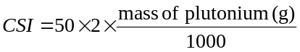
(c) If uranium is present with the plutonium, the mass of uranium shall be no more than 1% of the mass of the plutonium.”.
Current paragraphs 6.4.11.3 to 6.4.11.13 become new paragraphs 6.4.11.4 to 6.4.11.14.
6.4.11.4 (former 6.4.11.3) Replace “6.4.11.7 to 6.4.11.12” with “6.4.11.8 to 6.4.11.13”.
6.4.11.5 (former 6.4.11.4) Replace “6.4.11.7 to 6.4.11.12” with “6.4.11.8 to 6.4.11.13” and insert “either” at the end of the introductory sentence.
6.4.11.8 (former 6.4.11.7) In the last sentence of the introductory paragraph, insert “either of” before “the following:”.
In (a) and (b) (i), replace “6.4.11.12 (b)” with “6.4.11.13 (b)”.
6.4.11.9 (former 6.4.11.8) In the first sentence, replace “shall be closely” with “is closely”; in the last sentence replace “6.4.11.12 (b)” with “6.4.11.13 (b)” and “6.4.11.9 (c)” with “6.4.11.10 (c)”.
6.4.11.10 (former 6.4.11.9) In the introductory sentence replace “6.4.11.7 and 6.4.11.8” with “6.4.11.8 and 6.4.11.9”.
6.4.11.10 (former 6.4.11.9) In (b), replace “6.4.11.11 (b)” with “6.4.11.12 (b)”. In (c), replace “6.4.11.12 (b)” with “6.4.11.13 (b)”.
6.4.11.11 (former 6.4.11.10) In (b), replace “6.4.11.9” with “6.4.11.10” and “6.4.11.7” with “6.4.11.8”.
6.4.11.13 (former 6.4.11.12) In (c), replace “6.4.11.12 (b)” with “6.4.11.13 (b)”.
6.4.11.14 (former 6.4.11.13) Replace “6.4.11.11 and 6.4.11.12” with “6.4.11.12 and 6.4.11.13”.
6.4.13 In (c) replace “6.4.11.13” with “6.4.11.14”.
6.4.15.5 In (a), amend the beginning to read: “The equivalent of 5 times…”.
6.4.17.2 In the introductory paragraph, replace “6.4.11.12” with “6.4.11.13”.
6.4.17.2 In (b), move the phrase “so as to suffer maximum damage” to the end of the sentence after “on the target”.
6.4.17.2 In (c), Insert the following new third sentence: “The lower face of the steel plate shall have its edges and corners rounded off to a radius of not more than 6 mm.”.
6.4.19.1 Replace “6.4.11.7 to 6.4.11.12” with “6.4.11.8 to 6.4.11.13”.
6.4.19.2 Replace “6.4.11.12” with “6.4.11.13”.
6.4.20.2 In the first sentence, insert “vertical” before “solid”. In the second sentence replace “the probe to the surface of the specimen shall be as to cause” with “the package specimen and the impact point on the package surface shall be such as to cause”.
6.4.22.4 Amend to read as follows:
“6.4.22.4 Each package design for fissile material which is not excepted by any of the paragraphs 2.7.2.3.5 (a) to (f), 6.4.11.2 and 6.4.11.3 shall require multilateral approval.”.
Insert a new paragraph to read as follows:
“6.4.22.6 The design for a fissile material excepted from “FISSILE” classification in accordance with 2.7.2.3.5 (f) shall require multilateral approval.
6.4.22.7 Insert a new paragraph to read as follows:
“6.4.22.7 Alternative activity limits for an exempt consignment of instruments or articles in accordance with 2.7.2.2.2(b) shall require multilateral approval.”
6.4.23.2 In the introductory sentence replace “shipment approval” with “approval of shipment”.
In (c), amend the end of the paragraph to read as follows: “… referred to in the certificate of approval for the package design, if applicable, issued under 5.1.5.2.1 (a) (iii), (vi) or (vii), are to be put into effect.”.
6.4.23.4 In (f), insert “nuclear” after “irradiated” and replace “6.4.11.4 (b)” with “6.4.11.5 (b)”. In (i), replace “quality assurance programme” with “management system” and “1.1.2.3.1” with “1.5.3.1”.
6.4.23.5 In the introductory sentence, delete “for package approval”.
6.4.23.5 In (a), replace “6.4.8.5, 6.4.8.6” with “6.4.8.4 to 6.4.8.6”.
6.4.23.5 In (d), amend the beginning of the sentence to read: “A statement of the range”.
6.4.23.6 Replace “quality assurance programme” with “management system” and “1.1.2.3.1” with “1.5.3.1”.
6.4.23.7 Replace “quality assurance programme” with “management system” and “1.1.2.3.1” with “1.5.3.1”.
6.4.23.8 In (d) replace “quality assurance programme” with “management system” and “1.1.2.3.1” with “1.5.3.1”.
6.4.23.9 Insert a new paragraph to read as follows:
“6.4.23.9 An application for approval of design for fissile material excepted from “FISSILE” classification in accordance with Table 2.7.2.1.1, under 2.7.2.3.5 (f) shall include:
(a) A detailed description of the material; particular reference shall be made to both physical and chemical states;
(b) A statement of the tests that have been carried out and their results, or evidence based on calculation methods to show that the material is capable of meeting the requirements specified in 2.7.2.3.6;
(c) A specification of the applicable management system as required in 1.5.3.1;
(d) A statement of specific actions to be taken prior to shipment.”.
6.4.23.10 Insert a new paragraph to read as follows:
“6.4.23.10 An application for approval of alternative activity limits for an exempt consignment of instruments or articles shall include:
(a) An identification and detailed description of the instrument or article, its intended uses and the radionuclide(s) incorporated;
(b) The maximum activity of the radionuclide(s) in the instrument or article;
(c) Maximum external radiation levels arising from the instrument or article;
(d) The chemical and physical forms of the radionuclide(s) contained in the instrument or article;
(e) Details of the construction and design of the instrument or article, particularly as related to the containment and shielding of the radionuclide in routine, normal and accident conditions of transport;
(f) The applicable management system, including the quality testing and verification procedures to be applied to radioactive sources, components and finished products to ensure that the maximum specified activity of radioactive material or the maximum radiation levels specified for the instrument or article are not exceeded, and that the instruments or articles are constructed according to the design specifications;
(g) The maximum number of instruments or articles expected to be shipped per consignment and annually;
(h) Dose assessments in accordance with the principles and methodologies set out in the International Basic Safety Standards for Protection against Ionizing Radiation and for the Safety of Radiation Sources, Safety Series No.115, IAEA, Vienna (1996), including individual doses to transport workers and members of the public and, if appropriate, collective doses arising from routine, normal and accident conditions of transport, based on representative transport scenarios the consignments are subject to.”.
Current paragraphs 6.4.23.9 to 6.4.23.11 become new paragraphs 6.4.23.11 to 6.4.23.13.
6.4.23.11 (former 6.4.23.9) In the introductory sentence, replace “approval certificate” with “certificate of approval”.
6.4.23.11 (former 6.4.23.9) (a) Replace “6.4.23.10 (b)” with “6.4.23.12 (b).
6.4.23.11 (former 6.4.23.9) (b) Insert “or alternative activity limit for exempt consignment” at the end of the first sentence. Amend the second sentence to read: “The identification mark of the approval of shipment shall be clearly related to the identification mark of the approval of design.”.
6.4.23.11 (former 6.4.23.9) (c) In the introductory sentence, replace “types of approval certificates” with “types of certificate of approval”. Insert the following line between those corresponding to LD and T: “FE Fissile material complying with the requirements of 2.7.2.3.6”. Add the following line at the end of the list: “AL Alternative activity limits for an exempt consignment of instruments or articles”.
6.4.23.11 (former 6.4.23.9) (d) Insert “certificates of approval of” before “package design”, delete (twice) “approval certificates” after “radioactive material”, and replace “6.24.2 to 6.24.4” with “6.4.24.2 to 6.4.24.5”.
6.4.23.12 (former 6.4.23.10) In the introductory sentence replace “type codes” with “identification marks”.
6.4.23.12 (former 6.4.23.10) (a) Replace “6.4.23.9 (a), (b), (c) and (d)” with “6.4.23.11 (a), (b), (c) and (d)”; “design approval” with “approval of design”, and “shipment approval” with “the approval of shipment”.
6.4.23.12 (former 6.4.23.10) (a) For A/132/B(M)F-96, replace “package design approval certificate” with “certificate of approval for the package design”.
6.4.23.12 (former 6.4.23.10) (a) For A/132/B(M)F-96T, replace “shipment approval” with “approval of shipment”.
6.4.23.12 (former 6.4.23.10) (a) For A/137/X, replace “A special arrangement approval” with “An approval of special arrangement”;
6.4.23.12 (former 6.4.23.10) (a) For A/139/IF-96 and A/145/H(U)-96, replace “package design approval certificate” with “certificate of approval for the package design”.
6.4.23.12 (former 6.4.23.10) (b) Replace “according to 6.4.23.16” with “in accordance with 6.4.23.20”.
6.4.23.12 (former 6.4.23.10) (c) Replace (twice) “package design approval certificate” with “certificate of approval for the package design”; and “approval certificate” with “certificate of approval” in the last sentence.
6.4.23.13 (former 6.4.23.11) In the introductory sentence replace “approval certificate” with “certificate of approval” and in (i) replace “quality assurance programme” with “management system” and “1.1.2.3.1” with “1.5.3.1”.
6.4.23.14 Insert a new paragraph to read as follows:
“6.4.23.14 Each certificate of approval issued by a competent authority for material excepted from classification as “FISSILE” shall include the following information:
(a) Type of certificate;
(b) The competent authority identification mark;
(c) The issue date and an expiry date;
(d) List of applicable national and international regulations, including the edition of the IAEA Regulations for the Safe Transport of Radioactive Material under which the exception is approved;
(e) A description of the excepted material;
(f) Limiting specifications for the excepted material;
(g) A specification of the applicable management system as required in 1.5.3.1;
(h) Reference to information provided by the applicant relating to specific actions to be taken prior to shipment;
(i) If deemed appropriate by the competent authority, reference to the identity of the applicant;
(j) Signature and identification of the certifying official;
(k) Reference to documentation that demonstrates compliance with 2.7.2.3.6.”.
Current paragraphs 6.4.23.12 to 6.4.23.14 become new paragraphs 6.4.23.15 to 6.4.23.17.
6.4.23.15 (former 6.4.23.12) In the introductory sentence replace “approval certificate” with “certificate of approval”.
6.4.23.15 (former 6.4.23.12) (j) Replace “amounts” with “mass” and amend the end of the paragraph to read as follows: “…special form radioactive material, low dispersible radioactive material or fissile material excepted under 2.7.2.3.5 (f) if applicable;”.
6.4.23.15 (former 6.4.23.12) (k)(v) Replace “6.4.11.4 (b)” with “6.4.11.5(b)”.
6.4.23.15 (former 6.4.23.12) (r) Replace “quality assurance programme” with “management system” and “1.1.2.3.1” with “1.5.3.1”.
6.4.23.16 (former 6.4.23.13) (i) In the introductory sentence, replace “approval certificate” with “certificate of approval”.
6.4.23.16 (former 6.4.23.13) (i) Replace “design approval certificate(s)” with “certificate(s) of approval of design”.
6.4.23.16 (former 6.4.23.13) Replace “amounts” with “mass” and amend the end of the paragraph to read as follows: “…special form radioactive material, low dispersible radioactive material or fissile material excepted under 2.7.2.3.5 (f) if applicable;”.
6.4.23.16 (former 6.4.23.13) (l) Replace “quality assurance programme” with “management system” and “1.1.2.3.1” with “1.5.3.1”.
6.4.23.17 (former 6.4.23.14) In the introductory sentence, replace “approval certificate” with “certificate of approval”.
6.4.23.17 (former 6.4.23.14) (h) Replace “shipment approval” with “approval of shipment”.
6.4.23.17 (former 6.4.23.14) (l) Amend the end of the second sentence to read as follows: “…mass in grams (for fissile material the total mass of fissile nuclides or the mass for each fissile nuclide, when appropriate) and whether special form radioactive material, low dispersible radioactive material or fissile material excepted under 2.7.2.3.5 (f), if applicable;”.
6.4.23.17 (former 6.4.23.14) (n) Amend the introductory sentence to read as follows: “For package designs containing fissile material which require multilateral approval of the package design in accordance with 6.4.22.4:”.
6.4.23.17 (former 6.4.23.14) (n)(vi) Replace “6.4.11.4 (b)” with “6.4.11.5 (b)”.
6.4.23.17 (former 6.4.23.14) (t) Replace “quality assurance programme” with “management system” and “1.1.2.3.1” with “1.5.3.1”.
6.4.23.18 Insert a new paragraph 6.4.23.18 to read as follows:
“6.4.23.18 Each certificate issued by a competent authority for alternative activity limits for an exempt consignment of instruments or articles according to 5.1.5.2.1 (d) shall include the following information:
(a) Type of certificate;
(b) The competent authority identification mark;
(c) The issue date and an expiry date;
(d) List of applicable national and international regulations, including the edition of the IAEA Regulations for the Safe Transport of Radioactive Material under which the exemption is approved;
(e) The identification of the instrument or article;
(f) A description of the instrument or article;
(g) Design specifications for the instrument or article;
(h) A specification of the radionuclide(s), the approved alternative activity limit(s) for the exempt consignment(s) of the instrument(s) or article(s);
(i) Reference to documentation that demonstrates compliance with 2.7.2.2.2 (b);
(j) If deemed appropriate by the competent authority, reference to the identity of the applicant;
(k) Signature and identification of the certifying official.”.
Current paragraphs 6.4.23.15 and 6.4.23.16 become 6.4.23.19 and 6.4.23.20 respectively.
6.4.24.1 Amend to read as follows:
“Packages not requiring competent authority approval of design (excepted packages, Type IP-1, Type IP-2, Type IP-3 and Type A packages) shall meet these Regulations in full, except that packages that meet the requirements of the 1985 or 1985 (as amended 1990) Editions of IAEA Regulations for the Safe Transport of Radioactive Material (IAEA Safety Series No.6):
(a) May continue in transport provided that they were prepared for transport prior to 31 December 2003, and subject to the requirements of 6.4.24.4, if applicable;
(b) May continue to be used provided that:
(i) They were not designed to contain uranium hexafluoride;
(ii) The applicable requirements of 1.5.3.1 of these Regulations are applied;
(iii) The activity limits and classification in Chapter 2.7 of these Regulations are applied;
(iv) The requirements and controls for transport in Parts 1, 3, 4, 5 and 7 of these Regulations are applied;
(v) The packaging was not manufactured or modified after 31 December 2003.”
6.4.24.2 Amend to read as follows:
“6.4.24.2 Packages requiring competent authority approval of the design shall meet these Regulations in full unless the following conditions are met:
(a) The packagings were manufactured to a package design approved by the competent authority under the provisions of the 1973 or 1973 (as amended) or the 1985 or 1985 (as amended 1990) Editions of IAEA Safety Series No.6);
(b) The package design is subject to multilateral approval;
(c) The applicable requirements of 1.5.3.1 of these Regulations are applied;
(d) The activity limits and classification in Chapter 2.7 of these Regulations are applied;
(e) The requirements and controls for transport in in Parts 1, 3, 4, 5 and 7 of these Regulations are applied;
(f) For a package containing fissile material and transported by air, the requirement of 6.4.11.11 is met;
(g) For packages that meet the requirements of the 1973 or 1973 (as amended) Editions of IAEA Safety Series No. 6:
(i) The packages retain sufficient shielding to ensure that the radiation level at 1 m from the surface of the package would not exceed 10 mSv/h in the accident conditions of transport defined in the 1973 Revised or 1973 Revised (as amended) Editions of IAEA Safety Series No.6 with the maximum radioactive contents which the package is authorized to contain;
(ii) The packages do not utilize continuous venting;
(iii) A serial number in accordance with the provision of 5.2.1.5.5 is assigned to and marked on the outside of each packaging.”
6.4.24.3 Amend to read as follows:
“No new manufacture of packagings to a package design meeting the provisions of the 1973, 1973 (as amended), 1985, and 1985 (as amended 1990) Editions of IAEA Safety Series No.6 shall be permitted to commence.”.
6.4.24.4 Insert a new paragraph to read as follows:
“Packages excepted from the requirements for fissile materials under the Regulations annexed to the 16th revised edition or the seventeenth revised edition of the United Nations Recommendations on the Transport of Dangerous Goods (2009 Edition of IAEA Safety Standard Series No.TS-R-1)
6.4.24.4 Packages containing fissile material that is excepted from classification as “FISSILE” according to 2.7.2.3.5 (a)(i) or (iii) of the Regulations annexed to the 16th revised edition or the seventeenth revised edition of the United Nations Recommendations on the Transport of Dangerous Goods (paras. 417 (a) (i) or (iii) of the 2009 Edition of IAEA Regulations for the Safe Transport of Radioactive Material) prepared for transport before 31 December 2014 may continue in transport and may continue to be classified as non-fissile or fissile-excepted except that the consignment limits in Table 2.7.2.3.5 of these editions shall apply to the conveyance. The consignment shall be transported under exclusive use.”.
Current paragraph 6.4.24.4 becomes new 6.4.24.5.
6.4.24.5 (former 6.4.24.4) In the first sentence, replace “programme of quality assurance” with “management system” and “1.1.2.3.1” with “1.5.3.1”. Replace the last sentence with the following: “No new manufacture of such special form radioactive material shall be permitted to commence.”.
Chapter 6.5
Amend 6.5.2.2.2 to read as follows:
“6.5.2.2.2 The maximum permitted stacking load applicable when the IBC is in use shall be displayed on a symbol as shown in Figure 6.5.1 or Figure 6.5.2. The symbol shall be durable and clearly visible.

Figure 6.5.1 Figure 6.5.2
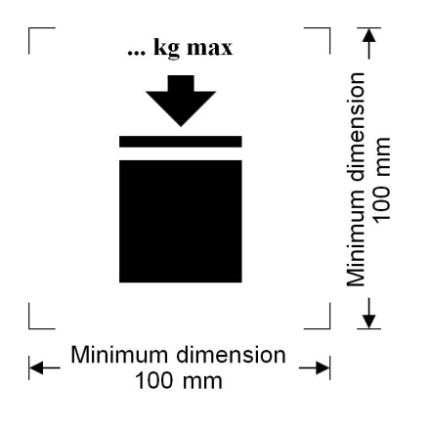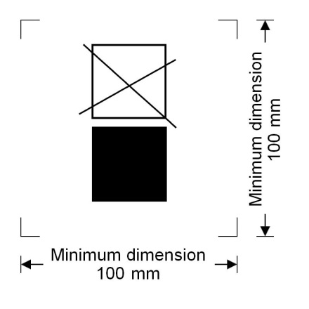
IBCs capable of being stacked IBCs NOT capable of being stacked
The minimum dimensions shall be 100 mm x 100 mm. The letters and numbers indicating the mass shall be at least 12 mm high. The area within the printer’s marks indicated by the dimensional arrows shall be square. Where dimensions are not specified, all features shall be in approximate proportion to those shown. The mass marked above the symbol shall not exceed the load imposed during the design type test (see 6.5.6.6.4) divided by 1.8.
NOTE: The provisions of 6.5.2.2.2 shall apply to all IBCs manufactured, repaired or remanufactured as from 1 January 2011. The provisions of 6.5.2.2.2 of the seventeenth revised edition of the Recommendations on the Transport of Dangerous Goods, Model Regulations may continue to be applied to all IBCs manufactured, repaired or remanufactured between 1 January 2011 and 31 December 2016.”.
6.5.2.2.4 After “The date of the manufacture of the plastics inner receptacle may alternatively be marked on the inner receptacle adjacent to the remainder of the marking.” add the following new sentence: “In such a case, the two digits of the year in the primary marking and in the inner circle of the clock shall be identical.”. At the end, add a new Note to read as follows:
“NOTE: Other methods that provide the minimum required information in a durable, visible and legible form are also acceptable.”.
Chapter 6.6
6.6.2.2 At the beginning, replace “The letter “W”” with “The letters “T” or “W”” and insert a new second sentence to read as follows: “The letter “T” signifies a large salvage packaging conforming to the requirements of 6.6.5.1.9.”.
6.6.3.2 Insert a new second example to read as follows:
“ |  | 50AT/Y/05/01/B/PQRS  2500/1000 | For a large steel salvage packaging suitable for stacking; stacking load: 2 500 kg; maximum gross mass: 1 000 kg.”.

Amend 6.6.3.3 to read as follows:
“6.6.3.3 The maximum permitted stacking load applicable when the large packaging is in use shall be displayed on a symbol as shown in Figure 6.6.1 or Figure 6.6.2. The symbol shall be durable and clearly visible.
Figure 6.6.1 Figure 6.6.2
Large packagings capable of being stacked Large packagings NOT capable of being stacked
The minimum dimensions shall be 100 mm x 100 mm. The letters and numbers indicating the mass shall be at least 12 mm high. The area within the printer’s marks indicated by the dimensional arrows shall be square. Where dimensions are not specified, all features shall be in approximate proportion to those shown. The mass marked above the symbol shall not exceed the load imposed during the design type test (see 6.6.5.3.3.4) divided by 1.8.
“NOTE: The provisions of 6.6.3.3 shall apply to all large packagings manufactured, repaired or remanufactured as from 1 January 2015. The provisions of 6.6.3.3 from the seventeenth revised edition of the Recommendations on the Transport of Dangerous Goods, Model Regulations may continue to be applied to all IBCs manufactured, repaired or remanufactured between 1 January 2015 and 31 December 2016.”.
6.6.5.1.9 Insert the following new paragraph to read as follows:
“6.6.5.1.9 Large salvage packagings
Large salvage packagings shall be tested and marked in accordance with the provisions applicable to packing group II large packagings intended for the transport of solids or inner packagings, except as follows:
(a) The test substance used in performing the tests shall be water, and the large salvage packagings shall be filled to not less than 98% of their maximum capacity. It is permissible to use additives, such as bags of lead shot, to achieve the requisite total package mass so long as they are placed so that the test results are not affected. Alternatively, in performing the drop test, the drop height may be varied in accordance with 6.6.5.3.4.4.2 (b);
(b) Large salvage packagings shall, in addition, have been successfully subjected to the leakproofness test at 30 kPa, with the results of this test reflected in the test report required by 6.6.5.4; and
(c) Large salvage packagings shall be marked with the letter “T” as described in 6.6.2.2.”.
Chapter 6.7
6.7.2.20.2, 6.7.3.16.2 and 6.7.5.13.2 Replace “shall be marked” with “shall be durably marked”.
6.7.5.2.4 (a) Replace “ISO 11114-1:1997” with “ISO 11114-1:2012”.
Chapter 6.8
6.8.4.6 After “BKx”, add a reference to footnote 1. The footnote reads as follows: “x should be replaced with “1” or “2” as appropriate.”.
Chapter 7.1
7.1.8.1.1 In (b) delete “the critical group of”.
Table 7.1.8.2 At the end of the current heading of column 2 insert: “other than inland waterway craft”.
7.1.8.3.2 Replace “approval certificate” with “certificate of approval”.
Table 7.1.8.3.3 Amend the two first rows under the heading to read as follows:
Freight container
 | Small freight container | 50
 | Large freight container | 50

In note “a” to the table, replace “7.2.3.1.3” with “7.2.3.1.2”.
7.1.8.4 Amend to read as follows: “Additional requirements relating to transport and storage in transit of fissile material”.
Table 7.1.8.4.2 Amend the two first rows under the heading to read as follows:
Freight container
 | Small freight container | 50 | n.a
 | Large freight container | 50 | 100

Amend the end of note “b” to the table to read as follows: “… and stowed so as to maintain a spacing of at least 6 m from other groups.”.
Amend the end of the first sentence of note “c” to the table to read as follows: “… and stowed so as to maintain a spacing of at least 6 m from other groups.”.
7.1.8.4.3 Insert a new paragraph to read as follows:
“7.1.8.4.3 Fissile material meeting one of the provisions (a) to (f) of 2.7.2.3.5 shall meet the following requirements:
(a) Only one of the provisions (a) to (f) of 2.7.2.3.5 is allowed per consignment;
(b) Only one approved fissile material in packages classified in accordance with 2.7.2.3.5 (f) is allowed per consignment unless multiple materials are authorized in the certificate of approval;
(c) Fissile material in packages classified in accordance with 2.7.2.3.5 (c) shall be transported in a consignment with no more than 45 g of fissile nuclides;
(d) Fissile material in packages classified in accordance with 2.7.2.3.5 (d) shall be transported in a consignment with no more than 15 g of fissile nuclides;
(e) Unpackaged or packaged fissile material classified in accordance with 2.7.2.3.5 (e) shall be transported under exclusive use on a conveyance with no more than 45 g of fissile nuclides.”.
7.1.8.5.4 Amend the end of the paragraph to read as follows:
“… and shall not be re-used unless the following conditions are fulfilled:
(a) the non-fixed contamination shall not exceed the limits specified in 4.1.9.1.2;
(b) the radiation level resulting from the fixed contamination shall not exceed 5 μSv/h at the surface.”.

