UN/SCETDG/41/INF.7
Committee of Experts on the Transport of Dangerous Goods
and on the Globally Harmonized System of Classification
and Labelling of Chemicals
Sub-Committee of Experts on the Transport of Dangerous Goods 17 April 2012
Forty-first session
Geneva, 25 June – 4 July 2012
Item 3 (b) of the provisional agenda
Listing, classification and packing: miscellaneous
Assignment of fire extinguishers to UN No. 1044
Transmitted by the expert from Germany
Supporting document relating to ST/SG/AC.10/C.3/2012/44

OTIF |  | ORGANISATION INTERGOUVERNEMENTALE POUR LES TRANSPORTS INTERNATIONAUX FERROVIAIRES  ZWISCHENSTAATLICHE ORGANISATION FÜR DEN  INTERNATIONALEN EISENBAHNVERKEHR  INTERGOVERNMENTAL ORGANISATION FOR INTERNATIONAL CARRIAGE BY RAIL

RID/ADR/ADN

Joint Meeting of the RID Committee of Experts and the
Working Party on the Transport of Dangerous Goods
(Berne, 19 – 23 March 2012)

Item 4 of the agenda: Interpretation of RID/ADR/ADN

Assignment of fire extinguishers to UN No. 1044

Transmitted by the Government of Germany

SUMMARY

Executive Summary: Clarification of issues relating to which types of fire extinguishers are covered by UN No. 1044 and further specification of special provision 594.

Action to be taken: Deliberate the way forward.

Related documents: Directive 2010/35/EU on transportable pressure equipment

Introduction

1. Directive 2010/35/EU on transportable pressure equipment (PED – OJ EU No. L 165 of 30 June 2010, p. 1) has to be applied by the Member States of the European Union since 1 July 2011.

2. The above mentioned Directive excludes fire extinguishers from its scope (see Article 2 (1)) and assigns them to Directive 97/23/EC on (stationary) pressure equipment. The latter Directive, in turn, excludes all pressure equipment covered by the provisions of RID/ADR (see Article 1 No. 3.19). Fire extinguishers assigned to UN No. 1044, however, are not covered by the provisions of RID/ADR relating to carriage only when the requirements stipulated in special provision (SP) 594 are met.

3. SP 594 of RID/ADR permits the exemption of fire extinguishers (UN No. 1044) if special requirements (manufacture and filling according to the regulations of the manufacturing State, strong outer packaging, and protection against inadvertent discharge) are met. It is only in this specific case that fire extinguishers fall within the scope of the PED.
4. However, if said exemption is not made use of or if it can’t be used because not all of its requirements are met, the fire extinguishers are subject to all requirements of Chapter 6.2 of RID/ADR and the provisions relating to packing and carriage (e.g. in parts 4 and 5).

5. Currently, the table in section 6.2.4 of RID/ADR does not list a specific standard for fire extinguishers. Fire extinguishers cannot or not completely meet the referenced standard for gas cylinders, tubes or pressure drums, in particular regarding equipment, test and filling pressures. Fire extinguishers are constructed and equipped in accordance with the specific standards EN 3 and EN 1866-1.

6. This means that there is a need to specify and determine which types of fire extinguishers are covered by UN No. 1044. Furthermore, deliberations in Germany have shown that for certain larger types of fire extinguishers – particularly wheeled extinguishers or extinguishers permanently mounted on wheeled platforms – compliance with the packing requirements stipulated in SP 594 is either not possible or does not seem reasonable or absolutely necessary. As the standards referenced in the table in section 6.2.4 of RID/ADR cannot or not completely be met, the question arises whether to include a reference to the appropriate standards EN 3 and EN 1866-1 in the table.

7. The Annex lists and describes commercial fire extinguishers known in Germany; moreover, proposals are offered as to how, from a German perspective, these extinguishers should be assigned to UN No. 1044 and carried. Additionally the need for certain amendments to SP 594 is explained and justified.

Proposal

8. The Joint Meeting RID/ADR/ADN is asked to consider these items and coordinate the way forward towards a solution of the unresolved issues. As many types of fire extinguishers mainly are carried within Europe by road and rail and as SP 594 only is applicable to RID/ADR, it is suggested to the Joint Meeting to solve the issues. If, however, as outcome of the discussions consequential amendments might become necessary they then can be presented to the UN Sub Committee of Experts on the Transport of Dangerous Goods.

9. Germany is willing to draw up a proposal to amend RID/ADR based on the results of the deliberations and further written comments, if any. Written comments are requested by 30 April 2012 to Ref-UI33@bmvbs.bund.de.

Justification

Safety: The sought-after specifications of and amendments to RID/ADR will contribute to increasing legal certainty for users and enforcement bodies.

Feasibility: The application of RID/ADR with regard to the classification and carriage of fire extinguishers is facilitated.

Actual application: Increased legal certainty will make it easier to deal with the practical aspects of carrying fire extinguishers.

Annex

Types of fire extinguishers (complete and ready-to-use equipment)

1. Portable manually handled fire extinguishers in accordance with standard EN 3 (harmonised standard in accordance with the PED) subdivided into stored-pressure, cartridge-type, and carbon dioxide extinguishers:

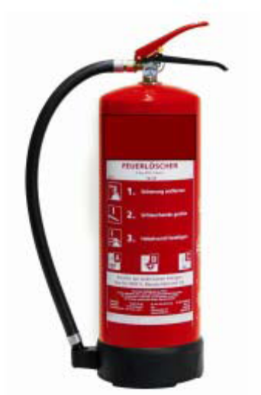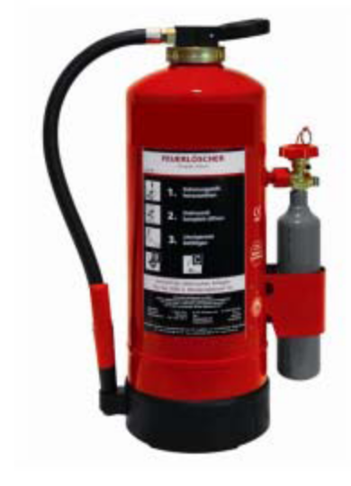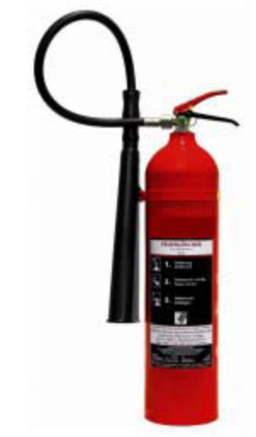

2. Wheeled fire extinguishers or fire extinguishers permanently mounted on wheeled platforms in accordance with standard EN 1866-1 (harmonised standard in accordance with the PED), subdivision as above (stored-pressure, cartridge-type and carbon dioxide extinguishers):
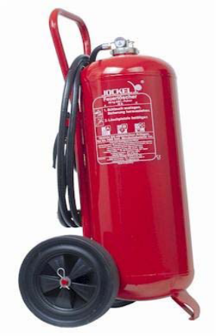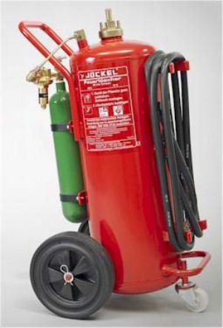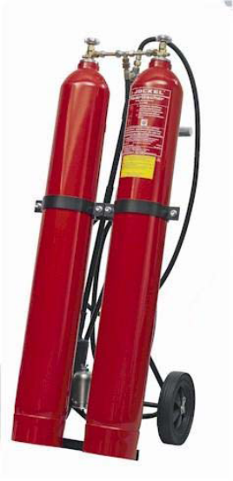

3. Other fire extinguishers which are not covered by any standard, such as movable fire extinguishers (e.g. fire extinguishers permanently installed on trailers) and large fire extinguishers which are transported to the location of use by means of a vehicle.

By their construction and accessories, some of these extinguishers look similar to a battery-vehicle or a pressure drum. For such extinguishers, even if assigned to UN No. 1044 in accordance with RID/ADR, the requirements of special provision 594, in particular the requirement of a strong outer packaging, cannot be met, nor do they seem reasonable.

Thus, such extinguishers would have to fully comply with the requirements of RID/ADR. As there is no appropriate standard, and such fire extinguishers were constructed in the Member States in accordance with non-harmonised national regulations, the provisions of 6.2.5 of RID/ADR would probably need to be applied even if the extinguishers were assigned to UN No. 1044.

An alternative would be to establish a new special provision 6xx that exempts such fire extinguishers stipulating no packing requirements but general requirements e.g. for the protection of parts vulnerable during carriage such as valves.

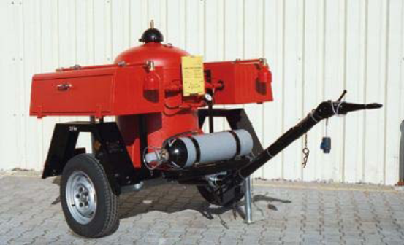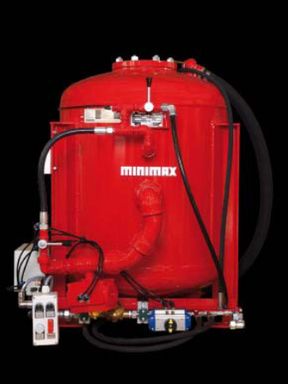

Extinguishing agent containers

This adresses containers with closures which are not complete and cannot immediately be used as fire extinguishers.

Containers/equipment for installation in stationary installations which are/is carried individually and, in the form carried, are/is not complete and cannot be used as fire extinguishers/fire-fighting appliance; this category also includes propellant gas cylinders which are intended for carriage as a single package and, after carriage, are installed and used in the above portable, movable and other cartridge-type extinguishers at the relevant location.

Note: In the picture on the bottom left, only the red cylinder on the side is the object of carriage; equipment like that shown in the picture on the right is handled like a large packaging or container when carried.

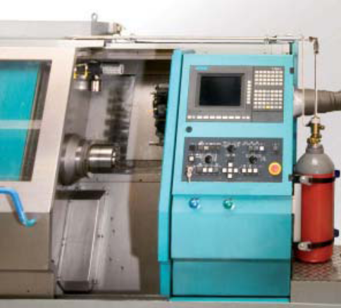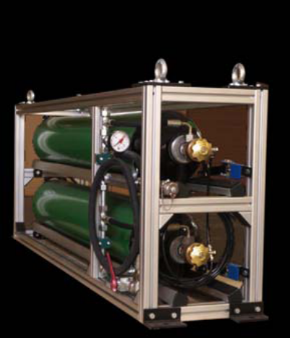

Pre-installed components for stationary fire-fighting installations

This addresses components which are not complete and cannot immediately be used as fire extinguishers, e.g. extinguishing agent containers with piping, pre-installed in a cabinet.
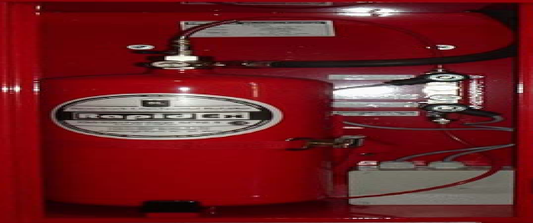

Suggestion for a definition of fire extinguishers assigned to UN No. 1044

"Fire-extinguishers assigned to UN No. 1044 include

- portable manually handled equipment in accordance with standard EN 3,

2. wheeled finished equipment or finished equipment mounted on wheeled platforms in accordance with standard EN 1866-1, or

3. large ready-to-use equipment which is not covered by the standards under nos. 1 and 2, constructed in accordance with national regulations, movable or constitutes a large frame-mounted equipment to be used in stationary installations for fire-fighting purposes.

Fire extinguishers are not used for the carriage of gases but, when carried, constitute a dangerous object which is filled with gases and other substances and whose construction, equipment and condition is not governed by Chapter 6.2 of RID/ADR."

This may result in the following classification:

1. Portable manually handled fire extinguishers in accordance with standard EN 3 = fire extinguishers assigned to UN No. 1044; the hose need not necessarily be fitted but may be enclosed in the package; if special provision 594 is applied, the transport operation is not subject to the requirements of RID/ADR.

2. Wheeled fire extinguishers or fire extinguishers permanently mounted on wheeled platforms under standard EN 1866-1 = fire extinguishers assigned to UN No. 1044; in the case that special provision 594 is applied, the transport operation not subject to RID/ADR.

3. Other fire extinguishers without applicable specific standard = fire extinguishers assigned to UN No. 1044; if special provision 594 is applied, they are subject to the construction, equipment and testing requirements of the national approval regulations which meet the requirements of section 6.2.5 of RID/ADR. For EU Member States, Directive 97/23/EC and the national regulation transposing the Directive constitute the approval regulations.

4. Extinguishing agent containers and propellant cylinders for fire extinguishers or stationary fire-fighting installations are not fire extinguishers of UN No. 1044; thus, they are normal pressure receptacles in accordance with Chapter 6.2 of RID/ADR and have to be carried in accordance with the provisions applicable to the contained gases.

5. Pre-installed components intended for stationary a fire-fighting installation are not fire extinguishers of UN No. 1044; in principle, these are normal pressure receptacles in accordance with Chapter 6.2 of RID/ADR. A related special provision could be examined and drawn up as appropriate.

__________

