 | United Nations | ST/SG/AC.10/C.3/82/Add.1
 | Secretariat |  | Distr.: General  6 August 2012  English  Original: English and French
Committee of Experts on the Transport of Dangerous Goods
and on the Globally Harmonized System of Classification
and Labelling of Chemicals
Sub-Committee of Experts on the Transport of Dangerous Goods
Report of the Sub-Committee of Experts on the Transport of Dangerous Goods on its forty first session
held in Geneva from 25 June–4 July 2012.
Addendum
Contents
Page
Annexes
I. Draft amendments to the fifth revised edition of the Recommendations on the
Transport of Dangerous Goods, Manual of Tests and Criteria 2
II. Draft amendments to the seventeenth revised edition of the Recommendations on the
Transport of Dangerous Goods, Model Regulations 8
III. Draft amendments to the Guiding Principles 31

Annex I
Draft amendments to the 5th revised edition of the UN Recommendations on the Transport of Dangerous Goods,
Manual of Tests and Criteria
Section 17
Amend 17.5.1.2 (b) to read:
“(b) 95 mm diameter by 95 mm long pellet with a density of 1 600 kg/m³ ± 50 kg/m³ of either 50/50 pentolite or 95/5 RDX/WAX;”
Amend 17.5.1.2 (c) to read:
“(c) Tubing, steel, seamless, with an outer diameter of 95.0 ± 7.0 mm, a wall thickness of 9.75 ± 2.75 mm and an inner diameter of 73.0 ± 7.0 mm, and with a length of 280 mm;”
Amend 17.5.1.2 (e) to read:
“(e) Polymethyl methacrylate (PMMA) rod, of 95 mm diameter by 70 mm long;”
Amend 17.5.1.2 (f) to read:
“(f) Mild steel plate, 200 mm × 200 mm × 20 mm;”
Delete 17.5.1.2 (g) and renumber current 17.5.1.2 (h) to be 17.5.1.2 (g).
(Reference documents: ST/SG/AC.10/C.3/2012/1 and informal document INF.67)
Section 18
18.4.1.2.5 Amend the formula to read as follows:
“L = ln 2 × (C_{p} / t_{1/2})”.
(Reference document: informal document INF.67)
18.4.1.2.6 Amend to read as follows:
"18.4.1.2.6 Dewar vessels filled with 400 ml of inert substance, with a heat loss of 100 mW/kg.K or less are suitable.".
(Reference document: informal document INF.67)
Amend 18.5.1.2.1 (b) to read:
“(b) 95 mm diameter by 95 mm long pellet with a density of 1 600 kg/m³ ± 50 kg/m³ of either 50/50 pentolite or 95/5 RDX/WAX;”
(Reference documents: ST/SG/AC.10/C.3/2012/1 and informal document INF.67)
Amend 18.5.1.2.1 (c) to read:
“(c) Tubing, steel, seamless, with an outer diameter of 95.0 ± 7.0 mm, a wall thickness of 9.75 ± 2.75 mm and an inner diameter of 73.0 ± 7.0 mm, and with a length of 280 mm;”
(Reference documents: ST/SG/AC.10/C.3/2012/1 and informal document INF.67)
Amend 18.5.1.2.1 (e) to read:
“(e) Polymethyl methacrylate (PMMA) rod, of 95 mm diameter by 70 mm long. A gap length of 70 mm results in an incident shock pressure at the ANE interface somewhere between 3.5 and 4 GPa, depending on the type of donor used (see Table 18.5.1.1 and Figure 18.5.1.2);”
(Reference documents: ST/SG/AC.10/C.3/2012/1 and informal document INF.67)
Amend 18.5.1.2.1 (f) to read:
“(f) Mild steel plate, 200 mm × 200 mm × 20 mm;”
(Reference documents: ST/SG/AC.10/C.3/2012/1 and informal document INF.67)
Delete 18.5.1.2.1(g) and renumber current 18.5.1.2.1(h) to be 18.5.1.2.1(g).
(Reference documents: ST/SG/AC.10/C.3/2012/1 and informal document INF.67)
Amend Table 18.5.1.1 as follows:
In the "PENTOLITE 50/50 DONOR" column, revise the “Barrier Pressure Value” for the 55mm gap length entry to read “4.91” instead of “4.76”.
In the "PENTOLITE 50/50 DONOR" column, revise the “Barrier Pressure Value” for the 60mm gap length entry to read “4.51” instead of “4.31”.
(Reference documents: ST/SG/AC.10/C.3/2012/1 and informal document INF.67)
Section 20
Amend figure 20.1 (b) to read as follows:
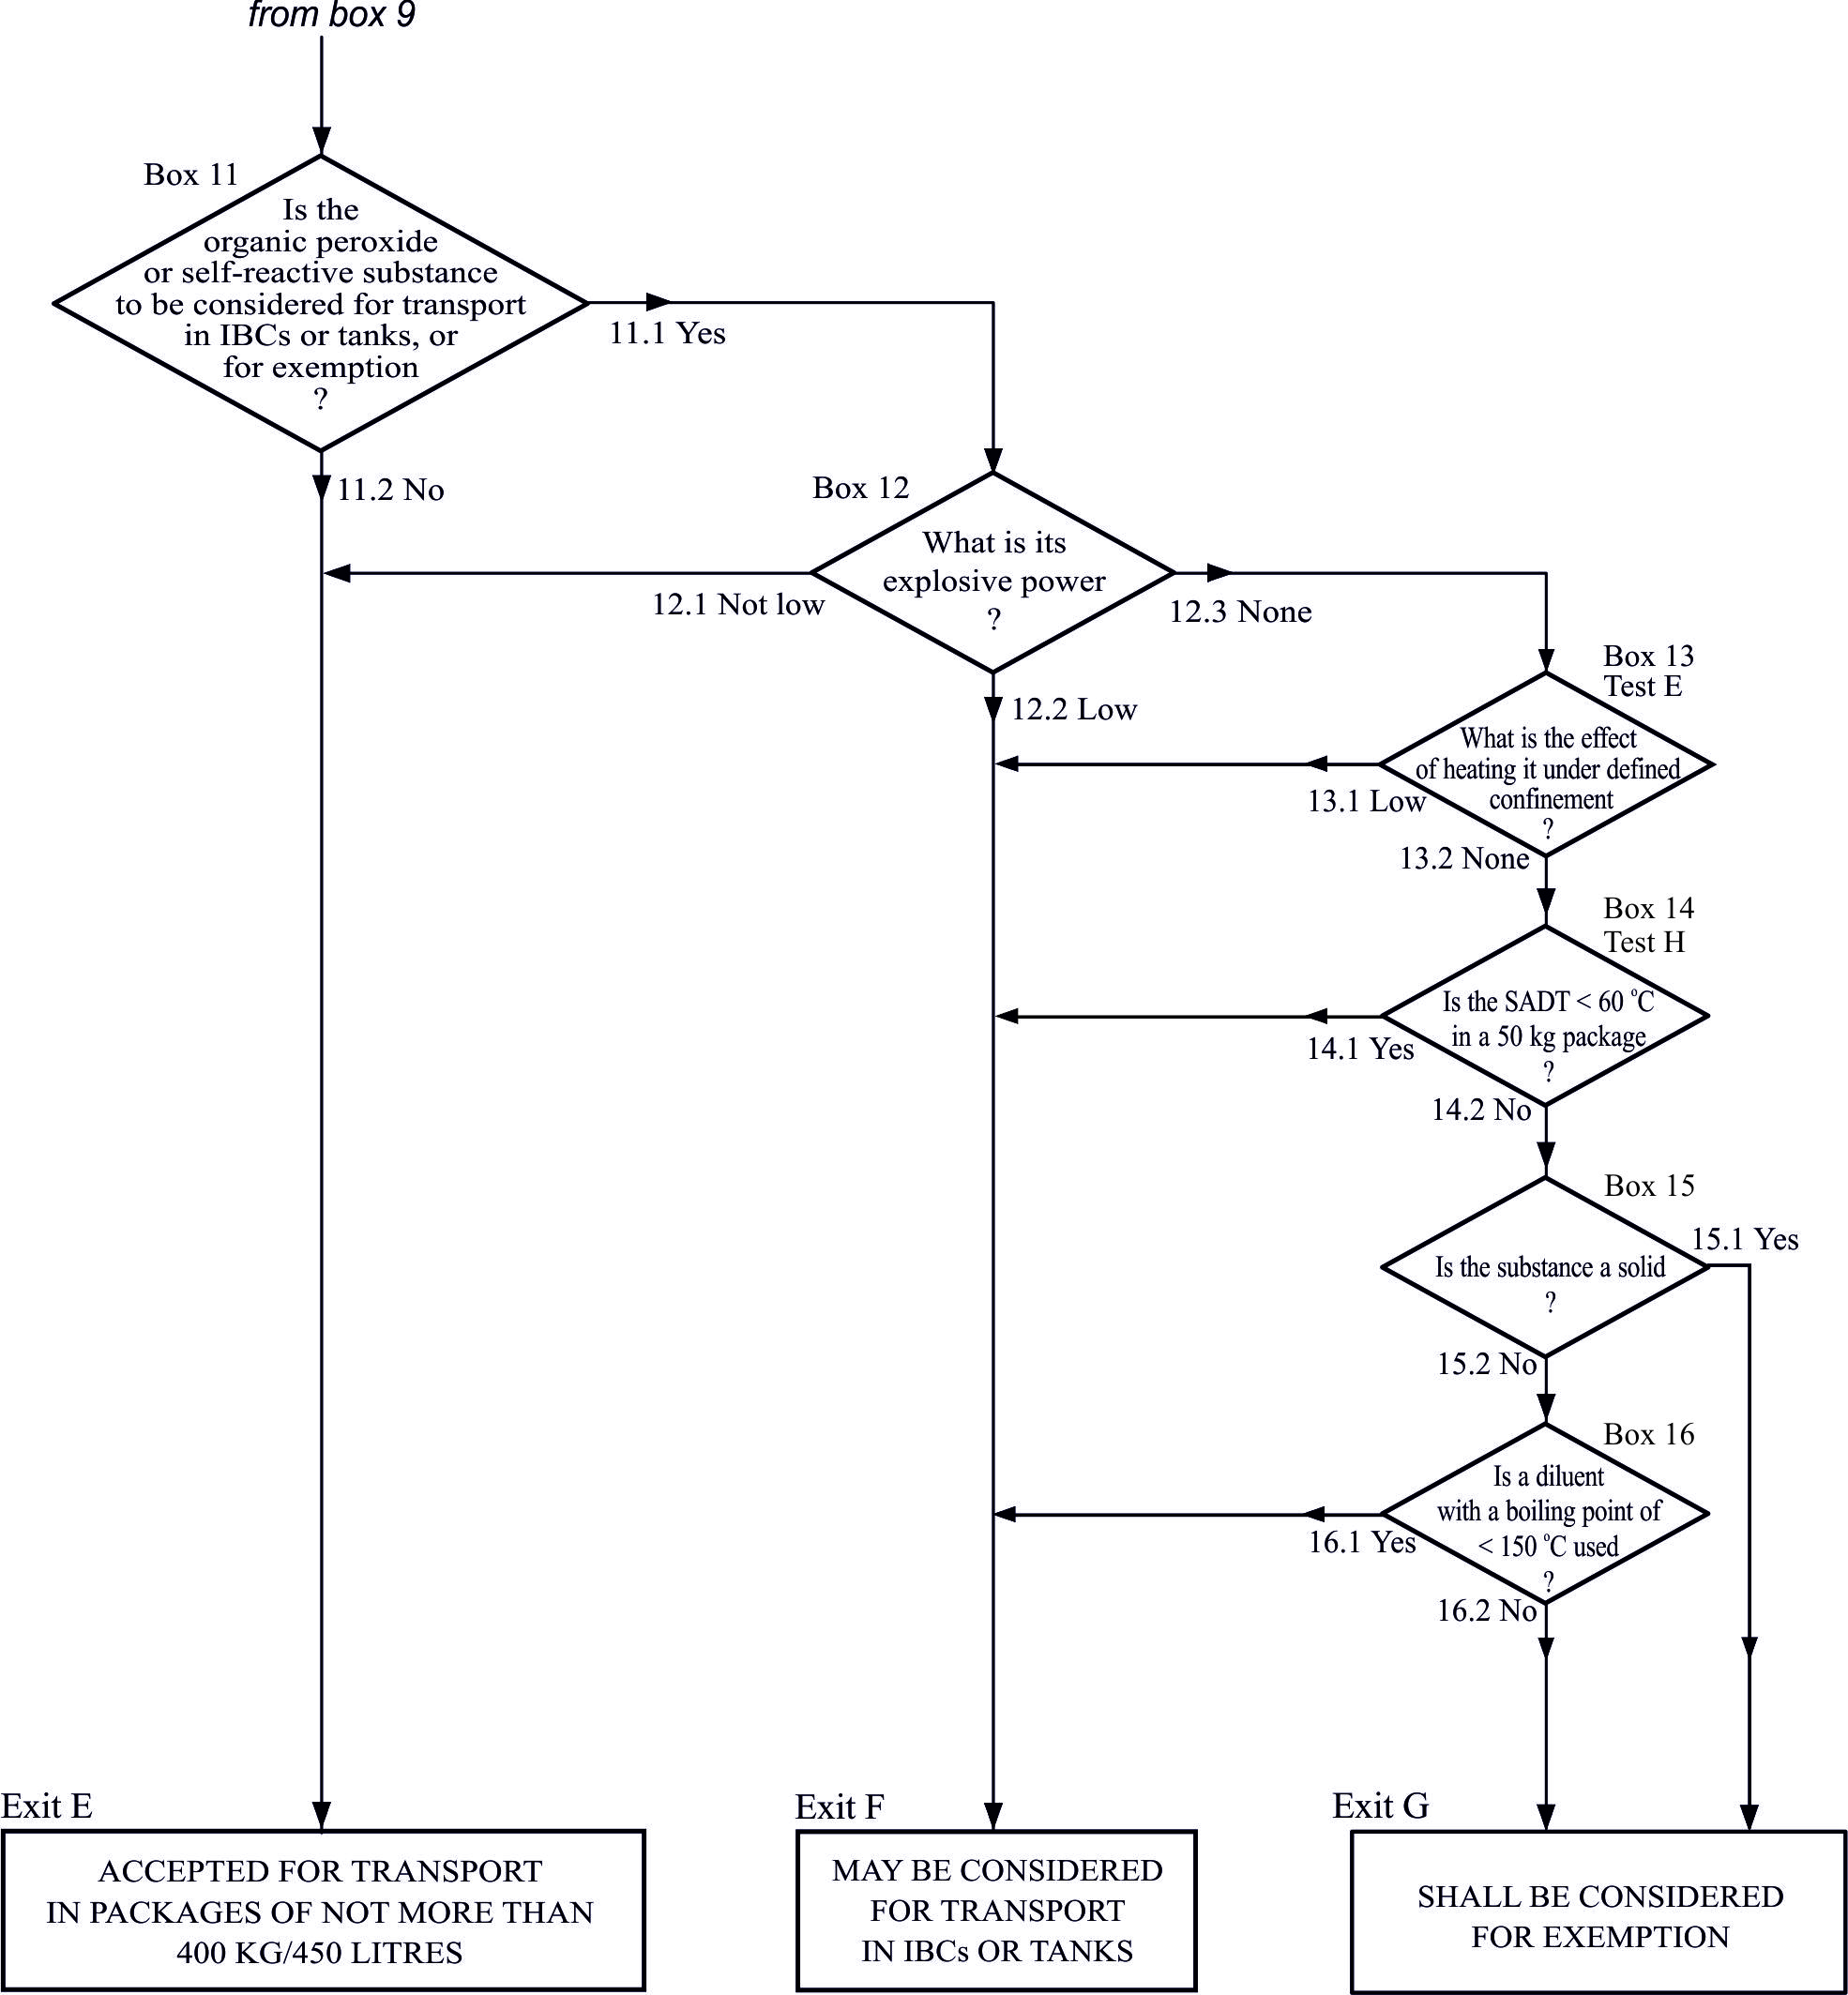
(Reference document: ST/SG/AC.10/C.3/2012/49)
20.3.3.3 In the first sentence, delete "and exothermic decomposition energy". Add the following new second sentence: "Exothermic decomposition energy may be estimated using a suitable calorimetric technique such as differential scanning calorimetry.".
(Reference documents: ST/SG/AC.10/C.3/2012/22 and informal document INF.67)
Section 28
28.3.5 Amend the formula to read as follows:
“L = ln 2 × (C_{p} / t_{1/2})”
(Reference document: informal document INF.67)
Section 38
38.3.4.6.2 In the heading, replace “greater than 20 mm in diameter” with “not less than 18.0 mm in diameter”.
38.3.4.6.3 In the heading, replace “not more than 20 mm in diameter” with “less than 18.0 mm in diameter”.
After the heading in 38.3.4.6.2 and 38.3.4.6.3 add a new Note to read as follows:
“NOTE: Diameter here refers to the design parameter (for example the diameter of 18650 cells is 18.0 mm).”.
(Reference document: ST/SG/AC.10/C.3/2012/6)
Appendix 7
Rename Appendix 7 to read "Flash Composition Tests”
Insert a new subsection heading “A. HSL Flash Composition Tests” at the beginning.
Add the following new procedure at the end:
“B. US Flash Composition Test
- Introduction
This test may be used to determine if pyrotechnic substances in powder form or as pyrotechnic units as presented in fireworks that are used to produce an aural effect or used as a bursting charge or propellant charge, may be considered a “flash composition” for the purposes of the default fireworks classification table in 2.1.3.5.5 of the Model Regulations.
- Apparatus and materials
The experimental set up consists of:
- a cardboard or fibreboard sample tube with a minimum inside diameter of 25 mm and height 150 mm with a maximum wall thickness of 3.8 mm, closed at the base with a thin cardboard or paperboard disk, plug or cap just sufficient to retain the sample;
- a 1.0 mm thick 160 × 160 mm steel witness plate;
- an electric igniter, e.g. a fuse head, with lead wires of at least 30 cm length:
- a mild steel confinement sleeve (weighing approximately 3 kg) which is bored from a solid billet approximately 1 mm deeper than the overall sample tube length and having an inside diameter of 38 mm, an outside diameter of 63 mm and a height of 165 mm with a notch or groove cut into one radius of the open end sufficient to allow the igniter lead wires to pass through (the steel sleeve might be provided with a rugged steel handle for easier handling);
- a steel ring of approximately 50 mm height with an inner diameter of approximately 95 mm; and
- a solid metal base, e.g. a plate of approximately 25 mm thickness and 150 mm square.
- Procedure
3.1 Prior to testing, the pyrotechnic substance is stored for at least 24 hours in a desiccator at a temperature of 20 - 30 °C. Twenty-five (25) g net mass of the pyrotechnic substance to be tested as a loose powder or granulated or coated onto any substrate, is pre-weighed and then poured carefully into a fibreboard sample tube with the bottom end closed with a cardboard or paperboard disk, cap or plug. After filling, the top cardboard or paperboard disk, cap or plug might be inserted lightly to protect the sample from spillage during transport to the test stand. The height of the sample substance in the tube will vary depending on its density. The sample should be first consolidated by lightly tapping the tube on a non-sparking surface. The final density of the pyrotechnic substance in the tube should be as close as possible to the density achieved when contained in a fireworks device.
3.2 The witness plate is placed on the supporting ring. If present, the paperboard or cardboard top disk, cap or plug of the fibreboard sample tube is removed and the electric igniter is inserted into the top of the pyrotechnic substance to be tested and visually positioned to an approximate depth of 10 mm. The paperboard or cardboard top disk, cap or plug is then inserted or re-inserted, fixing the igniter's position in the fibreboard sample tube and the depth of its match head. The lead wires are bent over and down along the sidewall and bent away at the bottom. The sample tube is placed vertically and centred on the witness plate. The steel sleeve is placed over the fibreboard sample tube. The igniter lead wires are positioned to pass through the slotted groove in the bottom edge of the steel confining sleeve and will be ready to attach to the firing circuit apparatus. See Figure A7.10 as an example of the test set-up.
3.3 The electric igniter is then initiated from a safe position. After initiation and a suitable interval the witness plate is recovered and examined. The test should be performed 3 times unless a positive result is obtained earlier.
- Test criteria and method of assessing results
The result is considered positive “+” and the substance is considered to be a “flash composition” if in any trial the witness plate is torn, perforated, pierced or otherwise penetrated (i.e. light is visible through the plate). Otherwise, the result is considered negative “-”. Bulges or folds in the witness plate are not to be considered positive “+” results.
Figure A7.10
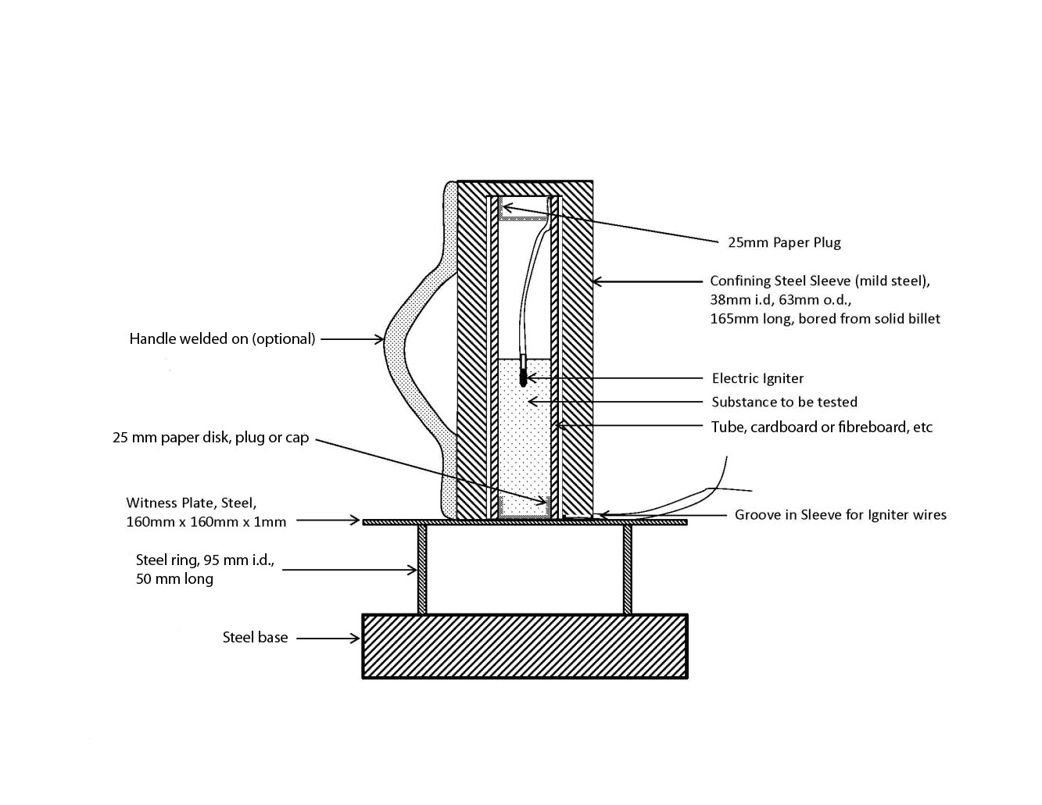”.

(Reference document: informal document INF.67)
Annex II
Draft amendments to the 17th revised edition of the UN Recommendations on the Transport of Dangerous Goods,
Model Regulations
Chapter 2.1
Amend Note 2 in 2.1.3.5.5 to read as follows:
“NOTE 2: “Flash composition” in this table refers to pyrotechnic substances in powder form or as pyrotechnic units as presented in the firework that are used to produce an aural effect or used as a bursting charge, or propellant charge unless:
(a) The pyrotechnic substance gives a negative "-" result in the US Flash Composition Test in Appendix 7 of the Manual of Tests and Criteria; or
(b) The time taken for the pressure rise is demonstrated to be more than 6 ms for 0.5 g of pyrotechnic substance in the HSL Flash Composition Test in Appendix 7 of the Manual of Tests and Criteria.”.
(Reference document: Informal document INF.67)
Chapter 2.4
Amend the second part of figure 2.4.1 to read as follows:
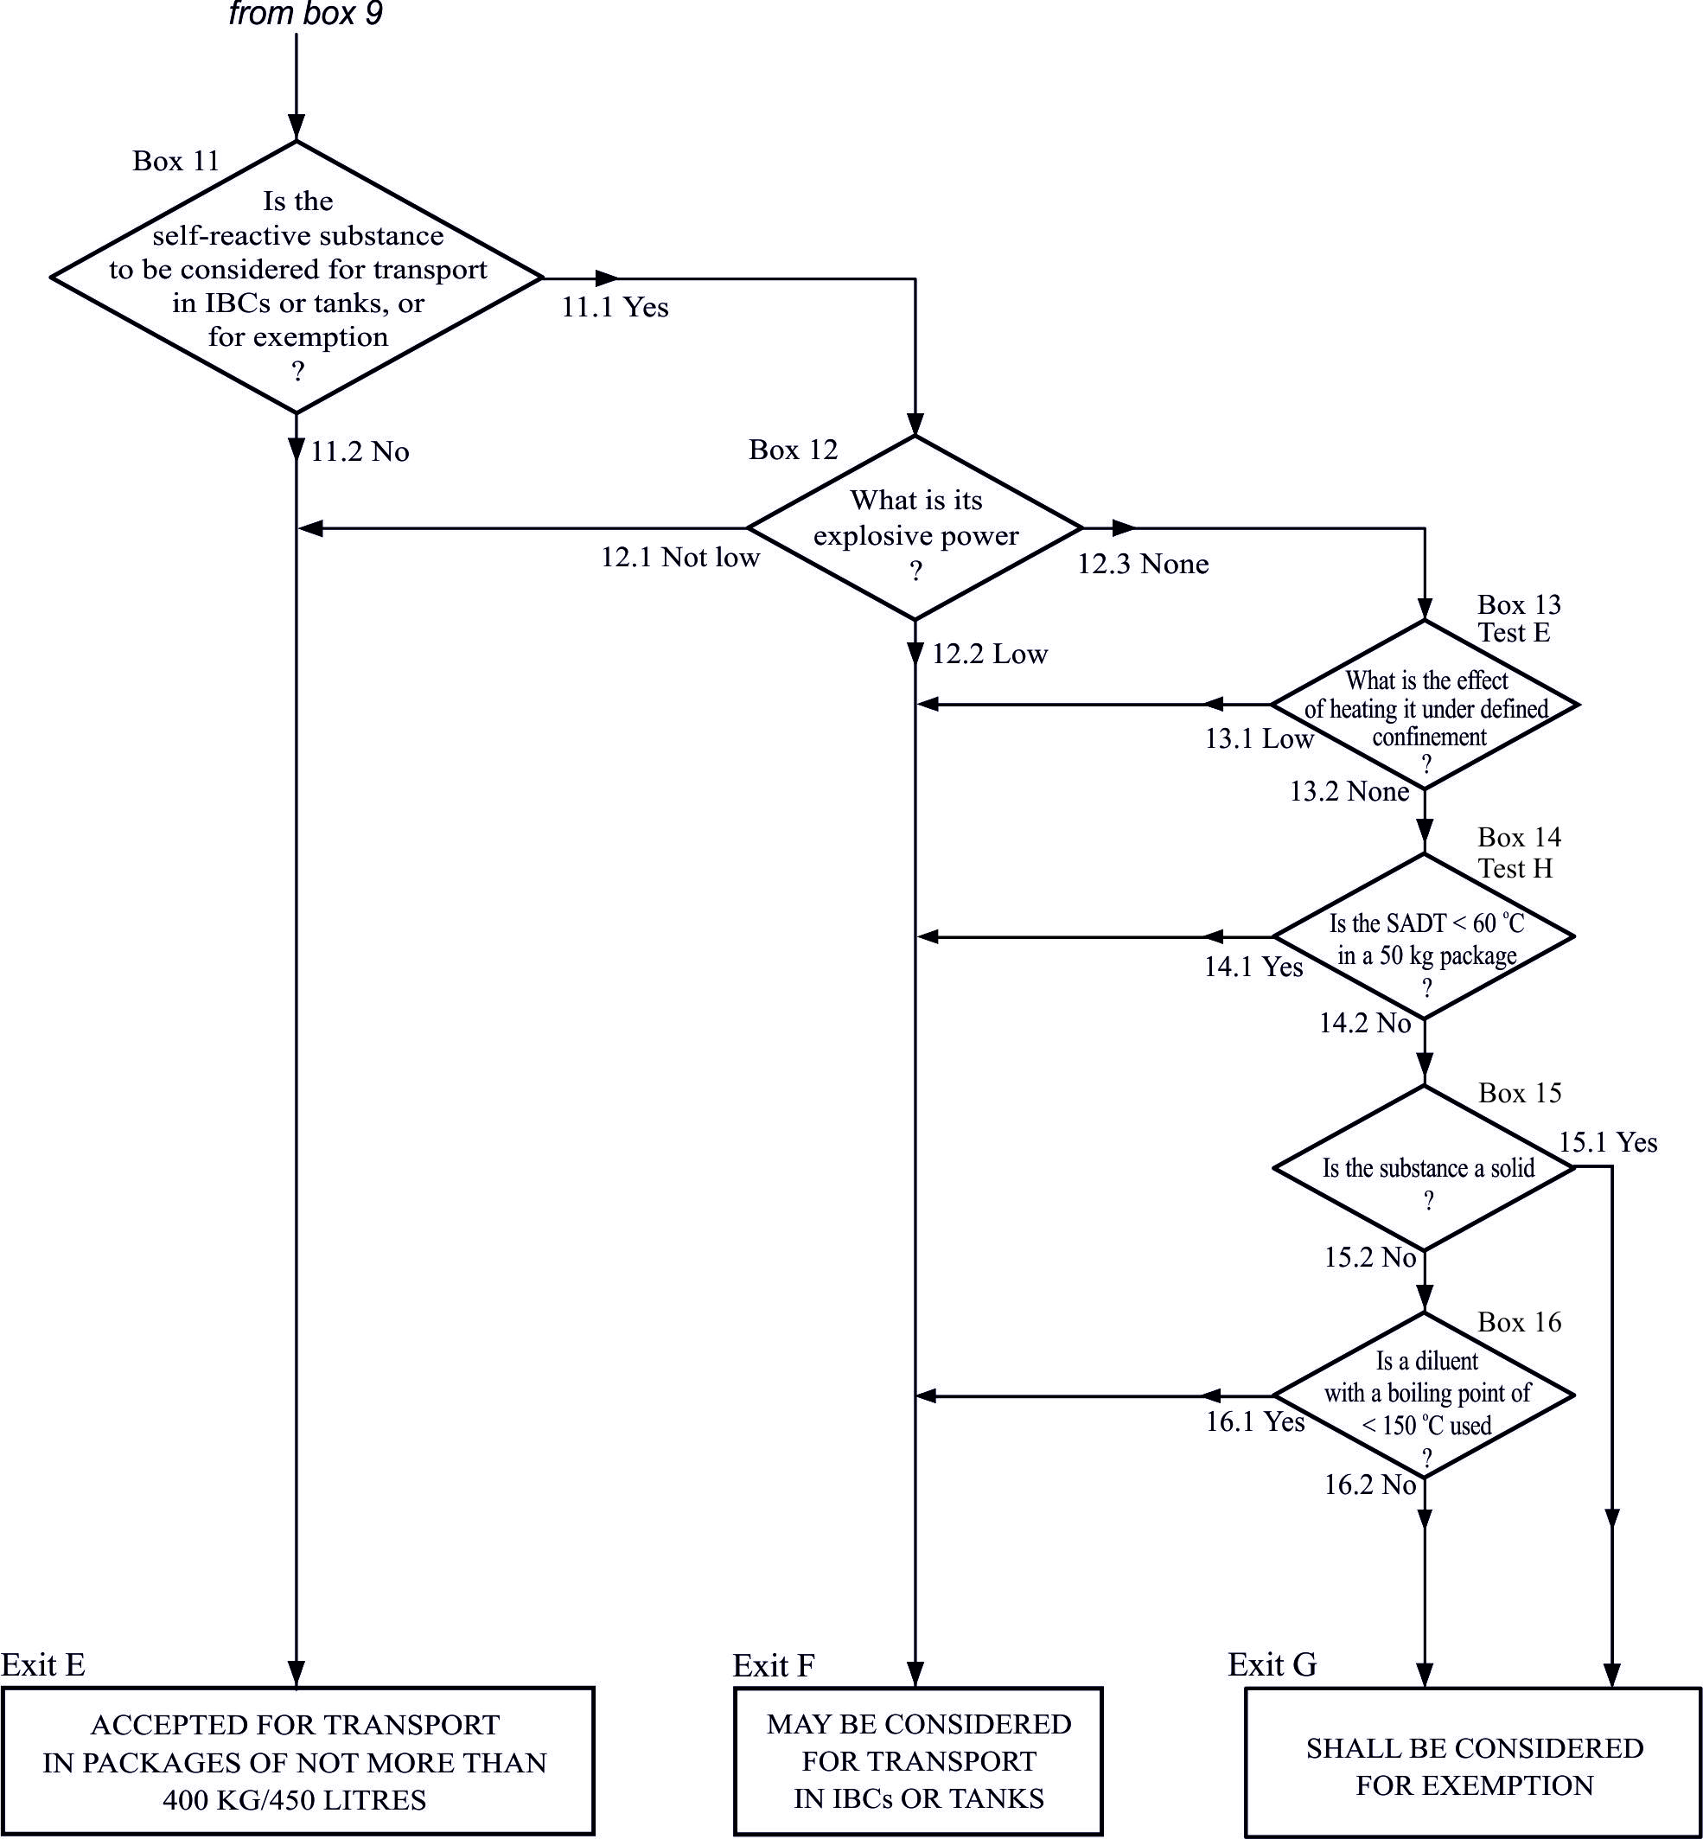
(Reference document: ST/SG/AC.10/C.3/2012/49)
Chapter 2.5
Amend the second part of figure 2.5.1 to read as follows:
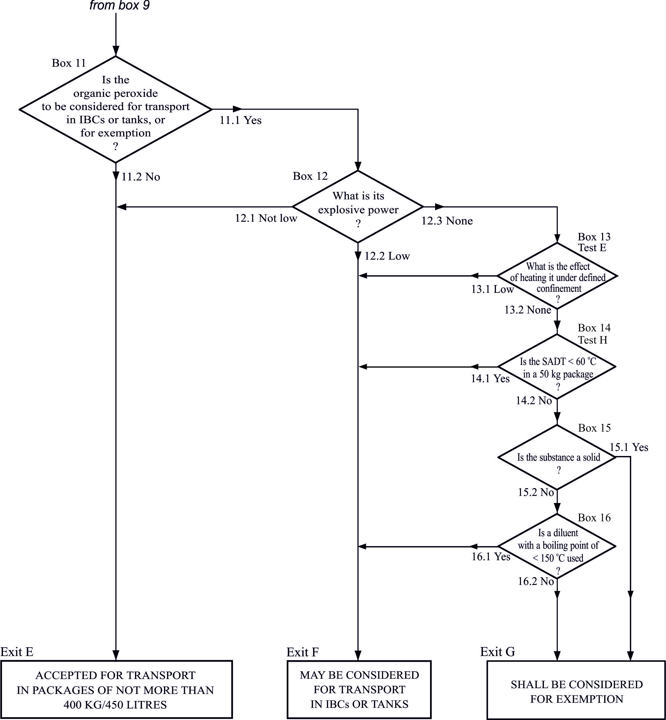
(Reference document: ST/SG/AC.10/C.3/2012/49)
Chapter 2.9
2.9.2 Replace all three entries for UN No. 3268 with “3268 SAFETY DEVICES, electrically initiated”.
(Reference document: informal document INF.70, Consequential amendment)
Chapter 3.2, Dangerous goods list
UN 0222 In column (8) insert “IBC100”. In column (9), insert "[B2, B17] [B3, B17]".
(Reference documents: ST/SG/AC.10/C.3/2012/17 and informal document INF.67 as amended)
UN 0222 Amend column (2) to read “AMMONIUM NITRATE”. In column (6) insert “[370]”.
(Reference document: informal document INF.68)
UN No. 0503 In column (2), amend name to read: “SAFETY DEVICES, PYROTECHNIC†”.
(Reference document: informal document INF.70 as amended)
UN 1942 Amend column (2) to read “AMMONIUM NITRATE with not more than 0.2% combustible substances, including any organic substance calculated as carbon, to the exclusion of any other added substance.”.
(Reference document: ST/SG/AC.10/C.3/2012/19 Option b)
UN 2212 In column (2) amend the name to read "ASBESTOS AMPHIBOLE (amosite, tremolite, actinnolite, anthophyllite, crocidolite)". In column (6), insert "274".
UN 2590 In column (2) amend the name to read "ASBESTOS CHRYSOTILE or ASBESTOS CHRYSOTILE FIBRE".
(Reference document: ST/SG/AC.10/C.3/2012/48 as amended)
UN 3089, packing group III In column (8) replace "IBC06" by "IBC08". In column (9) insert "B2, B4".
(Reference document: ST/SG/AC.10/C.3/2012/11)
UN Nos. 3090, 3091, 3480 and 3481 In column (8) insert "LP903".
(Reference document: ST/SG/AC.10/C.3/2012/39)
UN 3316 Replace the existing entry with the two following new entries:
(1) | (2) | (3) | (4) | (5) | (6) | (7a) | (7b) | (8) | (9) | (10) | (11)
3316 | CHEMICAL KIT or FIRST AID KIT | 9 |  | II | 251  340 | See  SP251 | See SP340 | P901
3316 | CHEMICAL KIT or FIRST AID KIT | 9 |  | III | 251  340 | See  SP251 | See SP340 | P901
(Reference document: ST/SG/AC.10/C.3/2012/12)
UN 3268 In column (2), amend the name to read: “SAFETY DEVICES, electrically initiated”.
(Reference document: informal document INF.70)
UN 3375 In column (8), replace "P099 IBC99" by "P505 IBC02". In column (9), insert "B16".
(Reference document: informal document INF.67)
Chapter 3.3
SP122 At the end, add: “and 4.2.5.2.6 portable tank instruction T23.”.
(Reference document: informal document INF.35)
SP172 Amend to read as follows:
“172 Where a radioactive material has a subsidiary risk:
- The substance shall be allocated to Packing Group I, II or III, if appropriate, by application of the packing group criteria provided in Part 2 corresponding to the nature of the predominant subsidiary risk;
- Packages shall be labelled with subsidiary risk labels corresponding to each subsidiary risk exhibited by the material; corresponding placards shall be affixed to transport units in accordance with the relevant provisions of 5.3.1;
- The dangerous goods transport document shall indicate the subsidiary class or division and, where assigned the packing group as required by 5.4.1.4.1(d) and (e)
- The proper shipping name described on the dangerous goods transport document [and as marked on the package] shall be supplemented with the name of the constituents which most predominantly contribute to this (these) subsidiary risk(s) and [which] shall be enclosed in parenthesis.
For packing, see also 4.1.9.1.5.”.
(Reference document: informal document INF.69)
SP235 Amend to read as follows: “235 This entry applies to articles which contain Class 1 explosive substances and which may also contain dangerous goods of other classes. These articles are used to enhance safety in vehicles, vessels or aircraft – e.g. air bag inflators, air bag modules, seat-belt pretensioners, and pyromechanical devices.”.
(Reference document: informal document INF.70)
SP280 Amend to read as follows: “This entry applies to safety devices for vehicles, vessels or aircraft – e.g. air bag inflators, air bag modules, seat-belt pretensioners, and pyromechanical devices and which contain dangerous goods of Class 1 or dangerous goods of other classes and when transported as component parts and if these articles as presented for transport have been tested in accordance with Test Series 6(c) of Part 1 of the Manual of Tests and Criteria, with no explosion of the device, no fragmentation of device casing or pressure vessel, and no projection hazard nor thermal effect which would significantly hinder fire-fighting or emergency response efforts in the immediate vicinity. This entry does not apply to life saving appliances described in special provision 296 (UN Nos. 2990 and 3072).”.
(Reference document: informal document INF.70)
SP289 Amend to read as follows: “Safety devices, electrically initiated and safety devices, pyrotechnic installed in vehicles, vessels or aircraft or in completed components such as steering columns, door panels, seats, etc. are not subject to these Regulations.”.
(Reference document: informal document INF.70)
SP306 Amend to read as follows: “This entry may only be used for substances that are too insensitive for acceptance into Class 1 when tested in accordance with Test Series 2 (see Manual of Tests and Criteria, Part I).”.
(Reference document: ST/SG/AC.10/C.3/2012/18 as amended in accordance with informal document INF.67)
SP309 Amend the last sentence to read as follows: "Substances shall satisfactorily pass Tests 8(a), (b) and (c) of Test Series 8 of the Manual of Tests and Criteria, Part I, Section 18 and be approved by the competent authority.".
(Reference documents: ST/SG/AC.10/C.3/2012/15 and informal document INF.67)
SP335 At the end, add the following new text:
"[Inner packagings containing not more than 10 ml of an environmentally hazardous liquid packed in a combination packaging not exceeding 30 kg total gross mass conforming to general packing provisions 4.1.1.1, 4.1.1.2, 4.1.1.4, and 4.1.1.8 and meeting the construction requirements of 6.1.4 are not subject to these Regulations, if the packaging is designed to prevent the release of the liquid content by using an intermediate packaging (plastic bag, blister or similar) or by adding absorbing material in a part of the packaging (outer or intermediate packaging).]".
(Reference document: ST/SG/AC.10/C.3/2012/27)
SP363 In subparagraph (c), replace “loaded in an orientation” with “oriented”.
(Reference document: informal document INF.47)
Add a new special provision to read as follows:
“[370] This entry applies to:
- ammonium nitrate with more than 0.2% combustible substances, including any organic substance calculated as carbon, to the exclusion of any added substance; and
- ammonium nitrate with not more than 0.2% combustible substances, including any organic substance calculated as carbon, to the exclusion of any added substance, that are not too sensitive for acceptance into Class 1 when tested in accordance with Test Series 2 (see Manual of Tests and Criteria, Part I). See also UN No. 1942.”.
(Reference document: informal document INF.68 as amended)
Chapter 3.4
Amend sections 3.4.7 and 3.4.8 to read as follows:
“3.4.7 Marking for packages containing limited quantities
3.4.7.1 Except for air transport, packages containing dangerous goods in limited quantities shall bear the marking shown in Figure 3.4.1:
Figure 3.4.1
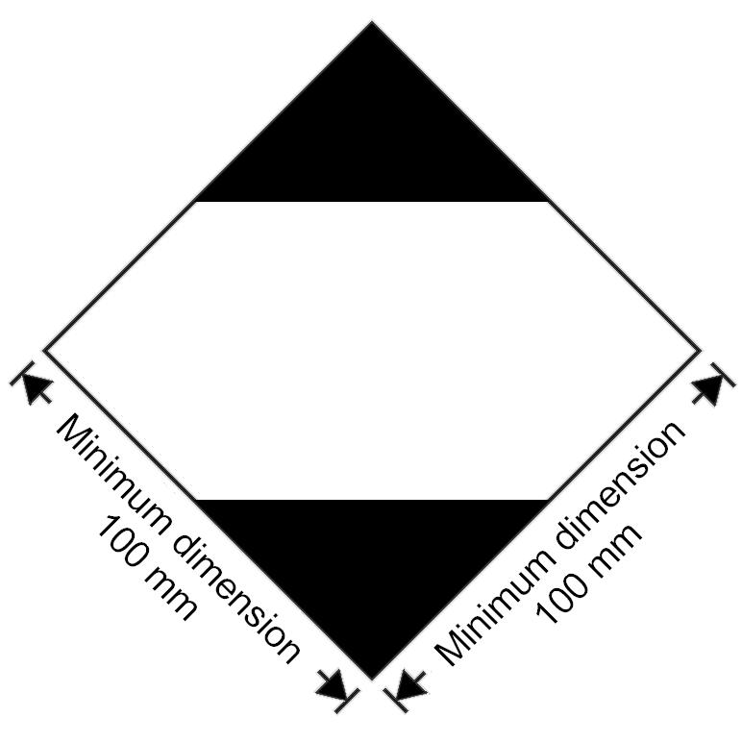
Marking for packages containing limited quantities
The marking shall be readily visible, legible and able to withstand open weather exposure without a substantial reduction in effectiveness.
The marking shall be in the form of a square set at an angle of 45 degrees (diamond-shaped). The top and bottom portions and the surrounding line shall be black. The centre area shall be white or a suitable contrasting background. The minimum dimensions shall be 100 mm x 100 mm and the minimum width of line forming the diamond shall be 2 mm. Where dimensions are not specified, all features shall be in approximate proportion to those shown.
3.4.7.2 If the size of the package so requires, the minimum outer dimensions shown in Figure 3.4.1 may be reduced to be not less than 50 mm x 50 mm provided the marking remains clearly visible. The minimum width of the line forming the diamond may be reduced to a minimum of 1 mm.
3.4.8 Marking for packages containing limited quantities conforming to Part 3, Chapter 4 of the ICAO Technical Instructions for the Safe Transport of Dangerous Goods by Air.
3.4.8.1 Packages containing dangerous goods packed in conformity with the provisions of Part 3, Chapter 4 of the ICAO Technical Instructions for the Transport of Dangerous Goods may bear the marking shown in Figure 3.4.2 to certify conformity with these provisions:

Figure 3.4.2
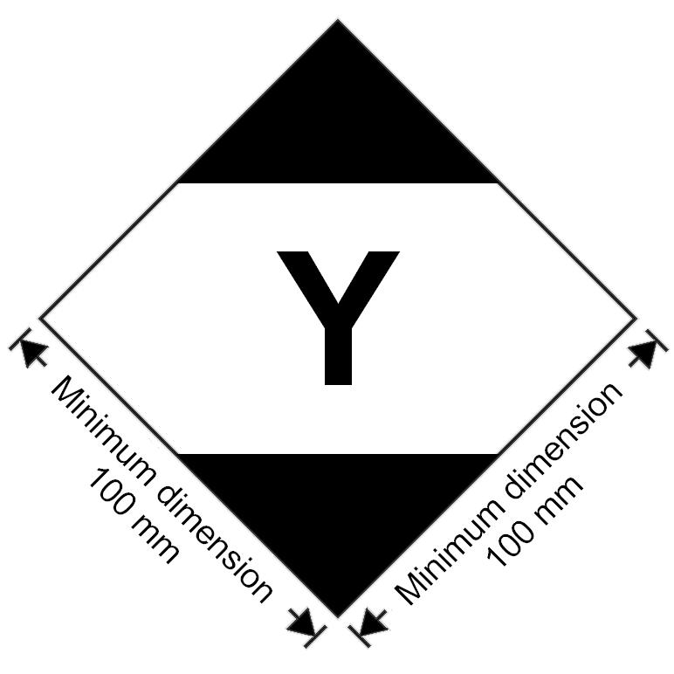
Marking for packages containing limited quantities conforming to Part 3, Chapter 4 of the ICAO Technical Instructions for the Safe Transport of Dangerous Goods by Air
The marking shall be readily visible, legible and able to withstand open weather exposure without a substantial reduction in effectiveness.
The marking shall be in the form of a square set at an angle of 45 degrees (diamond-shaped). The top and bottom portions and the surrounding line shall be black. The centre area shall be white or a suitable contrasting background. The minimum dimensions shall be 100 mm x 100 mm and the minimum width of line forming the diamond shall be 2 mm. The symbol "Y" shall be placed in the centre of the mark and shall be clearly visible. Where dimensions are not specified, all features shall be in approximate proportion to those shown.
3.4.8.2 If the size of the package so requires, the minimum outer dimensions shown in Figure 3.4.2 may be reduced to be not less than 50 mm x 50 mm provided the marking remains clearly visible. The minimum width of the line forming the diamond may be reduced to a minimum of 1 mm. The symbol "Y" shall remain in approximate proportion to that shown in Figure 3.4.2.”.
(Reference document: informal document INF.32 as amended)
Chapter 3.5
Amend 3.5.4.2 and 3.5.4.3 to read as follows:
“3.5.4.2 Excepted quantities mark

Figure 3.5.1

Minimum dimension 100 mm
Minimum dimension 100 mm

Excepted quantities mark
* The Class or, when assigned, the Division number(s) shall be shown in this location.
** The name of the consignor or of the consignee shall be shown in this location if not shown elsewhere on the package.
The marking shall be in the form of a square. The hatching and symbol shall be of the same colour, black or red, on white or suitable contrasting background. The minimum dimensions shall be 100 mm x 100 mm. Where dimensions are not specified, all features shall be in approximate proportion to those shown.
3.5.4.3 An overpack containing dangerous goods in excepted quantities shall display the markings required by 3.5.4.1, unless such markings on packages within the overpack are clearly visible.”.
(Reference document: informal document INF.32 as amended)
Appendix B
Amend the entry for “AIR BAG INFLATORS, PYROTECHNIC or AIR BAG MODULES, PYROTECHNIC or SEAT-BELT PRETENSIONERS, PYROTECHNIC” to read, “SAFETY DEVICES, electrically initiated”
Amend the definition to read as follows:
“Articles which contain pyrotechnic substances or dangerous goods of other classes and are used in vehicles, vessels or aircraft to enhance safety to persons. Examples are: air bag inflators, air bag modules, seat-belt pretensioners and pyromechanical devices. These pyromechanical devices are assembled components for tasks such as but not limited to separation, locking, or release-and-drive or occupant restraint. The term includes “SAFETY DEVICES, PYROTECHNIC”.”.
(Reference document: informal document INF.70 as amended)
Alphabetical index
Amend the entries for “AIR BAG INFLATORS, PYROTECHNIC or AIR BAG MODULES, PYROTECHNIC or SEAT-BELT PRETENSIONERS, PYROTECHNIC” to read as follows:
«Air bag inflators, see | 1.4G  9 | 0503  3268»
«Air bag modules, see | 1.4G  9 | 0503  3268»
«Seat-belt pretensioners, see | 1.4G  9 | 0503  3268»
Add two new entries in alphabetical order to read as follows:
“SAFETY DEVICES, electrically initiated 9 3268”.
“SAFETY DEVICES, PYROTECHNIC 1.4G 0503”.
(Reference document: informal document INF.70, consequential amendment)
Chapter 4.1
4.1.4.1
P650 Amend the diagram to read as follows:
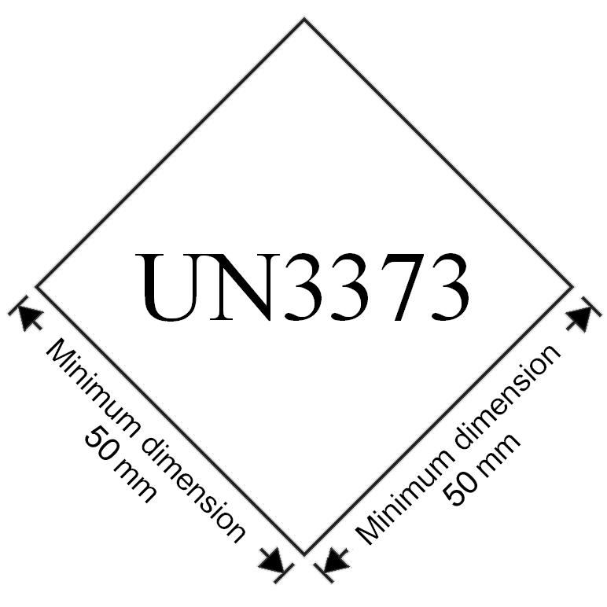
(Reference document: ST/SG/AC.10/C.3/2012/32)
P903 In paragraph (2), replace subparagraphs (a) and (b) with the following subparagraphs (a) to (c):
“(a) Strong outer packagings;
(b) Protective enclosures (e.g., fully enclosed or wooden slatted crates); or
(c) Pallets or other handling devices.”.
(Reference document: ST/SG/AC.10/C.3/2012/29 as amended)
P904 Amend the diagram to read as follows:
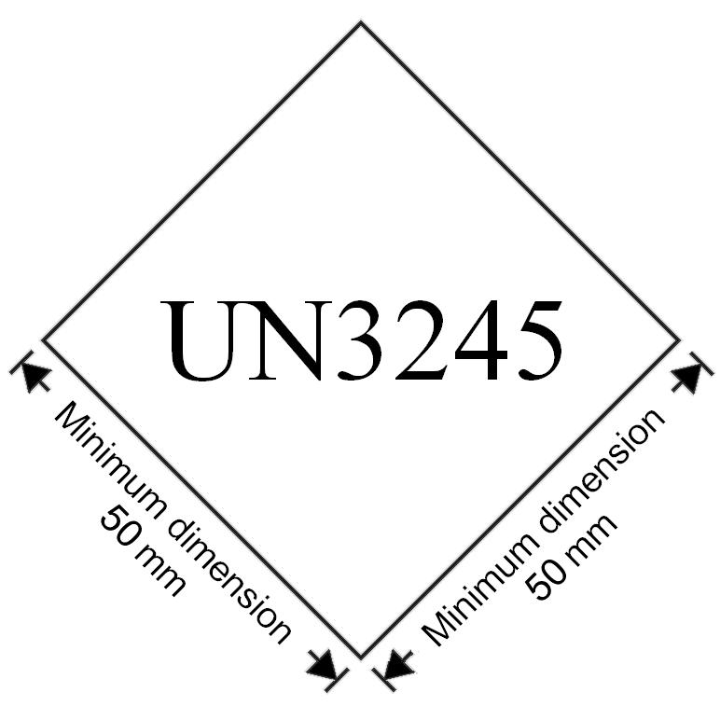
(Reference document: ST/SG/AC.10/C.3/2012/32)
4.1.4.1 Insert the following new packing instruction:
P505 | PACKING INSTRUCTION |  |  | P505
This instruction applies to UN No. 3375
The following packagings are authorized, provided that the general provisions of 4.1.1 and 4.1.3 are met:
Combination packagings: |  | Inner packaging maximum capacity | Outer packaging maximum net mass
Boxes (4B, 4C1, 4C2, 4D, 4G, 4H2) or drums (1B2, 1G, 1N2, 1H2, 1D) jerricans (3B2, 3H2) with glass, plastics or metal inner packagings |  | 5 l | 125 kg
Single packagings: |  | Maximum capacity
Drums
aluminium (1B1, 1B2), plastics (1H1, 1H2) |  | 250 l
Jerricans
aluminium (3B1, 3B2), plastics (3H1, 3H2) |  | 60 l
Composite packagings
plastics receptacle with outer aluminium drum (6HB1) |  | 250 l
plastics receptacle with outer fibre, plastics or plywood drum (6HG1, 6HH1, 6HD1) |  | 250 l
plastics receptacle with outer aluminium crate or box or plastics receptacle with outer wooden, plywood, fibreboard or solid plastics box (6HB2, 6HC, 6HD2, 6HG2 or 6HH2) |  | 60 l
glass receptacle with outer aluminium, fibre or plywood drum (6PB1, 6PG1, 6PD1) or with outer solid plastics or expanded plastics receptacles (6PH1 or 6PH2) or with outer aluminium crate or box or with outer wooden or fibreboard box or with outer wickerwork hamper (6PB2, 6PC, 6PG2 or 6PD2) |  | 60 l
(Reference documents: informal document INF.67)
4.1.4.2 In IBC02, insert the following new special provision B16:
"B16 For UN 3375, IBCs of type 31A and 31N are not allowed without competent authority approval.".
(Reference documents: informal document INF.67)

4.1.4.3 Insert the following new packing instruction:
LP903 | PACKING INSTRUCTION | LP903
This instruction applies to UN Nos. 3090, 3091, 3480 and 3481
The following large packagings are authorized for a single battery, including for a battery contained in equipment, provided that the general provisions of 4.1.1 and 4.1.3 are met:
Rigid large packagings conforming to the packing group II performance level, made of:
steel (50A);
aluminium (50B);
metal other than steel or aluminium (50N);
rigid plastics (50H);
natural wood (50C);
plywood (50D);
reconstituted wood (50F);
rigid fibreboard (50G).
The battery shall be packed so that the battery is protected against damage that may be caused by its movement or placement within the large packaging.
Additional requirement:
Batteries shall be protected against short circuit.
(Reference document: ST/SG/AC.10/C.3/2012/39 as amended)
IBC100 In the first line of packing instruction IBC100, insert “0222” after “0082”. Insert the following special packing provisions:
[“B2 For UN No. 0222 in IBCs other than metal or rigid plastics IBCs, the IBCs shall be transported in closed cargo transport units.”]
[“B3 For UN No. 0222, flexible IBCs shall be sift-proof and water resistant or shall be fitted with a sift-proof and water resistant liner.”]
[“B17 For UN No. 0222, metal IBCs are not authorized.”]
(Reference documents: ST/SG/AC.10/C.3/2012/17 and informal document INF.67 as amended)
        - Replace “ISO 11114-1:1997” with “ISO 11114-1:2012”.
(Reference documents: ST/SG/AC.10/C.3/2012/40)
Chapter 4.2
4.2.5.2.6 Amend the header to the tabulated portable tank instructions for T1 – T22 to read as follows:
"These portable tank instructions apply to liquid and solid substances of Class 1 and Classes 3 to 9. The general provisions of section 4.2.1 and the requirements of section 6.7.2 shall be met.".
(Reference documents: ST/SG/AC.10/C.3/2012/13 and informal document INF.67)
4.2.5.2.6 In tank instruction T23, at the end of footnote d add: ““CORROSIVE” subsidiary risk placard required (Model No 8, see 5.2.2.2.2).”.
(Reference document: informal document INF.35)
4.2.5.3 In special provision TP32, paragraph (b), at the beginning, insert "For UN 3375 only,".
(Reference documents: informal document INF.67)
Chapter 5.2
Amend 5.2.1.6.3 and figure 5.2.2 to read as follows:
“5.2.1.6.3 The environmentally hazardous substance mark shall be as shown in Figure 5.2.2.
Figure 5.2.2
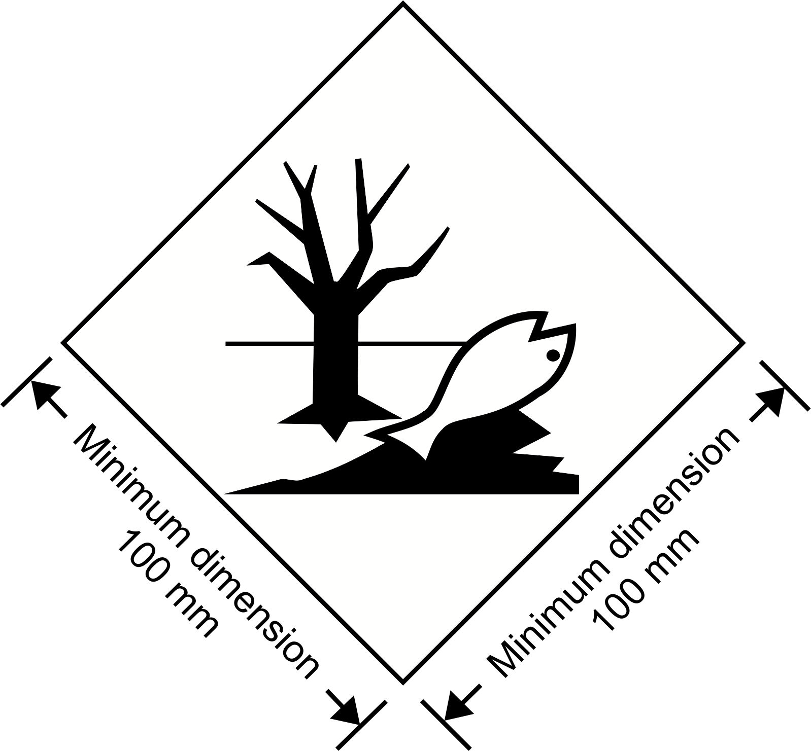
Environmentally hazardous substance mark
The marking shall be in the form of a square set at an angle of 45 degrees (diamond-shaped). The symbol (fish and tree) shall be black on white or suitable contrasting background. The minimum dimensions shall be 100 mm x 100 mm and the minimum width of line forming the diamond shall be 2 mm. If the size of the package so requires, the dimensions/line thickness may be reduced, provided the marking remains clearly visible. Where dimensions are not specified, all features shall be in approximate proportion to those shown.
NOTE: The labelling provisions of 5.2.2 apply in addition to any requirement for packages to bear the environmentally hazardous substance mark.”.
(Reference document: ST/SG/AC.10/C.3/2012/32)
5.2.1.7.1 Number the figures and amend the caption to read as follows:
“ Figure 5.2.3 Figure 5.2.4

or
Two black or red arrows on white or suitable contrasting background.
The rectangular border is optional
All features shall be in approximate proportion to those shown.”.
(Reference document: ST/SG/AC.10/C.3/2012/32)
5.2.2.2.1.1 Amend to read as follows:
“5.2.2.2.1.1 Labels shall be configured as shown in Figure 5.2.5.
Figure 5.2.5
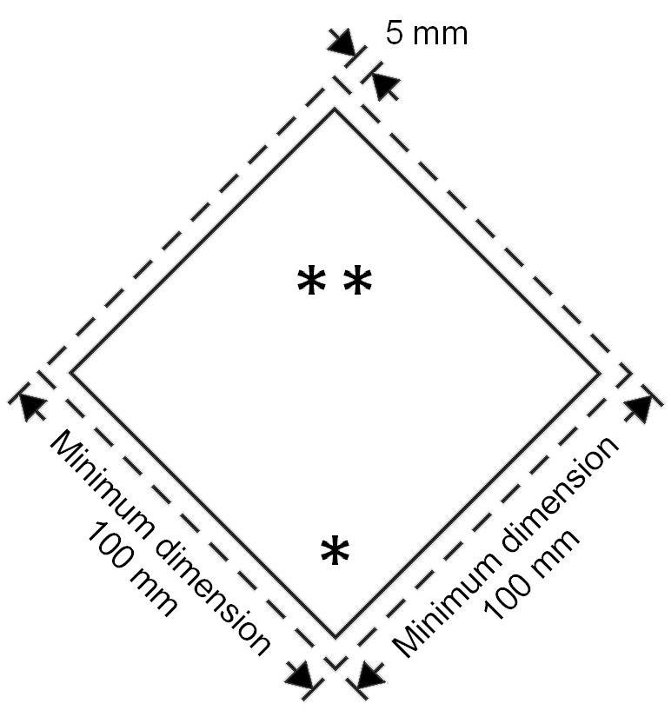
Class/division label
* Class or division number shall be shown in this location in the bottom corner.
** The class or division symbol/numeral/text shall be shown in this location.
5.2.2.2.1.1.1 Labels shall be displayed on a background of contrasting colour, or shall have either a dotted or solid outer boundary line.
5.2.2.2.1.1.2 The label shall be in the form of a square set at an angle of 45 degrees (diamond-shaped). The minimum dimensions shall be 100 mm x 100 mm and the minimum width of the line inside the edge forming the diamond shall be 2 mm. The line inside the edge shall be parallel and 5 mm from the outside of that line to the edge of the label. The line inside the edge on the upper half of the label shall be the same colour as the symbol and the line inside the edge on the lower half of the label shall be the same colour as the class or division number in the bottom corner. Where dimensions are not specified, all features shall be in approximate proportion to those shown.
5.2.2.2.1.1.3 If the size of the package so requires the dimensions may be reduced, provided the symbols and other elements of the label remain clearly visible. The line inside the edge shall remain 5 mm to the edge of the label. The minimum width of the line inside the edge shall remain 2 mm. Dimensions for cylinders shall comply with 5.2.2.2.1.2.”.
(Reference document: ST/SG/AC.10/C.3/2012/32)
Chapter 5.3
Amend paragraph 5.3.1.2.1 to read as follows:
"5.3.1.2.1 Except as provided in 5.3.1.2.2 for the Class 7 placard, and in 5.3.2.3.2 for the environmentally hazardous substance mark, a placard shall be configured as shown in Figure 5.3.0.
Figure 5.3.0
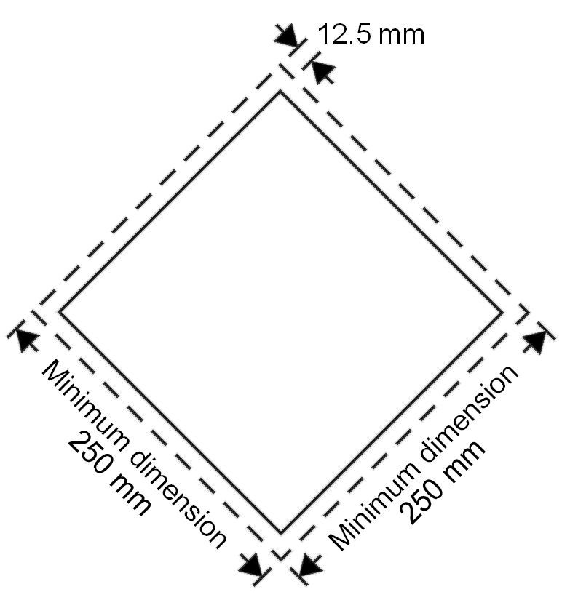
Placard (except for class 7)
The placard shall be in the form of a square set at an angle of 45 degrees (diamond-shaped). The minimum dimensions shall be 250 mm x 250 mm (to the edge of the placard). The line inside the edge shall be parallel and 12.5 mm from the outside of that line to the edge of the placard. The symbol and line inside the edge shall correspond in colour to the label for the class or division of the dangerous goods in question. The class or division symbol/numeral shall be positioned and sized in proportion to those prescribed in 5.2.2.2 for the corresponding class or division of the dangerous goods in question. The placard shall display the number of the class or division (and for goods in Class 1, the compatibility group letter) of the dangerous goods in question in the manner prescribed in 5.2.2.2 for the corresponding label, in digits not less than 25 mm high. Where dimensions are not specified, all features shall be in approximate proportion to those shown.".
(Reference document: ST/SG/AC.10/C.3/2012/32 as amended)
5.3.2.2 Amend to read as follows:
“5.3.2.2 Elevated temperature substances
Cargo transport units containing a substance that is transported or offered for transport in a liquid state at a temperature equal to or exceeding 100 °C, in a solid state at a temperature equal to or exceeding 240 °C shall bear on each side and on each end the mark shown in Figure 5.3.4.
Figure 5.3.4
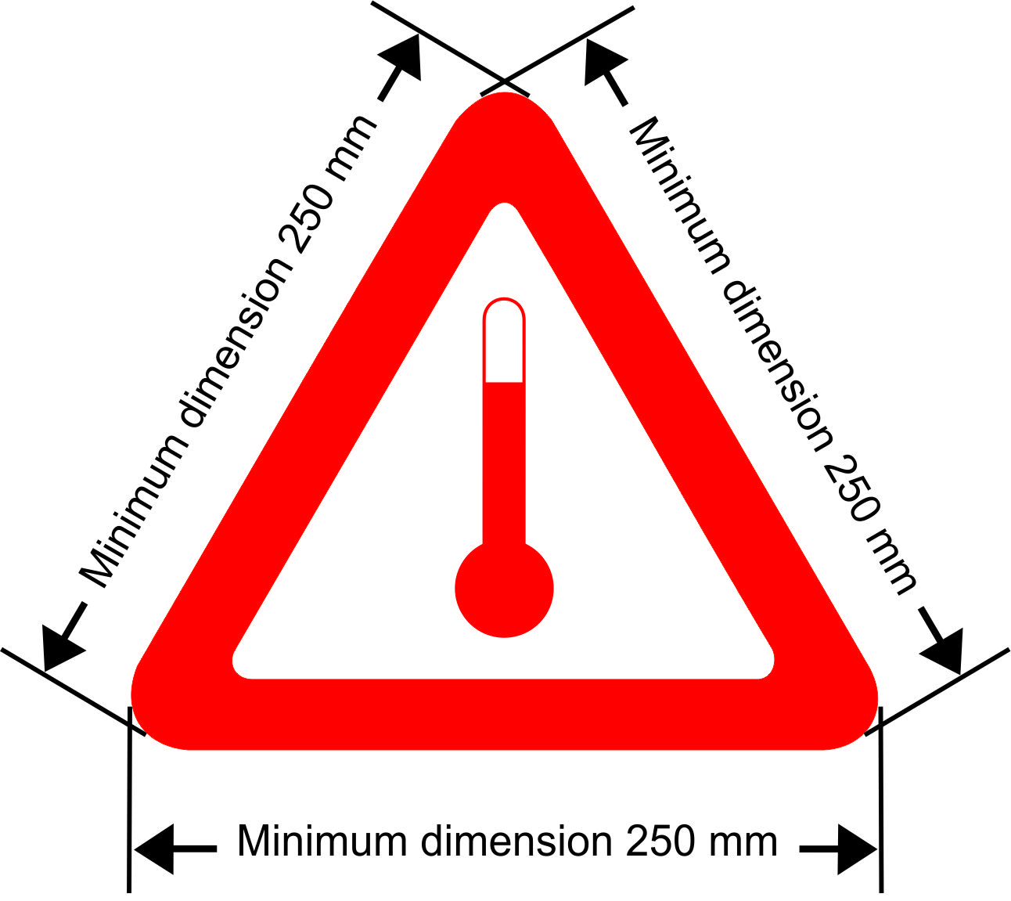

Mark for carriage at elevated temperature
The marking shall be an equilateral triangle. The colour of the mark shall be red. The minimum dimension of the sides shall be 250 mm. Where dimensions are not specified, all features shall be in approximate proportion to those shown.”.
(Reference document: ST/SG/AC.10/C.3/2012/32)
Add a new paragraph 5.3.2.3.2 as follows:
“5.3.2.3.2 The environmentally hazardous substance mark for cargo transport units shall be as described in 5.2.1.6.3 and Figure 5.2.2, except that the minimum dimensions shall be 250 mm x 250 mm.”.
(Reference document: ST/SG/AC.10/C.3/2012/32 as amended)
Chapter 5.5
Amend 5.5.2.3.2 and Figure 5.5.1 to read as follows:
“5.5.2.3.2 The fumigation warning mark shall be as shown in Figure 5.5.1.
Figure 5.5.1
* Insert details as appropriate
DANGER

THIS UNIT IS UNDER FUMIGATION
WITH ( fumigant name* ) APPLIED ON
( date* )
( time* )
VENTILATED ON ( date* )

DO NOT ENTER

Minimum dimension 400 mm
Minimum dimension 300 mm
* Insert details as appropriate.
Fumigation warning mark
The marking shall be a rectangle. The minimum dimensions shall be 400 mm wide x 300 mm high and the minimum width of the outer line shall be 2 mm. The marking shall be in black print on a white background with lettering not less than 25 mm high. Where dimensions are not specified, all features shall be in approximate proportion to those shown.”.
(Reference document: ST/SG/AC.10/C.3/2012/32 as amended)
5.5.3 Add a new subparagraph 5.5.3.1.4 to read as follows:
“5.5.3.1.4 Cargo transport units containing substances used for cooling or conditioning purposes include cargo transport units containing substances used for cooling or conditioning purposes inside packages as well as cargo transport units with unpackaged substances used for cooling or conditioning purposes.”.
(Reference document: ST/SG/AC.10/C.3/2012/53 as amended)
5.5.3.2.2 Amend subparagraph to read as follows:
“5.5.3.2.2 When dangerous goods are loaded in cargo transport units containing substances used for cooling or conditioning purposes any provisions of these Regulations relevant to these dangerous goods apply in addition to the provisions of this section.”.
(Reference document: ST/SG/AC.10/C.3/2012/53)
5.5.3.2.4 Amend subparagraph to read as follows:
“5.5.3.2.4 Persons engaged in the handling or transport of cargo transport units containing substances used for cooling or conditioning purposes shall be trained commensurate with their responsibilities.”.
(Reference document: ST/SG/AC.10/C.3/2012/53)
5.5.3.6.1 Add “purposes” after “cooling or conditioning” in the first sentence.
(Reference document: ST/SG/AC.10/C.3/2012/53)
5.5.3.6.2 Amend paragraph to read as follows:
“5.5.3.6.2 The warning mark shall be as shown in Figure 5.5.2
Figure 5.5.2
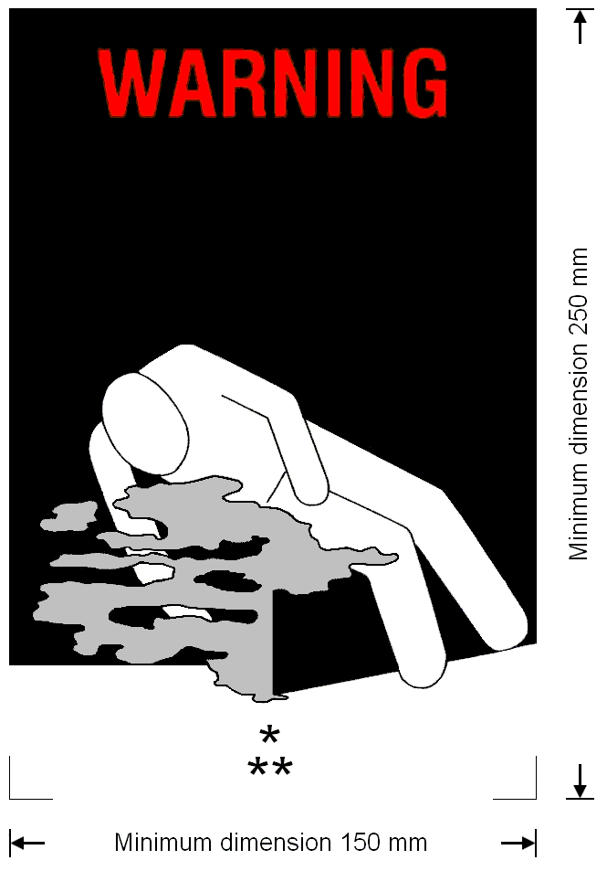
Coolant/conditioning warning mark for cargo transport units
* Insert proper shipping name of the coolant/conditioner. The lettering shall be in capitals, all be on one line and shall be at least 25 mm high. If the length of the proper shipping name is too long to fit in the space provided, the lettering may be reduced to the maximum size possible to fit. For example: CARBON DIOXIDE, SOLID.
** Insert “AS COOLANT” or “AS CONDITIONER” as appropriate. The lettering shall be in capitals, all be on one line and be at least 25 mm high.”.
(Reference document: ST/SG/AC.10/C.3/2012/32)
5.5.3.7.1 Replace “that have been cooled or conditioned” with “containing or have contained substances used for cooling or conditioning purposes”.
(Reference document: ST/SG/AC.10/C.3/2012/53)
Chapter 6.2
6.2.2 Add the following new second sentence: “Manufacture of new pressure receptacles or service equipment according to any particular standard in 6.2.2.1 and 6.2.2.3 is not permitted after the date shown in the right hand column of the tables.”
Renumber the existing NOTE as “NOTE 1”
Add the following new note: “NOTE 2: UN pressure receptacles and service equipment constructed according to standards applicable at the date of manufacture may continue in use subject to the periodic inspection provisions of these Regulations.”
(Reference document: ST/SG/AC.10/C.3/2012/52 as amended)
6.2.2.1.1 In the table, add a new third column. Add a new first row with the following text:

Reference | Title | Applicable for manufacture

For ISO Standards “ISO 9809-1:1999”, “ISO 9809-2:2000”and “ISO 9809-3:2000”, in the third column, add “Until 31 December 2018”.

After ISO Standard “ISO 9809-1:1999” add the following new standard:

ISO 9809-1:2010 | Gas cylinders -- Refillable seamless steel gas cylinders -- Design, construction and testing -- Part 1: Quenched and tempered steel cylinders with tensile strength less than 1 100 MPa | Until further notice

After ISO Standard “ISO 9809-2:2000” add the following new standard:

ISO 9809-2:2010 | Gas cylinders – Refillable seamless steel gas cylinders – Design, construction and testing – Part 2: Quenched and tempered steel cylinders with tensile strength greater than or equal to 1 100 MPa | Until further notice

After ISO Standard “ISO 9809-3:2000” add the following new standard:

ISO 9809-3:2010 | Gas cylinders -- Refillable seamless steel gas cylinders -- Design, construction and testing -- Part 3: Normalized steel cylinders | Until further notice

For all the other standards, in the column “Applicable for manufacture”, add “Until further notice”.
(Reference document: ST/SG/AC.10/C.3/2012/52)
6.2.2.1.2 In the table, add a new third column. Add a new first row with the following text:

Reference | Title | Applicable for manufacture

For ISO Standard “ISO 11120:1999”, in the column “Applicable for manufacture”, add “Until further notice”.
6.2.2.1.3 Amend the first table to read as follows:
Reference | Title | Applicable for manufacture
ISO 9809-1:1999 | Gas cylinders – Refillable seamless steel gas cylinders – Design, construction and testing – Part 1: Quenched and tempered steel cylinders with tensile strength less than 1 100 MPa  NOTE: The note concerning the F factor in section 7.3 of this standard shall not be applied for UN cylinders. | Until 31 December 2018
ISO 9809-1:2010 | Gas cylinders – Refillable seamless steel gas cylinders – Design, construction and testing – Part 1: Quenched and tempered steel cylinders with tensile strength less than 1 100 MPa | Until further notice
ISO 9809-3:2000 | Gas cylinders – Refillable seamless steel gas cylinders – Design, construction and testing – Part 3: Normalized steel cylinders | Until 31 December 2018
ISO 9809-3:2010 | Gas cylinders – Refillable seamless steel gas cylinders – Design, construction and testing – Part 3: Normalized steel cylinders | Until further notice

6.2.2.1.3 (second table), 6.2.2.1.4 and 6.2.2.1.5 In the tables, add a new third column. Add a new first row with the following text:

Reference | Title | Applicable for manufacture

For all the standards, in the column “Applicable for manufacture”, add “Until further notice”.
(Reference document: ST/SG/AC.10/C.3/2012/52 as amended)
After 6.2.2.1.5 insert a new paragraph.
“6.2.2.1.6 The standard shown below applies for the design, construction and initial inspection and test of UN bundles of cylinders. Each cylinder in a UN bundle of cylinders shall be a UN cylinder complying with the requirements of 6.2.2. The inspection requirements related to the conformity assessment system and approval for UN bundles of cylinders shall be in accordance with 6.2.2.5.

Reference | Title | Applicable for manufacture
ISO 10961:2010 | Gas cylinders – Cylinder bundles – Design, manufacture, testing and inspection | Until further notice
NOTE: Changing one or more cylinders of the same design type, including the same test pressure, in an existing UN bundle of cylinders does not require re-certification of the existing bundle.”.
(Reference document: ST/SG/AC.10/C.3/2012/40 as amended)
6.2.2.2 Replace “ISO 11114-1:1997” with “ISO 11114-1:2012”. In the title for standard “ISO 11114-1:2012”, delete "Transportable". Delete the note at the end.
(Reference document: ST/SG/AC.10/C.3/2012/40)
6.2.2.3 Amend the first table to read as follows:

Reference | Title | Applicable for manufacture
ISO 11117:1998 | Gas cylinders – Valve protection caps and valve guards for industrial and medical gas cylinders – Design, construction and tests | Until 31 December 2014
ISO 11117:2008 + Cor 1:2009 | Gas cylinders − Valve protection caps and valve guards − Design, construction and tests | Until further notice
ISO 10297:1999 | Gas cylinders – Refillable gas cylinder valves – Specification and type testing | Until 31 December 2008
ISO 10297:2006 | Gas cylinders – Refillable gas cylinder valves – Specification and type testing | Until further notice
ISO 13340:2001 | Transportable gas cylinders – Cylinders valves for non-refillable cylinders – Specification and prototype testing | Until further notice

6.2.2.3 In the second table, add a new third column. Add a new first row with the following text:

Reference | Title | Applicable for manufacture

For ISO Standard “ISO 16111:2008”, in the column “Applicable for manufacture”, add “Until further notice”.
(Reference document: ST/SG/AC.10/C.3/2012/52 as amended)
6.2.2.4 In the second table, add a new third column. Add a new first row with the following text:

Reference | Title | Applicable for manufacture

For all standards, in the column “Applicable for manufacture”, add “Until further notice”.
(Reference document: ST/SG/AC.10/C.3/2012/52)
6.2.2.7 Amend the note to read as follows: “NOTE: Marking requirements for UN metal hydride storage systems are given in 6.2.2.9 and marking requirements for UN bundles of cylinders are given in 6.2.2.10.”.
(Reference documents: ST/SG/AC.10/C.3/2012/40 and informal document INF.54 as amended)
6.2.2.7.4 (p) Replace “ISO 11114-1:1997” with “ISO 11114-1:2012”.
(Reference document: ST/SG/AC.10/C.3/2012/40)
Delete subparagraph 6.2.2.7.9.
(Reference documents: ST/SG/AC.10/C.3/2012/40 and informal document INF.54 as amended)
6.2.2.9.2 (j) Replace “ISO 11114-1:1997” with “ISO 11114-1:2012”.
(Reference document: ST/SG/AC.10/C.3/2012/40)
6.2.2.10 Add the following new section:
"6.2.2.10 Marking of bundles of cylinders
6.2.2.10.1 Individual cylinders in a bundle of cylinders shall be marked in accordance with 6.2.2.7.
6.2.2.10.2 Refillable UN bundles of cylinders shall be marked clearly and legibly with certification, operational, and manufacturing marks. These marks shall be permanently affixed (e.g. stamped, engraved, or etched) on a plate permanently attached to the frame of the bundle of cylinders. Except for the UN packaging symbol, the minimum size of the marks shall be 5 mm. The minimum size of the UN packaging symbol shall be 10 mm.
6.2.2.10.3 The following marks shall be applied:
(a) The certification marks specified in 6.2.2.7.2 (a), (b), (c), (d) and (e);
(b) The operational marks specified in 6.2.2.7.3 (f), (i), (j) and the total of the mass of the frame of the bundle and all permanently attached parts (cylinders, manifold, fittings and valves). Bundles intended for the carriage of UN 1001 acetylene, dissolved and UN 3374 acetylene, solvent free shall bear the tare mass as specified in clause B.4.2 of ISO 10961:2010; and
(c) The manufacturing marks specified in 6.2.2.7.4 (n), (o) and, where applicable, (p).
6.2.2.10.4 The marks shall be placed in three groups:
(a) The manufacturing marks shall be the top grouping and shall appear consecutively in the sequence given in 6.2.2.10.3 (c);
(b) The operational marks in 6.2.2.10.3 (b) shall be the middle grouping and the operational mark specified in 6.2.2.7.3 (f) shall be immediately preceded by the operational mark specified in 6.2.2.7.3 (i) when the latter is required;
(c) Certification marks shall be the bottom grouping and shall appear in the sequence given in 6.2.2.10.3 (a).".
(Reference documents: ST/SG/AC.10/C.3/2012/40 and informal document INF.54)
Chapter 6.5
Amend 6.5.2.2.2 to read as follows:
"6.5.2.2.2 The maximum permitted stacking load applicable when the IBC is in use shall be displayed on a symbol as shown in Figure 6.5.1 or Figure 6.5.2. The symbol shall be durable and clearly visible.
Figure 6.5.1 Figure 6.5.2
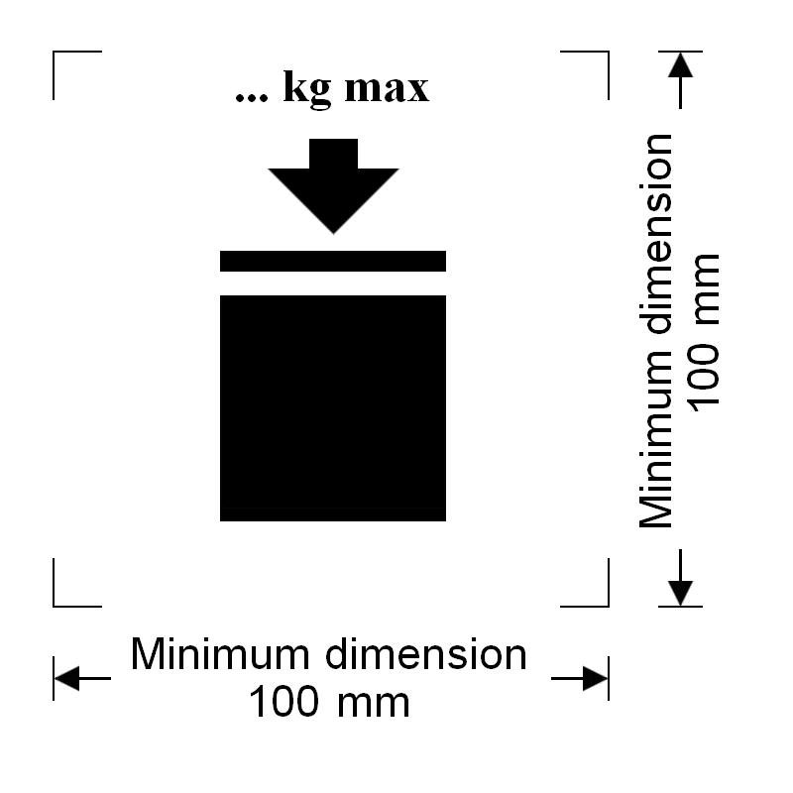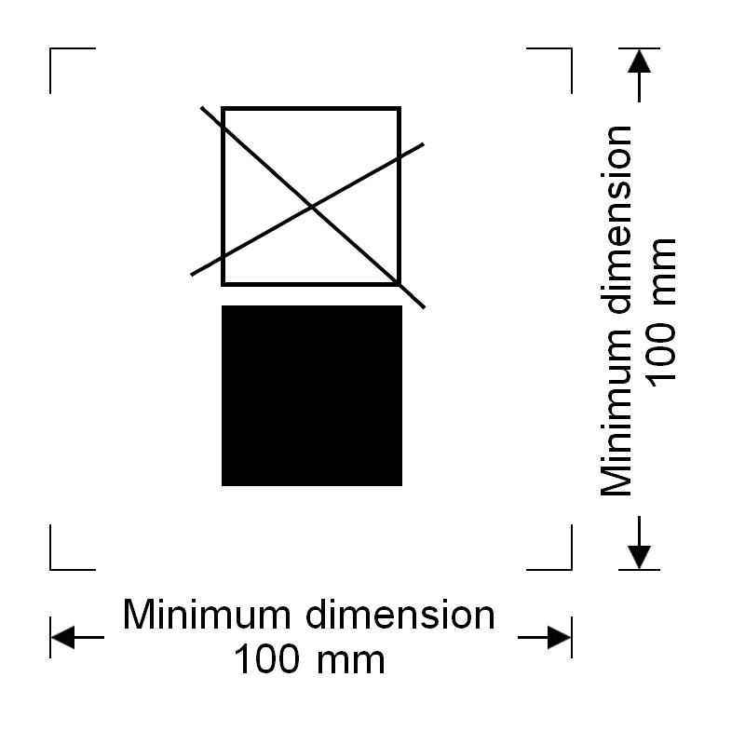
IBCs capable of being stacked IBCs NOT capable of being stacked
The minimum dimensions shall be 100 mm x 100 mm. The letters and numbers indicating the mass shall be at least 12 mm high. The area within the printer’s marks indicated by the dimensional arrows shall be square. Where dimensions are not specified, all features shall be in approximate proportion to those shown. The mass marked above the symbol shall not exceed the load imposed during the design type test (see 6.5.6.6.4) divided by 1.8.”.
(Reference document: ST/SG/AC.10/C.3/2012/32)
Chapter 6.6
Amend 6.6.3.3 to read as follows:
"6.6.3.3 The maximum permitted stacking load applicable when the large packaging is in use shall be displayed on a symbol as shown in Figure 6.6.1 or Figure 6.6.2. The symbol shall be durable and clearly visible.
Figure 6.6.1 Figure 6.6.2
Large packagings capable of being stacked Large packagings NOT capable of being stacked
The minimum dimensions shall be 100 mm x 100 mm. The letters and numbers indicating the mass shall be at least 12 mm high. The area within the printer’s marks indicated by the dimensional arrows shall be square. Where dimensions are not specified, all features shall be in approximate proportion to those shown. The mass marked above the symbol shall not exceed the load imposed during the design type test (see 6.6.5.3.3.4) divided by 1.8.
NOTE: The provisions of 6.6.3.3 shall apply to all large packagings manufactured, repaired or remanufactured as from 1 January 2015.”.
(Reference document: ST/SG/AC.10/C.3/2012/32)
Chapter 6.7
6.7.5.2.4 (a) Replace “ISO 11114-1:1997” with “ISO 11114-1:2012”.
(Reference document: ST/SG/AC.10/C.3/2012/40)

Annex III
Draft amendments to the Guiding principles
Add the following text into the Guiding Principles:
"Part 4
Packing and tank provisions
4.1 Basic principles for developing packing instructions for the Model Regulations
General provisions
1. Packing Instructions should be clear and provide as wide a choice of packagings as possible.
2. The Packing Instructions consist of a small number of general instructions supplemented by a limited number of more specific instructions for particularly hazardous or specialized dangerous goods.
3. Packing Instructions should be developed with the objective of being suitable for multimodal transport. More severe packaging restrictions, in some instances, may be necessary for mode specific regulations.
4. A rationalized approach (based on similar properties or hazards presented) should be used for allocating packing instructions to specific substances.
5. The Packing Instructions are primarily intended for the person preparing the package for consignment. They should not address classification or operational provisions.
The Packing Instruction Structure
There are Packing Instructions for:
- Packagings, prefixed by “P”. Included are:
˗ Packagings in accordance with Chapter 6.1 (up to 450 l and/or 400 kg net, as appropriate).
˗ Pressure receptacles in accordance with Chapter 6.2.
˗ Packagings for Division 6.2 substances in accordance with Chapter 6.3.
˗ Packagings or packing methods not subject to the provisions of Chapters 6.1, 6.2, 6.3, 6.5 or 6.6.
- IBCs, prefixed by "IBC", up to 3 m³ (intermediate bulk containers in accordance with Chapter 6.5);
- Large packagings, prefixed by "LP", exceeding 400 kg net or 450 l (large packagings in accordance with Chapter 6.6).
The majority of substances and articles, excluding Classes 1, 2 and 7, have been allocated to a packing instruction beginning "P00*". When considering new Packing Instructions the use of one of these numbers should be considered first; class specific packing instructions should only be used when there is need for restricted packaging options or extensive special conditions. The exception to this rule is P004 to which fuel cell cartridges containing dangerous goods of different Classes are assigned.
Where the "P00*" instructions cannot be used then there are series of class specific packing instructions all beginning with the class number. In some cases it will be necessary to indicate in the Packing Instruction that in addition to the permitted design types packages and any quantity thresholds that are specified, there are some ‘Additional Requirements’ that apply for all substances or articles assigned to that Packing Instruction. An example is the requirement to protect cells and batteries against short circuit as may be found in Packing Instruction P801 or P903. Some Packing Instructions may need to include provisions which are relevant only for a small number of substances or articles among many others that are assigned to a particular Packing Instruction. These are referred to as Special Packing Provisions and because these are indicated in Column 9 of the Dangerous Goods List they are individually numbered as PPxx. An example is PP28 which is specific to Perchloric Acid in Packing Instruction P502. Some, such as PP26 which requires packagings to be lead free, will appear in more than one Packing Instruction with the same number since the requirement is the same but the UN numbers to which it applies are different.
Where a solid or liquid substance can only be transported in a cylinder then allocation to Table 3 of P200 shall be considered.
Packagings "P"
Some general principles of assignment of substances to Packing Instructions and examples of exceptions are given below:
Class 1 P100s
Given the intrinsic properties of explosive substances and articles and the variable effects that they display depending on the manner in which they are packaged, the classification process addresses issues of possible over-confinement, for example in metal packagings. Such packagings are often chosen for their robustness in handling rather than their appropriateness in transport.
However, given the desirability of uniformity in assessing packaging in relation to the classification process (as set out in the Manual of Tests and Criteria) it has been decided that packagings used to transport explosive substances and articles should meet the Packing Group II test performance level.
Similar principles apply to the assignment of packaging for organic peroxides and self-reactive substances.
Class 2 P200s
For gases, except some small articles containing gas such as UN2037 or UN3150 which are allocated to P003.
Class 3 P300s
Flammable liquids with explosive properties are assigned to P300 (UN 3064). Substances that form part of chemical kits are assigned to P302.
Class 4 P400s
Many substances of this class have been allocated to special P400 Packing Instructions.
Self reactive substances in Division 4.1 are packaged in the same way as organic peroxides and are allocated to P520. This Packing Instruction contains packing method codes OP1 to OP8 which refer to the packing methods for the various types of organic peroxides/self reactive substances.
Class 5 P500s
Chemical oxygen generators only are assigned to P500 and stabilized hydrogen peroxide only is assigned to P501.
Substances of Division 5.2 are assigned to P520. This Packing Instruction contains packing method codes OP1 to OP8 which refer to the packing methods for the various types of organic peroxides/self reactive substances.
Division 6.1 P600s
Toxic ammunition and tear gas candles are assigned to P600.
Division 6.2 P600s
Infectious substances are assigned to P620, P621 or P650.
Class 7
No packing instructions have yet been allocated to radioactive materials as the packaging requirements have been set by IAEA and do not align easily to the system for the other classes. Instead radioactive material is assigned to special UN numbers which depend on a number of characteristics including packaging such as the activity level of radionuclides in the package, or the fissile or non fissile properties.
Class 8
There are a number of specific Packing Instructions for Class 8 substances and articles.
Class 9
Substances and articles of this Class each have a hazard not covered by other Classes. When any substance or article is assigned to this Class its unique properties will need to be considered in developing or assigning a Packing Instruction.
The following should form the template for any new proposal to the UN Subcommittee of experts for new Packing Instruction (PXXX) for Classes/Divisions 3, 4, 5.1, 6, 8 or 9.
PXXX | PACKING INSTRUCTION |  |  | PXXX
For specific UN number(s) ONLY:
This instruction applies to UNXXXX…..
(E.g. see P301)
The following packagings are authorized, provided that the general provisions of 4.1.1 and 4.1.3 are met:
Sometimes additional paragraphs will need to be quoted or alternatives given e.g. P620
 |  |  | Maximum net mass (see 4.1.3.3)
Combination packagings
Inner packagings |  | Outer packagings
List permitted types  and capacity/mass |  | Drums List permitted types
Boxes List permitted types
Jerricans List permitted types
 |  |  | Maximum capacity (see 4.1.3.3)
Single packagings
Drums List permitted types
Jerricans List permitted types
Boxes List permitted types
Bags List permitted types
Composite packagings List permitted types
Pressure receptacles, provided the general provisions of 4.1.3.6 are met
If 4.1.3.6 is not sufficient then the use of cylinders should be addressed in detail. E.g.P602(4)
Additional requirements
This section should contain additional packaging information which should be applicable to specific or all the packaging choices listed above
Special packing provision
PPXX For UNxxxx…….
These should address specific requirements for individual or groups of substances. The provision should only address packaging issues and not classification or operational provisions.
”.
(Reference document: ST/SG/AC.10/C.3/2012/42 as amended)
Add the following text into Part 6 of the Guiding Principles:
“Chapter 6.2: System for providing a period of transition when new standards replace existing referenced standards for UN pressure receptacles, their service equipment and periodic inspection and test
- Principles
- When an existing standard is replaced by either a revised version or another standard having the same scope, there shall be a period during which either the new or old standard may be used. This will allow for the issue of new type approvals, the adjustment of procedures and where necessary, the acquisition of new equipment.
- The period shall be expressed by setting a limiting date after which the old standard can no longer be used. The new standard can be used from the date at which the regulations in which they are listed come into force.
- For standards covering the design and manufacture of pressure receptacles and their closures, the limiting date shall normally be set at six years from the close of the biennium in which the new standard was agreed for referencing in the Model Regulations. For example, if a standard is adopted in the 2011/2012 biennium, the standard which it replaces shall have a limiting date of 31 December 2018.
NOTE: Given the time taken to transfer new provisions from the Model Regulations into the international provisions for the air, sea and land modes, it is expected that this will result in an actual transition period of four years.
- For standards covering periodic inspection a limiting date of four years from the end of the biennium of adoption of the new standard shall be set. When the transition period is completed, the old standard shall be deleted.
- If the Sub Committee of Experts on the Transport of Dangerous Goods believes that the new standard provides a significant improvement in public safety, it may set shorter transition periods.
- A transition period is not envisaged for standards in sub section 6.2.2.2 concerning materials (ISO 11114, parts 1 and 2 concerning the compatibility of materials with gases) since these provide information and guidance only.
- A transition period shall not be set when a new standard is introduced having a scope not previously covered in section 6.2.2.
- The regulations shall include a statement that UN pressure receptacles constructed according to standards applicable at the date of manufacture may continue in use subject to periodic inspection provisions of the Model Regulations.”.
Presentation of the transition periods in the Model Regulations
Each table of standards shall have a column at the right showing the date after which the standard shall not be used. In the case of standards for design and manufacture this column shall be headed “Applicable for manufacture”. In the table in the sub section for Periodic inspection and test, the column shall be headed “Applicable”.
Alongside each standard for which a limit date has been set shall appear “Until 31 December 2XYZ”. If no date has been set the words “Until further notice” shall appear.
Examples of how the standards shall be listed
- The table below gives an example for sub section 6.2.2.1 Design, construction and initial inspection and test showing a revised standard adopted in the biennium 2011/2012 (for the eighteenth Revised Edition).0

Reference | Title | Applicable for manufacture
ISO 9809-2:2000 | Gas cylinders – Refillable seamless steel gas cylinders – Design, construction and testing – Part 2: Quenched and tempered steel cylinders with tensile strength greater than or equal to 1 100 MPa | Until 31 December 2018
ISO 9809-2:2010 | Gas cylinders – Refillable seamless steel gas cylinders – Design, construction and testing – Part 2: Quenched and tempered steel cylinders with tensile strength greater than or equal to 1 100 MPa | Until further notice

- The table gives an example for sub section 6.2.2.4 Periodic inspection and test showing a revised standard adopted in the biennium 2015/2016 (for the twentieth Revised edition).

Reference | Title | Applicable
ISO 6406: 2005 | Periodic inspection and testing of seamless steel gas cylinders | Until 31 December 2020
ISO 6406: 2015 | Periodic inspection and testing of seamless steel gas cylinders | Until further notice

The 2005 version of the standard could be deleted in the twenty-second Revised Edition.”.
(Reference document: ST/SG/AC.10/C.3/2012/52 as amended)

