 | United Nations | ST/SG/AC.10/C.3/2012/30
 | Secretariat |  | Distr.: General  5 April 2012  Original: English
Committee of Experts on the Transport of Dangerous Goods
and on the Globally Harmonized System of Classification
and Labelling of Chemicals
Sub-Committee of Experts on the Transport of Dangerous Goods
Forty-first session
Geneva, 25 June – 4 July 2012
Item 2 (d) of the provisional agenda
Explosives and related matters: DDT Test and criteria for flash composition
Proposed alternate flash composition test for fireworks classification using the default table
Transmitted by the expert from the United States of America
Background
- At the 37th session, the expert from the United States of America first presented an alternative test method (the “Deflagration to Detonation Transition” [DDT] Flash Composition Test) to the current HSL Flash Composition Test method for evaluating pyrotechnic mixtures (see ST/SG/AC.10/C.3/2010/31) supported by test data from ten different materials. At the 39th session, the expert from the United States provided a revised drawing of the DDT Flash Composition Test Fixture and test results for twelve additional materials using the methodology (see informal document INF.44, 39th session). Other informal papers were also presented by the expert from Japan (INF.22) and the expert from Germany (INF.16). All of the testing done indicated general agreement with the results obtained by the expert from the United States of America.
- Since the proposed method is easier to perform and utilizes larger samples, it was considered by the Working Group on Explosives to be an attractive alternative test. There was group consensus that the DDT test proposed by the United States of America was a good way forward (see the report of the Working Group on Explosives in informal document INF.58, 39th session). A number of comments were received that the United States has worked to address in this revised proposal. For example, Germany pointed out some safety issues related to the size of the mortar that could be encountered in performing the test. Germany also cautioned that the mass of the mortar could be an influencing factor on the outcome of the test and offered to investigate further. Japan and the United Kingdom observed that their work indicates that the degree of granularity of composition can affect results, and consideration should be given to expanding the method to include samples with granular material. They agreed that the weight of the tube could be a safety or test outcome-influencing factor and support Germany’s further research. Other experts such as the Netherlands and Australia also expressed the opinion that the sample mass could influence the outcome of the test and recommended that this potential effect should be studied further. The United Kingdom observed that the test was really straightforward to perform and supported its continued development. The Netherlands observed that the test only screens for detonation and that the criteria may not coincide with what would have been referred to as “flash powder” 15 years ago. AEISG requested additional time to review the proposal to try to identify any criteria that may have been over-prescribed. The United Kingdom observed that acceptance of the test would be easier if the focus was fireworks rather than flash powder.
3. Taking note of the working group’s comments, the United States of America has continued to refine and prove the reliability of the test, particularly, concerns related to the reproducibility of test results, comparison of the test results with the HSL Flash Composition Test Method, effect of the weight of the steel confining tube on the sample mass, and preliminary results related to granulated material. Five additional compositions have also been examined in addition to the twenty-two prior results, bringing the total DDT Flash Composition Test data base to twenty-nine different pyrotechnic substances.
4. The experimental results with DDT Test Fixtures and with HSL Flash Composition Test Fixtures are given in annex I (English only). The revised proposals for adoption of the DDT Flash Composition test are given in annex II.
Annex I
English only
A. Experimental results with DDT Test Fixtures
1. To address questions about the reproducibility of the DDT Flash Composition Test, the expert from the United States has redone testing on all the twenty-two compositions previously reported plus added five new compositions. All test conditions were identical to those used previously except that the steel confining sleeve had been slightly modified by the addition of a handle (See Figure 1.) which added approximately 200 grams to its weight. The added handle made it easier to place the confining sleeve over the fiberboard sample tube and also made a convenient place to attach a 12 meter long steel cable for safety reasons.
2. The results of these re-tests, as compared to the original results are shown in Table I. In twenty-one of twenty-two cases, there was no change in the outcome. In almost every case, the results were quite reproducible in triplicate. However, in the case of Sample No. 3, the original single positive ( + ) result could not be duplicated, even after eight re-tests. It is believed that the first result, which was marginally positive (a very slight “tear” in the witness plate) was possibly the result of a non-uniform sample. The composition contained an unusually wide particle size distribution of magnesium metal powder, and the one sample first tested might have been higher in the ultra-small particle size fraction than realized.
Figure 1. Standard DDT test fixture
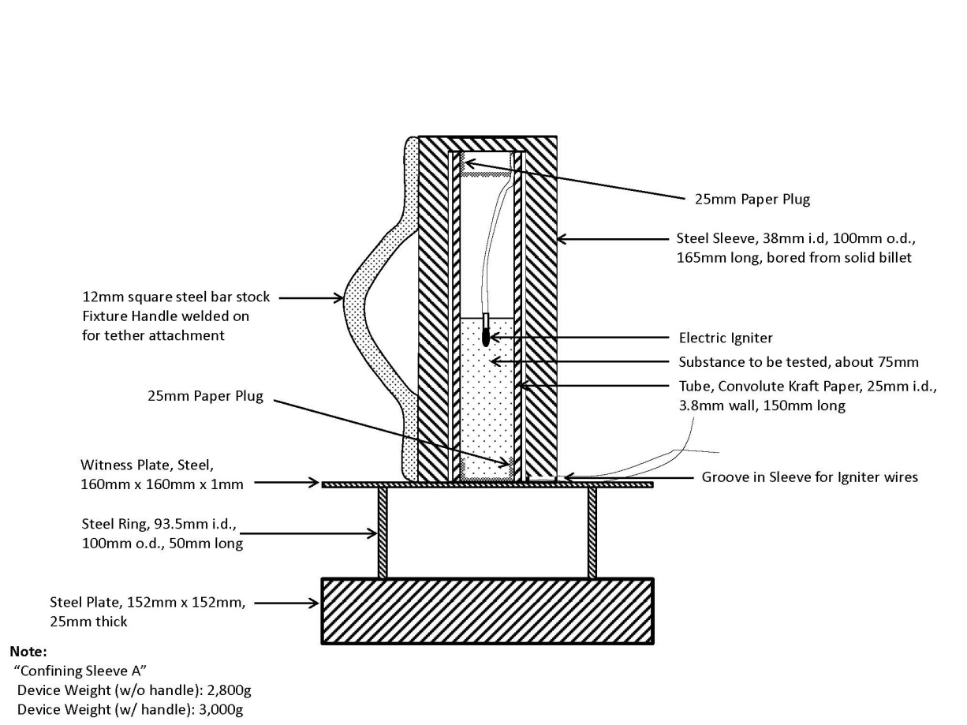
Table I

Sample  No. | Composition  Descriptions | DDT Test Results With 2.8 Kg. Steel Confining Sleeve | Re-Tested in Triplicate with 3.0 Kg. Steel Confining Sleeve (Handle added)
1 | Goex Black powder -- 5FA “Unglazed” | ( - ), ( - ), ( - ) | ( - ), ( - ), ( - )
2 | 35 wt.% Potassium Nitrate (100% < 37 µ)/ 31% wt. Potassium Perchlorate (100% < 37 µ) /13.5% wt. % Potassium Benzoate (fine powder)/ 10 wt.% Sulfur (fine powder)/10.5 wt. %Lampblack (nano-material). | ( - ), ( - ), ( - ) | ( - ), ( - ), ( - )
3 | 70 wt. % Potassium Perchlorate (100% < 37 µ) / 30 wt. % “Semi-coarse” Magnesium powder -- (297µ<25%>149µ; 148µ<58%>53µ; 52µ< 5%>44µ; 12%<43µ) | ( + ) : not tested further.  Note: Very slight tear in witness plate | ( - ), ( - ), ( - ),  ( - ), ( - ), ( - ),  ( - ), ( - )  Could not reproduce earlier positive result in 8 trials
4 | 65 wt. % Potassium Perchlorate (100% < 44µ)/ 35 wt. % Magnesium (105µ 5%>74µ; 73µ <39%>44µ; 46%<43µ) | ( + ) : not tested further | ( + ), ( + ), ( + )
5 | 65 wt. % Potassium Perchlorate (100% < 44µ)/ 35 wt. % “Ground” Magnesium (100% <43µ) | ( + ) : not tested further | ( + ), ( + ), ( + )
6 | 70 wt. % Potassium Perchlorate (100% < 37 µ)/ 30 wt, % “Atomized” Aluminum powder (74µ<2.4%>53µ; 52µ<2.9%>44µ; 94.7%<44µ) | ( + ) : not tested further | ( + ), ( + ), ( + )
7 | 65 wt. % Potassium Perchlorate (100% < 44µ)/ 35 wt. % “Flake” Aluminum “A” (105µ <72%>53µ; 52µ <17%>44µ; 11.5%<43µ) | ( + ) : not tested further | ( + ), ( + ), ( + )
8 | 65 wt. % Potassium Perchlorate (100% < 44µ)/35% “Flake ” Aluminum “B” (74µ<39% >53µ; 52µ<22%>44µ; 40%<43µ) | ( + ) : not tested further | ( + ), ( + ), ( + )
9 | 70 wt. % Potassium Perchlorate (100% < 37 µ)/ 30 wt. % “Ground” Magnalium powder --(74µ<37%>53µ; 52µ<11%>44µ; 52%<44µ) | ( + ) : not tested further | ( + ), ( + ), ( + )  ( + ), ( + ), ( + ),  ( + ), ( + )
10 | 68 wt. % Barium Nitrate (105µ < 10% > 74 µ; 73 µ<12%>44 µ; 43 µ< 24%>37 µ; 53%<37 µ)/23 wt. % “Dark Flake” Aluminum (100%< 73 µ)/9 wt. % Sulfur (fine powder) | ( - ), ( - ), ( - ) | ( - ), ( - ), ( - )
11 | 85 wt. % Potassium Perchlorate (97% < 74µ & 30% < 37µ)/ 10 wt. % Sulfur (very fine ground flour)/ 5 wt. % powdered charcoal | ( - ), ( - ), ( - ) | ( - ), ( - ), ( - )
12 | 80 wt. % Potassium Perchlorate (97% < 74µ & 30% < 37µ)/10 wt. % Sulfur (very fine ground flour)/10 wt. % powdered charcoal | ( - ), ( - ), ( - ) | ( - ), ( - ), ( - )
13 | 75 wt. % Potassium Perchlorate (97% < 74µ & 30% < 37µ)/10 wt. % Sulfur (very fine ground flour)/15 wt. % powdered charcoal | ( - ), ( - ), ( - ) | ( - ), ( - ), ( - )
14 | 70 wt. % Potassium Perchlorate (97% < 74µ & 30% < 37µ)/10 wt. % Sulfur (very fine ground flour)/20 wt. % powdered charcoal | ( - ), ( - ), ( - ) | ( - ), ( - ), ( - )
15 | 65 wt. % Potassium Perchlorate (97% < 74µ & 30% < 37µ)/10 wt. % Sulfur (very fine ground flour)/25 wt. % powdered charcoal | ( - ), ( - ), ( - ) | ( - ), ( - ), ( - )
16 | 60 wt. % Potassium Perchlorate (97% < 74µ & 30% < 37µ)/10. wt % Sulfur (very fine ground flour)/30 wt. % powdered charcoal | ( - ), ( - ), ( - ) | ( - ), ( - ), ( - )
17 | 52 wt. % Potassium Perchlorate (97% < 74µ & 30% < 37µ)/17 wt. % Sulfur (very fine ground flour)/5 wt. % powdered charcoal/26 wt. % Antimony trisulfide | ( - ), ( - ), ( - ) | ( - ), ( - ), ( - )
18 | 50 wt. % Potassium Perchlorate (97% < 74µ & 30% < 37µ)/30 wt. % Sulfur (very fine ground flour)/20 wt. % powdered charcoal | ( - ), ( - ), ( - ) | ( - ), ( - ), ( - )
19 | 70 wt. % Potassium Perchlorate (97% < 74µ & 30% < 37µ)/20 wt. % Sulfur (very fine ground flour)/10 wt. % powdered charcoal | ( - ), ( - ), ( - ) | ( - ), ( - ), ( - )
20 | 60 wt. % Potassium Perchlorate (97% < 74µ & 30% < 37µ)/30 wt. % Sulfur (very fine ground flour)/10 wt. % powdered charcoal | ( - ), ( - ), ( - ) | ( - ), ( - ), ( - )
21 | 60 wt. % Potassium Perchlorate (97% < 74µ & 30% < 37µ)/20 wt. % Sulfur (very fine ground flour)/20 wt. % powdered charcoal | ( - ), ( - ), ( - ) | ( - ), ( - ), ( - )
22 | 48 wt. % Potassium Perchlorate (100 < 37µ)/52 wt. % Iron Powder (100% <45µ and 94% < 37µ) | ( - ), ( - ), ( - )  Burned only | ( - ), ( - ), ( - )  Burned only
23 | Eurenco CSB-4 single base porous smokeless flake powder | Not Tested Before | ( - ), ( - ), ( - )
24 | Alliantech Systems “Green Dot” double base coated smokeless flake powder | Not Tested Before | ( - ), ( - ), ( - )
25 | 70 wt. % Potassium Perchlorate(97% < 74µ & 30% < 37µ) /30 wt. % Potassium benzoate (fine powder) – a “whistle-making” composition | Not Tested Before | ( + ), ( + ), ( + )
26 | 40 wt. % Potassium Perchlorate(97% < 74µ & 30% < 37µ)/60 wt, % ground magnesium powder (100% <43µ) | Not Tested Before | ( + ), ( + ), ( + )
27 | 50 wt. % Potassium Perchlorate(97% < 74µ & 30% < 37µ)/27 wt. % antimony sulfide powder/23 wt. % “Atomized” aluminum powder (74µ<2.4%>53µ; 52µ<2.9%>44µ; 94.7%<44µ) | Not Tested Before | ( + ), ( + ), ( + )
In addition to the original 22 formulations or compositions re-tested, the expert for the United States has also tested five new compositions (23-27) which were included in Table I. Perhaps the most surprising test result was that for Formulation No. 27, a frequently used “Whistle Powder” mixture of ground potassium perchlorate and fine potassium benzoate (70/30 by weight). Even though this mixture contained NO metal particulate fuels, the results clearly show that the formulation met the proposed criteria for a “flash composition” as shown. Thus, it can be stated that “flash compositions” at least as defined by the proposed test method, need not always contain metal particulate fuels.
3. The question was asked by the expert from Germany whether increasing the weight of the steel confining sleeve or the quantity of sample would shift the result outcomes. To fully answer the German expert’s question, a brief review of how the final Alternate Flash Composition Test Method evolved to its current state is appropriate here.
The test method was simply developed by a process of trial and error beginning with a small number of compositions which the expert from the United States knew were already being widely used in aerial fireworks “salute” shells. These included Formulation Sample Numbers 4-8 in Table 1. Initially, a 71 gram (3 ounce) sample size was selected, primarily because it was the approximate quantity of “Flash Compositions” commonly found in 80 mm (3 inch) diameter spherical aerial “salute” shells. For initial tests, almost no confinement was used other than a paperboard container, which was placed on top of the witness plate. A steel ring the same diameter as the support ring was also placed around the container, just to contain the horizontal flash effect. The 71 gram sample formulations 4-8 all easily and reproducibly punctured the witness plate when ignited with a Davey-Bickford electric match. The formulations sample size was then halved to 35 grams, with the same light confinement in the same paperboard containers and the results were unchanged from the 71 gram sample sizes for Formulations 4-8. However, when the sample size was halved again to 17.5 grams, negative ( - ) results started to occur, either through poor ignition or inadequate sample depth or both. It was decided to replace the wider paperboard containers with convolute fiberboard wound tubing of approx. 25 mm in diameter and approximately 150 mm in height and thereby improve the sample depth. This replacement was partially successful, but the sample size had to be increased, first to 20 grams and then ultimately to 25 grams for optimal reproducibility.
4. Because of the relative instability of a tall, thinner sample formulation holder under ambient wind conditions on a typical outdoor test site, the fiberboard tube was then enclosed in a 150 mm high section of inexpensive steel pipe having a diameter just slightly larger than the fiberboard. This led to much more reproducible results, but the inexpensive steel pipe sleeves had to be frequently replaced because they bulged out from the force of the explosions. The final solution was to custom design a confining sleeve, precisely bored from a solid billet of steel a size, weight and thickness which would prove rugged enough so as to only need very infrequent replacement. It was decided at this point to also add top confinement to the steel sleeve design to make it more similar to other DDT apparatus. Several prototype designs were tried for the steel confining sleeve, some lighter and some heavier, but the final dimensions of what became the “Standard” 3 Kilogram fixture (shown in Figure 1) were chosen based on the fixture ruggedness and overall handling convenience for the technicians conducting the tests. The confining sleeves were all machined out of non-stainless steels and will slowly corrode depending on ambient moisture, but their service life, due to continual end abuse (rising in air and falling back from achieved heights of up to 15 meters) is perhaps a few months to a year, well below any presumed long term corrosion effects that may occur.
5. However, it is logical to assume that the more the confining sleeve weighs, the longer the confinement will remain around the sample tube and therefore the more force might be directed downward on the witness plate. To prove this, a very heavy steel confining sleeve was fabricated which weighed approximately five to six times more than the “Standard” confining sleeve shown in Figure 1. This heavy confining sleeve fixture is depicted in Figure 2 below.
Figure 2. Heavy steel confining sleeve fixture

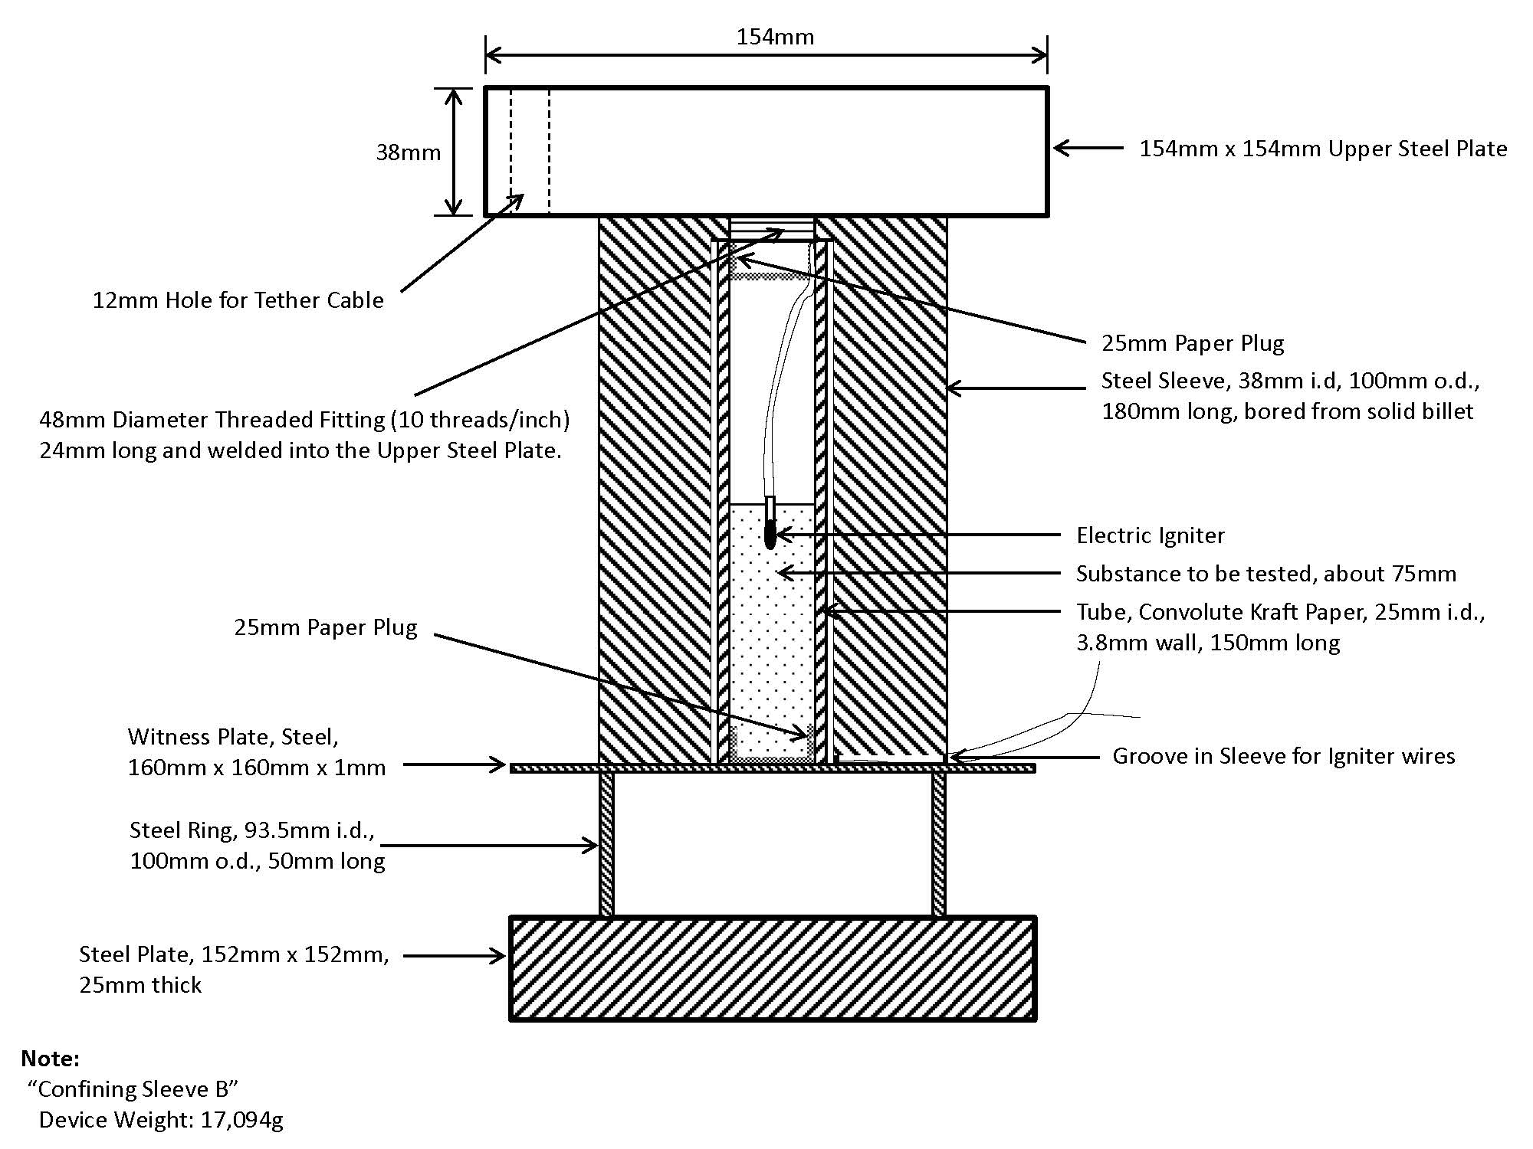

Table II. Comparison of standard and heavy steel confining sleeve results
Sample  No | Composition Descriptions | DDT Test Results With Standard Steel Confining Sleeve “A” | DDT Test Results with Heavy Steel Confining Sleeve “B”.
1 | Goex Black powder -- 5FA “Unglazed” | ( - ), ( - ), ( - ) | ( - ), ( - ), ( - )
2 | 35 wt. % Potassium Nitrate (100% < 37 µ)/ 31% Potassium Perchlorate (100% < 37 µ) /13.5% wt. Potassium Benzoate (fine powder)/ 10 wt. % Sulfur (fine powder)/10.5 wt. %Lampblack (nano-material). | ( - ), ( - ), ( - ) | ( + ), ( + ), ( + )
3 | 70 wt. % Potassium Perchlorate (100% < 37 µ) / 30 wt. % “Semi-coarse” Magnesium powder -- (297µ<25%>149µ; 148µ<58%>53µ; 52µ< 5%>44µ; 12%<43µ) | ( - ), ( - ), ( - ) | ( + ), ( + ), ( + )
10 | 68 wt. % Barium Nitrate (105µ < 10% > 74 µ; 73 µ<12%>44 µ; 43 µ< 24%>37 µ; 53%<37 µ)/23 wt. % “Dark Flake” Aluminum (100%< 73 µ)/9 wt. % Sulfur (fine powder) | ( - ), ( - ), ( - ) | ( + ), ( + ), ( + )
13 | 75 wt. % Potassium Perchlorate (97% < 74µ & 30% < 37µ)/10 wt. % Sulfur (very fine ground flour)/15 wt % powdered charcoal | ( - ), ( - ), ( - ) | ( - ), ( + ), ( + )
17 | 52 wt. % Potassium Perchlorate (97% < 74µ & 30% < 37µ)/17 wt. % Sulfur (very fine ground flour)/5 wt. % powdered charcoal/26 wt % Antimony trisulfide | ( - ), ( - ), ( - ) | ( - ), ( + ), ( + )
Results with the heavier confining “B” sleeve on six compositions that previously had given negative “( - )” results with the standard “A” sleeve, showed that all had been shifted to positive “( + )” outcomes except Goex 5FA black powder.
6. The question then evolves as to whether the heavier “B” sleeve should actually replace the standard “A” sleeve in the DDT Flash Composition test method? There are two counter-arguments against taking that decision in the view of the expert from the United States. The first is that shifting more and more pyrotechnic compositions into the category of “flash compositions” which really do not have a potential for violent energetic release when accidentally ignited in a low state of confinement typically found in fireworks articles do not pose a significant risk in transport may “over-regulate” the fireworks industry. The second is the operational concern of conducting the testing with a 17 kilogram steel sleeve that increases the risk of accidental ignition in the event of a sudden drop in its final positioning on the steel witness plate and puts the operator at risk of injury. For these reasons, replacement of the Standard “A” confining sleeve with the heavier “B” confining sleeve is not preferred.
7. The question was also raised by the expert from Japan as to whether granulating or “coating” of a composition which tested positive in the propose DDT Flash Composition would alter its performance. Some preliminary trials were made using 25 grams of sample No. 6 ( a 70/30 potassium perchlorate / atomized aluminum mixture) coated onto rice hulls at two different volumetric ratios as show in Figure 3. Results are shown in Table III below.
Figure 3
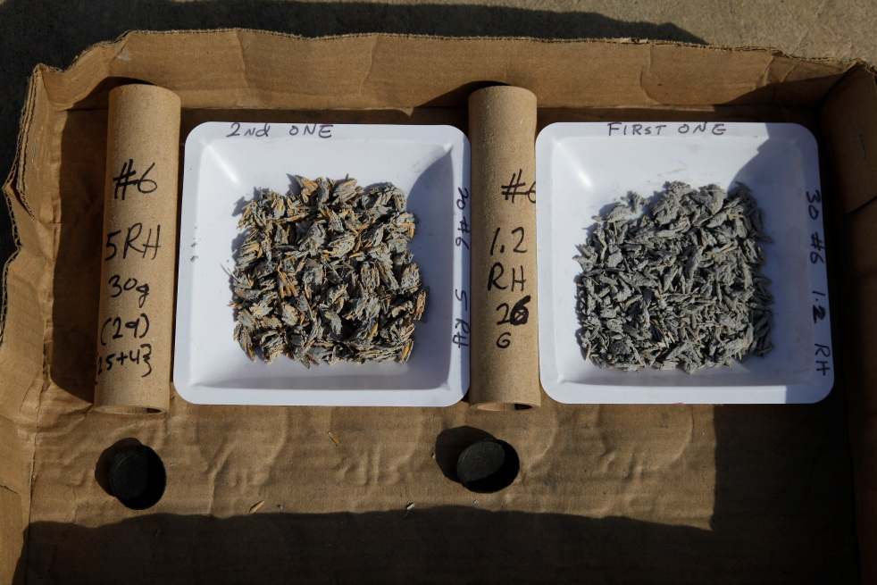

Table III. Comparison of Uncoated and Coated Compositions
Sample No. | Composition - 25 grams of Pyrotechnic Composition in All Tests | DDT Test Result with Standard Confining Sleeve “A”
6 | 70% Potassium Perchlorate (100% < 37 µ)/ 30% “Atomized” Aluminum powder (74µ<2.4%>53µ; 52µ<2.9%>44µ; 94.7%<44µ) | ( + ), ( + ), ( + )
6RH1.2 | Composition Sample 6 Coated with acetone/vinyl acetate “sol” onto Rice Hulls at approximately at 1:1 volumetric ratio | ( - )
6RH5 | Composition Sample 6 Coated with acetone/vinyl acetate “sol” onto Rice Hulls at approximately at 1:3 volumetric ratio | ( - )
8. These results, although limited, do show that the proposed alternate Flash Composition test method is amenable to testing substances which are non-uniform agglomerates such as rice hulls coated with 25 grams of a formulation known to have previously tested as a “flash composition”, which is another advantage when compared to the HSL Flash Composition Test fixture which is much more quantity limited.
9. The issue of overall operational safety of the proposed DDT Flash Composition Test has been previously raised by the expert from Canada. The chief concern to the operating personnel would be from the flying steel confining sleeve as it is propelled straight up into the air by the force of the burning 25 gram pyrotechnic sample material, but also from lateral hazard from the witness plate and supporting ring which can be thrown at high speeds as well. To address these concerns, the test methodology has now been revised to include a 12 meter long steel cable at least 1.2 cm in diameter to be attached to the standard “A” steel confining sleeve by looping it though a rugged handle which has been added along its side. The other end of the steel cable is attached to a passenger car or truck tire, which is in turn chained to either a mooring post or to a 25 kilogram cement filled container. The attached steel cable line, as it stretches during the flight of the confining sleeve, pulls it away from the witness plate and test ring, so that it cannot damage them further. To protect operators from injury from a “flying” witness plate and supporting ring, the DDT Test Fixture could also be placed behind a heavy wire or heavy plywood enclosure at least 1.5-2.0 meters in height.
B. Experimental Results with HSL Flash Composition Test Fixtures
10. The expert from the United States also sought to compare the DDT Flash Composition Method and the HSL Flash Composition Test Method results for the same formulations. Two HSL Time-Pressure Fixtures were constructed from the drawings and directions provided in Appendix 7 of the Manual of Tests and Criteria. Since the Chemring Energetics LLC “Vulcan” igniters were found to be unavailable in the United States, a study was first made of various available igniters to determine which might be the most suitable replacement for the “Vulcan” igniter. The results of this study are shown below in Table IV.
Table IV. Comparison of ignition sources in the HSL flash composition fixture
Test Number | Igniter Type | Response Time | PSI
1001 | Davey Fire “F” Igniter | 9.2ms, 9.2ms, 8.8ms | 28, 24, 36
1002 | Davey Fire “Mini F” Igniter | 10.0ms, 14.0ms, 12.0ms | 36, 40, 32
1003 | Davey Fire “B” Igniter | 9.6ms, 7.2ms, 11.6ms | 60, 56, 72
1004 | Davey Fire “BR” Igniter | 8.8ms, 5.6ms, 5.6ms | 100, 92, 88
1005 | Atlas Igniter | 20.0ms, 13.2ms,24.8ms | 68, 68, 84
1006 | Schafler “Standard” Igniter | 8.4ms, 18.4ms, 12.8ms | 20, 32, 28
1007 | Schafler “Green” Igniter | 8.0ms, 8.0ms, 8.0ms | 40, 24, 40
1008 | Schafler “High Sensitive”Igniter | 13.6ms, 8.0ms, 13.6ms | 52, 76, 60
1009 | Schafler “1WPP” Igniter | 8.0ms, 8.0ms, 2.8ms | 68, 76, 64
1010 | Schafler “52.651PP” Igniter | 8.0ms, 8.0ms, 8.0ms | 124, 160, 128
1011 | J-Tek #1 Igniter | 40.0ms, 8.0ms, 12.8ms | 28, 48, 44
Based on this comparison the Davey Fire “F” Igniter was chosen for use as having the best combination of shortest average response time and lowest average contributory pressures.
11. In attempting to gather data using the HSL Flash Composition Test Fixture on the same pyrotechnic compositions previously examined using the proposed DDT Flash Composition Test Fixture, the expert from the United States experienced significant difficulties with the apparatus in its current design which slowed or hindered this effort. Specifically, the inset screws which hold the igniter wire in position and make electric contact with the connecting pins to the firing circuit were very prone to fouling and breakage. The minute plastic insulator that goes against one of the set screws was found to melt and seal the screw holes if the apparatus were not cooled down thoroughly between tests. The plastic insulated leg (See Figure 4 below.) also frequently was damaged by heat and/or pressure and had to be constantly replaced. As a result of these equipment design limitations, data gathering was extremely slow with frequent clean-outs and replacements of the set screws and plastic parts. Often, only a few tests could be run before the whole apparatus had to be dis-assembled, cleaned or re-bored and re-threaded.
Figure 4. HSL Fixture Plastic Insulated Component Damage
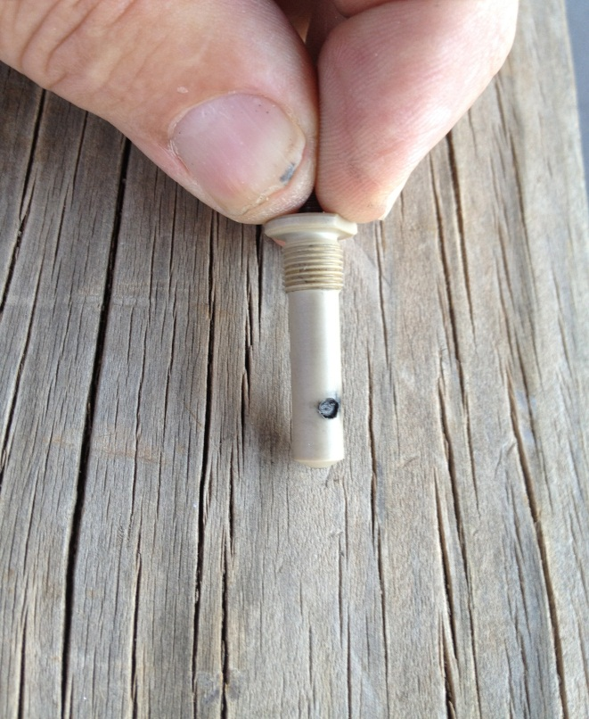
12. Twenty-two of the pyrotechnic compositions that were previously tested with the DDT Flash Composition Test Method were re-tested using the HSL Flash Composition Test as given in Annex 7 of the UN Manual of Tests and Criteria and the results are shown in Table V below. All tests were run three times and the shortest interval of the three firings was used for classification per Paragraph 3.2 of Annex 7 in the UN Manual of Tests and Criteria (5th Revision).
13. Good agreement between the HSL Flash Composition Test Results shown in Table V and the proposed DDT Test Results in Table I was achieved for Formulations 4-8, Formulations 11, 12 and 22.
Table V. HSL flash composition test results
Sample  No. | Composition Descriptions | Pressure Rise Times, milliseconds | Final Classification (based on shortest rise Time)
1 | Goex Black powder -- 5FA “Unglazed” | 2.88, 1.88, 2.24 | ( +)  Flash Composition
2 | 35 wt. % Potassium Nitrate (100% < 37 µ)/ 31 wt. % Potassium Perchlorate (100% < 37 µ) /13.5 wt.% Potassium Benzoate (fine powder)/ 10% Sulfur (fine powder)/10.5%Lampblack (nano-material). | 3.90, 1.00, 0.88 | ( + )  Flash Composition
3 | 70% wt. Potassium Perchlorate (100% < 37 µ) / 30 wt. % “Semi-coarse” Magnesium powder -- (297µ<25%>149µ; 148µ<58%>53µ; 52µ< 5%>44µ; 12%<43µ) | 6.3.4.9, 6.8 | ( + )  Flash Composition
4 | 65 wt. % Potassium Perchlorate (100% < 44µ)/ 35 wt. % Magnesium (105µ 5%>74µ; 73µ <39%>44µ; 46%<43µ) | 7.6, 0.96, 1.9 | ( + )  Flash Composition
5 | 65 wt. % Potassium Perchlorate (100% < 44µ)/ 35 wt. % Magnesium (105µ 5%>74µ; 73µ <39%>44µ; 46%<43µ) | 0.40, 0.68, 0.32 | ( + )  Flash Composition
6 | 70 wt. % Potassium Perchlorate (100% < 37 µ)/ 30 wt. % “Atomized” Aluminum powder (74µ<2.4%>53µ; 52µ<2.9%>44µ; 94.7%<44µ) | 2.8, 50.8, 92.0 | ( + )  Flash Composition
7 | 65 wt. % Potassium Perchlorate (100% < 44µ)/ 35 wt. % “Flake” Aluminum “A” (105µ <72%>53µ; 52µ <17%>44µ; 11.5%<43µ) | 0.40, 0.44, 1.08 | ( + )  Flash Composition
8 | 65 wt. % Potassium Perchlorate (100% < 44µ)/35 wt. % “Flake ” Aluminum “B” (74µ<39% >53µ; 52µ<22%>44µ; 40%<43µ) | 0.44, 0.48, 0.56 | ( + )  Flash Composition
9 | 70 wt. % Potassium Perchlorate (100% < 37 µ)/ 30 wt. % “Ground” Magnalium powder --(74µ<37%>53µ; 52µ<11%>44µ; 52%<44µ) | 9.6, 9.6, 114 | ( - )  Not Flash Composition
10 | 68 wt. % Barium Nitrate (105µ < 10% > 74 µ; 73 µ<12%>44 µ; 43 µ< 24%>37 µ; 53%<37 µ)/23 wt. % “Dark Flake” Aluminum (100%< 73 µ)/9 wt. % Sulfur (fine powder) | 2.0, 1.8, 1.4 | ( + )  Flash Composition
11 | 85 wt. % Potassium Perchlorate (97% < 74µ & 30% < 37µ)/ 10 wt. % Sulfur (very fine ground flour)/ 5 wt. % powdered charcoal | 8.3, 8.4, 85 | ( - )  Not Flash Composition
12 | 80 wt. % Potassium Perchlorate (97% < 74µ & 30% < 37µ)/10 wt. % Sulfur (very fine ground flour)/10 wt. % powdered charcoal | 8.2, 80, 91 | ( - )  Not Flash Composition
13 | 75 wt. % Potassium Perchlorate (97% < 74µ & 30% < 37µ)/10 wt. % Sulfur (very fine ground flour)/15 wt. % powdered charcoal | 1.74, 8.2, 8.2 | ( + )  Flash Composition
14 | 70 wt. % Potassium Perchlorate (97% < 74µ & 30% < 37µ)/10 wt. % Sulfur (very fine ground flour)/20. wt % powdered charcoal | 2.64, 42.8, 25.2 | ( + )  Flash Composition
15 | 65 wt. % Potassium Perchlorate (97% < 74µ & 30% < 37µ)/10 wt. % Sulfur (very fine ground flour)/25 wt. % powdered charcoal | 2.12, 34.0, 8.0 | ( + )  Flash Composition
16 | 60 wt. % Potassium Perchlorate (97% < 74µ & 30% < 37µ)/10 wt. % Sulfur (very fine ground flour)/30 wt. % powdered charcoal | 2.96, 11.2, 12.8 | ( + )  Flash Composition
17 | 52 wt. % Potassium Perchlorate (97% < 74µ & 30% < 37µ)/17 wt. % Sulfur (very fine ground flour)/5 wt. % powdered charcoal/26 wt. % Antimony trisulfide | 2.08, 8.4, 19.2 | ( + )  Flash Composition
18 | 50 wt. % Potassium Perchlorate (97% < 74µ & 30% < 37µ)/30 wt. % Sulfur (very fine ground flour)/20 wt. % powdered charcoal | 3.68, 34.8, 13.6 | ( + )  Flash Composition
19 | 70 wt. % Potassium Perchlorate (97% < 74µ & 30% < 37µ)/20 wt. % Sulfur (very fine ground flour)/10 wt % powdered charcoal | 2.32, 20.0, 25.0 | ( + )  Flash Composition
20 | 60 wt. % Potassium Perchlorate (97% < 74µ & 30% < 37µ)/30 wt. % Sulfur (very fine ground flour)/10 wt % powdered charcoal | 4.32, 19.4, 19.6 | ( + )  Flash Composition
21 | 60 wt. % Potassium Perchlorate (97% < 74µ & 30% < 37µ)/20 wt. % Sulfur (very fine ground flour)/20 wt % powdered charcoal | 2.16, 24.4, 6.8 | ( + )  Flash Composition
22 | 48 wt. % Potassium Perchlorate (100 < 37µ)/52 wt. % Iron Powder (100% <45µ and 94% < 37µ) | - 8 | ( - )  Not Flash Composition
14. Anomalous correlation results between the HSL Flash Composition Test Results in Table V and the proposed DDT Flash Composition test results were seen with Formulations 1-3, 9, 10 and 13-21. In all these cases but one (Formulation No. 9), the HSL Flash Composition Test gave a positive outcome whereas the DDT Flash Composition gave a negative outcome, indicating that the HSL Flash Composition was giving a more “conservative” assessment of the hazard of that particular formulation than the proposed DDT Flash Composition Test. Formulation No. 9 which gave a negative outcome in the HSL Flash Composition Test and a positive outcome in the proposed DDT Flash Composition Test, both initially and upon seven additional trials, represents the only unexplainable experimental result. The specific potassium perchlorate/Magnalium mixture in Formulation No. 9 is known to have been used in “salute” shells for producing typical large aural effects, so the HSL Test results are of concern.
15. Moreover, the classification of traditional black powders like formulation No. 1 as “flash compositions” using the HSL Flash Composition Test Criteria raises the question of fireworks industry “over-regulation” because black powder, either a propellant or expellant composition, has historically not been considered a “flash composition”. As noted in Table II, even with heavy steel confinement, Goex 5FA black powder did not damage the witness plate sufficiently to be considered a “flash composition” in the strictest sense.
Annex II
Revised proposals for adoption of the DDT Flash Composition Test
Proposal 1: Revise Note 2 of 2.1.3.5.5 of the Recommendations on the Transport of Dangerous Goods Model Regulations (UN Model Regulations Default Fireworks Classification Table) to read as follows:
“Flash Composition” in this table refers to any pyrotechnic substances in powder form or as pyrotechnic units as presented in fireworks that are used to produce an aural effect, or used as a bursting charge or lifting charge, unless the time taken for the pressure rise is demonstrated to be not more than 8 milliseconds is demonstrated to be more than 8 ms. For 0.5 g of pyrotechnic substance in the HSL Flash Composition Test in Appendix 7 of the Manual of Tests and Criteria, or unless at least two positive ( + ) results are achieved in up to ten (10) trials for a 25 g net weight of pyrotechnic substance in the DDT Flash Composition Test in Annex XX of the Manual of Tests and Criteria.
Proposal 2: Add the following procedure as a new Appendix XX to the Manual of Tests and Criteria:
DDT Flash Composition Test
Introduction
The DDT Flash Composition Test may be used to determine if a pyrotechnic substances in powder form or as pyrotechnic units as presented in fireworks that are used to produce an aural effect or used as a bursting charge or lifting charge, may be considered a “Flash Composition” for the purposes of the UN Model Regulations Default Fireworks Classification Table in Section 2.1.3.5.5 of the Model Regulations.
Apparatus and materials
The experimental set up for the DDT Flash Composition Test consists of a heavy-wall cardboard or fiberboard convolute sample tube with an inside diameter of 25.4 mm and height 150 mm with a maximum wall thickness of 3.8 mm, closed at the base with a thin cardboard or paperboard plug or cap just sufficient to retain the sample. This cardboard or fibreboard sample tube is centred on a square rolled mild steel witness plate of the same type used in the UN 5a Cap Sensitivity Test - 1 mm in thickness and 160 mm on edge. The ignition source is provided by an electric igniter inserted in the top of the pyrotechnic sample in the tube. Any suitable electric igniter may be used for this purpose, provided the lead wires are at least 30 cm in length. The lead wires are bent so the electric igniter match-head is approximately in the center of the interior pyrotechnic sample column and to a depth of approximately 10 mm. Another paperboard or cardboard plug or cap is then inserted into the top of the fibreboard tube to retain the positioning of the igniter wires. The lead wires of the igniter outside the fibreboard sample tube are then bent down and travel along the outside of the sample tube to the bottom.
A mild steel confinement sleeve which is bored from a solid billet approx 1 mm deeper than the overall sample tube length and having an inside diameter of 38 mm, an outside diameter of 100 mm and a height of 165 mm with a rugged steel handle attached and a notch or groove cut into one radius of the open end sufficient to allow the igniter lead wires to pass through and weighing approx. 3 kilograms is then placed over the sample tube and also rests on the witness plate.
Supporting the sample tube and its surrounding steel confining sleeve is the square shaped steel witness plate which is itself supported on a steel ring of approximately 51 mm height with an inner diameter of approx. 93.5 mm, an outer diameter of approx. 100 mm having a 6.5 mm wall thickness. The entire apparatus is placed onto a square shaped steel base plate of approx. 25mm thickness and 152 mm on edge. (See Figure YY below.). The handle of the steel sleeve can be attached securely to a steel safety cable or chain to restrain its travel by any means appropriate. As a precautionary measure, the test stand fixture may be enclosed on three sides with heavy chain-link fencing, concrete block or plywood at least 18 mm thickness up to 1.5 meters in height.
Procedure
Prior to testing, all pyrotechnic substances whose sensitivity could be moisture dependent should be stored for at least 24 hours in desiccators at a temperature of 28 - 30 °C. Twenty-five (25) grams net weight of the pure pyrotechnic substance to be tested, as a loose powder or granulated or coated onto any substrate, is pre-weighed and then poured carefully into a fiberboard sample tube with the bottom end closed with one of the cardboard or paperboard caps or plugs. After filling, the top cardboard or paperboard cap or plug can be inserted lightly to protect the sample from spillage during transport to the test stand. The height of the sample substance in the tube will vary, depending on its density. The sample should be first consolidated by lightly tapping the tube on a non-sparking surface. The final density of the pyrotechnic substance in the tube should be as close as possible to the density achieved when it contained in a fireworks device. The sample tube is placed in the center of the steel confining sleeve fixture shown in the diagram in Figure YY. which rests on the witness plate, steel ring and steel base plate.
The steel base plate, supporting ring and witness plate are pre-positioned on the test stand. If present, the paperboard or cardboard to plug or cap of the fibreboard sample tube is removed and the electric igniter is inserted into the top of the pyrotechnic composition to be tested and visually positioned to an approximate depth of 10 mm. The paperboard or cardboard top cap or plug is then inserted or re-inserted, fixing the igniter’s position in the fibreboard sample tube and the depth of its match-head. The lead wires are bent over and down along the sidewall and bent away at the bottom. The sample tube is placed vertically and centred exactly on the steel witness plate. The 3 kilogram “tethered” steel confining sleeve is placed over the fibreboard sample tube and re-centred. The igniter lead wires are positioned to pass through the slotted groove in the bottom edge of the steel confining sleeve and will be ready to attach to the firing circuit apparatus.
The entire apparatus is made secure so nothing will shift or change orientation. As a safety precaution, the fourth side of the test bay could then be closed with a portable section of chain-link fence or 18 mm plywood sheets to a height of at least 1.5 meters. The electric igniter is then initiated from a safe position from the test bay. After initiation and a suitable interval to allow for falling debris, if any, the witness plate is recovered and examined. The test should be repeated at least twice, and as many as ten (10) times if necessary.
Test criteria and method of assessing results
The result of any one test shall be considered positive, ( + ) if the pyrotechnic substance being tested is found to have undergone a “deflagration to detonation transition” (DDT) event. The proof of a DDT event shall be if the witness plate is torn, perforated, pierced or otherwise penetrated (i.e. light is visible through the plate). NOTE: Bulges or folds in the witness plate shall NOT be considered to be proof of DDT event and those results shall be considered “( - )“.
For any pyrotechnic substance to meet the definition of a “Flash Composition” by the DDT Flash Composition Test, there must be at least two (2) positive ( + ) DDT events in up to ten (10) sequential trials. For example, if there are two consecutive positive ( + ) DDT events in the first two trials, the pyrotechnic substance can be considered a “Flash Composition” without further testing. If however, there is only one positive ( + ) DDT event occurs in the first two trials, and there are intervening negative ( - ) results, testing should be continued until either another positive ( + ) result is obtained or until ten (10) trials have been conducted, whichever comes first. If after ten consecutive trials there is still only one positive ( + ) result, the pyrotechnic substance shall NOT be considered as having met the definition of a “Flash Composition.
Figure YY
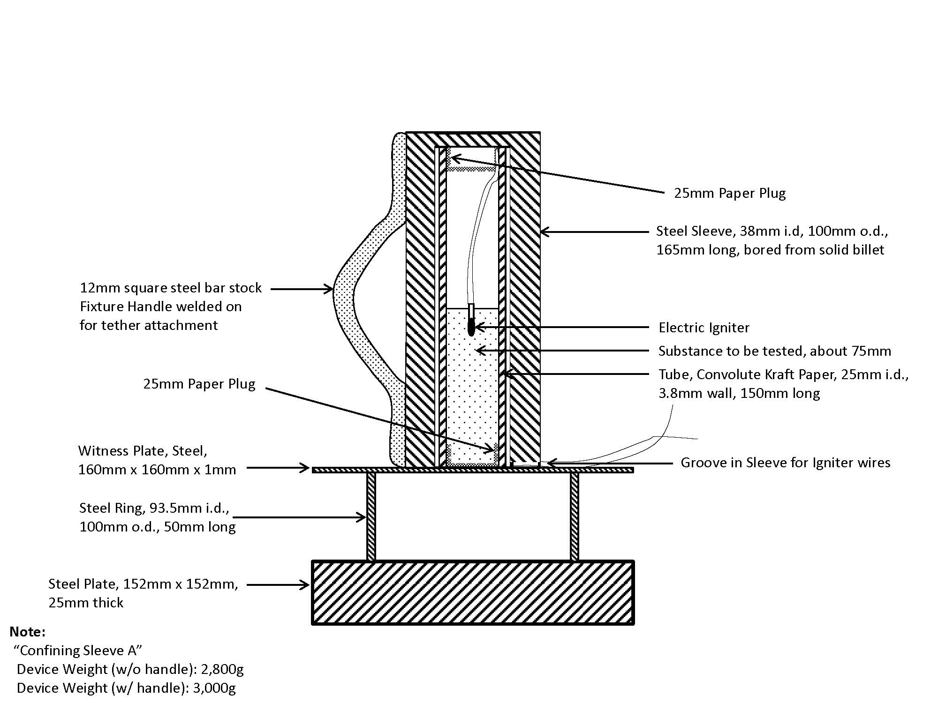

? In accordance with the programme of work of the Sub-Committee for 2011-2012 approved by the Committee at its fifth session (refer to ST/SG/AC.10/C.3/76, para. 116 and ST/SG/AC.10/38, para. 16).

