Summary:
The Technical Service Group (TSG) has received a number of complaints from its members. These are associated firstly with regards to copies of approval labels and products, and secondly with regards to issuing an ECE R44 approval certificate for belt guides. These products have been sold in EU states and in Russia.

Requests to GRSP and WP 29:
The TSG requests GRSP to consider the information provided in this report and to help to devise and implement a mechanism by which these practices, that are compromising the safety of child restraints, can be prevented. Is it possible to set up a means of notifying the companies involved to stop these “unlawful” activities.
The following are some examples of these practices:

- False use of a certification label: found on Russian website – company Börn
They use the Baby Safe Infant Carrier Seat approval no. E1 04301146 from Britax Römer in their web page (http://www.born-sitz.ru/3in1.html, at to the bottom of the page), with the name of their seat Foxy on the approval ECE 44 label as shown in Figure 1. The label is false as it says that the Foxy child seat from company Börn was approved in Germany by KBA Authority (false statement) under the approval number (another false statement) which belongs to Britax Römer. Britax Römer has talked to KBA and learned that the use of the KBA logo, by Börn, was unauthorised, according to §5.2 of Regulation 44.

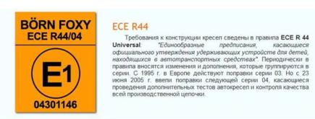
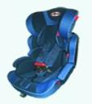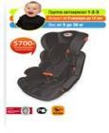
Figure 1: Foxy seat displayed in the Börn company web page

They are also using a certificate on the approval of the same Foxy seat, with an E13 (Luxemburg) and a number 04301259.

An email has been sent to Russian GRSP representatives (Annex 1) to inform them: Mr Vladimir SALNIKON, Deputy General Director, Deputy Chief, Science and Education, Secretary, Scientific Technical Council, Research Centre for Automotive Vehicle Testing and Refining (NICIAMT FSUE NAMI), Mr. Igor PLIEV, Deputy General Director, State Scientific Centre NAMI and Mr. Anatoly YABCHINSKIY, Expert

- Copied Apramo seat – company Börn
The Apramo company has a problem where one of their seats has been copied. This has an E4 certificate, the E4 number is 045013. Their distributor "Heyner" found a copy of the seat "BORN" in the German market, and now he offers the pictures of that seat. It looks extremely similar to the Group 123 seat from Apramo except for the headrest adjust mechanism on the back of headrest (Figure 2 and 3).
Apramo applied for a patent including headrest adjust mechanism and seat contour last year, and the application was accepted by China Patent Buro.

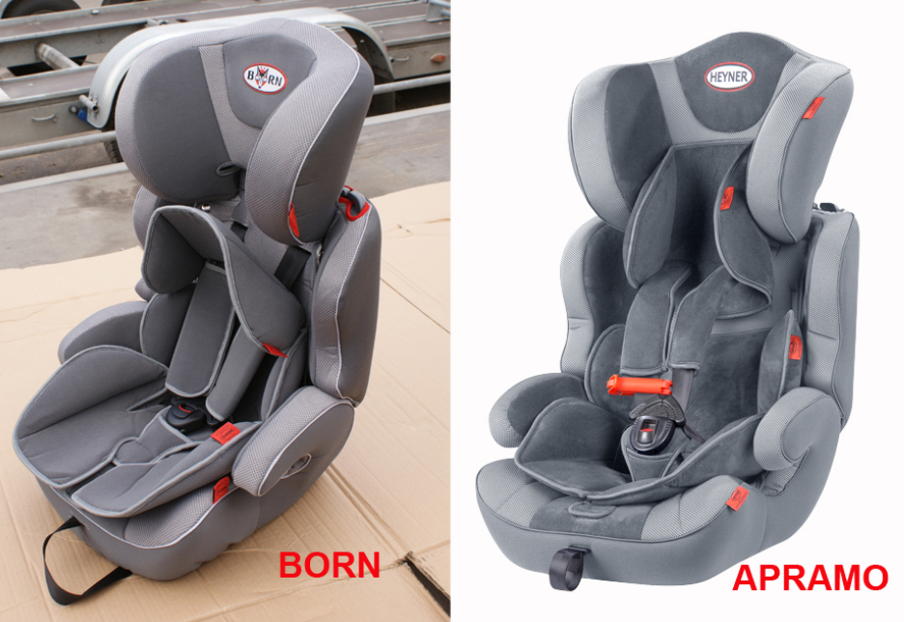
Figure 2: Apramo genuine seat and its copy

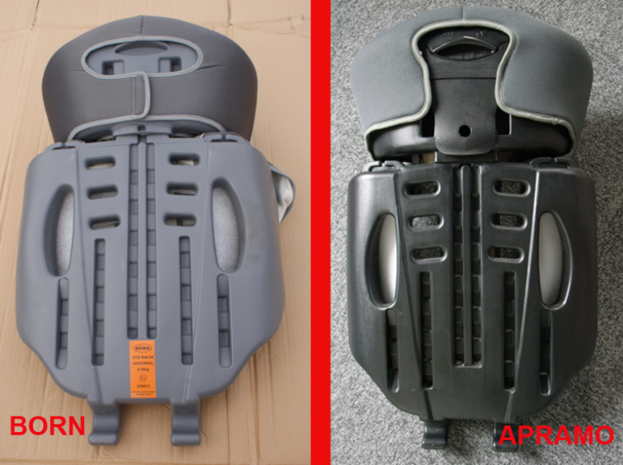

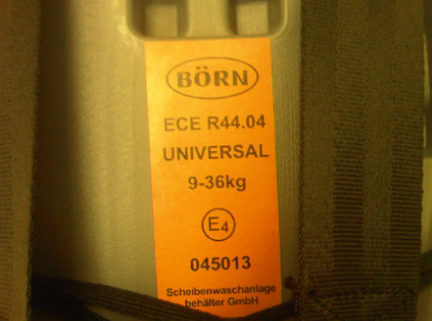Figure 3: Details of Apramo seat genuine back and its copy

- Belt guide approved as a child restraint
A belt guide is being proposed for sale as an “Approved in compliance with European standards and meets the requirements of gost R41.44-2005 (Rule of EEC UN No. 44) (http://fest.fest-k.ru/index.php?category=32&id=210). The system is recommended for ECE 44 groups I, II and III. Such systems have been proposed in the past and were considered as dangerous and thus were not approved in EU.

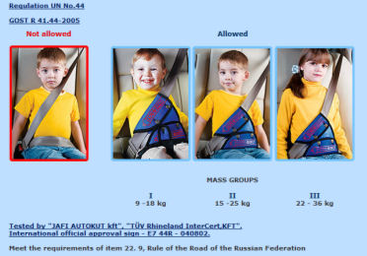
Figure 4: Extract from website promoting the belt guide

- Copied buckle used in various products
Holmbergs Childsafety, a producer of buckles, found a copy of their buckle on a number of seats in Poland. The buckle is in no way fulfilling the demands in ECE regulation (see results below). During the last few months they have seen a huge increase in seats/travel systems using this fake buckle, as well as on fairs in Turkey, Czech Republic and Russia.

List of seats using the copy of the HC buckle:
  - Tako : Warior , Jumper – importer Tako Poland ( http://www.tako.net.pl )
  - Dorjan: Danny Sport , Danny Prestige – importer Hradil / producer DORJAN Poland (http://www.dorjan.com.pl/ )
  - Baby Smile: Neo, V-Max , V-Cross – importer Baby Smile / producer POLAK Poland (http://www.polak.com.pl/ )
  - Firkon : Twist – importer M.Hrdličková Tuchlovice / producer FIRKON Poland (http://www.firkon.pl/)
  - Bebetto Vulcano , Holland / producer BEBETTO Poland (http://www.bebetto.pl/)
  - Implast Canu, Bolder / producer IMPLAST Poland (http://www.implast.com.pl/)
  - Wampol: Ring / producer WAMPOL Poland (http://www.wampol.com.pl/ )
  - Car seat Carlo / producer KARWALA Poland (http://www.karwala.pl/)

Holmbergs Childsafety hold the patent and design pattern rights in the following countries: SE, JP, DK, AT; CH, BE, AU, DE, ES, FR, IT, GB, NL, CA.
There are no IP-rights in Eastern Europe where the main market of this copied buckle seems to be.
Indications show that the copied buckle is produced in China but there is no proof yet as to who is producing the buckle.
All these seats are marked with the ECE-marking (E20).

Test results – comparison of Holmbergs genuine buckle with the copy (Karwala)

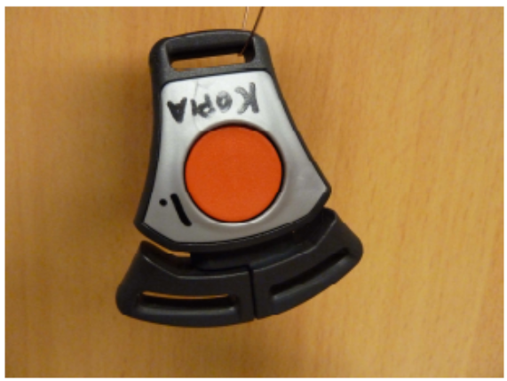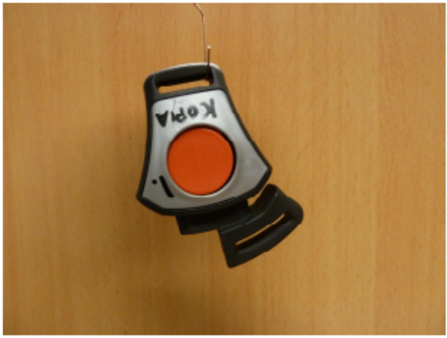
Partial engagement is obvious. Tongues can get stuck half way inserted in the buckle body and don’t fall out when turned upside down.
When inserting the left tongue a clear click is heard and the single tongue is fastened in the buckle.

Figure 5: False buckle

Weight of copied buckle is low (39,5 grams compared to 51,5). This indicates that simple materials are usd for the production of the parts (most likely PP). In the original buckle, glass fibre filled material is used to get the necessary tensile strength. There was no indication of this in the parts examined.

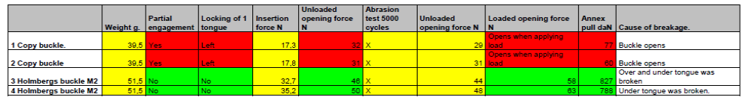
Table 1: Test results by Holmbergs Childsafety

Annex 1:

De : Bendjellal, Farid
Envoyé : mardi 8 février 2011 18:58
À : 'v.salnikov@autorc.ru'
Cc : 'pliev@mail.ru'; 'yabchinsky2006@rambler.ru'; 'Eleri Wessman'
Objet : Raising a Complaint from Britax Römer Child Restraint System Manufacturer

To Mr Vladimir SALNIKON
Deputy General Director, Deputy Chief, Science and
Education, Secretary,
Scientific Technical Council
Research Centre for Automotive Vehicle Testing and Refining (NICIAMT FSUE NAMI)
Russian Federation

cc. Mr. Igor PLIEV Deputy General Director, State Scientific Centre NAMI Mr. Anatoly RYABCHINSKIY Expert

Dear Mr SALNIKOV
I am writing to you upon a recommendation of Philippe JEAN, Head of Automotive Industry Unit, EU Commission.
We at Britax Römer are facing a problem for which your support might be needed.
The problem in short: A Russian company named Börn, a child seat manufacturer, is selling one of their products using a false approval number. Please see copy in attachment 1. The approval number for regulation R44 contains among others 2 key codes: the code of the country which has delivered the approval (E1 for Germany) and the number (04301146).
This number, together the country code E1 was delivered by the German Authority KBA for one of our products (infant Carrier Baby Safe). It is the KBA who informed us about this issue, when they have found an unauthorized usage of KBA logo by Börn company.
What did we do so far: We have done the necessary check internally and are planning to launch a legal action against this company for wrong doing and usage of false official approval numbers.
How you can help us: This problem of false approval is a very damaging issue for approval authorities, for the credibility of the approval system and for the industry. We would like to know if you can use your authority to get this company stopping such unacceptable practice.
Thank you for your help and please don’t hesitate to contact me if you need additional information.

