 | United Nations | ECE/TRANS/WP.29/2011/42
 | Economic and Social Council |  | Distr.: General  22 December 2010  Original: English
Economic Commission for Europe
Inland Transport Committee
World Forum for Harmonization of Vehicle Regulations
153rd session
Geneva, 8–11 March 2011
Item 8.6 of the provisional agenda
Other business – Revision of the Consolidated
Resolution on the Construction of Vehicles (R.E.3)
Revision of the Consolidated Resolution on the Construction of Vehicles (R.E.3)
Note by the Secretariat*
The secretariat transmits herewith a revised consolidated version of the Resolution on the Construction of Vehicles (R.E.3), which contains all the amendments adopted by the World Forum for Harmonization of Vehicle Regulations (WP.29). The document has been completed by references to Regulations annexed to the 1958 Agreement and by specific requirements, test methods, reference materials, ("Standard Annexes") appearing, without modification, in several documents. This Revision supersedes ECE/TRANS/WP.29/2009/123, ECE/TRANS/WP.29/2009/123/Corr.1 to ECE/TRANS/WP.29/2009/123/Corr.4, TRANS/WP.29/78/Rev.1 and replaces TRANS/WP.29/78/Rev.1 and its amendments 1 to 4. The document is submitted to the World Forum for Harmonization of Vehicle Regulations (WP.29) for consideration and possible adoption.
Contents
Page
Preamble. 3
Introduction 4
1. Definitions of vehicles 5
2. Classification of power-driven vehicles and trailers 5
3. Scope of Regulations annexed to the 1958 Agreement 14
4. Active safety requirements 33
5. Passive safety requirements 35
6. Requirements for the protection of the environment 36
7. General safety requirements 37
8. Recommendations 38
Annexes
1. Standard annex on the procedure for determining the "H" point and the actual torso angle for seating positions in motor vehicles 73
Appendix 1 – Prescription of the three-dimensional "H" point machine (3-D H machine) 78
Appendix 2 – Three-dimensional reference system 81
Appendix 3 – Reference data concerning seating positions 82
2. Standard annex on lighting and light-signalling devices:
minimum requirements for sampling by an inspector 83
3. Standard annex on lighting and light-signalling devices:
minimum requirements for conformity of production control procedures 87
4. Standard annex on colour of lights 89
5. Standard annex on requirements for headlamps incorporating lenses of plastic material -
testing of lens or material samples and of complete lamps 90
Appendix 1 – Chronological order of approval tests 95
Appendix 2 – Method of measurement of the diffusion and transmission of light 97
Appendix 3 – Spray testing method 99
Appendix 4 – Adhesive tape adherence test 100
6. Standard annex on the tests for stability of photometric performance of headlamps in operation 101
7. Distinguishing number of contracting parties to the 1958 agreement in the approval mark 105
Preamble
The World Forum for Harmonization of Vehicle Regulations,
Desiring to establish the greatest uniformity in the regulations, rules and recommendations relating to the construction of vehicles, to improve road safety and the protection of the environment, and to facilitate international road traffic and trade in vehicles and their equipment and parts,
Bearing in mind that the provisions of the Convention on Road Traffic of Vienna, 8 November 1968 and of the European Agreements supplementing that Convention provide the basis for harmonization of the performance requirements,
Bearing in mind also that the provisions of the Agreement concerning the Adoption of Uniform Technical Prescriptions for Wheeled Vehicles, Equipment and Parts, which can be Fitted and/or be Used on Wheeled Vehicles and the Conditions for Reciprocal Recognition of Approvals Granted on the Basis of these Prescriptions, done at Geneva on 20 March 1958 ("1958 Agreement") provides further possibilities for harmonization,
Bearing in mind that the Special Resolution No. 1 concerning the common definitions of vehicle categories, masses and dimensions (S.R. 1) setting forth common definitions, to be used in the global technical regulations established under the framework of the Agreement concerning the establishing of global technical regulations for wheeled vehicles, equipment and parts which can be fitted and/or be used on wheeled vehicles, done in Geneva on 25 June 1998 ("1998 Agreement"), does not apply to the Regulations annexed to the 1958 Agreement,
Noting that the application of the provisions of the 1958 Agreement still leave open the possibility of divergences between one country and another as regards some issues when they establish domestic rules for vehicles design and for the protection of the environment,
Recommends Governments, in order to eliminate these divergences as far as possible, to align their domestic legislation with the recommendations of the Consolidated Resolutions and the provisions of the above-mentioned Agreements, applying them forthwith to the fullest extent possible.
Introduction
The text hereafter updates the recommendations of the Consolidated Resolution on the Construction of Vehicles and provides information on the legal texts under the framework of the 1958 Agreement (Regulations, Rules and specific requirements) applicable in the vehicle design, aiming the improvement of safety and the protection of the environment.
Chapters 1 and 2 contain general definitions and the classification used in the documents referred. Chapter 3 indicates the scope of the Regulation(s) and Rule(s). Tables of Chapters 4 to 7 contain the main requirements for the construction of vehicles so far established and already included into Regulation(s) and Rule(s) by the World Forum. Similar requirements are grouped. For any requirement or group of requirements references are made to the relevant Regulations, identified by the number allocated to them by the 1958 Agreement, to the still valid Recommendations reproduced in Chapter 8 and to the Standard Annexes to Regulations reproduced in the annexes to this recommendation. Chapter 9 includes, as complementary information, an updated list of the distinguishing numbers allocated to Contracting Parties by the 1958 Agreement.
1. Definitions of vehicles
1.1. "Power-driven vehicle" means any self-propelled road vehicle, other than a moped in the territories of Contracting Parties which do not treat mopeds as motor cycles, and other than a rail-borne vehicle.
1.2. "Motor vehicle" means any power-driven vehicle which is normally used for carrying persons or goods by road or for drawing, on the road, vehicles used for the carriage of persons or goods. This term embraces trolley-buses, that is to say, vehicles connected to an electric conductor and not rail-borne. It does not cover vehicles such as agricultural tractors, which are only incidentally used for carrying persons or goods by road or for drawing, on the road, vehicles used for the carriage of persons or goods.
1.3. "Motor cycle" means any two-wheeled vehicle, with or without side-car, which is equipped with a propelling engine. Contracting Parties may also treat as motor cycles in their domestic legislation three-wheeled vehicles whose unladen mass does not exceed 400 kg. The term "motor cycle" does not include mopeds, although Contracting Parties may treat mopeds as motor cycles for the purpose of the Convention.
1.4. "Moped" means any two-wheeled or three-wheeled vehicle which is fitted with an internal combustion engine having a cylinder capacity not exceeding 50 cm³ and a maximum design speed not exceeding 50 km per hour.
1.5. "Trailer" means any non-self propelled vehicle, which is designed and constructed to be towed by a power driven vehicle and includes semi–trailers.
1.6. "Combination of vehicles" means coupled vehicles which travel on the road as a unit.
1.7. "Articulated vehicle" means a combination of vehicles comprising a motor vehicle and semi–trailer coupled to the motor vehicle.
1.8. "Road tractor" means road motor vehicle designed, exclusively or primarily, to haul other road vehicles which are not power-driven (mainly semi–trailers).
1.9. "Agricultural tractor" means a vehicle specifically designed to deliver a high tractive effort at slow speeds, for the purposes of hauling a trailer or machinery.
2. Classification of power-driven vehicles and trailers
2.1. Category L – Motor vehicles with less than four wheels
2.1.1. "Category L₁": A two-wheeled vehicle with an engine cylinder capacity in the case of a thermic engine not exceeding 50 cm³ and whatever the means of propulsion a maximum design speed not exceeding 50 km/h.
2.1.2. "Category L₂":A three-wheeled vehicle of any wheel arrangement with an engine cylinder capacity in the case of a thermic engine not exceeding 50 cm³ and whatever the means of propulsion a maximum design speed not exceeding 50 km/h.
2.1.3. "Category L₃": A two-wheeled vehicle with an engine cylinder capacity in the case of a thermic engine exceeding 50 cm³ or whatever the means of propulsion a maximum design speed exceeding 50 km/h.
2.1.4. "Category L₄": A vehicle with three wheels asymmetrically arranged in relation to the longitudinal median plane with an engine cylinder capacity in the case of a thermic engine exceeding 50 cm³ or whatever the means of propulsion a maximum design speed exceeding 50 km/h (motor cycles with sidecars).
2.1.5. "Category L₅": A vehicle with three wheels symmetrically arranged in relation to the longitudinal median plane with an engine cylinder capacity in the case of a thermic engine exceeding 50 cm³ or whatever the means of propulsion a maximum design speed exceeding 50 km/h.
2.1.6. "Category L₆": A vehicle with four wheels whose unladen mass is not more than 350 kg, not including the mass of the batteries in case of electric vehicles, whose maximum design speed is not more than 45 km/h, and whose engine cylinder capacity does not exceed 50 cm³ for spark (positive) ignition engines, or whose maximum net power output does not exceed 4 kW in the case of other internal combustion engines, or whose maximum continuous rated power does not exceed 4 kW in the case of electric engines.
2.1.7. "Category L₇": A vehicle with four wheels, other than that classified for the category L₆, whose unladen mass is not more than 400 kg (550 kg for vehicles intended for carrying goods), not including the mass of batteries in the case of electric vehicles and whose maximum continuous rated power does not exceed 15 kW.
2.2. Category M - Power-driven vehicles having at least four wheels and used for the carriage of passengers
2.2.1. "Category M₁": Vehicles used for the carriage of passengers and comprising not more than eight seats in addition to the driver's seat.
2.2.2. "Category M₂": Vehicles used for the carriage of passengers, comprising more than eight seats in addition to the driver's seat, and having a maximum mass not exceeding 5 tonnes.
2.2.3. "Category M₃": Vehicles used for the carriage of passengers, comprising more than eight seats in addition to the driver's seat, and having a maximum mass exceeding 5 tonnes.
2.2.4. Vehicles of category M₂ and M₃ belong to:
2.2.4.1. "Class I": Vehicles constructed with areas for standing passengers, to allow frequent passenger movement.
2.2.4.2. "Class II": Vehicles constructed principally for the carriage of seated passengers, and designed to allow the carriage of standing passengers in the gangway and/or in an area which does not exceed the space provided for two double seats.
2.2.4.3. "Class III": Vehicles constructed exclusively for the carriage of seated passengers.
2.2.4.4. "Class A": Vehicles designed to carry standing passengers; a vehicle of this class has seats and may have provisions for standing passengers.
2.2.4.5. "Class B": Vehicles not designed to carry standing passengers; a vehicle of this class has no provision for standing passengers.
2.2.5. Remarks.
2.2.5.1. "Articulated bus or coach" is a vehicle which consists of two or more rigid sections which articulate relative to one another; the passengers compartments of each section intercommunicate so that passengers can move freely between them; the rigid sections are permanently connected so that they can only be separated by an operation involving facilities which are normally only found in workshop.
2.2.5.2. Articulated buses or coaches comprising two ore more non-separable but articulated units shall be considered as single vehicles.
2.2.5.3. In the case of a towing vehicle designed to be coupled to a semi–trailer (tractor for semi–trailer), the mass to be considered for classifying the vehicle is the mass of the tractor vehicle in running trim, increased by the mass corresponding to the maximum static vertical load transferred to the tractor vehicle by the semi–trailer and, where applicable, by the maximum mass of the tractor vehicle's own load.
2.2.5.4. "Mass of a vehicle in running order" means the mass of an unladen vehicle with bodywork, and with coupling device in the case of a towing vehicle, or the mass of the chassis with cab if the manufacturer does not fit the bodywork and/or coupling device, including coolant, oils, 90 % of fuel, 100 % of other liquids except used waters, tools, spare wheel, driver (75 kg) and, for buses and coaches, the mass of the crew member (75 kg) if there is a crew seat in the vehicle.
2.3. Category N - Power-driven vehicles having at least four wheels and used for the carriage of goods
2.3.1. "Category N₁": Vehicles used for the carriage of goods and having a maximum mass not exceeding 3.5 tonnes.
2.3.2. "Category N₂": Vehicles used for the carriage of goods and having a maximum mass exceeding 3.5 tonnes but not exceeding 12 tonnes.
2.3.3. "Category N₃": Vehicles used for the carriage of goods and having a maximum mass exceeding 12 tonnes.
2.3.4. Remarks
2.3.4.1. In the case of a towing vehicle designed to be coupled to a semi–trailer (tractor for semi–trailer), the mass to be considered for classifying the vehicle is the mass of the tractor vehicle in running trim, increased by the mass corresponding to the maximum static vertical load transferred to the tractor vehicle by the semi–trailer and, where applicable, by the maximum mass of the tractor vehicles own load.
2.3.4.2. The equipment and installations carried on certain special purpose vehicles (crane vehicles, workshop vehicles, publicity vehicles, etc.) are regarded as being equivalent to goods.
2.4. Category O - Trailers (including semi–trailers)
2.4.1. "Category O₁": Trailers with a maximum mass not exceeding 0.75 tonnes.
2.4.2. "Category O₂": Trailers with a maximum mass exceeding 0.75 tonnes, but not exceeding 3.5 tonnes.
2.4.3. "Category O₃": Trailers with a maximum mass exceeding 3.5 tonnes, but not exceeding 10 tonnes.
2.4.4. "Category O₄": Trailers with a maximum mass exceeding 10 tonnes.
2.4.5. Furthermore, trailers of categories O₂, O₃ and O₄ are of one of the three following types:
2.4.5.1. "Semi–trailer": A towed vehicle, in which the axle(s) is (are) positioned behind the centre of gravity of the vehicle (when uniformly loaded), and which is equipped with a connecting device permitting horizontal and vertical forces to be transmitted to the towing vehicle. One or more of the axles may be driven by the towing vehicle.
2.4.5.2. "Full trailer": A towed vehicle having at least two axles, and equipped with a towing device which can move vertically (in relation to the trailer) and controls the direction of the front axle(s), but which transmits no significant static load to the towing vehicle. One or more of the axles may be driven by the towing vehicle.
2.4.5.3. "Centre-axle trailer": A towed vehicle, equipped with a towing device which cannot move vertically (in relation to the trailer) and in which the axle(s) is (are) positioned close to the centre of gravity of the vehicle (when uniformly loaded) such that only a small static vertical load, not exceeding 10 % of that corresponding to the maximum mass of the trailer or a load of 1,000 daN (whichever is the lesser) is transmitted to the towing vehicle. One or more of the axles may be driven by the towing vehicle.
2.4.6. Remark.
In the case of a semi–trailer or centre-axle trailer, the maximum mass to be considered for classifying the trailer corresponds to the static vertical load transmitted to the ground by the axle or axles of the semi–trailer or centre-axle trailer when coupled to the towing vehicle and carrying its maximum load.
2.5. "Special purpose vehicle": A vehicle of category M, N or O for conveying passengers or goods and for performing a special function for which special body arrangements and/or equipment are necessary.
2.5.1. "Motor caravan": A special purpose M₁ category vehicle constructed to include accommodation space which contains at least the following equipment:
(a) seats and table;
(b) sleeping accommodation which may be converted from the seats;
(c) cooking facilities, and
(d) storage facilities.
This equipment shall be rigidly fixed to the living compartment; however, the table may be designed to be easily removable.
2.5.2. "Armoured vehicle": Vehicle intended for the protection of conveyed passengers and/or goods and complying with armour plating anti-bullet requirements.
2.5.3. "Ambulance": Motor vehicle of category M intended for the transport of sick or injured people and having special equipment for such purpose.
2.5.4. "Hearse": Motor vehicle intended for the transport of deceased people and having special equipment for such purpose.
2.6. "Agricultural and Forestry tractors"- Category T: A power-driven vehicle, either wheeled or track laying, which has at least two-axles, whose function depends essentially on its tractive power, and which is specially designed to pull, push, carry or actuate certain implements, machines or trailers intended for use in agriculture or forestry. Such a tractor may be arranged to carry a load and attendants.
2.7. "Non-road mobile machinery": Any mobile machine, transportable industrial equipment or vehicle with or without body work, not intended for the use of passenger- or goods-transport on the road, in which an internal combustion engine is installed.∗
2.8. Category G - off-road vehicles
2.8.1. Definition.
Off-road vehicles are considered to be the vehicles of categories M and N satisfying the requirements of this paragraph, checked under the conditions indicated in paragraphs 2.8.2. and 2.8.3.
2.8.1.1. Vehicles in category N₁ with a maximum mass not exceeding 2 tonnes and vehicles in category M₁ are considered to be off-road vehicles if they have:
(a) at least one front axle and at least one rear axle designed to be driven simultaneously including vehicles where the drive to one axle can be disengaged;
(b) at least one differential locking mechanism or at least one mechanism having a similar effect and
(c) if they can climb a 30 % gradient calculated for a solo vehicle.
(d) In addition, they must satisfy a least five of the following six requirements:
(i) the approach angle must be at least 25°;
(ii) the departure angle must be at least 20°;
(iii) the ramp angle must be at least 20°;
(iv) the ground clearance under the front axle must be at least 180 mm;
(v) the ground clearance under the rear axle must be at least 180 mm;
(vi) the ground clearance between the axles must be at least 200 mm.
2.8.1.2. Vehicles in category N₁ with a maximum mass exceeding 2 tonnes or in category N₂, M₂ or M₃ with a maximum mass not exceeding 12 tonnes are considered to be off-road vehicles either if all their wheels are designed to be driven simultaneously, including vehicles where the drive to one axle can be disengaged, or if the following three requirements are satisfied:
(a) at least one front axle and at least one rear axle are designed to be driven simultaneously, including vehicles where the drive to one axle can be disengaged;
(b) there is at least one differential locking mechanism or at least one mechanism having a similar effect;
(c) they can climb a 25 % gradient calculated for a solo vehicle.
2.8.1.3. Vehicles in category M₃ with a maximum mass exceeding 12 tonnes or in category N₃ are considered to be off-road either if the wheels are designed to be driven simultaneously, including vehicles where the drive to one axle can be disengaged, or if the following requirements are satisfied:
(a) at least half the wheels are driven;
(b) there is at least one differential locking mechanism or at least one mechanism having a similar effect;
(c) they can climb a 25 % gradient calculated for a solo vehicle;
(d) at least four of the following six requirements are satisfied:
(i) the approach angle must be at least 25°;
(ii) the departure angle must be at least 25°;
(iii) the ramp angle must be at least 25°;
(iv) the ground clearance under the front axle must be at least 250 mm;
(v) the ground clearance between the axles must be at least 300 mm;
(vi) the ground clearance under the rear axle must be at least 250 mm.
2.8.2. Load and checking conditions.
2.8.2.1. Vehicles in category N₁ with a maximum mass not exceeding two tonnes and vehicles in category M₁ must be in running order, namely with coolant fluid, lubricants, fuel, tools, spare-wheel and a driver considered to weigh a standard 75 kilograms.
2.8.2.2. Power-driven vehicles other than those referred to in paragraph 2.8.2.1. must be loaded to the technically permissible maximum mass stated by the manufacturer.
2.8.2.3. The ability to climb the required gradients (25 % and 30 %) is verified by simple calculation. In exceptional cases, however, the technical services may ask for a vehicle of the type concerned to be submitted to it for an actual test.
2.8.2.4. When measuring front and rear incidence angles and ramp angles, no account is taken of underrun protective devices.
2.8.3. Definitions and sketches of front and rear incidence angles, ramp angle and ground clearance.
2.8.3.1. "Approach angle" – see Standard ISO 612:1978, term No. 6.10.
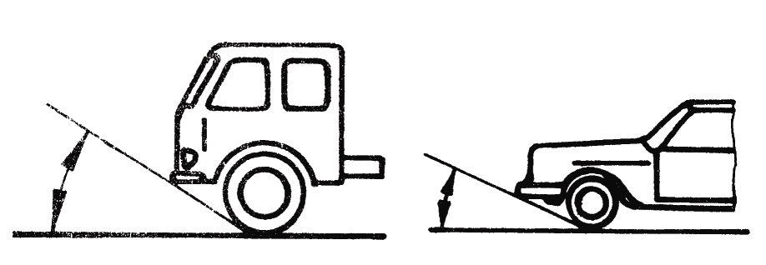
2.8.3.2. "Departure angle" – see Standard ISO 612:1978, term No.6.11.
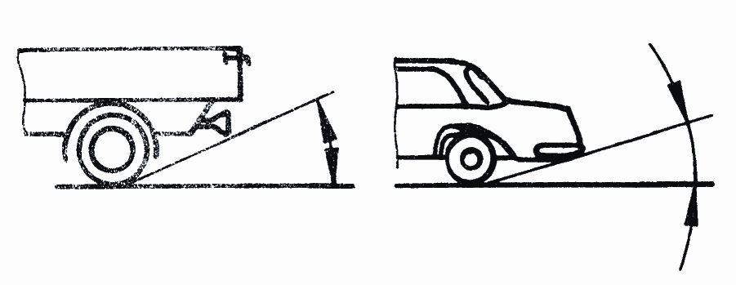
2.8.3.3. "Ramp angle" – see Standard ISO 612:1978, term No. 6.9.
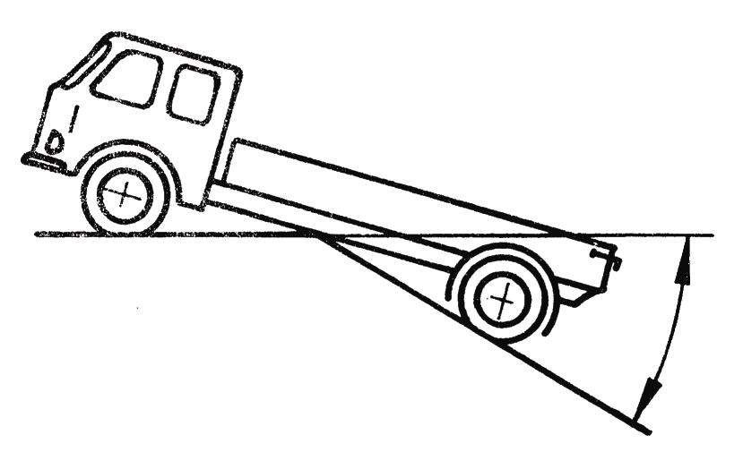
2.8.3.4. "Ground clearance between the axles": means the shortest distance between the ground plane and the lowest fixed point of the vehicle.
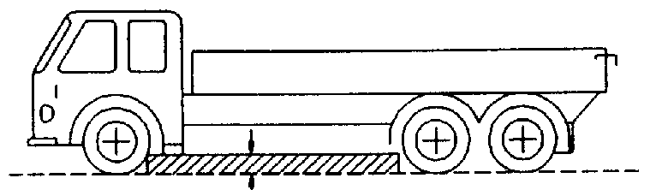

2.8.3.5. "Ground clearance beneath one axle": means the distance beneath the highest point of the arc of a circle passing through the centre of the tyre footprint of the wheels on one axle (the inner wheels in the case of twin tyres) and touching the lowest fixed point of the vehicle between the wheels.
No rigid part of the vehicle may project into the shaded area of the diagram.
Where appropriate, the ground clearance of several axles is indicated in accordance with their arrangement, for example 280/250/250.
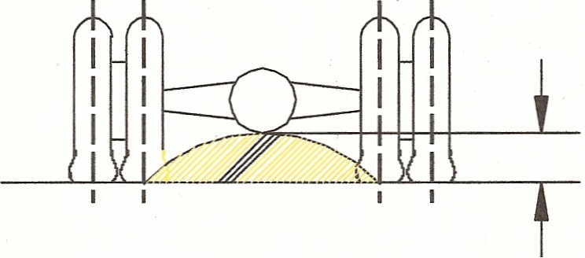
2.8.4. Combined designation.
Symbols M and N may be combined with symbol G. For example, a vehicle of category N₁ which is suited for off-road use may be designated as N₁G.
2.9. Definition of type of bodywork (only for complete/completed vehicles)
The type of bodywork may be indicated by the following codification:
2.9.1. Passenger cars (M₁)
2.9.1.1 AA Saloon:
Standard ISO 3833:1977, term No. 3.1.1.1., but including also vehicles with more than 4 side windows.
2.9.1.2. AB Hatchback
Saloon (AA) with a hatch at the rear end of the vehicle.
2.9.1.3. AC Station Wagon (Estate car)
Standard ISO 3833:1977, term No. 3.1.1.4.
2.9.1.4. AD Coupé
Standard ISO 3833:1977, term No. 3.1.1.5.
2.9.1.5. AE Convertible
Standard ISO 3833:1977, term No. 3.1.1.6.
2.9.1.6. AF Multi-purpose vehicle
Motor vehicle other than those mentioned in AA to AC intended for carrying passengers and their luggage or goods, in a single compartment. However, if such a vehicle meets both of the following conditions it is not considered to be a vehicle of category M₁:
(a) The number of seating positions, excluding the driver, is not more than six. A "seating position" shall be regarded as existing if the vehicle is provided with "accessible" seat anchorages. "Accessible" shall mean those anchorages to which can be used. In order to prevent anchorages being "accessible" the manufacturer shall physically obstruct their use, for example by welding over cover plates or by fitting similar permanent fixtures which cannot be removed by use of normally available tools; and
(b) P - (M + N x 68) > N x 68
where:
P = technically permissible maximum laden mass in kg
M = mass in running order in kg
N = number of seating positions excluding the driver
2.9.2. Special purpose vehicles (M₁)
2.9.2.1. SA Motor caravan: see paragraph 2.5.1.
2.9.2.2. SB Armoured vehicle: see paragraph 2.5.2.
2.9.2.3. SC Ambulance: see paragraph 2.5.3.
2.9.2.4. SD Hearse: see paragraph 2.5.4.

3. Scope of Regulations annexed to the 1958 Agreement
The scope of Regulations indicated below reflects the situation of the Regulations on [27 August 2010]. The scopes are shown by categories of vehicles, but some of them may be limited to a specific subcategory/class or to a minimum/maximum weight within the category.
Regulations are continuously adapted to the technical progress and their scope may be modified.

Regulation No. | Title | L₁ | L₂ | L₃ | L₄ | L₅ | L₆ | L₇ | M₁ | M₂ | M₃ | N₁ | N₂ | N₃ | O₁ | O₂ | O₃ | O₄ | Tractors | NRMM ∗
1  and  2 | Uniform provisions concerning the approval of motor vehicle headlamps emitting an asymmetrical passing beam and/or a driving beam and equipped with filament lamps of categories R₂ and/or HS1 |  |  |  |  |  |  |  | x | x | x | x | x | x
3 | Uniform provisions concerning the approval of retro-reflecting devices for power-driven vehicles and their trailers | x | x | x | x | x | x | x | x | x | x | x | x | x | x | x | x | x | x
4 | Uniform provisions concerning the approval of devices for the illumination of rear registration plates of power-driven vehicles and their trailers |  |  |  |  |  |  |  | x | x | x | x | x | x | x | x | x | x | x
5 | Uniform provisions concerning the approval of motor vehicle "sealed beam" headlamps (SB) emitting a European asymmetrical passing beam or a driving beam or both |  |  |  |  |  |  |  |  |  |  |  |  |  |  |  |  |  | x
6 | Uniform provisions concerning the approval of direction indicators for power-driven vehicles and their trailers | x | x | x | x | x | x | x | x | x | x | x | x | x | x | x | x | x | x
7 | Uniform provisions concerning the approval of front and rear position lamps, stop-lamps and end-outline marker lamps for motor vehicles (except motor cycles) and their trailers | x | x | x | x | x | x | x | x | x | x | x | x | x | x | x | x | x | x
8 | Uniform provisions concerning the approval of motor vehicle headlamps emitting an asymmetrical passing beam or a driving beam or both and equipped with halogen filament lamps (H₁, H₂, H₃, HB₃, HB₄, H₇, H₈, H₉, HIR1, HIR2 and/or H₁₁) |  |  |  |  |  |  |  | x | x | x | x | x | x
9 | Uniform provisions concerning the approval of category L₂, L₄ and L₅ vehicles with regard to noise |  | x |  | x | x
10 | Uniform provisions concerning the approval of vehicles with regard to electromagnetic compatibility | x | x | x | x | x | x | x | x | x | x | x | x | x | x | x | x | x
11 | Uniform provisions concerning the approval of vehicles with regard to door latches and door retention components |  |  |  |  |  |  |  | x |  |  | x
12 | Uniform provisions concerning the approval of vehicles with regard to the protection of the driver against the steering mechanism in the event of impact |  |  |  |  |  |  |  | x |  |  | x
13 | Uniform provisions concerning the approval of vehicles of categories M, N and O with regard to braking |  |  |  |  |  |  |  |  | x | x | x | x | x | x | x | x | x
13-H | Uniform provisions concerning the approval of passenger cars with regard to braking |  |  |  |  |  |  |  | x |  |  | x
14 | Uniform provisions concerning the approval of vehicles with regard to safety-belt anchorages, ISOFIX anchorage systems and ISOFIX top tether anchorages |  |  |  |  |  |  |  | x | x | x | x | x | x
15 | This Regulation is obsolete
16 | Uniform provisions concerning the approval of:  I. Safety-belts, restraint systems, child restraint systems and ISOFIX child restraint systems for occupants of power-driven vehicles  II. Vehicles equipped with safety-belts, safety belt reminder, restraint systems, child restraint systems and ISOFIX child restraint systems |  | x |  | x | x | x | x | x | x | x | x | x | x | x | x | x | x | x
17 | Uniform provisions concerning the approval of vehicles with regard to the seats, their anchorages and any head restraints |  |  |  |  |  |  |  | x | x | x | x | x | x
18 | Uniform provisions concerning the approval of motor vehicles with regard to their protection against unauthorized use |  |  |  |  |  |  |  |  | x | x |  | x | x
19 | Uniform provisions concerning the approval of power-driven vehicle fog lamps |  |  | x | x | x |  | x | x | x | x | x | x | x |  |  |  |  | x
20 | Uniform provisions concerning the approval of motor vehicle headlamps emitting an asymmetrical passing beam or a driving beam or both and equipped with halogen filament lamps (H₄ lamps) |  |  |  |  |  |  |  | x | x | x | x | x | x
21 | Uniform provisions concerning the approval of vehicles with regard to their interior fittings |  |  |  |  |  |  |  | x
22 | Uniform provisions concerning the approval of protective helmets and their visors for drivers and passengers of motor cycles and mopeds
23 | Uniform provisions concerning the approval of reversing lights for power-driven vehicles and their trailers |  |  |  |  |  |  |  | x | x | x | x | x | x | x | x | x | x | x
24 | Uniform provisions concerning:  I. The approval of compression ignition (C.I.) engines with regard to the emission of visible pollutants  II. The approval of motor vehicles with regard to the installation of C.I. engines of an approved type  III. The approval of motor vehicles equipped with C.I. engines with regard to the emission of visible pollutants by the engine  IV. The measurement of power of C.I. engine | x | x | x | x | x | x | x | x | x | x | x | x | x
25 | Uniform provisions concerning the approval of head restraints (headrests), whether or not incorporated in vehicle seats |  | x |  | x | x | x | x | x | x | x | x | x | x
26 | Uniform provisions concerning the approval of vehicles with regard to their external projections |  |  |  |  |  |  |  | x
27 | Uniform provisions for the approval of advance-warning triangles
28 | Uniform provisions concerning the approval of audible warning devices and of motor vehicles with regard to their audible signals |  |  | x | x | x |  |  | x | x | x | x | x | x
29 | Uniform provisions concerning the approval of vehicles with regard to the protection of the occupants of the cab of a commercial vehicle |  |  |  |  |  |  |  |  |  |  | x | x | x
30 | Uniform provisions concerning the approval of pneumatic tyres for motor vehicles and their trailers |  |  |  |  |  |  |  | x |  |  |  |  |  | x | x
31 | Uniform provisions concerning the approval of power-driven vehicle's sealed-beam headlamps (SB) emitting an European asymmetrical passing beam or a driving beam or both |  |  |  |  |  |  |  | x | x | x | x | x | x |  |  |  |  | x
32 | Uniform provisions concerning the approval of vehicles with regard to the behaviour of the structure of the impacted vehicle in a rear-end collision |  |  |  |  |  |  |  | x
33 | Uniform provisions concerning the approval of vehicles with regard to the behaviour of the structure of the impacted vehicle in a head-on collision |  |  |  |  |  |  |  | x
34 | Uniform provisions concerning the approval of vehicles with regard to the prevention of fire risks |  |  |  |  |  |  |  | x | x | x | x | x | x | x | x | x | x
35 | Uniform provisions concerning the approval of vehicles with regard to the arrangement of foot controls |  |  |  |  |  |  |  | x
36 | Uniform provisions concerning the approval of large passenger vehicles with regard to their general construction |  |  |  |  |  |  |  |  | x | x
37 | Uniform provisions concerning the approval of filament lamps for use in approved lamp units of power-driven vehicles and of their trailers | x | x | x | x | x | x | x | x | x | x | x | x | x | x | x | x | x | x
38 | Uniform provisions concerning the approval of rear fog lamps for power-driven vehicles and their trailers |  |  | x | x | x |  | x | x | x | x | x | x | x | x | x | x | x | x
39 | Uniform provisions concerning the approval of vehicles with regard to the speedometer equipment including its installation | x | x | x | x | x | x | x | x | x | x | x | x | x
40 | Uniform provisions concerning the approval of motor cycles equipped with a positive-ignition engine with regard to the emission of gaseous pollutants by the engine |  |  | x | x | x
41 | Uniform provisions concerning the approval of motor cycles with regard to noise |  |  | x
42 | Uniform provisions concerning the approval of vehicles with regard to their front and rear protective devices (bumpers, etc.) |  |  |  |  |  |  |  | x
43 | Uniform provisions concerning the approval of safety glazing materials and their installation on vehicles | x | x | x | x | x | x | x | x | x | x | x | x | x | x | x | x | x | x
44 | Uniform provisions concerning the approval of restraining devices for child occupants of power-driven vehicles ("child restraint system")
45 | Uniform provisions concerning the approval of headlamp cleaners, and of power-driven vehicles with regard to headlamp cleaners | x | x | x | x | x | x | x | x | x | x | x | x | x |  |  |  |  | x
46 | Uniform provisions concerning the approval of devices for indirect vision, and of motor vehicles with regard to the installation of these devices | x | x | x | x | x | x | x | x | x | x | x | x | x
47 | Uniform provisions concerning the approval of mopeds equipped with a positive-ignition engine with regard to the emission of gaseous pollutants by the engine | x | x
48 | Uniform provisions concerning the approval of vehicles with regard to the installation of lighting and light-signalling devices |  |  |  |  |  |  |  | x | x | x | x | x | x | x | x | x | x
49 | Uniform provisions concerning the measures to be taken against the emission of gaseous and particulate pollutants from compression-ignition engines for use in vehicles, and the emission of gaseous pollutants from positive-ignition engines fuelled with natural gas or liquefied petroleum gas for use in vehicles |  |  |  |  |  |  |  | x | x | x | x | x | x
50 | Uniform provisions concerning the approval of front position lamps, rear position lamps, stop lamps, direction indicators and rear-registration-plate illuminating devices for vehicles of category L | x | x | x | x | x | x | x
51 | Uniform provisions concerning the approval of motor vehicles having at least four wheels with regard to their noise emissions |  |  |  |  |  |  |  | x | x | x | x | x | x
52 | Uniform provisions concerning the approval of M₂ and M₃ small capacity vehicles with regard to their general construction |  |  |  |  |  |  |  |  | x | x
53 | Uniform provisions concerning the approval of category L₃ vehicles with regard to the installation of lighting and light-signalling devices |  |  | x
54 | Uniform provisions concerning the approval of pneumatic tyres for commercial vehicles and their trailers |  |  |  |  |  |  |  |  | x | x | x | x | x |  |  | x | x
55 | Uniform provisions concerning the approval of mechanical coupling components of combinations of vehicles |  |  |  |  |  |  |  | x | x | x | x | x | x | x | x | x | x
56 | Uniform provisions concerning the approval of headlamps for mopeds and vehicles treated as such | x | x
57 | Uniform provisions concerning the approval of headlamps for motor cycles and vehicles treated as such |  |  | x | x | x | x | x
58 | Uniform provisions concerning the approval of:  I. Rear underrun protective devices (RUPDs)  II. Vehicles with regard to the installation of a RUPD of an approved type  III. Vehicles with regard to their rear underrun protection (RUP) |  |  |  |  |  |  |  |  |  |  |  | x | x |  |  | x | x
59 | Uniform provisions concerning the approval of replacement silencing systems |  |  |  |  |  |  |  | x |  |  | x
60 | Uniform provisions concerning the approval of two-wheeled motor cycles and mopeds with regard to driver-operated controls including the identification of controls, tell-tales and indicators | x |  | x
61 | Uniform provisions concerning the approval of commercial vehicles with regard to their external projections forward of the cab's rear panel |  |  |  |  |  |  |  |  |  |  | x | x | x
62 | Uniform provisions concerning the approval of power-driven vehicles with handlebars with regard to their protection against unauthorized use | x | x | x | x | x | x | x
63 | Uniform provisions concerning the approval of two-wheeled mopeds with regard to noise | x
64 | Uniform provisions concerning the approval of vehicles with regard to their equipment which may include a temporary-use spare wheel and tyre unit, run flat tyres and/or a run flat system |  |  |  |  |  |  |  | x |  |  | x
65 | Uniform provisions concerning the approval of special warning lamps for power-driven vehicles and their trailers | x | x | x | x | x | x | x | x | x | x | x | x | x | x | x | x | x | x | x
66 | Uniform provisions concerning the approval of large passenger vehicles with regard to the strength of their superstructure |  |  |  |  |  |  |  |  | x | x
67 | Uniform provisions concerning the approval of:  I. Specific equipment of motor vehicles using liquefied petroleum gases in their propulsion system  II. A vehicle fitted with specific equipment for the use of liquefied petroleum gases in its propulsion system with regard to the installation of such equipment |  |  |  |  |  |  |  | x | x | x | x | x | x
68 | Uniform provisions concerning the approval of power-driven vehicles including pure electric vehicles with regard to the measurement of the maximum speed |  |  |  |  |  |  |  | x |  |  | x
69 | Uniform provisions concerning the approval of rear marking plates for slow-moving vehicles (by construction) and their trailers |  |  |  |  |  |  |  | x | x | x | x | x | x | x | x | x | x | x | x
70 | Uniform provisions concerning the approval of rear marking plates for heavy and long vehicles |  |  |  |  |  |  |  |  | x | x |  |  | x | x | x | x | x
71 | Uniform provisions concerning the approval of agricultural tractors with regard to the driver"s field of vision |  |  |  |  |  |  |  |  |  |  |  |  |  |  |  |  |  | x
72 | Uniform provisions concerning the approval of motor cycle headlamps emitting an asymmetrical passing beam and a driving beam and equipped with halogen filament lamps (HS₁ lamps) |  |  | x | x | x
73 | Uniform provisions concerning the approval of goods vehicles, trailers and semi–trailers with regard to their lateral protection |  |  |  |  |  |  |  |  |  |  |  | x | x |  |  | x | x
74 | Uniform provisions concerning the approval of category L₁ vehicles with regard to the installation of lighting and light-signalling devices | x
75 | Uniform provisions concerning the approval of pneumatic tyres for motor cycles and mopeds | x | x | x | x | x
76 | Uniform provisions concerning the approval of headlamps for mopeds emitting a driving beam and a passing beam | x | x |  |  |  | x
77 | Uniform provisions concerning the approval of parking lamps for power-driven vehicles |  |  |  |  |  |  |  | x | x | x | x | x | x |  |  |  |  | x
78 | Uniform provisions concerning the approval of vehicles of category L₁, L₂, L₃, L₄ and L₅ with regard to braking | x | x | x | x | x
79 | Uniform provisions concerning the approval of vehicles with regard to steering equipment |  |  |  |  |  |  |  | x | x | x | x | x | x | x | x | x | x
80 | Uniform provisions concerning the approval of seats of large passenger vehicles and of these vehicles with regard to the strength of the seats and their anchorages |  |  |  |  |  |  |  |  | x | x
81 | Uniform provisions concerning the approval of rear-view mirrors of two-wheeled power-driven vehicles with or without side car, with regard to the mounting of rear-view mirrors on handlebars | x | x | x | x | x | x | x
82 | Uniform provisions concerning the approval of moped headlamps equipped with filament halogen lamps (HS₂) | x | x |  |  |  | x
83 | Uniform provisions concerning the approval of vehicles with regard to the emission of pollutants according to engine fuel requirements |  |  |  |  |  |  |  | x | x |  | x | x
84 | Uniform provisions concerning the approval of passenger cars equipped with an internal combustion engine with regard to the measurement of fuel consumption |  |  |  |  |  |  |  | x |  |  | x
85 | Uniform provisions concerning the approval of internal combustion engines or electric drive trains intended for the propulsion of motor vehicles of categories M and N with regard to the measurement of the net power and the maximum 30 minutes power of electric drive trains |  |  |  |  |  |  |  | x | x | x | x | x | x
86 | Uniform provisions concerning the approval of agricultural or forestry tractors with regard to the installation of lighting and light-signalling devices |  |  |  |  |  |  |  |  |  |  |  |  |  |  |  |  |  | x
87 | Uniform provisions concerning the approval of daytime running lamps for power-driven vehicles | x | x | x | x | x | x | x | x | x | x | x | x | x |  |  |  |  | x
88 | Uniform provisions concerning the approval of retroreflective tyres for two-wheeled vehicles | x
89 | Uniform provisions concerning the approval of:  I. Vehicles with regard to limitation of their maximum speed or their adjustable speed limitation function  II. Vehicles with regard to the installation of a speed limitation device (SLD) or adjustable speed limitation device (ASLD) of an approved type  III. Speed limitation devices (SLD) and adjustable speed limitation device (ASLD) |  |  |  |  |  |  |  | x | x | x | x | x | x
90 | Uniform provisions concerning the approval of replacement brake lining assemblies and drum-brake linings for power-driven vehicles and their trailers | x | x | x | x | x | x | x | x | x | x | x | x | x | x | x | x | x
91 | Uniform provisions concerning the approval of side-marker lamps for motor vehicles and their trailers |  |  |  |  |  |  |  | x | x | x | x | x | x | x | x | x | x | x
92 | Uniform provisions concerning the approval of non-original replacement exhaust silencing systems (RESS) for motorcycles, mopeds and three-wheeled vehicles | x | x | x | x | x
93 | Uniform provisions concerning the approval of:  I. Front underrun protective devices (FUPDs)  II. Vehicles with regard to the installation of an FUPD of an approved type  III. Vehicles with regard to their front underrun protection (FUP) |  |  |  |  |  |  |  |  |  |  |  | x | x
94 | Uniform provisions concerning the approval of vehicles with regard to the protection of the occupants in the event of a frontal collision |  |  |  |  |  |  |  | x
95 | Uniform provisions concerning the approval of vehicles with regard to the protection of the occupants in the event of a lateral collision |  |  |  |  |  |  |  | x |  |  | x
96 | Uniform provisions concerning the approval of compression ignition (C.I.) engines to be installed in agricultural and forestry tractors and in non-road mobile machinery with regard to the emissions of pollutants by the engine |  |  |  |  |  |  |  |  |  |  |  |  |  |  |  |  |  | x | x
97 | Uniform provisions concerning the approval of vehicle alarm systems (VAS) and of motor vehicles with regard to their alarm systems (AS) |  |  |  |  |  |  |  | x |  |  | x
98 | Uniform provisions concerning the approval of motor vehicle headlamps equipped with gas-discharge light sources |  |  | x |  |  |  |  | x | x | x | x | x | x
99 | Uniform provisions concerning the approval of gas-discharge light sources for use in approved gas-discharge lamp units of power-driven vehicles |  |  |  |  |  |  |  | x | x | x | x | x | x
100 | Uniform provisions concerning the approval of battery electric vehicles with regard to specific requirements for the construction, functional safety and hydrogen emission |  |  |  |  |  |  |  | x | x | x | x | x | x
101 | Uniform provisions concerning the approval of passenger cars powered by an internal combustion engine only, or powered by a hybrid electric power train with regard to the measurement of the emission of carbon dioxide and fuel consumption and/or the measurement of electric energy consumption and electric range and of categories M₁ and N₁ vehicles powered by an electric power train only with regard to the measurement of electric energy consumption and electric range |  |  |  |  |  |  |  | x |  |  | x
102 | Uniform provisions concerning the approval of:  I. A close-coupling device (CCD)  II. Vehicles with regard to the fitting of an approved type of CCD |  |  |  |  |  |  |  |  |  |  |  | x | x |  |  | x | x
103 | Uniform provisions concerning the approval of replacement catalytic converters for power-driven vehicles |  |  |  |  |  |  |  | x |  |  | x
104 | Uniform provisions concerning the approval of retro-reflective markings for vehicles of category M, N and O |  |  |  |  |  |  |  |  | x | x | x | x | x |  | x | x | x
105 | Uniform provisions concerning the approval of vehicles intended for the carriage of dangerous goods with regard to their specific construction features |  |  |  |  |  |  |  |  |  |  | x | x | x |  | x | x | x
106 | Uniform provisions concerning the approval of pneumatic tyres for agricultural vehicles and their trailers |  |  |  |  |  |  |  |  |  |  |  |  |  |  |  |  |  | x
107 | Uniform provisions concerning the approval of category M₂ and M₃ vehicles with regard to their general construction |  |  |  |  |  |  |  |  | x | x
108 | Uniform provisions concerning the approval for the production of retreated pneumatic tyres for motor vehicles and their trailers |  |  |  |  |  |  |  | x |  |  |  |  |  | x | x
109 | Uniform provisions concerning the approval for the production of retreated pneumatic tyres for commercial vehicles and their trailers |  |  |  |  |  |  |  |  | x | x | x | x | x |  |  | x | x
110 | Uniform provisions concerning the approval of:  I. Specific components of motor vehicles using compressed natural gas (CNG) in their propulsion system;  II. Vehicles with regard to the installation of specific components of an approved type for the use of compressed natural gas (CNG) in their propulsion system |  |  |  |  |  |  |  | x | x | x | x | x | x
111 | Uniform provisions concerning the approval of tank vehicles of categories N and O with regard to rollover stability |  |  |  |  |  |  |  |  |  |  |  | x | x |  |  | x | x
112 | Uniform provisions concerning the approval of motor vehicle headlamps emitting an asymmetrical passing beam or a driving beam or both and equipped with filament lamps | x | x | x | x | x | x | x | x | x | x | x | x | x |  |  |  |  | x
113 | Uniform provisions concerning the approval of motor vehicle headlamps emitting a symmetrical passing beam or a driving beam or both and equipped with filament lamps or gas-discharge light sources | x | x | x | x | x | x | x |  |  |  |  |  |  |  |  |  |  | x
114 | Uniform provisions concerning the approval of:  I. An airbag module for a replacement airbag system;  II. A replacement steering wheel equipped with an airbag module of an approved type;  III. A replacement airbag system other than that installed in a steering wheel |  |  |  |  |  |  |  | x | x | x | x | x | x
115 | Uniform provisions concerning the approval of:  I. Specific LPG (liquefied petroleum gases) retrofit systems to be installed in motor vehicles for the use of LPG in their propulsion system;  II. Specific CNG (compressed natural gases) retrofit systems to be installed in motor vehicles for the use of CNG in their propulsion system |  |  |  |  |  |  |  | x | x | x | x | x | x
116 | Uniform technical prescriptions concerning the protection of motor vehicles against unauthorized use |  |  |  |  |  |  |  | x |  |  | x
117 | Uniform provisions concerning the approval of tyres with regard to rolling sound emissions and to adhesion on wet surfaces |  |  |  |  |  |  |  | x |  |  | x |  |  | x | x
118 | Uniform technical prescriptions concerning the burning behaviour of materials used in the interior construction of certain categories of motor vehicles |  |  |  |  |  |  |  |  |  | x
119 | Uniform provisions concerning the approval of cornering lamps for power-driven vehicles |  |  |  |  |  |  |  | x | x | x | x | x | x |  |  |  |  | x
120 | Uniform provisions concerning the approval of internal combustion engines to be installed in agricultural and forestry tractors and in non-road mobile machinery, with regard to the measurement of the net power, net torque and specific fuel consumption |  |  |  |  |  |  |  |  |  |  |  |  |  |  |  |  |  | x | x
121 | Uniform provisions concerning the approval of vehicles with regard to the location and identification of hand controls, tell-tales and indicators |  |  |  |  |  |  |  | x | x | x | x | x | x
122 | Uniform technical prescriptions concerning the approval of vehicles of categories M, N and O with regard to their heating systems |  |  |  |  |  |  |  | x | x | x | x | x | x | x | x | x | x
123 | Uniform provisions concerning the approval of adaptive front-lighting systems (AFS) for motor vehicles |  |  |  |  |  |  |  | x | x | x | x | x | x
124 | Uniform provisions concerning the approval of wheels for passenger cars |  |  |  |  |  |  |  | x |  |  |  |  |  | x | x
125 | Uniform provisions concerning the approval of motor vehicles with regard to the forward field of vision of the motor vehicle driver |  |  |  |  |  |  |  | x
126 | Uniform provisions concerning the approval of partitioning systems to protect passengers against displaced luggage, supplied as non original vehicle equipment |  |  |  |  |  |  |  | x

4. Active safety requirements
The table below contains the requirements or a group of requirements in the field of active safety, already adopted by the World Forum and included into Regulations. For any requirement or group of requirements, references are given to the relevant regulations by their number in the 1958 Agreement and to the relevant Recommendations and Standard Annexes.
Subject |  |  | Relevant Documents
 |  |  | Regulations annexed to the 1958 Agreement |  | Recommendations | Standard Annexes
A. | Braking, power-driven vehicles, and theirs trailers |  | 13, 13H, 90 |  | See paragraphs 8.1. to 8.3.2.
B. | Braking, motor cycles |  | 78 |  | See paragraphs 8.1. to 8.3.2.
C. | Audible warning device |  | 28 |  | See paragraph 8.4.
D. | Lighting and light-signalling devices, power-driven vehicles |  | 1, 2, 4, 5, 6, 7, 8, 19, 20, 23, 31, 37, 38, 45, 65, 77, 87, 91, 98, 99, 112, 119, 123 |  | - | 2, 3, 4, 5, 6
E. | Lighting and light-signalling devices, motor cycles |  | 50, 57, 72, 113 |  | - | 2, 3, 4, 5, 6
F. | Lighting and light-signalling devices, mopeds |  | 56, 76, 82 |  | - | 3
G. | Lighting and light-signalling, installation, motor vehicles |  | 48 |  | - | 3
H. | Lighting and light-signalling, installation, motor cycles |  | 53 |  | - | 3
I. | Lighting and light-signalling, installation, mopeds |  | 74 |  | -
J. | Lighting and light-signalling, installation, agricultural tractors |  | 86 |  | -
K. | Retro reflecting devices, markings |  | 3, 69, 70, 88, 104 |  | - | 2, 3
L. | Pneumatic tyres, wheels, motor vehicles |  | 30, 64, 108, 117, 124 | -
M. | Pneumatic tyres, commercial vehicles |  | 54, 109, 117 | -
N. | Pneumatic tyres, motor cycles/mopeds |  | 75 | -
O. | Pneumatic tyres, tractors |  | 106 | -
P. | Controls, tell-tales, motor vehicles |  | 35, 121 | - |  | 1
Q. | Controls, tell-tales, motor cycles, mopeds |  | 60 | -
R. | Forward field of vision, motor vehicles |  | 125 | - |  | 1
S. | Indirect vision, motor vehicles |  | 46 | - |  | 1
T. | Rear-view mirrors, motor cycles, mopeds |  | 81 | -
U. | Drivers field of vision, tractors |  | 71 | -
V. | Speed limitation (SLD) |  | 89 | -
W. |  | Steering equipment | 79 | -
5. Passive safety requirements
The table below contains the requirements or a group of requirements in the field of passive safety, already adopted by the World Forum and included into Regulations. For any requirement or group of requirements, references are given to the relevant regulations by their number in the 1958 Agreement and to the relevant Recommendations and Standard Annexes.
Subject |  | Relevant Documents
 |  | Regulations annexed to the 1958Agreements | Recommendations | Standard Annexes
A. | Frontal collision | 33, 94,12 | - | 1
B. | Lateral collision | 95 | - | 1
C. | Rear-end collision | 32 | - | 1
D. | Front and rear protection device | 42 | -
E. | Frontal collision for electric vehicles | 12 | - | 1
F. | Front and rear underrun protection device | 58, 93 | -
G. | Lateral protection | 73 | -
H. | External projections | 26, 61 | See paragraphs 8.6. and 8.7. | 1
I. | Interior fittings | 21 | - | 1
J. | Seat strength | 17,80 | -
K. | Restraint systems for adults | 14, 16, 17, 25, 80, 114 | - | 1
L. | Child restraint systems | 44 | -
M. | Steering protection | 12 | - | 1
N. | Door latches and retention components | 11 | See paragraph 8.9.
O. | Cabin of a commercial vehicle | 29 | See paragraphs 8.14. to 8.17. | 1
P. | Fire risk | 34, 118 | -
Q. | Passengers protection against displaced luggage | 126,17 | - | 1
R. | Pedestrian safety |  | See paragraph 8.37.
6. Requirements for the protection of the environment
The Table below contains the requirements or a group of requirements for the protection of environment, already adopted by the World Forum and included into Regulations. For any requirement or group of requirements, references are given to the relevant regulations by their number in the 1958 Agreement and to the relevant Recommendations and Standard Annexes.
Subject |  |  | Relevant Documents
 |  |  | Regulations annexed to the 1958 Agreement | Recommendations | Standard Annexes
A. | Pollutant emissions, motor vehicles |  | 24, 49, 83, 103 | -
B. | Pollutant emissions, motor cycles, mopeds, P.I. engines |  | 40, 47 | -
C. | Pollutant emissions, tractors |  | 96 | -
D. | Measurements, maximum. speed, fuel consumption, net power |  | 68, 84, 85, 101, 120 | -
E. | Noise emissions, motor vehicles | 51, 59, 117 |  | See paragraph 8.8.
F. | Noise emissions, motor cycles, mopeds | 9, 41, 63, 92 |  | See paragraph 8.8.

7. General safety requirements
The Table below contains the requirements or a group of requirements in the field of general safety, already adopted by the World Forum and included into Regulations. For any requirement or group of requirements, references are given to the relevant regulations by their number in the 1958 Agreement and to the relevant Recommendations and Standard Annexes.
Subject |  | Relevant Documents
 |  | Regulations annexed to the 1958 Agreement | Recommendations | Standard Annexes
A. | Protective helmets | 22
B. | Advance-warning triangles | 27 |  |  | 2, 3
C. | Liquefied Petroleum Gas (LPG) vehicles, Compressed Natural Gas (CNG) vehicles and electric vehicles | 67, 100, 110, 115
D. | Coupling devices | 55, 102 | See paragraph 8.12.
E. | Vehicles of specific use, ADR, tank vehicles | 105, 111 | -
F. | Vehicle alarm, anti-theft systems and | 18, 62, 97, 116 | See paragraph 8.24.
G. | Buses and coaches | 36, 52, 66, 107
H. | Electromagnetic compatibility | 10
I. | Heating systems | 122
J. | Safety glazing | 43 |  |  | 1
K. | Speedometer | 39
L. | Measures to prevent unauthorized modifications to mopeds and motor cycles in use | - | See paragraph 8.24.
M | Weight and axle load distribution | - | See paragraph 8.13.
N | Mudguards | - | See paragraph 8.27.
O | First aid kits | - | See paragraph 8.31.
8. Recommendations
This chapter contains the text of the Recommendations of the Consolidated Resolution, which are still valid.
8.1. Braking
8.1.1. Vehicles in service, used singly
8.1.1.1. A single motor vehicle may be maintained in service only if the respective performance of the service, emergency a parking braking devices are at least equal to 90 % of the performance prescribed for a new motor vehicle in Regulations Nos. 13 and 13-H.
8.1.1.2. The performance may be verified by methods and at speeds different from those prescribed in the relevant Regulations.
8.1.1.3. For the purpose of testing a motor vehicle in service, the vehicle is regarded as belonging to the category resulting from its characteristics and the weight indicated in its registration document.
8.1.2. Combination of new vehicles.
8.1.2.1. General Provisions
8.1.2.1.1. In addition to the requirements which, by virtue of Regulations Nos. 13, must be met by each of their components, combinations of new vehicles must satisfy the following conditions:
8.1.2.1.1.1. In a combination of which at least one component is used for the carriage of passengers, the performance of the service braking device and of the emergency braking device must meet the requirements laid down in Regulation No. 13 for the drawing vehicle.
8.1.2.1.1.2. In other combinations.
8.1.2.1.1.2.1. The performance of the service braking device must be such that the stopping distance is:
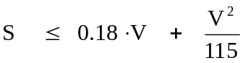
V = Initial speed in km/h
S = Stopping distance in metres.
(The second term corresponding to a mean braking deceleration of 4.4 m/sec²)
8.1.2.1.1.2.2. The performance of the secondary braking device must be such that the stopping distance is:
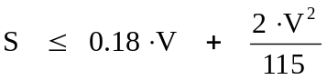
(The second term corresponding to a mean braking deceleration of 2.2 m/sec²)
8.1.2.1.3. The performances indicated in paragraphs 8.1.2.1.1.1. and 8.1.2.1.1.2. above shall be checked by a type-0 test with the engine disconnected, as described in Regulation No. 13, Annex 4, paragraph 1.4. The test must be carried out at the speed prescribed for the motor vehicle, and the force applied on the controls must not exceed the maximum prescribed for the braking of the motor vehicle alone (Regulation No. 13, Annex 4, paragraph 3.).
8.1.2.2. Continuous braking devices
8.1.2.2.1. In a combination of vehicles equipped with continuous braking devices, the vehicles of that combination must meet the requirements laid down in Regulation No. 13 and in addition, the following conditions:
8.1.2.2.1.1. In an emergency manoeuvre, the time elapsing between the moment when the control begins to be actuated and the moment when the braking force on the least favourably placed axle reaches the level corresponding to the prescribed performance must not exceed 0.6 sec (see Regulation No. 13, Annex 4, paragraph 5.);
8.1.2.2.1.2. the action of the service brakes must be appropriately distributed and synchronized between the motor vehicle and the trailer.
8.1.3. Combinations of vehicles in service
8.1.3.1. A combination of vehicles, where both the motor vehicle and the trailer have been in use, may be maintained in service only:
8.1.3.1.1. if the respective performances of the service, emergency and parking braking devices are at least equal to 90 % of the performances prescribed in Regulation No. 13 (the parking brake performance for new motor vehicles and trailers is assumed to be 18 %), for each of the components when new;
8.1.3.1.2. if the respective performances of the service and emergency braking devices are at least equal to 90 % of the performances prescribed in Regulation No. 13, Annex 4, paragraph 2.3.2.
8.1.3.2. A combination of vehicles where either the drawing vehicle or the trailer has been in use must satisfy the following conditions:
8.1.3.2.1. The requirements of Regulation No. 13 must be met by that component of the combination, which is new.
8.1.3.2.2. For that component of the combination which has been in use, the respective performances of the service, emergency and parking braking devices must be at least equal to 90 % of the performances prescribed for new vehicles in Regulation No. 13.
8.1.3.2.3. For the combination as a whole, the above provisions must be met (see paragraph 8.1.3.1.2.).
8.1.3.4. The performance required under paragraphs 8.1.3.1., 8.1.3.2.2. and 8.1.3.2.3. may be verified by methods and at speeds different from those prescribed for new vehicles and combinations of new vehicles.
8.1.3.5. For the purpose of testing a vehicle in operation, the vehicle is regarded as belonging to the category resulting from its characteristics and the weight indicated in its registration document.
8.2. Resistance of brake pipes to corrosion
The resistance of brake pipes to corrosion shall be at least equivalent to that of steel pipes coated with a 12-micron layer of zinc. It is further recommended that encouragement be given to information campaigns for the benefit of vehicle users, maintenance workshops and motor vehicle inspection services on the dangers of brake pipe corrosion.
8.3. Brake fluids
8.3.1. Manufacturers should include in the maintenance handbooks for their vehicles, in addition to the usual indications of the fluids to be used in braking equipment, a specific statement as to whether or not fluids of the non-petroleum type can be used.
8.3.2. Users' associations should draw the attention of vehicle users to the dangers of using unsuitable fluids or of mixing different, possibly incompatible, fluids.
8.4. Audible warning devices
8.4.1. The provision of a bell is compulsory on cycles with auxiliary engine (if this category of vehicle is provided for in national regulations). This bell may, however, be replaced by a warning device. This audible warning shall be in conformity with the provisions of Regulation No. 28, however, the sound-pressure level of the device fitted to the vehicle shall be equal to or greater than 76 dB(A).
8.4.2. On motor vehicles as defined in the 1968 Convention on Road Traffic, the provision of an audible warning device is compulsory.
8.4.3. The provision of additional audible warning devices is not compulsory on cycles with auxiliary engine or on motor vehicles.
8.4.4. Electrically-operated audible warning devices shall not be subject to stricter conditions than those set out below, it being understood that the present recommendation does not apply either to any audible warning devices mounted on vehicles for use in built-up areas only, or to the use and characteristics of alternating-tone or special-tone audible warning devices.
8.5. Pollutant emissions
It is recommended to apply the requirements of the Regulations listed in paragraph 6, the table, lines A, B and C.
8.6. External projections
8.6.1. Passenger cars
Provisions contained in Regulation No. 26 apply. For devices not covered by that Agreement, the following provisions apply.
8.6.1.1. A non-essential additional part (ornament or other accessory) may be mounted on the vehicle only if either it is so attached that a person struck can slide easily along it without being held or injured, or it bends under slight pressure so as to present no danger. In no case shall it exhibit sharp edges, points, hooks or projections.
8.6.1.2. Any device (light surround, bumper or the like) installed or replaced by the user of a vehicle shall meet requirements similar to those prescribed in the above-mentioned Regulation No. 26.
8.6.1.3. Roof rack, advertising panels, route indicators, taxi signs and other taxi accessories shall be securely attached to the vehicle and shall exhibit no point, sharp edge or tapered projection. The radii of curvature of the external parts, including the fastenings, shall be not less than 2.5 mm.
8.6.1.4. The parts of a coupling device which extend beyond the external contour of the vehicle shall meet requirements similar to those prescribed in Regulation No. 26.
8.6.1.5. Flag-holders and other devices of the same kind shall be able to tilt under slight pressure.
8.6.1.6. In windscreen visors the radius of the extremities and that of the fastenings shall not be less than 2.5 mm.
8.6.1.7. Air or rain deflectors at the windows or on the roof shall not exhibit any point or sharp or cutting edge liable to endanger such road-users outside the vehicle as may come into contact with the deflectors.
8.7. External projections of L vehicles
8.7.1. Purpose of the recommendation
This Recommendation is intended to ensure that the external projections on the vehicle are designed in such a way as to ensure that injuries, especially those caused by laceration or penetration, from which a person might suffer as a result of contact with (parts of) the vehicle, are reduced as far as reasonably practicable.
The persons envisaged are:
8.7.1.1. the user of the vehicle (rider and passenger(s)),
8.7.1.2. other road users, not themselves in vehicles, principally pedestrians, cyclists and motor cyclists, who might come into contact with the vehicle in the event of a low speed impact.
8.7.2. Scope
This Recommendation applies to category L vehicles
8.7.3. Definitions
8.7.3.1. "Outer vehicle parts" means all parts which are likely to be contacted in case of a collision with people;
8.7.3.2. "Brushing" means any contact which, under certain conditions, could cause injury by laceration;
8.7.3.3. "Striking" means any contact which, under certain conditions, could cause injury by penetration;
8.7.3.4. Criteria for distinguishing between "brushing" and "striking".
8.7.3.4.1. While moving the test device (see appendix, figure 5) along the vehicle in accordance with subparagraph 8.7.5.2. below, the components of the vehicle touched by the device shall be considered as either:
8.7.3.4.1.1. Group 1: those parts of components of the vehicle which brush against the test device, or
8.7.3.4.1.2. Group 2: those parts or components of the vehicle which strike against the test device.
8.7.3.4.1.3. In order to unambiguously differentiate between Group 1 and Group 2 parts or components, the following method shall be applied (Figure 1.)
8.7.3.5. "Radius of curvature" means the approximate extent of the round as distinct from a precise geometrical form.

Figure 1
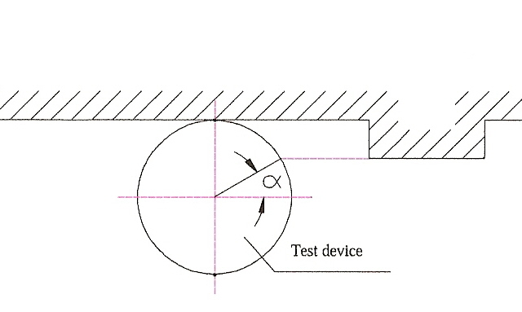

α > 45° : group 1
α < 45° : group 2
Thus for the fullest striking contact α = 0°.
8.7.4. General provisions
8.7.4.1. In any case, the outside of the vehicle shall not exhibit, directed outwards, any pointed or sharp parts or any projections of such shape, dimensions, direction or hardness as to be likely to increase the risk or seriousness of bodily injury to a person hit by the vehicle or brushing against it in the event of a collision or involved in a fall from the vehicle.
8.7.4.2. Vehicles shall be designed in such a manner that those parts with which the rider is likely to come into contact in the event of an accident shall cause as little injury as possible.
8.7.4.3. Vehicles shall be designed so that those parts with which other road users are likely to come into contact shall meet the requirements of paragraphs 8.7.6. and 8.7.7. below, as appropriate.
8.7.4.4. Any external projection covered by this Recommendation which is made of, or covered by, rubber or soft plastic with a rigidity below shore 60 A, shall be deemed to meet the requirements of paragraphs 8.7.6. and 8.7.7. below.
8.7.5. Test methodology
8.7.5.1. Test device and conditions
8.7.5.1.1. The test device shall be as shown in the annex (Figure 5).
8.7.5.1.2. The test vehicle shall be parked in the straight ahead position and shall be upright. The handlebars (if any) shall be free to rotate through their normal range of movement.
A dummy shall be mounted on the test vehicle in the normal riding position and in such a way that it does not restrict the movement of the handlebars (if any).
8.7.5.2. Test procedure
The test device shall be moved from the front to the rear of the test vehicle, causing (if applicable and if they can be touched by the test device) the handlebars to turn to the full lock position. The test device shall remain in contact with the vehicle (see appendix, figure 6). The test shall be carried out on both sides of the vehicle.
8.7.6. Criteria
8.7.6.1. The criteria specified in this paragraph shall not apply to those parts covered by the provisions of paragraph 8.7.7. below.
8.7.6.2. Subject to the provisions contained in paragraph 8.7.4.4. above, the following minimum criteria shall apply:
8.7.6.2.1. Requirements for Group 1
8.7.6.2.1.1. In the case of a plate (Figure 2)

Figure 2
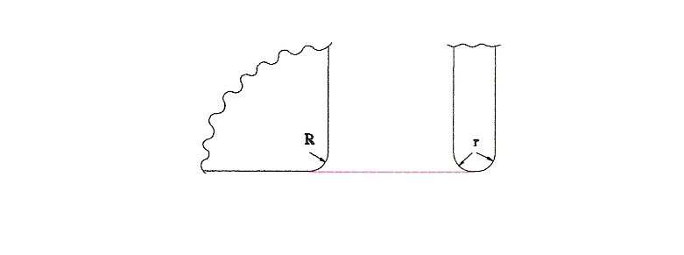
The corners shall have a radius of curvature (R) of the at least 3 mm.edges shall have a radius of curvature (r) of at least 0.5 mm.
8.7.6.2.1.2. In the case of a shaft (Figure 3)

Figure 3
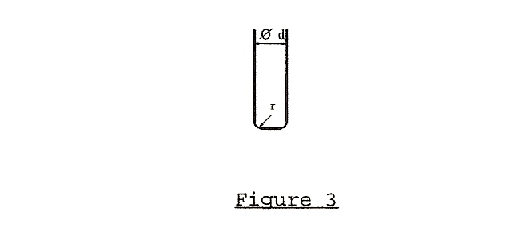
The diameter of the shaft (d) shall be at least 10 mm.
The edges at the end of the shaft shall have a radius of curvature (r) of at least 2 mm.
8.7.6.2.2. Requirements for Group 2
8.7.6.2.2.1. In the case of a plate (figure 2)
The corners shall have a radius of curvature (R) of at least 2 mm. The edges shall have a radius of curvature (r) of at least 2 mm.
8.7.6.2.2.2. In the case of a shaft (Figure 4)

Figure 4
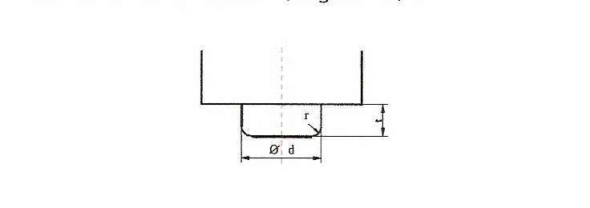
The length (t) shall be less than d/2, if the diameter of the shaft (d) is less than 20 mm.
The radius of curvature (r) of the edges at the end of the shaft shall be at least 2 mm, if the diameter of the shaft (d) is equal to or more than 20 mm.
8.7.7. Particular specifications
8.7.7.1. The upper edge of the wind shield or fairing shall have a radius of curvature of at least 2 mm or shall be covered with protective material.
8.7.7.2. The outer ends of hand-operated clutch and brake levers shall be rounded and shall have a minimum radius of curvature of 7 mm.
8.7.7.3. The leading edge of the front mudguard shall have a radius of curvature of at least 2 mm.
8.7.7.4. Filler caps located on the upper surface of the fuel reservoir and liable to be contacted by the driver in case of a frontal collision shall not project at their rear edge, more than 15 mm above the surrounding surface; their connections to the surrounding surface shall be levelled or rounded.
8.7.7.5. Ignition keys shall have protective caps.
This does not apply to collapsible keys and to keys that are flush with the surface.
8.7.7.6. Added ornaments shall not project more than 10 mm above the surrounding surface.
Up to a thickness of 5 mm they shall have chamfered edges and with a thickness of over 5 mm a radius of curvature of at least 2.5 mm.

Figure 5
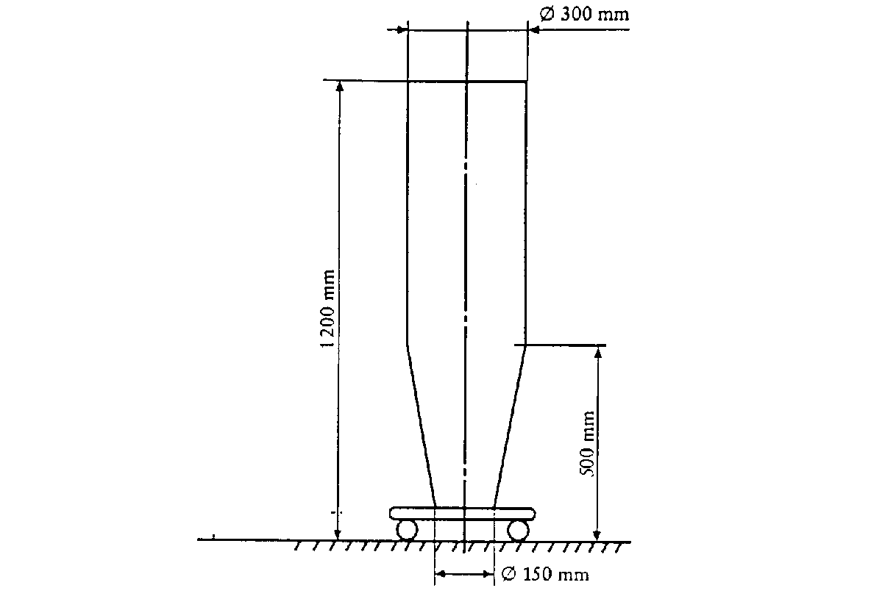

Figure 6

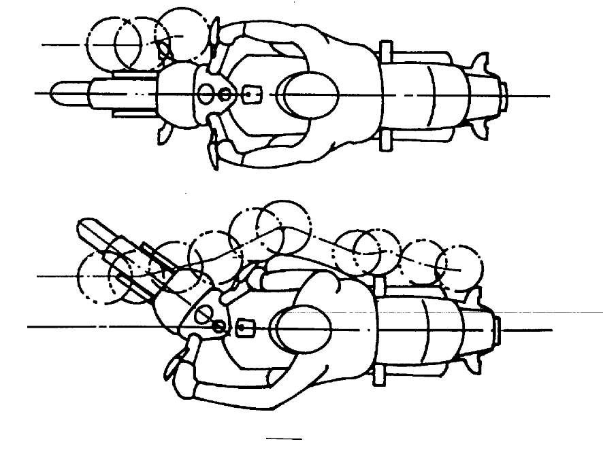
8.8. Noise emissions
8.8.1. Noise Inside vehicles
8.8.1.1. Scope
This recommendation sets out provisions concerning the measurement of noise inside motor vehicles of categories M₂, M₃, N₁, N₂ and N₃, to which the driver and/or passengers occupying seats in the cab of the vehicle or in the passenger compartment are exposed.
8.8.1.2. Methods of measuring the sound level
The noise produced by the vehicle type shall be measured in accordance with the two methods described above for moving vehicles and for stationary vehicles (see paragraph 8.8.2. in this document). The two values measured shall be recorded in a test report.
The test on the vehicle when stationary may usefully be taken as a reference value by technical services wishing to use this method to check vehicles in service.
8.8.2. Noise emitted by vehicles in use
8.8.2.1. To facilitate the prevention of sound pollution by vehicles in use through the introduction of simple checks, the use of the following sound-level measuring methods is recommended:
8.8.2.1.1. For four-wheeled vehicles, the method described in Regulation No. 51, Annex 3, paragraph 3.2. (Measurement of noise emitted by stationary vehicles, in proximity to the exhaust).
8.8.2.1.2. For motor cycles, the method described in Regulation No. 41, Annex 3, paragraph 3.2. (Measurement of noise emitted by stationary motor cycles, in proximity to the exhaust).
8.8.2.1.3. For mopeds, the method described in Regulation No. 63, Annex 3, paragraph 3.2. (Measurement of noise emitted by stationary mopeds, in proximity to the exhaust).
8.8.2.2. In view of the tolerances of measuring instruments, the disturbances that may occur at the time of measurement and the scatter of measurements for vehicles of the same type, it will be necessary to allow for a margin of 5 dB(A) in comparison with the corresponding value recorded at the time of the type approval.
8.8.2.3. The last-mentioned value, and also the initial constant running speed of the engine, shall be entered in the registration documents of each new vehicle, or on the manufacturer’s plate in the case of vehicles for which registration is not required.
8.8.2.4. Checks on vehicles brought into use prior to the introduction of this method shall be carried out in accordance with the procedures previously in force.
8.8.2.5. A visual inspection of the exhaust system and a check of its marking shall also be carried out where possible.
8.9. Door latches and door retention components
Direction of operation of inside door handles
Manufacturers should fit their door handles, when they rotate round a horizontal axis, in such a way that:
(a) the handles move symmetrically to the median longitudinal axis of the vehicle;
(b) in the closed (as distinct from the locked) position the handle is horizontal or nearly so and is pulled upwards to open the door.
8.10. Child restraints
It is recommended to apply the requirements of the Regulations listed paragraph 5, the table, line J.
8.11. Compatibility between drawing vehicles and trailers
Not yet established.
8.12. Device to indicate a broken coupling
Drawing vehicles to which a trailer is coupled need not necessarily be equipped with a device for automatic signalling of the breakage of the trailers coupling.
8.13. Weight and axle load distribution
8.13.1. Passenger cars
Not yet established
8.13.2. Motor coaches and buses
The load distribution on the axles of motor coaches and buses shall be such that the front axle or axles carry at least 25 % of the total weight of the vehicle when stationary on a level road.
This condition shall be complied with both:
8.13.2.2.1. when the vehicle is empty and a weight equivalent to that of a driver is placed on the driver's seat; and
8.13.2.2.2. when the vehicle is fully laden with a load consisting of:
(a) a weight equivalent to that of a passenger, which is placed on each seat provided;
(b) a weight equivalent to that of the permissible number of standing passengers, which is distributed uniformly over the area set aside for them; and
(c) a weight equivalent to the total permissible weight of luggage, which is distributed among the spaces reserved for luggage.
8.14. Protection of the occupants of goods-carrying power-driven vehicles against the shifting of loads
8.14.1. The equipment of vehicles (without prejudice to the provisions concerning the arrangement, and possibly concerning the securing, of loads on the vehicle) shall be in conformity with provisions calculated to reduce the risks run by the driver and the other occupants of goods-carrying vehicles in the event of a forward shift of the load on sudden braking, the following provisions being taken as a model:
8.14.1.1. The occupants of such a vehicle shall be protected by a screen or headboard capable of withstanding, without breaking, a uniformly-distributed static force of 800 daN per ton of the vehicle permissible load, exerted horizontally and parallel to the longitudinal median plane of the vehicle.
This protective screen or headboard may be detachable.
It must meet the following requirements:
8.14.1.1.1. Its width (measured at right angles to the longitudinal median axis of the vehicle) must be at least equal to the width of the space provided for the occupants and, where there is a separate cab, at least equal to the width of the cab;
8.14.1.1.2. In height it must reach at least 800 mm above the level of the loading platform where there is a separate cab, or be of the same over-all height as the load compartment where there is no separate cab;
8.14.1.1.3. It must be secured directly to the chassis or to the front of the loading platform. If it is secured to the loading platform or, where appropriate, to the body, the anchorage of that platform to the chassis must be capable of withstanding the thrust transmitted. In cases where the cab is integral with the body, the protective screen or headboard may be secured to, or form part of, the body structure. In the case of an articulated vehicle, no protective screen need be provided on the vehicle drawing a semi–trailer; such a screen must always be placed at the front of the semi–trailers loading platform.
8.14.2. In addition, if a power-driven vehicle or a semi–trailer is loaded with beams, pipes, girders, sheet metal or similar loads liable, in the event of failure of the securing devices, dangerously to penetrate the cab of the power-driven vehicle under the effect of sudden braking, the protective screen or headboard must have a resistance at least equal to that of a steel plate not less than 3 mm thick.
8.14.3. Where a vehicle is equipped with a trestle or bolster behind the cab for the purpose of supporting long loads, such as steel girders or telegraph poles, the trestle or bolster must be capable of withstanding the combined effect of two forces, each of 600 daN per ton of permissible load, acting forwards and downwards on the top of the trestle.
8.14.4. This recommendation shall not apply to passenger cars even when they are carrying goods, to tank-lorries and special-purpose vehicles for the carriage of containers, or to special-purpose vehicles used for the carriage of indivisible objects, where the latter vehicles and their operation are already subject to special regulations.
8.15. Locking, for safe operation, of tilt cabs of motor vehicles normally used for carrying goods by road
8.15.1. Cab in dropped position
8.15.1.1. Tilt cabs shall be fitted with a main locking system and an auxiliary locking system.
8.15.1.2. The main and auxiliary locking systems shall be independent of each other so that the failure of either does not entail the failure of the other.
8.15.1.3. The main and auxiliary locking systems shall be able to withstand a force directed vertically upwards equivalent to one-and-one-half times the cab's weight.
8.15.1.4. The main and auxiliary locking devices shall be so designed that they cannot either be worked inadvertently or open at the wrong time through the vehicle's acceleration or deceleration or vibrations due to the use of the vehicle.
8.15.1.5. If the driver himself cannot readily make certain, whether from outside the vehicle or from his seat, that the main locking device is properly engaged, a warning signal must be fitted.
8.15.1.6. At least the auxiliary locking device must be able to operate automatically when the cab is dropped to the normal driving position.
8.15.1.7. The auxiliary locking device shall be able to hold the cab in position should the main locking device fail.
8.15.1.8. A steady manual effort shall be required to release the auxiliary locking device so that the cab can tilt.
8.15.1.9. A plate or label indelibly inscribed with precise instructions on the operation of the locking devices shall be affixed in a clearly visible position on the vehicle.
8.15.2. Cab in raised position
The cab shall be capable of being held in the raised position either automatically or by means of a retaining device.
8.16. Mounting of the body or load platform of commercial vehicles
8.16.1. The axle-load limits shall not be exceeded when the vehicle is loaded to its permissible maximum weight, the load being uniformly distributed over the space provided for it.
8.16.2. The body or load platform shall be made and mounted taking into account the specifications, if any, of the chassis manufacturer.
8.16.3. The size and positioning of the mounting holes and/or welds shall be such that the strength of the chassis frame is not adversely affected. Holes in and welding on the flanges and the adjacent ends of the web of the side-members of the chassis frame shall be prohibited except where expressly permitted by the chassis manufacturer. In addition, no welding shall be allowed if this is expressly prohibited by the chassis manufacturer.
    - In mounting the body or load platform, all practicable steps shall be taken to keep the centre of gravity of the vehicle as low as possible.
In addition, this mounting shall not adversely affect the stability of the vehicle.
8.16.5. The body, including the necessary intermediate components, shall be attached directly to the chassis frame of the vehicle.
8.16.6. When U bolts are employed to secure the body or load platform to the chassis frame, spacers shall be used between the flanges of side-members to prevent buckling.
8.16.7. For mountings, use shall be made of round holes and suitable bolts with the least possible play, at least at the foremost and rearmost attachment points.
8.16.8. The mounting of the body or load platform shall be such as not to impair the soundness and functioning of the wiring and braking circuits.
8.16.9. Where the cab and bodywork are integral, account shall be taken of the flexibility of the cab mounting.
8.16.10. In the mounting of rigid bodies such as tanks, account shall be taken of any flexibility in the chassis frame.
8.16.11. In the case of tank-vehicles, where outrigger brackets are used to fasten the tank to the chassis of the vehicle, the vertical face of the brackets shall not be less in height than the depth of the chassis frame to which they are attached.
8.16.12. In the case of tipping vehicles, where there is no supplementary under frame to distribute the load, the pivot brackets for rearward-tipping bodies shall be located as near as possible to the rear spring brackets to minimize additional bending stresses on the chassis frame during tipping.
8.16.13. In the case of bodies tipping rearwards only, guide plates shall be provided to control the lateral movement of the body when lowered onto the chassis frame.
8.16.14. In the case of tipping bodies, steps shall be taken to prevent excessive noise caused by the bodywork of the vehicle when it is unladen.
8.17. Lashing and securing arrangements on road vehicles for sea transport on Ro/Ro ships
It is recommended to apply ISO standards (9367-1:1989, 9367-2:1989).
8.18. Caravans
Not yet established.
8.19. Driver's field of vision
It is recommended to apply the requirements of the Regulations listed in paragraph 4, the table, lines R and U.
8.20. Identification of controls and tell-tales
It is recommended to apply the requirements of the Regulations listed in paragraph 4, the table, lines P and Q.
8.21. Windscreen-wipers and washers
Not yet established.
8.22. Windscreen de-frosting and de-misting systems
Not yet established
8.23. Flammability of materials intended to be used inside road vehicles
It is recommended to apply the requirements of the Regulations listed in paragraph 5, the table, line P.
8.24. Measures to prevent unauthorized modifications to mopeds and motor cycles in use
8.24.1 Purpose of the Recommendation
This Recommendation is intended to reduce to the extent possible unauthorized modification to certain classes of power-driven vehicles which are subject by legislation to restrictions on their engine capacity and/or their performance and/or their maximum speed.
8.24.2 Scope
8.24.2.1. This Recommendation applies to:
8.24.2.1.1. Mopeds as defined in article 1 (m) of the 1968 Convention on Road Traffic and having two wheels only.
8.24.2.1.2. Mopeds within that definition but subject to other restrictions according to national legislation.
8.24.2.1.3. Derivatives of mopeds.
8.24.2.1.4. Certain motor cycles (as defined in article 1 (n) of the 1968 Convention on Road Traffic), designed and constructed in accordance with national legislations, so as to have a restricted engine capacity and/or performance and/or maximum speed.
8.24.2.1.5. Certain motor cycles of other categories, used only for limited purposes, which are designed and constructed specially to meet such limitations, in agreement with the manufacturer.
8.24.3. General specifications
8.24.3.1. All vehicles offered for sale shall comply in all respects with the type approval (or the equivalent national) requirements.
8.24.3.2. The information on marking required in accordance with paragraph 8.24.4.1. below shall be annexed to the documents submitted with the application for type approval, or first registration as appropriate, of the vehicle.
8.24.4. Specific requirements
8.24.4.1. Marking of certain parts or components.
8.24.4.1.1. The parts or components listed below shall be durably and indelibly marked with code number(s) and/or symbol(s) given by the vehicle manufacturer or alternatively by the manufacturer of such parts or components or by the type approval authority in order to identify those parts or components. Such marking shall be visible (so far as practicable) without the necessity of dismantling the part in question or other parts of the vehicle.
8.24.4.1.2. Letters figures or symbols shall preferably be at least 5 mm in height and shall be easily readable. In cases where a height of 5 mm is not practicable, this dimension may be reduced but shall not be less than 3 mm.
8.24.4.1.3. The parts and components referred to in paragraph 8.24.1.1. above are the following:
8.24.4.1.3.1. Intake silencer (air filter or cleaner);
8.24.4.1.3.2. Carburettor or equivalent instrument;
8.24.4.1.3.3. Inlet manifold (if cast separately from the carburettor or cylinder);
8.24.4.1.3.4. Cylinder;
8.24.4.1.3.5. Cylinder head;
8.24.4.1.3.6. Crankcase;
8.24.4.1.3.7. Exhaust pipe(s);
8.24.4.1.3.8. Silencer(s);
8.24.4.1.3.9. Transmission driver member (front chain wheel (sprocket) or pulley);
8.24.4.1.3.10. Transmission driven member (rear chain wheel (sprocket) or pulley);
8.24.4.1.3.11. Speed-limitation devices.
8.24.4.2. Vehicle Manufacturers Identification Plate.
8.24.4.2.1. A plate shall be affixed to each vehicle in a durable and permanent manner and in a visible place. On this plate the vehicle manufacturer shall state:
8.24.4.2.1.1. His name or trade mark;
8.24.4.2.1.2. The type of vehicle;
8.24.4.2.1.3. The code number(s) or symbol(s) identifying the part or component marked in accordance with paragraph 8.24.4.1. above. A suggested model for simple correlation of the parts or components with their corresponding code number(s) or symbol(s) is shown in Figure 7 below.

Figure 7
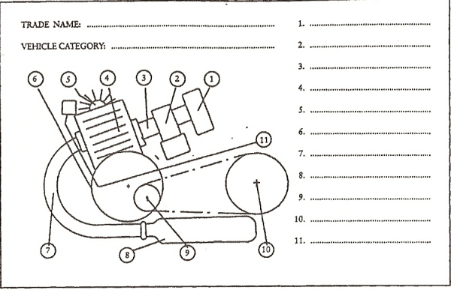
8.24.4.2.2. Letters, figures or symbols shall be at least 3 mm in height and shall be easily readable.
8.24.4.2.3. In the case of alternative parts or components being type approved (or granted an authorization) for the same vehicle, the code number(s) or symbol(s) of such alternative parts or components shall be shown on the plate.
8.24.5. Technical specifications
8.24.5.1. Each vehicle shall be so designed and constructed as to comply with the specifications set out below:
8.24.5.1.1. Cylinder head gasket: the maximum thickness of the cylinder head gasket shall not exceed 1.3 mm.
8.24.5.1.2. Cylinder/crankcase joint: the maximum thickness of any gasket between the base of the cylinder and the crankcase shall not exceed 0.5 mm.
8.24.5.1.3. The piston, when in the position at top dead centre, shall not cover the inlet port. This provision does not apply to those parts of the transfer port coincident with the inlet port in the case of vehicles, the engine of which is equipped with an induction system incorporating reed valve(s).
8.24.5.1.4. Rotation of the piston through 180° shall not increase the performance of the vehicle nor its design maximum speed.
8.24.5.1.5. In the event of the removal of the intake silencer, the design maximum speed of the vehicle shall not be increased by more than 5 km/h or 10 % of that speed, whichever is the lower.
8.24.5.1.6. There shall be no artificial restrictions in the gas passage which can be easily removed or modified.
8.24.5.1.6.1. This provision applies equally to reed or rotary valve systems, if such removal or modification causes an increase in the design maximum speed of the vehicle of more than 5 km/h or 10 % of that speed, whichever is the lower.
8.24.5.1.6.2. The valve guides of a four-stroke engine are not considered to be artificial restrictions.
8.24.5.1.7. The part(s) of the exhaust system inside the silencer(s) which determine(s) the effective length of the exhaust pipe shall be so affixed to the silencer(s) that it (they) cannot be removed.
8.24.5.1.8. In the event of a variation of the ignition timing and/or a change of the carburettor jet(s), the design maximum speed of the vehicle shall not be increased by more than 5 km/h or 10 % of that speed, whichever is the lower.
8.24.5.1.9. The design of cylinder and cylinder heads intended for different performance levels of the same basic engine shall be such that these parts cannot be fitted to an engine for which they are not appropriate; this can be obtained, for example, by different cylinder liner diameters, by different bolt patterns or different bolt diameters.
8.24.5.1.10. For 4-stroke engines a variation in camshaft timing shall not increase the maximum design speed above the values indicated in paragraphs 8.24.5.1.5 and 8.24.5.1.8.
8.24.5.1.11. For 4-stroke engines the design of the cylinder head shall be such that it cannot accommodate various camshafts intended for different performance levels of the same basic engine.
8.24.5.1.12. If the moped is equipped with electrical/electronic devices which limit the moped speed, the manufacturer shall provide data and evidence to the test authorities to demonstrate that modification or disconnection of the device, or its wiring system, will either not increase the maximum speed of the moped or will render the moped inoperative.
Electrical/electronic devices which cut or inhibit the spark ignition are forbidden if their disconnection results in an increase in either fuel consumption or unburnt hydrocarbons.
Electrical/electronic devices which vary the spark advance shall be designed so that the engine power, measured with the device functioning, does not differ by more than 10 % from the power measured with the device disconnected and with the advance set for maximum road speed.
The maximum road speed shall be achieved with the spark advance set within ± 5° of the value specified for the development of maximum power.
8.25. Light-signalling
It is recommended to apply the requirements of the Regulations listed in paragraph 4, the table, lines D to J.
8.26. Tyres
It is recommended to apply the requirements of the Regulations listed in paragraph 4, the table, lines L to O.
8.27. Mudguards
The bodies of motor vehicles (other than special-purpose vehicles, agricultural or forest tractors and vehicles with a maximum rated speed not exceeding 20 km/h), and the bodies of all trailers coupled thereto, shall be equipped with effective mudguards, at least for their rear wheels.
8.28. Tachographs
The fitting of a tachograph should be compulsory on motor vehicles whose permissible maximum weight, including that of trailers permitted to be coupled to the vehicle, exceeds 7.5 tonnes, or which belong to category D as defined in annexes 6 and 7 to the 1968 Convention on Road Traffic.
8.29. Information and communication systems in motor vehicles
8.29.1. Developments in the sphere of guidance, information and communications technology will result in crucial contributions towards solving transport problems in the field of road traffic. The following aspects, in particular, are of far-reaching significance:
8.29.1.1. the meshing and interconnecting of modes of transport in an integrated overall transport system;
8.29.1.2. a more efficient use of the transport infrastructure of all modes of transport;
8.29.1.3. enhancing road safety and reducing environmental pollution;
8.29.1.4. traffic avoidance and shifting traffic to more environment-friendly modes of transport.
8.29.2. The relevant systems, which either exist or are in development, are designed to assist the driver in performing his function of driving his vehicle, but they also make claims on his attention. To ensure that the use of such systems does not impair road safety, it is necessary to ensure that the licensing and design of these systems comply with certain requirements.
8.29.3. Guidelines for the design and installation of information and communications systems in motor vehicles will create a common basis on which the public sector and industry can tackle the tasks they face. They can also provide orientation for systems under development. Such Guidelines can also supply a sound basis for the licensing and marketability of innovative products at the time being, not precluding, however, further development into Regulations.
8.29.4. In some spheres, further studies will have to be conducted to deepen knowledge. These guidelines reflect a framework-model.
8.29.5. Governments wishing to apply provisions for the design and installation of information and communications systems in motor vehicles more precise through further research are recommended to consider the short and medium-term implementation of findings from the following fields:
8.29.5.1. Road safety (providing safe assistance to the driver in road traffic);
8.29.5.1.1. System safety (reliability of systems, suitability for international approval and monitoring, e.g. also electromagnetic compatibility);
8.29.5.1.2. Interaction safety (design of the driver-system interface);
8.29.5.2. Legal safety (questions of liability and issues relating to traffic legislation).
8.29.5.3. The ongoing standardisation activities at CEN and ISO level should be also taken into account.
8.29.6. In keeping with the findings currently available, these guidelines deal primarily with the sphere of road safety, thereby also taking account of the priority that is attached to road safety. Governments wishing to apply requirements relating to in vehicle systems are recommended to base them on the following basic requirements:
8.29.6.1. All types of information and communications equipment in motor vehicles must be designed such that the driver is not forced or encouraged to use both hands simultaneously while driving to operate it, not even for brief moments.
8.29.6.2. The use of all communications and information equipment that requires the driver to look at it must be minimized while the vehicle is in motion. This means primarily that while the vehicle is in motion, functional information may be provided, i.e. information that assists the driver in his immediate task of driving his vehicle (including finding his way and planning his journey) and serves the purposes of freight and fleet management, vehicle checks, automatic registration of charges and other tasks related to driving. Information that is likely to greatly distract the driver visually (for instance TV, video, commercials) must either be switched off completely while the vehicle is in motion or may be presented only in such a way that the driver cannot see it directly.
8.29.6.3. The information system must not deactivate or interfere with existing control equipment and prescribed instruments, in particular those that are required for road safety and safety of operation and those that the driver requires to be able to drive his vehicle safely.
8.29.6.4. The proper use of information systems in motor vehicles, as well as the total or partial failure of such systems, must not impair the safe operation of the vehicle. This means that the driver must at all times be able to perform by himself his primary task of driving his vehicle.
8.29.6.5. The information system must not pose a danger to the passengers or other road users. This statement also applies to the foreseeable incorrect operation of the system by inexperienced users.
8.29.6.6. In the case of speech-based communications systems that are designed to be used by the driver while the vehicle is in motion, provision must be made for hands-free speaking and listening equipment.
8.29.7. Irrespective of a further research that has to be done it is agreed that in the development and employment of information and communications systems for road vehicles, it is recommended that account be taken of the following requirements:
8.29.8.1. The mere presence of a system, and the functions of a system, should not result in any impairment of the functions of other systems in the vehicle or of the vehicle itself.
8.29.7.2. Information systems should be easy to use.
8.29.8.3. It should be possible to switch off the output of information by the system, in order to leave it to the driver whether or not he wishes to use the system.
8.29.7.4. If the information system is designed for use by the front-seat passenger and the driver, it should be installed such that proper use by the passenger cannot have a negative effect on the driver.
8.29.8.5. Visual information and communication should not be distributed over several display media if this could result in the driver having to divide his attention in the visual sphere, which would be detrimental to safety.
8.29.7.6. The position of the information systems should be selected such that when the driver averts his eyes from the road ahead the movement of his eyes horizontally and vertically is as slight as possible, and that the systems are easy to read.
8.29.8.7. The information system should be designed such that it does not distract the driver excessively and could not potentially cause him to drive in a dangerous manner (for instance by overreacting).
8.29.7.8. In order to ensure that it is used, the information system should not require the driver to reply or respond within a specific period of time. The driver must be able to determine the speed of interaction himself or to interrupt it. Nor must the attention that he driver requires for the primary task of driving his vehicle be diverted for any length of time.
8.29.8.9. The information provided should, whenever practicable, assist the driver in a timely manner and in line with his requirements. Thus, for instance, routine information should be provided well in advance, to enable the driver to execute the necessary manoeuvre safely.
8.29.7.10. Input by keyboard should be minimized while the vehicle is in motion or should be possible when the vehicle is stationary. Lengthy and repeated series of actions should be avoided. Controls should be limited to those that are absolutely necessary and designed such that they can largely be operated without looking (haptic aids).
8.29.8.11. In order to minimize the amount of time during which the driver has to avert his eyes and to reduce the over-stimulation of his sense of vision, it is recommended that the acoustic information channel be used.
8.29.7.12. Instructions regarding the information system, its installation and operation should be correct, adequate, simple and written in the language of the country concerned. They should be designed such that future users can also learn how to use the system (learning by using).
8.29.7.13. The operating instructions should also highlight potential dangers and system constraints, and should point out that vehicle information systems may only be used in such a way that they do not constitute a safety hazard.
8.30. Supports for motor cycles
8.30.1. Purpose of the recommendation
This Recommendation is intended to ensure, so far as is reasonably practicable, that the installation and use of the supports with which two-wheeled motor vehicles are equipped do not present hazards either to the users of the vehicle or to any other road user.
8.30.2. Scope
This Recommendation applies to mopeds and motor cycles having two wheels only and not equipped with side-cars.
8.30.3. Definitions
8.30.3.1. "Vehicle" means a moped or a motor-cycle as defined in the Vienna Convention on Road Traffic, 1968, article 1 (m) and (n) respectively, to the exclusion of vehicles equipped with side-cars or having three wheels;
8.30.3.2. "Support" means a device securely affixed to the vehicle by means of which the vehicle can be maintained in the parked, upright (or near upright) position when it is at rest and not attended by the rider;
8.30.3.3. "Side stand" means a support which, when extended or pivoted into the open position, supports the vehicle on one side only, leaving both wheels in contact with the supporting surface;
8.30.3.4. "Centre stand" means a support which, when extended into open position, supports the vehicle by providing an area, or areas, of contact between the vehicle and the supporting surface, distributed on either side of the longitudinal median plane of the vehicle;
8.30.3.5. "Tilt" means the inclination, measured as a percentage (see figure 8 below), of the supporting surface produced by raising or lowering one side of the supporting surface in relation to the horizontal in such a manner that the intersection of the supporting surface and the horizontal plane is parallel to the longitudinal median plane of the vehicle;
8.30.3.6. "Slope" means the inclination, measured as a percentage (see figure 9 below), of the supporting surface produced by raising or lowering one side of the supporting surface in relation to the horizontal in such a manner that the intersection of the supporting surface and the horizontal plane is perpendicular to the longitudinal median plane of the vehicle;
8.30.3.7. "Longitudinal median plane" of the vehicle means the longitudinal plane of symmetry of the rear wheel of the vehicle;
8.30.3.8. "Unladen kerb mass" means the mass of the vehicle in running order, without occupant or load, but with fuel, coolant, lubricant, tool-kit and spare wheel (if normally provided by the manufacturer).
8.30.4. General requirements
8.30.4.1. Every vehicle shall be equipped with some form of support to ensure its stability at rest (for example, when it is parked) and not maintained in a static position by human or external means.
8.30.4.2. Such support shall be either:
8.30.4.2.1. A side stand; or
8.30.4.2.2. A centre stand.
8.30.4.3. This Recommendation shall neither require a vehicle to be equipped with more than one, or more than one type of, support, nor prevent a vehicle from being so equipped.
8.30.4.4. Supports shall be so designed and constructed as to be:
8.30.4.4.1. Free from all unnecessary sharp edges and projections which might cause injury to the rider, the passenger or third parties coming into contact with the support (Radius of curvature of not less than 2.5 mm is considered to satisfy this requirement);
8.30.4.4.2. Easy to use and precise in their action;
8.30.4.4.3. Unlikely to cause permanent deformation of the supporting surface when in the open or parking position.
8.30.4.5. In the case of a support which is hinged to the lower part or underside of the vehicle, the outer extremity (extremities) of the support shall, in order to place it in the closed or riding position, move towards the rear of the vehicle.
8.30.5. Special requirements
8.30.5.1. Side stands
8.30.5.1.1. Side stands shall possess the following characteristics:
8.30.5.1.1.1. The ability to support the vehicle, in such a manner as to ensure the lateral stability of the vehicle, whether on a horizontal supporting surface or under conditions of tilt, so that the vehicle cannot be either too easily further inclined (and hence made to overbalance, using the side stand as a fulcrum) or too easily moved into or beyond the vertical position (and hence made to overbalance and fall onto the side opposite the side stand);
8.30.5.1.1.2. The ability to support the vehicle in such a manner as to ensure positive positioning when the vehicle is under conditions of slope;
8.30.5.1.1.3. The ability to fold back into the closed or riding position automatically;
8.30.5.1.1.3.1.When the vehicle is returned to the normal (vertical) position for riding, or
8.30.5.1.1.3.2.As a result of the vehicle being moved forward by a deliberate action of the rider, or
8.30.5.1.1.3.3.Without disturbing the equilibrium of the vehicle, if the side stand comes into contact with the supporting surface while the vehicle is moving;
8.30.5.1.1.4. Notwithstanding the provisions of paragraph 8.30.5.1.1.3. above, the side stand shall nevertheless be designed and constructed in such a manner that
8.30.5.1.1.4.1.once moved into the open or parking position,
8.30.5.1.1.4.2.with the vehicle inclined in order to bring the outer extremity of the side stand into contact with the ground, or
8.30.5.1.1.4.3. when the vehicle is left unattended in the parked position, the side stand will not automatically close if the angle of inclination is inadvertently changed (for example, because the vehicle is slightly moved by a third party or because of wind pressure created by a passing vehicle).
8.30.5.1.2. Instead of conforming to the provisions of paragraphs 8.30.5.1.1.3. and 8.30.5.1.1.4. above, the vehicle may be equipped with a side stand which is connected to its ignition system in such a manner that the ignition system can only be activated when the side stand is in the closed or riding position.
8.30.5.2. Centre stands
8.30.5.2.1. Centre stands shall possess the following characteristics:
8.30.5.2.1.1. The ability to support the vehicle with one wheel, both wheels or neither wheel in contact with the supporting surface in such a manner as to ensure the stability of the vehicle:
(a) On a horizontal supporting surface;
(b) Under conditions of tilt;
(c) Under conditions of slope.
8.30.5.2.1.2. The ability to fold back into the closed or riding position automatically:
(a) When the vehicle is moved forward in such a manner as to disengage the centre stand from the supporting surface, or
(b) Without disturbing the equilibrium of the vehicle, if the centre stand comes into contact with the supporting surface while the vehicle is moving.
8.30.5.2.2. Instead of conforming to the provisions of paragraph 8.30.5.2.1.2. above, a vehicle to which only a centre stand is fitted may be equipped with a centre stand which is connected to its ignition system in such a manner that the ignition system can only be activated when the centre stand is in the closed or riding position.
8.30.5.3. All supports
8.30.5.3.1. Vehicles which are equipped in accordance with the provisions of paragraphs 8.30.5.1.2. or 8.30.5.2.2. above may in addition be equipped with a warning light, clearly discernible by the rider when seated in the riding position which, when the ignition is switched on, comes on and remains on until the support is in the closed or riding position.
8.30.5.3.2. Supports shall be equipped with a retaining system to secure them in the closed or riding position.
The system may consist of either:
(a) Two independent devices, such as two separate springs or a spring and a retaining device such as a clip, or
(b) A single device which shall be capable of operating without failure for at least10,000 cycles of normal use if the vehicle is equipped with two supports, or 15,000 cycles of normal use if the vehicle is equipped with a single support.
8.30.6. Tests for stability
In order to establish the ability to support the vehicle in a stable condition as specified in paragraph 8.30.5. of this Recommendation, the following tests shall be undertaken.
8.30.6.1. Condition of the vehicle
8.30.6.1.1. The vehicle shall be at its unladen kerb mass.
8.30.6.1.2. The tyres shall be inflated to the pressure recommended by the manufacturer for these conditions.
8.30.6.1.3. The transmission shall be in neutral or, in the case of automatic transmission, in the parking position if provided.
8.30.6.1.4. If the vehicle is equipped with a parking brake, it shall be applied.
8.30.6.1.5. The steering head shall be in the locked position. If the steering can be locked when turned either to the left or to the right, the tests shall be carried out with the steering head in both positions.
8.30.6.2. Test area
Any flat, horizontal area with a hard, dry surface, free from grit, may be used for the tests defined in paragraph 8.30.7.1. below.
8.30.6.3. Test equipment
8.30.6.3.1. A parking platform shall be used for the tests set out in paragraph 8.30.7.2. below.
8.30.6.3.2. The parking platform shall be a rigid, flat, rectangular surface capable of supporting the vehicle without significant flexing.
8.30.6.3.3. The surface of the parking platform shall provide sufficient friction to prevent the vehicle from sliding in relation to the supporting surface during the tests for tilt or slope.
8.30.6.3.4. The parking platform shall be so constructed as to be capable of assuming at least the inclinations to the horizontal prescribed in paragraph 8.30.7.2.2.
8.30.7. Test procedure
8.30.7.1. Stability on a horizontal supporting surface (Test for paragraph 8.30.5.1.1.4. above).
8.30.7.1.1. With the vehicle in the test area, the side stand shall be placed in the open or parking position and the vehicle allowed to rest upon the side stand.
8.30.7.1.2. The vehicle shall be moved so that the angle formed by the longitudinal median plane and the supporting surface is increased by moving the vehicle towards the upright position by 3°.
8.30.7.1.3. The side shall not, as a result of this movement, automatically return to the closed or riding position.
8.30.7.2. Stability on an inclined surface (Tests for paragraphs 8.30.5.1.1.1., 8.30.5.1.1.2., 8.30.5.2.1.1.2.. and 8.30.5.2.1.1.3. above).
8.30.7.2.1. The vehicle shall be placed on the parking platform with the side stand, and separately, with the centre stand placed in the open or parking position, and the vehicle allowed to rest upon the support.
8.30.7.2.2. The parking platform shall be inclined as shown in figures 1 and figures 2 according to the following minimum tilt and slope inclinations:
Side stand |  |  | Centre stand
 | Mopeds | Motor cycles | Mopeds | Motor cycles
Tilt | 5 % | 6 % | 6 % | 8 %
Slope downward | 5 % | 6 % | 6 % | 8 %
Slope upward | 6 % | 8 % | 12 % | 14 %

8.30.7.2.3. Where a vehicle is placed on an inclined parking platform by use of the centre stand and one wheel only and can be maintained in that position with the centre stand and either the front or the rear wheel in contact with the supporting surface, provided the other conditions of this paragraph are complied with, the foregoing tests shall be carried out with the vehicle placed upon the centre stand and the rear wheel only.
8.30.7.2.4. With the parking platform inclined to each of the prescribed inclinations and the foregoing conditions duly observed, the vehicle shall remain in a stable condition.
8.30.7.2.5. Instead of this procedure, the parking platform may be pre-set to the requisite inclinations before the vehicle is placed in position.

Figure 8
Tilt
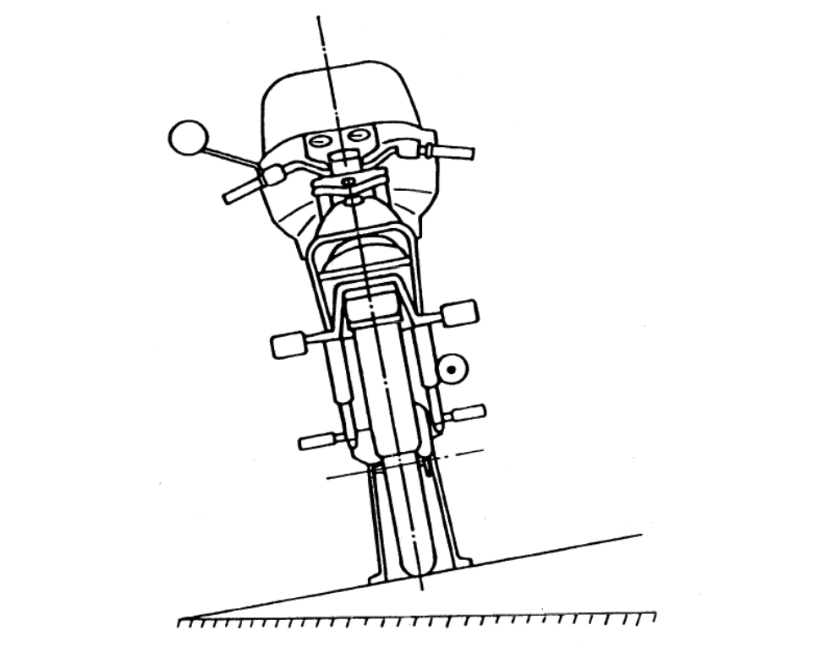

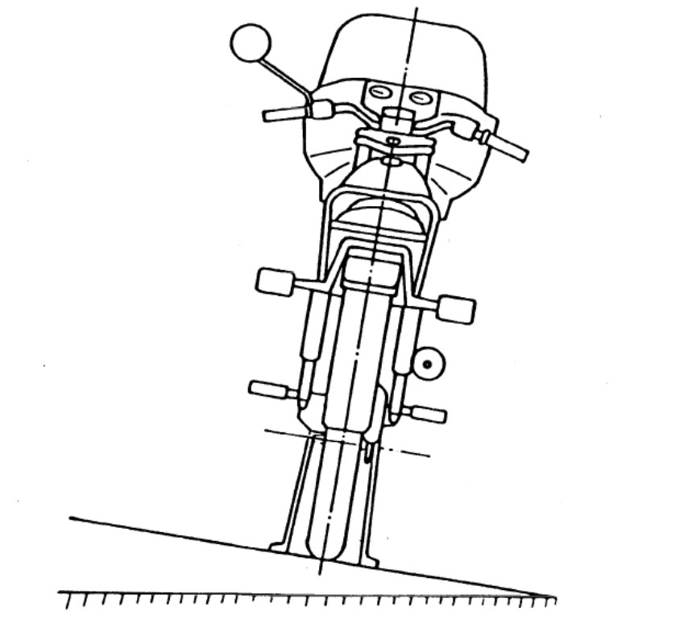

Figure 9 (a)
Slope – Upward inclination
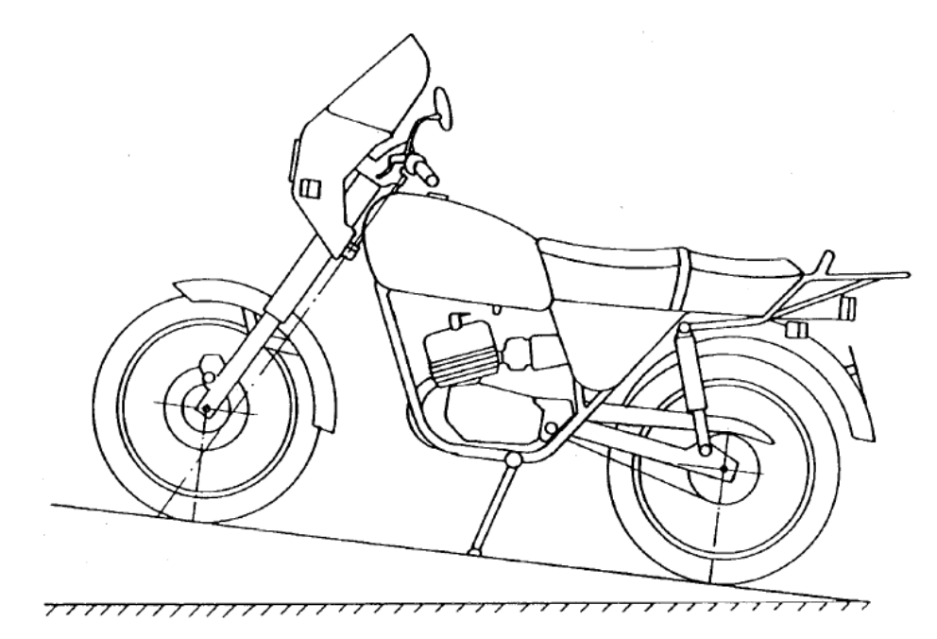

Figure 9 (b)
Slope – Downward inclination
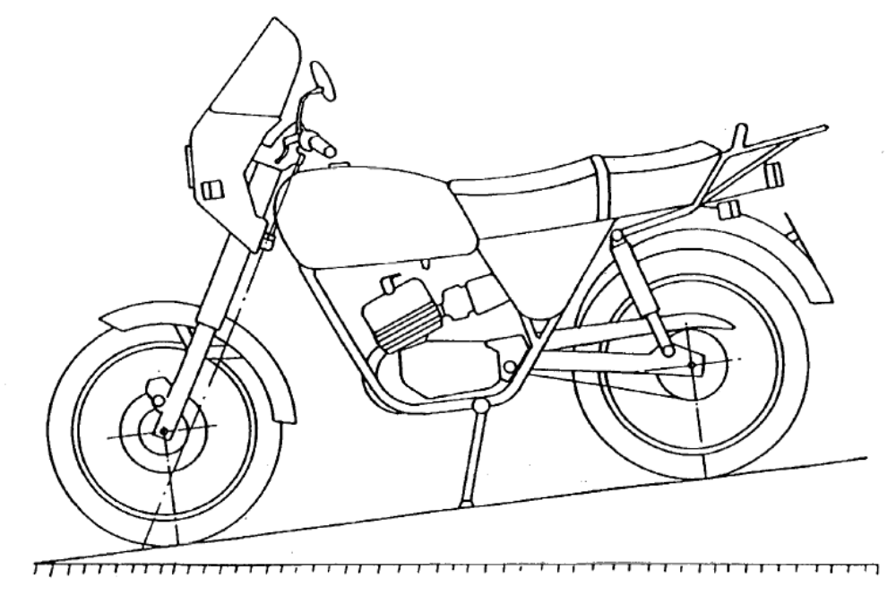8.31. First-aid kits
It should be compulsory for motor vehicles of category D as defined in Annexes 6 and 7 to the 1968 Convention on Road Traffic, other than those used for urban services, to carry a first aid kit.
8.32. Harmonization of technical standards
8.32.1. When instituting a procedure for the preparation of any national regulation or for an amendment whose content does not conform to or embodies requirements additional to:
(a) those embodied in one or more Regulations annexed to the 1958 Agreement, and dealing with the same topic; or
(b) one or more Recommendations established by the World Forum in the sphere to which the proposed national regulation relates, Governments should inform the Executive Secretary of the Economic Commission for Europe of their intention as soon possible, so that the information can be communicated to the other countries concerned.
8.32.1.2. Governments of countries considering bringing into force, in the matter of the construction or equipment of road vehicles, a national regulation dealing with topics not referred to in the above-mentioned Regulations and Recommendations should inform the Executive Secretary thereof in the manner and for the purposes specified above.
8.32.1.3. Governments of countries bringing into force a regulation relating to questions which have not been dealt with by the World Forum or its subsidiary organs should so far as possible provide for a simple procedure for the amendment of such regulation so that it can, if this is deemed necessary, be brought promptly into conformity with such international recommendations or provisions as may subsequently be prepared on the same questions.
8.33. Measures to prevent the sale of unauthorized spare parts and equipments
8.33.1. For the purposes of this recommendation, "unauthorized parts or equipment" means any vehicle part or item of equipment covered directly or indirectly by a Regulation annexed to the 1958 Agreement concerning the Adoption of Uniform Conditions of Approval and Reciprocal Recognition of Approval for Motor Vehicle Equipment and Parts which:
8.33.1.1. Either, should bear the approval mark prescribed by that Regulation but which regularly:
8.33.1.1.1. Does not bear the approval mark, even though such marking on the part or item of equipment concerned is compulsory under the national regulations of the country concerned; or
8.33.1.1.2. Bears an approval mark which has never been issued; or
8.33.1.1.3. Bears an approval mark which was issued to a manufacturer other than the actual manufacturer of the product; or
8.33.1.1.4. Bears an approval mark issued to the manufacturer but for another product;
8.33.1.2. Or, while not required to bear the approval mark, has been recognized by a technical service responsible for approval tests as having a performance that is clearly inadequate, having regard to the requirements of the Regulation concerned and, if it bears a manufacturer's mark or trademark, has been denounced by the owner of such mark as an unauthorized product within the meaning of these Recommendations.
8.33.2. Governments made aware of the offer for sale within their country of parts or items of equipment not authorized under the approval regulations shall take the following measures:
8.33.2.1. Obtain proof of the infringement, either:
8.33.2.1.1. In the case of paragraphs 8.33.1.1. and 8.33.1.2. above, by sampling at points of sale;
8.33.1.2. In other cases (paragraphs 8.33.1.1.2. to 8.33.1.1.4. by reference to its own records or by request addressed to the administrative service of the country whose identifying number appears on the approval mark;
8.33.2.2. If possible communicate to the competent administration(s) of the country of origin of the product (if it is not a Party to the 1958 Agreement) the information that an establishment in its country has offered for sale unauthorized parts or items of equipment;
8.33.2.3. Inform the secretariat of the Economic Commission for Europe of the infringement, providing all information in its possession, and in particular:
8.33.2.3.1. The description of the part or item of equipment;
8.33.2.3.2. The approval mark (or absence of mark);
8.33.2.3.3. The names and addresses of the manufacturer and/or the exporter; and
8.33.2.3.4. The names and addresses of the importer and/or the distributor.
8.33.3. Once in possession of the particulars referred to above, the secretariat shall circulate the information:
8.33.3.1. To the other Parties to the 1958 Agreement, and
8.33.3.2. To the countries which, while not party to the Agreement, unilaterally apply the Regulation to which the unauthorized part or item of equipment is subject.
8.33.4. Governments made aware of the infringement either directly or through the information procedure provided for above shall:
8.33.4.1. If possible take the necessary measures in accordance with their national law and without prejudice to any civil or criminal proceedings which might be initiated, to ensure that the unauthorized part or item of equipment:
8.33.4.1.1. Is prevented from entering their respective countries; and
8.33.4.1.2. Is withdrawn from the market if it has already been offered for sale.
8.33.4.2. Inform the manufacturer of the product, if known, of the prohibition of the offering for sale of the unauthorized part or item of equipment in the territory of their respective countries.
8.34. Restriction on the sale of equipment, parts or accessories which have not been approved
8.34.1. When motor vehicle equipment, parts or accessories are subject to approval, it is dangerous to permit non-approved equipment, parts or accessories of the same kind to be offered to the public under a name similar to that of approved articles.
8.34.2. Governments which subject to approval certain items of equipment, parts or accessories for motor vehicles or for road-users (such as headlights, retro-reflectors, safety belts, crash helmets for motor cycles, etc.) should consider the possibility of prohibiting the offering for sale of non-approved equipment, parts or accessories of the same kind under a name liable to be confused with that of approved articles.
8.35. Restraint systems for adults
It is recommended to apply the requirements of the Regulations listed in paragraph 5, the table, line K.
8.36. Rear marking plates on slow-moving/heavy/long vehicles
It is recommended to apply the requirements of the Regulations listed in paragraph 4, the table, line K.
8.37. Protection of pedestrians and other vulnerable road users in the event of a (head-on) collision with a passenger car
The following text is intended to provide motor vehicle manufacturers with guidelines concerning the design of future vehicle types and, in particular, the qualitative characteristics of the structure and deformation capacity of the front section of passenger cars; its purpose is to reduce as much as possible the severity of the injuries sustained by a person struck by the front of a vehicle travelling at a speed of up to 40 km/h.
8.37.1. Area of initial impact
The area of initial contact with the legs of the person struck should be below and forward of the conventional bumper. It should extend over a vertical height sufficient to distribute the force over the legs, preferably below the knees of an adult person.
8.37.2. Front structure of the vehicle
8.37.2.1. The rear third of the bonnet, the windscreen frame and the front pillars (A) should receive particular attention as regards both their energy-absorption capacity and their form.
It should not be possible for the head to strike the windscreen-wiper pivots. Should such contact be possible, the windscreen-wiper pivots shall have a suitable protective covering.
Should such contact be possible, the windscreen-wiper pivots shall have a suitable protective covering.
8.37.2.2. The bonnet leading edge should be such that the impact should not be against a hard edge but against a structure which is sufficiently large and if possible energy-absorbent.
8.37.2.3. An adequate deformation of the front third of the bonnet would, in particular, reduce the severity of head injuries to children.
8.37.2.4. Rigid parts located under the bonnet should be placed some distance back so as to allow sufficient deformation of the bonnet on impact.
8.37.3. Headlamps and other lamps
Headlamps and other front lamps should not have rigid projecting frames. If possible, they should be mounted slightly recessed in the bodywork.
8.37.4. Accessories
External accessories (trimmings, spoilers, etc.) should be deformable, retractable or detachable so as to minimize the risk of injury. In the latter cases, these recommendations shall also apply to the residual parts.
8.37.5. Structural elements
8.37.5.1. Preference should be given to structures with adequate energy-absorption capacity.
8.37.5.2. The curvature radius of parts of the vehicle which may be impacted should be as large as possible, with due account being taken of technical requirements.
8.38. Methods and instruments for measuring noise inside motor vehicles
8.38.1. Measuring instruments
8.38.1.1. An omnidirectional sound level meter of high precision complying at least with the specifications of Publication No. 651 [1979] "Precision sound level meters" of the International Electro technical Commission (IEC) concerning the characteristics of sound level meters shall be used. Measurement shall be carried out with frequency weighting A and time weighting F conforming to curve A and the "fast response" time respectively. The type of sound level meter shall be stated in the test report.
8.38.1.2. The sound level meter shall be calibrated against a sound pressure calibrator immediately before and after each series of test runs. If the meter readings obtained from these calibrations differ by more than 1 dB, the test shall be considered invalid.
8.38.1.3. A suitable wind shield may be used to reduce the influence of wind on the measurements in open vehicles. Wind shields recommended by the sound level meter manufacturer will generally be suitable.
8.38.1.4. If alternative measuring equipment, including, for example, a tape recorder and/or level recorder, is used, its overall electro-acoustic performance shall conform to the relevant provisions of IEC Publication 651 [1979] for class I instruments.
If a tape-recorder is used as part of the measuring equipment, it may be necessary to include suitable additional pre-emphasis and de-emphasis circuits for recording and reproduction to provide an adequate signal-to-noise ratio over the whole frequency range concerned.
8.38.1.5. The rotational speed of the engine shall be measured by an independent tachometer whose accuracy is within 3 % of the actual speed of rotation.
8.38.2. Measured quantities
8.38.2.1. All readings of the sound level meter are to be taken with time weighting F
8.38.2.2. The values to be measured at all microphone positions during type and monitoring tests are A-weighted sound pressure levels, LpA, expressed in decibels(dB). If the weighting curve used is not stated, the measured values shall be expressed in dB(A).
8.38.3. Conditions of measurement
8.38.3.1 Site
8.38.3.1.1. The test site shall be such that the sound radiated by the vehicle to the outside contributes to the inside noise only by reflections from the road surface and not by reflections from buildings, walls or similar large objects outside the vehicle. During the period of measurement, the distance of the vehicle from large objects shall be greater than 20 m.
8.38.3.1.2. The ambient air temperature in which the vehicle is operating shall be in the range -5 to +35°C. The wind speed along the test track at a height of approximately 1.2 m shall not exceed 5 m/s. The other meteorological conditions shall be such that they do not influence the measurements. The speed of the wind and the direction of the wind relative to the test track shall be stated in the test report.
8.38.3.1.3. For all measurements of A-weighted sound pressure levels the lower limit of the dynamic range set by the background noise level and by the inherent noise level of the measuring equipment shall be at least 10 dB below the A-weighted sound pressure levels of the vehicle noise.
8.38.3.1.4. The test road shall be hard and as smooth and level as possible, without gaps or ripples or similar macro-irregularities of surface texture which might contribute to the sound levels inside the motor vehicle. The surface shall be dry and free from snow, dust, stones, leaves, etc.
8.38.3.2. Vehicle
8.38.3.2.1. Engine and tyre conditions.
8.38.3.2.1.1. During the test, all operating conditions of the engine shall correspond to the specifications given by the manufacturer, for example, fuel, lubricating oil, timing of ignition or fuel injection pump for the test conditions. The engine shall be stabilized at its normal operating temperature immediately before commencing the test, e.g., by driving the vehicle for an adequate distance at a medium speed.
8.38.3.2.1.2. The tyres used shall be of a type specified by the vehicle manufacturer. If the use of off-road tyres is optional, tyres for road use shall be fitted. The tyres shall be nearly new, but with a minimum wear of 300 km. The type of tyres and inflation pressures at the time of testing shall be stated in the test report. The wheels of the vehicles should be statically and dynamically balanced if it is considered that wheels that are out of balance may affect the noise level inside the vehicle.
8.38.3.2.1.3. If the engine coolant radiators are equipped with devices such as flaps, the measurements shall be carried out with them open. Standard test conditions are with fan operating normally; if a vehicle is fitted with an automatic flap and/or fan, its operating conditions shall be stated in the test report.
8.38.3.2.2. Loading of the vehicle
8.38.3.2.2.1. The vehicle shall be unladen. In the cabs of trucks and similar vehicles, not more than two persons (the driver and observer) shall be allowed, and in public service vehicles with more than eight seats not more than three persons shall be allowed.
8.38.3.2.3. Openings, windows, auxiliary equipment
Openings such as skylights, all windows and ventilating inlets and/or outlets shall be closed, if possible. Auxiliary equipment such as windscreen wipers and heating and/or ventilating fans and air-conditioners shall not operate during the tests. If any auxiliary equipment is automatic, its operating condition shall be stated in the test report.
8.38.4. Methods of testing
8.38.4.1. General conditions of tests
8.38.4.1.1. At least two measurements shall be made at each microphone position and for each operating condition. If the spread of results of the A-weighted sound pressure level obtained under any measuring condition exceeds 3 dB, further measurements shall be made until the readings of two independent successive measurements fall within a range of 3 dB; the mean value of these two readings shall be taken as the test result.
8.38.4.1.2. The value stated in the test report shall be rounded to the nearest whole decibel.
8.38.4.1.3. Any peak which is obviously out of character with the general sound level being read shall be disregarded.
8.38.4.1.4. Whenever the sound level meter reading fluctuates, the mean value of the readings shall be determined. Occasional extreme peaks shall be disregarded.
8.38.4.1.5. The presence of clearly audible pure tones or noise of distinct impulse character shall be stated additionally in the test report.
8.38.4.2. Acceleration test
8.38.4.2.1. The procedure for the test is as follows:
The speed of the vehicle and of the engine shall be stabilized at the specified initial conditions.
When stable conditions are attained, the throttle shall be fully opened as fast as possible and held in this position until either 90 % of the engine speed for maximum power as specified by the manufacturer of the vehicle ("maximum power speed") or 100 km/h is reached, whichever is lower.
8.38.4.2.2. The initial operating conditions are specified as follows:
8.38.4.2.2.1. Vehicle with a manually-operated gear box
8.38.4.2.2.1.1.If the vehicle is fitted with a manually-operated gear box, it shall be in the highest gear with which the test is possible without exceeding 120 km/h; the gear setting shall not be changed during the test.
8.38.4.2.2.1.2.If, at an engine speed of 90 % of maximum power speed, a road speed of 120 km/h is exceeded in top gear, a lower gear shall be selected, but not lower than third for a four-speed or more than four-speed gearbox, and not lower than second for a three-speed gear-box. If 120 km/h is still exceeded in this lower gear, the vehicle shall be tested over the speed range 60 to 120 km/h in that gear.
8.38.4.2.2.1.3.The initial engine speed shall be the lowest allowing a continuously increasing engine speed during the test, but not lower than 45 % of the maximum power speed, unless 120 km/h is exceeded at 90 % of maximum power speed in the lowest gear allowed, in which case the initial engine speed shall be that corresponding to a road speed of 60 km/h.
8.38.4.2.3. Automatic transmission vehicle
8.38.4.2.3.1. For vehicles with automatic transmission, the initial engine speed shall be stabilized as near as possible to 45 % of the maximum power speed. The corresponding road speed shall be not higher than approximately 60 km/h.
8.38.4.2.4. If the setting changes before the final speed of 90 % of maximum power speed or 120 km/h is reached, the initial speed shall be 50 % of the speed at which the setting changes. If possible, kick-down mechanisms shall be made inoperative.
8.38.4.2.5. At full throttle acceleration, the maximum LpA value occurring in the specified acceleration range shall be recorded and stated in the test report, in accordance with provisions of paragraph 8.38.4.1. above.
8.38.4.3. Stationary test
8.38.4.3.1. Stationary tests shall be carried out in neutral gear with the engine operating at the idling speed indicated by the manufacturer.
8.38.4.3.2. The LpA values measured under the conditions stated in paragraph 8.38.4.3.1. above constitute the result of the measurement and shall be stated in the test report.
8.38.5. Microphone position
8.38.5.1. Microphone position in the vehicle
8.38.5.1.1. During the measurement no seat at which measurement is being made in the vehicle shall be occupied, with the exception of the driver's seat.
8.38.5.1.2. The microphone shall not be closer than 0.15 m to walls, upholstery or persons present. If an assistant is present during the measurement (see paragraph 8.38.6.2.), the assistant must keep at a minimum distance of 1 m from the microphone.
8.38.5.1.3. The microphone shall be oriented horizontally, with the axis of maximum sensitivity (according to the manufacturer's specification) pointing in the direction in which a person occupying the seat or standing position would be looking or, if such direction is not specified, in the driving direction.
8.38.5.2. Microphone position in relation to a seat: Setting of seats and head-restraints (see figure 10 below)
8.38.5.2.1. For the positioning of the microphone, in accordance with the conditions set out below, adjustable seats and head-restraints shall be set in the mid-position of the horizontal and vertical range of adjustment. If the back-rest of the seat is adjustable, this shall be set as near vertical as possible.
8.38.5.2.1.1. The vertical co-ordinate of the microphone shall be 0.7 ± 0.05 m above the intersection of the unoccupied seat surface and the surface of the back of the seat.
8.38.5.2.1.2. The horizontal co-ordinate shall be:
8.38.5.2.1.2.1. For an unoccupied seat (position A), the median plane (plane of symmetry) of the seat;
8.38.5.2.1.2.2. For the driver's seat, with the driver present (position B), 0.2 ± 0.02 m to the right (to the left for right-hand drive vehicles) of the median plane of the seat.
8.38.5.2.2. In case of doubt, a check may be made in relation to the H point of the seat. The H point is a reference point determined according to the procedure described in Regulation No. 46, annex 8.
8.38.5.2.2.1. For the determination of the H point, the reference line on the manikin described in Regulation No. 46, annex 8, is the line shown in figure 11 below.
The reference line is a straight line which, either on a test manikin having the weight and dimensions of a fiftieth-percentile adult male or on a test manikin having identical characteristics passes through the joint of the leg with the pelvis and the joint of the neck with the thorax.
8.38.5.2.2.2. The microphone shall be placed 0.7 ± 0.05 m above the H point of the unoccupied seat, as measured on the reference line (see figure 11 below).
8.38.5.2.2.3. The horizontal co-ordinate of the microphone shall be the median plane (plane of symmetry) of the unoccupied seat. At the driver's seat the horizontal co-ordinate shall be 0.2 ± 0.02 m to the right (to the left for right-hand drive vehicles) of the median plane of the seat.
8.38.5.2.2.4. If the vehicle seats are equipped with head-restraints, the distance of the microphone from the head-restraint centre shall be 0.1 ± 0.02 m.
8.38.5.3. Microphone position for standing places.
The vertical co-ordinate shall be 1.6 ± 0.1 m above the floor. The horizontal co-ordinate shall correspond to a person standing at selected points.
8.38.6. Measuring position selection
8.38.6.1. Measurements shall be made:
8.38.6.1.1. At the driver's seat;
8.38.6.1.2. At the permanently-used service seats (e.g., conductor's seat).
8.38.6.2. The other measuring positions shall be:
8.38.6.2.1. On vehicles with a maximum of three rows of seats, in the last row in the axis of the seat which is nearest to the longitudinal axis of the vehicle (passenger compartment), preferably on the right-hand side;
8.38.6.2.2. On vehicles having nine or more seats (in addition to the driver's seat), in the first row behind the driver's seat and in the last row of seats in the axis of the seat which is nearest to the longitudinal axis of the vehicle, preferably on the right-hand side. If there are more than three rows of seats behind the driver's seat, also in the row which is nearest to the middle point between the first and last row
8.38.6.2.3. In the area intended for standing passengers, on additional suitably selected places according to the individual layout of the vehicle, on the longitudinal axis of the vehicle or on the position nearest to this axis (preferably on the right-hand side).
8.38.6.3. The exact positions of the measuring points shall be identified in the schematic drawing.

Figure 10
Microphone position with respect to a seat (see paragraphs 8.38.5.2.1.2.1. and 8.38.5.2.1.2.2.)
Microphone positions A and B Microphone position B
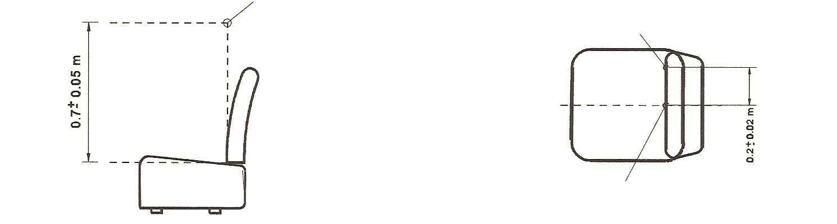
Microphone position A Microphone position A

Position A: unoccupied seat Position B: driver seat

Figure 11
Microphone position with respect to a seat (see paragraphs 8.38.5.2.2.1 and 8.38.5.2.2.2)
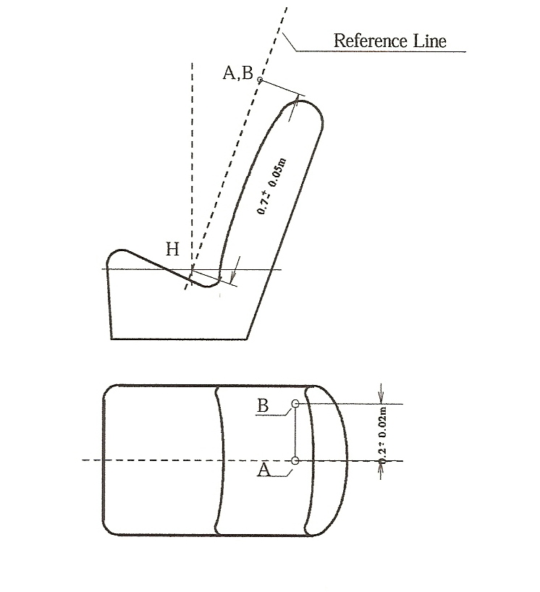
8.39. Passenger protection against displacement luggage
It is recommended to apply the requirements of the Regulations listed in paragraph 5, the table, line Q.

Annexes
The texts of the "Annexes" reproduced below appear, with almost the same text, in several (more than three) Regulations and Rules. The aim of their insertion in this document is to permit to replace their reproduction in extenso in the Regulations. The original numbering of paragraphs has been kept in order to show their relation with Regulations and Rules in which they appear.
Annex 1
Standard annex on the procedure for determining the "H" point and the actual torso angle for seating positions in motor vehicles
1. Purpose
The procedure described in this annex is used to establish the "H" point location and the actual torso angle for one or several seating positions in a motor vehicle and to verify the relationship of measured data to design specification given by the vehicle manufacturer.
2. Definitions
For the purposes of this annex:
2.1. "Reference data" means one or several of the following characteristics of a seating position:
2.1.1. the "H" point and the "R" point and their relationship;
2.1.2. the actual torso angle and the design torso angle and their relationship.
2.2. "[Three-dimensional] H-point machine" (3-D "H" point machine) means the device used for the determination of "H" points and actual torso angles. This device is described in Appendix 1 to this annex.
2.3. "H" point means the pivot centre of the torso and thigh of the 3-D H machine installed in the vehicle seat in accordance with the procedure described in paragraph 4. below. The "H" point is located in the centre of the centre line of the device which is between the ‘H’ point sight buttons on either side of the 3-D H machine. The "H" point corresponds theoretically to the "R" point (for tolerances, see paragraph 3.2.2. below). Once determined in accordance with the procedure described in paragraph 4., the "H" point is considered as fixed in relation to the seat-cushion structure and as moving with it when the seat is adjusted.
2.4. "R" point or "seating reference point" means a design point defined by the vehicle manufacturer for each seating position and established with respect to the three-dimensional reference system.
2.5. "Torso line" means the centre line of the probe of the 3-D H machine with the probe in the fully rearward position.
2.6. "Actual torso angle" means the angle measured between a vertical line through the "H" point and the torso line using the back angle quadrant on the 3-D H machine. The actual torso angle corresponds theoretically to the design torso angle (for tolerances, see paragraph 3.2.2. below).
2.7. "Design torso angle" means the angle measures between a vertical line through the "R" point and the torso line in a position which corresponds to the design position of the seat-back established by the vehicle manufacturer;
2.8. "Centre plane of occupant" (C/LO) means the median plane of the 3-D H machine positioned in each designated seating position; it is represented by the co-ordinate of the "H" point on the "Y" axis. For individual seats, the centre plane of the seat coincides with the centre plane of the occupant. For other seats, the centre plane of the occupant is specified by the manufacturer;
2.9. "Three-dimensional reference system" means a system as described in Appendix 2 to this annex;
2.10. "Fiducial marks" are physical points (holes, surfaces, marks or indentations) on the vehicle body as defined by the manufacturer;
2.11. "Vehicle measuring attitude" means the position of the vehicle as defined by the co-ordinates of fiducial marks in the three-dimensional reference system.
3. Requirements
3.1. Data presentation
For each seating position where reference data are required in order to demonstrate compliance with the provisions of the present Regulation, all or an appropriate selection of the following data shall be presented in the form indicated in Appendix 3 to this Annex:
3.1.1. the co-ordinates of the "R" point relative to the three-dimensional reference system;
3.1.2. the design torso angle;
3.1.3. all indications necessary to adjust the seat (if it is adjustable) to the measuring position set out in paragraph 4.3. below.
3.2. Relationship between measured data and design specifications
3.2.1. The coordinates of the "H" point and the value of the actual torso angle obtained by the procedure set out in paragraph 4. below shall be compared, respectively, with the coordinates of the "R" point and the value of the design torso angle indicated by the vehicle manufacturer.
3.2.2. The relative positions of the "R" point and the "H" point and the relationship between the design torso angle and the actual torso angle shall be considered satisfactory for the seating position in question if the "H" point, as defined by its coordinates, lies within a square of 50 mm side length with horizontal and vertical sides whose diagonals intersect at the "R" point, and if the actual torso angle is within 5° of the design torso angle.
3.2.3. If these conditions are met, the "R" point and the design torso angle shall be used to demonstrate compliance with the provisions of this Regulation;
3.2.4. If the "H" point or the actual torso angle does not satisfy the requirements of paragraph 3.2.2. above, the "H" point and the actual torso angle shall be determined twice more (three times in all). If the results of two of these three operations satisfy the requirements, the conditions of paragraph 3.2.3. above shall apply;
3.2.5. If the results of at least two of the three operations described in paragraph 3.2.4. above do not satisfy the requirements of paragraph 3.2.2. above, or if the verification cannot take place because the vehicle manufacturer has failed to supply information regarding the position of the "R" point or regarding the design torso angle, the centroid of the three measured points or the average of the three measured angles shall be used and be regarded as applicable in all cases where the "R" point or the design torso angle is referred to in this Regulation.
4. Procedure for "H" point and actual torso angle determination
4.1. The vehicle shall be preconditioned, at the manufacturer’s discretion, at a temperature of 20° C + 10° C to ensure that the seat material reaches room temperature. If the seat to be checked has never been sat upon, a 70 to 80 kg person or device shall sit on the seat twice for one minute to flex the cushion and back. At the manufacturer’s request, all seat assemblies shall remain unloaded for a minimum period of 30 minutes prior to installation of the 3-D H machine.
4.2. The vehicle shall be in the measuring attitude defined in paragraph 2.11. above.
4.3. The seat, if it is adjustable, shall be adjusted first to the rearmost normal driving or riding position, as indicated by the vehicle manufacturer, taking into consideration only the longitudinal adjustment of the seat, excluding seat travel used for purposes other than normal driving or riding positions. Where other modes of seat adjustment exist (vertical, angular, seat-back, etc.), these will then be adjusted to the position specified by the vehicle manufacturer. For suspension seats, the vertical position shall be rigidly fixed corresponding to a normal driving position as specified by the manufacturer.
4.4. The area of the seating position taken up by the 3-D H machine shall be covered by a muslin cotton, of sufficient size and appropriate texture, described as a plain cotton fabric having 18.9 threads per cm² and weighing 0.228 kg/m², or knitted or non-woven fabric having equivalent characteristics.
If the test is performed on a seat outside the vehicle, the floor on which the seat is placed shall have the same essential characteristics as the floor of the vehicle in which the seat is intended to be used.
4.5. Place the seat and back assembly of the 3-D H machine so that the centre plane of the occupant (CPO) coincides with the centre plane of the 3-D H machine. At the manufacturer’s request, the 3-D H machine may be moved inboard with respect to the CPO if the 3-D H machine is located so far outboard that the seat edge will not permit levelling of the 3-D H machine.
4.6. Attach the foot and lower leg assemblies to the seat-pan assembly, either individually or by using the T-bar and lower leg assembly. The line through the "H" point sight buttons shall be parallel to the ground and perpendicular to the longitudinal centre plane of the seat.
4.7. Adjust the feet and leg positions of the 3-D H machine as follows:
4.7.1. Designated seating position: driver and outside front passenger
4.7.1.1. Both feet and leg assemblies shall be moved forward in such a way that the feet take up natural positions on the floor, between the operating pedals if necessary. Where possible the left foot shall be located at approximately the same distance to the left of the centre plane of the 3-D H machine as the right foot is to the right. The spirit level verifying the transverse orientation of the 3-D H machine is brought to the horizontal by readjustment of the seat pan if necessary, or by adjusting the leg and foot assemblies towards the rear. The line passing through the "H" point sight buttons shall be maintained perpendicular to the longitudinal centre plane of the seat.
4.7.1.2. If the left leg cannot be kept parallel to the right leg and the left foot cannot be supported by the structure, move the left foot until it is supported. The alignment of the sight buttons shall be maintained.
4.7.2. Designated seating position: outboard rear seat
For rear seats or auxiliary seats, the legs are located as specified by the manufacturer. If the feet then rest on parts of the floor which are at different levels, the foot which first comes into contact with the front seat shall serve as a reference and the other foot shall be so arranged that the spirit level giving the transverse orientation of the seat of the device indicates the horizontal.
4.7.3. Other designated seating positions:
The general procedure indicated in paragraph 4.7.1. above shall be followed, except that the feet shall be placed as specified by the vehicle manufacturer.
4.8. Apply lower leg and thigh weights and level the 3-D H machine.
4.9. Tilt the back pan forward against the forward stop and draw the 3-D H machine away from the seat-back using the T-bar. Reposition the 3-D H machine on the seat by one of the following methods:
4.9.1. If the 3-D H machine tends to slide rearward, use the following procedure. Allow the 3-D H machine to slide rearward until a forward horizontal restraining load on the T-bar is no longer required, i.e. until the seat pan contacts the seat-back. If necessary, reposition the lower leg.
4.9.2. If the 3-D H machine does not tend to slide rearward, use the following procedure. Slide the 3-D H machine rearward by applying a horizontal rearward load to the T-bar until the seat pan contacts the seat-back (see figure 2 of the Appendix 1 to this annex).
4.10. Apply a 100 ± 10 N load to the back and pan assembly of the 3-D H machine at the intersection of the hip angle quadrant and the T-bar housing. The direction of load application shall be maintained along a line passing through the above intersection to a point just above the thigh bar housing (see figure 2 of Appendix 1 to this annex). Then carefully return the back pan to the seat-back. Care must be exercised throughout the remainder of the procedure to prevent the 3-D H machine from sliding forward.
4.11. Install the right and left buttock weights and then, alternately, the eight torso weights. Maintain the 3-D H machine level.
4.12. Tilt the back pan forward to release the tension on the seat-back. Rock the
3-D H machine from side to side through a 10° arc (5° to each side of the vertical centre plane) for three complete cycles to release any accumulated friction between the 3-D H machine and the seat.
During the rocking action, the T-bar of the 3-D H machine may tend to diverge from the specified horizontal and vertical alignment. The T-bar must therefore be restrained by applying an appropriate lateral load during the rocking motions. Care shall be exercised in holding the T-bar and rocking the 3-D H machine to ensure that no inadvertent exterior loads are applied in a vertical or fore and aft direction.
The feet of the 3-D H machine are not to be restrained or held during this step. If the feet change position, they should then be allowed to remain in that attitude for the moment.
Carefully return the back pan to the seat-back and check the two spirit levels for zero position. If any movement of the feet has occurred during the rocking operation of the 3-D H machine, they must be repositioned as follows:
Alternately, lift each foot off the floor the minimum necessary amount until no additional foot movement is obtained. During this lifting, the feet are to be free to rotate; no forward or lateral loads are to be applied. When each foot is placed back in the down position, the heel is to be in contact with the structure designed for this.
Check the lateral spirit level for zero position; if necessary, apply a lateral load to the top of the back pan sufficient to level the 3-D H machine’s seat pan on the seat.
4.13. Holding the T-bar to prevent the 3-D H machine from sliding forward on the seat cushion, proceed as follows:
(a) return the back pan to the seat-back,
(b) alternately apply and release a horizontal rearward load, not to exceed 25 N, to the back angle bar at a height approximately at the centre of the torso weights until the hip angle quadrant indicates that a stable position has been reached after load release. Care should be taken to ensure that no exterior downward or lateral loads are applied to the 3-D H machine. If another level adjustment of the 3-D H machine is necessary, rotate the back pan forward, re-level, and repeat the procedure from paragraph 4.12.
4.14. Take all measurements:
4.14.1. The coordinates of the "H" point are measured with respect to the three-dimensional reference system.
4.14.2. The actual torso angle is read at the back angle quadrant of the 3-D H machine with the probe in its fully rearward position.
4.15. If a rerun of the installation of the 3-D H machine is desired, the seat assembly shall remain unloaded for a minimum period of 30 minutes prior to the re-run. The3-D H machine shall not be left loaded on the seat assembly longer than the time required to perform the test.
4.16. If the seats in the same row can be regarded as similar (bench seat, identical seats, etc.) only one "H" point and one actual torso angle shall be determined for each row of seats, the 3-D H machine described in the Appendix 1 to this annex being seated in a place regarded as representative for the row.
This place shall be:
4.16.1. In the case of the front row, the driver’s seat.
4.16.2. In the case of the rear row or rows, an outer seat.

Appendix 1
Prescription of the three-dimensional "H" point machine (3-D H machine)
1. Back and seat pans
The back and seat pans are constructed of reinforced plastic and metal; they simulate the human torso and thigh and are mechanically hinged at the "H" point. A quadrant is fastened to the probe hinged at the "H" point to measure the actual torso angle. An adjustable thigh bar, attached to the seat pan, establishes the thigh centre line and serves as a baseline for the hip angle quadrant.
2. Body and leg elements
Lower leg segments are connected to the seat pan assembly at the T-bar joining the knees, which is a lateral extension of the adjustable thigh bar. Quadrants are incorporated in the lower leg segments to measure knee angles. Shoe and foot assemblies are calibrated to measure the foot angle. Two spirit levels orient the device in space. Body element weights are placed at the corresponding-centres of gravity to provide seat penetration equivalent to a 76 kg male. All joints of the 3-D H machine should be checked for free movement without encountering any noticeable friction.

Figure 1
3-D H Machine elements designation
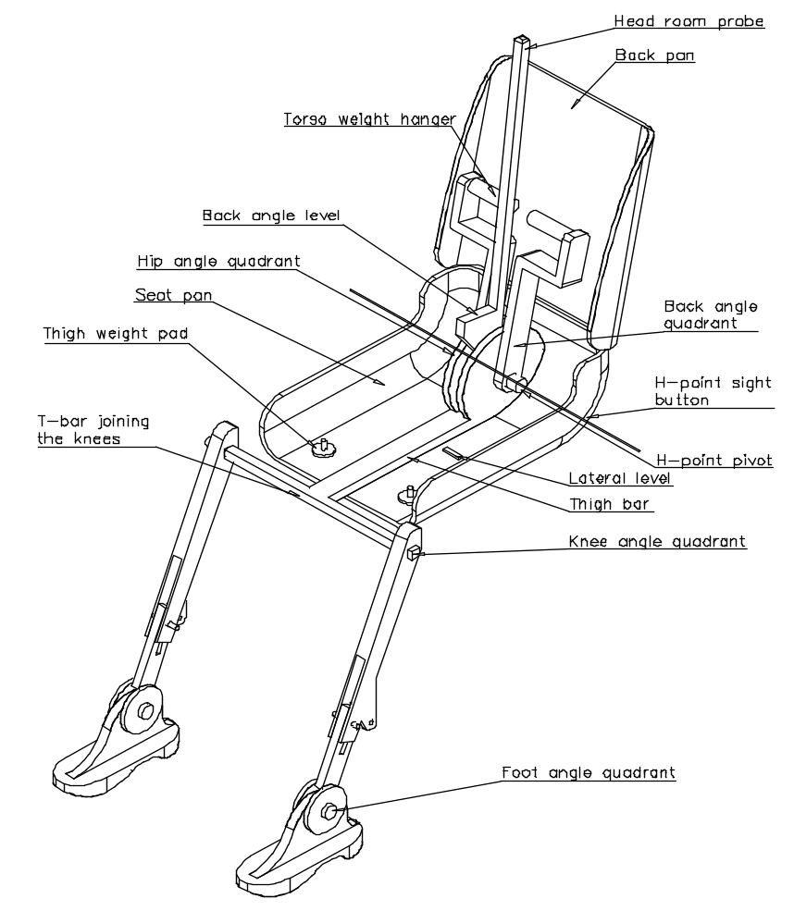

Figure 2
Dimensions of the 3-D H- machine elements and load distribution
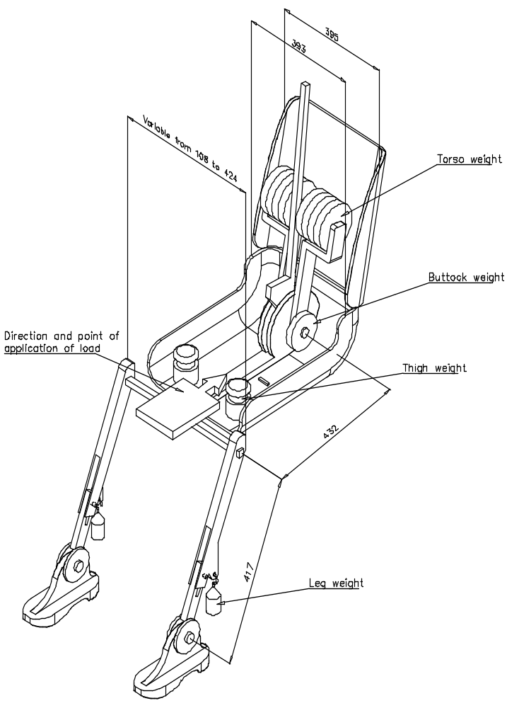

Appendix 2
Three-dimensional reference system
1. The three-dimensional reference system is defined by three orthogonal planes established by the vehicle manufacturer (see figure).
2. The vehicle measuring attitude is determined by positioning the vehicle on a supporting surface such that the co-ordinates of the fiducial marks correspond to the values indicated by the manufacturer.
3. The coordinates of the "R" point and the "H" point are established in relation to the fiducial marks defined by the vehicle manufacturer.
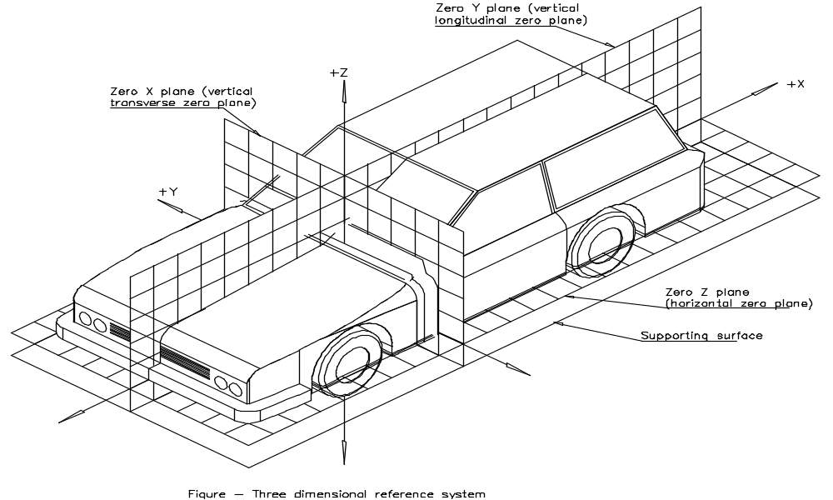

Appendix 3
Reference data concerning seating positions
1. Coding of reference data
Reference data are listed consecutively for each seating position. Seating positions are identified by a two-digit code. The first character is an Arabic numeral and designates the row of seats, counting from the front to the rear of the vehicle. The second digit is a capital letter which designates the location of the seating position in a row, as viewed in the direction of forward motion of the vehicle; the following letters shall be used:
L = left,
C = centre,
R = right.
2. Description of vehicle measuring attitude
2.1. Coordinates of fiducial marks
X
Y
Z
3. List of reference data
3.1. Seating position:
3.1.1. Coordinates of the "R" point:
X
Y
Z
3.1.2. Design torso angle:
3.1.3. Specifications for seat adjustment
horizontal:
vertical:
angular:
torso angle:
Note: List reference data for further seating positions under paragraphs 3.2., 3.3., etc.

Annex 2
Standard annex on lighting and light-signalling devices: minimum requirements for sampling by an inspector
1. General
1.1. The conformity requirements shall be considered satisfied from a mechanical and a geometric standpoint, in accordance with the requirements of this Regulation, if any, if the differences do not exceed inevitable manufacturing deviations.
1.2. With respect to photometric performances, the conformity of mass-produced lamps shall not be contested if, when testing photometric performances of any lamp chosen at random according to paragraph [x] of this Regulation:
1.2.1. No measured value deviates unfavourably by more than 20 % from the values prescribed in this Regulation.
1.2.2. If, in the case of a direction indicator equipped with a replaceable light source and if results of the test described above do not meet the requirements, tests on direction indicators shall be repeated using another standard filament lamp.
1.2.3. Direction indicators with apparent defects are disregarded.
1.3. The chromaticity coordinates shall be complied when tested under conditions of paragraph [x] of this Regulation.
2. First sampling
In the first sampling four direction indicators are selected at random. The first sample of two is marked A, the second sample of two is marked B.
2.1. The conformity is not contested
2.1.1. Following the sampling procedure shown in Figure 1 of this annex the conformity of mass-produced direction indicators shall not be contested if the deviation of the measured values of the direction indicators in the unfavourable directions are:
2.1.1.1. sample A
A1: one direction indicator 0 %
one direction indicator not more than 20 %
A2: both direction indicators more than 0 %
but not more than 20 %
go to sample B
2.1.1.2. sample B
B1: both direction indicators 0 %
2.1.2. or if the conditions of paragraph 1.2.2. for sample A are fulfilled.
2.2. The conformity is contested
2.2.1. Following the sampling procedure shown in Figure 1 of this annex the conformity of mass-produced direction indicators shall be contested and the manufacturer requested to make his production meet the requirements (alignment) if the deviations of the measured values of the direction indicators are:
2.2.1.1. sample A
A3: one direction indicator not more than 20 %
one direction indicator more than 20 %
but not more than 30 %
2.2.1.2. sample B
B2: in the case of A2
one direction indicator more than 0 %
but not more than 20 %
one direction indicator not more than 20 %
B3: in the case of A2
one direction indicator 0 %
one direction indicator more than 20 %
but not more than 30 %
2.2.2. or if the conditions of paragraph 1.2.2. for sample A are not fulfilled.
2.3. Approval withdrawn
Conformity shall be contested and paragraph 11. applied if, following the sampling procedure in Figure 1 of this annex, the deviations of the measured values of the direction indicators are:
2.3.1. sample A
A4: one direction indicator not more than 20 %
one direction indicator more than 30 %
A5: both direction indicators more than 20 %
2.3.2. sample B
B4: in the case of A2
one direction indicator more than 0 %
but not more than 20 %
one direction indicator more than 20 %
B5: in the case of A2
both direction indicators more than 20 %
B6: in the case of A2
one direction indicator 0 %
one direction indicator more than 3 0 %
2.3.3. or if the conditions of paragraph 1.2.2. for samples A and B are not fulfilled.
3. Repeated sampling
In the cases of A3, B2, B3 a repeated sampling, third sample C of two direction indicators and fourth sample D of two direction indicators, selected from stock manufactured after alignment, is necessary within two months' time after the notification.
3.1. The conformity is not contested
3.1.1. Following the sampling procedure shown in Figure 1 of this annex the conformity of mass-produced direction indicators shall not be contested if the deviations of the measured values of the direction indicators are:
3.1.1.1. sample C
C1: one direction indicator 0 %
one direction indicator not more than 20 %
C2: both direction indicators more than 0 %
but not more than 20 %
go to sample D
3.1.1.2. sample D
D1: in the case of C2
both direction indicators 0 %
3.1.2. or if the conditions of paragraph 1.2.2. for sample C are fulfilled.
3.2. The conformity is contested
3.2.1. Following the sampling procedure shown in Figure 1 of this annex the conformity of mass-produced direction indicators shall be contested and the manufacturer requested to make his production meet the requirements (alignment) if the deviations of the measured values of the direction indicators are:
3.2.1.1. sample D
D2: in the case of C2
one direction indicator more than 0 %
but not more than 20 %
one direction indicator not more than 20 %
3.2.1.2. or if the conditions of paragraph 1.2.2. for sample C are not fulfilled.
3.3. Approval withdrawn
Conformity shall be contested and paragraph 11. applied if, following the sampling procedure in Figure 1 of this annex, the deviations of the measured values of the direction indicators are:
3.3.1. sample C
C3: one direction indicator not more than 20 %
one direction indicator more than 20 %
C4: both direction indicators more than 20 %
3.3.2. sample D
D3: in the case of C2
one direction indicator 0 or more than 0 %
one direction indicator more than 20 %
3.3.3. or if the conditions of paragraph 1.2.2. for samples C and D are not fulfilled.

Figure 1
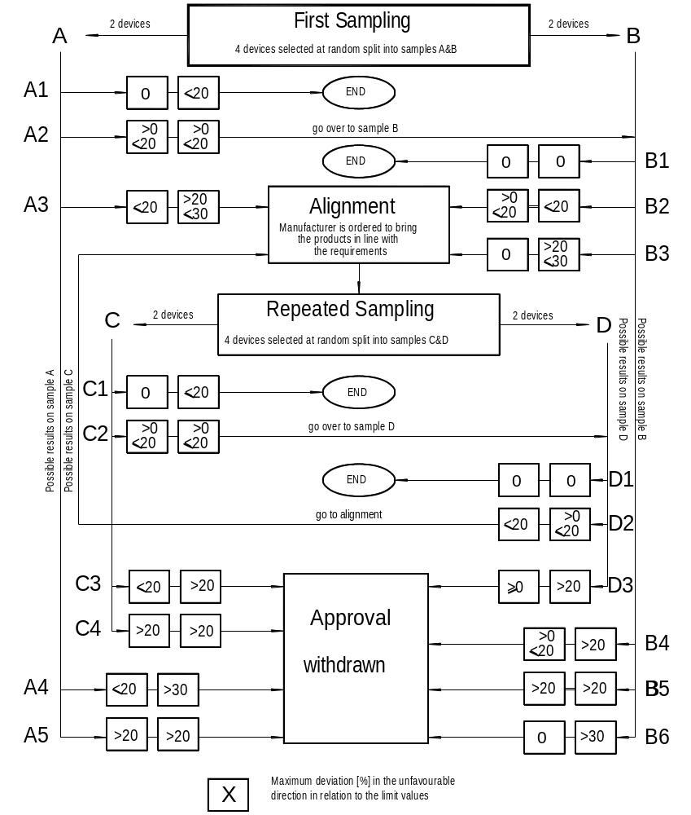
Annex 3
Standard annex on lighting and light-signalling devices: minimum requirements for conformity of production control procedures
1. General
1.1. The conformity requirements shall be considered satisfied from a mechanical and geometric standpoint, if the differences do not exceed inevitable manufacturing deviations within the requirements of this Regulation.
1.2. With respect to photometric performances, the conformity of mass-produced lamps shall not be contested if, when testing photometric performances of any lamp chosen at random according to paragraph [x] of this Regulation:
1.2.1. no measured value deviates unfavourably by more than 20 % from the values prescribed in this Regulation.
1.2.2. If, in the case of a direction indicator equipped with a replaceable light source and if results of the test described above do not meet the requirements, tests on direction indicators shall be repeated using another standard filament lamp.
1.3. The chromaticity coordinates shall be complied when tested under conditions of paragraph [x] of this Regulation.
2. Minimum requirements for verification of conformity by the manufacturer
For each type of direction indicator the holder of the approval mark shall carry out at least the following tests, at appropriate intervals. The tests shall be carried out in accordance with the provisions of this Regulation.
If any sampling shows non-conformity with regard to the type of test concerned, further samples shall be taken and tested. The manufacturer shall take steps to ensure the conformity of the production concerned.
2.1. Nature of tests
Tests of conformity in this Regulation shall cover the photometric and colorimetric characteristics.
2.2. Methods used in tests
2.2.1. Tests shall generally be carried out in accordance with the methods set out in this Regulation.
2.2.2. In any test of conformity carried out by the manufacturer, equivalent methods may be used with the consent of the competent authority responsible for approval tests. The manufacturer is responsible for proving that the applied methods are equivalent to those laid down in this Regulation.
2.2.3. The application of paragraphs 2.2.1. and 2.2.2. requires regular calibration of test apparatus and its correlation with measurements made by a competent authority.
2.2.4. In all cases the reference methods shall be those of this Regulation, particularly for the purpose of administrative verification and sampling.
2.3. Nature of sampling
Samples of direction indicators shall be selected at random from the production of a uniform batch. A uniform batch means a set of direction indicators of the same type, defined according to the production methods of the manufacturer.
The assessment shall in general cover series production from individual factories. However, a manufacturer may group together records concerning the same type from several factories, provided these operate under the same quality system and quality management.
2.4. Measured and recorded photometric characteristics
The sampled direction indicator shall be subjected to photometric measurements for the minimum values at the points listed in Annex [x], and the chromaticity coordinates listed in Annex [x], provided for in the Regulation.
2.5. Criteria governing acceptability
The manufacturer is responsible for carrying out a statistical study of the test results and for defining, in agreement with the competent authority, criteria governing the acceptability of his products in order to meet the specifications laid down for verification of conformity of products in paragraph [x] of this Regulation.
The criteria governing the acceptability shall be such that, with a confidence level of 95 %, the minimum probability of passing a spot check in accordance with Annex [x] (first sampling) would be 0.95.
Annex 4
Standard annex on colour of lights
Trichromatic coordinates:
1. From the "amber" zone:
Limit towards green: y ≤ x – 0.120
Limit towards red: y ≥ 0.390
Limit towards white: y ≥ 0.790 - 0.670 x
2. From the "red" zone:
Limit towards yellow: y ≤ 0.335
Limit towards purple: y ≥ 0.980 – x
3. From the "white" zone:
Limit towards blue: x ≥ 0.310
Limit towards yellow: x ≤ 0.500
Limit towards green: y ≤ 0,150 + 0.640 x
Limit towards green: y ≤ 0.440
Limit towards purple: y ≥ 0.050 + 0.750 x
Limit towards red: y ≥ 0.382
For checking these colorimetric characteristics, the test procedure described in paragraph [x] of this Regulation shall be applied.
However, for lamps equipped with non-replaceable light sources (filament lamps and other), the colorimetric characteristics should be verified with the light sources present in the lamp, in accordance with the relevant subparagraph of paragraph [x] of this Regulation.

Annex 5
Standard annex on requirements for headlamps incorporating lenses of plastic material – testing of lens or material samples and of complete lamps
1. General specifications
1.1. The samples supplied pursuant to paragraphs [x] and [x] of this Regulation shall satisfy the specifications indicated in paragraphs 2.1. to 2.5. below.
1.2. The two samples of complete lamps/systems supplied pursuant to paragraph 2.2.4. of this Regulation and incorporating lenses of plastic material shall, with regard to the lens material, satisfy the specifications below.
1.3. The samples of lenses of plastic material or samples of material shall be subjected, with the reflector to which they are intended to be fitted (where applicable), to approval tests in the chronological order indicated in table A reproduced in Appendix 1 to this annex.
1.4. However, if the lamp manufacturer can prove that the product has already passed the tests prescribed in paragraphs 2.1. to 2.5. below, or the equivalent tests pursuant to another Regulation, those tests need not be repeated; only the tests prescribed in Appendix 1, table B, shall be mandatory.
1.5. If the headlamps are designed for right-hand installation only, or for left-hand installation only, tests pursuant to this annex may be done on one sample only, at the choice of the applicant.
2. Test
2.1. Resistance to temperature changes
2.1.1. Tests
Three new samples (lenses) shall be subjected to five cycles of temperature and humidity (RH = relative humidity) change in accordance with the following programme:
3 hours at 40 ± 2 °C and 85-95 % RH;
1 hour at 23 ± 5 °C and 60-75 % RH;

15 hours at -30 ± 2 °C;
1 hour at 23 ± 5 °C and 60-75 % RH;
3 hours at 80 ± 2 °C;
1 hour at 23 ± 5 °C and 60-75 % RH;
Before this test, the samples shall be kept at 23 ± 5 °C and 60-75 % RH for at least four hours.
Note: The periods of one hour at 23 ± 5 °C shall include the periods of transition from one temperature to another which are needed in order to avoid thermal shock effects.
2.1.2. Photometric measurements
2.1.2.1. Method
Photometric measurements shall be carried out on the samples before and after the test.
These measurements shall be made using a standard lamp, at the following points:
B 50 L and 50 R for the passing beam of a passing lamp or a passing/driving lamp (B 50 R and 50 L in the case of headlamps intended for left-hand traffic);
Emax for the driving beam of a driving lamp or a passing/driving lamp.
2.1.2.2. Results
The variation between the photometric values measured on each sample before and after the test shall not exceed 10 % including the tolerances of the photometric procedure.
2.2. Resistance to atmospheric and chemical agents
2.2.1. Resistance to atmospheric agents
Three new samples (lenses or samples of material) shall be exposed to radiation from a source having a spectral energy distribution similar to that of a black body at a temperature between 5,500 K and 6,000 K. Appropriate filters shall be placed between the source and the samples so as to reduce as far as possible radiations with wave lengths smaller than 295 nm and greater than 2,500 nm. The samples shall be exposed to an energetic illumination of 1,200 W/m² ± 200 W/m² for a period such that the luminous energy that they receive is equal to 4,500 MJ/m² ± 200 MJ/m². Within the enclosure, the temperature measured on the black panel placed on a level with the samples shall be 50 ± 5 °C. In order to ensure a regular exposure, the samples shall revolve around the source of radiation at a speed between 1 and 5 min-1.
The samples shall be sprayed with distilled water of conductivity lower than 1 mS/m at a temperature of 23 ± 5 °C, in accordance with the following cycle:
Spraying: 5 minutes
Drying: 25 minutes
2.2.2. Resistance to chemical agents
After the test described in paragraph 2.2.1. above and the measurement described in paragraph 2.2.3.1. below have been carried out, the outer face of the said three samples shall be treated as described in paragraph 2.2.2.2. with the mixture defined in paragraph 2.2.2.1. below.
2.2.2.1. Test mixture
The test mixture shall be composed of 61.5 % n-heptane, 12.5 % toluene, 7.5 % ethyl tetrachloride, 12.5 % trichloroethylene and 6 % xylene (volume %).
2.2.2.2. Application of the test mixture
Soak a piece of cotton cloth (as per ISO 105) until saturation with the mixture defined in paragraph 2.2.2.1. above and, within 10 seconds, apply it for 10 minutes to the outer face of the sample at a pressure of 50 N/cm², corresponding to an effort of 100 N applied on a test surface of 14 x 14 mm.
During this 10-minute period, the cloth pad shall be soaked again with the mixture so that the composition of the liquid applied is continuously identical with that of the test mixture prescribed.
During the period of application, it is permissible to compensate the pressure applied to the sample in order to prevent it from causing cracks.
2.2.2.3. Cleaning
At the end of the application of the test mixture, the samples shall be dried in the open air and then washed with the solution described in paragraph 2.3. (Resistance to detergents) at 23 ± 5 °C.
Afterwards the samples shall be carefully rinsed with distilled water containing not more than 0.2 % impurities at 23 ± 5 °C and then wiped off with a soft cloth.
2.2.3. Results
2.2.3.1. After the test of resistance to atmospheric agents, the outer face of the samples shall be free from cracks, scratches, chipping and deformation, and the mean variation in transmission
Δt = (T2 - T3)/T2, measured on the three samples according to the procedure described in Appendix 2 to this annex shall not exceed 0.020 (Δtm < 0.020).
2.2.3.2. After the test of resistance to chemical agents, the samples shall not bear any traces of chemical staining likely to cause a variation of flux diffusion, whose mean variation
Δd = (T5 - T4)/T2, measured on the three samples according to the procedure described in Appendix 2 to this annex shall not exceed 0.020 (Δ dm < 0.020).
2.2.4. Resistance to light source radiations
The following test shall be done:
Flat samples of each light transmitting plastic component of the headlamp are exposed to the light of the gas-discharge light source. The parameters such as angles and distances of these samples shall be the same as in the headlamp. These samples shall have the same colour and surface treatment, if any, as the parts of the headlamp.
After 1,500 hours of continuous exposure, the colorimetric specifications of the transmitted light must be met with a new standard gas-discharge light source, and the surfaces of the samples shall be free of cracks, scratches, scalings or deformation.
2.3. Resistance to detergents and hydrocarbons
2.3.1. Resistance to detergents
The outer face of three samples (lenses or samples of material) shall be heated to 50 ± 5 °C and then immersed for five minutes in a mixture maintained at 23 ± 5 °C and composed of 99 parts distilled water containing not more than 0.02 % impurities and one part alkylaryl sulphonate.
At the end of the test, the samples shall be dried at 50 ± 5 °C. The surface of the samples shall be cleaned with a moist cloth.
2.3.2. Resistance to hydrocarbons
The outer face of these three samples shall then be lightly rubbed for one minute with a cotton cloth soaked in a mixture composed of 70 % n-heptane and 30 % toluene (volume %), and shall then be dried in the open air.
2.3.3. Results
After the above two tests have been performed successively, the mean value of the variation in transmission
Δt = (T2 - T3)/T2, measured on the three samples according to the procedure described in Appendix 2 to this annex shall not exceed 0.010
(Δtm < 0.010).
2.4. Resistance to mechanical deterioration
2.4.1. Mechanical deterioration method
The outer face of the three new samples (lenses) shall be subjected to the uniform mechanical deterioration test by the method described in Appendix 3 to this annex.
2.4.2. Results
After this test, the variations:
in transmission: Δt = (T2 - T3)/T2
and in diffusion: Δd = (T5 - T4)/T2
shall be measured according to the procedure described in Appendix 2 in the area specified in paragraph 2.2.4. above. The mean value of the three samples shall be such that:
Δtm ≤ 0.100;
Δdm ≤ 0.050.
2.5. Test of adherence of coatings, if any
2.5.1. Preparation of the sample
A surface of 20 mm x 20 mm in area of the coating of a lens shall be cut with a razor blade or a needle into a grid of squares approximately 2 mm x 2 mm. The pressure on the blade or needle shall be sufficient to cut at least the coating.
2.5.2. Description of the test
Use an adhesive tape with a force of adhesion of 2 N/(cm of width) ± 20 % measured under the standardized conditions specified in Appendix 4 to this annex. This adhesive tape, which shall be at least 25 mm wide, shall be pressed for at least five minutes to the surface prepared as prescribed in paragraph 2.5.1.
Then the end of the adhesive tape shall be loaded in such a way that the force of adhesion to the surface considered is balanced by a force perpendicular to that surface. At this stage, the tape shall be torn off at a constant speed
of 1.5 m/s ± 0.2 m/s.
2.5.3. Results
There shall be no appreciable impairment of the gridded area. Impairments at the intersections between squares or at the edges of the cuts shall be permitted, provided that the impaired area does not exceed 15 % of the gridded surface.
2.6. Tests of the complete headlamp incorporating a lens of plastic material
2.6.1. Resistance to mechanical deterioration of the lens surface
2.6.1.1. Tests
The lens of lamp sample No. 1 shall be subjected to the test described in paragraph 2.4.1. above.
2.6.1.2. Results
After the test, the results of photometric measurements carried out on the headlamp in accordance with this Regulation shall not exceed by more than 30 % the maximum values prescribed at points B 50 L and HV and not be more than 10 % below the minimum values prescribed at point 75 R (in the case of headlamps intended for left-hand traffic, the points to be considered are B 50 R, HV and 75 L).
2.6.2. Test of adherence of coatings, if any
The lens of lamp sample No. 2 shall be subjected to the test described in paragraph 2.5. above.
Appendix 1
Chronological order of approval tests
1. Tests on plastic materials (lenses or samples of material supplied pursuant to paragraph [x]. of this Regulation)
Samples  Tests | Lenses or samples of material |  |  |  |  |  |  |  |  |  | Lenses
Samples  Tests | 1 | 2 | 3 | 4 | 5 | 6 | 7 | 8 | 9 | 10 | 11 | 12 | 13 | 14
1.1. Limited photometry (para. 2.1.2.) |  |  |  |  |  |  |  |  |  |  | x | x | x
1.1.1. Temperature change (para. 2.1.1.) |  |  |  |  |  |  |  |  |  |  | x | x | x
1.2. Limited photometry (para. 2.1.2.) |  |  |  |  |  |  |  |  |  |  | x | x | x
1.2.1. Transmission measurement | x | x | x | x | x | x | x | x | x
1.2.2. Diffusion measurement | x | x | x |  |  |  | x | x | x
1.3. Atmospheric agents (para. 2.2.1.) | x | x | x
1.3.1. Transmission measurement | x | x | x
1.4. Chemical agents (para. 2.2.2.) | x | x | x
1.4.1. Diffusion measurements | x | x | x
1.5. Detergents (para. 2.3.1.) |  |  |  | x | x | x
1.6. Hydrocarbons (para. 2.3.2.) |  |  |  | x | x | x
1.6.1. Transmission measurement |  |  |  | x | x | x
1.7. Deterioration (para. 2.4.1.) |  |  |  |  |  |  | x | x | x
1.7.1. Transmission measurement |  |  |  |  |  |  | x | x | x
1.7.2. Diffusion measurement |  |  |  |  |  |  | x | x | x
1.8. Adherence (para. 2.5.) |  |  |  |  |  |  |  |  |  |  |  |  |  | x
1.9. Resistance to light source radiations (para. 2.2.4.) |  |  |  |  |  |  |  |  |  | x

2. Tests on complete headlamps (supplied pursuant to paragraph [x] of this Regulation)
Tests | Complete headlamp
Tests | Sample No.
Tests | 1 | 2
2.1. Deterioration (para. 2.6.1.1.1) | x
2.2. Photometry (para. 2.6.1.2.) | x
2.3. Adherence (para. 2.6.2.) |  | x
Appendix 2
Method of measurement of the diffusion and transmission of light
1. Equipment (see figure)
The beam of a collimator K with a half divergence β/2 = 17.4 x 10⁻⁴ rd is limited by a diaphragm D_{T} with an opening of 6 mm against which the sample stand is placed.
A convergent achromatic lens L₂, corrected for spherical aberrations, links the diaphragm D_{T} with the receiver R; the diameter of the lens L₂ shall be such that it does not diaphragm the light diffused by the sample in a cone with a half top angle of β/2 = 14°.
An annular diaphragm D_{D} with angles α/2 = 1° and α_{max}/2 = 12° is placed in an image focal plane of the lens L₂.
The non-transparent central part of the diaphragm is necessary in order to eliminate the light arriving directly from the light source. It shall be possible to remove the central part of the diaphragm from the light beam in such a manner that it returns exactly to its original position.
The distance L₂ D_{T} and the focal length F₂ * of the lens L₂ shall be so chosen that the image of D_{T} completely covers the receiver R.
When the initial incident flux is referred to 1,000 units, the absolute precision of each reading shall be better than 1 unit.
2. Measurements
The following readings shall be taken:
Reading | With sample | With central part of D_{D} | Quantity represented
T₁ | No | No | Incident flux in initial reading
T₂ | Yes (before test) | No | Flux transmitted by the new material in a field of 24°
T₃ | Yes (after test) | No | Flux transmitted by the tested material in a field of 24°
T₄ | Yes (before test) | Yes | Flux diffused by the new material
T₅ | Yes (after test) | Yes | Flux diffused by the tested material

Figure 1
Optical set up for measurement of variations in diffusion and transmission
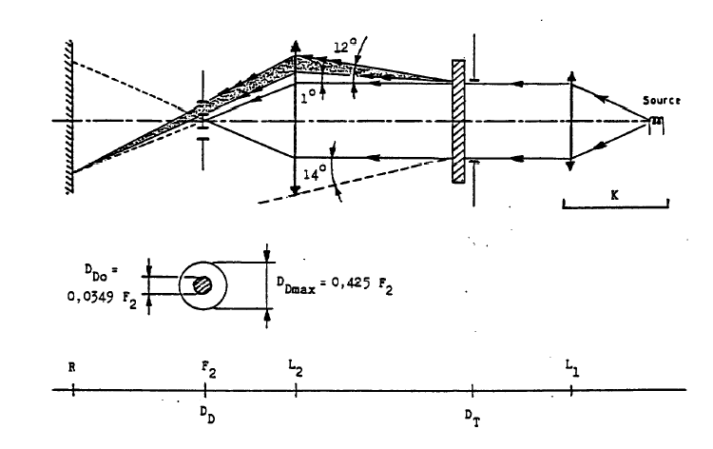
Appendix 3
Spray testing method
1. Test equipment
1.1. Spray gun
The spray gun used shall be equipped with a nozzle 1.3 mm in diameter allowing a liquid flow rate of 0.24 ± 0.02 l/minute at an operating pressure of 6.0 bars -0, +0.5 bar.
Under these operation conditions the fan pattern obtained shall be 170 mm ± 50 mm in diameter on the surface exposed to deterioration, at a distance of 380 mm ± 10 mm from the nozzle.
1.2. Test mixture
The test mixture shall be composed of:
Silica sand of hardness 7 on the Mohr scale, with a grain size between 0 and 0.2 mm and an almost normal distribution, with an angular factor of 1.8 to 2;
Water of hardness not exceeding 205 g/m³ for a mixture comprising 25 g of sand per litre of water.
2. Test
The outer surface of the lamp lenses shall be subjected once or more than once to the action of the sand jet produced as described above. The jet shall be sprayed almost perpendicular to the surface to be tested.
The deterioration shall be checked by means of one or more samples of glass placed as a reference near the lenses to be tested. The mixture shall be sprayed until the variation in the diffusion of light on the sample or samples measured by the method described in Appendix 2, is such that:
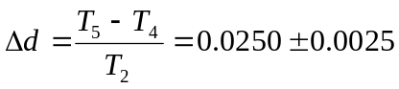
Several reference samples may be used to check that the whole surface to be tested has deteriorated homogeneously.
Appendix 4
Adhesive tape adherence test
1. Purpose
This method allows to determine under standard conditions the linear force of adhesion of an adhesive tape to a glass plate.
2. Principle
Measurement of the force necessary to unstick an adhesive tape from a glass plate at an angle of 90°.
3. Specified atmospheric conditions
The ambient conditions shall be at 23 ± 5 °C and 65 ± 15 % relative humidity (RH).
4. Test pieces
Before the test, the sample roll of adhesive tape shall be conditioned for 24 hours in the specified atmosphere (see para. 3. above).
Five test pieces each 400 mm long shall be tested from each roll. These test pieces shall be taken from the roll after the first three turns were discarded.
5. Procedure
The test shall be under the ambient conditions specified in paragraph 3.
Take the five test pieces while unrolling the tape radially at a speed of approximately 300 mm/s, then apply them within 15 seconds in the following manner:
Apply the tape to the glass plate progressively with a slight lengthwise rubbing movement of the finger, without excessive pressure, in such a manner as to leave no air bubble between the tape and the glass plate.
Leave the assembly in the specified atmospheric conditions for 10 minutes.
Unstick about 25 mm of the test piece from the plate in a plane perpendicular to the axis of the test piece.
Fix the plate and fold back the free end of the tape at 90°. Apply force in such a manner that the separation line between the tape and the plate is perpendicular to this force and perpendicular to the plate.
Pull to unstick at a speed of 300 mm/s ± 30 mm/s and record the force required.
6. Results
The five values obtained shall be arranged in order and the median value taken as the result of the measurement. This value shall be expressed in Newtons %imetre of width of the tape.

Annex 6
Standard annex on the tests for stability of photometric performance of headlamps in operation
Tests on complete headlamps
Once the photometric values have been measured according to the prescriptions of this Regulation, in the point of maximum illumination in zone D (Emax) and in point HV, a complete headlamp sample shall be tested for stability of photometric performance in operation. "Complete headlamp" shall be understood to mean the complete lamp itself including those surrounding body parts and lamps which could influence its thermal dissipation.
1. Test for stability of photometric performance
The tests shall be carried out in a dry and still atmosphere at an ambient temperature of 23°C + 5°C, the complete headlamp being mounted on a base representing the correct installation on the vehicle.
1.1. Clean headlamp
The headlamp shall be operated for 12 hours as described in subparagraph 1.1.1. and checked as prescribed in subparagraph 1.1.2.
1.1.1. Test procedure
The headlamp shall be operated for the specified time so that:
(a) in the case where only a front fog lamp is to be approved, the corresponding filament lamp(s) is (are) lit for the prescribed time;
(b) in the case of a front fog lamp reciprocally incorporated with another function:
if the applicant declares that the headlamp is to be used with a single filament lit at a time, the test shall be carried out in accordance with this condition, activating¹ each specified function successively for half the time specified in paragraph 1.1.;
in all other cases^{1, 2}, the headlamp shall be subjected to the following cycle until the time specified is reached:
15 minutes, front fog lamp filament(s) lit
5 minutes, all filaments (that can be lit simultaneously);
(c) in the case of grouped lighting functions all the individual functions shall be lit simultaneously for the time specified for individual lighting functions (a), also taking into account the use of reciprocally incorporated lighting functions, according to the manufacturer's specifications.
1.1.1.2. Test voltage
The voltage of the filament lamp shall be adjusted so as to supply 90 % of the maximum wattage specified in the Regulation for filament lamps (Regulation No. 37).
The applied wattage shall in all cases comply with the corresponding value of a filament lamp of 12 V rated voltage, except if the applicant for approval specifies that the headlamp may be used at a different voltage. In the latter case, the test shall be carried out with the filament lamp of which the wattage is the highest that can be used.
1.1.2. Test results
1.1.2.1. Visual inspection
Once the headlamp has been stabilized to the ambient temperature, the headlamp lens and the external lens, if any, shall be cleaned with a clean, damp cotton cloth. It shall then be inspected visually; no distortion, deformation, cracking or change in colour of either the headlamp lens or the external lens, if any, shall be noticeable.
1.1.2.2. Photometric test
To comply with the requirements of this Regulation, the following photometric values shall be verified in the following points:
HV, and point of Emax in zone D.
Another aiming may be carried out to allow for any deformation of the headlamp base due to heat (the change of the position of the cut-off line is covered in paragraph 2.).
A 10 % discrepancy between the photometric characteristics and the values measured prior to the test is permissible including the tolerances of the photometric procedure.
1.2. Dirty headlamp
After being tested as specified in subparagraph 1.1. above, the headlamp shall be operated for one hour as described in subparagraph 1.1.1., after being prepared as prescribed in subparagraph 1.2.1., and checked as prescribed in subparagraph 1.1.2.
1.2.1. Preparation of the headlamp
1.2.1.1. Test mixture
1.2.1.1.1. For headlamp with the outside lens in glass:
The mixture of water and a polluting agent to be applied to the headlamp shall be composed of:
9 parts by weight of silica sand with a particle size of 0-100 μm,
1 part by weight of vegetal carbon dust (beechwood) with a particle size of 0-100 μm,
0.2 part by weight of NaCMC, and
an appropriate quantity of distilled water, with a conductivity of ≤ 1 mS/m.
The mixture must not be more than 14 days old.
1.2.1.1.2. For headlamp with outside lens in plastic material:
The mixture of water and polluting agent to be applied to the headlamp shall be composed of:
9 parts by weight of silica sand with a particle size of 0-100 μm,
1 part by weight of vegetal carbon dust (beechwood) with a particle size of 0-100 μm,
0.2 part by weight of NaCMC ³,
13 parts by weight of distilled water with a conductivity of ≤ 1 mS/m, and
2 ± 1 parts by weight of surface-actant .
The mixture must not be more than 14 days old.
1.2.1.2. Application of the test mixture to the headlamp
The test mixture shall be uniformly applied to the entire light emitting surface of the headlamp and then left to dry. This procedure shall be repeated until the illumination value has dropped to 15-20 % of the values measured for the following point under the conditions described in this annex:
point of Emax in zone D.
1.2.1.3. Measuring equipment
The measuring equipment shall be equivalent to that used during headlamp approval tests. A standard (reference) filament lamp shall be used for the photometric verification.
2. Test for change in vertical position of the cut-off line under the influence of heat
This test consists of verifying that the vertical drift of the cut-off line under the influence of heat does not exceed the specified value for an operating front fog lamp.
The headlamp tested in accordance with paragraph 1., shall be subjected to the test described in 2.1., without being removed from or readjusted in relation to its test fixture.
2.1. Test
The test shall be carried out in a dry and still atmosphere at an ambient temperature of 23°C + 5°C.
Using a mass production filament lamp which has been aged for at least one hour the headlamp shall be operated without being dismounted from or readjusted in relation to its test fixture. (For the purpose of this test, the voltage shall be adjusted as specified in paragraph 1.1.1.2.). The position of the cut-off line between a point situated 2.25 m left and a point situated 2.25 m right of the line VV (see paragraph 6.4. of the Regulation) shall be verified after three minutes (r3) and 60 minutes (r60) respectively of operation.
The measurement of the variation in the cut-off line position as described above shall be carried out by any method giving acceptable accuracy and reproducible results.
2.2. Test results
2.2.1. The result expressed in milliradians (mrad) shall be considered acceptable when the absolute value 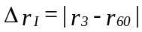 recorded on this headlamp is not more than 2 mrad Δ rI ≤ 2 mrad).
2.2.2. However, if this value is more than 2 mrad but not more than 3 mrad (2 mrad < Δ rI ≤ 3 mrad) a second headlamp shall be tested as described in paragraph 2.1. after being subjected three consecutive times to the cycle as described below, in order to stabilize the position of mechanical parts of the headlamp on a base representative of the correct installation on the vehicle:
Operation of the front fog lamp for one hour (the voltage shall be adjusted as specified in paragraph 1.1.1.2.).
Period of rest for one hour.
The headlamp type shall be considered acceptable if the mean value of the absolute values Δ rI measured on the first sample and Δ rII measured on the second sample is not more than 2 mrad.
Annex 7
Distinguishing number of contracting parties to the 1958 agreement in the approval mark
Any type approval granted by a Contracting Party to the 1958 Agreement shall contain a distinguishing number of the country that has granted the approval. The list of these numbers is included in any Regulation, generally as a footnote, similar to that reproduced below. It needs to be amended any time when there is a new Contracting Party to the Agreement, even if there is no significant modification of the Regulation. The list below, kept regularly up to date, permits to replace its in extenso reproduction in Regulations by a simple reference.
1 for Germany, 2 for France, 3 for Italy, 4 for the Netherlands, 5 for Sweden, 6 for Belgium, 7 for Hungary, 8 for the Czech Republic, 9 for Spain, 10 for Serbia, 11 for the United Kingdom, 12 for Austria, 13 for Luxembourg, 14 for Switzerland, 15 (vacant), 16 for Norway, 17 for Finland, 18 for Denmark, 19 for Romania, 20 for Poland, 21 for Portugal, 22 for the Russian Federation, 23 for Greece, 24 for Ireland, 25 for Croatia, 26 for Slovenia, 27 for Slovakia, 28 for Belarus, 29 for Estonia, 30 (vacant), 31 for Bosnia and Herzegovina, 32 for Latvia, 33 (vacant), 34 Bulgaria, 35 (vacant), 36 for Lithuania, 37 for Turkey, 38 (vacant), 39 for Azerbaijan, 40 for The former Yugoslav Republic of Macedonia, 41 (vacant), 42 for the European Community (Approvals are granted by its Member States using their respective ECE symbol), 43 for Japan, 44 (vacant), 45 for Australia, 46 for Ukraine, 47 for the Republic of South Africa, 48 for New Zealand, 49 for Cyprus, 50 for Malta , 51 for the Republic of Korea, 52 for Malaysia, 53 for Thailand, 54 (vacant), 55 (vacant), 56 for Montenegro, 57 (vacant) and 58 for Tunisia. Subsequent numbers shall be assigned to other countries in the chronological order in which they ratify the Agreement concerning the Adoption for Uniform Conditions of Approval and Reciprocal Recognition of Approval for Motor Vehicle Equipment and Parts, or in which they accede to that Agreement, and the numbers thus assigned shall be communicated by the Secretary-General of the United Nations to the Contracting Parties to the Agreement.

* * In accordance with the programme of work of the Inland Transport Committee for 2006–2010 (ECE/TRANS/166/Add.1, programme activity 02.4), the World Forum will develop, harmonize and update Regulations in order to enhance the performance of vehicles. The present document is submitted in conformity with that mandate.
? TRANS/WP.29/1045 as amended by ECE/TRANS/WP.29/1045/Amend.1
? According to the Convention on Road Traffic of Vienna, 8 November 1968 and of the European Agreements supplementing that Convention, except item H, taken from OECD "Glossary of statistical terms"
? The text reproduced in this paragraph is the up-to-date version of Annex 7 to the Consolidated Resolution (TRANS/WP.29/78/Rev.1) established by the Working Party on the Construction of Vehicles. It is based on document TRANS/WP.29/78/Rev.1/Amend.2 and Rev.1/Amend.4.
  At its ninety-eighth session, the Working Party on General Safety Provisions (GRSG) adopted a proposal for a definition of Non-Road Mobile Machinery (NRMM) (ECE/TRANS/WP.29/GRSG/2010/14) and requested the secretariat to submit it to WP.29 and AC.1 for consideration at their March 2010 session together with this proposal. This definition has been inserted in paragraph 2.7. of the present document.
  [At its ninety-eighth session, the Working Party on General Safety Provisions (GRSG) adopted a proposal for a definition of Non-Road Mobile Machinery (NRMM) (ECE/TRANS/WP.29/GRSG/2010/14) and requested the secretariat to submit it to WP.29 and AC.1 for consideration at their March 2010 session together with this proposal. This definition has been inserted in paragraph 2.7. of the present document.]
? In the case of vehicles of category L₄, the provisions below are not applicable to the space in between the sidecar and the motor cycle and the immediate surroundings thereof.
? According to the Convention on Road Traffic of Vienna, 8 November 1968 and of the European Agreements supplementing that Convention, except item H, taken from OECD "Glossary of statistical terms."
? Alternative measures (e.g. a deflector ramp behind the filler neck) shall be permitted if the 15 mm requirement cannot be fulfilled.
? The test laboratory may choose for vehicles of this category additional measuring points at the middle and the rear of the vehicle adjacent to the longitudinal axis of the vehicle.
? In any seating position other than front seats where the "H" point cannot be determined using the "three-dimensional H-point machine" or other procedures, the "R" point indicated by the vehicle manufacturer may be taken as a reference at the discretion of the Competent Authority.
? Tilt angle, height difference with a seat mounting, surface texture, etc.
? The machine corresponds to that described in ISO Standard 6549-1980. For details of the construction of the 3–DH machine refer to Society of Automotive Engineers (SAE), 400 Commonwealth Drive, Warrendale, Pennsylvania 15096, United States of America.
? The reference system corresponds to ISO Standard 4130:1978
? Strike out what does not apply.
* * For L₂ it is recommended to use a focal distance of about 80 mm.
? When the tested headlamp is grouped and/or reciprocally incorporated with signalling lamps, the latter shall be lit for the duration of the test. In the case of a direction indicator lamp, it shall be lit in flashing operation mode with an on/off time ratio of approximately one to one.
? Should two or more filaments be simultaneously lit when headlamp flashing is used, this shall not be considered as being normal use of the filaments simultaneously.
? NaCMC represents the sodium salt of carboxymethylcellulose, customarily referred to as CMC. The NaCMC used in the dirt mixture shall have a degree of substitution (DS) of 0.6-0.7 and a viscosity of 200-300 cP for a 2 % solution at 20°C.
? The tolerance on quantity is due to the necessity of obtaining a dirt that correctly spreads out on all the plastic lens.

