UN/SCETDG/39/INF.22
Committee of Experts on the Transport of Dangerous Goods
and on the Globally Harmonized System of Classification
and Labelling of Chemicals
Sub-Committee of Experts on the Transport of Dangerous Goods 10 June 2011
Thirty-ninth session
Geneva, 20 June – 24 June 2011
Item 2 (b) of the provisional agenda
Explosives and related matters:
screening test for substances that may have explosive properties

Comments on a new DDT Test and Criteria for flash compositions proposed by the United States of America (ST/SG/AC.10/C.3/2010/31)
Transmitted by the expert from Japan
- The expert from Japan welcomes the proposal from the United State of America regarding a new DDT test and criteria for flash composition classification (see ST/SG/AC.10/C.3/2010/31). The sample mass of 25 g seems to be appropriate in improving the reliability of classification keeping the method to be simple and inexpensive.
- To study the consistency of this US DDT test and criteria with Japanese hazard assessment for firework compositions, various firework compositions typically used by Japanese fireworks manufacturers were tested by this method. In addition, unknown bursting charges sampled from foreign firework products were also tested. The outline and results of this work are shown in the Annex of this document.
- Although a subject of inspection is limited to a fine powder in the original proposal, this work inspected not only fine powder but also granular sample in which the fine powder was coated on core materials such as rice chaff, cottonseed and cork (see Figs. 3 and 4). It should be noted that bursting charges in firework products are usually packed in a granular form to enhance the combustion rate. Therefore, the core material as well as the packing density was considered to influence the classification results.
- For the granular samples, the sample mass of 25 g can be defined in two different ways, i.e. “net explosive mass 25 g” and “powder mass 25 g”. Both definitions were employed in this work (see Figs. 5 and 6). In the former definition, the sample mass of 25 g means simply a mass of granular sample, i.e. a summation of masses of both core materials and explosive powder coated on them. In this case, the mass of explosive powder becomes less than 25 g. In the latter definition, total mass is adjusted so that the mass of explosive powder becomes 25 g by referring known mass ratio of explosive powder to core materials.
- In case of inspecting the foreign product, the subject of inspection had to be the granular sample of “net explosive mass 25 g” because no powder sample was available and the mass ratio of explosive powder to core materials was unknown (see Fig. 6).
- As for the results of classification using fine powder samples (see Figs. 5 and 6), all compositions for typical bursting charges, Nos. 1-3, showed [-], while the composition for report charge, No. 4, showed [+]. These results were consistent with Japanese hazard assessment for firework compositions.
- Figure 7 shows the difference in the classification of granular sample of No.2 between two different definitions of sample mass, i.e. “powder mass 25 g” and “net explosive mass 25 g”. In the case of “powder mass 25 g”, the result showed [+], while in the case of “net explosive mass 25 g”, the results became [-]. This means that if the both composition and core materials are identical, the former definition will give severer result than the latter definition. This is simply because that the former definition requires larger amount of sample than the latter. Thus, the definition of the sample mass is essential in testing granular samples.
- Figure 8 shows the difference in the classification between the fine powder sample and the granular sample. The fine powder of 25 g of composition No.3 showed [-], while the granular sample of net explosive mass 25 g consisting of the same explosive powder and rice chaff showed [+] despite the mass of the explosive powder was reduced to 20.5 g in the granular sample. This indicates that the intensity of explosion can be enhanced by granular configuration even if the amount of explosive powder is less than 25 g.
- The test results of the foreign firework products showed [+] for both types of granular samples (see Fig. 9). It should be mentioned again that there is no way but testing granular sample of “net explosive mass 25 g” in this product because no powder sample was available and the mass ratio of explosive powder to core materials was unknown.
- The results mentioned above demonstrate that this US DDT test could be more practical than the original proposal by expanding the subjects of inspection to cover granular samples of “net explosive mass 25 g”.
Proposal
- The expert from Japan basically supports this US DDT-test as a method for flash compositions classification. However the Sub-Committee is invited to discuss following issues,
- The subjects of inspection should be expanded to cover granular samples, and
- If so, the definition of the sample mass should be “net explosive mass 25 g”.
Annex
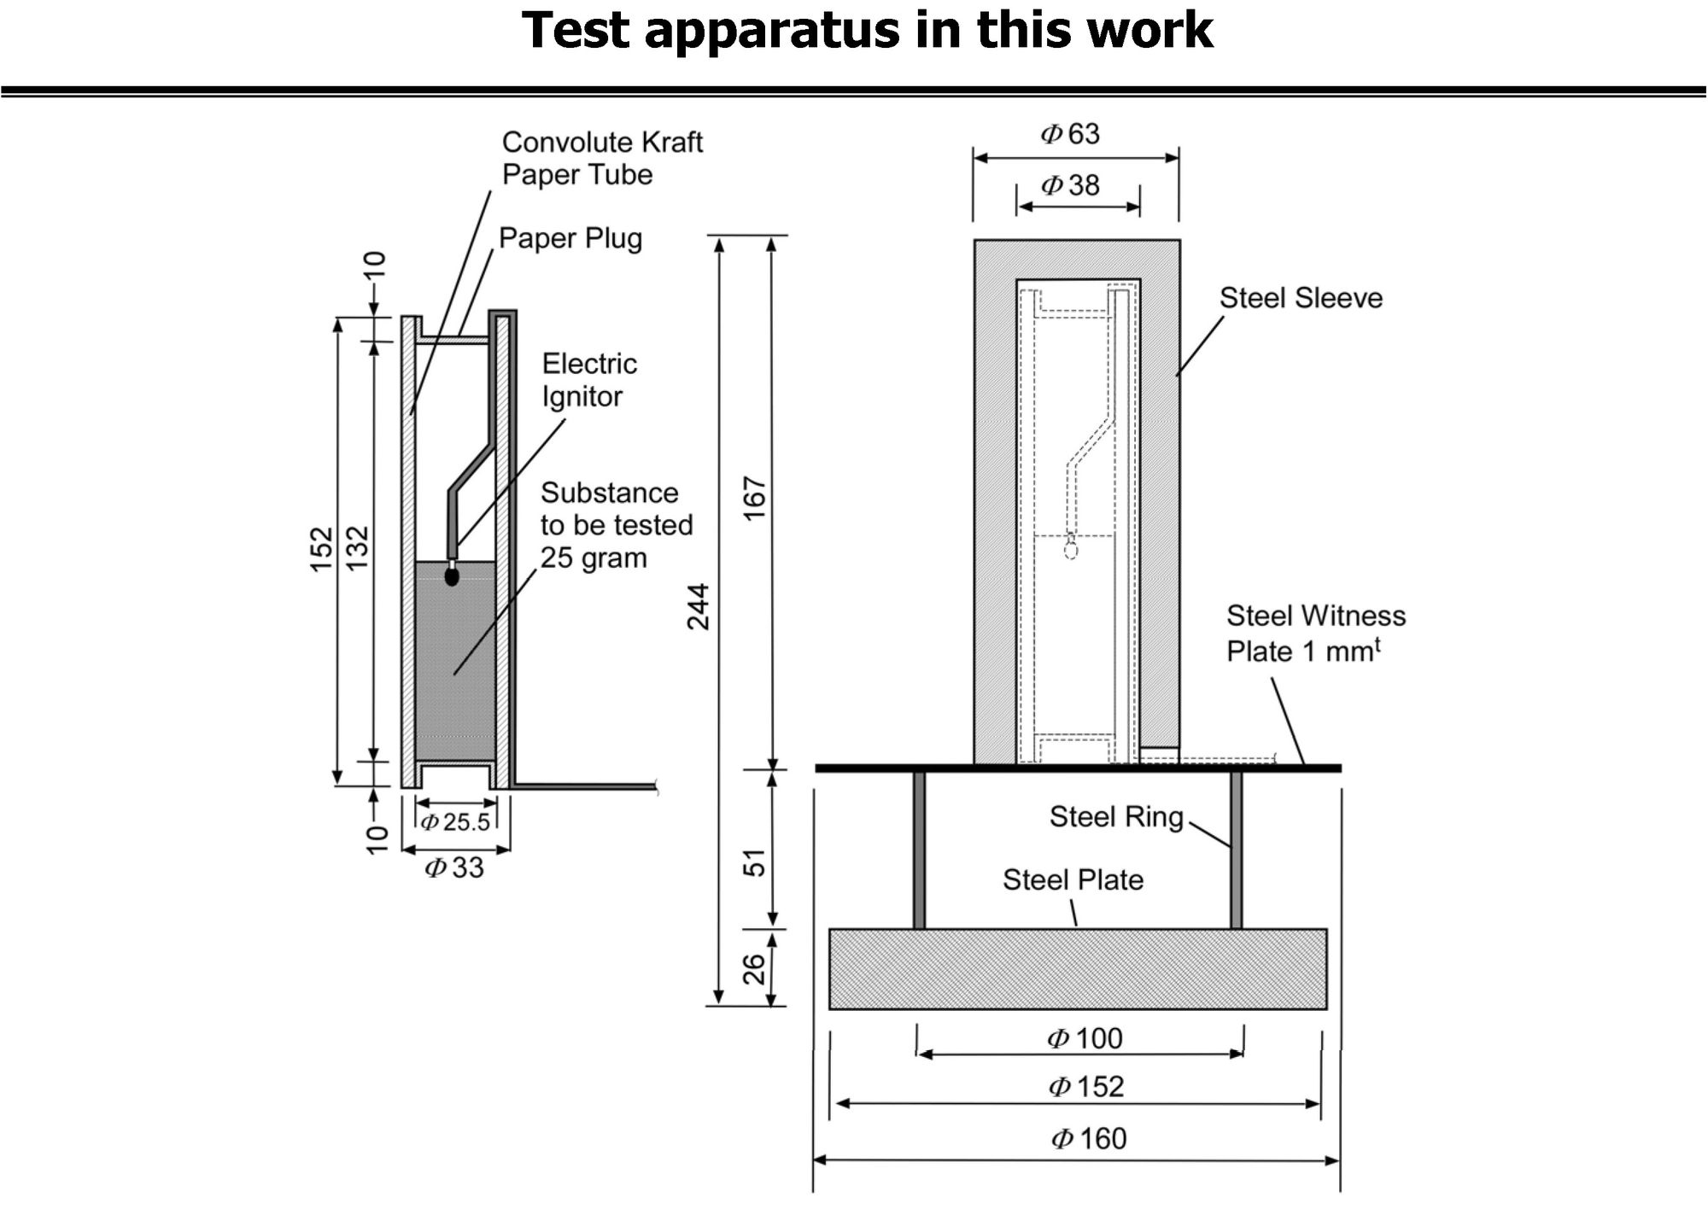
Fig. 1

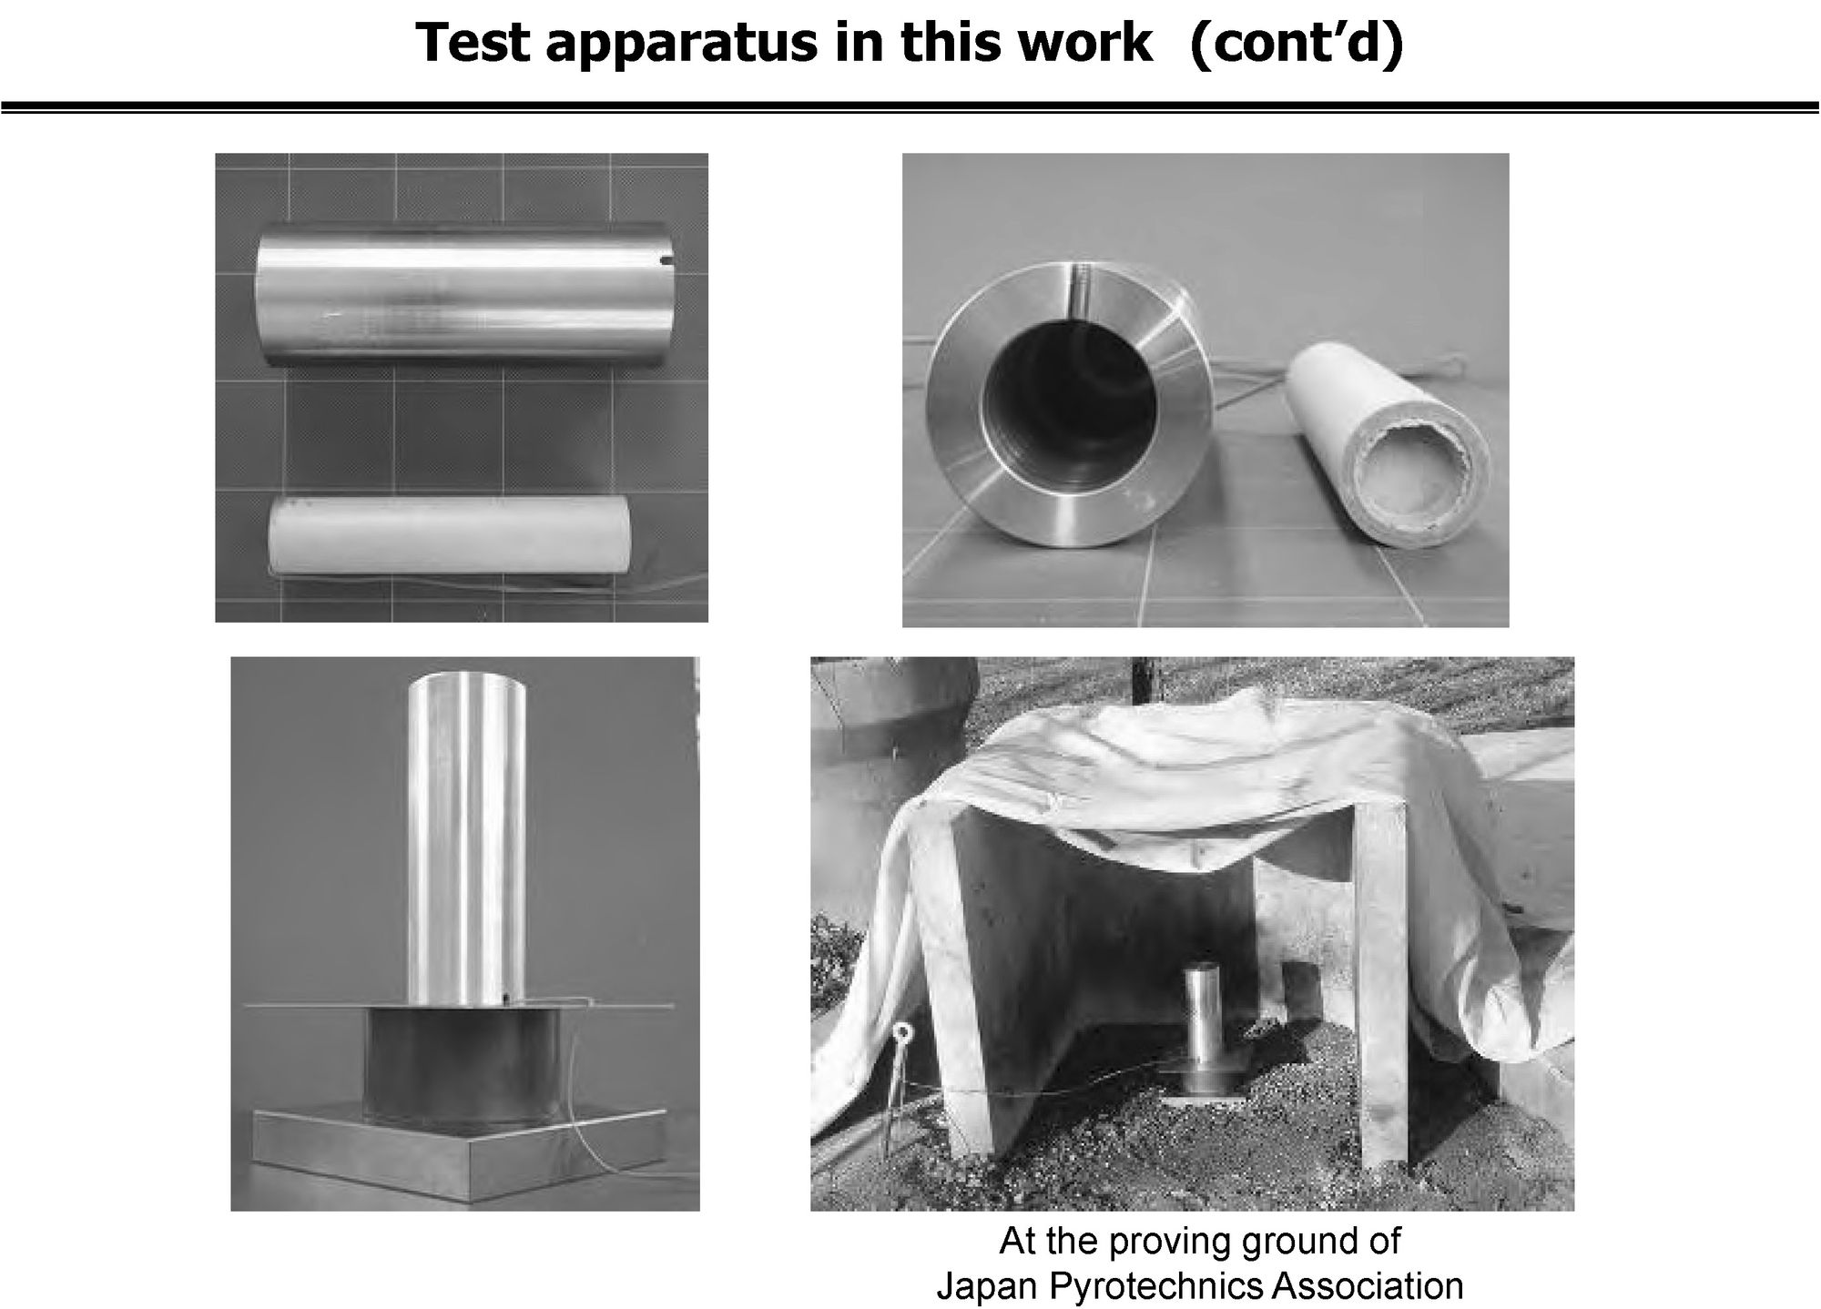
Fig. 2

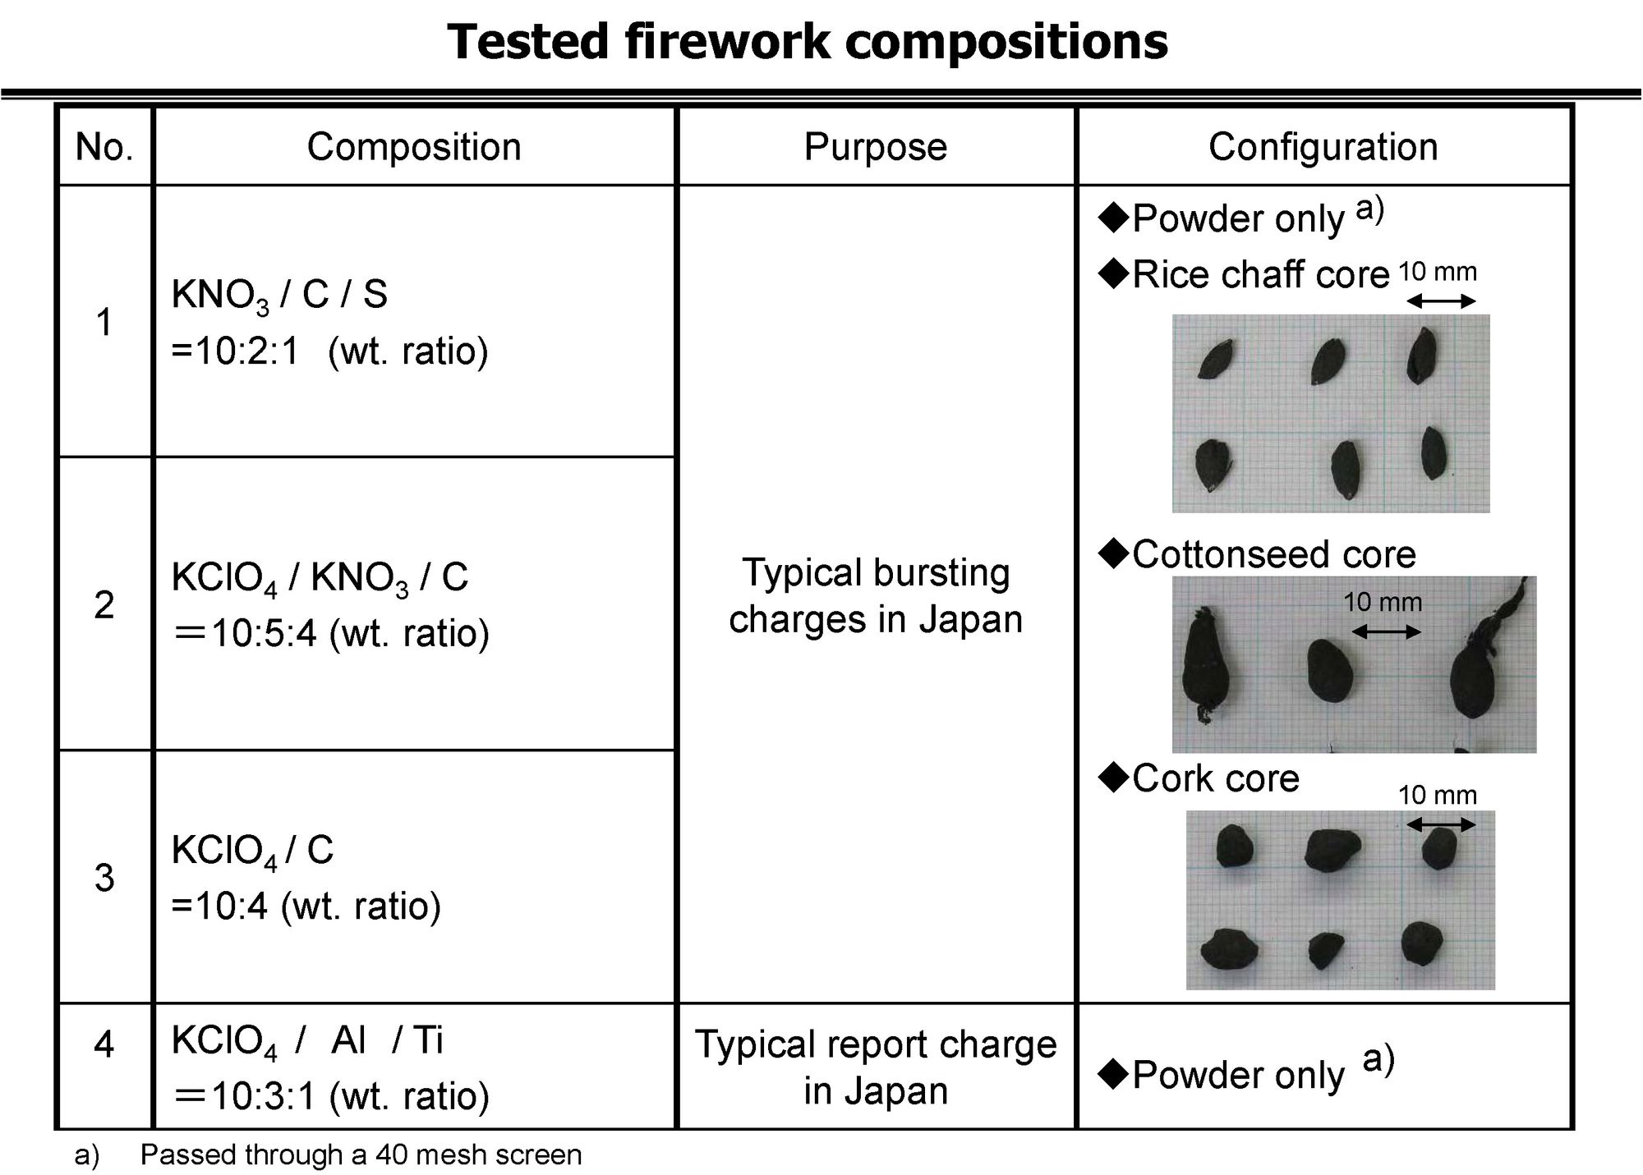
Fig. 3

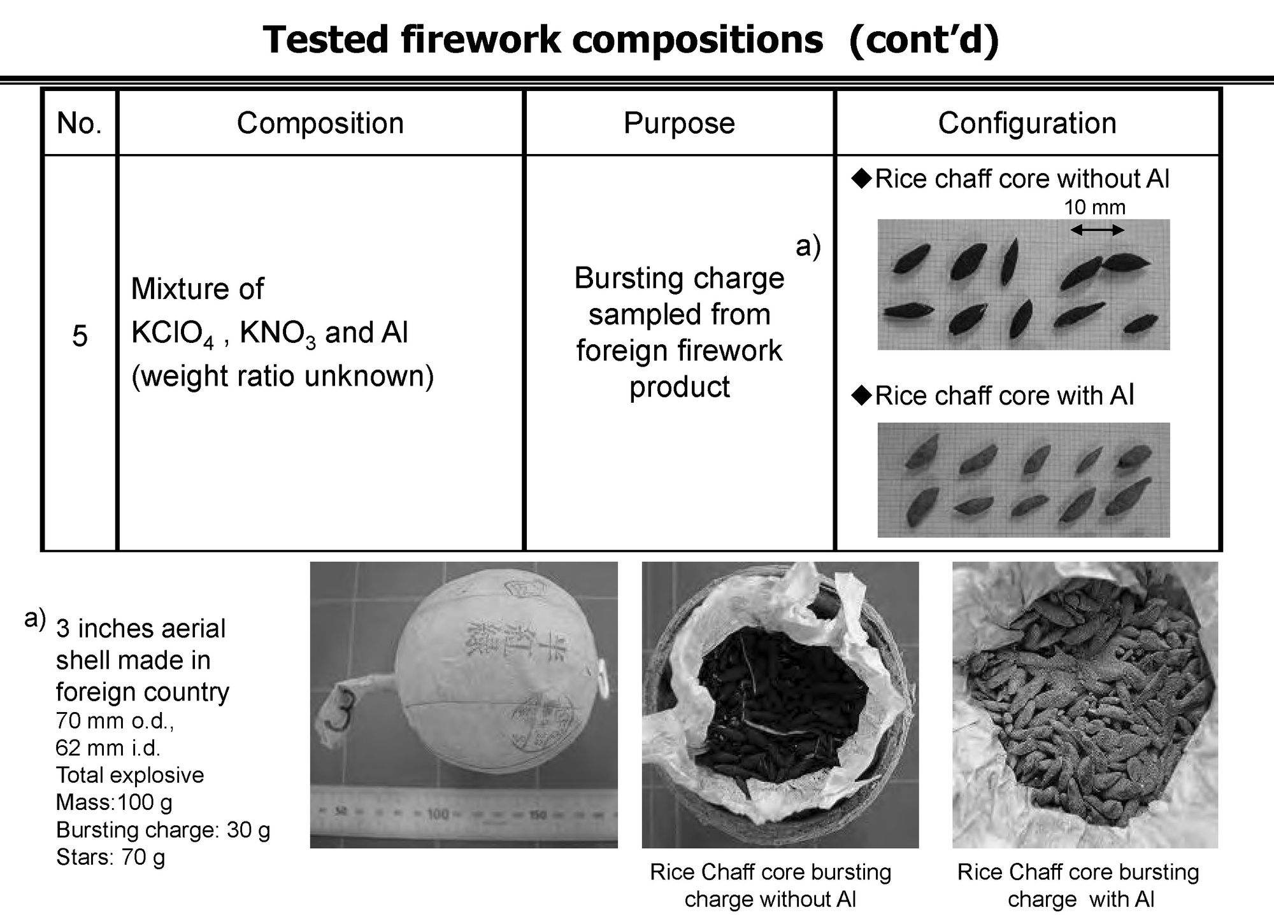
Fig. 4

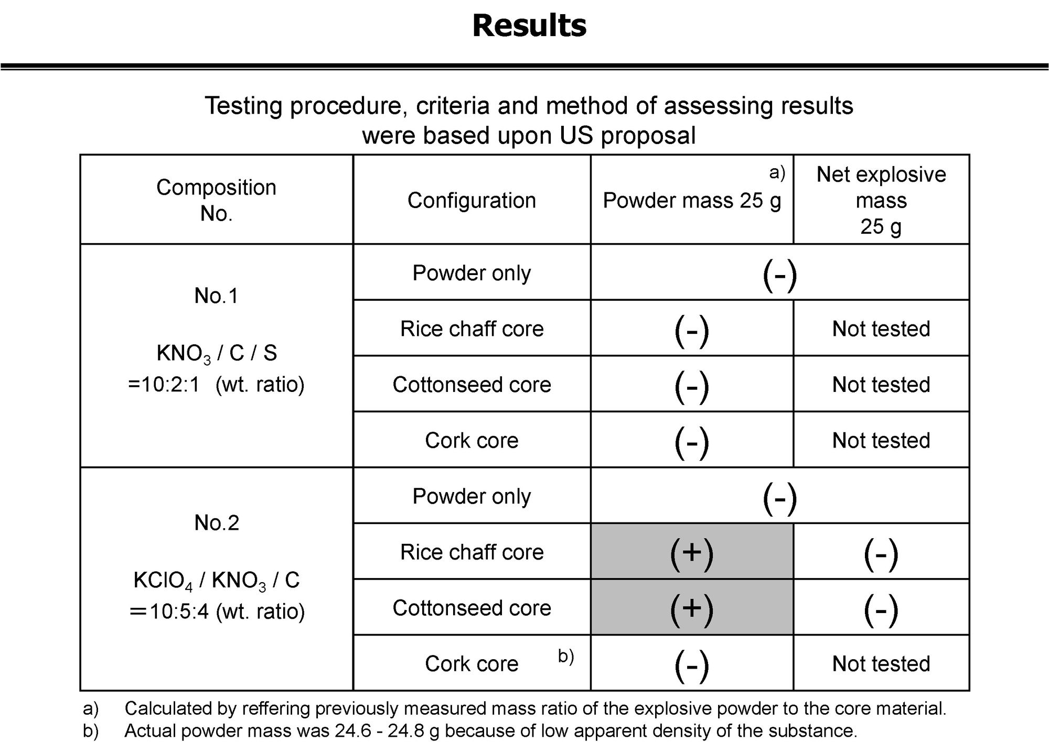
Fig. 5

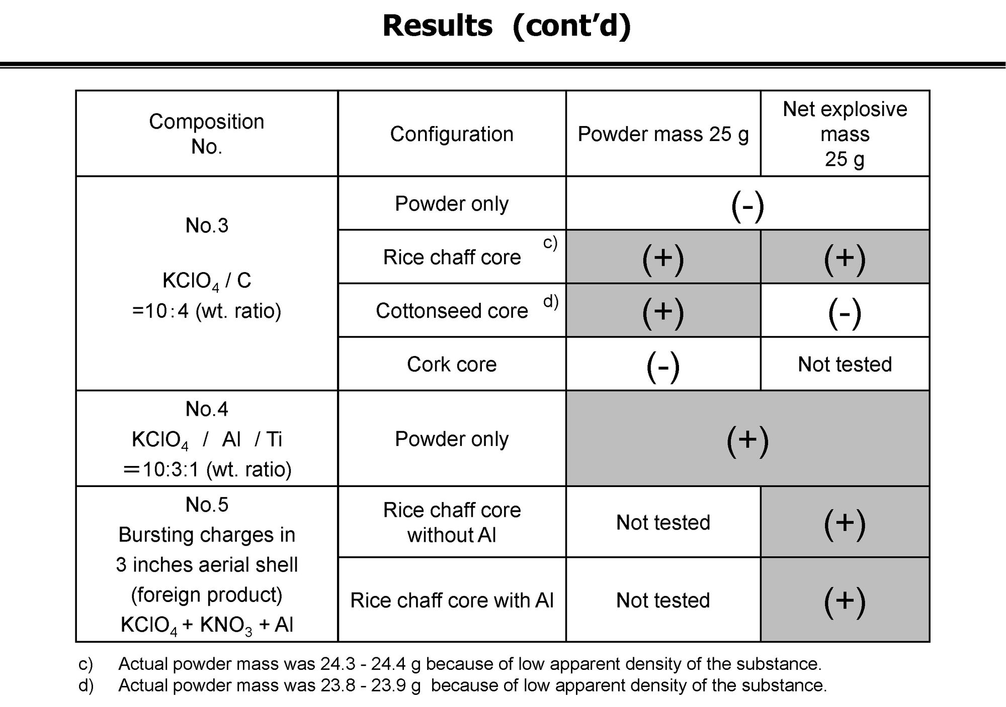
Fig. 6

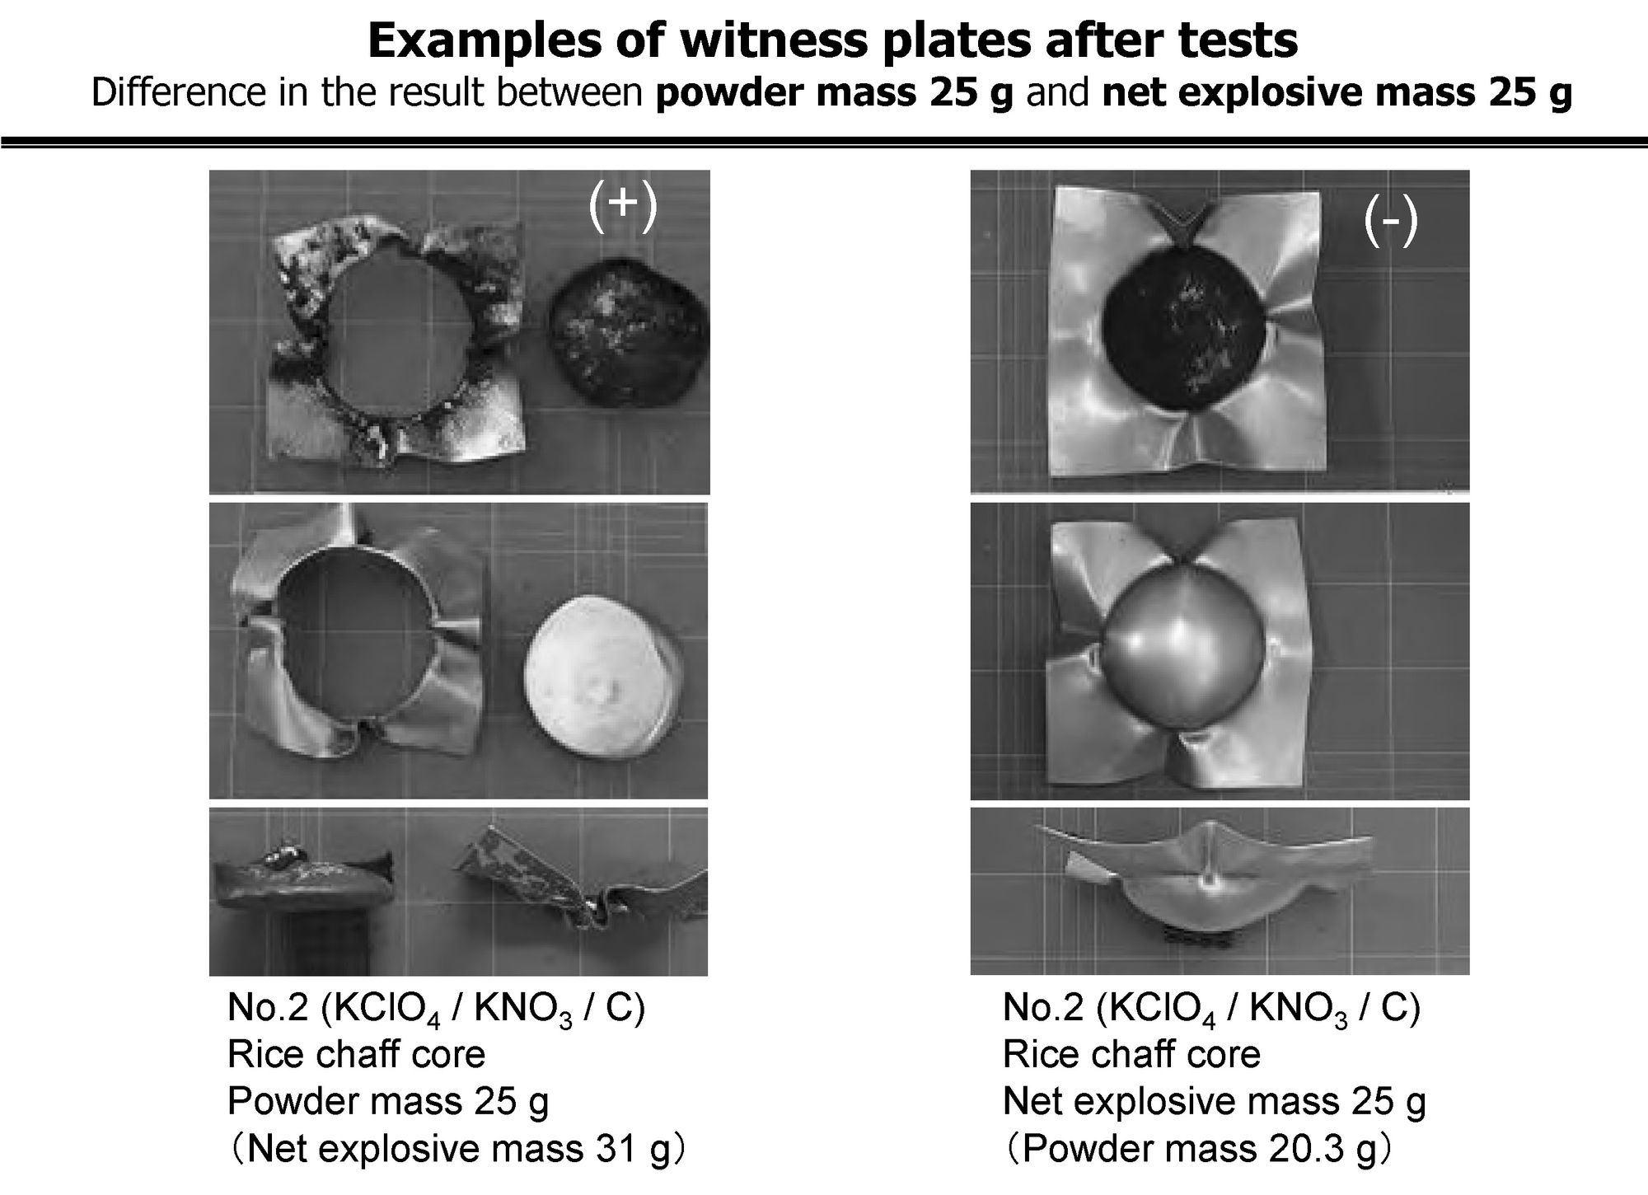
Fig.7

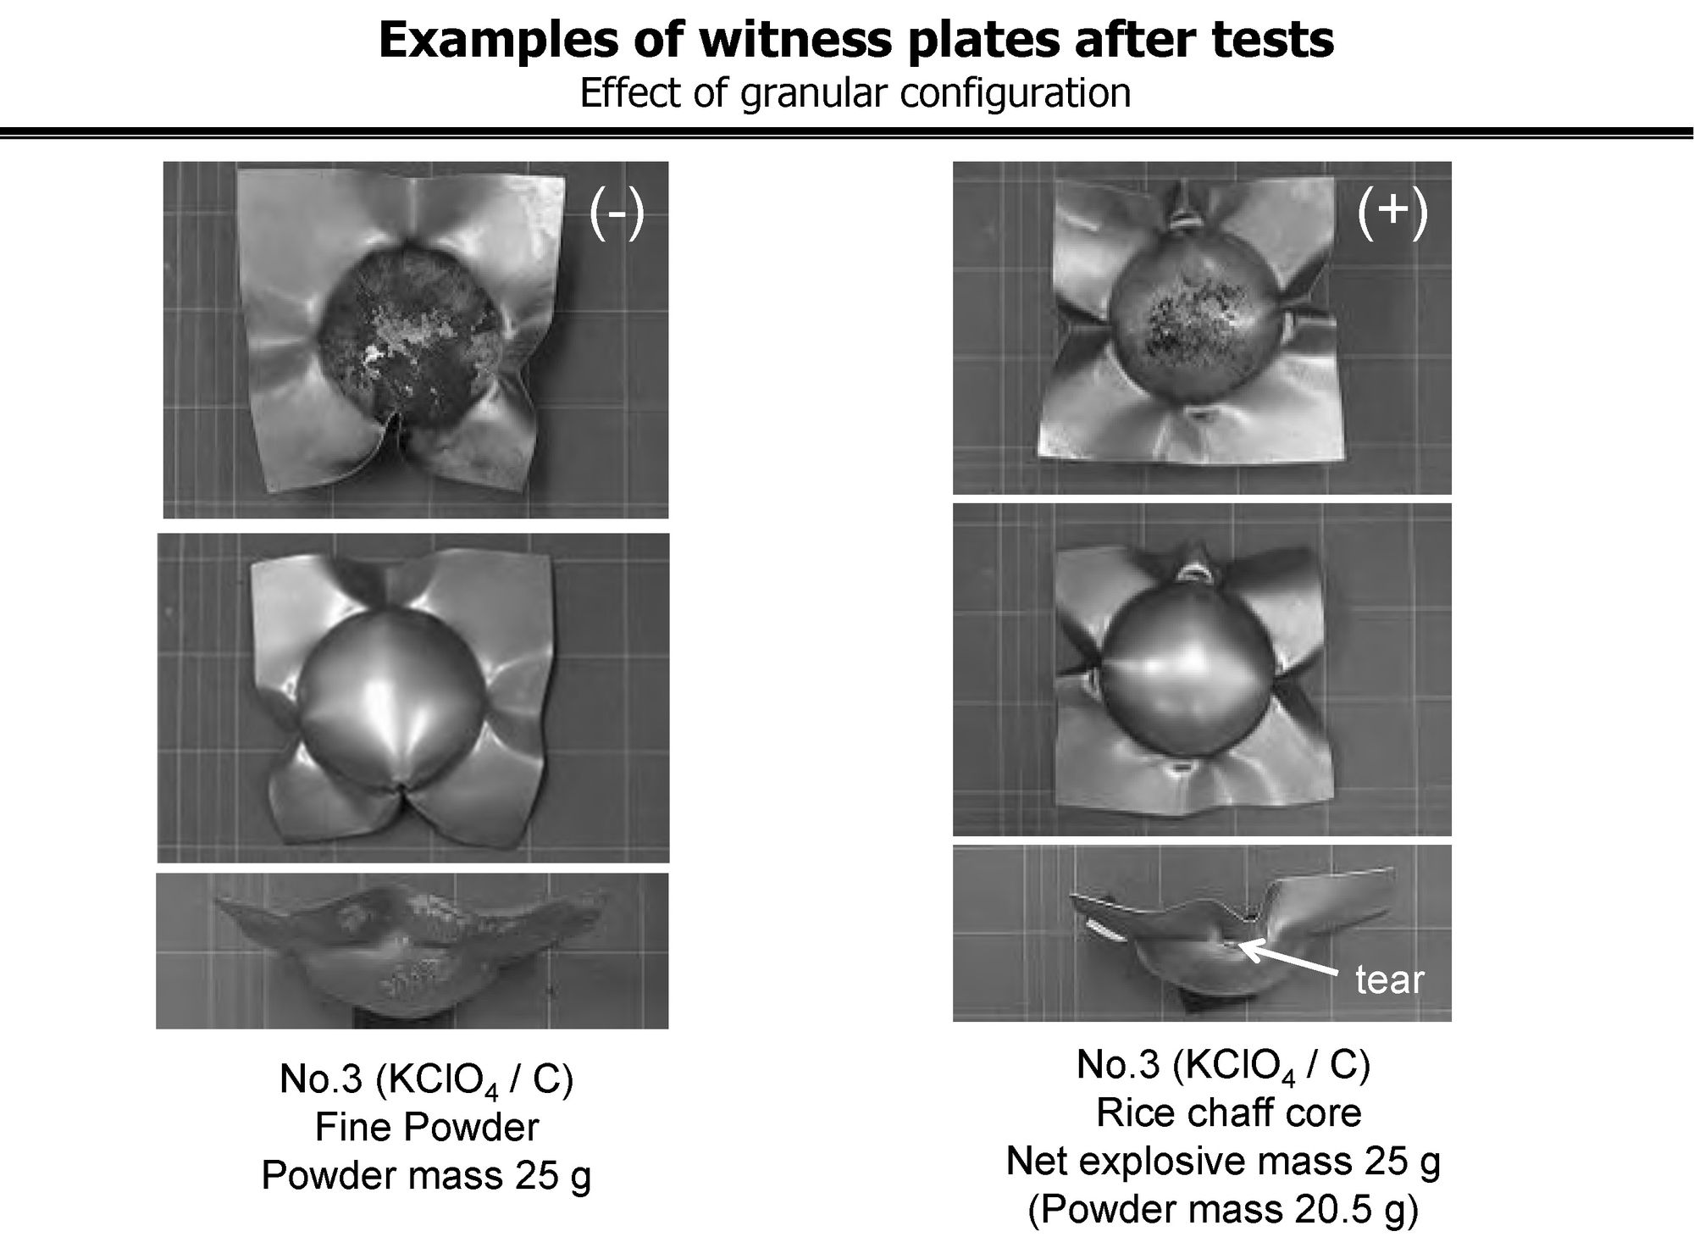
Fig. 8

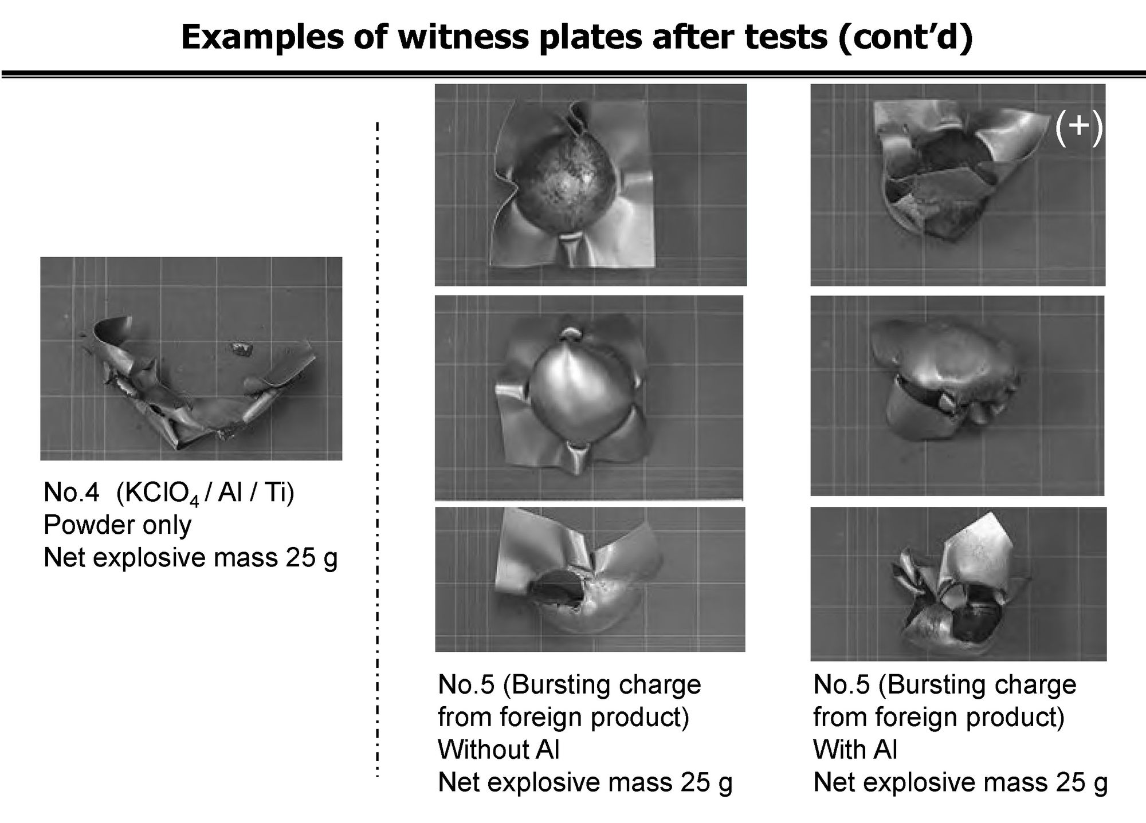
Fig. 9

