UNITED  NATIONS |  | E
 | Economic and Social  Council | Distr.  GENERAL  ECE/TRANS/WP.29/GRRF/2009/23/Rev.2  30 June 2010  Original: ENGLISH  ENGLISH AND FRENCH ONLY
ECONOMIC COMMISSION FOR EUROPE

INLAND TRANSPORT COMMITTEE

World Forum for Harmonization of Vehicle Regulations

Working Party on Brakes and Running Gear

Sixty-eighth session
Geneva, 21-23 September 2010
Item 5 of the provisional agenda

Regulation No. 90
(Replacement brake linings)

Proposal for amendments to Regulation No. 90

Submitted by the expert from Germany /

The text reproduced below was prepared by the informal group on Replacement Discs and Drums (RD&D) in order to cover also minimum performance standards for replacement brake discs and drums for vehicles of categories M, N and O. It is based on ECE/TRANS/WP.29/GRRF/2009/23 and includes the changes agreed by the Working Party on Brakes and Running Gear at its sixty-sixth session (ECE/TRANS/WP.29/GRRF/66, para. 31) and its sixty seventh session (ECE/TRANS/WP.29/GRRF/67, para. 23). The modifications to the existing text of the Regulation are marked in bold characters.
A. PROPOSAL

The title, (in both instances where the title is used), amend to read:
"UNIFORM PROVISIONS CONCERNING THE APPROVAL OF REPLACEMENT BRAKE LINING ASSEMBLIES, DRUM BRAKE LININGS AND DISCS AND DRUMS FOR POWER-DRIVEN VEHICLES AND THEIR TRAILERS"

The table of contents

Annex 1, amend to read:

"Annex 1A - Communication concerning the approval or extension or refusal or withdrawal of approval or production definitely discontinued of a replacement brake lining assembly or replacement drum brake lining pursuant to Regulation No. 90

Annex 1B - Communication concerning the approval or extension or refusal or withdrawal of approval or production definitely discontinued of a replacement brake drum or replacement brake disc pursuant to Regulation No. 90"

Annex 9, amend to read:

"Annex 9 - Special additional procedures for conformity of production"

Insert new Annexes 10 to 14, to read:

"Annex 10 - Illustrations

Annex 11 - Requirements for replacement brake discs/drums for vehicles of category M and N

Annex 12 - Requirements for replacement brake discs/drums for vehicles of category O

Annex 13 - Model test reports for a replacement brake disc/drum"

Text of the Regulation

Paragraph 1.1., amend to read (including footnote 1/):

"1.1. This Regulation applies to the basic braking function of the following replacement parts: 1/
___________________
1/ It does not apply to possible additional functions of replacement parts as for example speed sensing in the case of integrated speed sensing devices or guidance of the wheels in the case of integrated hubs."
Insert a new paragraph 1.1.4., to read:

"1.1.4. Replacement brake drums and discs intended for use in friction brakes forming part of a braking system of vehicles of category M, N and O which have a type approval in accordance with Regulation No. 13 or Regulation 13-H"

Insert new paragraphs 1.2 and 1.3., to read:

"1.2. Original brake discs and brake drums, fitted at time of manufacturing of the vehicle and original replacement discs and drums intended for the servicing of the vehicle are not subject to this Regulation.

1.3. This Regulation does not apply to "Special parts", as defined in paragraph 2.3.4."

Insert a new paragraph 2.1., to read:

"2.1. General definitions"

Insert new paragraphs 2.1.2. and 2.1.3., to read:

"2.1.2. "Replacement part": means either a replacement brake lining assembly type, a replacement drum brake lining type, a replacement drum brake lining, a replacement brake drum or a replacement brake disc.

2.1.3. "Original part": means either an original brake lining, an original brake lining assembly, an original drum brake lining, an original brake drum or an original brake disc."

Insert a new paragraph 2.2., to read:

"2.2. Definitions regarding the approval of a replacement brake lining assembly type, a replacement drum brake lining type or a replacement drum brake lining."

Paragraphs 2.1.(former) to 2.6., renumber as paragraphs 2.2.1. to 2.2.6.

Paragraph 2.7., renumber as paragraph 2.2.7. and amend to read (including footnote):

"2.2.7. "Original brake lining" means a brake lining type referenced in the vehicle type approval documentation, Regulation No. 13, Annex 2, paragraph 8.1.1., Regulation 13-H, Annex 1, paragraph 7.1. 2/ or Regulation No. 78, Annex 1, paragraph 5.4.;

2/ If such brake linings are not available on the market, alternatively, brake linings listed under paragraph 8.1.2. may be used."

Paragraphs 2.8. to 2.12., renumber as paragraphs 2.2.8. to 2.2.12.

Paragraph 2.13., renumber as paragraph 2.1.1. and amend to read:

"2.1.1. "Manufacturer" means the organization which can assume technical responsibility for the brake lining assemblies or drum brake linings or brake drums and discs and can demonstrate that it possesses the necessary means to achieve conformity of production."

Insert new paragraphs 2.3 to 2.3.13., to read:

"2.3. Definitions regarding the approval of a replacement brake drum or a replacement brake disc.

2.3.1. "Original brake disc / brake drum"

2.3.1.1. in the case of motor vehicles, a brake disc/drum having type approval in accordance with Regulation No. 13 or 13-H and which fulfils the conformity of production requirements of these Regulations.

2.3.1.2. in the case of trailers,
(a) a brake disc/drum having type approval in accordance with Regulation No. 13 and which fulfils the conformity of production requirements of this Regulation.
(b) a brake disc/drum which is part of a brake for which the axle manufacturer owns a test report according to Annex 11 of Regulation No. 13.

2.3.2. "Identification code" identifies the brake discs or brake drums covered by the braking system approval according to Regulations Nos. 13 and 13-H. It contains at least the manufacturer's trade name or trademark and an identification number.

The vehicle manufacturer shall provide on request of the technical service and/or approval authority the necessary information, which makes the link between the braking system type approval and the corresponding identification code.

2.3.3. Replacement parts

2.3.3.1. "Original replacement brake discs and brake drums": Original brake discs / brake drums intended for servicing the vehicle and carrying an identification code as defined in paragraph 2.3.2. affixed in such a way as to be indelible and clearly legible.

2.3.3.2. "Identical brake disc": Is a replacement brake disc which is chemically and physically identical in every respect with the exception of the vehicle manufacturer mark, which is absent, to the original brake disc. Furthermore the brake disc is produced under the same production and quality assurance systems and conditions as for the original parts pursuant to paragraph 2.3.1. The identical part is provided with a durably legible mark from the part manufacturer.

2.3.3.3. "Identical brake drum": Is a replacement brake drum which is chemically and physically identical in every respect with the exception of the vehicle manufacturer mark, which is absent, to the original brake drum. Furthermore the brake drum is produced under the same production and quality assurance systems and conditions as for the original parts pursuant to paragraph 2.3.1. The identical part is provided with a durably legible mark from the part manufacturer.

2.3.3.4. "Equivalent brake disc": Is a replacement brake disc which is identical to the original brake disc in respect to all dimensions, geometric features and basic design and is also from the same material sub-group as the original brake disc as defined in paragraph 5.3.3.2.

2.3.3.5. "Equivalent brake drum": Is a replacement brake drum which is identical to the original brake drum in respect to all dimensions, geometric features and basic design and is also from the same material sub-group as the original brake drum as defined in paragraph 5.3.3.2.

2.3.3.6. "Interchangeable brake disc": Is a replacement brake disc which has the same interface dimensions as the original brake disc but may differ from the original brake disc in terms of its design, material composition and mechanical properties.

2.3.3.7. "Interchangeable brake drum": Is a replacement brake drum which has the same interface dimensions as the original brake drum but may differ from the original brake drum in terms of its design, material composition and mechanical properties.

2.3.4. "Special brake disc/drum" means a replacement brake disc/drum not covered by paragraphs 2.3.1. to 2.3.3.

2.3.5. "Functional dimensions": all the measurements that are relevant with regard to the fitting and functioning of the components of the braking system (see paragraph 5.3.7.1. and Annex 10).

2.3.6. "Type of brake disc/drum": brake discs or drums having the same basic design and material group in accordance with the classification criteria pursuant to paragraphs 5.3.5.1. or 5.3.5.2. as appropriate.

2.3.7. "Test group": type of brake discs/drums having the same characteristics pursuant to paragraph 5.3.6.

2.3.8. "Variant": individual brake disc/drum within a given test group.

2.3.9. "Material": chemical composition and mechanical properties as per paragraph 3.4.1.2.

2.3.10. "Material group": e.g. grey cast iron, steel, aluminum, etc.

2.3.11. "Material sub-group", one of the sub-group defined in paragraph 5.3.3.2.

2.3.12. "Minimum thickness": the thickness of the brake disc is the point at which replacement becomes necessary.

2.3.13. "Maximum inside diameter": the maximum inside diameter of the brake drum is the point at which replacement becomes necessary."

Paragraphs 3.1. to 3.2., amend to read:

"3.1. An application for approval of a replacement part for (a) specific vehicle type(s) shall be submitted by the manufacturer of the replacement part or his duly accredited representative.

3.2. An application may be submitted by the holder of (a) vehicle type approval(s) to Regulations No. 13 or 13-H or 78 in respect of replacement part conforming to the type recorded in the vehicle type approval(s) documentation."

Insert a new paragraph 3.3., to read:

"3.3. In the case of an application regarding the approval of a replacement brake lining assembly type, a replacement drum brake lining type or a replacement drum brake lining:"

Paragraphs 3.3. (former) to 3.6.., renumber as paragraphs 3.3.1. to 3.3.4.

Paragraph 3.6.1., renumber as paragraph 3.3.4.1., and amend, to read:

"3.3.4.1. The applicant shall submit values for friction behaviour in accordance with Annex 9, Part A, paragraph 2.4.1. or 3.4.1. respectively of this Regulation."

Insert new paragraphs 3.4. to 3.4.3.5., to read:

"3.4. In the case of an application regarding the approval of a replacement brake drum or a replacement brake disc.

3.4.1. An application for approval shall be accompanied, in triplicate, by a description of replacement brake drum or a replacement brake disc with regard to the items specified in Annex 1B to this Regulation, and by the following particulars:

3.4.1.1. Disc or drum drawing(s) including the dimensions of the features mentioned in paragraph 5.3.7.1., together with tolerances, and any accompanying accessories
(a) Location and nature of the marking pursuant to 6.2.2. - dimensions in mm,
(b) weight in grams,
(c) material.

3.4.1.2. Component description

The manufacturer shall provide a component description containing at least the following information:
(a) the manufacturer of the unmachined part;
(b) a description of the process of manufacture of the unmachined part;
(c) proof of the reliability of the process (e.g. freedom from cracks and cavities, dimensions);
(d) material composition, specifically:
(i) chemical composition;
(ii) microstructure;
(iii) mechanical properties:
a. Brinell hardness pursuant to ISO 6506-1:2005
b. Tensile strength in accordance with ISO 6892:1998
(e) corrosion or surface protection;
(f) description of the balancing measures, maximum permissible balance error;
(g) amount of wear allowed (minimum thickness in the case of brake discs or the maximum internal diameter in the case of brake drums).

The applicant shall submit the information and specifications outlined in Annex 9, Part B, paragraph 2.5. of this Regulation

3.4.2. Conformity of production

The competent authority shall verify the existence of satisfactory arrangements for ensuring effective control of the conformity of production before type approval is granted.

3.4.2.1. The applicant shall submit the documentation in accordance with Annex 9, Part B, paragraph 2. of this Regulation.

3.4.3. Sample quantities and usage

3.4.3.1. A minimum number of disc or drum samples – of the design for which approval is requested – shall be provided, as shown in the following table.

The table also shows the recommended use of the samples.

Item No. | Check / Test | Sample Number |  |  |  |  |  | Remarks
 |  | 1 | 2 | 3 | 4 | 5 | 6
1 | Geometric check  Paragraphs 5.3.3.1., 5.3.4.1. | x | x | x | x | x | x
2 | Material check  Paragraphs 5.3.3.2., 5.3.4.2. | x | x
3 | Balancing provisions check  Paragraph 5.3.7.2. |  |  | x | x | x | x
4 | Wear condition marking check  Paragraph 5.3.7.3. |  |  | x | x | x | x
5 | Integrity test - thermal fatigue Paragraphs 4.1.1., 4.2.1. of Annex 11, 4.1.1., 4.2.1. of Annex 12 |  |  |  | x | x
6 | Integrity test - high load test  Paragraphs 4.1.2., 4.2.2. of Annex 11, and paragraphs 4.1.2., 4.2.2. of Annex 12 |  |  | x
7 | Service brake vehicle performance test Paragraph 2.2. of Annex 11, Paragraph 2.2. of Annex 12 |  |  |  |  |  | Pair of discs | either front or rear axle
8 | Parking brake vehicle performance test  Paragraph 2.3. of Annex 11, Paragraph 2.3. of Annex 12 |  |  |  |  |  | Pair of discs | if applicable
9 | Service brake dyno. performance test  Paragraph 3.3. of Annex 11, paragraph 3.3. of Annex 12 |  |  |  |  |  | x | alternative to vehicle test

3.4.3.2. Each disc and drum, other than those using geometric and material checks, shall be accompanied by the appropriate number of the suitable brake lining assemblies which have an approval to Regulation No. 13, 13-H or 90.

3.4.3.3. In the case where a comparison with the original brake disc or brake drum is required, an axle set of original brake discs or original brake drum, as applicable, shall be provided.

3.4.3.4. Where an equivalent replacement disc/drum approval is sought, two original brake disc/drum or original replacement brake disc/drum samples shall be provided for dimensional and material comparisons.

3.4.3.5. Where an interchangeable replacement disc/drum approval is sought, two original brake disc/drum or original replacement brake disc/drum samples shall be provided for dimensional comparison."

Paragraph 4.1., amend to read:

"4.1. If the replacement part submitted for approval pursuant to this Regulation meet the requirements of paragraph 5. below, approval of the replacement part shall be granted."

Paragraphs 4.2. to 4.5., amend to read:

"4.2. To each replacement part approved there shall be assigned an approval number comprising four groups of digits:

4.2.1. The first two digits (at present 02 for the Regulation in its 02 series of amendments) shall indicate the series of amendments incorporating the most recent major technical amendments made to the Regulation at the time of issue of the approval.

4.2.2. The following single digit shall indicate the category of the replacement part as follows:
A Replacement brake lining assembly
B Replacement drum brake lining
C Replacement brake disc
D Replacement brake drum

4.2.3. The next four digits shall indicate the manufacture and the type of the brake lining, the type of disc or the type of drum.

A suffix of four digits shall indicate
(a) the shoe or back plate or specific dimension in the case of drum brake linings
(b) the variant in the case of a replacement disc or replacement drum

 |  |  |  |  |  |  | _ | _ | _ |  | _ | _ | _ | _ | / | _ | _ | _ | _
 |  |  |  |  |  |  |  |  |  |  |  |  |  |  |  |  |  |  |  | 4 digits indicate the variant / shoe / back plate / specific dimension of the replacement part (0001 to 9999)
 |  |  |  |  |  |  |  |  |  |  |  |  |  |  |  |  |  |  |  | 4 digits indicate (manufacturer and) the type of the replacement part (0001 to 9999)
 |  |  |  |  |  |  |  |  |  |  |  |  |  |  |  |  |  |  |  | 1 digit (A to D) indicates the category of the replacement part
 |  |  |  |  |  |  |  |  |  |  |  |  |  |  |  |  |  |  |  | 2 digits indicate series of amendment (01 to 99)
Example:
 |  |  |  |  |  |  | 0 | 2 | C |  | 0 | 3 | 5 | 9 | / | 7 | 2 | 4 | 8
 |  |  |  |  |  |  |  |  |  |  |  |  |  |  |  |  |  |  |  | Variant No. 7248
 |  |  |  |  |  |  |  |  |  |  |  |  |  |  |  |  |  |  |  | Type No. 0359
 |  |  |  |  |  |  |  |  |  |  |  |  |  |  |  |  |  |  |  | Brake disc
 |  |  |  |  |  |  |  |  |  |  |  |  |  |  |  |  |  |  |  | Amendment 02

4.3. The same Contracting Party may not assign the same number to another replacement part. The same type approval number may cover the use of that replacement part on a number of differing vehicle types.

4.4. Notice of approval or of extension or refusal of approval or withdrawal of approval or production definitely discontinued of a replacement part pursuant to this Regulation shall be communicated to the Parties to the 1958 Agreement which apply this Regulation by means of a form conforming to the model in Annex 1 to this Regulation.

4.5. There shall be affixed, conspicuously and in a readily accessible place, to every replacement part approved under this Regulation, an international approval mark consisting of:"

Paragraphs 5.1. to 5.1.1., amend to read:

"5.1. General

A replacement part shall be so designed and constructed that, when substituted for the part originally fitted to a vehicle, the braking efficiency of that vehicle accords with that of the approved vehicle type.

Specifically:
(a) a replacement part for a vehicle type approved prior to Regulation No. 13, 09 series of amendments, or the original version of Regulation No. 13-H or Regulation No. 78, 01 series of amendments, shall satisfy as a minimum the appropriate above-mentioned Regulation level;

(b) a replacement part shall display performance characteristics similar to that of the original part it is intended to replace;

(c) a replacement part must possess adequate mechanical characteristics;

(d) brake linings shall not contain asbestos;

(e) a replacement brake disc/drum shall exhibit sufficient deformation resistance under temperature;

(f) The minimum thickness of the brake disc shall not be less than the minimum thickness of the original brake disc as specified by the vehicle manufacturer;

(g) The maximum permissible inside diameter of the brake drum shall not be more than the maximum permissible inside diameter of the original brake drum specified by the vehicle manufacturer.

5.1.1. Replacement brake lining assemblies or replacement drum brake linings conforming to the type specified in vehicle type approval documentation to Regulation No. 13 or to Regulation No. 13-H or Regulation No. 78 are deemed to satisfy the requirements of paragraph 5 of this Regulation."

Insert a new paragraph 5.1.2., to read:

"5.1.2. Replacement discs and replacement drums conforming to the identification code specified in vehicle type approval documentation to Regulation No. 13 or to Regulation No. 13-H are deemed to satisfy the requirements of paragraph 5. of this Regulation."

Insert a new paragraph 5.2., to read:

"5.2. Requirements regarding the approval of a replacement brake lining assembly type, a replacement drum brake lining type or a replacement drum brake lining"

Paragraphs 5.2.(former) to 5.3.2.3., renumber as paragraphs 5.2.1 to 5.2.2.2.3.

Insert new paragraphs 5.3. to 5.3.8., to read:

"5.3. Technical requirements regarding the approval of a replacement brake drum or a replacement brake disc

All replacement parts have to be separated in 4 groups:
(a) Original replacement brake disc/drum
(b) Identical brake disc/drum
(c) Equivalent disc/drum
(d) Interchangeable disc/drum

Depending on its group, the replacement brake disc or drum has to pass the following tests:

 | Performance tests according to Regulations Nos. 13/13-H (Type 0, I, II, etc.) | Comparison test with dynamic frictional properties of the original part | Integrity tests (High load and Thermal Fatigue)
Original replacement parts | No | No | No
Identical parts | No | No | No
Equivalent parts | No | No | Dynamometer test
Interchangeable parts | Vehicle test or alternative dynamometer test | Vehicle test or alternative dynamometer test | Dynamometer test

The test requirements for brake discs and drums for vehicles of category M and N are detailed in Annex 11.

The test requirements for brake discs and drums for vehicles of category O are detailed in Annex 12.

5.3.1. Original replacement brake discs/drums

5.3.1.1. Original replacement brake discs/drums are excluded from the scope of this Regulation provided they carry an identification code as defined in paragraph 2.3.2. affixed in such a way as to be indelible and clearly legible.

5.3.2. Identical brake discs/drums

5.3.2.1. Approval authorities must ensure, before granting an approval that suitable arrangements exist between the part and the vehicle manufacturer for the interchange of information to verify the "identical requirement" as per the definitions of paragraphs 2.3.3.2. and 2.3.3.3.

5.3.2.2. Since the identical brake discs/drums fulfils all requirement as the Original part no testing requirements are prescribed.

5.3.3. Equivalent replacement discs or drums

5.3.3.1. Geometric requirements

The brake discs or drums shall be identical to the original brake disc or drum in respect to all dimensions, geometric features and basic design.

5.3.3.1.1. For discs the following maximum values shall be met:

 | M₁, N₁, O₁, O₂ | M₂, M₃, N₂, N₃, O₃, O₄
Thickness variation | 0.015 mm | 0.030 mm
Cheek thickness variation (for ventilated disc only) | 1.5 mm | 2.0 mm
Lateral run-out friction surface | 0.050 mm* | 0.15 mm*
Location bore variation | H9 | H9
"Top hat" parallelism | 0.100 mm | 0.100 mm
Location face flatness | 0.050 mm | 0.050 mm
Friction surface roughness** | 3.2 µm | 3.2 µm
* n/a in the case of a floating disc
** Ra-value according to ISO 1302:2002
5.3.3.1.2. For drums the following maximum values shall be met:

 | M₁, N₁, O₁, O₂ | M₂, M₃, N₂, N₃, O₃, O₄
Radial run-out friction surface | 0.050 mm | 0.100 mm
Location bore variation | H9 | H9
Ovality | 0.040 mm | 0.150 mm
Location face flatness | 0.050 mm | 0.050 mm
Friction surface roughness* | 3.5 µm | 3.5 µm
* Ra-value according to ISO 1302:2002

5.3.3.2. Material and metallurgical requirements

In order to be considered "Equivalent" the replacement brake disc or drum shall be from the same material sub-group as the original brake disc or drum. Four original part material sub-groups are defined.

 | Test standard | Sub-group 1  Base cast iron  DIN EN 1561  EN-GJL-200 | Sub-group 2  Base high carbon  EN-GJL-150 | Sub-group 3  Alloyed high carbon | Sub-group 4  Unalloyed high carbon
Carbon Content |  | 3.20 – 3.60 per cent | 3.60 – 3.90 per cent | 3.55 – 3.90 per cent | 3.60 – 3.90 per cent
Silicon Content |  | 1.70 – 2.30 per cent | 1.60 – 2.20 per cent | 1.60 – 2.20 per cent | 1.60 – 2.20 per cent
Manganese Content |  | Min 0.40 per cent | Min 0.40 per cent | Min 0.40 per cent | Min 0.40 per cent
Chromium Content |  | Max 0.35 per cent | Max 0.35 per cent | 0.30 – 0.60 per cent | Max 0.25 per cent
Copper Content |  | - | 0.30 – 0.70 per cent | 0.30 – 0.70 per cent | Max 0.40 per cent
Hardness HBW | ISO 6506-1 :2005 | 190 – 248 | 160 - 210 | 180 - 230 | 160 – 200
Tensile strength | ISO 6892:1998 | Min 220 N/mm² | Min 160 N/mm² | Min 170 N/mm² | Min 150 N/mm²

5.3.3.3. Performance requirements
The part has to pass the integrity tests for high load and thermal fatigue according to Annexes 11 and 12.
5.3.4. Interchangeable replacement discs or drums

5.3.4.1. Geometric requirements

As paragraphs 5.3.3.1.1. and 5.3.3.1.2. plus the same interface dimensions.

An interchangeable replacement disc or drum may differ from the original part disc in design features such as:
(a) Type and geometry of ventilation (for vented discs)
(b) Integral or composite disc or drum
(c) Surface finish (e.g. holes, slots etc.)

5.3.4.2. Performance requirements

The part has to pass the following performance tests according to Annexes 11 and 12:
(a) the performance test according to Regulations No. 13 or 13-H
(b) the Comparison test with dynamic frictional properties of the original part
(c) the integrity tests for high load and thermal fatigue

5.3.5. Type

Brake discs/drums that do not differ in terms of their main characteristics as detailed below shall be regarded as one type within one report or approval:

5.3.5.1. Type criteria for brake discs

5.3.5.1.1. Basic design
a) With or without ventilation (e.g. solid, ventilated)
b) Design of ventilation
c) Surface (e.g. with or without grooves or holes)
d) Hub (with or without integrated parking brake drum)
e) Mounting (rigid, semi-floating, floating, etc.)
f) Hat (with or without integrated parking brake drum)

5.3.5.1.2. Material group

All material groups (including their respective sub-groups) are considered to be a separate type.

5.3.5.1.2.1. Cast iron

5.3.5.1.2.2. Steel

5.3.5.1.2.3. Composite materials

5.3.5.1.2.4. Multi-material construction

5.3.5.2. Type criteria for brake drums
(a) Material group (e.g. steel, cast iron, composite)
(b) Hub (with / without)
(c) Composite design

5.3.6. Test group criteria (within the same type)

The testing in test groups is possible for interchangeable parts only if the connection between the mounting area and the disc friction faces are of the same general form.

From each of the test groups mentioned below, at least one variant is subject to the corresponding tests laid down in Annexes 10, 11 or 12. The variant chosen from within a test group to test the replacement part is that which has the highest ratio of kinetic energy to its directly corresponding replacement part mass:

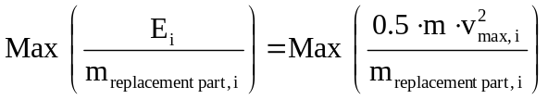
With:
vmax, i: maximum design speed of the vehicle to which the replacement part is fitted (in the case of trailers vmax, i is assumed at least at 80 km/h)
m: test mass as defined in Annex 11, paragraph 3.2.1.2 and Annex 12, paragraph 3.2.1.2
m_{replacement part, i}: mass of the replacement part" of the corresponding vehicle

5.3.6.1. Replacement brake discs

5.3.6.1.1. Criteria concerning the formation of test groups with regard to replacement brake discs in vehicles belonging to categories M₁, M₂, N₁, N₂, O₁ and O₂

5.3.6.1.1.1. Test group relating to the tests stipulated in paragraphs 1 to 4 of Annex 11 or Annex 12

This test group includes all brake discs where the outside diameter of the disc do not vary by more than 6 mm and the disc thickness by not more than 4 mm.

5.3.6.1.1.2. In the case of different materials within a group of materials, proof shall be furnished for each separate material that the requirements stipulated in Annex 11 or Annex 12 are met.

5.3.6.1.2. Criteria concerning the formation of test groups with regard to replacement brake discs in vehicles belonging to categories M₃, N₃, O₃ and O₄

5.3.6.1.2.1. Test group relating to the tests stipulated in paragraphs 1 to 4 of Annex 11 or Annex 12

This test group includes all brake discs where the outside diameter of the disc does not vary by more than 10 mm and the disc thickness by not more than 4 mm.

5.3.6.1.2.2. In the case of different materials within a group of materials, proof shall be furnished for each separate material that the requirements stipulated in Annex 11 or Annex 12 are met.

5.3.6.2. Replacement brake drums

5.3.6.2.1. Criteria concerning the formation of test groups with regard to replacement brake drums in vehicles belonging to categories M₁, M₂, N₁, N₂, O₁ and O₂

5.3.6.2.1.1. Test group relating to the tests stipulated in paragraphs 1 to 4 of Annex 11 or Annex 12

This test group includes all brake drums that do not vary by more than 30 mm in terms of the inside diameter of the drum and by more than 10 mm as regards the shoe width of the drum brake.

5.3.6.2.1.2. In the case of different materials within a group of materials, proof shall be furnished for each separate material that the requirements stipulated in Annex 11 or Annex 12 are met.

5.3.6.2.2. Criteria concerning the formation of test groups with regard to replacement brake drums in vehicles belonging to categories M₃, N₃, O₃ and O₄

5.3.6.2.2.1. Test group relating to the tests stipulated in paragraphs 1 to 4 of Annex 11 or Annex 12

This test group includes all brake drums that do not vary by more than 10 per cent (referring to the smallest value) in terms of the inside diameter of the drum and by more than 40 mm as regards the shoe width of the drum brake.

5.3.6.2.2.2. In the case of different materials within a group of materials, proof shall be furnished for each separate material that the requirements stipulated in Annex 11 or Annex 12 are met.

5.3.7. Scope of assessment with regard to replacement brake discs/drums

5.3.7.1. Geometric checks
Compared with original parts, replacement brake discs/drums shall be checked in terms of the following applicable characteristics (see also Annex 10):
(a) Disc/drum diameter, including friction surface diameters (in the case of a disc brake with an integrated parking brake drum, both diameters have to be checked)
(b) disc thickness (original dimensions and the minimum permissible wear indication) – mounting face to external friction surface
(c) mounting flange thickness
(d) pitch circle diameter of fixing holes / studs
(e) number of fixing holes / studs
(f) mounting flange diameter
(g) type of centering (e.g. central spigot or mounting bolts /studs)
(h) in the case of brake discs with integrated parking brake drums the width of the friction surface area and any heat compensation groove(s)
(i) additionally, in the case of ventilated brake discs
(i) the type of ventilation (internal/external)
(ii) the number of ribs and pillars
(iii) the dimensions of the ventilation duct

5.3.7.2. Balancing provision

The balancing provision with regard to the replacement brake discs/drums shall correspond to that of the original part being replaced.

5.3.7.3. Assessment of the wear condition of the friction surfaces

This shall conform to the vehicle manufacturer criteria.

5.3.7.4. Tests

Each test group (see 5.3.6.) within a particular type of replacement brake disc/drum (see 3.3.2.) shall be tested by the Technical Service.

5.3.8. Test report

A test report shall be produced, the content of which shall be at least that defined in Annex 13 to this Regulation."

Insert a new paragraph 6.1., to read:

"6.1. Packaging and marking requirements regarding a replacement brake lining assembly type, a replacement drum brake lining type or a replacement drum brake lining:"

Paragraphs 6.1.(former) to 6.5.3., renumber as paragraph 6.1.1. to 6.1.5.3

Insert new paragraphs 6.2. to 6.2.2.4. , to read:

"6.2. Packaging and marking requirements regarding replacement brake discs or replacement brake drums

6.2.1. Every unit sold shall at least exhibit the following information:

6.2.1.1. part number;

6.2.1.2. in the case of motor vehicles:

make, type and trade name of the vehicle, the axle intended to be fitted and period of manufacturing of the vehicle; should the period of manufacture not be readily available a reference to the original part number / identification code may be used;

6.2.1.3. in the case of trailers a reference to the original part number / identification code shall be used;

6.2.1.4. each package shall contain fitting instructions in an official ECE language, supplemented by the corresponding text in the language of the country where it is sold:

6.2.1.4.1. with particular reference to ancillary parts;

6.2.1.4.2. stating that replacement brake discs and drums should be replaced in axle sets.

6.2.2. Marking

Every brake disc/drum approved in accordance with this Regulation shall be durably marked with at least the following information:

6.2.2.1. Manufacturer's name or trade mark;

6.2.2.2. The approval number;

6.2.2.3. An indication which provides traceability of the production process (e.g. date, batch number, source code);

6.2.2.4. The minimum thickness of the brake disc or the maximum permissible inside diameter of the brake drum."

Paragraphs 7. to 7.1.1., amend to read:

"7. MODIFICATIONS AND EXTENSION OF APPROVAL OF REPLACEMENT PARTS

7.1. Every modification of the replacement part shall be notified to the administrative department which granted the type approval. The department may then either:

7.1.1. consider that the modifications made are unlikely to have appreciable adverse effects and that in any event the replacement part still complies with the requirements; or"

Paragraphs 8.1. and 8.2., amend to read:

"8.1. Replacement parts approved to this Regulation shall be so manufactured as to conform to the type approved.

8.2. Original parts being the subject of an application under paragraph 3.2. are deemed to satisfy the requirements of paragraph 8."

Paragraph 8.4.1., amend to read:

"8.4.1. ensure that for each replacement brake lining assembly type or replacement drum brake lining type at least the relevant tests prescribed in paragraph 5.2.2. and the relevant tests as prescribed in Annex 9 to this Regulation are carried out on a statistically controlled and random basis in accordance with a regular quality assurance procedure. For parking brake lining assemblies only the shear strength described in paragraph 5.2.2. is applicable.

Insert a new paragraph 8.4.2., to read:

"8.4.2. ensure that for each replacement disc and drum at least the tests prescribed in Annex 9 to this Regulation are carried out on a statistically controlled and random basis in accordance with a regular quality assurance procedure."

Paragraphs 8.4.2.(former), renumber as paragraph 8.4.3.

Paragraphs 9.1. and 9.2., amend to read:

"9.1. The approval granted in respect of a replacement brake lining assembly type or drum brake lining type pursuant to this Regulation may be withdrawn if the requirements laid down in paragraph 8.1. above are not complied with.

The approval granted in respect of the type of a replacement brake drum or a replacement brake disc pursuant to this Regulation may be withdrawn if the requirements laid down in paragraph 8.1. above are not complied with.

9.2. If a Contracting Party to the Agreement applying this Regulation withdraws an approval it has previously granted, it shall forthwith so notify the other Contracting Parties applying this Regulation, by means of a communication form conforming to the model in Annex 1A or Annex 1B to this Regulation."

Paragraph 10., amend to read:

"10. PRODUCTION DEFINITELY DISCONTINUED

If the holder of the approval completely ceases to manufacture a replacement part approved in accordance with this Regulation, he shall so inform the authority which granted the approval. Upon receiving the relevant communication that authority shall inform thereof the other Parties to the 1958 Agreement applying this Regulation by means of a communication form conforming to the model in Annex 1A or 1B to this Regulation."

Insert new paragraphs 12.1. to 12.2., to read:

"12.1. As from the official date of entry into force of the 02 series of amendments, no Contracting Party applying this Regulation shall refuse to grant approval under this Regulation as amended by the 02 series of amendments.

12.2. After the date of entry into force of the 02 series of amendments, brake lining assembly and drum brake lining approvals to the 01 series of amendments to the Regulation shall remain valid and Contracting Parties applying the Regulation shall continue to accept them."

Annex 1, renumber as Annex 1A

Insert a new Annex 1B, to read:

"Annex 1B

COMMUNICATION

(maximum format: A4 (210 x 297 mm))

issued by: Name of administration:
.......................
.......................
.......................
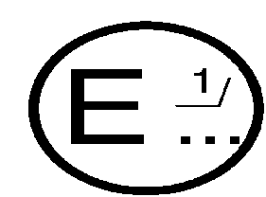

concerning: 2/ APPROVAL GRANTED
APPROVAL EXTENDED
APPROVAL REFUSED
APPROVAL WITHDRAWN
PRODUCTION DEFINITELY DISCONTINUED

of a replacement brake disc or a replacement brake drum pursuant to Regulation No. 90

Approval No. ....... Extension No. .......

1. Applicant name and address ...................................

2. Manufacturer name and address ...................................

3. Make and type of brake disc/drum ...................................

4. Vehicles/axles/brakes for which the replacement brake disc
or a replacement brake drum is approved:

5. Submitted for approval on

6. Technical service responsible for approval tests

6.1. Date of test report

6.2. Number of test report

7. Approval granted/extended/refused/withdrawn 2/

8. Place

9. Date

10. Signature

11. Annexed to this communication is a list of documents in the approval file deposited at the administrative services having delivered the approval and which can be obtained upon request.
_____________________
1/ Distinguishing number of the country which has granted/extended/refused/withdrawn approval (see approval provisions in the Regulation).

2/ Strike out what does not apply."

Annex 2

Existing approval mark and its explanatory text , amend to read:

"…..
(See paragraph 4.2. of this Regulation)

a
E2
a
3
-90 R 02 C0359/7248
a
3
a
2

a = 8 mm min.

The above approval mark shows that the item concerned has been approved in France (E2) pursuant to Regulation No. 90 under approval number C0359/7248. The first two digits of the approval number indicate that the approval was granted in accordance with the requirements of Regulation No. 90 as amended by the 02 series of amendments."

Annex 9

The title, amend to read:

"Annex 9

SPECIAL ADDITIONAL PROCEDURES FOR CONFORMITY OF PRODUCTION"

After the title, insert a new section heading, to read:

"PART A: DETERMINATION OF FRICTION BEHAVIOUR BY MACHINE TESTING"

Paragraph 1., amend to read:

"1. INTRODUCTION

Part A applies to replacement brake lining assemblies or replacement drum brake linings approved to this Regulation."

After paragraph 3.4.2., insert a new Part B to read:

"PART B: Conformity of production for brake discs and drums

1. INTRODUCTION

Part B applies to replacement brake discs and drums approved to this Regulation.

2. Requirements

Conformity of production is to be demonstrated through the routine control and documentation of at least the following:

2.1. Chemical composition

2.2. Microstructure

The microstructure must be characterised in accordance with ISO 945-1:2006
(a) Description of the composition of the matrix
(b) Description of the graphite shape, distribution and size

2.3. Mechanical properties

(a) Tensile strength measured in accordance with ISO 6892:1998
(b) Brinell hardness measured in accordance with ISO 6506-1:2005

In each case the measurements must be made on samples taken from the actual brake disc or drum.

2.4. Geometric features

Brake Discs:
(a) Thickness variation
(b) Friction surface run out
(c) Friction surface roughness
(d) Cheek thickness variation (for ventilated brake discs)

Brake Drums:
(a) Ovality
(b) Friction surface roughness

2.5. Acceptance criteria

With each application for approval of a replacement brake disc or drum there shall be submitted a production specification covering:
(a) Chemical composition and its permitted range, or where appropriate, maximum value, for each element
(b) Microstructure as per paragraph 2.2.
(c) Mechanical properties as per paragraph 2.3. and their permitted range, or where appropriate, minimum value

During routine production of an approved replacement brake disc or drum production must demonstrate compliance with these registered specifications.

In the case of Geometric features the values prescribed in paragraph 5.3.3.1.1. for brake discs and paragraph 5.3.3.1.2. for brake drums must not be exceeded.

2.6. Documentation

The documentation shall contain the manufacturer’s maximum and minimum permitted values.

2.7. Test frequency

The measurements prescribed in this annex should be carried out for each production batch."

Insert new Annexes 10 to 14, to read:
"Annex 10

ILLUSTRATIONS

1. Brake disc design types (examples)

Flat type
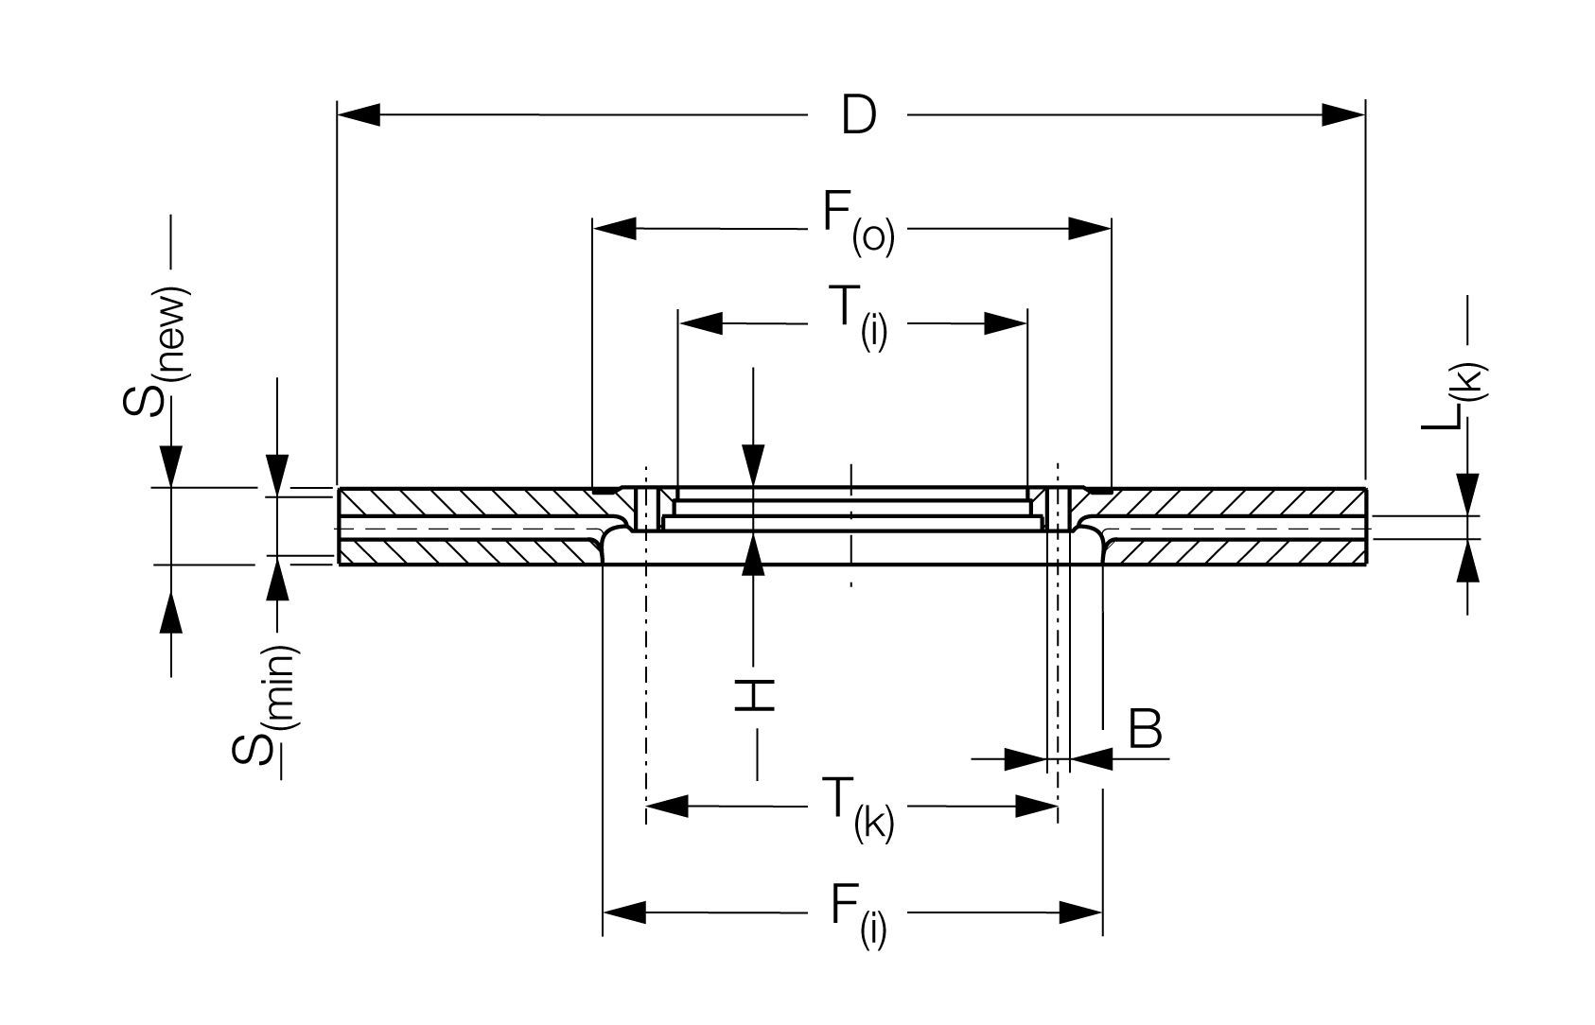

Cylinder type
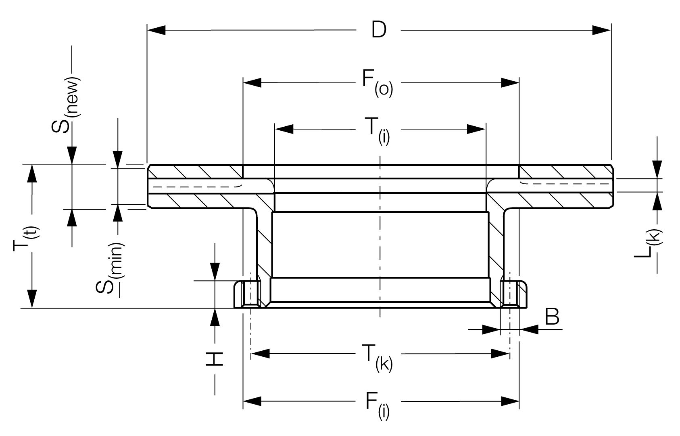

Pot type
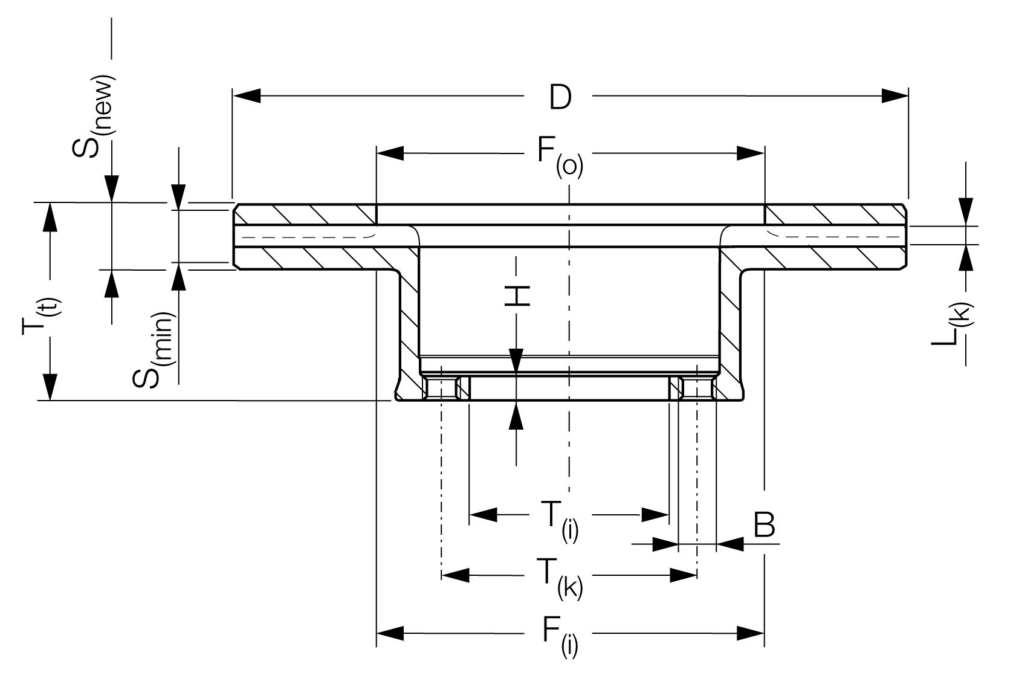
Conical type
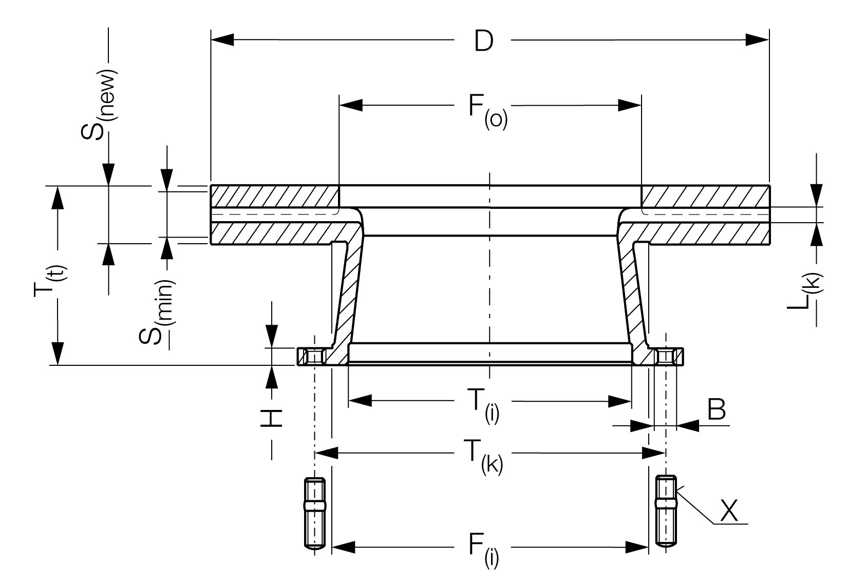

Double flange type
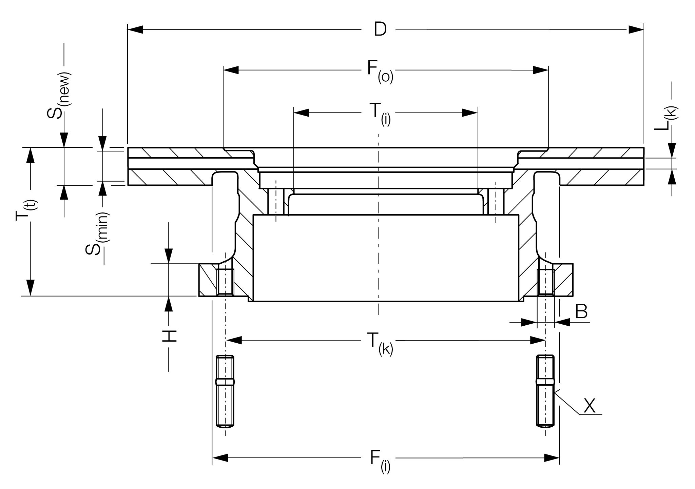
B Diameter of mounting bolt holes (or thread size in case of threaded holes)
D External diameter of disc
F _{(i)} Inner diameter of friction surface (inboard)
F _{(o)} Inner diameter of friction surface (outboard)
H Mounting flange thickness
L _{(k)} Width of cooling (ventilating) channel
S _{(new)} Disc thickness (nominal)
S _{(min)} Disc thickness (minimal permissible wear thickness)
T _{(i)} Internal diameter (mounting spigot diameter)
T _{(k)} "x" number of mounting bolt holes and pitch circle diameter
T _{(t)} Overall length of disc
2 Brake drum (example)

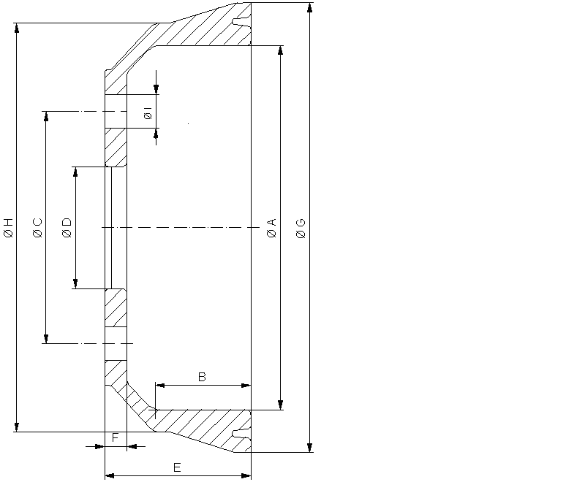

A Inside diameter of the drum
B Friction surface width
C "x" number of mounting bolt holes and pitch circle diameter
D Mounting spigot diameter
E Outside drum width
F Mounting flange thickness
G Outside diameter of the drum
H Casing diameter
I Diameter of the mounting bolt holes
Annex 11

REQUIREMENTS FOR REPLACEMENT BRAKE DISCS OR BRAKE DRUMS FOR VEHICLES OF CATEGORY M AND N

1. Test overview

The tests required in paragraph 5.3. of this Regulation are detailed as follows according to the vehicle category:

Table A11/1A: Vehicles of categories M1, N1
 | Vehicle test | Alternative dynamometer test
Performance tests according to Regulations No. 13/13-H | 2.2.1. Type 0, engine disconnected | 3.4.1. Type 0,
Performance tests according to Regulations No. 13/13-H | 2.2.2. Type 0, engine connected | 3.4.4. Brake tests simulation engine connected  Speed and load analog to item 2.2.2
Performance tests according to Regulations No. 13/13-H | 2.2.3. Type I | 3.4.2. Type I
Performance tests according to Regulations No. 13/13-H | 2.3. Parking braking system (if applicable) | -
Comparison test with original part | 2.4. Testing the dynamic frictional properties (comparison test conducted on the individual axles) | 3.5. Testing the dynamic frictional properties (comparison test conducted on the individual wheel brake)
Integrity tests | no vehicle test - use dynamometer test | 4.1. Brake discs  4.1.1. Brake disc thermal fatigue test  4.1.2. Brake disc high load test  4.2. Brake drums  4.2.1. Brake drum thermal fatigue test  4.2.2. Brake drum high load test

For each disc and drum type at least one test group (see definition in paragraph 5.3.6. of this Regulation) requires the Type 0 and Type I tests to be carried out on a vehicle.

Table A11/1B: Vehicles of categories M2, M3, N2, N3
 | Vehicle test | Alternative dynamometer test
Performance tests according to Regulation No. 13 | 2.2.1. Type 0, engine disconnected | 3.4.1. Type 0
Performance tests according to Regulation No. 13 | 2.2.3. Type I | 3.4.2. Type I
Performance tests according to Regulation No. 13 | 2.2.4. Type II | 3.4.3. Type II
Performance tests according to Regulation No. 13 | 2.3. Parking braking system (if required) | -
Comparison test with original part | 2.4. Testing the dynamic frictional properties (comparison test conducted on the individual axles) | 3.5. Testing the dynamic frictional properties (comparison test conducted on the individual wheel brake)
Integrity tests | no vehicle test - use dynamometer test | 4.1. Brake discs  4.1.1. Thermal fatigue  4.1.2. High load test  4.2. Brake drums  4.2.1. Thermal fatigue  4.2.2. High load test

2. Verification of the vehicle test requirements

2.1. Test vehicle

A vehicle that is representative for the selected test group (see definition in paragraph 5.3.6. of this Regulation) in respect of which an approval or parts report for a replacement brake disc/drum is applied for shall be fitted with this replacement brake disc/drum as well as be equipped with test devices for testing the brakes pursuant to the provisions of Regulation No. 13 or 13-H.

The replacement brake disc/drum shall be fitted to the axle in question together with an accompanying brake lining which has been type approved according to Regulations No. 13 or 13-H or 90 available from the vehicle or axle manufacturer.

Unless a uniform procedure is laid down for how braking is to effected, the test shall be carried out following agreement with the Technical Service. All the tests listed below shall be carried out on brakes that have been bedded in.

The same "bedding in" programme shall be used for both replacement and original brake discs and drums.

2.2. Service braking system

2.2.1. Type 0 brake tests, engine disconnected, vehicle laden

This test shall be carried out pursuant to Regulation No. 13, Annex 4, paragraph 1.4.2. or Regulation No. 13-H, Annex 3, paragraph 1.4.2.

2.2.2. Type 0 brake tests, engine connected, vehicle unladen and laden
This test shall be carried out pursuant to Regulation No. 13, Annex 4, paragraph 1.4.3. (supplementary test, how the vehicle behaves when braking from high speed) or Regulation No. 13-H, Annex 3, paragraph 1.4.3.

2.2.3. Type I brake tests

This test shall be carried out pursuant to Regulation No. 13, Annex 4, paragraph 1.5.1. or Regulation No. 13-H, Annex 3, paragraph 1.5.1.

At the end of the Type I brake test, the performance when the brakes are hot is to be satisfied pursuant to Regulation No. 13, Annex 4, paragraph 1.5.3. or Regulation No. 13-H, Annex 3, paragraph 1.5.2.

2.2.4. Type II brake tests

This test shall be carried out pursuant to Regulation No. 13, Annex 4, paragraph 1.6.

2.3. Parking braking system (if required)

2.3.1. If the service brake system and the parking brake system use a common disc or drum friction surface, it is not necessary to conduct a specific parking brake system test. The satisfactory achievement of the Type 0 laden test shall be taken as meeting the parking brake system requirements.

2.3.2. Static test with 18 per cent gradient, vehicle laden

2.3.3. The vehicle shall satisfy all the relevant provisions laid down in Regulation No. 13, Annex 4, paragraph 2.3. or Regulation No. 13-H, Annex 3, paragraph 2.3. that apply to this category of vehicle.

2.4. Testing the dynamic frictional properties (comparison test conducted on the individual axles)

For this test, the vehicle shall be laden and all brake applications carried out on a flat road with the engine disconnected.

The service braking system of the vehicle shall be provided with a device that separates the front-wheel brakes from the rear-wheel brakes so that they can always be operated independently of one another.

If an approval or a part report is required in connection with a replacement brake disc/drum for the front-wheel brakes, the rear-wheel brakes shall remain inoperative throughout the test.

If an approval or a part report is required in connection with a replacement brake disc/drum for the rear-wheel brakes, the front-wheel brakes shall remain inoperative throughout the test.

2.4.1 Performance comparison test when the brakes are cold

With cold brakes, the performance of the replacement brake disc/drum shall be compared with the original equivalents by comparing the results of the test below.

2.4.1.1 Using the replacement brake disc/drum, at least six consecutive brake applications with different, gradually increasing control forces or brake pressures are carried out as part of the process up to the point at which the wheels lock, or up to a mean fully developed deceleration of 6 m/s² (M₁, M₂, N₁) or 3.5 m/s² (M₃, N₂, N₃) or up to the maximum control force or line pressure permitted for this category of vehicle, in which connection the initial speed for the testing of front or rear axle brake discs and drums is as per the table below:

Table A11/2.4.1.1.
Vehicle category | Test speed in km/h
 | Front axle | Rear axle
M₁ | 70 | 45
M₂ | 50 | 40
N₁ | 65 | 50
M₃/N₂/N₃ | 45 | 45

Prior to each brake application, the initial temperature of the brake disc/drum shall be ≤ 100 °C.

2.4.1.2. The brake test described in paragraph 2.4.1.1. also has to be carried out using the original brake disc/drum.

2.4.1.3. The dynamic frictional properties of the replacement brake disc/drum can be regarded as similar to those of the original brake disc/drum, provided the values attained in relation to the mean fully developed deceleration at the same operating pressures or control forces in the region of the upper 2/3 of the curve generated do not deviate by either ± 10 per cent or ± 0.4 m/s² from those of the original brake disc/drum.

3. Inertia dynamometer test

3.1. Equipping the dynamometer

For testing purposes, the dynamometer shall be fitted out with the original brake caliper or wheel brake of the vehicle(s) concerned. The inertia dynamometer shall be equipped with a constant torque device and equipment for recording rotational speed, brake pressure, the number of revolutions after braking has commenced, brake torque, the braking period and the temperature of the brake discs/drums on a continuous basis.

3.2. Test conditions

3.2.1. Inertia mass of the inertia dynamometer

The inertia mass of the inertia dynamometer shall be set as close as possible, with a permissible variation of ± 5 per cent, to the theoretically required value which corresponds to that part of the total inertia of the vehicle braked by the appropriate wheel. The formula used for calculation purposes is as follows:

I = m ⋅ r_{dyn}²

where:
I = rotary inertia (kgm²);
r_{dyn} = dynamic rolling radius of the tyre (m);
m = test mass (part of the maximum mass of the vehicle braked by the appropriate wheel) as stipulated by this Regulation

3.2.1.1. Dynamic rolling radius

In calculating the inertia mass, the dynamic rolling radius (r_{dyn}) of the largest tyre authorised for the vehicle (or the axle) shall be taken into account.

3.2.1.2. Test mass

The test mass for calculating the inertia mass shall be as follows:

a) When testing front axle brake discs and drums:

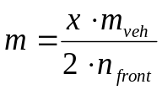 | m_{veh}: max. permitted mass of the vehicle  n_{front}: number of front axles

b) When testing rear axle brake discs and drums:

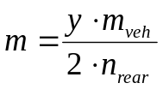 | m_{veh}: max. permitted mass of the vehicle  n_{rear}: number of rear axles

Table A11/3.2.1.2
Vehicle category | Percentage by mass m to be taken into account
 | X values (front axle) | Y values (rear axle)
M₁ | 77 | 32
M₂ | 69 | 44
N₁ | 66 | 39
M₃/N₂/N₃ | 55 | 55

3.2.2. The initial rotational speed of the dynamometer shall correspond to the linear speed of the vehicle at 80 km/h (M₁, N₁) or 60 km/h (M₂, M₃, N₂, N₃) based on the mean of the dynamic rolling radii of the largest and smallest tyre of the authorised tyre sizes.

3.2.3. Cooling

The cooling may be carried out either to paragraphs 3.2.3.1. or 3.2.3.2.

3.2.3.1. Test carried out with a complete wheel (rim and tyre), mounted on the moving part of the brake, as it would be on the vehicle (worst case).

With respect to the Type I and Type II tests air cooling at a velocity and air flow direction simulating actual conditions may be used during the heating runs, the speed of the air flow being v_{Air} = 0.33 v

where v = vehicle test speed at initiation of braking.

In other cases cooling air is not restricted.

The temperature of the cooling air shall be the ambient temperature.

3.2.3.2. Test carried out without a rim

With respect to the Type I and Type II tests during the heating runs no cooling is allowed.

In other cases cooling air is not restricted.

3.2.4. Preparation of the brake

3.2.4.1. Disc brakes

The test is conducted using a new disc with new brake lining assemblies which have been type approved according to Regulation No. 13, 13-H or 90 (in the condition as mounted on the vehicle, e.g. protective grease removed).

3.2.4.2. Drum brakes

The test is conducted using a new drum with new linings assemblies which have been type approved according to Regulation No. 13, 13-H or 90 (if applicable, protective grease removed).

Machining of the linings to achieve good lining to drum contact is permissible.

3.3. Alternative dynamometer performance test

Table A11/3.3.
1a. | In the case of vehicles of categories M₁, M₂, N₁  See bedding-in (burnishing) procedure as described in Annex 3, paragraph 2.2.2.3.
1b. | In the case of vehicles of categories M₃, N₂, N₃  Bedding-in (burnishing):  100 (disc) or 200 (drum) brake applications  T_{i} = 150°C (disc) or 100°C (drum)  v_{i} = 60 km/h  d_{m} = 1 and 2 m/s² alternating
2. | Dynamic friction properties, see paragraph 3.5.1. of this annex
3. | Brake test Type 0, see paragraph 3.4.1. of this annex
4. | Brake test Type I, see paragraph 3.4.2. of this annex
5. | Re-burnishing:  10 (disc) or 20 (drum) brake applications  T_{i} = 150°C (disc) or 100°C (drum)  v_{i} = 60 km/h,  d_{m} = 1 and 2 m/s² alternating
6. | Brake test Type 0, see paragraph 3.4.1. of this annex
7. | Brake tests simulation engine connected, see paragraph 3.4.4. of this annex
8. | Re-burnishing: (like No. 5.)
9. | Dynamic friction properties, see paragraph 3.5.1 of this annex
10. | Brake test Type II (if applicable), see paragraph 3.4.3. of this annex
11. | Re-burnishing: (like No. 5.)
 | Steps 12 to 19 are optional (if activation is not sufficient)
12. | Brake test Type 0, see paragraph 3.4.1. of this annex
13. | Brake test Type I, see paragraph 3.4.2. of this annex
14. | Re-burnishing: (like item 5.)
15. | Dynamic friction properties, see paragraph 3.5.1. of this annex
16. | Brake tests simulation engine connected, see paragraph 3.4.4. of this annex
17. | Re-burnishing: (like item 5.)
18. | Dynamic friction properties, see paragraph 3.5.1. of this annex
19. | Re-burnishing: (like item 5.)

3.4. Service braking system

3.4.1. Brake tests Type 0, vehicle laden

This test shall be carried out analogous to the provisions of Regulation No. 13, Annex 4, paragraph 1.4.2. or Regulation No. 13-H, Annex 3, paragraph 1.4.2.

3.4.2. Brake tests Type I

This test shall be carried out analogous to the provisions of Regulation No. 13, Annex 4, paragraph 1.5.1. or Regulation No. 13-H, Annex 3, paragraph 1.5.1.

At the end of the Type I brake test, the performance when the brakes are hot is to be satisfied pursuant to Regulation No. 13, Annex 4, paragraph 1.5.3. or Regulation No. 13-H, Annex 3, paragraph 1.5.2.

3.4.3. Brake tests Type II

This test shall be carried out analogous to the provisions of Regulation No. 13, Annex 4, paragraph 1.6.

3.4.4. Brake tests simulation engine connected

Instead of the Type 0 test with engine connected, for the purpose of this Regulation it is acceptable to carry out a test to simulating for the laden condition (see paragraph 3.2. of this annex) the test conditions which are prescribed for the Type 0 test with engine connected in Regulation No. 13, Annex 4, paragraph 2.1.1. or Regulation No. 13-H, Annex 3, paragraph 2.1.1.

3.5. Testing the dynamic frictional properties (comparison test conducted on the individual wheel brake)

With cold brakes, the performance of the replacement brake disc/drum shall be compared with the original equivalents by comparing the results of the test below.

3.5.1. Using the replacement brake disc/drum, at least six consecutive brake applications with different, gradually increasing control forces or brake pressures are carried out as part of the process up to a mean fully developed deceleration of 6 m/s² (M₁/M₂, N₁) or 5 m/s² (M₃, N₂/N₃). The control forces or line pressure have not to exceed the maximum allowed control forces or line pressure that is permanently guaranteed by the braking system of the vehicle (e. g. cut in pressure of the compressor). Prior to each brake application, the initial temperature of the brake disc/drum shall be ≤ 100° C.

3.5.2. The brake test described in paragraph 3.5.1. also has to be carried out using the original brake disc/drum.

3.5.3. The dynamic frictional properties at the end of the procedure (step 9 or 18) of the replacement brake disc/drum can be regarded as similar to those of the original brake disc/drum, provided the values attained in relation to the mean fully developed deceleration at the same operating pressures or control forces in the region of the upper 2/3 of the curve generated do not deviate by either ± 8 per cent or ± 0.4 m/s² from those of the original brake disc/drum.

4. Integrity tests using an inertia dynamometer

The tests are conducted in accordance with paragraph 4.1. (discs) or 4.2. (drums).

A single test per test group is required unless the replacement part does not achieve the required number of cycles before damage or failure (see paragraph 4.1.1.1.3. or 4.1.1.2.3. of this annex).

The brake should be installed on the dynamometer in accordance with its fitting position on the vehicle (rigidly mounted brakes or those installed by means of a stub axle are exempt)

The temperature of the brake disc/brake drum should be measured in as close proximity to the friction rubbing surface as possible. The temperature measurement should be recorded and the method and measuring point shall be the same for all tests.

If cooling air is used during a brake application or between brake applications inside one braking cycle, the speed of the airflow at the brake shall be limited to v_{air} = 0.33v

where v = vehicle test speed at initiation of braking.

In other cases cooling air is not restricted.

The temperature of the cooling air shall be the ambient temperature.

4.1. Brake discs

4.1.1. Brake disc thermal fatigue test

This test is conducted using a new disc, an original brake caliper of the vehicle(s) concerned and new brake lining assemblies of the vehicle(s) concerned which have been type approved according to Regulation No. 13, 13-H or 90 (in the condition as mounted on the vehicle, e.g. protective grease removed).
Worn brake linings may be replaced during the test if necessary.

4.1.1.1. Vehicles of categories M₁ / N₁

4.1.1.1.1. Test conditions (brake disc thermal fatigue)

The inertia mass of the inertia dynamometer shall be determined in accordance with the requirements laid down in paragraphs 3.2.1., 3.2.1.1. and 3.2.1.2. of Annex 11.
The rotational speed of the dynamometer shall correspond to the linear test speed of the vehicle based on the mean of the largest and smallest dynamic rolling radius of the tyres authorized for that vehicle.

4.1.1.1.2. Test program (brake disc thermal fatigue)

Brake linings submitted for test shall be fitted to the relevant brakes and bedded (burnished) according to the procedure of Annex 3, paragraph 1.1.2.:

Table A11/4.1.1.1.2.
Test provision | Cracking
Vehicle categories | M₁ / N₁
Type of braking | Sequential brake applications
Braking interval (= t_{total}) | 70 s
Number of brake applications per cycle | 2
Brake torque in accordance with a deceleration of | 5.0 m/s²
Total number of braking cycles | 100 or 150 (see 4.1.1.1.3.)
Brake applications  from  to | v_{max}  20 km/h
Initial temperature of the 1st brake application in each cycle | ≤ 100 °C

v_{max} the v_{max} to be used to test the replacement part is that corresponding to the vehicle which has the highest ratio of kinetic energy to disc mass
t_{bra} actual braking period during the application
t_{acc} minimum acceleration time in accordance with the accelerating power of the respective vehicle
t_{rest} rest period
t_{total} Braking interval (t_{bra} + t_{acc} + t_{rest})

4.1.1.1.3. Test result (brake disc thermal fatigue test)

The test is regarded as having been passed if 150 or more cycles are completed without damage or failure.

If less than 150 cycles but more than 100 cycles are completed without damage or failure then the test must be repeated on a new replacement part. Under these circumstances both tests must complete more than 100 cycles without damage or failure for the part to have passed the test.

If less than 100 cycles are completed before damage or failure then a test should be conducted on the original part and the results compared. If the damage or failure point is no worse than the number of cycles of the original part -10 per cent then the test is regarded as having been passed.

Damage in this context means:

(a) Radial cracks on the friction surface which are longer than 2/3 of the radial height of the friction surface.
(b) Cracks on the friction surface which reach the inner or outer diameter of the friction surface.
(c) Through-cracking of any friction ring.
(d) Any type of structural damage or cracks in any area outside the friction surface.

4.1.1.2. Vehicles of categories M₂, M₃, N₂ and N₃

4.1.1.2.1. Test conditions (brake disc thermal fatigue)

4.1.1.2.1.1.Vehicles with a maximum permissible mass > 7.5 t

By means of the following Test program, brake discs are tested as components of the braking system. It does not imitate actual driving conditions but is understood as being purely a component test. The parameters listed below in Table A11/4.1.1.2.1.1. cover the brakes that are presently used as a rule on vehicles with a maximum permitted mass > 7.5 t.

Table A11/4.1.1.2.1.1.
Outside disc diameter | Test parameter | Test parameter | Example of equipment
 | Test mass m [kg] | r_{dyn} [m] | "Brake size"/smallest possible rim size
320 – 350 | 3100 | 0.386 | 17.5"
351 – 390 | 4500 | 0.445 | 19.5"
391 – 440 | 5300 | 0.527 | 22.5"
> 440*/ | */ | */ | -

*/ The test mass and the dynamic tyre rolling radius to be agreed between the applicant and the Technical Service.

The inertia mass of the inertia dynamometer shall be determined in accordance with the requirements laid down in paragraph 3.2.1. of Annex 11 in conjunction with the parameters specified in the table above (test mass and r_{dyn}).

The rotational speed of the dynamometer shall correspond to the linear test speed of the vehicle based on the dynamic tyre rolling radii specified in Table A11/4.1.1.2.1.1.

4.1.1.2.1.2.Vehicles with a maximum permissible mass > 3.5 t and ≤ 7.5 t

As regards vehicles with a maximum permitted mass > 3.5 t and ≤ 7.5 t in respect of which the parameters listed in Table A11/4.1.1.2.1.1. do not apply, the test parameters shall be selected in such a way that the worst case scenario that formed the basis of the range of use of the replacement brake disc (maximum permitted vehicle mass, maximum tyre equipment size) is covered.

The inertia mass of the inertia dynamometer shall be determined in accordance with the requirements laid down in paragraphs 3.2.1., 3.2.1.1. and 3.2.1.2. of Annex 11.

The rotational speed of the dynamometer shall correspond to the linear test speed of the vehicle based on the mean of the largest and smallest dynamic rolling radius of the tyres authorized for that vehicle.

4.1.1.2.2. Test program (brake disc thermal fatigue)

Table A11/4.1.1.2.2.
„Bedding in" procedure | 100 brake applications  Initial speed: 60 km/h  Final speed: 30 km/h  dm alternating between 1 m/s² and 2 m/s²  Initial temperature : ≤ 300°C (beginning at room temperature)
1. Conditioned braking | 10 brake applications from 60 to 30 km/h  dm alternating between 1 m/s² and 2 m/s²  Initial temperature: ≤ 250°C
2. High-speed braking | 2 Brake applications from 130 to 80 km/h  dm 3 m/s²  Initial temperature: ≤ 100°C
3. Conditioned braking | see test stage 1
4. High-speed braking | see test stage 2
5. Conditioned braking | see test stage 1
6. Continuous braking (1) | 5 Brake applications  at a constant speed of: 85 km/h  Decelerating torque corresponding to 0.5 m/s²  Braking period 60 s  Initial temperature: ≤ 80°C
7. Conditioned braking | see test stage 1
8. Continuous braking (2) | 5 Brake applications  at a constant speed of: 85 km/h  Decelerating torque corresponding to 1.0 m/s²  Braking period 40 s  Initial temperature: ≤ 80°C
9. Repeat test stages 1 to 8: | 9 or 14 times (whichever is applicable)- see paragraph 4.1.1.2.3.

dm distance-related mean deceleration

4.1.1.2.3. Test result (brake disc thermal fatigue)

The test is regarded as having been passed if 15 or more cycles are completed without damage or failure.

If less than 15 cycles but more than 10 cycles are completed without damage or failure then the test must be repeated on a new replacement part. Under these circumstances both tests must complete more than 10 cycles without damage or failure for the part to have passed the test.

If less than 10 cycles are completed before damage or failure then a test should be conducted on the original part and the results compared. If the damage or failure point is no worse than the number of cycles of the original part then the test is regarded as having been passed.

Damage in this context means:
(a) Radial cracks on the friction surface which are longer than 2/3 of the radial height of the friction ring.
(b) Cracks on the friction surface which reach the inner or outer diameter of the friction surface.
(c) Through-cracking of any friction ring.
(d) Any type of structural damage or cracks in any area outside the friction surface.

4.1.2. Brake disc high load test
This test is conducted using a new disc, an original brake caliper of the vehicle(s) concerned and new brake lining assemblies of the vehicle(s) concerned which have been type approved according to Regulations No. 13, 13-H or 90 (in the condition as mounted on the vehicle, e.g. protective grease removed).
Worn brake linings may be replaced during the test if necessary.

4.1.2.1. Vehicles of categories M₁ - N₁

4.1.2.1.1. Test conditions (brake disc high load test)

See paragraph 4.1.1.1.1. above.

4.1.2.1.2. Test program (brake disc high load test)

The test has to be carried out according to the following table:

Table A11/4.1.2.1.2.
Test provision | High load test
Vehicle categories | M₁ / N₁
Type of braking | Single brake applications
Number of brake applications | 70
Initial temperature at the beginning of braking | ≤ 100 °C
Brake torque in accordance with | 10.0 m/s²  (however, brake pressure p ≤ 16000 kPa)
Brake applications  from  to | v_{max}  10 km/h

v_{max} the v_{max} to be used to test the replacement part is that corresponding to the vehicle which has the highest ratio of kinetic energy to disc mass

4.1.2.1.3. Test result (brake disc high load test)

The test is regarded as having been passed if 70 or more brake applications are completed without damage or failure.

If less than 70 brake applications are completed before damage or failure then a test should be conducted on the orginal part and the results compared. If the damage or failure point is no worse than the number of cycles of the original part -10 per cent then the test is regarded as having been passed.

Damage in this context means:
(a) Radial cracks on the friction surface which are longer than 2/3 of the radial height of the friction surface.
(b) Cracks on the friction surface which reach the inner or outer diameter of the friction surface.
(c) Through-cracking of any friction ring.
(d) Any type of structural damage or cracks in any area outside the friction surface.

4.1.2.2. Vehicles of categories M₂,M₃, N₂ and N₃

4.1.2.2.1. Test conditions (brake disc high load test)

See paragraph 4.1.1.2.1. above.

4.1.2.2.2. Test program (brake disc high load test)

500 brake applications are carried out from a speed of 50 km/h to 10 km/h with a brake torque of 90 per cent of the maximum brake torque specified by the applicant.

Initial temperature: ≤ 200 °C

4.1.2.2.3. Test result (brake disc high load test)

The test is regarded as having been passed if the brake disc does not exhibit any signs of fracture after 500 brake applications.

4.2. Brake drums

4.2.1. Brake drum thermal fatigue test

The test is conducted using a new drum with new linings assemblies which have been type approved according to Regulations No. 13, 13-H or 90 (if applicable, protective grease removed).

Machining of the linings to achieve good lining to drum contact is permissible.

4.2.1.1. Vehicles of categories M₁ and N₁

4.2.1.1.1. Test conditions (brake drum thermal fatigue)

The inertia mass of the inertia dynamometer shall be determined in accordance with the requirements laid down in paragraphs 3.2.1., 3.2.1.1. and 3.2.1.2. of Annex 11.

The rotational speed of the dynamometer shall correspond to the linear test speed of the vehicle based on the mean of the largest and smallest dynamic rolling radius of the tyres authorized for that vehicle.

4.2.1.1.2. Test program (brake drum thermal fatigue)

The thermal fatigue requirements for brake drums are covered by the high load tests of paragraph 4.2.2.1.2.

4.2.1.1.3. Test result (brake drum thermal fatigue)

See paragraph 4.2.2.1.3.

4.2.1.2. Vehicles of categories M₂ – M₃ – N₂ – N₃

4.2.1.2.1. Test conditions (brake drum thermal fatigue)

4.2.1.2.1.1. Vehicles with a maximum permissible mass > 7.5 t
By means of the following Test program, brake discs are tested as components of the braking system. It does not imitate actual driving conditions but is understood as being purely a component test. The parameters listed below in Table A11/4.2.1.2.1.1. cover the brakes that are presently used as a rule on vehicles with a maximum permitted mass > 7.5 t.

Table A11/4.2.1.2.1.1.
Inner drum diameter  [mm] | Lining width |  |  |  |  |  | Typical rim diameter
Inner drum diameter  [mm] | < 130 mm |  | 130 -190 mm |  | >190 mm |  | Typical rim diameter
Inner drum diameter  [mm] | Test mass [kg] | Tyre radius  [m] | Test mass [kg] | Tyre radius  [m] | Test mass [kg] | Tyre radius  [m] | Typical rim diameter
< 330 | 2750 | 0.402 | 3200 | 0.390 | 5500 | 0.402 | 17.5"
330 - 390 | */ | */ | 3400 | 0.480 | 5500 | 0.516 | 19.5"
391 - 430 | 3400 | 0.510 | 4500 | 0.527 | 5500 | 0.543 | 22.5"
> 430 | */ | */ | */ | */ | */ | */ | -

*/ The test mass and the dynamic tyre rolling radius to be agreed between the applicant and the Technical Service.

The inertia mass of the inertia dynamometer shall be determined in accordance with the requirements laid down in paragraph 3.2.1. of Annex 11 in conjunction with the parameters specified in the table above (test mass and r_{dyn}).

The rotational speed of the dynamometer shall correspond to the linear test speed of the vehicle based on the dynamic tyre rolling radii specified in Table A11/4.2.1.2.1.1.

4.2.1.2.1.2. Vehicles with a maximum permissible mass > 3.5 t and ≤ 7.5 t

As regards vehicles with a maximum permitted mass > 3.5 t and ≤ 7.5 t in respect of which the parameters listed in Table A11/4.1.1.2.1.1. do not apply, the test parameters shall be selected in such a way that the worst case scenario that formed the basis of the range of use of the replacement brake disc (maximum permitted vehicle mass, maximum tyre equipment size) is covered.

The inertia mass of the inertia dynamometer shall be determined in accordance with the requirements laid down in paragraphs 3.2.1., 3.2.1.1. and 3.2.1.2. of Annex 11.

The rotational speed of the dynamometer shall correspond to the linear test speed of the vehicle based on the mean of the largest and smallest dynamic rolling radius of the tyres authorized for that vehicle.

4.2.1.2.2. Test program (brake drum thermal fatigue)

Table A11/4.2.1.2.2.
Test provision | Thermal fatigue test
Type of braking | Sequential brake applications
Number of brake applications | 250 or 300 (whichever is applicable) - see paragraph 4.2.1.2.3.  NB: The test is interrupted when a through crack appears.
Brake torque in accordance with a [m/s²] | 3.0
Brake applications  from  to | 130  80 km/h
Initial temperature of each brake application | ≤ 50 °C
Cooling pursuant to paragraph 3.2.3. | permitted

4.2.1.2.3. Test result (brake drum thermal fatigue)

The test is regarded as having been passed if 300 or more brake applications are completed without damage or failure.

If less than 300 brake applications but more than 250 brake applications are completed without damage or failure then the Technical Service must repeat the test on a new replacement part. Under these circumstances both tests must complete more than 250 brake applications without damage or failure for the part to have passed the test.

If less than 250 brake applications are completed before damage or failure then a test should be conducted on the original part and the results compared – if the damage or failure point is no worse than the original part then the test is regarded as having been passed.

Damage in this context means:
(a) Cracks on the friction surface which are longer than 2/3 of the axial width of the friction surface.
(b) Cracks on the friction surface which reach the axial outer end of the drum.
(c) Through-cracking of the drum.
(d) Any type of structural damage or cracks in any area outside the friction surface.

4.2.2. Brake drum high load test
The high load test shall be conducted on the same test specimens following the alternative dynamometer test (see paragraph 3.3. of this annex.).

4.2.2.1. Vehicles of categories M₁ and N₁

4.2.2.1.1. Test conditions (brake drum high load test)

See paragraph 4.2.1.1.1. above.

4.2.2.1.2. Test program (brake drum high load test)

"Bedding in" procedure | Make 100 consecutive snub applications with v₁ = 80 km/h and v₂ = 10 km/h and an initial temperature of ≤ 100 °C.  The deceleration of the first application shall be constant 1.5 m/s². From the second up to the last application the pressure shall be constant and equivalent to the average of the first application.  The bedding should be continued until a minimum of 80 per cent lining to drum contact is achieved.
Test provision | Brake drum high load test
Type of braking | Single brake applications
Number of brake applications | 100
Initial temperature at the beginning of braking | ≤ 100 °C
Brake torque in accordance with | 10.0 m/s²  (however, brake pressure p ≤ 16000 kPa)
Brake applications  from  to | v_{max}  10 km/h

v_{max} the v_{max} to be used to test the replacement part is that corresponding to the vehicle which has the highest ratio of kinetic energy to disc mass

4.2.2.1.3. Test result (brake drum high load test)

The test is regarded as having been passed if 100 or more brake applications are completed without damage or failure.

If less than 100 brake applications are completed before damage or failure then a test should be conducted on the original part and the results compared. If the damage or failure point is no worse than the number of cycles of the original part -10 per cent then the test is regarded as having been passed.

Damage in this context means:
(a) Cracks on the friction surface which are longer than 2/3 of the axial width of the friction surface.
(b) Cracks on the friction surface which reach the axial outer end of the drum.
(c) Through-cracking of the drum.
(d) Any type of structural damage or cracks in any area outside the friction surface.

4.2.2.2. Vehicles of categories M₂, M₃, N₂ and N₃

4.2.2.2.1. Test conditions (brake drum high load test)

See above paragraph 4.2.1.2.1.

4.2.2.2.2. Test program (brake drum high load test)

Table A11/4.2.2.2.2.
Test provision
Type of braking | Braking to less than 5 km/h
Total number of brake applications | 150
Initial brake drum temperature at each brake application | ≤ 100 °C
Brake applications  from  to | 60 km/h  ≤ 5 km/h
Brake torque in accordance with a | 6 m/s²
Cooling (also deviating from paragraph 3.2.3. of this annex) | permitted

4.2.2.2.3. Test result (brake drum high load test)
The test result is positive provided the brake drum does not fracture.
Annex 12

REQUIREMENTS FOR REPLACEMENT BRAKE DISCS/DRUMS FOR VEHICLES OF CATEGORY O
1. Test overview

The tests required in paragraph 5.3. of this Regulation are detailed as follows according to the vehicle category:

Table A12/1A: Vehicles of categories O₁, O₂ and O₃
Track test | Alternative dynamometer test
2.2.1. Type 0 | 3.4.1. Type 0
2.2.2. Type I delete | 3.4.2. Type I delete
2.3. Parking brake system (if applicable) | -
2.4. Testing the dynamic frictional properties (comparison test conducted on the individual axles) | 3.5. Testing the dynamic frictional properties (comparison test conducted on the individual axles)

Table A12/1B: Vehicles of categories O₄
Track test | Alternative dynamometer test
2.2.1. Type 0 | 3.4.1. Type 0
2.2.3. Type III delete | 3.4.3. Type III delete
2.3. Parking brake system (if applicable) | -
2.4. Testing the dynamic frictional properties (comparison test conducted on the individual axles) | 3.5. Testing the dynamic frictional properties (comparison test conducted on the individual axles)

2. Verification of the vehicle test requirements

2.1. Test vehicle

A vehicle that is representative for the selected test group (see definition in paragraph 5.3.6. of this Regulation) in respect of which an approval or parts report for a replacement brake disc/drum is applied for shall be fitted with this replacement brake disc/drum as well as be equipped with test devices for testing the brakes pursuant to the provisions of Regulation No. 13.

The replacement brake disc/drum shall be fitted to the axle in question together with an accompanying brake lining which has been type approved according to Regulations No. 13, or 90 available from the vehicle or axle manufacturer. Unless a uniform procedure is laid down for how braking is to be effected, the test shall be carried out following agreement with the Technical Service. All the tests listed below shall be carried out on brakes that have been bedded in. The same "bedding in" programme shall be used for both replacement and original brake discs and drums.

2.2. Service braking system

2.2.1. Type 0 brake tests, vehicle laden

This test shall be carried out pursuant to Regulation No. 13, Annex 4, paragraph 1.4.4.

2.2.2. Type I brake tests

This test shall be carried out pursuant to Regulation No. 13, Annex 4, paragraph 1.5.2.

At the end of the Type I brake test, the performance when the brakes are hot is to be satisfied pursuant to Regulation No. 13, Annex 4, paragraph 1.5.3.

2.2.3. Type III brake tests

This test shall be carried out pursuant to Regulation No. 13, Annex 4, paragraph 1.7.

2.3. Parking braking system (if applicable)

2.3.1. If the service brake system and the parking brake system use a common disc or drum friction surface, it is not necessary to conduct a specific parking brake system test. The satisfactory achievement of the Type 0 laden test shall be taken as meeting the parking brake system requirements.

2.3.2. Static test with 18 per cent gradient, vehicle laden

2.3.3. The vehicle shall satisfy all the relevant provisions laid down in Regulation No. 13, Annex 4, paragraphs 2.3. and 3.2. that apply to this category of vehicle.

2.4. Testing the dynamic frictional properties (comparison test conducted on the individual axles)

For this test, the vehicle shall be laden and all brake applications carried out on a flat road.

The service braking system of the vehicle shall be provided with a device that separates the front-wheel brakes from the rear-wheel brakes so that they can always be operated independently of one another.

If an approval or a parts report is required in connection with a replacement brake disc/drum for the front-wheel brakes, the rear-wheel brakes shall remain inoperative throughout the test.

If an approval or a parts report is required in connection with a replacement brake disc/drum for the rear-wheel brakes, the front-wheel brakes shall remain inoperative throughout the test.

2.4.1. Performance comparison test when the brakes are cold

With cold brakes, the performance of the replacement brake disc/drum shall be compared with the original equivalents by comparing the results of the test below

2.4.1.1. Using the replacement brake disc/drum, at least six consecutive brake applications with different, gradually increasing control forces or brake pressures are carried out as part of the process up to the point at which the wheels lock, or up to a mean fully developed deceleration of 3.5 m/s², or up to the maximum control force permitted for this category of vehicle, in which connection the initial speed for testing purposes is 45 km/h:

Prior to each brake application, the initial temperature of the brake drum shall be ≤ 100 °C.

2.4.1.2. The brake test described in paragraph 2.4.1.1. also has to be carried out using the original brake disc/drum.

2.4.1.3. The dynamic frictional properties of the replacement brake disc/drum can be regarded as similar to those of the original brake disc/drum, provided the values attained in relation to the mean fully developed deceleration at the same operating pressures or control forces in the region of the upper 2/3 of the curve generated do not deviate by more than ± 10 per cent or ± 0.4 m/s² from those of the original brake disc/drum.

3. Inertia dynamometer test

3.1. Equipment of the dynamometer

For testing purposes, the dynamometer shall be fitted out with the original brake caliper or wheel brake of the vehicle concerned. The inertia dynamometer shall be equipped with a constant torque device and equipment for recording rotational speed, brake pressure, the number of revolutions after braking has commenced, brake torque, the braking period and the temperature of the brake drum on a continuous basis.

3.2. Test conditions

3.2.1. Inertia mass of the inertia dynamometer

The inertia mass of the inertia dynamometer shall be set as close as possible, with a permissible variation of ± 5 per cent, to the theoretically required value which corresponds to that part of the total inertia of the vehicle braked by the appropriate wheel. The formula used for calculation purposes is as follows:
I = m ⋅ r_{dyn}²

where:
I = rotary inertia (kgm²);
r_{dyn} = dynamic rolling radius of the tyre (m);
m = test mass (part of the maximum mass of the vehicle braked by the appropriate wheel) as stipulated by this Regulation

3.2.1.1. Dynamic rolling radius

In calculating the inertia mass, the dynamic rolling radius (r_{dyn}) of the largest tyre authorised for the vehicle (or the axle) shall be taken into account.

3.2.1.2. Test mass

The test mass for calculating the inertia mass shall be as follows:

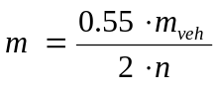 | m_{veh}: max. permitted mass of the vehicle  n: number of axles, or number of front or rear-axles in the case of full trailer

3.2.2. The initial rotational speed of the dynamometer shall correspond to the linear speed of the vehicle at 40 or 60 km/h (depending on the type of test) based on the mean of the dynamic rolling radii of the largest and smallest tyre of the authorised tyre sizes.

3.2.3. Cooling

The cooling may be carried out either to paragraphs 3.2.3.1. or 3.2.3.2.

3.2.3.1. Test carried out with a complete wheel according to Regulation No. 13, Annex 11, Appendix 2, paragraph 3.2.2.

With respect to the Type I and Type III tests air cooling at a velocity and air flow direction simulating actual conditions may be used during the heating runs, the speed of the air flow being v_{Air} = 0.33 v

where:
v = vehicle test speed at initiation of braking.
In other cases cooling air is not restricted.
The temperature of the cooling air shall be the ambient temperature.

3.2.3.2. Test carried out without a rim
With respect to the Type I and Type III tests during the heating runs no cooling is allowed.
In other cases cooling air is not restricted.

3.2.4. Preparation of the brake

3.2.4.1. Disc brakes

This test is conducted using a new disc with new brake lining assemblies which have been type approved according to Regulations No. 13 or 90 (in the condition as mounted on the vehicle, e.g. protective grease removed).

3.2.4.2. Drum brakes

The test is conducted using a new drum with new linings assemblies which have been type approved according to Regulations No. 13 or 90 (if applicable, protective grease removed).

Machining of the linings to achieve good lining to drum contact is permissible.

3.3. Alternative dynamometer performance test

Table A12/3.3
1. | Cold Bedding-in (cold burnishing):  100 (disc) or 200 (drum) brake applications  T_{i} = 150°C (disc) or 100°C (drum)  v_{i} = 60 km/h  d_{m} = 1 and 2 m/s² alternating
2. | Dynamic friction properties, see paragraph 3.5.1. of this annex
3. | Hot Bedding-in (Hot burnishing):  Make 30 consecutive snub applications with v₁ = 60 km/h and v₂ = 30 km/h with a cycle time of 60 s starting at a brake temperature of ≤ 100 °C at the first application. The deceleration of the first application shall be constant 3 m/s². From the second up to the last application the pressure shall be constant and equivalent to the average of the first application.
4. | Re-burnishing:  30 brake applications  Ti = 150 °C (disc) or 100 °C (drum)  vi = 60 km/h,  dm = 1 and 2 m/s² alternating
5. | Brake test Type 0, see paragraph 3.4.1. of this annex
6. | Brake test Type I (in the case of O₂ / O₃), see paragraph 3.4.2. of this annex
7. | Re-burnishing: (like item 4.)
8. | Brake test Type 0, see paragraph 3.4.1. of this annex
9. | Brake test Type III ((in the case of O₄), see paragraph 3.4.3. of this annex
10. | Re-burnishing: (like item 4.)

3.4. Service braking system

3.4.1. Brake tests Type 0, vehicle laden

This test shall be carried out analogous to the provisions of Regulation No. 13, Annex 4, paragraph 1.4.4.

3.4.2. Brake tests Type I

This test shall be carried out analogous to the provisions of Regulation No. 13, Annex 4, paragraph 1.5.2.

At the end of the Type I brake test, the performance when the brakes are hot is to be satisfied pursuant to Regulation No. 13, Annex 4, paragraph 1.5.3.

3.4.3. Brake tests Type III

This test shall be carried out analogous to the provisions of Regulation No. 13, Annex 4, paragraph 1.7.

3.5. Testing the dynamic frictional properties (comparison test conducted on the individual wheel brake)

3.5.1. The test shall be carried out in accordance of Regulation No. 13, Annex 19, paragraphs 4.4.3.1. to 4.4.3.4.

3.5.2. The brake test described in paragraph 3.5.1. also has to be carried out using the original brake disc/drum.

3.5.3. The dynamic frictional properties at step 2 oft the procedure of the replacement brake disc/drum can be regarded as similar to those of the original brake disc/drum, provided the values attained in relation to the mean fully developed deceleration at the same operating pressures or control forces in the region of the upper 2/3 of the curve generated do not deviate by more than ± 8 per cent or ± 0.4 m/s² from those of the original brake disc/drum.

4. Integrity tests using an inertia dynamometer

The tests are conducted in accordance with paragraph 4.1. (discs) or 4.2. (drums).

A single test per test group is required unless the replacement part does not achieve the required number of cycles before damage or failure (see paragraph 4.1.1.1.3. or 4.1.1.2.3. of this annex).

The brake should be installed on the dynamometer in accordance with its fitting position on the vehicle (rigidly mounted brakes or those installed by means of a stub axle are exempt).

The temperature of the brake disc/brake drum should be measured in as close proximity to the friction rubbing surface as possible. The temperature measurement should be recorded and the method and measuring point shall be the same for all tests.

If cooling air is used during a brake application or between brake applications inside one braking cycle, the speed of the airflow at the brake shall be limited to:
v_{air} = 0.33 v

where:
v = vehicle test speed at initiation of braking.
In other cases cooling air is not restricted.
The temperature of the cooling air shall be the ambient temperature.

4.1. Brake discs

4.1.1. Brake disc thermal fatigue test

This test is conducted using a new disc with new brake lining assemblies which have been type approved according to Regulation No. 13 or 90 (in the condition as mounted on the vehicle, e.g. protective grease removed).

4.1.1.1. Vehicles of categories O₁ and O₂

4.1.1.1.1. Test conditions (brake disc thermal fatigue)

The inertia mass of the inertia dynamometer shall be determined in accordance with the requirements laid down in paragraphs 3.2.1., 3.2.1.1. and 3.2.1.2. of Annex 12.

The rotational speed of the dynamometer shall correspond to the linear test speed of the vehicle based on the mean of the largest and smallest dynamic rolling radius of the tyres authorized for that vehicle.

4.1.1.1.2. Test program (brake disc thermal fatigue)

Table A12/4.1.1.1.2.
Test provision | Cracking
Vehicle categories | O₁ / O₂
Type of braking | Sequential brake applications
Braking interval (= t_{total}) | 70 s
Number of brake applications per cycle | 2
Brake torque in accordance with  a [m/s²] | 5.0
Total number of braking cycles | 100 or 150 (see paragraph 4.1.1.1.3.)
Brake applications  from  to | 80 km/h  20 km/h
Initial temperature of the 1st brake application in each cycle | ≤ 100 °C

v_{max} maximum design speed (as per its range of use)
t_{bra} actual braking period during the application
t_{acc} minimum acceleration time in accordance with the accelerating power of the respective vehicle
t_{rest} rest period
t_{total} Braking interval (t_{bra} + t_{acc} + t_{rest})

4.1.1.1.3. Test result (brake disc thermal fatigue)

The test is regarded as having been passed if 150 or more cycles are completed without damage or failure.

If less than 150 cycles but more than 100 cycles are completed without damage or failure then the test must be repeated on a new replacement part. Under these circumstances both tests must complete more than 100 cycles without damage or failure for the part to have passed the test.

If less than 100 cycles are completed before damage or failure then a test should be conducted on the original part and the results compared. If the damage or failure point is no worse than the number of cycles of the original part -10 per cent then the test is regarded as having been passed.

Damage in this context means:
(a) Radial cracks on the friction surface which are longer than 2/3 of the radial height of the friction surface.
(b) Cracks on the friction surface which reach the inner or outer diameter of the friction surface.
(c) Through-cracking of any friction ring.
(d) Any type of structural damage or cracks in any area outside the friction surface.

4.1.1.2. Vehicles of categories O₃ und O₄

4.1.1.2.1. Test conditions (brake disc thermal fatigue)

4.1.1.2.1.1. Vehicles with a maximum permissible mass > 7.5 t

By means of the following Test program, brake discs are tested as components of the braking system. It does not imitate actual driving conditions but is understood as being purely a component test. The parameters listed below in Table A12/4.1.1.2.1.1. cover the brakes that are presently used as a rule on vehicles with a maximum permitted mass > 7.5 t.

Table A12/4.1.1.2.1.1
Outside disc diameter | Test parameter | Test parameter | Example of equipment
 | Test mass m [kg] | r_{dyn} [m] | "Brake size"/smallest possible rim size
320 – 350 | 3100 | 0.386 | 17.5"
351 – 390 | 4500 | 0.445 | 19.5"
391 – 440 | 5300 | 0.527 | 22.5"
> 440*/ | */ | */ | -

*/ The test mass and the dynamic tyre rolling radius to be agreed between the applicant and the Technical Service.

The inertia mass of the inertia dynamometer shall be determined in accordance with the requirements laid down in paragraph 3.2.1. of Annex 12 in conjunction with the parameters specified in the table above (test mass and r_{dyn}).

The rotational speed of the dynamometer shall correspond to the linear test speed of the vehicle based on the dynamic tyre rolling radii specified in Table A12/4.1.1.2.1.1.

4.1.1.2.1.2. Vehicles with a maximum permissible mass > 3.5 t and ≤ 7.5 t

As regards vehicles with a maximum permitted mass > 3.5 t and ≤ 7.5 t in respect of which the parameters listed in Table A12/4.1.1.2.1.1. do not apply, the test parameters shall be selected in such a way that the worst case scenario that formed the basis of the range of use of the replacement brake disc (maximum permitted vehicle mass, maximum tyre equipment size) is covered.

The inertia mass of the inertia dynamometer shall be determined in accordance with the requirements laid down in paragraphs 3.2.1., 3.2.1.1. and 3.2.1.2. of Annex 12.

The rotational speed of the dynamometer shall correspond to the linear test speed of the vehicle based on the mean of the largest and smallest dynamic rolling radius of the tyres authorised for that vehicle.

4.1.1.2.2. Test program (brake disc thermal fatigue)

Table A12/4.1.1.2.2.
„Bedding in" procedure | 100 Brake applications  Initial speed: 60 km/h  Final speed: 30 km/h  dm alternating between 1 m/s² und 2 m/s²  Initial temperature : ≤ 300 °C (beginning at room temperature)
1. Conditioned braking | 10 Brake applications from 60 to 30 km/h  dm alternating between 1 m/s² und 2 m/s²  Initial temperature : ≤ 250 °C
2. High-speed braking | 2 Brake applications from 130 to 80 km/h  dm = 3 m/s²  Initial temperature: ≤ 100 °C
3. Conditioned braking | see test stage 1
4. High-speed braking | see test stage 2
5. Conditioned braking | see test stage 1
6. Continuous braking (1) | 5 Brake applications  at a constant speed of: 85 km/h  Decelerating torque corresponding to 0.5 m/s²  Braking period 60 s  Initial temperature: ≤ 80 °C
7. Conditioned braking | see test stage 1
8. Continuous braking (2) | 5 Brake applications  at a constant speed of: 85 km/h  Decelerating torque corresponding to 1.0 m/s²  Braking period 40 s  Initial temperature: ≤ 80 °C
9. Repeat test stages 1 to 8: | 9 or 14 times (whichever is applicable)- see paragraph 4.1.1.2.3.

dm distance-related mean deceleration

4.1.1.2.3. Test result (brake disc thermal fatigue)

The test is regarded as having been passed if 15 or more cycles are completed without damage or failure.

If less than 15 cycles but more than 10 cycles are completed without damage or failure then the test must be repeated on a new replacement part. Under these circumstances both tests must complete more than 10 cycles without damage or failure for the part to have passed the test.

If less than 10 cycles are completed before damage or failure then a test should be conducted on the original part and the results compared. If the damage or failure point is no worse than the number of cycles of the original part then the test is regarded as having been passed.

Damage in this context means:
(a) Radial cracks on the friction surface which are longer than 2/3 of the radial height of the friction surface.
(b) Cracks on the friction surface which reach the inner or outer diameter of the friction surface.
(c) Through-cracking of any friction ring.
(d) Any type of structural damage or cracks in any area outside the friction surface.

4.1.2. Brake disc high load test

The high load tests shall be conducted on the same test specimens following on from the alternative dynamometer test (see paragraph 3.3. of this annex).

4.1.2.1. Vehicles of categories O₁ and O₂

not applicable

4.1.2.2. Vehicles of categories O₃ and O₄

4.1.2.2.1. Test conditions (brake disc high load test)

see above paragraph 4.1.1.2.1.

4.1.2.2.2. Test program (brake disc high load test)

500 brake applications are carried out from a speed of 50 km/h to 10 km/h with a brake torque of 90 per cent of the maximum brake torque specified by the applicant.
Initial temperature: ≤ 200 °C

4.1.2.2.3. Test result (brake disc high load test)
The test is regarded as having been passed if the brake disc does not exhibit any signs of fracture after 500 brake applications.

4.2. Brake drums

4.2.1. Brake drum thermal fatigue test

The test is conducted using a new drum with new linings assemblies which have been type approved according to Regulation No. 13, 13-H or 90 (if applicable, protective grease removed).

Machining of the linings to achieve good lining to drum contact is permissible.

4.2.1.1. Vehicles of category O₁ and O₂

4.2.1.1.1. Test conditions (brake drum thermal fatigue)

4.2.1.1.1.1. Vehicles with a maximum permissible axle load ≤ 1200 kg

not applicable

4.2.1.1.1.2. Vehicles with a maximum permissible axle load > 1200 kg

The inertia mass of the inertia dynamometer shall be determined in accordance with the requirements laid down in paragraphs 3.2.1., 3.2.1.1. and 3.2.1.2. of Annex 12.

The rotational speed of the dynamometer shall correspond to the linear test speed of the vehicle based on the mean of the largest and smallest dynamic rolling radius of the tyres authorized for that vehicle.

4.2.1.1.2. Test program (brake drum thermal fatigue)

Table A12/4.2.1.1.2.
Test provision
Type of braking | Sequential brake applications
Number of brake applications | 250 or 300 (whichever is applicable) - see 4.2.1.1.3.  NB: The test is interrupted when a through crack appears.
Brake torque in accordance with a [m/s²] | 3.0
Brake applications  from  to | 130  80 km/h
Initial temperature of each brake application | ≤ 50 °C
Cooling pursuant to 3.2.3. | permitted

4.2.1.1.3. Test result (brake drum thermal fatigue)

The test is regarded as having been passed if 450 or more brake applications are completed without damage or failure.

If less than 450 brake applications but more than 300 brake applications are completed without damage or failure then the Technical Service must repeat the test on a new replacement part. Under these circumstances both tests must complete more than 300 brake applications without damage or failure for the part to have passed the test.
If less than 300 brake applications are completed before damage or failure then a test should be conducted on the original part and the results compared – if the damage or failure point is no worse than the original part then the test is regarded as having been passed.

Damage in this context means:
(a) Cracks on the friction surface which are longer than 2/3 of the axial width of the friction surface.
(b) Cracks on the friction surface which reach the axial outer end of the drum.
(c) Through-cracking of the drum.
(d) Any type of structural damage or cracks in any area outside the friction surface.

4.2.1.2. Vehicles of categories O₃ and O₄

4.2.1.2.1. Test conditions (brake drum thermal fatigue)

4.2.1.2.1.1. Vehicles with a maximum permissible mass > 7.5 t

By means of the following Test program, brake discs are tested as components of the braking system. It does not imitate actual driving conditions but is understood as being purely a component test. The parameters listed below in Table A12/4.2.1.2.1.1. cover the brakes that are presently used as a rule on vehicles with a maximum permitted mass > 7.5 t.

Table A12/4.2.1.2.1.1.
Inner drum diameter  [mm] | lining width |  |  |  |  |  | Typical rim diameter
Inner drum diameter  [mm] | < 130 mm |  | 130 -190 mm |  | >190 mm |  | Typical rim diameter
Inner drum diameter  [mm] | Test mass [kg] | Tyre radius  [m] | Test mass [kg] | Tyre radius  [m] | Test mass [kg] | Tyre radius  [m] | Typical rim diameter
< 330 | 2750 | 0.402 | 3200 | 0.390 | 5500 | 0.402 | 17.5"
330 - 390 | */ | */ | 3400 | 0.480 | 5500 | 0.516 | 19.5"
391 - 430 | 3400 | 0.510 | 4500 | 0.527 | 5500 | 0.543 | 22.5"
> 430 | */ | */ | */ | */ | */ | */ | -

*/ The test mass and the dynamic tyre rolling radius to be agreed between the applicant and the Technical Service.

The inertia mass of the inertia dynamometer shall be determined in accordance with the requirements laid down in paragraph 3.2.1. of Annex 12 in conjunction with the parameters specified in the table above (test mass and r_{dyn}).

The rotational speed of the dynamometer shall correspond to the linear test speed of the vehicle based on the dynamic tyre rolling radii specified in Table A12/4.2.1.2.1.1.

4.2.1.2.1.2. Vehicles with a maximum permissible mass > 3.5 t and ≤ 7.5 t

As regards vehicles with a maximum permitted mass > 3.5 t and ≤ 7.5 t in respect of which the parameters listed in Table A12/4.1.1.2.1.1. do not apply, the test parameters shall be selected in such a way that the worst case scenario that formed the basis of the range of use of the replacement brake disc (maximum permitted vehicle mass, maximum tyre equipment size) is covered.

The inertia mass of the inertia dynamometer shall be determined in accordance with the requirements laid down paragraphs 3.2.1., 3.2.1.1. and 3.2.1.2. of Annex 12.

The rotational speed of the dynamometer shall correspond to the linear test speed of the vehicle based on the mean of the largest and smallest dynamic rolling radius of the tyres authorized for that vehicle.

4.2.1.2.2. Test program (brake drum thermal fatigue)

Table A12/4.2.1.2.2.
Test provision | Thermal fatigue test
Type of braking | Sequential brake applications
Number of brake applications | 250 or 300 (whichever is applicable) - see 4.2.1.2.3.  NB: The test is interrupted when a through crack appears.
Brake torque in accordance with a [m/s²] | 3.0
Brake applications  from  to | 130  80 km/h
Initial temperature of each brake application | ≤ 50 °C
Cooling pursuant to paragraph 3.2.3. | permitted

4.2.1.2.3. Test result (brake drum thermal fatigue)

The test is regarded as having been passed if 300 or more brake applications are completed without damage or failure.

If less than 300 brake applications but more than 250 brake applications are completed without damage or failure then the Technical Service must repeat the test on a new replacement part. Under these circumstances both tests must complete more than 250 brake applications without damage or failure for the part to have passed the test.

If less than 250 brake applications are completed before damage or failure then a test should be conducted on the original part and the results compared – if the damage or failure point is no worse than the original part then the test is regarded as having been passed.

Damage in this context means:
(a) Cracks on the friction surface which are longer than 2/3 of the axial width of the friction surface.
(b) Cracks on the friction surface which reach the axial outer end of the drum.
(c) Through-cracking of the drum.
(d) Any type of structural damage or cracks in any area outside the friction surface.

4.2.2. Brake drum high load test

The high load test shall be conducted on the same test specimens following the alternative dynamometer test (see paragraph 3.3. of this annex.)

4.2.2.1. Vehicles of category O₁ and O₂

4.2.2.1.1. Test conditions (brake drum high load test)

See paragraph 4.2.1.1.1. above.

4.2.2.1.2. Test program (brake drum high load test)

See paragraph 4.2.2.2.2. below.

4.2.2.1.3. Test result (brake drum high load test)

See paragraph 4.2.2.2.3. below.

4.2.2.2. Vehicles of category O₃ and O₄

4.2.2.2.1. Test conditions (brake drum high load test)

See paragraph 4.2.1.2.1. above.

4.2.2.2.2. Test program (brake drum high load test)

Table A12/4.2.2.2.2.
Test provision
Type of braking | Braking to standstill
Total number of brake applications | 150
Initial temperature of the brake drum every time the brake is operated | ≤ 100 °C
Brake applications  from  to | 60 km/h  0 km/h
Brake torque in accordance with a | 6 m/s²
Cooling (also deviating from paragraph 3.2.3.) | permitted

4.2.2.2.3. Test result (brake drum high load test)

The test result is positive provided the brake drum does not fracture.

Annex 13

MODEL TEST REPORT FOR A REPLACEMENT BRAKE DISC/DRUM

Test Report No. …
concerning the approval of a replacement brake disc/drum
in accordance to Regulation No. 90

1. General technical description of a replacement brake disc/drum 1/

1.1. Applicant (name and address):

1.2. Manufacturer (name and address):

1.3. Trade name:

1.4. Category of replacement disc/drum :Original / Identical / Equivalent / Interchangeable 1/

1.5. Type of disc/drum 1/:

1.6. Marking:

 | Identification | Location of marking | Method of marking
Manufacturer name or trade name:
Approval number | E2-90R02 Cxxxx/yyyy
xxxx => Type No.
yyyy => Variant No.
Indication for traceability
Minimum thickness (disc) / maximum inside diameter (drum) 1/

1.7. Material

1.7.1. Material group:

1.7.2 Material sub-group 2/:

1.8. Application range:

With minimum of the following information:

Part
Replacement part |  | Original part
Variant | part number | part number | identification code

Motor-vehicle 2/
Make | Type of vehicle | Trade name | Maximum Gross weight | Maximum speed | Year of manufacture

Axle for trailers 2/
Make | Type of axle | Trade name | Maximum axle load | Range of dynamic tyre radius  (largest / smallest)

Brake
Position |  | Caliper 2/ | Dimensions | Type of construction
Front | Rear | Caliper 2/ | Dimensions | Type of construction

1.9. Additional information 2/

2. Test Groups

2.1. Dimensions per test group

2.1.1. Outside (disc) / inside (drum) 1/diameters:

2.1.2. Thickness (disc) / shoe width (drum) 1/ diameters:

2.2. Highest ratio of kinetic energy per test group in according to paragraph 5.3.6 of Regulation Regulation No. 90
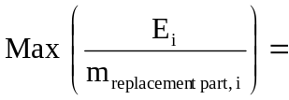

2.3. Disc/drum 1/ material per test group:

3. Technical data regarding the tests per test group

3.1. Vehicle test:

3.1.1. Data of the test vehicle:

3.1.1.1. Vehicle category:

3.1.1.2. Vehicle manufacturer:

3.1.1.3. Vehicle make:

3.1.1.4. Vehicle type and trade name:

3.1.1.5. Vehicle identification number:

3.1.1.6. Vehicle type approval No.:

3.1.1.7. Vehicle engine power:

3.1.1.8. Speed:

Maximum vehicle speed v_{max}:

3.1.1.9. Tyres:

3.1.1.10. Brake circuit configuration / layout:

3.1.1.11. Test masses

Axle 1:

Axle 2:

Axle ...:

3.1.1.12. Brake:

3.1.1.12.1. Test sample brake disc / brake drum 1/:

Identification code of the original replacement part:

Test group:

Part number:

Mass of the replacement part:

Outside disc diameter / Inside drum diameter 1/:

Radius r_{e}, effective:

Friction surface width:

Disc thickness (nominal) / Outside drum width 1/:

3.1.1.12.2. Brake caliper / brake drum mechanism 1/

Manufacturer:

Type:

Variant:

Part number:

Method of construction:

Maximum technically permissible torque C_{max,e} at
the brake lever (pneumatic) / line pressure (p_{max,e}) (hydraulic) 1/:

Threshold torque C_{0,e} (pneumatic) / line pressure (hydraulic) 1/:

Ratio l_{e} / e_{e} (pneumatic) / piston diameter (hydraulic) 1/:……… / ………

Maximum brake torque:

3.1.1.12.3. Brake pad / brake lining 1/

Manufacturer:

Make:

Type:

Approval number 2/:

Identification (e.g. part number):

Effective surface area:

3.1.2. Test equipment

3.1.2.1. Deceleration:

3.1.2.2. Pressure:

3.1.2.3. Speed:

3.1.2.4. Drum / disc temperature:

3.1.3. Test track:

3.1.3.1. Location:

3.1.3.2. Surface:

3.1.3.3. Condition (e.g. dry / wet):

3.2. Dynamometer test

3.2.1. Test data

3.2.1.1. Vehicle category:

3.2.1.2. Dynamic rolling radius

Dynamic rolling radius R_{Iner}for calculating the inertia:
with respect to paragraph 3.2.1 of Annex 11/12

Dynamic rolling radius R_{veh} with respect
to paragraph 3.2.2 of Annex 11/12:

3.2.1.3. Masses and inertia

Maximum permissible mass of the vehicle:

X-Value (front axle):

Y-Value (rear axle):

Test mass m:

Test inertia I_{Adj}:

3.2.1.4. Cooling

3.2.1.4.1. Speed of cooling air during Type I, Type II and / or Type III 1/

3.2.1.4.2. Speed of cooling air in other cases:

3.2.1.5. Speed

Maximum speed v_{max}:

3.2.1.6. Actuation device:

Manufacturer:

Make:

Type:

Variant:

Effective area (hydraulic) / Th_{A} - formula (pneumatic) 1/:

3.2.1.7. Brake

3.2.1.7.1. Test sample brake disc / brake drum 1/:

Identification code of the original replacement part:

Test group:

Part number:

Mass of the replacement part:

Outside disc diameter / inside drum diameter 1/:

Radius r_{e}, effective:

Friction surface width:

Disc thickness (nominal) / Outside drum width 1/:

3.2.1.7.2. Brake caliper / brake drum mechanism 1/

Manufacturer:

Type:

Variant:

Method of construction:

Maximum technical permissible torque C_{max,e} at the
brake lever (pneumatic) / line pressure (p_{max,e}) (hydraulic) 1/:

Threshold torque C_{0,e} (pneumatic) / line pressure (hydraulic) 1/:

Ratio l_{e} / e_{e} (pneumatic) / piston diameter (hydraulic) 1/……… / ………

Maximum Brake torque:

Identification-No.:

3.2.1.7.3. Brake pad / Brake Lining 1/

Manufacturer:

Make:

Type:

Approval number 2/:

Identification:

Width b_{e}:

Thickness d_{e}:

Surface, effective:

Method of attachment:

4. Record of Test results

4.1. Geometric check:

Drawing No. and issue level:

4.2. Material check:

4.3. Balancing provisions check:

4.4. Wear condition marking check:

4.5. Vehicle test / Alternative dynamometer test 1/:

4.5.1. Brake performance:

4.5.1.1. Service brake performance in the case of categories M, N 2/:

Test Type: |  | 0  disconnected 2/ | 0  connected | I
No. of Sample
Annex 11, paragraph: |  | 2.2.1./3.4.1. 1/ | 2.2.2. / 3.4.4.  1/ | 2.2.3./  3.4.2. 1/
Test speed
Initial | km/h
Final | km/h
Brake chamber pressure p_{e} | kPa
Number of applications | -
Duration of one brake cycle | s
Brake force 0.5 · T_{e} | daN
Braking ratio 0.5 · T_{e} / 9.81 · m  (m:= Test mass) | -
Brake chamber stroke s_{e} | mm
Threshold torque at the brake lever C_{e}  C_{0,e} | Nm  Nm

Free running:

4.5.1.2. Service brake performance in the case of categories M₂, M₃, N₂, N₃ 2/

Test Type: |  | 0 | II
No. Sample
Annex 11, paragraph: |  | 2.2.1. / 3.4.1. 1/ | 2.2.4. / 3.4.3. 1/
Test speed
Brake chamber pressure p_{e} | kPa
Number of applications | -
Duration of one brake cycle | s
Brake force 0.5 · T_{e} | daN
Braking ratio 0.5 · T_{e} / 9.81 · m  (m:= Test mass) | -
Brake chamber stroke s_{e} | mm
Threshold torque at the brake lever C_{e}  C_{0,e} | Nm  Nm

Free running:

4.5.1.3. Service brake performance in the case of categories O₁ O₂ O₃ 2/

Test Type: |  | 0 | I
No. Sample
Annex 12, paragraph: |  | 2.2.1 / 3.4.1 1/ | 2.2.2 / 3.4.2 1/
Test speed
Brake chamber pressure p_{e} | kPa
Number of applications | -
Duration of one brake cycle | s
Brake force 0.5T_{e} | daN
Braking ratio 0.5T_{e} / 9.81 · m  (m:= Test mass) | -
Brake chamber stroke s_{e} | mm
Threshold torque at the brake lever C_{e}  C_{0,e} | Nm  Nm

Free running:

4.5.1.4. Service brake performance in the case of categories O₄ 2/

Test Type: |  | 0 | III
No. Sample
Annex 12, paragraph: |  | 2.2.1. / 3.4.1. 1/ | 2.2.3. / 3.4.3. 1/
Test speed
Initial | km/h
Final | km/h
Brake chamber pressure p_{e} | kPa
Number of applications | -
Duration of one brake cycle | s
Brake force 0.5T_{e} | daN
Braking ratio 0.5T_{e} / 9.81 · m  (m:= Test mass) | -
Brake chamber stroke s_{e} | mm
Threshold torque at the brake lever C_{e}  C_{0,e} | Nm  Nm
Free running:

4.5.1.5. Parking brake performance 2/:

4.5.1.6. Dynamic friction properties Diagram: deceleration vs pressure

4.6. Integrity tests:

4.6.1. Thermal fatigue test:

Sample No. | Cycles without damage in accordance with  Annex 11: paragraphs 4.1.1.1.3. / 4.1.1.2.3. / 4.2.1.2.3.  Annex 12: paragraphs 4.1.1.1.3. / 4.1.1.2.3. / 4.2.1.1.3. / 4.2.1.2.3. 1/

4.6.2. High load test:

Sample No. | Cycles without damage in accordance with  Annex 11: paragraphs 4.1.2.1.3. / 4.1.2.2.3. / 4.2.2.1.3. / 4.2.2.2.3.  Annex 12: paragraphs 4.1.2.2.3. / 4.2.2.1.3. / 4.2.2.2.3. 1/

5. Test Documents

6. Appendices

Appendix ……………………………………………………………………

7. Date of Test:

8. This test has been carried out and the results reported in accordance with Regulation No. 90 as last amended by the 02 series of amendments.

Technical Service conducting the test

Signed: ................... Date: ..................

1/ Strike out what does not apply

2/ If applicable"

B. JUSTIFICATION

1) Background

The performance of a brake depends on both the brake lining and the mating surface of the disc or drum against which it rubs.

It was therefore agreed by the Working Party on brakes and Running gear (GRRF) to establish a minimum performance standard for replacement brake linings through Regulation No. 90. This Regulation should now be extended to establish minimum performance standards for replacement brake discs and drums for vehicles of categories M, N and O.

Replacement brake discs and drums are used for servicing of the vehicle and fall into one of four categories.

a) Original replacement parts: These are provided by the vehicle manufacturer and are the same parts as those included in the vehicle brake system type approval and fitted to the vehicle on the vehicle production line.

b) Identical parts: These are parts which are identical to the original parts with the exception that they do not carry the vehicle manufacturers marking but rather the marking of the actual component manufacturer.

c) Equivalent parts: These are parts which are identical in all dimensions to the original parts and fall into the same material sub-group as the OE part. A material sub-group, of which four have been defined, specifies the basic chemical composition and mechanical properties of the cast iron material.

d) Interchangeable parts: These are parts which have the same interface dimensions as the original part but may have a different design, a different material group or sub-group and/or different mechanical properties

2) Specific exclusions from the Regulation

a) An original brake disc or drum, which is fitted at the time of manufacturing the vehicle , is type approved in accordance with Regulation Nos. 13, 13-H and fulfils the conformity of production requirements of these Regulations, is not subject to this Regulation.

b) An original replacement brake disc or drum which is marked with its specific identification code is not subject to this Regulation. The identification code contains the manufacturers name and/or trade mark and a specific identification number which provides the link to the braking system type approval documentation for this part.

c) Similarly special parts which are intended to change the design of the brake are also not covered by this Regulation and remain subject to national approvals.
3) Identification code

As mentioned in paragraph 2b), an identification code has been defined to identify an original replacement part. This code which will be provided by the vehicle manufacturer contains the vehicle manufacturer’s name and or trade mark and a specific identification number.

The identification code is being added to the Communication sheet of Regulations Nos. 13 and 13-H to provide the link with the braking system type approval documentation.

4) Overview of the amendments to the Regulation

The amendments to Regulation No. 90 provide for an assessment of the replacement brake disc and drum in terms of its:
a) chemical composition, microstructure and mechanical properties
b) structural strength – if necessary relative to the original part
c) thermal fatigue resistance – if necessary relative to the original part
d) dynamic frictional performance to demonstrate compliance with Regulation No. 13 or 13-H, Type 0 and Type I & II tests

The approved product is also subject to prescribed conformity of production requirements.

An identical replacement part does not require any testing. Approval is granted on the basis of documented evidence presented to the technical service and/or approving authority, of the status of the part.

An equivalent replacement part is subject to the structural strength and thermal fatigue tests only.

An interchangeable replacement part is subject to all test elements.

5) Additions to Regulation No. 90

The amendment to Regulation No. 90 will add the following new annexes:

Annex 1B - Communication concerning the approval or extension or refusal or withdrawal of approval or production definitely discontinued of a replacement brake disc or drum pursuant to Regulation No. 90.

Annex 9 - Special additional procedures for conformity of production [The renumbering already takes into account that current Annex 8 will be renumbered as Annex 9 (see ECE/TRANS/WP.29/GRRF/2005/16 and TRANS/WP.29/2009/8)]

Annex 10 - Illustrations

Annex 11 - Requirements for replacement brake discs/drums for vehicles of category M and N

Annex 12 - Requirements for replacement brake discs/drums for vehicles of category O

Annex 13 - Model test reports for a replacement brake disc/drum

6) Amendment to paragraph 5.1. (a)

This paragraph was amended to provide clarification and added the omitted reference to Regulation No. 13-H.

7) Deletion of former Annex 13 (Requirements for replacement brake discs/drums for vehicles of category L).

Following the decision taken at the sixty-fifth session of GRRF this annex was deleted from this proposal.

8) Transitional provisions

As to paragraph 12.1.: The 12 month period allows the Approval Authorities and Technical Services to prepare for the implementation of this Regulation as updated by the 02 series of amendments.

As to paragraph 12.2: Once the 02 series of amendments have entered into force, time is required for the vehicle manufacturers to introduce the "identification code" and for the replacement brake disc and brake drum manufacturers to prepare themselves to meet the new requirements for new vehicle types. 24 months is considered an appropriate amount of time.

As to paragraph 12.3: Due to the large number of different vehicles in-service, which stretch back in time to the first motorised vehicles, it is not appropriate to make the requirements retroactive.

As to paragraph 12.4: .The technical requirements for brake lining assemblies and drum brake linings are not effected by the 02 series of amendments. Therefore, it should be possible to continue to use existing approvals until such time that the requirements for brake lining assemblies and drum brake linings change.

Existing paragraphs: The deletion of the existing paragraphs 12.1. and 12.2. together with the renumbering of paragraphs12.3. as 12.5. are in the interest of "good house keeping" as required with a new series of amendments.

- - - - -

/ In accordance with the programme of work of the Inland Transport Committee for 2006-2010 (ECE/TRANS/166/Add.1, programme activity 02.4), the World Forum will develop, harmonize and update Regulations in order to enhance performance of vehicles. The present document is submitted in conformity with that mandate.

