 | United Nations | ECE/TRANS/WP.29/2010/85
 | Economic and Social Council |  | Distr.: General  9 April 2010  Original: English
Economic Commission for Europe
Inland Transport Committee
World Forum for Harmonization of Vehicle Regulations
One-hundred-and-fifty-first session
Geneva, 22–25 June 2010
Item 8.5 of the provisional agenda
Other Business – Round table on climate change and transport
Organization of a Round Table on Climate Change and Transport in June 2010 - Literature review concerning inland transport and climate change
Note by the Secretariat*
The text reproduced below was prepared by the secretariat as a background paper to the brainstorming session which took place during the November 2009 session of the World Forum for Harmonization of Vehicle Regulations (WP.29) with the aim of organizing its forthcoming Round Table on Climate Change and Transport. After its review by the World Forum at its March 2010 session, it was agreed to submit it as a background document for the Round Table on Climate Change and Transport (ECE/TRANS/WP.29/1083, para. 74).
I. Abstract
1. This paper contains a review of the recent scientific literature concerning inland transport and climate change. It is organized along the following topics: (a) current status and future trends; (b) the role of transport in mitigation policies (technological options and life style changes); (c) the vulnerability of transport infrastructure to damages due to climate change (impact and possible adaptation). The main results are reported and the possible gaps in the research activity in this domain are identified. Keywords: Climate change, inland transport, literature review, mitigation, technology choices, fuel choices, life cycle analysis, adaptation, life style changes.
II. Introduction
2. This paper provides a summary of the scientific literature dealing with “inland transport and climate change”. It is based on a review of the most recent publications in this area of research. Our sources of documentation include the major scientific journals in relevant fields of research. A special focus is placed on “inland transport modes” which we define as encompassing terrestrial and fluvial transport (rail, road, inland waterways and oil pipelines). Thus, we shall not address in detail questions related to shipping or air transport.
3. An earlier review of the scientific literature on “transport and climate change” has been provided by Chapman (2007). It contains numerous references already provided in Hensher and Button (2003). Chapman (2007) organizes the review by mode (car, road freight, aviation, shipping, buses, walking and cycling) and focuses on the mitigation aspects of the problem. Complementary, Koetze and Rietveld (2009) undertook an extensive survey of the empirical literature regading the impacts of climate change on the transport sector. In this paper, we complement earlier reviews by presenting and analyzing the most recent publications in the field with a specific focus on inland transport modes.
4. In exploring the connection between inland transport and climate change we thus consider the following topics: (i) the current status; (ii) the role of transport in mitigation policies (technological options and life style changes); (iii) the vulnerability of transport infrastructure to damages due to climate change (impacts and possible adaptation).
III. Current Status and future trends
A. Literature review
5. The transport sector is a major contributor to climate change. It is considered to be currently responsible of 23 per cent to 25 per cent of world energy-related Green House Gases (GHG) emissions (International Energy Agency (IEA) (2009)), of which 65 per cent originates from road transport and 23 per cent from rail, domestic aviation and waterways (Chapman (2007)). Given current trends, transport energy use and CO₂ emissions are projected to increase by nearly 50 per cent by 2030 and more than 80 per cent by 2050.
6. In light of the above facts and projections, it is not surprising that the topic of “transport and climate change” has already been extensively reviewed in several reports on top of being widely discussed in the peer-reviewed scientific literatures.
7. First, the chapter “Transport and its infrastructure” (Ribeiro et al. (2007)) of the contribution of the Working Group 3 to the Fourth Assessment Report of the International Panel on Climate Change (IPCC) presents a detailed status, from the present and future energy consumption from the various transport modes (see figure 1) to the trends in car ownership.

Figure 1
Projection of transport energy consumption by region and mode
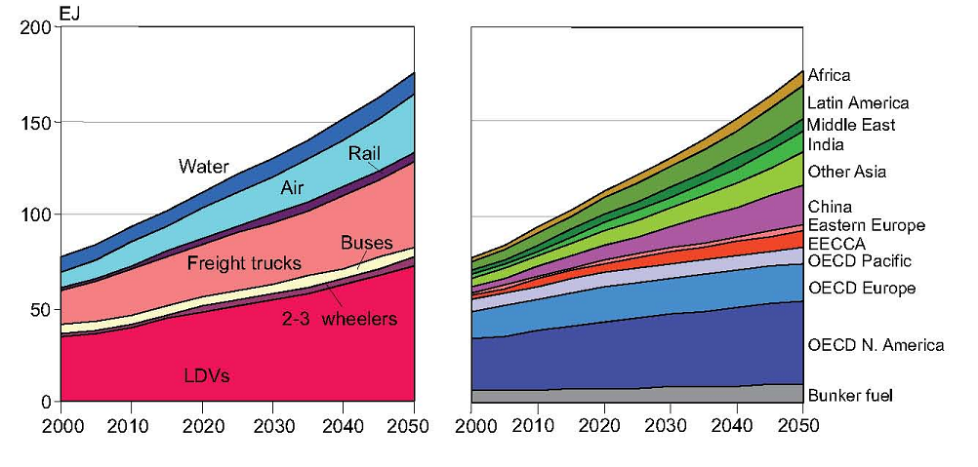
Source: Ribeiro et al. (2007)
8. Second, the International Energy Agency (IEA) provides a multitude of reports of interest and collects a wide range of data of interest. Among recent publications, IEA (2009) discusses the prospects for shifting more travel to the most efficient modes and reducing travel growth rates, improving vehicle fuel efficiency by up to 50 per cent using cost-effective, innovative technologies, and moving toward electricity, hydrogen, and advanced biofuels to achieve a more secure and sustainable transport future.
9. Thirdly, the European Environment Agency undertakes annually a broad review of the transport and the environment. The latest report (European Energy Agency (2009)) presents a rather dark picture of the environmental impacts of deals with transport and its impact on the recent evolution of environmental impacts of the transport sector in Europe.
10. Finally, the Stern Review (Stern (2006)) in its Annex 7.a also presents the current status and future business as usual (BAU) projections of transport trends relating to GHG emissions, based on similar sources as the fourth IPCC Assessment Report (see figure 2).

Figure 2
Trends in transport sector greenhouse gas emissions by country 1990-2006
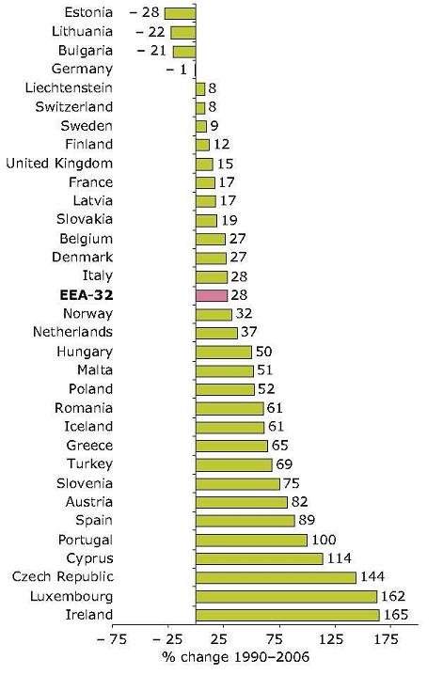
Source: European Energy Agency (2009)
11. National statistical offices, as well as Eurostat for the European Union, also provide important information with regard to the statistics relating to inland transport. The recent trends as presented in Noreland (2009) are of utmost importance for understanding the increasing share of inland transport related emissions. This report highlights that: “in 2007, EU-27 road freight transport, measured in tonne-kilometres (tkm), was 27 per cent higher than in 2000. The modal share of road freight transport in inland total freight transport (road, rail and inland waterways) has slowly increased over the years and is now 76 per cent. In 2006, passenger cars accounted for 83 per cent of the inland total passenger transport (passenger cars, buses and coaches, and trains), measured in passenger-kilometres (pkm).” Future publications might confirm that the recent economic slowdown has led to a decrease in transport activities.
12. The peer-reviewed literature also contains a number of interesting articles published recently, which nicely complement the information found in major reports. They generally target more specific aspects of the transport and climate change issue.
13. Among the major challenges for the transport sector highlighted in the various reports, car ownership is systematically considered a major one. Indeed, the car ownership trends in some developing countries are quite impressive. Han and Hayashi (2008) look at the potential for car ownership increase in China's 31 provinces, taking into account current socio-economic transition and consider its likely effect on atmospheric pollution (notably: carbon dioxide (CO₂), methane (CH₄), carbon monoxide (CO), non-methane volatile organic compounds (NMVOC), nitrogen oxides (NO_{x}) and sulphur dioxide (SO₂)) up to 2020. Their results indicate that not only “...the total number of private cars, but also the volume of related pollutant emissions will shoot up to considerably higher levels in the near future if recent behavioural trends and the present technical aspects of private car use persist. Despite the introduction of stricter controls on private car purchase and pollutant emissions, China will come under much greater pressure to cut back on emissions.”
14. Creuztig and He (2009) analyse a wider range of externalities of car transportation (e.g. congestion) restricting their scope to the city of Beijing and show that social costs induced by motorized transportation are equivalent to about 7.5–15 per cent of the city's gross domestic product (GDP) and underline the uncertainty of climate change costs. Nevertheless, they show that “...a road charge could not only address congestion but also has environmental beneﬁts”.
15. Regarding the political side of the Chinese transport growth, Hu et al. (2009) present an overview of the initiatives launched in energy supply and consumption and the challenges encountered in sustainable road transportation development in China. After having highlighted the trends from 2000 to 2007, where “China has witnessed a 156 per cent increase in total motor vehicle stock, 51 per cent increase in passenger traffic volume and 65 per cent increase in freight traffic volume”, the authors present a multitude of initiatives put forward by the Chinese government to control the growth and identify issues such as low emission standards and the higher relative costs of public transportation. They conclude by advising the government to “... strengthen fuel economy technology ...”, “promote high efficiency vehicle market penetration” or “give priority to public transport in mega-cities” but also advice on the promotion of “large-scale commercialization of coal-based alternative fuels” which might not solve the climate problem if not associated to carbon capture and storage technologies.
16. In developed countries, the public awareness of the climate problem is considered a prerequisite to behavioural changes. In this context and on the basis of a questionnaire administered in the Sacramento/California metropolitan region, Flamm (2009) assesses the effects of environmental knowledge and environmental attitudes on the numbers and types of vehicles owned per household, annual vehicle miles travelled, and fuel consumption. Interestingly, he finds that: “First, environmental knowledge and environmental attitudes are strongly related (respondents who indicate that protecting the natural environment is important to them know more about the environmental impacts of vehicle ownership and use). Second, environmental knowledge is significantly related to average fuel efficiency of household vehicles and the households of respondents who know more about the environmental impacts of vehicle ownership and use own, on average, more fuel-efficient vehicles. Third, environmental knowledge is not, however, associated with the ownership of fewer vehicles, less driving, or lower fuel consumption.” This underlines the gap between the awareness of the climate change problem and the actual actions and provides an additional rational to the use of economic instrument such as CO₂ taxes.
17. Chen and Zhang (2009) examine adoption of fuel efficiency technologies by the United States (US) automobile industry between 1985 and 2002 and consider the environmental implications. The analysis is based on the estimation of an efficient frontier between weight and fuel efficiency. They conclude that their analysis shows that: “the technology efficient frontier of the US automobile industry did not improve significantly for an extended period in the 1980s and 1990s, indicating a lack of systematic adoption of new fuel efficiency technologies. While the firm with inferior technology capability did push its efficient frontier outward to close the technology gap, the two leading manufacturers' efficient frontiers first showed signs of regression in the early 1990s, and were not pushed out significantly until the late 1990s. As a result, the industry might have missed an opportunity to reduce the economic and environmental impacts.” This kind of study provides sound arguments for promoting the implementation of governmental fuel efficiency regulations.
18. The contribution of the transport sector to the climate change problem is often taken in isolation from other economic sectors. O'Donnell et al. (2009) present a case study of a life cycle assessment of the contribution of transport to greenhouse gas emissions in the supply chain of the American wheat grain. An interesting concluding remark is that “... given the contribution of sequestration to the GHG footprint of the supply chain, efforts to green supply chains should consider changes in transportation together with the resultant changes in emissions from production if transportation changes result in changes in production location.”
19. Along the same lines, Liska and Cassman (2008) make a proposal for standardized life-cycle methods, metrics, and tools to evaluate biofuel systems based on performance of feedstock production and biofuel conversion at regional or national scales, as well as for estimating the net GHG mitigation of an individual biofuel production system to accommodate impending GHG-intensity regulations and GHG emissions trading.
B. Analysis and possible gaps in the reported research
20. Statistical data as well as surveys regarding the evolution of inland transport provide the main sources of information for analyzing the role of inland transport in the climate change problem and the underlying phenomena that drive it. Vast amount information is available in reports of various national and international institutes and organizations.
21. A lot of research is currently focusing on developing countries such as China (e.g. Han and Hayashi (2008), Creuztig and He (2009), Hu et al. (2009)), where the GHG emissions due to inland transport are growing extremely rapidly and add up to other externalities such as congestion or local air pollution.
22. Regarding developed countries, we mentioned two papers analyzing the consumers and producers behaviours (Flamm (2009) and Chen and Zhang (2009)). Interestingly, no peer-reviewed study seems to have been published on the impact of the current economic downturn on the reduction of the emissions of the inland transport. This is certainly due to the fact that the relevant statistics are not available yet.
23. Life-cycle assessment analysis such as in O'Donnell et al. (2009) and Liska and Cassman (2008) are extremely useful in the analysis of the climate problem because of its inter-sectoral nature. The next section also addresses this issue in the context of electric and hydrogen vehicles, as the energy production issues also need to be adequately considered.
IV. Mitigation
A. Literature review
24. Mitigation of climate change effects will involve transformation of the transport sector. New technologies will be used to provide the needed services and also new lifestyles should emerge from the necessity to curb GHG emissions due to transport. In this section, we review documents that are dealing with mitigation or abatement actions, including technological options and modal or lifestyle changes.
1. Technological options
25. Technology choices to be made in the transport sector in order to achieve substantial abatement of GHG emissions are considered in several publications related to “bottom-up” systems analytic modelling of the energy system. Labriet et al. (2005) describe abatement scenarios obtained with the world MARKAL model which includes a description of 15 interconnected regions. These scenarios show, in particular, an evolution toward the following choices of fuels in the different demand sectors including the transport sector, for the long term:

Figure 3
Fuel choices in world-MARKAL scenarios -Shares of final energy in end-use sectors
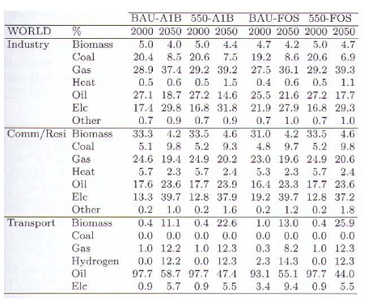
Source: Labriet et al. (2005)
26. These authors report similar results obtained with the TIMES integrated assessment model (Labriet and Loulou (2008)). The advantage of considering the transport sector within a fully fledged worldwide energy system is to relate energy choices in the transport system to some key choices made elsewhere in the energy supply system, like e.g. the development of electricity or hydrogen supply with zero emission.
27. In the same vein, Krzyzanowski et al. (2008) use a global MARKAL model (GMM) to assess the possible development of a hydrogen economy in the transport sector. They explore in particular the ways one can establish an efficient support of the transition towards hydrogen based transportation. They argue that hydrogen based transportation is an environmentally sound alternative to the current oil-based transportation. Based on their simulations, they predict that this transition could take place in the long run. The analysis shows that despite high initial costs, a transition to hydrogen based transportation could be feasible in the long run provided a number of concurrent developments take place. In particular, long-term transition would require significant external support, such as governmental aid in form of research, development and deployment (RD&D) support and in learning investments to help the technologies to follow their learning curve and become competitive in the long run ... .”
28. In figure 4, we reproduce the simplified description of the transport sector used in the global MARKAL model.

Figure 4
The representation of the transport sector in GMM
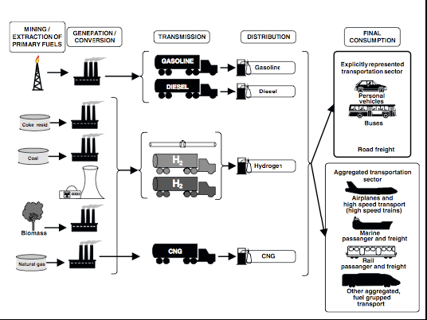
Source: Krzyzanowski et al. (2008)
29. This line of research can also be applied to the analysis of the future of transport in developing countries. Cadena and Haurie (2001) use a MARKAL model to analyse energy and environmental issues for Colombia, studying in particular the clean development mechanism (CDM) projects.
30. In figure 5, we reproduce part of the reference energy system of MARKAL-Colombia which indeed encompasses the transport sector.
Figure 5
The reference energy system considered in MARKAL-Colombia
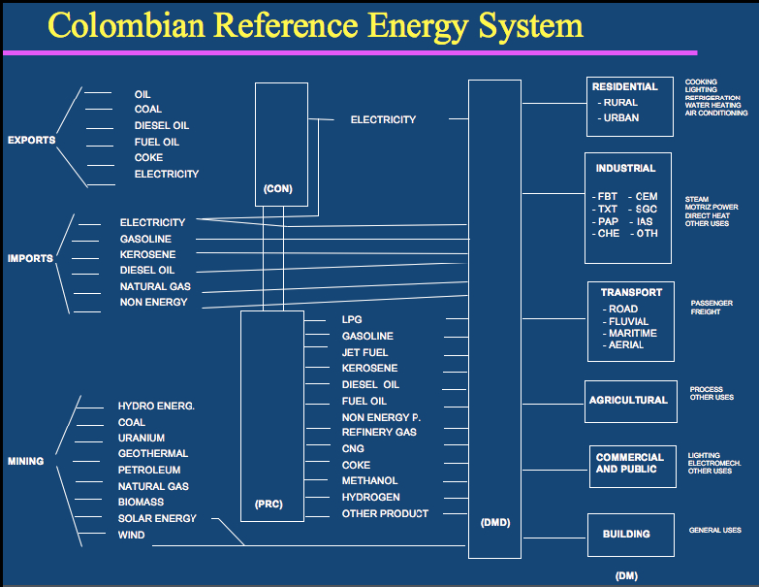
Source: Cadena and Haurie (2001)
31. The same type of analysis can also be performed at a more local level as shown by Caratti et al. (2003) who study the potential of fuel cell cars in an urban environment subject to severe limitations concerning GHG emissions. They use for their study a model called MARKAL-Lite which is a version of the MARKAL model adapted to the representation of energy/technology choices at a city or regional level. The interesting aspect of this analysis is the exploration of the links that could exist between the developments of a large fleet of electric or fuel cell based cars of trucks and the integration to the electricity supply system. Electric cars will provide electricity storage capacity whereas fuel cell cars could provide decentralized production units.
32. The transport sector is also considered in the computable general equilibrium models that have recently been developed to study the economics of climate change policies. For example Bernard and Vielle (2008) have developed the computable general equilibrium (CGE) model GEMINI-E3 which contains a description of the transport demand and of the marginal abatement cost curves used to build “top-down” scenarios of the economics of climate change mitigation.
33. In figure 6, we reproduce part of the nomenclature of GEMINI-E3 which shows the general economic environment in which the transport sectors are considered.

Figure 6
Sectors, fuels and countries considered in GEMINI-E3
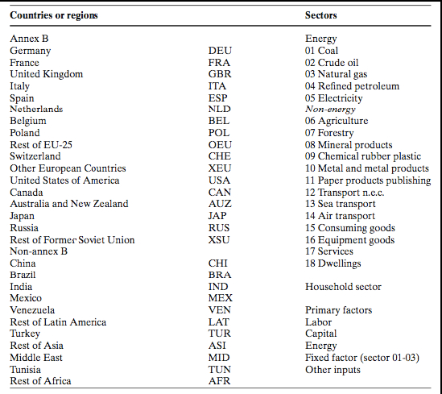
Source: Bernard and Vielle (2008)
34. Interesting results are obtained when one couples a “top-down” CGE model that describes the macroeconomic interactions and a bottom-up “techno-economic” that represents the technology choices in detail and thus permits a better evaluation of the “marginal abatement costs”.
35. Schafer and Jacoby (2006) propose a linked CGE MARKAL model system capable of simulating the macro-level economy and micro-level technology detail of the transport sector. Furthermore, in this approach, a mode choice submodel is used, based on a limited travel time budget of 1.2 hours per person and per day. The issues of calibration of such a hybrid system are delicate to address. In this application, the calibration was essentially one-way from MARKAL to EPPA (Emissions Predictions and Policy Analysis) model.
36. In figure 7, we reproduce the schematic representation of the coupling method between the “bottom-up” model like MARKAL, “modal split” models and the “top-down” model like EPPA.

Figure 7
The coupling procedure
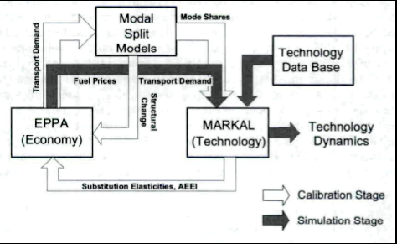
Source: Schafer and Jacoby (2006)
37. There are other detailed energy models permitting an assessment of the evolution of the transport sector under stricter climate policies. Yan and Crookes (2009) analyse the future trends of energy demand and GHG emissions in China's road transport sector and assess the effectiveness of possible reduction measures. To do that they use the Long-range Energy Alternatives Planning (LEAP) System. They analyse future trends of total energy demand, petroleum (including gasoline, diesel and liquid petroleum gas (LPG)) demand and GHG emissions in China for a “business as usual” (BAU) and for a “best case” (BC) scenario. The analysis shows relative reduction potentials as large as 40.5 per cent for energy use, 46.5 per cent for petroleum use and 39.9 per cent for GHG emissions. We reproduce below one of the figures summarizing these results.

Figure 8
GHG abatement in BC compared with BAU in China and role of each policy measure
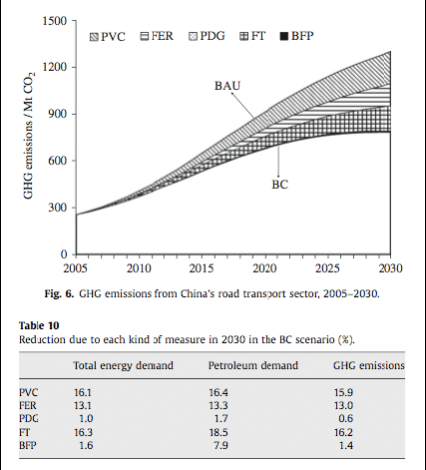
Source: Yan and Crookes (2009)
38. The measures considered are private vehicle control (PVC), fuel economy regulation (FER), promotion of diesel and gas (PDG), fuel tax (FT) and biofuel promotion (BFP). They are not including penetration of new carbon free technologies.
39. Technology assessment can also be performed at a very local level. Haseli et al. (2008) make a comparative assessment in terms of CO₂ emissions from a passenger train in Ontario, Canada, using four specific propulsion technologies: (a) conventional diesel internal combustion engine (ICE), (b) electrified train, (c) hydrogen ICE, and (d) hydrogen polymer electrolyte membrane fuel cell (PEMFC) train. The travel under scrutiny is about 60 kilometer long between Oshawa and Toronto.

Figure 9
Energy consumption (upper graph) and corresponding travel cost (lower graph) of trains with various power train technologies
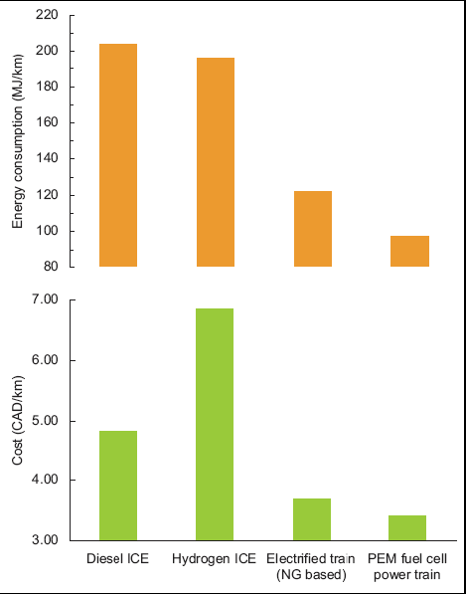
Source: Haseli et al. (2008)
40. It is also interesting to know that according to these authors: “... only an electric car based on Scenario 1 of electricity production [renewable energy sources including nuclear energy], with [3 or 4 people per car], may be competitive with a modern powertrain ... “.
41. Lutsey and Sperling (2009) compare transportation greenhouse gas mitigation options with other sectors by constructing greenhouse gas mitigation supply curves of near-term technologies for all the major sectors of the economy of the United States of America (US). To do that they use marginal abatement cost curves, also called “GHG mitigation supply curves” that are constructed using a bottom-up approach. The authors do not detail the models that have been used to obtain these marginal cost curves. In their conclusion they claim: “... [The] analysis shows that many transportation strategies are cost-effective when compared directly with options in other economic sectors under consistent assumptions. Many transportation efficiency measures generate cost savings over the life of the energy-efficiency equipment investment, when future energy savings are calculated using normal discount factors. [One finds] that such measures within the transportation sector represent half of all of the “no-regrets” options that are available in all the economic sectors...”.
42. A Kaya framework that decomposes greenhouse gas emissions into the product of population, transport intensity, energy intensity, and carbon intensity is used by Yang et al. (2009) to analyse emissions and mitigation options in California to reduce transportation greenhouse gas emissions 80 per cent below 1990 levels by 2050 (called 80 in 50 scenarios).
43. They first observe that in California, the transportation sector is the largest contributor of GHG emissions, making up over 40 per cent of the state's total in 2006. They also observe that no mitigation option can single-handedly meet the target goal because travel demand is expected to increase significantly by 2050 and advanced technologies and fuels may not be suitable for use in all sub-sectors or may be limited in availability. The “silver-bullet” scenarios explore the potential impact of a new “greener” technology and conclude that none of them can achieve the 80 in 50 goal (see figure 10 reproduced from the paper).

Figure 10:
Reduction in GHG emissions for each of the Silver Bullet scenarios relative to the 1990 level and the 2050 reference scenario
None of the Silver Bullet scenarios achieve the 80 in 50 goa
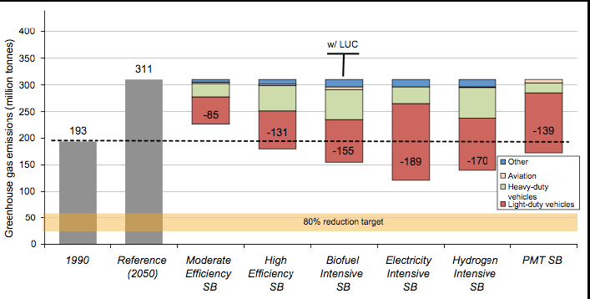
Source: Yang et al. (2009)
44. The 80 in 50 scenarios consist of: the efficient biofuels scenario which relies heavily on advanced technologies for biofuels production entirely from cellulose sources with negligible “land-use change (LUC)” impacts; the electric-drive scenario which relies heavily on advanced electric-drive technologies and low-carbon hydrogen and electricity. Limited availability of low-carbon biofuels constrains their use; and the actor-based scenario which presents a world where all actors (companies, governments, and individuals) are motivated, because of much high energy prices, to reduce energy consumption and GHG emissions, mainly through smaller, more efficient vehicles, reduced per-capita transportation activity, and increased vehicle occupancy load factors.
45. The authors conclude that “...The 80 in 50 scenarios illustrate that the 80 per cent reduction goal could potentially be met in multiple ways. The efficient biofuels 80 in 50 and electric-drive 80 in 50 scenarios show that if vehicle and fuel technologies become clean enough, California can preserve its current levels of mobility. The former requires more primary energy and relies heavily on biomass, while the latter uses fuel more efficiently and has the potential for a significantly more diverse resource mix. The actor-based 80 in 50 scenario shows that large shifts in social and travel behaviour are valuable mitigation options, especially if technology is not as successful. This scenario has the lowest energy resource requirements. ... ”
46. This research can be complemented by the analysis of Sperling and Gordon (2008). In a very detailed survey they examine the possible technological changes in vehicles, in particular for electric and fuel cell cars. They also debate about two fundamental challenges: (a) transforming vehicles to dramatically reduce oil use and greenhouse gas (GHG) emissions and (b) transforming the larger transportation system to expand personal mobility options and reduce their environmental and spatial footprints. Interestingly, they see in the fact that they provide “mobile electricity” the element which may prove most pivotal in determining the success of fuel cell vehicles, thus rejoining Caratti et al. (2003). In their conclusion they claim that “...The challenge of reducing car dependency is especially urgent for China, India, and others in the rapidly expanding economies of the developing world. The car-centric motorization path pioneered by the United States is very costly, not just in terms of energy and environment, but also because of the huge financial and social cost of shoehorning a network of new roads into their already large, dense cities. These developing countries need to find a new path. That new path is unlikely to be characterized by leapfrog technologies ...”

Figure 11
Transportation fuel use by 2050 in the 80in50 scenarios
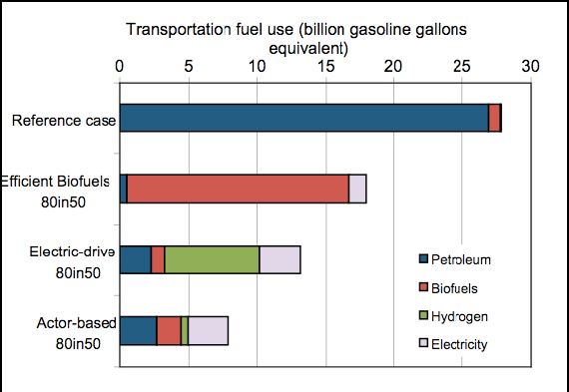
Source: Yang et al. (2009)
47. Considering a problem which is particular to Taiwan, Liao et al. (2009) examine carbon dioxide emissions of truck-only inland transport and compare those with intermodal coastal shipping and truck movements. They use an activity-based emission modelling approach: “... This study has illustrated possible positive changes in CO₂ emissions if intermodal of coastal shipping and truck is adopted in the place of truck-only transport for export/import container movements in Taiwan. The reductions in CO₂ emissions is mainly driven by the efficiency of maritime fuel (heavy oil and diesel) use compared to the diesel used by trucks ...”.
48. In a case study concerning Australia, Stanley et al. (2009) investigate two targets for road transport greenhouse gas emissions in 2020 and 2050, and what they might mean for the sector.
49. For the 2020 target (20 per cent below 2000 emission levels) the paper suggests the following six key ways to attain it: (a) Reduce urban car kilometres travelled; (b) Increase the share of urban trips performed by walking and cycling; (c) Increase public transport's mode share of urban motorized trips; (d) Increase urban car occupancy rates; (e) Reduce forecast fuel use for road freight; and (f) Improve vehicle efficiency.
50. For the 2050 target (80 per cent below 2000 levels), the authors claim that the only way to make it compatible is in significantly changing travel behaviour to increase the role of low carbon modes and/or, lowering the emission reduction target for the transport sector, which increases the burden to be taken up by other sectors.
51. Finally let us mention the multi-criteria analysis made by Granovskii et al. (2006) who compare conventional, hybrid, electric and hydrogen fuel cell vehicles using both economic and environmental indicators. The method produces a technology ranking.
2. Lifestyle Changes
52. The domain of research consisting of evaluating life style changes leading to sustainable transport is much less developed than the technological options one.
53. In a paper related to the one of Yang et al. (2009), McCollum and Yang (2009) investigate the potential for making deep cuts in United States of America transportation GHG emissions in the long-term (50–80 per cent below 1990 levels by 2050). Scenarios are used to envision how such a significant decarbonization might be achieved through the application of advanced vehicle technologies and fuels, and various options for behavioural change. They conclude that “... [the scenarios] confirm results from other studies, showing that no one mitigation option can single-handedly meet the ambitious GHG goals, especially since total travel demand in each sub-sector is expected to increase significantly by 2050. This puts a large burden on vehicle and fuel technologies to decarbonize, and by our estimates it is unreasonable to think a single technology approach can shoulder this burden entirely on its own, given the diversity of vehicle types and requirements in the transportation sector.”
54. Grazi et al. (2008) analyse whether urban form affect travel choices, by decomposing travel demand into components related to modal split and commuting distance by each mode. “...All taken together, urban form, and therefore policies that affect urban form, such as spatial and transport planning, deserve more attention in climate policy debates, as they can contribute to a reduction in greenhouse gases. For example, transport planning may try to stimulate modal shift by increasing density through the development of new public transport, such as the planned additional subway line in the centre of Amsterdam, and thus allow the design of a more effective transport infrastructure network as well as the creation of fast lanes for buses and separate lanes for bicyclists ....”.
55. Caulﬁeld (2009) examines the patterns of ride-sharing, in Dublin, and estimates the environmental benefits of ride-sharing both in terms of reductions in emissions and the vehicle kilometres travelled.
56. Wright and Fulton (2005) employ scenario analysis to examine the size and cost of potential emission reduction options from the urban transport sector of developing nations. In particular, the analysis compares the cost of greenhouse gas emission reductions from fuel technology options to reductions from measures promoting mode shifting. This comparative analysis indicates that a diversified package of measures with an emphasis on mode shifting is likely to be the most cost-effective means to greenhouse gas emission reductions.
B. Analysis and possible gaps in reported research
57. The analysis of technological options to mitigate climate change due to transport is tackled mostly through the use of bottom-up models. LEAP, MARKAL or TIMES models have been used to represent technology and energy choices for transport in relation with the evolution of the whole energy supply system (Labriet et al. (2005), Caratti et al. (2003), Krzyzanowski et al. (2008), Cadena and Haurie (2001)). A top-down approach, based on the use of computable general equilibrium models can also be coupled with the bottom-up analysis performed by MARKAL like models (Schafer and Jacoby (2006)). The linking concept between bottom-up and top-down models is the “marginal abatement cost” curve which can be constructed using an integrated energy supply model like MARKAL or more transport sector specific model (Lutsey and Sperling (2009), Yan and Crookes (2009)). The other papers in this section analyse specific technological options (Granovskii et al. (2006), Liao et al. (2009), or country/region specific options (Stanley et al. (2009), Yan and Crookes (2009), Yang et al. (2009)). One paper (Sperling and Gordon (2008)) examines the larger debate of improving current technologies versus transforming the transport system.
58. Our perception of the possible gaps in research is that the recent development of better top-down and bottom-up description of the world economy and of the world energy system, including a more precise description of emerging economies (Brazil, Russia, India and China (BRIC)), as well as the progresses in coupling methods to link bottom-up (BU) and top-down (TD) models, should be exploited to generate scenarios for the implementation of sustainable transport systems in emerging and developing countries. A similar analysis could also be undertaken for the European Union (EU), considering the availability of computable general equilibrium (GEMINI-E3, Bernard and Vielle (2008)) and technology rich (TIMES Labriet and Loulou (2008)) models well calibrated for this region of the world.
59. There is a need for the development of quantitative models, like LEAP, MARKAL, TIMES or GEMINI-E3 which would include actions oriented toward the modification of the demand pattern for energy or transport services. A modeling effort should be undertaken to generalize and to incorporate in a BU approach the trade-off between technology and system-wide improvements in the transport sector as proposed by Sperling and Gordon (2008). In particular the need for an active governmental support to invest in the needed infrastructure to permit a development of electric or fuel cell cars should be further studied.
V. Vulnerability and Adaptation Issues
A. Literature review
60. The increasing evidence that climate change is happening seems to have triggered an increased interest in the other side of the medal, i.e. the impact of climate change on transport and the potential ways of adaptation. Events such as hurricane Katrina have demonstrated the vulnerability of our societies, including our transportation systems, to climate variations. In the extensive report on the United States of America Gulf Coast Study on the Impacts of Climate Change and Variability on Transportation Systems and Infrastructure, Savonis et al. (2008) deal with impacts of Katrina on transport infrastructure, and especially on pipelines. They underline that: “At the peak of the disruption caused by Hurricane Katrina, [...] all major pipelines in the area were inoperable due to power outages. By 4 September 2005, i.e. 5 days after the storm, [...] all of the major crude or petroleum product pipelines had resumed operation at either full or near-full capacity”. In their conclusions, they stress the implications of climate change for transport planning, i.e. longer planning timeframes, connectivity of the intermodal system and the need for integrated analysis. Finally, they list climate data and projections, risk analysis tools, region-based analysis and interdisciplinary research as the major requirements for and adequate assessment of the impacts of a changing climate on transportation infrastructure and services.
61. Another detailed report (National Research Council (2008)) describes the potential impacts of climate change on the whole United States of America transportation. It presents the major impacts of climate change on transport infrastructure and operations, as reproduced in table 1. Finally, it concludes by presenting 14 recommendations for future transport planning, such as extending the planning horizon beyond the standard 20-30 years thus allowing one to take climate change into adequate consideration.
62. The transportation chapter in Lemmen and Warren (2004)] also provides an overview of research in the field of climate change impacts and adaptation focusing on Canada. They stress that “it is to be expected that many gaps exist in our understanding of potential climate change impacts and adaptation strategies in the transportation sector. Given the limited amount of work that has been completed, virtually all impact areas and adaptation strategies require further investigation. Specific priorities identified within papers cited in this chapter include:
(a) greater attention to impacts and adaptation issues for road transportation in southern Canada;
(b) increased research on the vulnerability of Canadian roads to changes in thermal conditions, including freeze-thaw cycles and extreme temperatures;
(c) studies that assess the significance of extreme weather events and weather variability in the design, cost, mobility and safety of Canadian transportation systems;
(d) a more thorough evaluation of existing adaptive measures and their relative ability to defer infrastructure upgrades, reduce operational costs, and maintain or improve mobility and safety;
(e) comprehensive studies that focus on key issues for shipping and navigation, including the opening of the Northwest Passage and lower water levels in the Great Lakes - St. Lawrence Seaway system;
(f) an analysis of how changes in factors external to climate, such as technology, land-use patterns and economics, affect societal vulnerability to climate and climate change; and
(g) studies that integrate mitigation (greenhouse gas emissions reduction) and climate change-related impacts and/or adaptation issues.”
63. In their survey of the empirical literature on the effects of climate change and weather conditions on the transport sector, Koetze and Rietveld (2009) also stress that far less literature has been published on the impacts of and adaptation to climate change than on mitigation. They summarize part of their finding as follows. “On a global scale especially the increase in temperatures may influence patterns in tourism and skiing holidays, with the associated changes in passenger transport. We may also expect global shifts in agricultural production, with associated changes in freight transport. The predicted rise in sea levels and the associated increase in frequency and intensity of storm surges and flooding incidences may furthermore be some of the most worrying consequences of climate change, especially for coastal areas. Empirical research for Europe is limited, but research for the United States of America East Coast and Gulf area shows that the effects on transport and transport infrastructure may be substantial. However, because flood-defences that are already in place are included in none of the studies, the insights may have limited value for assessing future flood-risk and exposure for specific locations, and likely also overestimate total exposure and damages due to climate change. Climate change related shifts in weather patterns might also affect infrastructure disruptions. For road transport most studies focus on traffic safety and congestion. With respect to traffic safety by far the most important variable is precipitation, most studies finding that precipitation increases accident frequency, but decreases accident severity. The mediating effect in here is likely that precipitation reduces traffic speed, thereby reducing the severity of an accident when it occurs. Furthermore, most studies show a reduction in traffic speed due to precipitation and especially snow. Interestingly, the effect is particularly large during peak hours and on congested roads. The few existing insights for rail transport show that high temperatures, icing, and strong winds, among others, may cause considerable delays. For the aviation sector, wind speeds, wind direction and visibility have clear effects on safety and delays and cancellations. This has large cost implications, both for airlines and travellers. However, implications of climate change on wind speeds but especially on wind directions and developments with respect to mist, fog and visibility are highly uncertain. Finally, changes in temperature and precipitation have consequences for riverine water levels. Low water levels will force inland waterway vessels to use only part of their maximum capacity, which may considerably increase transportation costs in the future.”

Table 1
Potential Climate Changes and Illustrative Impacts on Transportation
Potential climate change | Examples of impacts on operations | Examples of impacts on infrastructure
Increases in very hot days and heat waves: | Impact on lift-off load limits at high-altitude or hot weather airports with insufficient runway lengths, resulting in flight cancellations or limits on payload (i.e. weight restrictions), or both.  Limits on periods of construction activity due to health and safety concerns. | Thermal expansion on bridge expansion joints and paved surfaces.  Concerns regarding pavement integrity (e.g., softening), traffic-related rutting, migration of liquid asphalt.  Rail-track deformities.
Increases in Arctic temperatures: | Longer ocean transport season and more ice-free ports in northern regions.  Possible availability of a northern sea route or a northwest passage. | Thawing of permafrost, causing subsidence of roads, rail beds, bridge supports (cave-in), pipelines, and runway foundations.  Shorter season for ice roads.
Rising sea levels, combined with storm surges: | More frequent interruptions to coastal and low-lying roadway travel and rail service due to storm surges.  More severe storm surges, requiring evacuation or changes in development patterns.  Potential for closure or restrictions at several of the top 50 airports that lie in coastal zones, affecting service to the highest-density populations in the United States. | Inundation of roads, rail lines, and airport runways in coastal areas.  More frequent or severe flooding of underground tunnels and low-lying infrastructure.  Erosion of road base and bridge supports.  Reduced clearance under bridges.  Changes in harbor and port facilities to accommodate higher tides and storm surges.
Increases in intense precipitation events | Increases in weather-related delays and traffic disruptions.  Increased flooding of evacuation routes.  Increases in airline delays due to convective weather. | Increases in flooding of roadways, rail lines, subterranean tunnels, and runways.  Increases in road washout, damages to rail-bed support structures, and landslides and mud-slides that damage roadways and tracks.  Increases in scouring of pipeline roadbeds and damage to pipelines.
More frequent strong hurricanes:  (Category 4-5) | More frequent interruptions in air service.  More frequent and potentially more extensive emergency evacuations.  More debris on roads and rail lines, interrupting travel and shipping. | Greater probability of infrastructure failures.  Increased threat to stability of bridge decks.  Impacts on harbor infrastructure from wave damage and storm surges.
Source: National Research Council (2008)

64. More specifically, Jonkeren et al. (2009) assess the effect of low water levels on the costs of transport operations and modal split for inland waterway transport in North-West Europe under several climate scenarios. They find that: “climate change is likely to affect inland waterway transport prices via low water levels which may lead to a deterioration of the competitive position of inland waterway transport compared to rail and road transport. We studied this issue using NODUS, a geographic information system (GIS) based planning model for strategic freight network that combines supply, demand and cost functions to assign flows on a multimodal network. At ﬁrst, a base scenario was created describing a fictitious year with average daily water levels, as modelled from 1986 to 1995. The alternative scenarios were based on several climate scenarios which implied increases in the costs for inland waterway transport due to low water levels. Relative to the base scenario, we estimated a reduction in the annual quantity transported by barge of about 2.3 per cent in the case of KNMI'06 climate scenario M+, and about 5.4 per cent in the case of scenario W+, in the Kaub-related Rhine market. As a result, the volume of road vehicle kilometres and the volume of CO₂ emission increase with about 1 per cent.”
65. If inland waterways are very likely to be affected, other modes of transport are also at stake. Lindgren et al. (2009) summarize a case study on the future vulnerability to climate change of the Swedish railway transport system and its adaptive capacity. They also make a recent and complete literature review at the crossroad of adaptation and transportation. They conclude that: “… without doubt, it will be a challenge for the railway sector to cope with future climate change, and its adaptive capacity will be thoroughly tested during the coming decades. The results from this case study highlight several climate-related threats that could have severe negative consequences for the railway system. The most important of these relate to high water levels, both in streams and groundwater, high wind speeds and rapid changes in temperature. All of these are potential consequences of climate change. A positive aspect of climate change that may reduce the vulnerability, especially for Northern Europe, relates to milder conditions in winter.”
66. In chapter 4.3 of Savonis et al. (2008), we find some case studies of adaptation of transport infrastructure to climate changes, for instance adaptation to sea level rise by elevation of a highway. They provide the example of Louisiana Highway 1, which is in process of getting some of its portions elevated, and stress the importance of hurricane Katrina in raising the awareness of vulnerability.
67. Climate change is also very likely to have significant impacts on urban transportation systems of costal cities. Suarez et al. (2005) study the impacts of flooding and climate change on urban transportation in the Boston Metro Area. They conclude that: “... the Boston metro area is already heavily built and, therefore, there will not be much change in urban infrastructure compared to other metropolitan areas in the United States of America and worldwide. The transportation network has great redundancy and, therefore, it is not too vulnerable to extreme events from a system wide perspective. Consequently, there is little margin of action in terms of modifying the existing infrastructure based on the results of this modeling effort. However, for urban areas experiencing more rapid land use conversion, or located in more hazard-prone areas, the methodology presented in this work can prove very useful for exploring choices in terms of how to guide urban growth and how to develop an integrated plan for managing transportation systems facing the threat of increased flooding.”.
68. More globally, Jaroszweski et al. (2009) emphasize the need to utilize an interdisciplinary approach to Climate Change Impact Assessment (CCIA) taking into account both climate and socioeconomic scenarios. They emphasize that: “... the nature of future society cannot be predicted. However, it is possible to present a range of plausible scenarios that may happen. It is this concept of scenarios which is a key to developing a useful CIA. Depending on the dominant socio-economic drivers present over the coming century, the transport network of the future may be more or less vulnerable to the impacts of meteorological events. It will both drive the type of infrastructural projects which are commenced during this period and influence the way in which they are used. By providing a range of scenarios it is possible for governments, organisations and companies to have a greater insight into the 'futures' into which their investments will be placed”.
69. Institution of Mechanical Engineers (2008) examines climate change predictions, using the GENIE-1 model (http://www.genie.ac.uk/), for three geographical regions (United Kingdom, Shanghai in China and Botswana), chosen for their differing maritime, monsoonal and continental climates, and different stages of economic development. The Institution of Mechanical Engineers has a strong belief that: “... unless we adapt, we are likely to face a difficult future”. It also views adaptation as the next challenge for engineer and state that “... all current modes of transport will still be in use in 100-200 years' time, albeit in modified forms. Much of the built infrastructure will need to be assessed for vulnerability and resilience to climate change. Master planning will need to consider alternative routes and extra capacity as well as build in redundancy, particularly in the case of rail where much of the infrastructure is sited on flood plains and coastal fringes”.
B. Analysis and possible gaps in the reported research
70. The climate changes that could have a direct impact on transport infrastructure are sea level rise (oceans), low water levels (rivers), storm surge and flooding (Koetze and Rietveld (2009)). Impacts on transport demands (freight, agriculture, and passenger) are more difficult to assess but the possible availability of a northern sea route or a northwest passage might have significant consequences on international freight transportation.
71. The question of evaluating climate impact on transportation is a key point (Jaroszweski et al. (2009)) and needs a global approach to be answered. It could be interesting to develop this field of research, probably by a global modeling approach.
72. Several researches have been carried out in the United States of America (National Research Council (2008), Savonis et al. (2008), Suarez et al. (2005)), Canada (Lemmen and Warren (2004)) and Europe (Jonkeren et al. (2009)), with some focusing particularly on flooding and sea level rise impacts. There are still few researches on adaptation in developing countries and papers such as Molua (2009) do not deal with climate change impacts on transportation. Therefore, research could be extended to developing countries and more specifically in Middle East, North Africa and East Asia, regions known to be highly vulnerable.
73. So far, it remains very difficult to assess adaptation policies (Lemmen and Warren (2004), Lindgren et al. (2009)). Today, most adaptation measures are still taken as a response to current climate variability. The major question governments are facing is how to include long term climate change in the transport systems strategy and planning. Finally, it would also be interesting to evaluate current adaptation projects.
VI. List of Journals by Domain
A. Transport science
(a) Transportation research Part A
(b) Transportation research Part D
(c) Transport Reviews
B. Geography and economics
(a) Journal of Transport Geography
C. Political science
(a) Political Science
D. Engineering
(a) European Journal of Transport and Infrastructure research
(b) The IES Journal Part A: Civil and structural Engineering
E. Energy
(a) Energy
(b) Energy Journal
(c) Energy Policy
(d) International Journal of Hydrogen Energy
F. Environmental science
(a) The Annual Review of Environment and Resources
VI. References
Bernard, A., and Vielle, M. GEMINI-E3, a general equilibrium model of international–national interactions between economy, energy and the environment. Computational Management Science, 5(3):173–206, 2008. 13, 24.
Cadena, A., and Haurie, A. Modelling energy and environmental issues for a developing country. Journal of the Operational Research Society of India, 38(1):44–66, 2001. 10, 12, 24.
Caratti, P., and others. Exploring the Fuel Cell Car Future: an Integrated Energy Model at the City Level. WIT Press, Southampton, 2003. 10, 22, 24.
Caulﬁeld, Brian. Estimating the environmental benefits of ride-sharing: A case study of Dublin. Transportation research Part D, 14:527–531, 2009. 23.
Chapman, Lee. Transport and climate change: a review. Journal of transport geography, 15:354–367, 2007. 2.
Chen, Chialin, and Zhang, Jung. The inconvenient truth about improving vehicle fuel efficiency: A multi-attributes analysis of the technology efficient frontier of the US automobile industry. Transportation research Part D, 14:22–31, 2009. 6, 8.
Creuztig, Feliax, and He, Dongquan. Climate change mitigation and co-benefits of feasible transport demand policies in Beijing. Transportation research Part D, 13:120–131, 2009. 4, 7.
European Energy Agency. Transport at a crossroads. TERM 2008: indicators tracking transport and environment in the European Union, Volume 3. 2009. 3, 5.
Flamm, Bradley. The impacts of environmental knowledge and attitudes on vehicle ownership and use. Transportation research Part D, 14:272–279, 2009. 6, 8.
Granovskii, Mikhail, Dincer, Ibrahim, and Rosen, Marc A. Economic and environmental comparison of conventional, hybrid, electric and hydrogen fuel cell vehicles. Journal of Power Sources, 159(2):1186–1193, 2006. 22, 24.
Grazi, Fabio, van den Bergh, Jeroen C. J. M, and van Ommeren, Jos N. An empirical analysis of urban form, transport, and global warming. Energy Journal, 29(4):97–122, 2008. ISSN 01956574. 23.
Han, Ji and Hayashi, Yoshitsugu. Assessment of private car stock and its environmental impacts in China from 2000 to 2020. Transportation research Part D, 13:471–478, 2008. 4, 7.
Haseli,Y., Naterer, G.F., and Dincer,I. Comparative assessment of greenhouse gas mitigation of hydrogen passenger trains. International Journal of Hydrogen Energy, 33(7):1788–1796, 2008. 17, 18.
Hensher, D. A., and Button, K.J. Handbook of Transport and Environment. Number 4 in Handbooks in Transport. Elsevier, 2003. 2.
Hu, Xiaojun, and others. Energy for sustainable road transportation in China: Challenges, initiatives and policy implications. Energy, 2009. 6, 7.
Institution of Mechanical Engineers. Climate change adapting to the inevitable? Technical report, Institution of Mechanical Engineers, 2008. 30.
International Energy Agency. Transport, Energy and CO2: moving towards sustainability. 2009. 2, 3.
Jaroszweski, David, Chapman, Lee, and Petts, Judith. Assessing the potential impact of climate change on transportation: The need for an interdisciplinary approach. Journal of Transport Geography, 2009. 30, 31.
Jonkeren, Olaf, Jourquin, Bart, and Rietveld, Piet. Modal-split effects of climate change: The effect of low water levels on the competitive position of inland waterway transport in the river Rhine area. Transportation Research Part A: Policy and Practice, 2009. 28, 31.
Kahn Ribeiro, S., and others. Transport and its infrastructure, chapter 5, pages 323–386. Cambridge University Press, Cambridge, United Kingdom and New York, NY, USA, 2007. 3.
Koetze, Mark J., and Rietveld, Piet. The impact of climate change and weather on transport: an overview of empirical findings. Transportation Research Part D, 14:205–221, 2009. 2, 26, 30.
Krzyzanowski, Daniel A., Kypreos, Socrates, and Barreto, Leonardo. Supporting hydrogen based transportation: case studies with global MARKAL model. Computational Management Science, 5(3), 2008. 10, 11, 24.
Labriet, Maryse, and Loulou, Richard. ETSAP-TIAM: the TIMES integrated assessment model part i: Model structure. Computational Management Science, 5(1-2):7–40, 2008. 10, 24.
Labriet, Maryse, Loulou, Richard, and Kanudia, Amit. Global Energy and CO2 emission scenarios: analysis with a 15-region world MARKAL model, chapter 8. Springer, 2005. 8, 9, 24.
Lemmen, D.S., and Warren, F.J., eds. Climate Change Impacts and Adaptation: A Canadian Perspective. Government of Canada, Ottawa, ON, 2004. 26, 31.
Liao, Chun-Hsiung, Tseng, Po-Hsing, and Lu, Chin-Shan. Comparing carbon dioxide emissions of trucking and intermodal container transport in Taiwan. Transportation research Part D, 14:493–496, 2009. 22, 24.
Lindgren, Johan, Jonsson, Daniel K., and Carlsson-Kanyama, Annika. Climate adaptation of railways: lessons from Sweden. European Journal of Transport and Infrastructure Research, 9(2):164–181, 2009. 29, 31.
Liska, Adam J., and Cassman, Kenneth G. Towards standardization of life-cycle metrics for biofuels: Greenhouse gas emissions mitigation and net energy yield. Journal of Biobased Materials and Bioenergy, 2(3):187–203, 2008. 7, 8.
Lutsey, Nicholas, and Sperling, Daniel. Greenhouse gas mitigation supply curve for the United States for transport versus other sectors. Transportation research Part D, 14:222–229, 2009. 19, 24.
McCollum, David, and Yang, Christopher. Achieving deep reductions in US transport greenhouse gas emissions: Scenario analysis and policy implications. Energy Policy, In Press, Corrected Proof:–, 2009. 23.
Molua, Ernest L. Accomodation of climate change in coastal areas of Cameroon: selection of household-level protection options. Mitigation and Adaptation Strategies for Global change, 2009. 31.
National Research Council. Potential impacts of climate change on U.S. Transportation. Transportation Research Board, 2008. 25, 27, 31.
Noreland, Jonas. Inland freight and passenger transport in the EU-27 up to 2007. Technical report, Eurostat, 2009. 4.
O'Donnell, Brendon, and others. The relative contribution of transportation to supply chain greenhouse gas emissions: a case study of American wheat. Transportation research Part D, 14: 487–492, 2009. 7, 8.
Savonis, Michael J., Burkett, Virginia R., and Potter, Joanne R. Impacts of climate change and variability on transportation systems and infrastructure: Gulf Coast study, part i. Synthesis and assessment product 4.7, U.S. Climate Change Science Program and the subcommittee on global change research, 2008. 25, 29, 31.
Schafer, Andreas, and Jacoby, Henry D. Experiments with a hybrid CGE¬MARKAL model. Energy Journal, 27:171–177, 2006. 14, 24.
Sperling, Daniel, and Gordon, Deborah. Advanced passenger transport technologies. Annual review of environment and ressources, 33:63–84, 2008. 20, 24, 25.
Stanley, John K., Hensher, David A., and Loader, Chris. Road transport and climate change: stepping off the greenhouse gas. Transportation Research Part A: Policy and Practice, 2009. 22, 24.
Stern, Nicholas. The economics of climate change: the Stern review. Cambridge University Press, Cambridge, United Kingdom and New York, NY, USA, 2006. 4.
Suarez, Pablo, and others. Impacts of flooding and climate change on urban transportation: a system-wide performance assessment of the Boston metro area. Transportation research Part D, 10:231–244, 2005. 29, 31.
Wright, Lloyyd, and Fulton, Lewis. Climate change mitigation and transport in developing nations. Transport Reviews, 25(6):691–717, 2005. 23.
Yan, Xiaoyu, and Crookes, Roy J. Reduction potentials of energy demand and GHG emissions in China's road transport sector. Energy Policy, 37:658–668, 2009. 14, 16, 24.
Yang, Christopher, and others. Meeting an 80 per cent reduction in greenhouse gas emissions from transportation by 2050: a case study in California. Transportation research Part D, 14: 147–156, 2009. 19, 20, 21, 23, 24.

* * In accordance with the programme of work of the Inland Transport Committee for 2006–2010 (ECE/TRANS/166/Add.1, programme activity 02.4), the World Forum will develop, harmonize and update Regulations in order to enhance the performance of vehicles. The present document is submitted in conformity with that mandate.
? This literature review was jointly prepared in November 2009 by Alain Haurie (Director of Ordecsys and Professor (emeritus) of Operations Research, HEC-Management Studies at the University of Geneva), André Sceia (Economics and Environmental Management Laboratory, Swiss Federal Institute of Technology at Lausanne (EPFL) and UNECE Transport Division) and Julien Thénié (Ordecsys, Place de l'Etrier 4, CH-1224 Chêne-Bougeries, Switzerland).
? MARKAL and TIMES models are developed under the aegis of ETSAP an implementation committee of the IEA. These models are described on the following website: <http: //www.etsap.org/Tools.asp>.
? More information on the LEAP model is available at: <http://www.energycommunity.org/default.asp>.
? The Kaya identity is an equation relating factors that determine the level of human impact on climate, in the form of emissions of the greenhouse gas carbon dioxide. It states that total emission level can be expressed as the product of four inputs: population, GDP per capita, energy use per unit of GDP, carbon emissions per unit of energy consumed.
? “KNMI” means the Royal Netherlands Meteorological Institute.

